**Bank Sim  
Design Document**

**CIS 3296 Section 01**

**Spring 2022**

**Team Members:**

- Kyle Hrivnak

- Tommy Ngo

**Repository URL:**

* <https://github.com/cis3296s22/banksim-01-hrivnak-ngo-sd22.git>

**Project Board**

* <https://trello.com/b/gL3ZqbBh/banksim-01-hrivnak-ngo-sd22>

**API JavaDocs (download):**

* <https://drive.google.com/file/d/1uu0QGouSTeUxruPTnm2TS3iHUepTSJ-1/view?usp=sharing>
* Table of Contents

Document Overview 4

Architecture 4

API 6

## Document Overview

This Design Document describes the software architecture and how the requirements are mapped into the design. This document will be a combination of diagrams and text that is describing what the diagrams are showing. The Design Document also specify the complete design of the software implementation using Javadoc.

## 

## Architecture

This section describes how to observe the race condition and explain how the race condition may occur using UML sequence diagrams.

UML sequence diagram of race condition in the initial version of BankSim program.

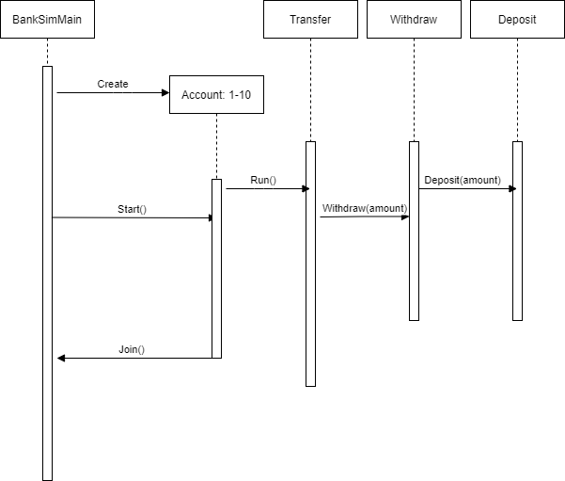

UML sequence diagram w/ test() method call is invoked after Task 3.

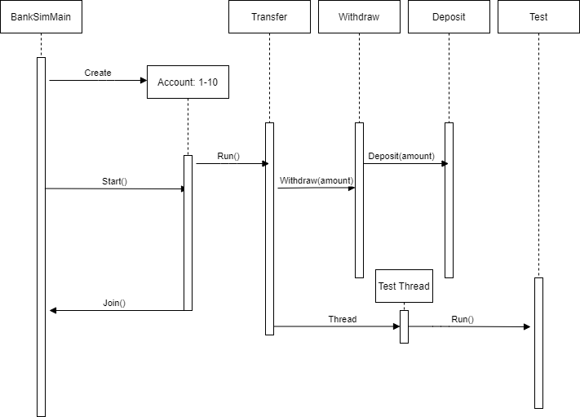

UML class diagram:

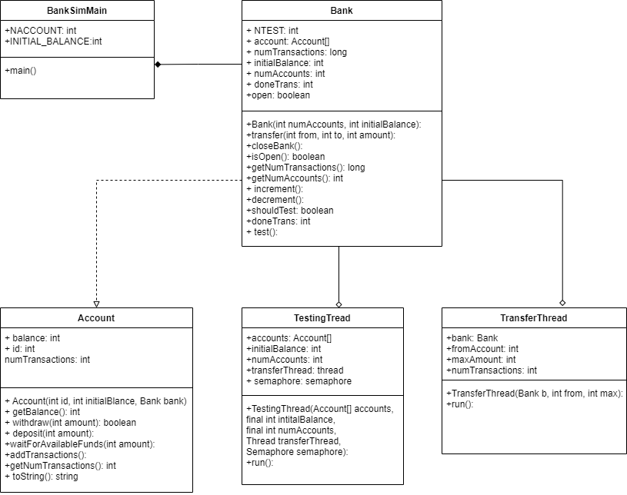

## Detail Design API

For each class define the data fields, methods.

* The purpose of the class.
* The purpose of each data field.
* The purpose of each method
* Pre-conditions if any.
* Post-conditions if any.
* Parameters and data types
* Return value and output variables
* Exceptions thrown*.

This information should be in structured comments (e.g. Javadoc) in the source files. A documentation generation tool (e.g. Javadoc) may be used to generate the document as a draft.

JavaDocs(download): <https://drive.google.com/file/d/1uu0QGouSTeUxruPTnm2TS3iHUepTSJ-1/view?usp=sharing>

# Package edu.temple.cis.c3238.banksim

package edu.temple.cis.c3238.banksim

* **Classes**
* **Class**
* **Description**
* **Account**
* **Bank**
* **BankSimMain**
* **TestingThread**
* **TransferThread**

SKIP NAVIGATION LINKS

* PACKAGE
* CLASS
* TREE
* INDEX
* HELP
* SUMMARY:
* NESTED |
* FIELD |
* CONSTR |
* METHOD
* DETAIL:
* FIELD |
* CONSTR |
* METHOD

SEARCH:

**Package** edu.temple.cis.c3238.banksim

# Class Account

[java.lang.Object](https://docs.oracle.com/en/java/javase/17/docs/api/java.base/java/lang/Object.html)

edu.temple.cis.c3238.banksim.Account

public class **Account**

extends [Object](https://docs.oracle.com/en/java/javase/17/docs/api/java.base/java/lang/Object.html)

* ***Constructor Summary*Constructors**
* **Constructor**
* **Description**
* **Account**(int id, int initialBalance, **Bank** bank)
* ***Method Summary*All MethodsInstance MethodsConcrete Methods**
* **Modifier and Type**
* **Method**
* **Description**
* void
* **addTransaction**()
* void
* **deposit**(int amount)
* int
* **getBalance**()
* int
* **getNumTransactions**()
* [**String**](https://docs.oracle.com/en/java/javase/17/docs/api/java.base/java/lang/String.html)
* **toString**()
* void
* **waitForAvailableFunds**(int amount)
* boolean
* **withdraw**(int amount)
* **Methods inherited from class java.lang.**[**Object**](https://docs.oracle.com/en/java/javase/17/docs/api/java.base/java/lang/Object.html)[clone](https://docs.oracle.com/en/java/javase/17/docs/api/java.base/java/lang/Object.html#clone()), [equals](https://docs.oracle.com/en/java/javase/17/docs/api/java.base/java/lang/Object.html#equals(java.lang.Object)), [finalize](https://docs.oracle.com/en/java/javase/17/docs/api/java.base/java/lang/Object.html#finalize()), [getClass](https://docs.oracle.com/en/java/javase/17/docs/api/java.base/java/lang/Object.html#getClass()), [hashCode](https://docs.oracle.com/en/java/javase/17/docs/api/java.base/java/lang/Object.html#hashCode()), [notify](https://docs.oracle.com/en/java/javase/17/docs/api/java.base/java/lang/Object.html#notify()), [notifyAll](https://docs.oracle.com/en/java/javase/17/docs/api/java.base/java/lang/Object.html#notifyAll()), [wait](https://docs.oracle.com/en/java/javase/17/docs/api/java.base/java/lang/Object.html#wait()), [wait](https://docs.oracle.com/en/java/javase/17/docs/api/java.base/java/lang/Object.html#wait(long)), [wait](https://docs.oracle.com/en/java/javase/17/docs/api/java.base/java/lang/Object.html#wait(long,int))
* ***Constructor Details***

**Account**public Account(int id,

int initialBalance,

* + Bank bank)
* ***Method Details***
  + **getBalance**public int getBalance()
  + **withdraw**public boolean withdraw(int amount)
  + **deposit**public void deposit(int amount)
  + **waitForAvailableFunds**public void waitForAvailableFunds(int amount)
  + **addTransaction**public void addTransaction()
  + **getNumTransactions**public int getNumTransactions()
  + **toString**public [String](https://docs.oracle.com/en/java/javase/17/docs/api/java.base/java/lang/String.html) toString()  
    **Overrides:**[toString](https://docs.oracle.com/en/java/javase/17/docs/api/java.base/java/lang/Object.html#toString()) in class [Object](https://docs.oracle.com/en/java/javase/17/docs/api/java.base/java/lang/Object.html)

SKIP NAVIGATION LINKS

* PACKAGE
* CLASS
* TREE
* INDEX
* HELP
* SUMMARY:
* NESTED |
* FIELD |
* CONSTR |
* METHOD
* DETAIL:
* FIELD |
* CONSTR |
* METHOD

SEARCH:

**Package** edu.temple.cis.c3238.banksim

# Class Bank

[java.lang.Object](https://docs.oracle.com/en/java/javase/17/docs/api/java.base/java/lang/Object.html)

edu.temple.cis.c3238.banksim.Bank

public class **Bank**

extends [Object](https://docs.oracle.com/en/java/javase/17/docs/api/java.base/java/lang/Object.html)

* ***Field Summary*Fields**
* **Modifier and Type**
* **Field**
* **Description**
* int
* **donetrans**
* static final int
* **NTEST**
* (package private) [**Semaphore**](https://docs.oracle.com/en/java/javase/17/docs/api/java.base/java/util/concurrent/Semaphore.html)
* **semaphore**
* (package private) [**AtomicInteger**](https://docs.oracle.com/en/java/javase/17/docs/api/java.base/java/util/concurrent/atomic/AtomicInteger.html)
* **signal**
* ***Constructor Summary*Constructors**
* **Constructor**
* **Description**
* **Bank**(int numAccounts, int initialBalance)
* ***Method Summary*All MethodsInstance MethodsConcrete Methods**
* **Modifier and Type**
* **Method**
* **Description**
* (package private) void
* **closeBank**()
* (package private) void
* **decrement**()
* int
* **doneTrans**()
* int
* **getNumAccounts**()
* long
* **getNumTransactions**()
* (package private) void
* **increment**()
* (package private) boolean
* **isOpen**()
* boolean
* **shouldTest**()
* void
* **test**()
* void
* **transfer**(int from, int to, int amount)
* **Methods inherited from class java.lang.**[**Object**](https://docs.oracle.com/en/java/javase/17/docs/api/java.base/java/lang/Object.html)[clone](https://docs.oracle.com/en/java/javase/17/docs/api/java.base/java/lang/Object.html#clone()), [equals](https://docs.oracle.com/en/java/javase/17/docs/api/java.base/java/lang/Object.html#equals(java.lang.Object)), [finalize](https://docs.oracle.com/en/java/javase/17/docs/api/java.base/java/lang/Object.html#finalize()), [getClass](https://docs.oracle.com/en/java/javase/17/docs/api/java.base/java/lang/Object.html#getClass()), [hashCode](https://docs.oracle.com/en/java/javase/17/docs/api/java.base/java/lang/Object.html#hashCode()), [notify](https://docs.oracle.com/en/java/javase/17/docs/api/java.base/java/lang/Object.html#notify()), [notifyAll](https://docs.oracle.com/en/java/javase/17/docs/api/java.base/java/lang/Object.html#notifyAll()), [toString](https://docs.oracle.com/en/java/javase/17/docs/api/java.base/java/lang/Object.html#toString()), [wait](https://docs.oracle.com/en/java/javase/17/docs/api/java.base/java/lang/Object.html#wait()), [wait](https://docs.oracle.com/en/java/javase/17/docs/api/java.base/java/lang/Object.html#wait(long)), [wait](https://docs.oracle.com/en/java/javase/17/docs/api/java.base/java/lang/Object.html#wait(long,int))
* ***Field Details***
  + **NTEST**public static final int NTEST  
    **See Also:**
    - Constant Field Values
  + **donetrans**public int donetrans
  + **signal**[AtomicInteger](https://docs.oracle.com/en/java/javase/17/docs/api/java.base/java/util/concurrent/atomic/AtomicInteger.html) signal
  + **semaphore**[Semaphore](https://docs.oracle.com/en/java/javase/17/docs/api/java.base/java/util/concurrent/Semaphore.html) semaphore
* ***Constructor Details***

**Bank**public Bank(int numAccounts,

* + int initialBalance)
* ***Method Details***

**transfer**public void transfer(int from,

int to,

int amount)

* + throws [InterruptedException](https://docs.oracle.com/en/java/javase/17/docs/api/java.base/java/lang/InterruptedException.html)**Throws:**[InterruptedException](https://docs.oracle.com/en/java/javase/17/docs/api/java.base/java/lang/InterruptedException.html)
  + **closeBank**void closeBank()
  + **isOpen**boolean isOpen()
  + **getNumTransactions**public long getNumTransactions()
  + **getNumAccounts**public int getNumAccounts()
  + **increment**void increment()
  + **decrement**void decrement()
  + **shouldTest**public boolean shouldTest()
  + **doneTrans**public int doneTrans()
  + **test**public void test()

SKIP NAVIGATION LINKS

* PACKAGE
* CLASS
* TREE
* INDEX
* HELP
* SUMMARY:
* NESTED |
* FIELD |
* CONSTR |
* METHOD
* DETAIL:
* FIELD |
* CONSTR |
* METHOD

SEARCH:

**Package** edu.temple.cis.c3238.banksim

# Class BankSimMain

[java.lang.Object](https://docs.oracle.com/en/java/javase/17/docs/api/java.base/java/lang/Object.html)

edu.temple.cis.c3238.banksim.BankSimMain

public class **BankSimMain**

extends [Object](https://docs.oracle.com/en/java/javase/17/docs/api/java.base/java/lang/Object.html)

* ***Field Summary*Fields**
* **Modifier and Type**
* **Field**
* **Description**
* static final int
* **INITIAL_BALANCE**
* static final int
* **NACCOUNTS**
* ***Constructor Summary*Constructors**
* **Constructor**
* **Description**
* **BankSimMain**()
* ***Method Summary*All MethodsStatic MethodsConcrete Methods**
* **Modifier and Type**
* **Method**
* **Description**
* static void
* **main**([**String**](https://docs.oracle.com/en/java/javase/17/docs/api/java.base/java/lang/String.html)[] args)
* **Methods inherited from class java.lang.**[**Object**](https://docs.oracle.com/en/java/javase/17/docs/api/java.base/java/lang/Object.html)[clone](https://docs.oracle.com/en/java/javase/17/docs/api/java.base/java/lang/Object.html#clone()), [equals](https://docs.oracle.com/en/java/javase/17/docs/api/java.base/java/lang/Object.html#equals(java.lang.Object)), [finalize](https://docs.oracle.com/en/java/javase/17/docs/api/java.base/java/lang/Object.html#finalize()), [getClass](https://docs.oracle.com/en/java/javase/17/docs/api/java.base/java/lang/Object.html#getClass()), [hashCode](https://docs.oracle.com/en/java/javase/17/docs/api/java.base/java/lang/Object.html#hashCode()), [notify](https://docs.oracle.com/en/java/javase/17/docs/api/java.base/java/lang/Object.html#notify()), [notifyAll](https://docs.oracle.com/en/java/javase/17/docs/api/java.base/java/lang/Object.html#notifyAll()), [toString](https://docs.oracle.com/en/java/javase/17/docs/api/java.base/java/lang/Object.html#toString()), [wait](https://docs.oracle.com/en/java/javase/17/docs/api/java.base/java/lang/Object.html#wait()), [wait](https://docs.oracle.com/en/java/javase/17/docs/api/java.base/java/lang/Object.html#wait(long)), [wait](https://docs.oracle.com/en/java/javase/17/docs/api/java.base/java/lang/Object.html#wait(long,int))
* ***Field Details***
  + **NACCOUNTS**public static final int NACCOUNTS  
    **See Also:**
    - Constant Field Values
  + **INITIAL_BALANCE**public static final int INITIAL_BALANCE  
    **See Also:**
    - Constant Field Values
* ***Constructor Details***
  + **BankSimMain**public BankSimMain()
* ***Method Details***

**main**public static void main([String](https://docs.oracle.com/en/java/javase/17/docs/api/java.base/java/lang/String.html)[] args)

* + throws [InterruptedException](https://docs.oracle.com/en/java/javase/17/docs/api/java.base/java/lang/InterruptedException.html)**Throws:**[InterruptedException](https://docs.oracle.com/en/java/javase/17/docs/api/java.base/java/lang/InterruptedException.html)

SKIP NAVIGATION LINKS

* PACKAGE
* CLASS
* TREE
* INDEX
* HELP
* SUMMARY:
* NESTED |
* FIELD |
* CONSTR |
* METHOD
* DETAIL:
* FIELD |
* CONSTR |
* METHOD

SEARCH:

**Package** edu.temple.cis.c3238.banksim

# Class TestingThread

[java.lang.Object](https://docs.oracle.com/en/java/javase/17/docs/api/java.base/java/lang/Object.html)

[java.lang.Thread](https://docs.oracle.com/en/java/javase/17/docs/api/java.base/java/lang/Thread.html)

edu.temple.cis.c3238.banksim.TestingThread

**All Implemented Interfaces:**

[Runnable](https://docs.oracle.com/en/java/javase/17/docs/api/java.base/java/lang/Runnable.html)

public class **TestingThread**

extends [Thread](https://docs.oracle.com/en/java/javase/17/docs/api/java.base/java/lang/Thread.html)

* ***Nested Class Summary  
  Nested classes/interfaces inherited from class java.lang.***[***Thread***](https://docs.oracle.com/en/java/javase/17/docs/api/java.base/java/lang/Thread.html)[Thread.State](https://docs.oracle.com/en/java/javase/17/docs/api/java.base/java/lang/Thread.State.html), [Thread.UncaughtExceptionHandler](https://docs.oracle.com/en/java/javase/17/docs/api/java.base/java/lang/Thread.UncaughtExceptionHandler.html)
* ***Field Summary*Fields inherited from class java.lang.**[**Thread**](https://docs.oracle.com/en/java/javase/17/docs/api/java.base/java/lang/Thread.html)[MAX_PRIORITY](https://docs.oracle.com/en/java/javase/17/docs/api/java.base/java/lang/Thread.html#MAX_PRIORITY), [MIN_PRIORITY](https://docs.oracle.com/en/java/javase/17/docs/api/java.base/java/lang/Thread.html#MIN_PRIORITY), [NORM_PRIORITY](https://docs.oracle.com/en/java/javase/17/docs/api/java.base/java/lang/Thread.html#NORM_PRIORITY)
* ***Constructor Summary*Constructors**
* **Constructor**
* **Description**
* **TestingThread**(**Account**[] accounts, int intialBalance, int numAccounts, [**Thread**](https://docs.oracle.com/en/java/javase/17/docs/api/java.base/java/lang/Thread.html) transferThread, [**Semaphore**](https://docs.oracle.com/en/java/javase/17/docs/api/java.base/java/util/concurrent/Semaphore.html) semaphore)
* ***Method Summary*All MethodsInstance MethodsConcrete Methods**
* **Modifier and Type**
* **Method**
* **Description**
* void
* **run**()
* **Methods inherited from class java.lang.**[**Thread**](https://docs.oracle.com/en/java/javase/17/docs/api/java.base/java/lang/Thread.html)[activeCount](https://docs.oracle.com/en/java/javase/17/docs/api/java.base/java/lang/Thread.html#activeCount()), [checkAccess](https://docs.oracle.com/en/java/javase/17/docs/api/java.base/java/lang/Thread.html#checkAccess()), [clone](https://docs.oracle.com/en/java/javase/17/docs/api/java.base/java/lang/Thread.html#clone()), [countStackFrames](https://docs.oracle.com/en/java/javase/17/docs/api/java.base/java/lang/Thread.html#countStackFrames()), [currentThread](https://docs.oracle.com/en/java/javase/17/docs/api/java.base/java/lang/Thread.html#currentThread()), [dumpStack](https://docs.oracle.com/en/java/javase/17/docs/api/java.base/java/lang/Thread.html#dumpStack()), [enumerate](https://docs.oracle.com/en/java/javase/17/docs/api/java.base/java/lang/Thread.html#enumerate(java.lang.Thread%5B%5D)), [getAllStackTraces](https://docs.oracle.com/en/java/javase/17/docs/api/java.base/java/lang/Thread.html#getAllStackTraces()), [getContextClassLoader](https://docs.oracle.com/en/java/javase/17/docs/api/java.base/java/lang/Thread.html#getContextClassLoader()), [getDefaultUncaughtExceptionHandler](https://docs.oracle.com/en/java/javase/17/docs/api/java.base/java/lang/Thread.html#getDefaultUncaughtExceptionHandler()), [getId](https://docs.oracle.com/en/java/javase/17/docs/api/java.base/java/lang/Thread.html#getId()), [getName](https://docs.oracle.com/en/java/javase/17/docs/api/java.base/java/lang/Thread.html#getName()), [getPriority](https://docs.oracle.com/en/java/javase/17/docs/api/java.base/java/lang/Thread.html#getPriority()), [getStackTrace](https://docs.oracle.com/en/java/javase/17/docs/api/java.base/java/lang/Thread.html#getStackTrace()), [getState](https://docs.oracle.com/en/java/javase/17/docs/api/java.base/java/lang/Thread.html#getState()), [getThreadGroup](https://docs.oracle.com/en/java/javase/17/docs/api/java.base/java/lang/Thread.html#getThreadGroup()), [getUncaughtExceptionHandler](https://docs.oracle.com/en/java/javase/17/docs/api/java.base/java/lang/Thread.html#getUncaughtExceptionHandler()), [holdsLock](https://docs.oracle.com/en/java/javase/17/docs/api/java.base/java/lang/Thread.html#holdsLock(java.lang.Object)), [interrupt](https://docs.oracle.com/en/java/javase/17/docs/api/java.base/java/lang/Thread.html#interrupt()), [interrupted](https://docs.oracle.com/en/java/javase/17/docs/api/java.base/java/lang/Thread.html#interrupted()), [isAlive](https://docs.oracle.com/en/java/javase/17/docs/api/java.base/java/lang/Thread.html#isAlive()), [isDaemon](https://docs.oracle.com/en/java/javase/17/docs/api/java.base/java/lang/Thread.html#isDaemon()), [isInterrupted](https://docs.oracle.com/en/java/javase/17/docs/api/java.base/java/lang/Thread.html#isInterrupted()), [join](https://docs.oracle.com/en/java/javase/17/docs/api/java.base/java/lang/Thread.html#join()), [join](https://docs.oracle.com/en/java/javase/17/docs/api/java.base/java/lang/Thread.html#join(long)), [join](https://docs.oracle.com/en/java/javase/17/docs/api/java.base/java/lang/Thread.html#join(long,int)), [onSpinWait](https://docs.oracle.com/en/java/javase/17/docs/api/java.base/java/lang/Thread.html#onSpinWait()), [resume](https://docs.oracle.com/en/java/javase/17/docs/api/java.base/java/lang/Thread.html#resume()), [setContextClassLoader](https://docs.oracle.com/en/java/javase/17/docs/api/java.base/java/lang/Thread.html#setContextClassLoader(java.lang.ClassLoader)), [setDaemon](https://docs.oracle.com/en/java/javase/17/docs/api/java.base/java/lang/Thread.html#setDaemon(boolean)), [setDefaultUncaughtExceptionHandler](https://docs.oracle.com/en/java/javase/17/docs/api/java.base/java/lang/Thread.html#setDefaultUncaughtExceptionHandler(java.lang.Thread.UncaughtExceptionHandler)), [setName](https://docs.oracle.com/en/java/javase/17/docs/api/java.base/java/lang/Thread.html#setName(java.lang.String)), [setPriority](https://docs.oracle.com/en/java/javase/17/docs/api/java.base/java/lang/Thread.html#setPriority(int)), [setUncaughtExceptionHandler](https://docs.oracle.com/en/java/javase/17/docs/api/java.base/java/lang/Thread.html#setUncaughtExceptionHandler(java.lang.Thread.UncaughtExceptionHandler)), [sleep](https://docs.oracle.com/en/java/javase/17/docs/api/java.base/java/lang/Thread.html#sleep(long)), [sleep](https://docs.oracle.com/en/java/javase/17/docs/api/java.base/java/lang/Thread.html#sleep(long,int)), [start](https://docs.oracle.com/en/java/javase/17/docs/api/java.base/java/lang/Thread.html#start()), [stop](https://docs.oracle.com/en/java/javase/17/docs/api/java.base/java/lang/Thread.html#stop()), [suspend](https://docs.oracle.com/en/java/javase/17/docs/api/java.base/java/lang/Thread.html#suspend()), [toString](https://docs.oracle.com/en/java/javase/17/docs/api/java.base/java/lang/Thread.html#toString()), [yield](https://docs.oracle.com/en/java/javase/17/docs/api/java.base/java/lang/Thread.html#yield())**Methods inherited from class java.lang.**[**Object**](https://docs.oracle.com/en/java/javase/17/docs/api/java.base/java/lang/Object.html)[equals](https://docs.oracle.com/en/java/javase/17/docs/api/java.base/java/lang/Object.html#equals(java.lang.Object)), [finalize](https://docs.oracle.com/en/java/javase/17/docs/api/java.base/java/lang/Object.html#finalize()), [getClass](https://docs.oracle.com/en/java/javase/17/docs/api/java.base/java/lang/Object.html#getClass()), [hashCode](https://docs.oracle.com/en/java/javase/17/docs/api/java.base/java/lang/Object.html#hashCode()), [notify](https://docs.oracle.com/en/java/javase/17/docs/api/java.base/java/lang/Object.html#notify()), [notifyAll](https://docs.oracle.com/en/java/javase/17/docs/api/java.base/java/lang/Object.html#notifyAll()), [wait](https://docs.oracle.com/en/java/javase/17/docs/api/java.base/java/lang/Object.html#wait()), [wait](https://docs.oracle.com/en/java/javase/17/docs/api/java.base/java/lang/Object.html#wait(long)), [wait](https://docs.oracle.com/en/java/javase/17/docs/api/java.base/java/lang/Object.html#wait(long,int))
* ***Constructor Details***

**TestingThread**public TestingThread(Account[] accounts,

int intialBalance,

int numAccounts,

[Thread](https://docs.oracle.com/en/java/javase/17/docs/api/java.base/java/lang/Thread.html) transferThread,

* + [Semaphore](https://docs.oracle.com/en/java/javase/17/docs/api/java.base/java/util/concurrent/Semaphore.html) semaphore)
* ***Method Details***
  + **run**public void run()  
    **Specified by:**[run](https://docs.oracle.com/en/java/javase/17/docs/api/java.base/java/lang/Runnable.html#run()) in interface [Runnable](https://docs.oracle.com/en/java/javase/17/docs/api/java.base/java/lang/Runnable.html)**Overrides:**[run](https://docs.oracle.com/en/java/javase/17/docs/api/java.base/java/lang/Thread.html#run()) in class [Thread](https://docs.oracle.com/en/java/javase/17/docs/api/java.base/java/lang/Thread.html)

SKIP NAVIGATION LINKS

* PACKAGE
* CLASS
* TREE
* INDEX
* HELP
* SUMMARY:
* NESTED |
* FIELD |
* CONSTR |
* METHOD
* DETAIL:
* FIELD |
* CONSTR |
* METHOD

SEARCH:

**Package** edu.temple.cis.c3238.banksim

# Class TransferThread

[java.lang.Object](https://docs.oracle.com/en/java/javase/17/docs/api/java.base/java/lang/Object.html)

[java.lang.Thread](https://docs.oracle.com/en/java/javase/17/docs/api/java.base/java/lang/Thread.html)

edu.temple.cis.c3238.banksim.TransferThread

**All Implemented Interfaces:**

[Runnable](https://docs.oracle.com/en/java/javase/17/docs/api/java.base/java/lang/Runnable.html)

class **TransferThread**

extends [Thread](https://docs.oracle.com/en/java/javase/17/docs/api/java.base/java/lang/Thread.html)

* ***Nested Class Summary  
  Nested classes/interfaces inherited from class java.lang.***[***Thread***](https://docs.oracle.com/en/java/javase/17/docs/api/java.base/java/lang/Thread.html)[Thread.State](https://docs.oracle.com/en/java/javase/17/docs/api/java.base/java/lang/Thread.State.html), [Thread.UncaughtExceptionHandler](https://docs.oracle.com/en/java/javase/17/docs/api/java.base/java/lang/Thread.UncaughtExceptionHandler.html)
* ***Field Summary*Fields inherited from class java.lang.**[**Thread**](https://docs.oracle.com/en/java/javase/17/docs/api/java.base/java/lang/Thread.html)[MAX_PRIORITY](https://docs.oracle.com/en/java/javase/17/docs/api/java.base/java/lang/Thread.html#MAX_PRIORITY), [MIN_PRIORITY](https://docs.oracle.com/en/java/javase/17/docs/api/java.base/java/lang/Thread.html#MIN_PRIORITY), [NORM_PRIORITY](https://docs.oracle.com/en/java/javase/17/docs/api/java.base/java/lang/Thread.html#NORM_PRIORITY)
* ***Constructor Summary*Constructors**
* **Constructor**
* **Description**
* **TransferThread**(**Bank** b, int from, int max)
* ***Method Summary*All MethodsInstance MethodsConcrete Methods**
* **Modifier and Type**
* **Method**
* **Description**
* void
* **run**()
* **Methods inherited from class java.lang.**[**Thread**](https://docs.oracle.com/en/java/javase/17/docs/api/java.base/java/lang/Thread.html)[activeCount](https://docs.oracle.com/en/java/javase/17/docs/api/java.base/java/lang/Thread.html#activeCount()), [checkAccess](https://docs.oracle.com/en/java/javase/17/docs/api/java.base/java/lang/Thread.html#checkAccess()), [clone](https://docs.oracle.com/en/java/javase/17/docs/api/java.base/java/lang/Thread.html#clone()), [countStackFrames](https://docs.oracle.com/en/java/javase/17/docs/api/java.base/java/lang/Thread.html#countStackFrames()), [currentThread](https://docs.oracle.com/en/java/javase/17/docs/api/java.base/java/lang/Thread.html#currentThread()), [dumpStack](https://docs.oracle.com/en/java/javase/17/docs/api/java.base/java/lang/Thread.html#dumpStack()), [enumerate](https://docs.oracle.com/en/java/javase/17/docs/api/java.base/java/lang/Thread.html#enumerate(java.lang.Thread%5B%5D)), [getAllStackTraces](https://docs.oracle.com/en/java/javase/17/docs/api/java.base/java/lang/Thread.html#getAllStackTraces()), [getContextClassLoader](https://docs.oracle.com/en/java/javase/17/docs/api/java.base/java/lang/Thread.html#getContextClassLoader()), [getDefaultUncaughtExceptionHandler](https://docs.oracle.com/en/java/javase/17/docs/api/java.base/java/lang/Thread.html#getDefaultUncaughtExceptionHandler()), [getId](https://docs.oracle.com/en/java/javase/17/docs/api/java.base/java/lang/Thread.html#getId()), [getName](https://docs.oracle.com/en/java/javase/17/docs/api/java.base/java/lang/Thread.html#getName()), [getPriority](https://docs.oracle.com/en/java/javase/17/docs/api/java.base/java/lang/Thread.html#getPriority()), [getStackTrace](https://docs.oracle.com/en/java/javase/17/docs/api/java.base/java/lang/Thread.html#getStackTrace()), [getState](https://docs.oracle.com/en/java/javase/17/docs/api/java.base/java/lang/Thread.html#getState()), [getThreadGroup](https://docs.oracle.com/en/java/javase/17/docs/api/java.base/java/lang/Thread.html#getThreadGroup()), [getUncaughtExceptionHandler](https://docs.oracle.com/en/java/javase/17/docs/api/java.base/java/lang/Thread.html#getUncaughtExceptionHandler()), [holdsLock](https://docs.oracle.com/en/java/javase/17/docs/api/java.base/java/lang/Thread.html#holdsLock(java.lang.Object)), [interrupt](https://docs.oracle.com/en/java/javase/17/docs/api/java.base/java/lang/Thread.html#interrupt()), [interrupted](https://docs.oracle.com/en/java/javase/17/docs/api/java.base/java/lang/Thread.html#interrupted()), [isAlive](https://docs.oracle.com/en/java/javase/17/docs/api/java.base/java/lang/Thread.html#isAlive()), [isDaemon](https://docs.oracle.com/en/java/javase/17/docs/api/java.base/java/lang/Thread.html#isDaemon()), [isInterrupted](https://docs.oracle.com/en/java/javase/17/docs/api/java.base/java/lang/Thread.html#isInterrupted()), [join](https://docs.oracle.com/en/java/javase/17/docs/api/java.base/java/lang/Thread.html#join()), [join](https://docs.oracle.com/en/java/javase/17/docs/api/java.base/java/lang/Thread.html#join(long)), [join](https://docs.oracle.com/en/java/javase/17/docs/api/java.base/java/lang/Thread.html#join(long,int)), [onSpinWait](https://docs.oracle.com/en/java/javase/17/docs/api/java.base/java/lang/Thread.html#onSpinWait()), [resume](https://docs.oracle.com/en/java/javase/17/docs/api/java.base/java/lang/Thread.html#resume()), [setContextClassLoader](https://docs.oracle.com/en/java/javase/17/docs/api/java.base/java/lang/Thread.html#setContextClassLoader(java.lang.ClassLoader)), [setDaemon](https://docs.oracle.com/en/java/javase/17/docs/api/java.base/java/lang/Thread.html#setDaemon(boolean)), [setDefaultUncaughtExceptionHandler](https://docs.oracle.com/en/java/javase/17/docs/api/java.base/java/lang/Thread.html#setDefaultUncaughtExceptionHandler(java.lang.Thread.UncaughtExceptionHandler)), [setName](https://docs.oracle.com/en/java/javase/17/docs/api/java.base/java/lang/Thread.html#setName(java.lang.String)), [setPriority](https://docs.oracle.com/en/java/javase/17/docs/api/java.base/java/lang/Thread.html#setPriority(int)), [setUncaughtExceptionHandler](https://docs.oracle.com/en/java/javase/17/docs/api/java.base/java/lang/Thread.html#setUncaughtExceptionHandler(java.lang.Thread.UncaughtExceptionHandler)), [sleep](https://docs.oracle.com/en/java/javase/17/docs/api/java.base/java/lang/Thread.html#sleep(long)), [sleep](https://docs.oracle.com/en/java/javase/17/docs/api/java.base/java/lang/Thread.html#sleep(long,int)), [start](https://docs.oracle.com/en/java/javase/17/docs/api/java.base/java/lang/Thread.html#start()), [stop](https://docs.oracle.com/en/java/javase/17/docs/api/java.base/java/lang/Thread.html#stop()), [suspend](https://docs.oracle.com/en/java/javase/17/docs/api/java.base/java/lang/Thread.html#suspend()), [toString](https://docs.oracle.com/en/java/javase/17/docs/api/java.base/java/lang/Thread.html#toString()), [yield](https://docs.oracle.com/en/java/javase/17/docs/api/java.base/java/lang/Thread.html#yield())**Methods inherited from class java.lang.**[**Object**](https://docs.oracle.com/en/java/javase/17/docs/api/java.base/java/lang/Object.html)[equals](https://docs.oracle.com/en/java/javase/17/docs/api/java.base/java/lang/Object.html#equals(java.lang.Object)), [finalize](https://docs.oracle.com/en/java/javase/17/docs/api/java.base/java/lang/Object.html#finalize()), [getClass](https://docs.oracle.com/en/java/javase/17/docs/api/java.base/java/lang/Object.html#getClass()), [hashCode](https://docs.oracle.com/en/java/javase/17/docs/api/java.base/java/lang/Object.html#hashCode()), [notify](https://docs.oracle.com/en/java/javase/17/docs/api/java.base/java/lang/Object.html#notify()), [notifyAll](https://docs.oracle.com/en/java/javase/17/docs/api/java.base/java/lang/Object.html#notifyAll()), [wait](https://docs.oracle.com/en/java/javase/17/docs/api/java.base/java/lang/Object.html#wait()), [wait](https://docs.oracle.com/en/java/javase/17/docs/api/java.base/java/lang/Object.html#wait(long)), [wait](https://docs.oracle.com/en/java/javase/17/docs/api/java.base/java/lang/Object.html#wait(long,int))
* ***Constructor Details***

**TransferThread**public TransferThread(Bank b,

int from,

* + int max)
* ***Method Details***
  + **run**public void run()  
    **Specified by:**[run](https://docs.oracle.com/en/java/javase/17/docs/api/java.base/java/lang/Runnable.html#run()) in interface [Runnable](https://docs.oracle.com/en/java/javase/17/docs/api/java.base/java/lang/Runnable.html)**Overrides:**[run](https://docs.oracle.com/en/java/javase/17/docs/api/java.base/java/lang/Thread.html#run()) in class [Thread](https://docs.oracle.com/en/java/javase/17/docs/api/java.base/java/lang/Thread.html)