Chris Waring

CIS 399

Week 2 – Homework

1. Instance ID: i-9d971840 Private IP: 10.0.7.187
2. To find the public IP from AWS console, go to “ec2” under “compute”, click on “running instances”, click on your desired instance, and look to the right column under “public IP”.
3. Disk space

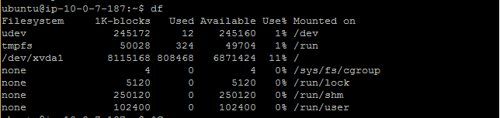

1. Memory Space

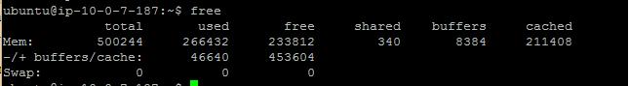

1. List processes

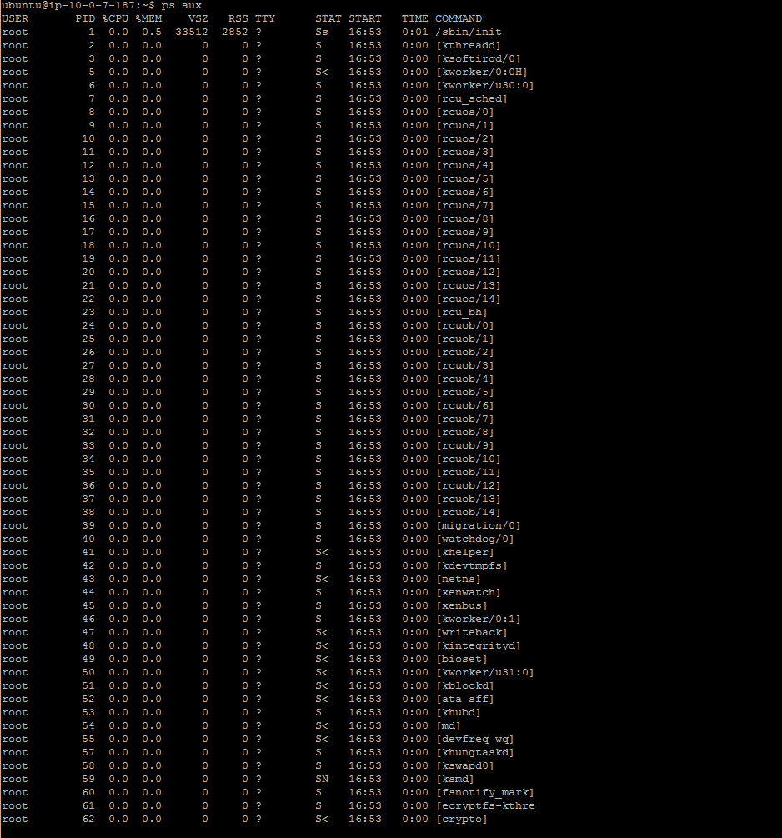

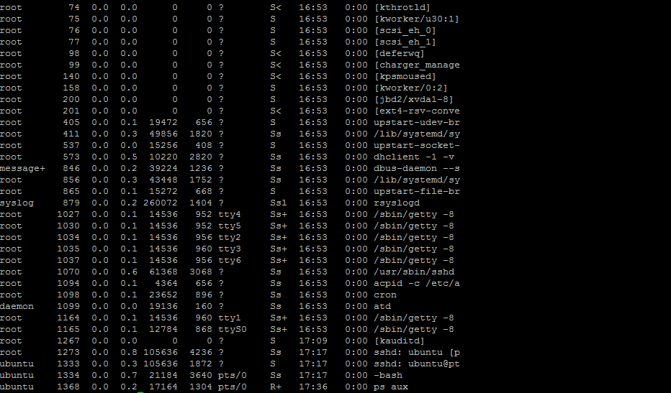

1. Network configuration

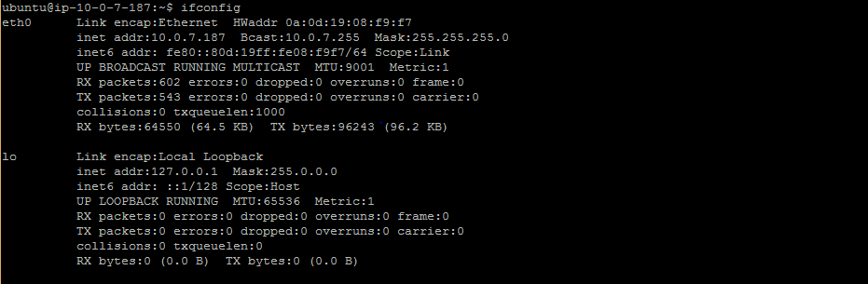

1. Routing table



1. Connections and ports

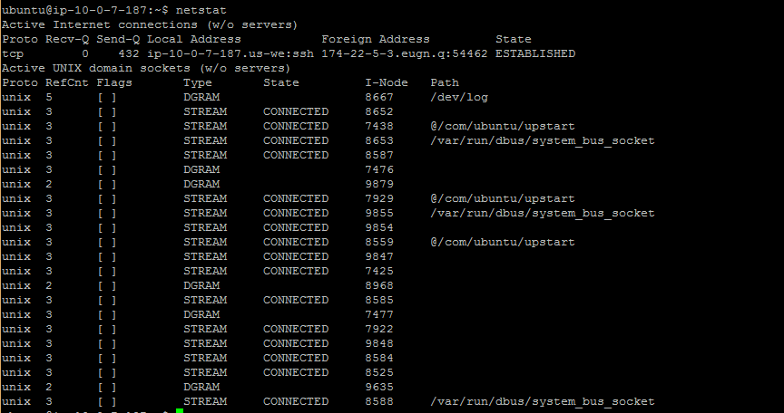

9. installed software packages

ubuntu@ip-10-0-7-187:~$ dpkg --get-selections

accountsservice install

acpid install

adduser install

apparmor install

apport install

apport-symptoms install

apt install

apt-transport-https install

apt-utils install

apt-xapian-index install

aptitude install

aptitude-common install

at install

base-files install

base-passwd install

bash install

bash-completion install

bc install

bind9-host install

bsdmainutils install

bsdutils install

busybox-initramfs install

busybox-static install

byobu install

bzip2 install

ca-certificates install

cloud-guest-utils install

cloud-init install

command-not-found install

command-not-found-data install

console-setup install

coreutils install

cpio install

cron install

cryptsetup install

cryptsetup-bin install

curl install

dash install

dbus install

debconf install

debconf-i18n install

debianutils install

dh-python install

diffutils install

dmidecode install

dmsetup install

dnsutils install

dosfstools install

dpkg install

e2fslibs:amd64 install

e2fsprogs install

eatmydata install

ed install

eject install

ethtool install

file install

findutils install

fonts-ubuntu-font-family-console install

friendly-recovery install

ftp install

fuse install

gawk install

gcc-4.8-base:amd64 install

gcc-4.9-base:amd64 install

gdisk install

geoip-database install

gettext-base install

gir1.2-glib-2.0 install

gnupg install

gpgv install

grep install

groff-base install

grub-common install

grub-gfxpayload-lists install

grub-legacy-ec2 install

grub-pc install

grub-pc-bin install

grub2-common install

gzip install

hdparm install

hostname install

ifupdown install

info install

init-system-helpers install

initramfs-tools install

initramfs-tools-bin install

initscripts install

insserv install

install-info install

iproute2 install

iptables install

iputils-ping install

iputils-tracepath install

irqbalance install

isc-dhcp-client install

isc-dhcp-common install

iso-codes install

kbd install

keyboard-configuration install

klibc-utils install

kmod install

krb5-locales install

landscape-client install

landscape-common install

language-selector-common install

laptop-detect install

less install

libaccountsservice0:amd64 install

libacl1:amd64 install

libapparmor-perl install

libapparmor1:amd64 install

libapt-inst1.5:amd64 install

libapt-pkg4.12:amd64 install

libarchive-extract-perl install

libasn1-8-heimdal:amd64 install

libasprintf0c2:amd64 install

libattr1:amd64 install

libaudit-common install

libaudit1:amd64 install

libbind9-90 install

libblkid1:amd64 install

libboost-iostreams1.54.0:amd64 install

libbsd0:amd64 install

libbz2-1.0:amd64 install

libc-bin install

libc6:amd64 install

libcap-ng0 install

libcap2:amd64 install

libcap2-bin install

libcgmanager0:amd64 install

libck-connector0:amd64 install

libclass-accessor-perl install

libcomerr2:amd64 install

libcryptsetup4 install

libcurl3:amd64 install

libcurl3-gnutls:amd64 install

libcwidget3 install

libdb5.3:amd64 install

libdbus-1-3:amd64 install

libdbus-glib-1-2:amd64 install

libdebconfclient0:amd64 install

libdevmapper1.02.1:amd64 install

libdns100 install

libdrm2:amd64 install

libdumbnet1 install

libedit2:amd64 install

libelf1:amd64 install

libept1.4.12:amd64 install

libestr0 install

libevent-2.0-5:amd64 install

libexpat1:amd64 install

libffi6:amd64 install

libfreetype6:amd64 install

libfribidi0:amd64 install

libfuse2:amd64 install

libgc1c2:amd64 install

libgcc1:amd64 install

libgck-1-0:amd64 install

libgcr-3-common install

libgcr-base-3-1:amd64 install

libgcrypt11:amd64 install

libgdbm3:amd64 install

libgeoip1:amd64 install

libgirepository-1.0-1 install

libglib2.0-0:amd64 install

libglib2.0-data install

libgnutls-openssl27:amd64 install

libgnutls26:amd64 install

libgpg-error0:amd64 install

libgpm2:amd64 install

libgssapi-krb5-2:amd64 install

libgssapi3-heimdal:amd64 install

libhcrypto4-heimdal:amd64 install

libheimbase1-heimdal:amd64 install

libheimntlm0-heimdal:amd64 install

libhx509-5-heimdal:amd64 install

libicu52:amd64 install

libidn11:amd64 install

libio-string-perl install

libisc95 install

libisccc90 install

libisccfg90 install

libjson-c2:amd64 install

libjson0:amd64 install

libk5crypto3:amd64 install

libkeyutils1:amd64 install

libklibc install

libkmod2:amd64 install

libkrb5-26-heimdal:amd64 install

libkrb5-3:amd64 install

libkrb5support0:amd64 install

libldap-2.4-2:amd64 install

liblocale-gettext-perl install

liblockfile-bin install

liblockfile1:amd64 install

liblog-message-simple-perl install

liblwres90 install

liblzma5:amd64 install

libmagic1:amd64 install

libmodule-pluggable-perl install

libmount1:amd64 install

libmpdec2:amd64 install

libncurses5:amd64 install

libncursesw5:amd64 install

libnewt0.52:amd64 install

libnfnetlink0:amd64 install

libnih-dbus1:amd64 install

libnih1:amd64 install

libnuma1:amd64 install

libp11-kit0:amd64 install

libpam-cap:amd64 install

libpam-modules:amd64 install

libpam-modules-bin install

libpam-runtime install

libpam-systemd:amd64 install

libpam0g:amd64 install

libparse-debianchangelog-perl install

libparted0debian1:amd64 install

libpcap0.8:amd64 install

libpci3:amd64 install

libpcre3:amd64 install

libpipeline1:amd64 install

libplymouth2:amd64 install

libpng12-0:amd64 install

libpod-latex-perl install

libpolkit-agent-1-0:amd64 install

libpolkit-backend-1-0:amd64 install

libpolkit-gobject-1-0:amd64 install

libpopt0:amd64 install

libprocps3:amd64 install

libpython-stdlib:amd64 install

libpython2.7:amd64 install

libpython2.7-minimal:amd64 install

libpython2.7-stdlib:amd64 install

libpython3-stdlib:amd64 install

libpython3.4-minimal:amd64 install

libpython3.4-stdlib:amd64 install

libreadline6:amd64 install

libroken18-heimdal:amd64 install

librtmp0:amd64 install

libsasl2-2:amd64 install

libsasl2-modules:amd64 install

libsasl2-modules-db:amd64 install

libselinux1:amd64 install

libsemanage-common install

libsemanage1:amd64 install

libsepol1:amd64 install

libsigc++-2.0-0c2a:amd64 install

libsigsegv2:amd64 install

libslang2:amd64 install

libsqlite3-0:amd64 install

libss2:amd64 install

libssl1.0.0:amd64 install

libstdc++6:amd64 install

libsub-name-perl install

libsystemd-daemon0:amd64 install

libsystemd-login0:amd64 install

libtasn1-6:amd64 install

libterm-ui-perl install

libtext-charwidth-perl install

libtext-iconv-perl install

libtext-soundex-perl install

libtext-wrapi18n-perl install

libtimedate-perl install

libtinfo5:amd64 install

libudev1:amd64 install

libusb-0.1-4:amd64 install

libusb-1.0-0:amd64 install

libustr-1.0-1:amd64 install

libuuid1:amd64 install

libwind0-heimdal:amd64 install

libwrap0:amd64 install

libx11-6:amd64 install

libx11-data install

libxapian22 install

libxau6:amd64 install

libxcb1:amd64 install

libxdmcp6:amd64 install

libxext6:amd64 install

libxml2:amd64 install

libxmuu1:amd64 install

libxtables10 install

libyaml-0-2:amd64 install

linux-headers-3.13.0-74 install

linux-headers-3.13.0-74-generic install

linux-headers-generic install

linux-headers-virtual install

linux-image-3.13.0-74-generic install

linux-image-virtual install

linux-virtual install

locales install

lockfile-progs install

login install

logrotate install

lsb-base install

lsb-release install

lshw install

lsof install

ltrace install

makedev install

man-db install

manpages install

mawk install

mime-support install

mlocate install

module-init-tools install

mount install

mountall install

mtr-tiny install

multiarch-support install

nano install

ncurses-base install

ncurses-bin install

ncurses-term install

net-tools install

netbase install

netcat-openbsd install

ntfs-3g install

ntpdate install

open-vm-tools install

openssh-client install

openssh-server install

openssh-sftp-server install

openssl install

os-prober install

overlayroot install

parted install

passwd install

patch install

pciutils install

perl install

perl-base install

perl-modules install

plymouth install

plymouth-theme-ubuntu-text install

policykit-1 install

pollinate install

popularity-contest install

powermgmt-base install

ppp install

pppconfig install

pppoeconf install

procps install

psmisc install

python install

python-apt install

python-apt-common install

python-chardet install

python-cheetah install

python-configobj install

python-debian install

python-gdbm install

python-json-pointer install

python-jsonpatch install

python-minimal install

python-oauth install

python-openssl install

python-pam install

python-pkg-resources install

python-prettytable install

python-pycurl install

python-requests install

python-serial install

python-six install

python-twisted-bin install

python-twisted-core install

python-twisted-names install

python-twisted-web install

python-urllib3 install

python-xapian install

python-yaml install

python-zope.interface install

python2.7 install

python2.7-minimal install

python3 install

python3-apport install

python3-apt install

python3-commandnotfound install

python3-dbus install

python3-distupgrade install

python3-gdbm:amd64 install

python3-gi install

python3-minimal install

python3-newt install

python3-problem-report install

python3-pycurl install

python3-software-properties install

python3-update-manager install

python3.4 install

python3.4-minimal install

readline-common install

resolvconf install

rsync install

rsyslog install

run-one install

screen install

sed install

sensible-utils install

sgml-base install

shared-mime-info install

software-properties-common install

ssh-import-id install

strace install

sudo install

systemd-services install

systemd-shim install

sysv-rc install

sysvinit-utils install

tar install

tasksel install

tasksel-data install

tcpd install

tcpdump install

telnet install

time install

tmux install

tzdata install

ubuntu-keyring install

ubuntu-minimal install

ubuntu-release-upgrader-core install

ubuntu-standard install

ucf install

udev install

ufw install

unattended-upgrades install

update-manager-core install

update-notifier-common install

upstart install

ureadahead install

usbutils install

util-linux install

uuid-runtime install

vim install

vim-common install

vim-runtime install

vim-tiny install

w3m install

wget install

whiptail install

xauth install

xkb-data install

xml-core install

xz-utils install

zerofree install

zlib1g:amd64 install

10 upgrade software

ubuntu@ip-10-0-7-187:~$ sudo apt-get dist-upgrade

Reading package lists... Done

Building dependency tree

Reading state information... Done

Calculating upgrade... Done

The following NEW packages will be installed:

linux-headers-3.13.0-91 linux-headers-3.13.0-91-generic

linux-image-3.13.0-91-generic

The following packages will be upgraded:

apport apt apt-transport-https apt-utils base-files bash-completion

bind9-host ca-certificates cloud-guest-utils cloud-init coreutils cpio curl

dnsutils dosfstools dpkg gcc-4.8-base grub-common grub-legacy-ec2 grub-pc

grub-pc-bin grub2-common ifupdown initramfs-tools initramfs-tools-bin

initscripts klibc-utils libapt-inst1.5 libapt-pkg4.12 libbind9-90 libc-bin

libc6 libcurl3 libcurl3-gnutls libdns100 libdrm2 libexpat1 libgcrypt11

libgnutls-openssl27 libgnutls26 libisc95 libisccc90 libisccfg90 libklibc

liblwres90 libnuma1 libpam-modules libpam-modules-bin libpam-runtime

libpam-systemd libpam0g libpci3 libpcre3 libssl1.0.0 libstdc++6

libsystemd-daemon0 libsystemd-login0 libtasn1-6 libudev1 libxml2

linux-headers-generic linux-headers-virtual linux-image-virtual

linux-virtual login lsb-base lsb-release multiarch-support ntpdate

openssh-client openssh-server openssh-sftp-server openssl os-prober passwd

pciutils perl perl-base perl-modules python3-apport python3-problem-report

rsync systemd-services sysv-rc sysvinit-utils tzdata udev usbutils wget

89 upgraded, 3 newly installed, 0 to remove and 0 not upgraded.

Need to get 56.1 MB of archives.

After this operation, 120 MB of additional disk space will be used.

Do you want to continue? [Y/n] y

Get:1 http://us-west-2.ec2.archive.ubuntu.com/ubuntu/ trusty-updates/main base-files amd64 7.2ubuntu5.4 [67.6 kB]

Get:2 http://us-west-2.ec2.archive.ubuntu.com/ubuntu/ trusty-updates/main coreutils amd64 8.21-1ubuntu5.4 [1,091 kB]

Get:3 http://us-west-2.ec2.archive.ubuntu.com/ubuntu/ trusty-updates/main dpkg amd64 1.17.5ubuntu5.7 [1,956 kB]

Get:4 http://us-west-2.ec2.archive.ubuntu.com/ubuntu/ trusty-updates/main login amd64 1:4.1.5.1-1ubuntu9.2 [301 kB]

Get:5 http://us-west-2.ec2.archive.ubuntu.com/ubuntu/ trusty-updates/main perl amd64 5.18.2-2ubuntu1.1 [2,648 kB]

Get:6 http://us-west-2.ec2.archive.ubuntu.com/ubuntu/ trusty-updates/main perl-base amd64 5.18.2-2ubuntu1.1 [1,146 kB]

Get:7 http://us-west-2.ec2.archive.ubuntu.com/ubuntu/ trusty-updates/main perl-modules all 5.18.2-2ubuntu1.1 [2,673 kB]

Get:8 http://us-west-2.ec2.archive.ubuntu.com/ubuntu/ trusty-updates/main libc-bin amd64 2.19-0ubuntu6.9 [1,165 kB]

Get:9 http://us-west-2.ec2.archive.ubuntu.com/ubuntu/ trusty-updates/main libc6 amd64 2.19-0ubuntu6.9 [4,717 kB]

Get:10 http://us-west-2.ec2.archive.ubuntu.com/ubuntu/ trusty-updates/main gcc-4.8-base amd64 4.8.4-2ubuntu1~14.04.3 [16.2 kB]

Get:11 http://us-west-2.ec2.archive.ubuntu.com/ubuntu/ trusty-updates/main libstdc++6 amd64 4.8.4-2ubuntu1~14.04.3 [259 kB]

Get:12 http://us-west-2.ec2.archive.ubuntu.com/ubuntu/ trusty-updates/main libapt-pkg4.12 amd64 1.0.1ubuntu2.14 [638 kB]

Get:13 http://us-west-2.ec2.archive.ubuntu.com/ubuntu/ trusty-updates/main apt amd64 1.0.1ubuntu2.14 [955 kB]

Get:14 http://us-west-2.ec2.archive.ubuntu.com/ubuntu/ trusty-updates/main libpam0g amd64 1.1.8-1ubuntu2.2 [56.1 kB]

Get:15 http://us-west-2.ec2.archive.ubuntu.com/ubuntu/ trusty-updates/main libpam-modules-bin amd64 1.1.8-1ubuntu2.2 [31.2 kB]

Get:16 http://us-west-2.ec2.archive.ubuntu.com/ubuntu/ trusty-updates/main libpam-modules amd64 1.1.8-1ubuntu2.2 [234 kB]

Get:17 http://us-west-2.ec2.archive.ubuntu.com/ubuntu/ trusty-updates/main libpcre3 amd64 1:8.31-2ubuntu2.3 [144 kB]

Get:18 http://us-west-2.ec2.archive.ubuntu.com/ubuntu/ trusty-updates/main libapt-inst1.5 amd64 1.0.1ubuntu2.14 [58.6 kB]

Get:19 http://us-west-2.ec2.archive.ubuntu.com/ubuntu/ trusty-updates/main libexpat1 amd64 2.1.0-4ubuntu1.3 [71.1 kB]

Get:20 http://us-west-2.ec2.archive.ubuntu.com/ubuntu/ trusty-updates/main libgcrypt11 amd64 1.5.3-2ubuntu4.3 [239 kB]

Get:21 http://us-west-2.ec2.archive.ubuntu.com/ubuntu/ trusty-updates/main libtasn1-6 amd64 3.4-3ubuntu0.4 [43.6 kB]

Get:22 http://us-west-2.ec2.archive.ubuntu.com/ubuntu/ trusty-updates/main libgnutls-openssl27 amd64 2.12.23-12ubuntu2.5 [18.4 kB]

Get:23 http://us-west-2.ec2.archive.ubuntu.com/ubuntu/ trusty-updates/main libgnutls26 amd64 2.12.23-12ubuntu2.5 [393 kB]

Get:24 http://us-west-2.ec2.archive.ubuntu.com/ubuntu/ trusty-updates/main libssl1.0.0 amd64 1.0.1f-1ubuntu2.19 [828 kB]

Get:25 http://us-west-2.ec2.archive.ubuntu.com/ubuntu/ trusty-updates/main ntpdate amd64 1:4.2.6.p5+dfsg-3ubuntu2.14.04.8 [57.2 kB]

Get:26 http://us-west-2.ec2.archive.ubuntu.com/ubuntu/ trusty-updates/main libdrm2 amd64 2.4.64-1~ubuntu14.04.1 [25.4 kB]

Get:27 http://us-west-2.ec2.archive.ubuntu.com/ubuntu/ trusty-updates/main sysvinit-utils amd64 2.88dsf-41ubuntu6.3 [52.9 kB]

Get:28 http://us-west-2.ec2.archive.ubuntu.com/ubuntu/ trusty-updates/main sysv-rc all 2.88dsf-41ubuntu6.3 [36.6 kB]

Get:29 http://us-west-2.ec2.archive.ubuntu.com/ubuntu/ trusty-updates/main lsb-base all 4.1+Debian11ubuntu6.1 [13.0 kB]

Get:30 http://us-west-2.ec2.archive.ubuntu.com/ubuntu/ trusty-updates/main passwd amd64 1:4.1.5.1-1ubuntu9.2 [759 kB]

Get:31 http://us-west-2.ec2.archive.ubuntu.com/ubuntu/ trusty-updates/main initscripts amd64 2.88dsf-41ubuntu6.3 [27.7 kB]

Get:32 http://us-west-2.ec2.archive.ubuntu.com/ubuntu/ trusty-updates/main udev amd64 204-5ubuntu20.19 [735 kB]

Get:33 http://us-west-2.ec2.archive.ubuntu.com/ubuntu/ trusty-updates/main libudev1 amd64 204-5ubuntu20.19 [33.8 kB]

Get:34 http://us-west-2.ec2.archive.ubuntu.com/ubuntu/ trusty-updates/main bash-completion all 1:2.1-4ubuntu0.2 [153 kB]

Get:35 http://us-west-2.ec2.archive.ubuntu.com/ubuntu/ trusty-updates/main libcurl3-gnutls amd64 7.35.0-1ubuntu2.6 [165 kB]

Get:36 http://us-west-2.ec2.archive.ubuntu.com/ubuntu/ trusty-updates/main libnuma1 amd64 2.0.9~rc5-1ubuntu3.14.04.2 [20.5 kB]

Get:37 http://us-west-2.ec2.archive.ubuntu.com/ubuntu/ trusty-updates/main libpam-systemd amd64 204-5ubuntu20.19 [25.5 kB]

Get:38 http://us-west-2.ec2.archive.ubuntu.com/ubuntu/ trusty-updates/main systemd-services amd64 204-5ubuntu20.19 [197 kB]

Get:39 http://us-west-2.ec2.archive.ubuntu.com/ubuntu/ trusty-updates/main libsystemd-daemon0 amd64 204-5ubuntu20.19 [10.2 kB]

Get:40 http://us-west-2.ec2.archive.ubuntu.com/ubuntu/ trusty-updates/main libpam-runtime all 1.1.8-1ubuntu2.2 [37.8 kB]

Get:41 http://us-west-2.ec2.archive.ubuntu.com/ubuntu/ trusty-updates/main pciutils amd64 1:3.2.1-1ubuntu5.1 [282 kB]

Get:42 http://us-west-2.ec2.archive.ubuntu.com/ubuntu/ trusty-updates/main libpci3 amd64 1:3.2.1-1ubuntu5.1 [26.3 kB]

Get:43 http://us-west-2.ec2.archive.ubuntu.com/ubuntu/ trusty-updates/main libsystemd-login0 amd64 204-5ubuntu20.19 [27.2 kB]

Get:44 http://us-west-2.ec2.archive.ubuntu.com/ubuntu/ trusty-updates/main libxml2 amd64 2.9.1+dfsg1-3ubuntu4.8 [573 kB]

Get:45 http://us-west-2.ec2.archive.ubuntu.com/ubuntu/ trusty-updates/main curl amd64 7.35.0-1ubuntu2.6 [123 kB]

Get:46 http://us-west-2.ec2.archive.ubuntu.com/ubuntu/ trusty-updates/main libcurl3 amd64 7.35.0-1ubuntu2.6 [172 kB]

Get:47 http://us-west-2.ec2.archive.ubuntu.com/ubuntu/ trusty-updates/main klibc-utils amd64 2.0.3-0ubuntu1.14.04.1 [107 kB]

Get:48 http://us-west-2.ec2.archive.ubuntu.com/ubuntu/ trusty-updates/main libklibc amd64 2.0.3-0ubuntu1.14.04.1 [40.8 kB]

Get:49 http://us-west-2.ec2.archive.ubuntu.com/ubuntu/ trusty-updates/main initramfs-tools all 0.103ubuntu4.3 [44.4 kB]

Get:50 http://us-west-2.ec2.archive.ubuntu.com/ubuntu/ trusty-updates/main initramfs-tools-bin amd64 0.103ubuntu4.3 [9,172 B]

Get:51 http://us-west-2.ec2.archive.ubuntu.com/ubuntu/ trusty-updates/main cpio amd64 2.11+dfsg-1ubuntu1.2 [73.8 kB]

Get:52 http://us-west-2.ec2.archive.ubuntu.com/ubuntu/ trusty-updates/main linux-image-3.13.0-91-generic amd64 3.13.0-91.138 [15.3 MB]

Get:53 http://us-west-2.ec2.archive.ubuntu.com/ubuntu/ trusty-updates/main multiarch-support amd64 2.19-0ubuntu6.9 [4,484 B]

Get:54 http://us-west-2.ec2.archive.ubuntu.com/ubuntu/ trusty-updates/main tzdata all 2016d-0ubuntu0.14.04 [167 kB]

Get:55 http://us-west-2.ec2.archive.ubuntu.com/ubuntu/ trusty-updates/main apt-utils amd64 1.0.1ubuntu2.14 [172 kB]

Get:56 http://us-west-2.ec2.archive.ubuntu.com/ubuntu/ trusty-updates/main lsb-release all 4.1+Debian11ubuntu6.1 [11.5 kB]

Get:57 http://us-west-2.ec2.archive.ubuntu.com/ubuntu/ trusty-updates/main ifupdown amd64 0.7.47.2ubuntu4.4 [53.1 kB]

Get:58 http://us-west-2.ec2.archive.ubuntu.com/ubuntu/ trusty-updates/main apt-transport-https amd64 1.0.1ubuntu2.14 [25.0 kB]

Get:59 http://us-west-2.ec2.archive.ubuntu.com/ubuntu/ trusty-updates/main bind9-host amd64 1:9.9.5.dfsg-3ubuntu0.8 [46.3 kB]

Get:60 http://us-west-2.ec2.archive.ubuntu.com/ubuntu/ trusty-updates/main dnsutils amd64 1:9.9.5.dfsg-3ubuntu0.8 [96.9 kB]

Get:61 http://us-west-2.ec2.archive.ubuntu.com/ubuntu/ trusty-updates/main libisc95 amd64 1:9.9.5.dfsg-3ubuntu0.8 [147 kB]

Get:62 http://us-west-2.ec2.archive.ubuntu.com/ubuntu/ trusty-updates/main libdns100 amd64 1:9.9.5.dfsg-3ubuntu0.8 [645 kB]

Get:63 http://us-west-2.ec2.archive.ubuntu.com/ubuntu/ trusty-updates/main libisccc90 amd64 1:9.9.5.dfsg-3ubuntu0.8 [15.7 kB]

Get:64 http://us-west-2.ec2.archive.ubuntu.com/ubuntu/ trusty-updates/main libisccfg90 amd64 1:9.9.5.dfsg-3ubuntu0.8 [36.2 kB]

Get:65 http://us-west-2.ec2.archive.ubuntu.com/ubuntu/ trusty-updates/main liblwres90 amd64 1:9.9.5.dfsg-3ubuntu0.8 [32.8 kB]

Get:66 http://us-west-2.ec2.archive.ubuntu.com/ubuntu/ trusty-updates/main libbind9-90 amd64 1:9.9.5.dfsg-3ubuntu0.8 [22.0 kB]

Get:67 http://us-west-2.ec2.archive.ubuntu.com/ubuntu/ trusty-updates/main openssl amd64 1.0.1f-1ubuntu2.19 [490 kB]

Get:68 http://us-west-2.ec2.archive.ubuntu.com/ubuntu/ trusty-updates/main ca-certificates all 20160104ubuntu0.14.04.1 [190 kB]

Get:69 http://us-west-2.ec2.archive.ubuntu.com/ubuntu/ trusty-updates/main dosfstools amd64 3.0.26-1ubuntu0.1 [60.1 kB]

Get:70 http://us-west-2.ec2.archive.ubuntu.com/ubuntu/ trusty-updates/main openssh-sftp-server amd64 1:6.6p1-2ubuntu2.7 [34.2 kB]

Get:71 http://us-west-2.ec2.archive.ubuntu.com/ubuntu/ trusty-updates/main openssh-server amd64 1:6.6p1-2ubuntu2.7 [322 kB]

Get:72 http://us-west-2.ec2.archive.ubuntu.com/ubuntu/ trusty-updates/main openssh-client amd64 1:6.6p1-2ubuntu2.7 [564 kB]

Get:73 http://us-west-2.ec2.archive.ubuntu.com/ubuntu/ trusty-updates/main rsync amd64 3.1.0-2ubuntu0.2 [284 kB]

Get:74 http://us-west-2.ec2.archive.ubuntu.com/ubuntu/ trusty-updates/main usbutils amd64 1:007-2ubuntu1.1 [205 kB]

Get:75 http://us-west-2.ec2.archive.ubuntu.com/ubuntu/ trusty-updates/main wget amd64 1.15-1ubuntu1.14.04.2 [271 kB]

Get:76 http://us-west-2.ec2.archive.ubuntu.com/ubuntu/ trusty-updates/main grub-pc amd64 2.02~beta2-9ubuntu1.8 [173 kB]

Get:77 http://us-west-2.ec2.archive.ubuntu.com/ubuntu/ trusty-updates/main grub-pc-bin amd64 2.02~beta2-9ubuntu1.8 [879 kB]

Get:78 http://us-west-2.ec2.archive.ubuntu.com/ubuntu/ trusty-updates/main grub2-common amd64 2.02~beta2-9ubuntu1.8 [501 kB]

Get:79 http://us-west-2.ec2.archive.ubuntu.com/ubuntu/ trusty-updates/main grub-common amd64 2.02~beta2-9ubuntu1.8 [1,682 kB]

Get:80 http://us-west-2.ec2.archive.ubuntu.com/ubuntu/ trusty-updates/main python3-problem-report all 2.14.1-0ubuntu3.21 [9,710 B]

Get:81 http://us-west-2.ec2.archive.ubuntu.com/ubuntu/ trusty-updates/main python3-apport all 2.14.1-0ubuntu3.21 [75.3 kB]

Get:82 http://us-west-2.ec2.archive.ubuntu.com/ubuntu/ trusty-updates/main apport all 2.14.1-0ubuntu3.21 [182 kB]

Get:83 http://us-west-2.ec2.archive.ubuntu.com/ubuntu/ trusty-updates/main linux-headers-3.13.0-91 all 3.13.0-91.138 [8,872 kB]

Get:84 http://us-west-2.ec2.archive.ubuntu.com/ubuntu/ trusty-updates/main linux-headers-3.13.0-91-generic amd64 3.13.0-91.138 [705 kB]

Get:85 http://us-west-2.ec2.archive.ubuntu.com/ubuntu/ trusty-updates/main linux-virtual amd64 3.13.0.91.97 [1,772 B]

Get:86 http://us-west-2.ec2.archive.ubuntu.com/ubuntu/ trusty-updates/main linux-image-virtual amd64 3.13.0.91.97 [2,248 B]

Get:87 http://us-west-2.ec2.archive.ubuntu.com/ubuntu/ trusty-updates/main linux-headers-virtual amd64 3.13.0.91.97 [1,756 B]

Get:88 http://us-west-2.ec2.archive.ubuntu.com/ubuntu/ trusty-updates/main linux-headers-generic amd64 3.13.0.91.97 [2,238 B]

Get:89 http://us-west-2.ec2.archive.ubuntu.com/ubuntu/ trusty-updates/main os-prober amd64 1.63ubuntu1.1 [18.0 kB]

Get:90 http://us-west-2.ec2.archive.ubuntu.com/ubuntu/ trusty-updates/main cloud-guest-utils all 0.27-0ubuntu9.2 [13.8 kB]

Get:91 http://us-west-2.ec2.archive.ubuntu.com/ubuntu/ trusty-updates/main cloud-init all 0.7.5-0ubuntu1.18 [198 kB]

Get:92 http://us-west-2.ec2.archive.ubuntu.com/ubuntu/ trusty-updates/main grub-legacy-ec2 all 0.7.5-0ubuntu1.18 [22.5 kB]

Fetched 56.1 MB in 1s (40.1 MB/s)

Extracting templates from packages: 100%

Preconfiguring packages ...

(Reading database ... 51150 files and directories currently installed.)

Preparing to unpack .../base-files_7.2ubuntu5.4_amd64.deb ...

Unpacking base-files (7.2ubuntu5.4) over (7.2ubuntu5.3) ...

Processing triggers for plymouth-theme-ubuntu-text (0.8.8-0ubuntu17.1) ...

update-initramfs: deferring update (trigger activated)

Processing triggers for install-info (5.2.0.dfsg.1-2) ...

Processing triggers for man-db (2.6.7.1-1ubuntu1) ...

Processing triggers for initramfs-tools (0.103ubuntu4.2) ...

update-initramfs: Generating /boot/initrd.img-3.13.0-74-generic

Setting up base-files (7.2ubuntu5.4) ...

Installing new version of config file /etc/issue ...

Installing new version of config file /etc/issue.net ...

Installing new version of config file /etc/lsb-release ...

Installing new version of config file /etc/os-release ...

Processing triggers for plymouth-theme-ubuntu-text (0.8.8-0ubuntu17.1) ...

update-initramfs: deferring update (trigger activated)

Processing triggers for initramfs-tools (0.103ubuntu4.2) ...

update-initramfs: Generating /boot/initrd.img-3.13.0-74-generic

(Reading database ... 51150 files and directories currently installed.)

Preparing to unpack .../coreutils_8.21-1ubuntu5.4_amd64.deb ...

Unpacking coreutils (8.21-1ubuntu5.4) over (8.21-1ubuntu5.3) ...

Processing triggers for install-info (5.2.0.dfsg.1-2) ...

Processing triggers for man-db (2.6.7.1-1ubuntu1) ...

Setting up coreutils (8.21-1ubuntu5.4) ...

(Reading database ... 51150 files and directories currently installed.)

Preparing to unpack .../dpkg_1.17.5ubuntu5.7_amd64.deb ...

Unpacking dpkg (1.17.5ubuntu5.7) over (1.17.5ubuntu5.5) ...

Processing triggers for man-db (2.6.7.1-1ubuntu1) ...

Setting up dpkg (1.17.5ubuntu5.7) ...

(Reading database ... 51150 files and directories currently installed.)

Preparing to unpack .../login_1%3a4.1.5.1-1ubuntu9.2_amd64.deb ...

Unpacking login (1:4.1.5.1-1ubuntu9.2) over (1:4.1.5.1-1ubuntu9.1) ...

Processing triggers for man-db (2.6.7.1-1ubuntu1) ...

Setting up login (1:4.1.5.1-1ubuntu9.2) ...

(Reading database ... 51150 files and directories currently installed.)

Preparing to unpack .../perl_5.18.2-2ubuntu1.1_amd64.deb ...

Unpacking perl (5.18.2-2ubuntu1.1) over (5.18.2-2ubuntu1) ...

Preparing to unpack .../perl-base_5.18.2-2ubuntu1.1_amd64.deb ...

Unpacking perl-base (5.18.2-2ubuntu1.1) over (5.18.2-2ubuntu1) ...

Processing triggers for man-db (2.6.7.1-1ubuntu1) ...

Setting up perl-base (5.18.2-2ubuntu1.1) ...

(Reading database ... 51150 files and directories currently installed.)

Preparing to unpack .../perl-modules_5.18.2-2ubuntu1.1_all.deb ...

Unpacking perl-modules (5.18.2-2ubuntu1.1) over (5.18.2-2ubuntu1) ...

Preparing to unpack .../libc-bin_2.19-0ubuntu6.9_amd64.deb ...

Unpacking libc-bin (2.19-0ubuntu6.9) over (2.19-0ubuntu6.6) ...

Preparing to unpack .../libc6_2.19-0ubuntu6.9_amd64.deb ...

Unpacking libc6:amd64 (2.19-0ubuntu6.9) over (2.19-0ubuntu6.6) ...

Processing triggers for man-db (2.6.7.1-1ubuntu1) ...

Setting up libc6:amd64 (2.19-0ubuntu6.9) ...

Setting up libc-bin (2.19-0ubuntu6.9) ...

(Reading database ... 51149 files and directories currently installed.)

Preparing to unpack .../gcc-4.8-base_4.8.4-2ubuntu1~14.04.3_amd64.deb ...

Unpacking gcc-4.8-base:amd64 (4.8.4-2ubuntu1~14.04.3) over (4.8.4-2ubuntu1~14.04) ...

Setting up gcc-4.8-base:amd64 (4.8.4-2ubuntu1~14.04.3) ...

(Reading database ... 51149 files and directories currently installed.)

Preparing to unpack .../libstdc++6_4.8.4-2ubuntu1~14.04.3_amd64.deb ...

Unpacking libstdc++6:amd64 (4.8.4-2ubuntu1~14.04.3) over (4.8.4-2ubuntu1~14.04) ...

Setting up libstdc++6:amd64 (4.8.4-2ubuntu1~14.04.3) ...

Processing triggers for libc-bin (2.19-0ubuntu6.9) ...

(Reading database ... 51149 files and directories currently installed.)

Preparing to unpack .../libapt-pkg4.12_1.0.1ubuntu2.14_amd64.deb ...

Unpacking libapt-pkg4.12:amd64 (1.0.1ubuntu2.14) over (1.0.1ubuntu2.10) ...

Setting up libapt-pkg4.12:amd64 (1.0.1ubuntu2.14) ...

Processing triggers for libc-bin (2.19-0ubuntu6.9) ...

(Reading database ... 51149 files and directories currently installed.)

Preparing to unpack .../apt_1.0.1ubuntu2.14_amd64.deb ...

Unpacking apt (1.0.1ubuntu2.14) over (1.0.1ubuntu2.10) ...

Processing triggers for man-db (2.6.7.1-1ubuntu1) ...

Setting up apt (1.0.1ubuntu2.14) ...

Processing triggers for libc-bin (2.19-0ubuntu6.9) ...

(Reading database ... 51149 files and directories currently installed.)

Preparing to unpack .../libpam0g_1.1.8-1ubuntu2.2_amd64.deb ...

Unpacking libpam0g:amd64 (1.1.8-1ubuntu2.2) over (1.1.8-1ubuntu2) ...

Setting up libpam0g:amd64 (1.1.8-1ubuntu2.2) ...

Processing triggers for libc-bin (2.19-0ubuntu6.9) ...

(Reading database ... 51149 files and directories currently installed.)

Preparing to unpack .../libpam-modules-bin_1.1.8-1ubuntu2.2_amd64.deb ...

Unpacking libpam-modules-bin (1.1.8-1ubuntu2.2) over (1.1.8-1ubuntu2) ...

Processing triggers for man-db (2.6.7.1-1ubuntu1) ...

Setting up libpam-modules-bin (1.1.8-1ubuntu2.2) ...

(Reading database ... 51149 files and directories currently installed.)

Preparing to unpack .../libpam-modules_1.1.8-1ubuntu2.2_amd64.deb ...

Unpacking libpam-modules:amd64 (1.1.8-1ubuntu2.2) over (1.1.8-1ubuntu2) ...

Processing triggers for man-db (2.6.7.1-1ubuntu1) ...

Setting up libpam-modules:amd64 (1.1.8-1ubuntu2.2) ...

(Reading database ... 51149 files and directories currently installed.)

Preparing to unpack .../libpcre3_1%3a8.31-2ubuntu2.3_amd64.deb ...

Unpacking libpcre3:amd64 (1:8.31-2ubuntu2.3) over (1:8.31-2ubuntu2.1) ...

Processing triggers for man-db (2.6.7.1-1ubuntu1) ...

Setting up libpcre3:amd64 (1:8.31-2ubuntu2.3) ...

Processing triggers for libc-bin (2.19-0ubuntu6.9) ...

(Reading database ... 51149 files and directories currently installed.)

Preparing to unpack .../libapt-inst1.5_1.0.1ubuntu2.14_amd64.deb ...

Unpacking libapt-inst1.5:amd64 (1.0.1ubuntu2.14) over (1.0.1ubuntu2.10) ...

Preparing to unpack .../libexpat1_2.1.0-4ubuntu1.3_amd64.deb ...

Unpacking libexpat1:amd64 (2.1.0-4ubuntu1.3) over (2.1.0-4ubuntu1.1) ...

Preparing to unpack .../libgcrypt11_1.5.3-2ubuntu4.3_amd64.deb ...

Unpacking libgcrypt11:amd64 (1.5.3-2ubuntu4.3) over (1.5.3-2ubuntu4.2) ...

Preparing to unpack .../libtasn1-6_3.4-3ubuntu0.4_amd64.deb ...

Unpacking libtasn1-6:amd64 (3.4-3ubuntu0.4) over (3.4-3ubuntu0.3) ...

Preparing to unpack .../libgnutls-openssl27_2.12.23-12ubuntu2.5_amd64.deb ...

Unpacking libgnutls-openssl27:amd64 (2.12.23-12ubuntu2.5) over (2.12.23-12ubuntu2.4) ...

Preparing to unpack .../libgnutls26_2.12.23-12ubuntu2.5_amd64.deb ...

Unpacking libgnutls26:amd64 (2.12.23-12ubuntu2.5) over (2.12.23-12ubuntu2.4) ...

Preparing to unpack .../libssl1.0.0_1.0.1f-1ubuntu2.19_amd64.deb ...

Unpacking libssl1.0.0:amd64 (1.0.1f-1ubuntu2.19) over (1.0.1f-1ubuntu2.16) ...

Preparing to unpack .../ntpdate_1%3a4.2.6.p5+dfsg-3ubuntu2.14.04.8_amd64.deb ...

Unpacking ntpdate (1:4.2.6.p5+dfsg-3ubuntu2.14.04.8) over (1:4.2.6.p5+dfsg-3ubuntu2.14.04.6) ...

Preparing to unpack .../libdrm2_2.4.64-1~ubuntu14.04.1_amd64.deb ...

Unpacking libdrm2:amd64 (2.4.64-1~ubuntu14.04.1) over (2.4.60-2~ubuntu14.04.1) ...

Preparing to unpack .../sysvinit-utils_2.88dsf-41ubuntu6.3_amd64.deb ...

Unpacking sysvinit-utils (2.88dsf-41ubuntu6.3) over (2.88dsf-41ubuntu6.2) ...

Preparing to unpack .../sysv-rc_2.88dsf-41ubuntu6.3_all.deb ...

Unpacking sysv-rc (2.88dsf-41ubuntu6.3) over (2.88dsf-41ubuntu6.2) ...

Processing triggers for man-db (2.6.7.1-1ubuntu1) ...

Processing triggers for ureadahead (0.100.0-16) ...

Setting up sysvinit-utils (2.88dsf-41ubuntu6.3) ...

Setting up sysv-rc (2.88dsf-41ubuntu6.3) ...

(Reading database ... 51149 files and directories currently installed.)

Preparing to unpack .../lsb-base_4.1+Debian11ubuntu6.1_all.deb ...

Unpacking lsb-base (4.1+Debian11ubuntu6.1) over (4.1+Debian11ubuntu6) ...

Setting up lsb-base (4.1+Debian11ubuntu6.1) ...

(Reading database ... 51150 files and directories currently installed.)

Preparing to unpack .../passwd_1%3a4.1.5.1-1ubuntu9.2_amd64.deb ...

Unpacking passwd (1:4.1.5.1-1ubuntu9.2) over (1:4.1.5.1-1ubuntu9.1) ...

Processing triggers for man-db (2.6.7.1-1ubuntu1) ...

Processing triggers for ureadahead (0.100.0-16) ...

Setting up passwd (1:4.1.5.1-1ubuntu9.2) ...

(Reading database ... 51150 files and directories currently installed.)

Preparing to unpack .../initscripts_2.88dsf-41ubuntu6.3_amd64.deb ...

Unpacking initscripts (2.88dsf-41ubuntu6.3) over (2.88dsf-41ubuntu6.2) ...

Preparing to unpack .../udev_204-5ubuntu20.19_amd64.deb ...

Adding 'diversion of /bin/udevadm to /bin/udevadm.upgrade by fake-udev'

Unpacking udev (204-5ubuntu20.19) over (204-5ubuntu20.15) ...

Preparing to unpack .../libudev1_204-5ubuntu20.19_amd64.deb ...

Unpacking libudev1:amd64 (204-5ubuntu20.19) over (204-5ubuntu20.15) ...

Preparing to unpack .../bash-completion_1%3a2.1-4ubuntu0.2_all.deb ...

Unpacking bash-completion (1:2.1-4ubuntu0.2) over (1:2.1-4ubuntu0.1) ...

Preparing to unpack .../libcurl3-gnutls_7.35.0-1ubuntu2.6_amd64.deb ...

Unpacking libcurl3-gnutls:amd64 (7.35.0-1ubuntu2.6) over (7.35.0-1ubuntu2.5) ...

Preparing to unpack .../libnuma1_2.0.9~rc5-1ubuntu3.14.04.2_amd64.deb ...

Unpacking libnuma1:amd64 (2.0.9~rc5-1ubuntu3.14.04.2) over (2.0.9~rc5-1ubuntu3.14.04.1) ...

Preparing to unpack .../libpam-systemd_204-5ubuntu20.19_amd64.deb ...

systemd-logind stop/waiting

Unpacking libpam-systemd:amd64 (204-5ubuntu20.19) over (204-5ubuntu20.15) ...

Preparing to unpack .../systemd-services_204-5ubuntu20.19_amd64.deb ...

Unpacking systemd-services (204-5ubuntu20.19) over (204-5ubuntu20.15) ...

Preparing to unpack .../libsystemd-daemon0_204-5ubuntu20.19_amd64.deb ...

Unpacking libsystemd-daemon0:amd64 (204-5ubuntu20.19) over (204-5ubuntu20.15) ...

Preparing to unpack .../libpam-runtime_1.1.8-1ubuntu2.2_all.deb ...

Unpacking libpam-runtime (1.1.8-1ubuntu2.2) over (1.1.8-1ubuntu2) ...

Processing triggers for ureadahead (0.100.0-16) ...

Processing triggers for man-db (2.6.7.1-1ubuntu1) ...

Setting up libpam-runtime (1.1.8-1ubuntu2.2) ...

(Reading database ... 51151 files and directories currently installed.)

Preparing to unpack .../pciutils_1%3a3.2.1-1ubuntu5.1_amd64.deb ...

Unpacking pciutils (1:3.2.1-1ubuntu5.1) over (1:3.2.1-1ubuntu5) ...

Preparing to unpack .../libpci3_1%3a3.2.1-1ubuntu5.1_amd64.deb ...

Unpacking libpci3:amd64 (1:3.2.1-1ubuntu5.1) over (1:3.2.1-1ubuntu5) ...

Preparing to unpack .../libsystemd-login0_204-5ubuntu20.19_amd64.deb ...

Unpacking libsystemd-login0:amd64 (204-5ubuntu20.19) over (204-5ubuntu20.15) ...

Preparing to unpack .../libxml2_2.9.1+dfsg1-3ubuntu4.8_amd64.deb ...

Unpacking libxml2:amd64 (2.9.1+dfsg1-3ubuntu4.8) over (2.9.1+dfsg1-3ubuntu4.6) ...

Preparing to unpack .../curl_7.35.0-1ubuntu2.6_amd64.deb ...

Unpacking curl (7.35.0-1ubuntu2.6) over (7.35.0-1ubuntu2.5) ...

Preparing to unpack .../libcurl3_7.35.0-1ubuntu2.6_amd64.deb ...

Unpacking libcurl3:amd64 (7.35.0-1ubuntu2.6) over (7.35.0-1ubuntu2.5) ...

Preparing to unpack .../klibc-utils_2.0.3-0ubuntu1.14.04.1_amd64.deb ...

Unpacking klibc-utils (2.0.3-0ubuntu1.14.04.1) over (2.0.3-0ubuntu1) ...

Preparing to unpack .../libklibc_2.0.3-0ubuntu1.14.04.1_amd64.deb ...

Unpacking libklibc (2.0.3-0ubuntu1.14.04.1) over (2.0.3-0ubuntu1) ...

Preparing to unpack .../initramfs-tools_0.103ubuntu4.3_all.deb ...

Unpacking initramfs-tools (0.103ubuntu4.3) over (0.103ubuntu4.2) ...

Preparing to unpack .../initramfs-tools-bin_0.103ubuntu4.3_amd64.deb ...

Unpacking initramfs-tools-bin (0.103ubuntu4.3) over (0.103ubuntu4.2) ...

Preparing to unpack .../cpio_2.11+dfsg-1ubuntu1.2_amd64.deb ...

Unpacking cpio (2.11+dfsg-1ubuntu1.2) over (2.11+dfsg-1ubuntu1.1) ...

Selecting previously unselected package linux-image-3.13.0-91-generic.

Preparing to unpack .../linux-image-3.13.0-91-generic_3.13.0-91.138_amd64.deb ...

Done.

Unpacking linux-image-3.13.0-91-generic (3.13.0-91.138) ...

Preparing to unpack .../multiarch-support_2.19-0ubuntu6.9_amd64.deb ...

Unpacking multiarch-support (2.19-0ubuntu6.9) over (2.19-0ubuntu6.6) ...

Processing triggers for man-db (2.6.7.1-1ubuntu1) ...

Setting up multiarch-support (2.19-0ubuntu6.9) ...

(Reading database ... 52056 files and directories currently installed.)

Preparing to unpack .../tzdata_2016d-0ubuntu0.14.04_all.deb ...

Unpacking tzdata (2016d-0ubuntu0.14.04) over (2015g-0ubuntu0.14.04) ...

Setting up tzdata (2016d-0ubuntu0.14.04) ...

Current default time zone: 'Etc/UTC'

Local time is now: Tue Jul 5 20:36:55 UTC 2016.

Universal Time is now: Tue Jul 5 20:36:55 UTC 2016.

Run 'dpkg-reconfigure tzdata' if you wish to change it.

(Reading database ... 52072 files and directories currently installed.)

Preparing to unpack .../apt-utils_1.0.1ubuntu2.14_amd64.deb ...

Unpacking apt-utils (1.0.1ubuntu2.14) over (1.0.1ubuntu2.10) ...

Preparing to unpack .../lsb-release_4.1+Debian11ubuntu6.1_all.deb ...

Unpacking lsb-release (4.1+Debian11ubuntu6.1) over (4.1+Debian11ubuntu6) ...

Preparing to unpack .../ifupdown_0.7.47.2ubuntu4.4_amd64.deb ...

Unpacking ifupdown (0.7.47.2ubuntu4.4) over (0.7.47.2ubuntu4.1) ...

Preparing to unpack .../apt-transport-https_1.0.1ubuntu2.14_amd64.deb ...

Unpacking apt-transport-https (1.0.1ubuntu2.14) over (1.0.1ubuntu2.10) ...

Preparing to unpack .../bind9-host_1%3a9.9.5.dfsg-3ubuntu0.8_amd64.deb ...

Unpacking bind9-host (1:9.9.5.dfsg-3ubuntu0.8) over (1:9.9.5.dfsg-3ubuntu0.6) ...

Preparing to unpack .../dnsutils_1%3a9.9.5.dfsg-3ubuntu0.8_amd64.deb ...

Unpacking dnsutils (1:9.9.5.dfsg-3ubuntu0.8) over (1:9.9.5.dfsg-3ubuntu0.6) ...

Preparing to unpack .../libisc95_1%3a9.9.5.dfsg-3ubuntu0.8_amd64.deb ...

Unpacking libisc95 (1:9.9.5.dfsg-3ubuntu0.8) over (1:9.9.5.dfsg-3ubuntu0.6) ...

Preparing to unpack .../libdns100_1%3a9.9.5.dfsg-3ubuntu0.8_amd64.deb ...

Unpacking libdns100 (1:9.9.5.dfsg-3ubuntu0.8) over (1:9.9.5.dfsg-3ubuntu0.6) ...

Preparing to unpack .../libisccc90_1%3a9.9.5.dfsg-3ubuntu0.8_amd64.deb ...

Unpacking libisccc90 (1:9.9.5.dfsg-3ubuntu0.8) over (1:9.9.5.dfsg-3ubuntu0.6) ...

Preparing to unpack .../libisccfg90_1%3a9.9.5.dfsg-3ubuntu0.8_amd64.deb ...

Unpacking libisccfg90 (1:9.9.5.dfsg-3ubuntu0.8) over (1:9.9.5.dfsg-3ubuntu0.6) ...

Preparing to unpack .../liblwres90_1%3a9.9.5.dfsg-3ubuntu0.8_amd64.deb ...

Unpacking liblwres90 (1:9.9.5.dfsg-3ubuntu0.8) over (1:9.9.5.dfsg-3ubuntu0.6) ...

Preparing to unpack .../libbind9-90_1%3a9.9.5.dfsg-3ubuntu0.8_amd64.deb ...

Unpacking libbind9-90 (1:9.9.5.dfsg-3ubuntu0.8) over (1:9.9.5.dfsg-3ubuntu0.6) ...

Preparing to unpack .../openssl_1.0.1f-1ubuntu2.19_amd64.deb ...

Unpacking openssl (1.0.1f-1ubuntu2.19) over (1.0.1f-1ubuntu2.16) ...

Preparing to unpack .../ca-certificates_20160104ubuntu0.14.04.1_all.deb ...

Unpacking ca-certificates (20160104ubuntu0.14.04.1) over (20141019ubuntu0.14.04.1) ...

Preparing to unpack .../dosfstools_3.0.26-1ubuntu0.1_amd64.deb ...

Unpacking dosfstools (3.0.26-1ubuntu0.1) over (3.0.26-1) ...

Preparing to unpack .../openssh-sftp-server_1%3a6.6p1-2ubuntu2.7_amd64.deb ...

Unpacking openssh-sftp-server (1:6.6p1-2ubuntu2.7) over (1:6.6p1-2ubuntu2.4) ...

Preparing to unpack .../openssh-server_1%3a6.6p1-2ubuntu2.7_amd64.deb ...

Unpacking openssh-server (1:6.6p1-2ubuntu2.7) over (1:6.6p1-2ubuntu2.4) ...

Preparing to unpack .../openssh-client_1%3a6.6p1-2ubuntu2.7_amd64.deb ...

Unpacking openssh-client (1:6.6p1-2ubuntu2.7) over (1:6.6p1-2ubuntu2.4) ...

Preparing to unpack .../rsync_3.1.0-2ubuntu0.2_amd64.deb ...

Unpacking rsync (3.1.0-2ubuntu0.2) over (3.1.0-2ubuntu0.1) ...

Preparing to unpack .../usbutils_1%3a007-2ubuntu1.1_amd64.deb ...

Unpacking usbutils (1:007-2ubuntu1.1) over (1:007-2ubuntu1) ...

Preparing to unpack .../wget_1.15-1ubuntu1.14.04.2_amd64.deb ...

Unpacking wget (1.15-1ubuntu1.14.04.2) over (1.15-1ubuntu1.14.04.1) ...

Preparing to unpack .../grub-pc_2.02~beta2-9ubuntu1.8_amd64.deb ...

Unpacking grub-pc (2.02~beta2-9ubuntu1.8) over (2.02~beta2-9ubuntu1.7) ...

Preparing to unpack .../grub-pc-bin_2.02~beta2-9ubuntu1.8_amd64.deb ...

Unpacking grub-pc-bin (2.02~beta2-9ubuntu1.8) over (2.02~beta2-9ubuntu1.7) ...

Preparing to unpack .../grub2-common_2.02~beta2-9ubuntu1.8_amd64.deb ...

Unpacking grub2-common (2.02~beta2-9ubuntu1.8) over (2.02~beta2-9ubuntu1.7) ...

Preparing to unpack .../grub-common_2.02~beta2-9ubuntu1.8_amd64.deb ...

Unpacking grub-common (2.02~beta2-9ubuntu1.8) over (2.02~beta2-9ubuntu1.7) ...

Preparing to unpack .../python3-problem-report_2.14.1-0ubuntu3.21_all.deb ...

Unpacking python3-problem-report (2.14.1-0ubuntu3.21) over (2.14.1-0ubuntu3.19) ...

Preparing to unpack .../python3-apport_2.14.1-0ubuntu3.21_all.deb ...

Unpacking python3-apport (2.14.1-0ubuntu3.21) over (2.14.1-0ubuntu3.19) ...

Preparing to unpack .../apport_2.14.1-0ubuntu3.21_all.deb ...

apport stop/waiting

Unpacking apport (2.14.1-0ubuntu3.21) over (2.14.1-0ubuntu3.19) ...

Selecting previously unselected package linux-headers-3.13.0-91.

Preparing to unpack .../linux-headers-3.13.0-91_3.13.0-91.138_all.deb ...

Unpacking linux-headers-3.13.0-91 (3.13.0-91.138) ...

Selecting previously unselected package linux-headers-3.13.0-91-generic.

Preparing to unpack .../linux-headers-3.13.0-91-generic_3.13.0-91.138_amd64.deb ...

Unpacking linux-headers-3.13.0-91-generic (3.13.0-91.138) ...

Preparing to unpack .../linux-virtual_3.13.0.91.97_amd64.deb ...

Unpacking linux-virtual (3.13.0.91.97) over (3.13.0.74.80) ...

Preparing to unpack .../linux-image-virtual_3.13.0.91.97_amd64.deb ...

Unpacking linux-image-virtual (3.13.0.91.97) over (3.13.0.74.80) ...

Preparing to unpack .../linux-headers-virtual_3.13.0.91.97_amd64.deb ...

Unpacking linux-headers-virtual (3.13.0.91.97) over (3.13.0.74.80) ...

Preparing to unpack .../linux-headers-generic_3.13.0.91.97_amd64.deb ...

Unpacking linux-headers-generic (3.13.0.91.97) over (3.13.0.74.80) ...

Preparing to unpack .../os-prober_1.63ubuntu1.1_amd64.deb ...

Unpacking os-prober (1.63ubuntu1.1) over (1.63ubuntu1) ...

Preparing to unpack .../cloud-guest-utils_0.27-0ubuntu9.2_all.deb ...

Unpacking cloud-guest-utils (0.27-0ubuntu9.2) over (0.27-0ubuntu9.1) ...

Preparing to unpack .../cloud-init_0.7.5-0ubuntu1.18_all.deb ...

Unpacking cloud-init (0.7.5-0ubuntu1.18) over (0.7.5-0ubuntu1.15) ...

Preparing to unpack .../grub-legacy-ec2_0.7.5-0ubuntu1.18_all.deb ...

Leaving 'diversion of /usr/sbin/grub-set-default to /usr/sbin/grub-set-default.real by grub-legacy-ec2'

Unpacking grub-legacy-ec2 (0.7.5-0ubuntu1.18) over (0.7.5-0ubuntu1.15) ...

Processing triggers for man-db (2.6.7.1-1ubuntu1) ...

Processing triggers for ureadahead (0.100.0-16) ...

Processing triggers for ufw (0.34~rc-0ubuntu2) ...

Processing triggers for install-info (5.2.0.dfsg.1-2) ...

Processing triggers for shared-mime-info (1.2-0ubuntu3) ...

Setting up libapt-inst1.5:amd64 (1.0.1ubuntu2.14) ...

Setting up libexpat1:amd64 (2.1.0-4ubuntu1.3) ...

Setting up libgcrypt11:amd64 (1.5.3-2ubuntu4.3) ...

Setting up libtasn1-6:amd64 (3.4-3ubuntu0.4) ...

Setting up libgnutls26:amd64 (2.12.23-12ubuntu2.5) ...

Setting up libgnutls-openssl27:amd64 (2.12.23-12ubuntu2.5) ...

Setting up libssl1.0.0:amd64 (1.0.1f-1ubuntu2.19) ...

Setting up ntpdate (1:4.2.6.p5+dfsg-3ubuntu2.14.04.8) ...

Installing new version of config file /etc/network/if-up.d/ntpdate ...

Setting up libdrm2:amd64 (2.4.64-1~ubuntu14.04.1) ...

Setting up initscripts (2.88dsf-41ubuntu6.3) ...

Installing new version of config file /etc/init.d/ondemand ...

Setting up libudev1:amd64 (204-5ubuntu20.19) ...

Setting up udev (204-5ubuntu20.19) ...

udev stop/waiting

udev start/running, process 21066

Removing 'diversion of /bin/udevadm to /bin/udevadm.upgrade by fake-udev'

update-initramfs: deferring update (trigger activated)

Setting up bash-completion (1:2.1-4ubuntu0.2) ...

Setting up libcurl3-gnutls:amd64 (7.35.0-1ubuntu2.6) ...

Setting up libnuma1:amd64 (2.0.9~rc5-1ubuntu3.14.04.2) ...

Setting up libsystemd-daemon0:amd64 (204-5ubuntu20.19) ...

Setting up systemd-services (204-5ubuntu20.19) ...

Setting up libpam-systemd:amd64 (204-5ubuntu20.19) ...

systemd-logind start/running, process 21692

Setting up libpci3:amd64 (1:3.2.1-1ubuntu5.1) ...

Setting up pciutils (1:3.2.1-1ubuntu5.1) ...

Setting up libsystemd-login0:amd64 (204-5ubuntu20.19) ...

Setting up libxml2:amd64 (2.9.1+dfsg1-3ubuntu4.8) ...

Setting up libcurl3:amd64 (7.35.0-1ubuntu2.6) ...

Setting up curl (7.35.0-1ubuntu2.6) ...

Setting up libklibc (2.0.3-0ubuntu1.14.04.1) ...

Setting up klibc-utils (2.0.3-0ubuntu1.14.04.1) ...

Setting up initramfs-tools-bin (0.103ubuntu4.3) ...

Setting up cpio (2.11+dfsg-1ubuntu1.2) ...

Setting up initramfs-tools (0.103ubuntu4.3) ...

update-initramfs: deferring update (trigger activated)

Setting up linux-image-3.13.0-91-generic (3.13.0-91.138) ...

Running depmod.

update-initramfs: deferring update (hook will be called later)

Examining /etc/kernel/postinst.d.

run-parts: executing /etc/kernel/postinst.d/apt-auto-removal 3.13.0-91-generic /boot/vmlinuz-3.13.0-91-generic

run-parts: executing /etc/kernel/postinst.d/initramfs-tools 3.13.0-91-generic /boot/vmlinuz-3.13.0-91-generic

update-initramfs: Generating /boot/initrd.img-3.13.0-91-generic

run-parts: executing /etc/kernel/postinst.d/update-notifier 3.13.0-91-generic /boot/vmlinuz-3.13.0-91-generic

run-parts: executing /etc/kernel/postinst.d/x-grub-legacy-ec2 3.13.0-91-generic /boot/vmlinuz-3.13.0-91-generic

Searching for GRUB installation directory ... found: /boot/grub

Searching for default file ... found: /boot/grub/default

Testing for an existing GRUB menu.lst file ... found: /boot/grub/menu.lst

Searching for splash image ... none found, skipping ...

Found kernel: /boot/vmlinuz-3.13.0-74-generic

Found kernel: /boot/vmlinuz-3.13.0-91-generic

Found kernel: /boot/vmlinuz-3.13.0-74-generic

Replacing config file /run/grub/menu.lst with new version

Updating /boot/grub/menu.lst ... done

run-parts: executing /etc/kernel/postinst.d/zz-update-grub 3.13.0-91-generic /boot/vmlinuz-3.13.0-91-generic

Generating grub configuration file ...

Found linux image: /boot/vmlinuz-3.13.0-91-generic

Found initrd image: /boot/initrd.img-3.13.0-91-generic

Found linux image: /boot/vmlinuz-3.13.0-74-generic

Found initrd image: /boot/initrd.img-3.13.0-74-generic

done

Setting up apt-utils (1.0.1ubuntu2.14) ...

Setting up lsb-release (4.1+Debian11ubuntu6.1) ...

Setting up apt-transport-https (1.0.1ubuntu2.14) ...

Setting up libisc95 (1:9.9.5.dfsg-3ubuntu0.8) ...

Setting up libdns100 (1:9.9.5.dfsg-3ubuntu0.8) ...

Setting up libisccc90 (1:9.9.5.dfsg-3ubuntu0.8) ...

Setting up libisccfg90 (1:9.9.5.dfsg-3ubuntu0.8) ...

Setting up libbind9-90 (1:9.9.5.dfsg-3ubuntu0.8) ...

Setting up liblwres90 (1:9.9.5.dfsg-3ubuntu0.8) ...

Setting up bind9-host (1:9.9.5.dfsg-3ubuntu0.8) ...

Setting up dnsutils (1:9.9.5.dfsg-3ubuntu0.8) ...

Setting up openssl (1.0.1f-1ubuntu2.19) ...

Setting up ca-certificates (20160104ubuntu0.14.04.1) ...

Setting up dosfstools (3.0.26-1ubuntu0.1) ...

Setting up openssh-client (1:6.6p1-2ubuntu2.7) ...

Setting up openssh-sftp-server (1:6.6p1-2ubuntu2.7) ...

Setting up openssh-server (1:6.6p1-2ubuntu2.7) ...

ssh stop/waiting

ssh start/running, process 30194

Setting up rsync (3.1.0-2ubuntu0.2) ...

update-rc.d: warning: default stop runlevel arguments (0 1 6) do not match rsync Default-Stop values (none)

System start/stop links for /etc/init.d/rsync already exist.

Setting up usbutils (1:007-2ubuntu1.1) ...

Setting up wget (1.15-1ubuntu1.14.04.2) ...

Setting up grub-common (2.02~beta2-9ubuntu1.8) ...

Setting up grub2-common (2.02~beta2-9ubuntu1.8) ...

Setting up grub-pc-bin (2.02~beta2-9ubuntu1.8) ...

Setting up grub-pc (2.02~beta2-9ubuntu1.8) ...

Installing for i386-pc platform.

Installation finished. No error reported.

Generating grub configuration file ...

Found linux image: /boot/vmlinuz-3.13.0-91-generic

Found initrd image: /boot/initrd.img-3.13.0-91-generic

Found linux image: /boot/vmlinuz-3.13.0-74-generic

Found initrd image: /boot/initrd.img-3.13.0-74-generic

done

Setting up python3-problem-report (2.14.1-0ubuntu3.21) ...

Setting up python3-apport (2.14.1-0ubuntu3.21) ...

Setting up apport (2.14.1-0ubuntu3.21) ...

apport start/running

Setting up linux-headers-3.13.0-91 (3.13.0-91.138) ...

Setting up linux-headers-3.13.0-91-generic (3.13.0-91.138) ...

Setting up linux-image-virtual (3.13.0.91.97) ...

Setting up linux-headers-generic (3.13.0.91.97) ...

Setting up linux-headers-virtual (3.13.0.91.97) ...

Setting up linux-virtual (3.13.0.91.97) ...

Setting up os-prober (1.63ubuntu1.1) ...

Setting up cloud-guest-utils (0.27-0ubuntu9.2) ...

Setting up grub-legacy-ec2 (0.7.5-0ubuntu1.18) ...

Searching for GRUB installation directory ... found: /boot/grub

Searching for default file ... found: /boot/grub/default

Testing for an existing GRUB menu.lst file ... found: /boot/grub/menu.lst

Searching for splash image ... none found, skipping ...

Found kernel: /boot/vmlinuz-3.13.0-91-generic

Found kernel: /boot/vmlinuz-3.13.0-74-generic

Updating /boot/grub/menu.lst ... done

Processing triggers for ureadahead (0.100.0-16) ...

Setting up ifupdown (0.7.47.2ubuntu4.4) ...

Setting up cloud-init (0.7.5-0ubuntu1.18) ...

Leaving 'diversion of /etc/init/ureadahead.conf to /etc/init/ureadahead.conf.disabled by cloud-init'

Setting up perl-modules (5.18.2-2ubuntu1.1) ...

Setting up perl (5.18.2-2ubuntu1.1) ...

Processing triggers for libc-bin (2.19-0ubuntu6.9) ...

Processing triggers for initramfs-tools (0.103ubuntu4.3) ...

update-initramfs: Generating /boot/initrd.img-3.13.0-91-generic

Processing triggers for ca-certificates (20160104ubuntu0.14.04.1) ...

Updating certificates in /etc/ssl/certs... 19 added, 19 removed; done.

Running hooks in /etc/ca-certificates/update.d....done.