|  |
| --- |
|  |

**REGISTRATION BOARD**

Final Project Design Document

Prepared by: BJ MacLean

Date Submitted: 2014-05-15

# Table of contents

Document Change Control

Document Sign-Off

1.1 Project Team members

1.2 Project Description

1.3 Primary Functions

1.3.1 Administration

1.3.2 Login

1.3.3 Court reservation

1.4 Secondary Functions

2.1 Class Design

2.2 Interface Design

2.2.1 Main Menu

# Document Change Control

|  |  |  |
| --- | --- | --- |
| **Date** | **Authors** | **Summary of Changes** |
| 2014-05-27 | BJ MacLean | Initial version started from proposal |
| 2014-06-09 | Roger Myers | Added documentation for PD and reports |
|  |  |  |
|  |  |  |
|  |  |  |
|  |  |  |

# Document Sign-Off

The following people have reviewed and approved the entire content of this document.

|  |  |  |  |
| --- | --- | --- | --- |
| **Position** | **Name** | **Signature** | **Date** |
| Instructor | BJ MacLean |  |  |
| Learner | BJ MacLean |  |  |
|  |  |  |  |
|  |  |  |  |
|  |  |  |  |

# 

# 

# 

# 1.1 Project Team members

BJ MacLean

## 

# 1.2 Project Description

The registration board had a web based application to maintain information about their members. Support for this application has been discontinued. This project will be a replacement for that project. Some background information about the dietitians’ registration can be found on their [current website](http://peidietitians.ca/members.php):

Members will have access to the web application. They will be able to modify their personal information and view their current status. Administrators will also have the ability to add members, update member information, update administrative information (dues, dates), have reports available, and be able to provide information to all members.

# 1.3 Primary Functions

### BF1: Authentication

This will allow secure

### BF2: Member information update

#### BF2-1: Member Information – Biographical

This business function will allow maintaining and viewing of the basic biographical information of members.

#### BF2-2: Member information – Professional Development

This is related to the professional development record information that dietitians must maintain. See appendix A for details. Allow for members to complete the [PDF](http://peidietitians.ca/media/pdfs/Professional-Development-Record-Guidelines.pdf) online. When the dietitians mark that they have completed a professional development it will ask them for information about the event.

Members will have an option to fill out a PD event. When they do they will be prompt with date and description. They will be asked how many hours, and based off this we will be able to allocate the points.

### BF3: Add members

This will be a section for the administrators only. The administrator will be able to create an account for the member and provide a method for the member to access the system for the first time. This will require a username and password for secure access.

### BF4: Administrator member information update

This will be closely related to the member information update (BF-2), but will have additional capabilities for administrators. Administrators can update information for all members.

### BF5: Reports

#### BF5-1 Individual member report

This report will allow the user to view all information about a specific member.

#### BF5-2 Member Progress

This Report will display how many hours are currently completed. The report will also display how many hours remaining to complete.

#### BF5-3 Member PD History

This will allow a member to view their previous entered information. Will allow them to make sure they haven’t missed a report.

#### BF6: Member notifications

This function will allow administrators to send a notification to all active members using their email address.

# 1.4 Secondary Functions

* Social media integration
* Self registration/account creation.
* Payments
* SSL security (This will be required prior to official use)

# 2.1 Class Design

In progress:

Member information:

status (yes/no)

Email address

Current year- will this be needed to indicate that they are currently completed for the current year (ie. Have met their pd requirements and registered)

# 2.2 Interface Design

Provide a mockup of the screens that you expect to use in your project. Also provide a brief description (paragraph of two) describing each of the screens to be used in your program.

### 2.2.1 Main Menu

*This section should provide screen mockups for the screens of the system. As well notes can be provided to clarify the functionality where required.*

|  |
| --- |
| Dietitians PEI  Login  Member Id  Password:  Enter |

Notes:

|  |  |  |  |  |  |
| --- | --- | --- | --- | --- | --- |
| Dietitians PEI  Main Menu(Member)   |  | | --- | | Member Details | | Professional Development | | Reports | | Notices | | Logout | |

|  |  |  |  |  |  |  |  |  |  |
| --- | --- | --- | --- | --- | --- | --- | --- | --- | --- |
| Dietitians PEI  Professional Development  Add PD Event   |  | | --- | | Member Details | | Professional Development | | Reports | | Notices | | Logout |  |  | | --- | | Event in Dropdown | | Date | | Description |  |  | | --- | | Add | |

Notes:

* Allows user to add an event based on drop down. They will be required to enter the date and enter a description of the event attended.

|  |  |  |  |  |  |  |
| --- | --- | --- | --- | --- | --- | --- |
| Dietitians PEI  Professional Development  Add PD Event   |  | | --- | | Member Details | | Professional Development | | Reports | | Notices | | Logout |   Gets Comments from Database  Asks for amount of hours   |  | | --- | | Add | |

Notes:

* If number of hours attended is required it will send them to this page.

|  |  |  |  |  |  |  |
| --- | --- | --- | --- | --- | --- | --- |
| Dietitians PEI  Reports  Add PD Event   |  | | --- | | Member Details | | Professional Development | | Reports | | Notices | | Logout |   View events by ID(Admin only)  View my event History   |  | | --- | | Back | |

Notes:

* Viewing the report. Allow the admin to view a certain user or allow you to view your own pass PD events.

|  |  |  |  |  |  |  |  |  |
| --- | --- | --- | --- | --- | --- | --- | --- | --- |
| Dietitians PEI  Reports  Admin Enter ID   |  | | --- | | Member Details | | Professional Development | | Reports | | Notices | | Logout |  |  | | --- | | Enter ID | | Go |  |  | | --- | | Back | |

Notes:

* If admin wants to enter a user id bring them to this page that accepts user ID.

|  |  |  |  |  |  |  |  |  |  |  |  |
| --- | --- | --- | --- | --- | --- | --- | --- | --- | --- | --- | --- |
| Dietitians PEI  Reports  View My Event History   |  | | --- | | Member Details | | Professional Development | | Reports | | Notices | | Logout |  |  |  |  |  |  | | --- | --- | --- | --- | --- | | Transaction | Event | Date | Description | Hours |  |  | | --- | | Back | |

Notes:

* Once the user id is known bring up a report of all past events attended.

#### Database Design:

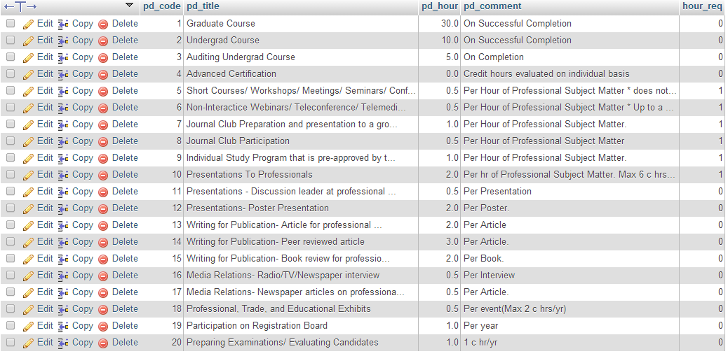

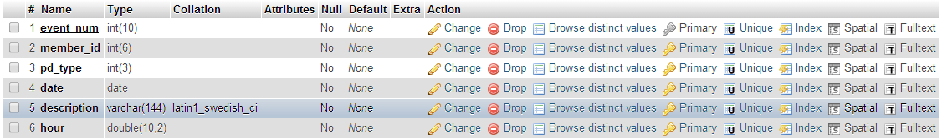

### Appendix A: Professional Development Record

This is from the PEI Dietitians website:

**Professional Development Record**

**Name: _____________________________________________ Date: ___________________________**

|  |  |  |  |  |
| --- | --- | --- | --- | --- |
| **Date** | **Code** | **Category / Description / Location** | **Hours** | Board Use Only |