|  |
| --- |
|  |
| Colisión y difusión |
|  |

|  |
| --- |
| Juan Carlos Navidad García |

|  |  |
| --- | --- |
| MAC | Puerto |
| 00:05:5E:A8:05:01 | 0 |
| 00:90:2B:0A:4D:02 | 1 |
| 00:E0:A3:49:10:03 | 2 |

Switch 0

Switch 1

|  |  |
| --- | --- |
| MAC | Puerto |
| 00:60:2F:C4:4B:04 | 0 |

Switch 2

|  |  |
| --- | --- |
| MAC | Puerto |
| 00:D0:D3:AA:0C:05 | 0 |
| 00:60:2F:E8:4D:06 | 1 |
| 00:01:64:43:EB:07 | 2 |

Hub 0

|  |  |
| --- | --- |
| MAC | Puerto |
| 00:0B:BE:81:60:08 | 0 |
| 00:05:5E:56:B7:09 | 1 |

Hub 1

|  |  |
| --- | --- |
| MAC | Puerto |
| 00:07:EC:1B:03:10 | 0 |
| 00:50:0F:3C:47:11 | 1 |

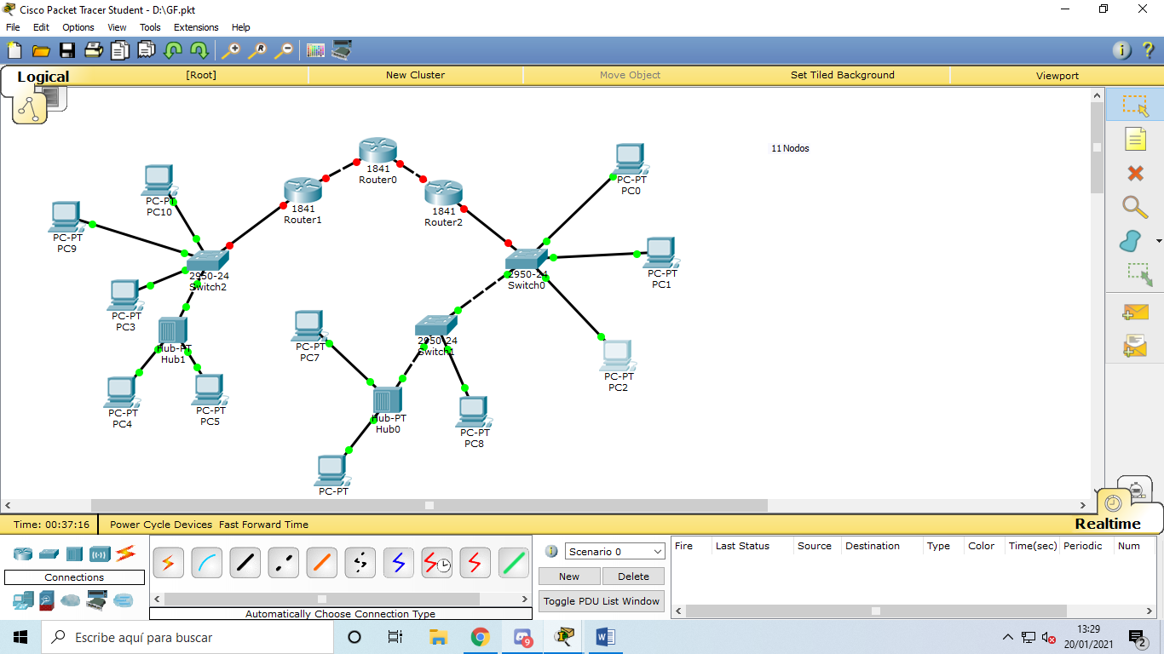

**Verde:** Difusión

**Naranja:** Colisión

**Hay 14 nodos y 5 puntos de acceso**