Cyclistic bike-share case study with R

**About Cyclistic**

Cyclistic is a bike-share program that features more than 5,800 bicycles and 600 docking stations. Cyclistic sets itself apart by also offering reclining bikes, hand tricycles, and cargo bikes, making bike-share more inclusive to people with disabilities and riders who can’t use a standard two-wheeled bike. The majority of riders opt for traditional bikes; about 8% of riders use the assistive options. Cyclistic users are more likely to ride for leisure, but about 30% use them to commute to work each day.

**Questions for analysis**

Three questions will guide the future marketing program:

1. How do annual members and casual riders use Cyclistic bikes differently?

2. Why would casual riders buy Cyclistic annual memberships?

3. How can Cyclistic use digital media to influence casual riders to become members?

**Business task**

Identify potential strategies to increase memberships by finding differences in trends among members and non-members.

**Tools**

R and R studio.

Google Sheets.

**Data**

Cysclistic trip data for 2022. The data contains 13 columns and a total of 5,667,717 rows. The columns are

* ride_id which represents a unique series of numbers and letters to represent each ride.
* rideable_type which represents the type of bike used.
* started_at and ended_at which are date-time data types which represent the start and end date-time of the ride.
* start _station_name, end_station_name which are the addresses of the bike stations where they started and ended their ride.
* start_station _id and end_station_id are the start and end bike stations for the ride using the station's unique Id instead of address.
* start_lat, start_lng, end_lat, end_lng are the latitude and longitude of the starting and ending stations.
* member_casual states whether the rider has a membership or is just a casual rider.

Bike data can be found [here](https://github.com/cisco-eric/Projects/tree/main/data_analysis/bike_data/trip_data)

**Analysis**

First step of the analysis is adding two new columns. The first column trip_length which is the amount of time each ride lasts. The second column is weekday which is a numeric value from 1-7 where the numbers represent the day of the week with 1 representing Sunday.

Second step is to divide the data by member status. We get two data frames, one for casuals and one for members.

**Average Trip Times**

| Member status | Minutes | Seconds |
| --- | --- | --- |
| All | 19 | 26 |
| Member | 12 | 42 |
| Casual | 29 | 08 |

Table 1

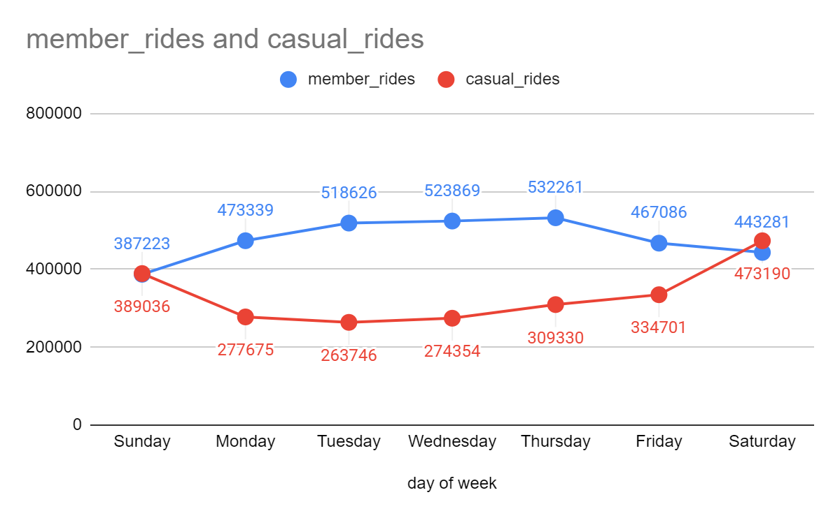

Chart 1

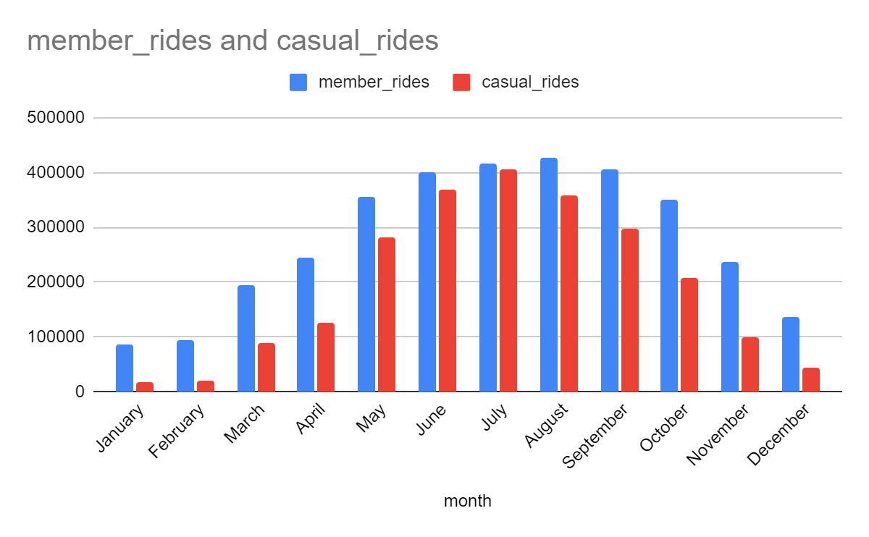

Chart 2

**Summary**

Based on the charts and table, members tend to travel more during the week than they do during the weekend. While casual riders tend to ride more during weekends. Members also tend to spend significantly less time per ride than casual riders. As you can see in chart 2 as the weather gets warmer both casual and member rides increase. However, in the colder months like Jan-Apr, Nov, and Dec there are significantly more member rides compared to casual rides. For the second part of our analysis we will focus on these months to gain insights and trends in our data.

**Average Trip Times for Focus Months**

| Member status | Minutes | Seconds |
| --- | --- | --- |
| All | 15 | 58 |
| Member | 11 | 24 |
| Casual | 27 | 14 |

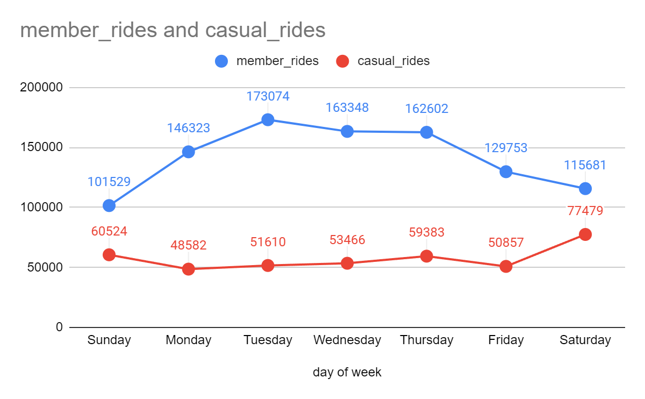

**Summary** **of Focus Months**

Based on the analysis of the focus months we can see that the focus months follow the same trends as the overall data. Members tend to have much shorter trips compared to casual riders. Member riders also tend to ride more during the week while casual riders tend to ride more during the weekends.

**Conclusion**

It is important to understand that we did not have a way of tracking individual riders which would give us more information on differences between people who have a membership and those that do not. However, based on the information provided some suggestions for increasing yearly memberships are

1. Targeting casual riders who tend to ride during colder months and weekdays with advertisements for your yearly membership.
2. Targeting riders who tend to have shorter rides closer to 10-15 minutes with advertisements for yearly memberships.
3. Doing a discount/sale on memberships around mid spring to try and capitalize on the summer surge of casual riders.