**Capstone Project 1: Exploratory Data Analysis**

Exploratory data analysis, EDA, is one of the initial analyses that are performed on a dataset when searching for main trends, summarizing the data’s characteristics, and using visual methods to get a better understanding of the data. John Tukey defined EDA as "Procedures for analyzing data, techniques for interpreting the results of such procedures, ways of planning the gathering of data to make its analysis easier, more precise or more accurate, and all the machinery and results of (mathematical) statistics which apply to analyzing data."

Since the goal of this recommender system is to provide a user with suggestions on similar games that are also favored by other users, the average rating for each game was the logical place to start when comparing board games. I checked to see if there were any games that had no ratings at all. There turned out to be 7,206 games that had no ratings. This came out to be almost 20% of the dataset. These board games were ignored when obtaining the mean and median average rating. The data then showed that even though 80% of the board games had ratings, a vast majority only had a handful or less ratings per game. Figure 1 below illustrates this finding.

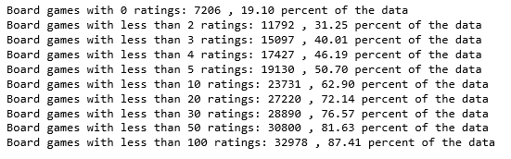

**Fig 1.** Percentage of data per number of ratings

Since so much of the data had such few ratings. I compared the mean and median average rating and the mean and median number of ratings for each grouping. The data was grouped into games that had 1 or more ratings, less than five ratings, less than ten ratings, and less than 30 ratings. Figure 2 below shows the summary results.

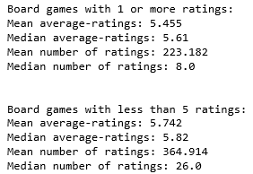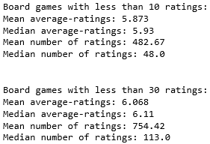

**Fig 2.** Summary results per group

The mean and median of the average ratings are close for all four groups. Since this is the case, it can be said that the dataset of board games with at least 30 ratings per game would reasonably reflect the games with fewer ratings.

Data visualization tools were used to illustrate characteristics of the data. The average rating box plot below, Figure 3, shows that most of the average ratings users gave the games are between 3.5 and 8, with a mean average rating of about 6. Outside these bounds there are many outliers, however, most of the games are rated within this range. The histogram in Figure 3 shows that the data is normally distributed. The QQ plot, in Figure 4 below, shows this as well. However, it can be seen in the histogram that the data is slightly left skewed. This left skewness is more clearly seen in the QQ plot.

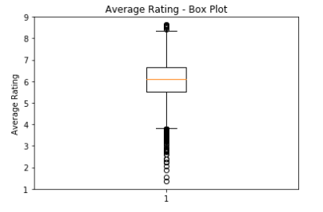 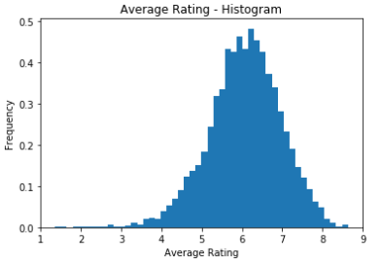

**Fig 3**. Box plot and Histogram

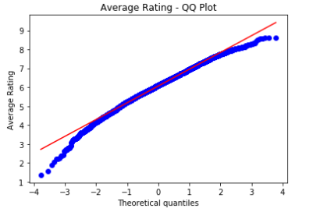

**Fig 4**. QQ plot

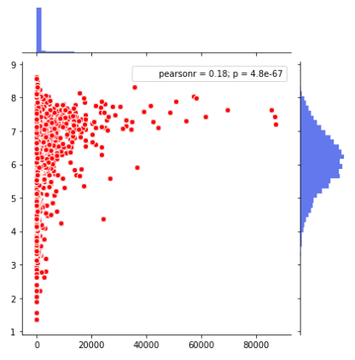

**Fig 5.** Joint plot

The joint plot in Figure 5 is a combination of a Number of Ratings vs. Average Ratings scatter plot, a histogram of the average ratings, and a bar graph of the number of ratings. The scatter plot shows the number of ratings vs the average rating of a board game. The plot shows that games with a higher number of ratings tend to receive a higher average rating. The histogram on the right demonstrates that the average, average-rating is around 6. The Bar graph on top illustrates that a vast majority of the board games have few ratings. The joint plot also contains a correlation analysis. The two variables are shown to have an r of .18 and a p-value of zero.

The correlation was then analyzed independent of the joint plot. First, the correlation between the average rating and the number of ratings was taken for games with at least 30 ratings. It was found to have a positive correlation of .182.The p-value for the correlation coefficient is zero, meaning that it is statistically significant. The correlation between the two variables was then taken without considering the number of ratings. Here, the correlation coefficient decreases slightly to .105.

The top twenty games in terms of average rating and number of ratings are shown in Figure 6 and 7 respectively. The top twenty includes only games that had at least thirty ratings.

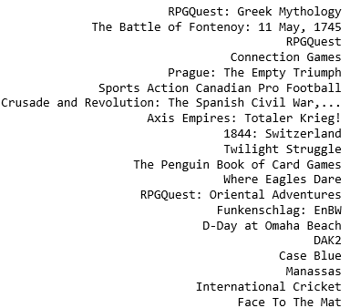

**Fig 6.** Top 20 Board games with the highest average rating

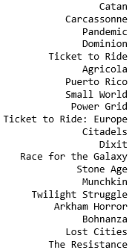

**Fig 7.** Top 20 rated games

The list of games that received the greatest number of ratings has games that are widely popular and can be found at most toy and bookstores. It is interesting to note, however, that none of those games made it to the top twenty list of games by average rating. Evidently the number of ratings is not the only factor related to a game’s average rating.

The correlation coefficient between average rating and number of ratings was .182. The correlation between the other attributes in comparison to average rating was calculated to search for any attributes that may be highly correlated. Figure 8 shows the attributes that had a positive or negative correlation greater than .1.

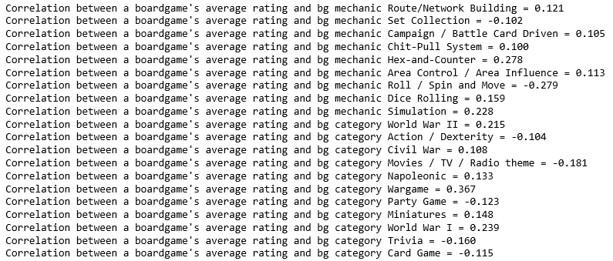

**Fig 8.** Correlations greater than .1/ less than -.1

The list above shows that there is a high, positive correlation between wargames, World War I, and World War II games. There is a strong, negative correlation between a roll-spin-move games and that game's average rating. Hex-and-counter games, on the other hand, have a strong positive correlation. From the correlation results, it can be concluded that games that simulate war tend to receive higher ratings. In addition to this, games that do not rely on luck or “the roll of the die” tend to be more well-liked by users.