Deliverable 4 — Mini Systematic Review
PRISMA 2020 Flow Record

1. Review question and scope
The three databases searched for this deliverable yielded 55 records, of which 8 studies were included. The review asks: which runtime mechanisms verify or block the actions of LLM-based agents against formal or procedural constraints, how are they evaluated, and does any derive those constraints from process event logs in a regulated domain?
The question is framed with CIMO, the framework for Design Science reviews, and derives from the Protocol (Deliverable 3) and the Method-Fit Matrix (Deliverable 2).
CIMO element | Definition in this review
Context | LLM-based agents executing actions in regulated or safety-relevant processes
Intervention | A runtime verification, monitoring or enforcement layer around the agent
Mechanism | Formal or symbolic constraints (temporal logic, rule DSLs, SMT, policy engines) checked before or while an action executes
Outcome | Fewer constraint violations with task performance preserved

Scope: peer-reviewed journal and conference papers with a DOI, published 2022–2026, in English or Spanish.

2. Information sources and search strategy
Six searches were run across Scopus, IEEE Xplore and Web of Science, with two strings per database. All searches were limited to 2022–2026 and to articles and conference papers.
ID | Database | String | Date | Records
S1 | Scopus | Option 1 — core gap | 2026-10-08 | 5
S2 | Scopus | Option 2 — agent enforcement | 2026-10-08 | 24
S3 | Web of Science | Option 1 — core gap | 2026-10-08 | 1
S9 | Web of Science | Option 2 — agent enforcement | 2026-10-08 | 5
S4 | IEEE Xplore | Option 1 — core gap | 2026-10-08 | 1
S8 | IEEE Xplore | Option 2 — agent enforcement | 2026-10-08 | 19
 | Total |  |  | 55

Option 1 combines three concept blocks: LLM agents AND runtime verification or enforcement AND process mining or temporal logic. Option 2 replaces the third block with formal or neuro-symbolic constraints and excludes jailbreak, toxicity and content-moderation work.
Scopus — Option 1 (S1)
TITLE-ABS-KEY( ( "LLM agent*" OR "LLM-based agent*" OR "language agent*" OR agentic OR ( ( "large language model*" OR LLM* ) W/5 agent* ) ) AND ( "runtime verification" OR "runtime enforcement" OR "runtime monitor*" OR "action verification" OR "constraint enforcement" OR shield* OR guardrail* ) AND ( "process mining" OR "declarative process*" OR "Declare constraint*" OR LTLf OR "linear temporal logic" OR "temporal logic" OR "conformance checking" OR "compliance checking" ) ) AND PUBYEAR > 2021 AND PUBYEAR < 2027 AND ( LIMIT-TO(DOCTYPE,"ar") OR LIMIT-TO(DOCTYPE,"cp") )
Scopus — Option 2 (S2)
TITLE-ABS-KEY( ( "LLM agent*" OR "LLM-based agent*" OR "language agent*" OR agentic OR ( ( "large language model*" OR LLM* ) W/5 agent* ) ) AND ( "runtime verification" OR "runtime enforcement" OR "runtime monitor*" OR shield* OR guardrail* OR "policy enforcement" OR "action constraint*" ) AND ( "neuro-symbolic" OR neurosymbolic OR "formal verification" OR "formal specification" OR "temporal logic" OR "domain-specific language" OR "rule-based" OR "safety specification*" ) AND NOT ( jailbreak* OR toxic* OR "content moderation" ) ) AND PUBYEAR > 2021 AND PUBYEAR < 2027 AND ( LIMIT-TO(DOCTYPE,"ar") OR LIMIT-TO(DOCTYPE,"cp") )
Web of Science — Option 1 (S3)
TS=(("LLM agent*" OR "LLM-based agent*" OR "language agent*" OR agentic OR (("large language model*" OR LLM*) NEAR/5 agent*)) AND ("runtime verification" OR "runtime enforcement" OR "runtime monitor*" OR "action verification" OR "constraint enforcement" OR shield* OR guardrail*) AND ("process mining" OR "declarative process*" OR "Declare constraint*" OR LTLf OR "linear temporal logic" OR "temporal logic" OR "conformance checking" OR "compliance checking")) | Refined by: Publication Years 2022–2026; Document Types: Article, Proceedings Paper
Web of Science — Option 2 (S9)
TS=(("LLM agent*" OR "LLM-based agent*" OR "language agent*" OR agentic OR (("large language model*" OR LLM*) NEAR/5 agent*)) AND ("runtime verification" OR "runtime enforcement" OR "runtime monitor*" OR shield* OR guardrail* OR "policy enforcement" OR "action constraint*") AND ("neuro-symbolic" OR neurosymbolic OR "formal verification" OR "formal specification" OR "temporal logic" OR "domain-specific language" OR "rule-based" OR "safety specification*") NOT (jailbreak* OR toxic* OR "content moderation")) | Refined by: Publication Years 2022–2026; Document Types: Article, Proceedings Paper
IEEE Xplore — Option 1 (S4)
("All Metadata":"LLM agent" OR "All Metadata":"LLM-based agent" OR "All Metadata":"language agent" OR "All Metadata":agentic) AND ("All Metadata":"runtime verification" OR "All Metadata":"runtime enforcement" OR "All Metadata":"runtime monitoring" OR "All Metadata":guardrail OR "All Metadata":shield) AND ("All Metadata":"process mining" OR "All Metadata":"conformance checking" OR "All Metadata":"compliance checking" OR "All Metadata":LTLf OR "All Metadata":"temporal logic" OR "All Metadata":"declarative process") | Filters: 2022–2026; Conferences, Journals
IEEE Xplore — Option 2 (S8)
("All Metadata":"LLM agent" OR "All Metadata":"LLM-based agent" OR "All Metadata":"language agent" OR "All Metadata":agentic) AND ("All Metadata":"runtime verification" OR "All Metadata":"runtime enforcement" OR "All Metadata":"runtime monitoring" OR "All Metadata":shield* OR "All Metadata":guardrail* OR "All Metadata":"policy enforcement" OR "All Metadata":"action constraint*") AND ("All Metadata":"neuro-symbolic" OR "All Metadata":neurosymbolic OR "All Metadata":"formal verification" OR "All Metadata":"formal specification" OR "All Metadata":"temporal logic" OR "All Metadata":"domain-specific language" OR "All Metadata":"rule-based" OR "All Metadata":"safety specification*") NOT ("All Metadata":jailbreak* OR "All Metadata":toxic* OR "All Metadata":"content moderation") | Filters: 2022–2026; Conferences, Journals

3. Eligibility criteria
Criteria were fixed before screening and applied unchanged at both stages. Every exclusion in the flow diagram cites one code below.
Code | Type | Criterion
IC1 | Inclusion | Peer-reviewed journal article or conference paper with a DOI, published 2022–2026
IC2 | Inclusion | Written in English or Spanish
IC3 | Inclusion | Proposes, implements or evaluates a mechanism that verifies, monitors, constrains or blocks the actions of LLM-based agents; or uses LLMs for conformance or compliance checking of business processes
IC4 | Inclusion | Reports an evaluation of the artifact (empirical, formal or case-based)
Not IC3 | Exclusion | Off-topic: does not meet IC3
EC1 | Exclusion | Preprints (arXiv, SSRN), theses, technical reports, blogs, editorials or book chapters
EC2 | Exclusion | No LLM or agent component, or no LLM agent in the evaluation
EC3 | Exclusion | Guardrails limited to textual content or outputs, without control over actions or procedural rules
EC4 | Exclusion | Position papers, manifestos or theoretical work without artifact evaluation; secondary studies (used for snowballing only)
EC5 | Exclusion | Full text not available
EC6 | Exclusion | Duplicate or earlier version of an included study

An author-accepted copy (arXiv, SSRN or an institutional repository) of a paper published with a DOI counts as its full text; the published version is the one cited. This rule does not admit preprints that were never published, which remain excluded by EC1.

4. Selection process
One reviewer (the doctoral researcher) screened all records, assisted by an LLM (Claude). The assistant proposed a decision, an exclusion code and a one-line rationale for every record; the reviewer verifies each one in the screening log.
- Export. Results from each search were exported with abstracts (Scopus CSV, IEEE Xplore CSV, Web of Science Full Record).
- Deduplication. Records were matched across the six exports by DOI. A record retrieved by several searches was kept once.
- Title and abstract screening. Each unique record was judged against IC3 and the exclusion codes. Records in doubt went forward to full text.
- Retrieval. Full texts were sought through the UNMSM library proxy (MyLOFT), publisher open access and author copies (arXiv, SSRN, repositories, ResearchGate).
- Full-text eligibility. Each retrieved report was assessed against IC1–IC4, recording the decision and a quotation from the paper as evidence.
One decision was corrected for consistency. R36 (Policy Over Tokens) was first excluded under EC3, but R33 (PolicyAgent) applies declarative policies to LLM outputs in a comparable way and had passed. R36 was therefore sent to full text.

5. PRISMA 2020 flow record
The flow runs 55 → 37 → 15 → 9 → 8. These values are entered in the official PRISMA 2020 flow diagram tool, template for new reviews with databases only. The “other methods” column is switched off: no study entered through citation searching or websites.
Phase | Box in the official tool | n | Breakdown or reason
Identification | Records identified from databases | 55 | Scopus 29; IEEE Xplore 20; Web of Science 6
Identification | Records identified from registers | 0 | No registers searched
Identification | Duplicate records removed | 18 | Same DOI retrieved by more than one search
Identification | Records marked as ineligible by automation tools | 0 | Assisted screening is reported under screening, not as automatic removal
Identification | Records removed for other reasons | 0 | —
Screening | Records screened | 37 | Title and abstract
Screening | Records excluded | 22 | Not IC3, off-topic (7); EC2, no LLM component (6); EC3, output-only guardrails (2); EC4, survey, theoretical or position paper (7)
Screening | Reports sought for retrieval | 15 | —
Screening | Reports not retrieved | 6 | Full text not accessible by the record date (R04, R05, R12, R15, R22, R36)
Eligibility | Reports assessed for eligibility | 9 | Full text
Eligibility | Reports excluded | 1 | EC2: no LLM agent in the evaluation (R20)
Included | Studies included in review | 8 | —
Included | Reports of included studies | 8 | One report per study

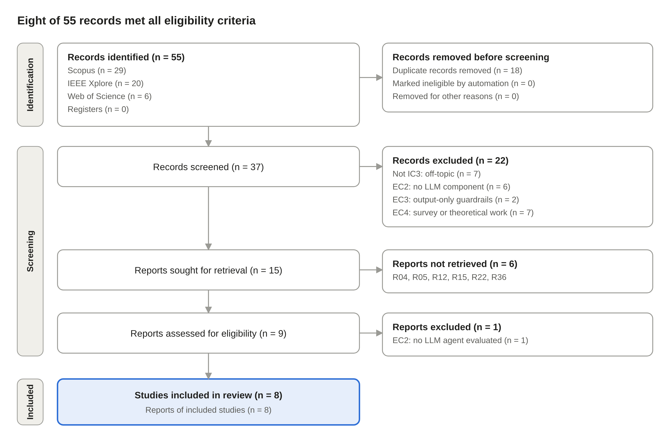
Figure 1. PRISMA 2020 flow diagram
Most records fell at screening (22 of 37). Retrieval, not eligibility, is what keeps the review below 10 studies: 6 of 15 reports could not be obtained.

6. Flow narrative
Identification. Six searches in three databases returned 55 records. Removing 18 duplicates by DOI left 37 unique records. The core-gap string (Option 1) returned only 1–5 records per database, and all were also found by Option 2. That convergence is itself evidence that the core question is barely studied.
Screening. Title and abstract screening excluded 22 of 37 records:
- Not IC3 (7). The agent’s actions are not the object of control. Examples are a credit-default prediction case, a refusal agent in Minecraft, privacy protection in SaaS, geospatial automation and attention-level alignment.
- EC2 (6). No LLM component. These are reinforcement-learning or MLP agents with safety shields (UAV, nuclear reactor, private networks), RL network management, Large Action Models and autonomous driving.
- EC3 (2). Guardrails act only on text, through clinical-note classification or prompt-injection filtering, with no control over procedural actions.
- EC4 (7). Surveys, a taxonomy built from a literature review, a manifesto, a position paper, purely theoretical work and a non-empirical design case. The surveys are kept for snowballing.
Retrieval. Of the 15 reports sought, 6 could not be obtained in full text by the record date:
- R04 is open access at Wiley but had not been downloaded.
- R05 and R12 are Springer papers.
- R15 and R22 are IEEE papers. The file received for R15 was a different paper.
- R36 is an IEEE paper sent to full text after the consistency check.
All six are reported as not retrieved rather than assessed from their abstracts.
Eligibility. Nine full texts were assessed and one was excluded. Miller’s MARIS-TRA (R20) states that its experiments are “not direct validation of tool-using LLM agents”, which fails EC2. The remaining 8 met IC1–IC4. One of them, R27, is a borderline fit: an LLM only supplies advisory risk scores to a policy engine that blocks agent transactions.

7. Included studies
All 8 included studies are conference papers from 2025–2026, and none derives its constraints from process event logs. In every one the rules are written by hand or compiled from policy documents.
ID | Study and DOI | Venue | Mechanism | Evaluation
R24 | Wang, Poskitt & Sun (2026). AgentSpec  doi:10.1145/3744916.3764546 | ICSE 2026 | Hand-written rule DSL (trigger, predicate, enforcement) checked before each action | Code, embodied and driving agents; LLM-generated rules
R09 | Alamdari, Klassen & McIlraith (2026)  doi:10.1145/3805689.3812339 | FAccT 2026 | LTL progression for auditing, predictive monitoring and intervention | Three environments; LLM-judge baselines
R07 | Xia, Li, Ehsan & Ortiz (2026). TraceFix  doi:10.1145/3786335.3813159 | CAIS 2026 | TLA+-verified coordination protocol plus runtime topology monitor | 48 tasks; 3,456 runs; paired ablation
R17 | Syed & Silaghi (2026). Epistemic Edge  doi:10.1109/IRI69576.2026.00017 | IEEE IRI 2026 | Subjective-logic uncertainty checks plus action whitelists | 2,800 trials; ablations; paired Wilcoxon
R18 | Koohestani (2025). AgentGuard  doi:10.1109/ASEW67777.2025.00023 | ASE Workshops 2025 | Online-learned MDP plus probabilistic model checking | Proof of concept on RepairAgent; no quantitative results
R33 | Goel & Apuri (2026). PolicyAgent  doi:10.1109/ECAI69016.2026.11613679 | ECAI 2026 | SMT verification of financial regulatory obligations | 47,200 simulated queries; ablations
R34 | Karuppuchamy (2026). Semantic Agents  doi:10.1109/ICSC67292.2026.00035 | IEEE ICSC 2026 | Ontology-based contracts and business rules on API actions | 40 test cases vs LLM-only and rule-based baselines
R27 | Bhushan, Pappu, Jadav & Jaiswal (2026)  doi:10.1109/SoutheastCon63549.2026.11476129 | SoutheastCon 2026 | OPA policies and tiered human approval on agent transactions | 120 requests; 20 escalation tests (borderline)

8. Arithmetic consistency check
Every stage subtracts exactly the exclusions reported beside it, so Identified − Excluded = Included holds: 55 − 47 = 8.
Step | Calculation | Result
After deduplication | 55 identified − 18 duplicates | 37 screened
After screening | 37 screened − 22 excluded | 15 sought
After retrieval | 15 sought − 6 not retrieved | 9 assessed
After eligibility | 9 assessed − 1 excluded | 8 included
All removals | 18 + 22 + 6 + 1 | 47

The screening log recomputes these figures from the record-level data and flags any mismatch. Its consistency checks read OK at this version.

