

MSc Management & Business Analytics

BUSI49152 : Data Analysis for Managerial Decision Making

” Examining Inventory Management and Supply Chain Strategies: Product Variety, Color Options, and Performance Analysis”

Cise ALACA
NTU ID: 0985928

Word count: 3982

Date of submission: 30/04/2023

Introduction 3
1.Product Analysis and Data Description 4
Data Information and Data Cleaning 4
Descriptive Statistics 5
Demand Distribution 6
Sales and Profitability Analysis on the basis of Product Variety and Color Options 7
2.Supply Chain and Operations Management: Stock Control and Strategic Planning Optimization with Predictive and Prescriptive Analysis 11
Business Operations and Supply Chain Management Strategies 11
Increasing Color Variety and Make-to-Order Business Model 11
Adjusting Inventory Levels Based on Demand 11
Grouping of Powder Orders and Reducing Delivery Costs 11
Accelerating Production Processes and Cooperation with Suppliers 11
Buffer Stock and Operations 14
Forecast based on current Sales and Profitability data 16
Decision Tree Model 19
3.Conclusions and Suggestions 20
Appendices 22
Appendix 2. Profit Values by different Product Families 23
Appendix 3. Demand of Bins and Planters by Month 23
References 24

Figure 1:Descriptive Statistics for Powder Weight and Cost, Price, Profit and Profit Margin Percentage 5
Figure 2:Descriptive Statistics for Due Date Performance 5
Figure 3: Due Date Performance Distribution 6
Figure 4: Demand Distribution of Product Families by Month 6
Figure 5:Average Profit Margin (%) by Product Families 7
Figure 6: Highest and Lowest Selling Products 7
Figure 7: Annual Profibility Trends 8
Figure 8: Annual Total Sales 9
Figure 9: Sales distribution of new and existing colours in 2011 and 2012 9
Figure 10: Sales Distribution of New Colour Options 9
Figure 11: Moving Average for Annual Sales 13
Figure 12: Moving Average for Annual Profit 13
Figure 13: Correlation Matrix by Powder weight, Powder Cost, Price,Profit,Sales and Date Performance 15
Figure 14: Correlation Matrix by Profit and Sales 15
Figure 15: Profitability Forecast for 2013-2016 16
Figure 16:Profit Forecast by Different Product Families 17
Figure 17: Performance Score 18
Figure 18:Decision Tree in the context of Profitability 19

Introduction

This study concentrates on a company that operates in the horticulture and waste management industries and offers a unique selection of plastic containers and trash cans. With a focus on the self-watering and Planterware product lines, the company uses a Tailor Made business model to meet the specific requirements of its customers. Evaluating the impact of the company's strategies, such as increasing colour variety and employing the Make-to-Order business model. In addition, the report assesses the potential for cost reduction and productivity enhancement, such as adjusting supply levels and order frequency, clustering powder orders, and accelerating production processes. This study focuses on a company that offers two types of planter products: self-watering and planterware. The self-watering receptacles are designed with an integrated water chamber and capillary mechanisms to provide customers with an unrivalled value proposition. With the exception of black and standard green, the majority of the company's expanded colour selection was introduced in 2011 in an effort to increase its competitiveness. Additionally, the company has adopted the Make-to-Order business model in order to meet specific consumer requirements.
Planters have a standard advance time of two weeks, while crates require three weeks. The company purchases coloured granules from a supplier 500 miles away at a per-kilogram cost that varies based on the colour. The delivery cost per 20-foot container for a 500-mile distance with a capacity of 10 pallets is £750. Powder has a minimum order quantity of one pallet per colour, with each pallet weighing 500kg. The company has its own storage facilities for both basic materials and finished products, and the holding cost corresponds to 7 percent of the total amount of capital committed to inventory.
By aligning their marketing strategies with their operations and supply chain strategies, continuously monitoring market demands, and modifying their practises accordingly, businesses can gain a competitive advantage. This alignment can contribute to long-term growth, increased customer satisfaction, and increased customer loyalty.

1.Product Analysis and Data Description

Data Information and Data Cleaning
The first section of the data set contains product description, colour, powder weight, sales price, and historical sales data. In addition, additional characteristics such as product family and delivery performance are listed for each product. Annual reports cover the years 2006 through 2012. In the sales data columns, there are both "0" and "empty" values. In addition, the second document of the data set contains information on production and sales, including powder costs of various colours and average flower pot/trash receptacle demands. The dataset contains vital information regarding the inventory and supply chain strategies of the company. On the basis of this information, it is estimated that the voids (zero or blank) in the sales columns occurred prior to 2011, when colours other than black and standard green were not available for purchase. However, since 2011, products displaying negative revenues are interpreted as having never been sold.
Since the data will be analysed in both Excel and R Studio, inconsistencies have been introduced into the entire dataset so that it can be processed in R. Due to the fact that R would inaccurately analyse the data if the annual sales section was presented with two headings, the headings were merged. The value "0" is assigned to "Empty" entries. The spaces between sentences have been supplied with R-specific special characters. As the study progressed and new data (such as profitability and totals) were obtained, the Excel file was updated in the R environment. To perform specific analyses, verbal data were converted to a numeric format.
Descriptive Statistics
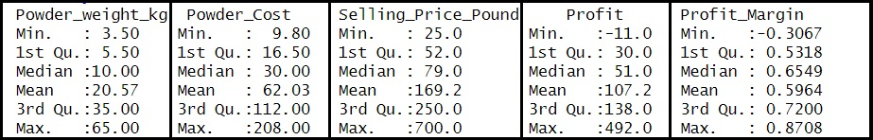
Figure 1:Descriptive Statistics for Powder Weight and Cost, Price, Profit and Profit Margin Percentage
According to the above statistical data;

• Powder Weight (kg): Shows data according to total powder weight. It is seen that there are orders with a minimum of 3.5 kg and a maximum of 65 kg of dust. Average powder weight was calculated as 20.57 kg.
• Powder Cost: The cost of powder is shown in Pounds. The lowest cost was recorded as 9.80 Pounds and the highest as 208.00 Pounds. Average cost is £62.03.
• Selling Price: The selling price is shown in Pounds. The lowest selling price was calculated as £25 and the highest selling price was £700. Average selling price is £169.2.
• Profit: Profit is calculated based on the difference between selling price and powder cost. The lowest profit was calculated as -11, the highest profit was calculated as 492. Average profit is 107.2 Pounds. Profit Margin (%): The profit margin is calculated on the selling price of the powder. The lowest profit margin was recorded as -0.3067, the highest profit margin was recorded as 0.8708. Average profit margin is 0.5964.
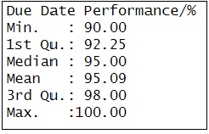
Figure 2:Descriptive Statistics for Due Date Performance
The average value for the Due Date Performance variable is 95.09, and the median value is 95.00. This indicates that the products are mostly delivered on time.

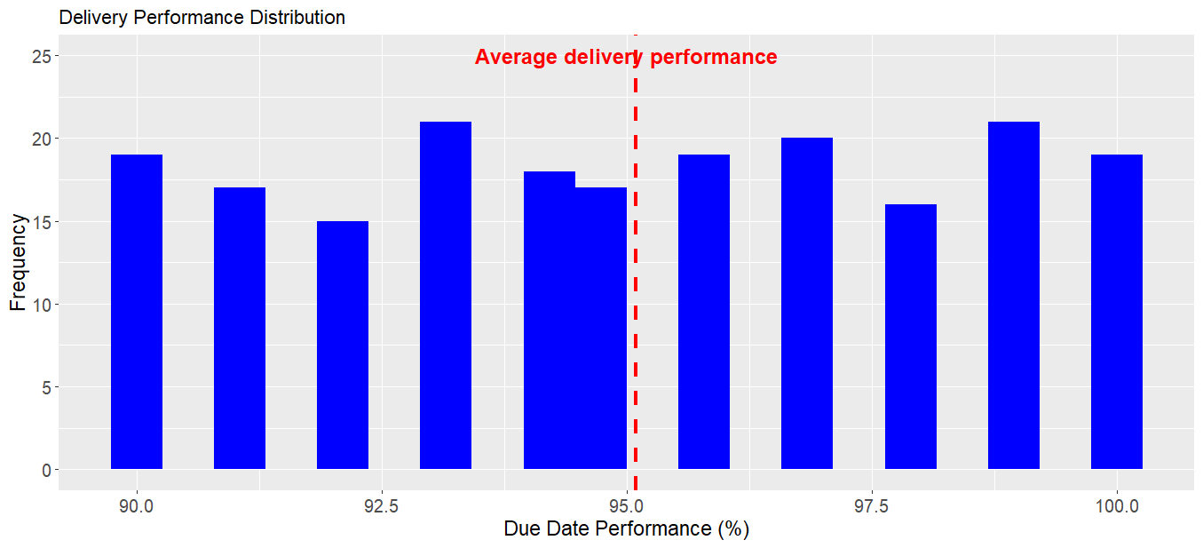
Figure 3: Due Date Performance Distribution

Demand Distribution
Figure 4: Demand Distribution of Product Families by Month

As can be seen in Figure 4, seasonal demands for Planters and Bins frequently exhibit contrasting intensities. Here, the seasonal impact of seasonal consumer demand for plant and garden products is observed.

Sales and Profitability Analysis on the basis of Product Variety and Color Options

In figure 5 below, the distribution of different product families according to profit margin percentages is presented. The profit margin percentage of Self watering and Bins products is on average two times higher than Planterware.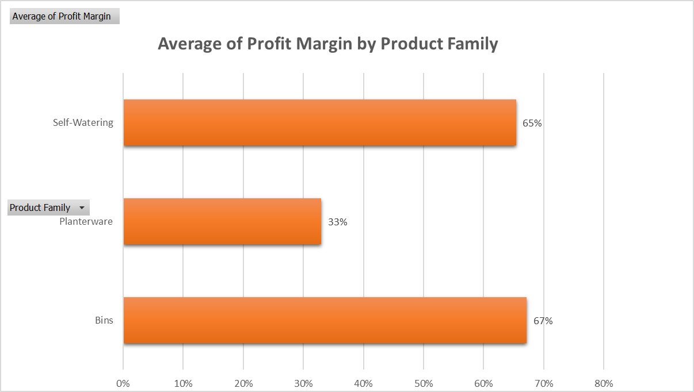
Figure 5:Average Profit Margin (%) by Product Families
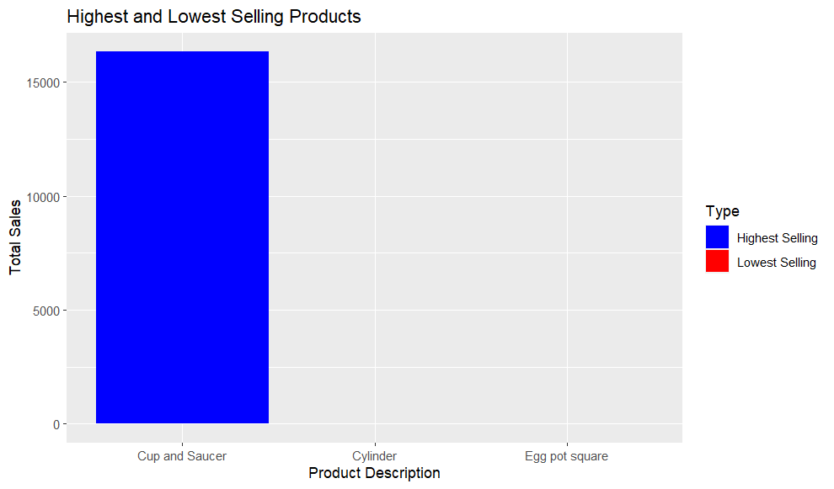
Figure 6: Highest and Lowest Selling Products
Cup and Saucer is the best-selling product of all time, and the Cylinder and Egg Pot Square, which were never sold, are highlighted in Figure 6.
Analysis of Sales and Profitability for Newly Introduced Colours
Since 2011, the company has begun to offer additional colours to its consumers, in addition to Black and Standard Green, to increase sales by increasing product variety and customization. Below, the sales and profitability levels as of 2011 are examined, and information regarding the benefits of introducing new colours is sought.
As shown in Figures 6 and 7, the annual sales and annual profitability levels have increased since 2011. This may be owing to the introduction of new colours.

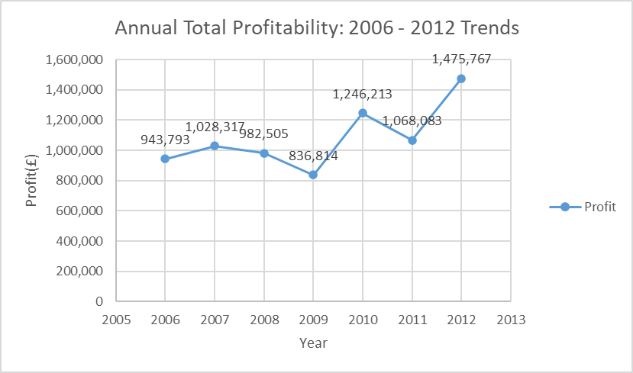
Figure 7: Annual Profibility Trends

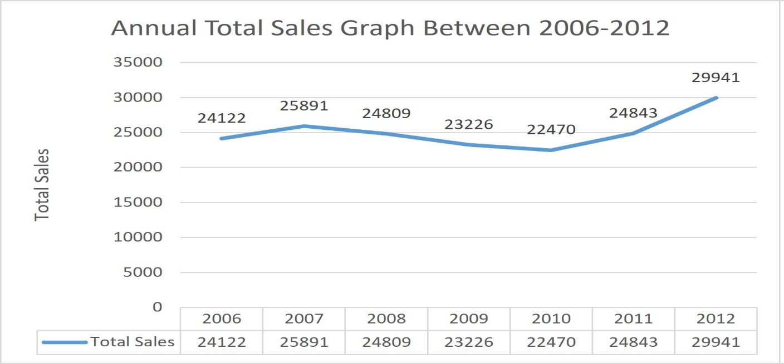
Figure 8: Annual Total Sales

Figure 9 depicts the new colours introduced to the market in 2011 and the sales figures for 2011-2012. Compared to other colours, Pink Granite and Brown were preferred by the majority of customers. Since these demands may be related to seasonal fashions and trends (for instance, a colour that is popular this year may be out of style in a few years), they should be adhered to over the long term. In any event, all of the newly introduced colours were profitable. In addition, Moss Stone was never sold in 2012.
As shown more obviously in Figure 10, new colours contributed 37% to 2011 sales. In 2012, the rate increased to 42%. The following table summarises the average profit margin and total sales values according to colour combinations of product families.
Figure 9: Sales distribution of new and existing colours in 2011 and 2012
- Colours with the highest profit margin average: Light Green: 72% (59 sales), Moss Stone: 70% (5 sales), Standard Green: 69% (51,299 sales)
- Colours with the lowest profit margin average: 38% for White Marble (5 sales), 38% for Terracotta (7,699 sales), and 40% for Brown (1,053 sales).
- Colours with the greatest number of sales: Black: 88,453 units sold with a margin of 62%, Standard Green: 51,299 units sold with a margin of 69%, and Terracotta: 7,699 units sold with a margin of 38%.
Figure 10: Sales Distribution of New Colour Options
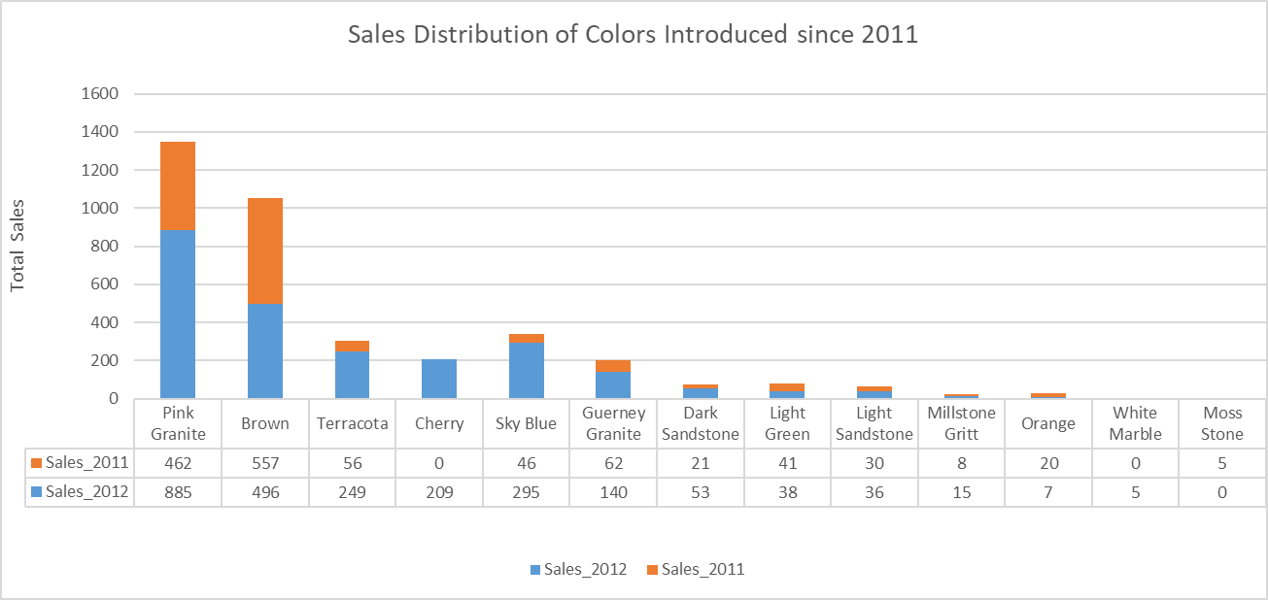
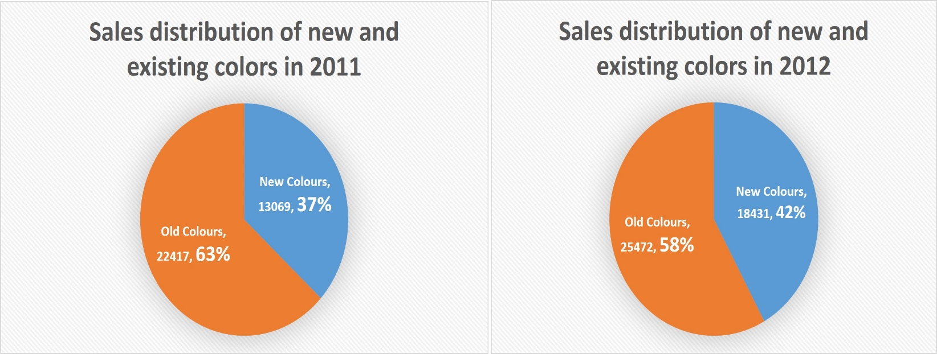

2.Supply Chain and Operations Management: Stock Control and Strategic Planning Optimization with Predictive and Prescriptive Analysis

Business Operations and Supply Chain Management Strategies
Increasing Color Variety and Make-to-Order Business Model

Since 2011, the company has attempted to boost its competitiveness by expanding its colour selection. This strategy aims to improve customer satisfaction and increase market share. Using descriptive analysis, it was determined that this company initiative resulted in an increase in overall sales and profitability. Moreover, the company's adoption of the Make-to-Order business model optimises production processes and inventory management. The make-to-order model safeguards the business from being burdened with superfluous product costs and lower-than-anticipated demand. The significance of the make-to-order system becomes apparent, particularly given the high cost of certain colour powders.
Adjusting Inventory Levels Based on Demand
In order to reduce costs and increase efficiency, it is essential for the business to modify the inventory levels and order frequency in light of the monthly demand distribution. This strategy enables companies to better manage their inventory and production based on demand forecasts (Axsater, 2006). Taking into account the general demand distribution of the firm, the company can maintain more balanced stock levels, as the demand for two distinct product families peaks in opposing seasons. As a result of this report, the company will be able to maintain its inventory management in the future based on this seasonal distribution (Silver et al., 1998).
Grouping of Powder Orders and Reducing Delivery Costs
Critical to the company's supply chain management strategy is gathering powder orders in numerous colours to maximise container capacity and reduce delivery costs. This method becomes more valuable as the diversity of colours increases, particularly in the plastics industry (Chen et al., 2016).

Accelerating Production Processes and Cooperation with Suppliers
By providing faster service, the possibility of the company accelerating its production processes and reducing industry-standard lead times by collaborating more closely with its suppliers will provide a competitive advantage. This approach is especially essential for companies employing Make - to - Order business models, as it positively affects customer satisfaction and order cycle times. The company's marketing strategy concentrates on expanding its selection of colours for its self-watering containers and flowerpots. This strategy seeks to increase market competitiveness. In addition to adopting a make-to-order business model, the company also produces products based on consumer demand. The company's operations strategy, on the other hand, concentrates on supplying a standard industry lead time for planters and bins. They presume that their warehouse will always be available for raw materials and finished products. By attracting more consumers, the company's current marketing strategy to expand its colour palette can have a positive effect on sales. However, the company's operations strategy of providing a standard lead time may negatively impact its sales if the company is unable to meet the standard lead time as product demand increases. In addition, the company's supplier/order and delivery cost/pallet cost can increase production costs, which can have a negative effect on profit margin.
Moving Average Analysis

By analysing past performance, time series analysis enables businesses to foresee future trends and patterns. This type of analysis is an essential instrument for evaluating the efficacy of business strategies and providing data for future decisions (Box, Jenkins, & Reinsel, 2008). In time series analysis, moving averages are a popular technique. This method smoothes out the irregularities in the time series by aggregating the data over a specific period, making it simpler to identify trends (Brockwell and Davis, 2002). Numerous disciplines and industries have recognised the significance and utility of time series analysis. Using time series analysis, businesses can make more informed judgements in areas such as production, inventory management, and pricing (Makridakis, Wheelwright, & Hyndman, 1998). Overall, time series analysis is a valuable instrument that enables businesses to assess their past performance and anticipate future trends and patterns. Methods such as moving averages and exponential smoothing level out irregular data, making it simpler to identify trends and patterns and enabling businesses to make more informed and effective decisions (Hayya et al., 2007).
In this report, a time series analysis was conducted to evaluate the company's total sales and earnings between 2006 and 2012. The objective is to forecast the company's future performance and gain a deeper understanding of its business strategies by analysing the data collected during this period. In the descriptive section of the report, data on the total profit and total sales for the years 2016-2012 were extracted from the complex dataset and tabulated. Initially, two time series of the company's total annual revenues and profits were compiled. These time series include numbers representing annual revenues and profits. Then, using the moving average method, irregularities in the time series were smoothed out and trends were observed with greater clarity. Using this procedure, the data for a specific time period for each year were averaged, thereby reducing the impact of short-term fluctuations in the time series.
Moving Average Analysis for Sales Data
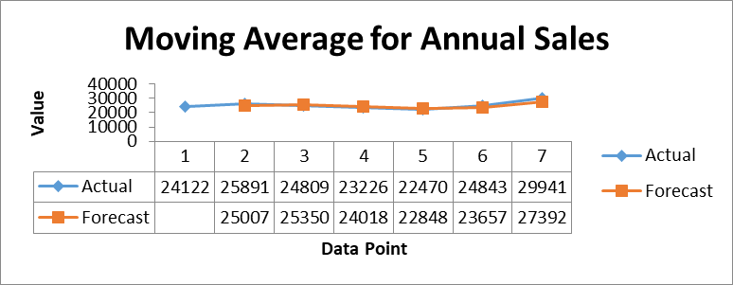
Figure 11: Moving Average for Annual Sales

In the time series analysis of sales between 2006 and 2012, the moving average values generally show an increasing trend. While sales were declining from 2006 to 2009, they started to recover and increase significantly from 2010. The increase of 733 units between 2006 and 2007 was then offset by a decrease of 678 units between 2008 and 2009. A lower increase of 620 units was observed between 2009 and 2010, while between 2011 and 2012 there was a large increase of 1,988 units with a stronger recovery.

Moving Average Analysis for Profit Data
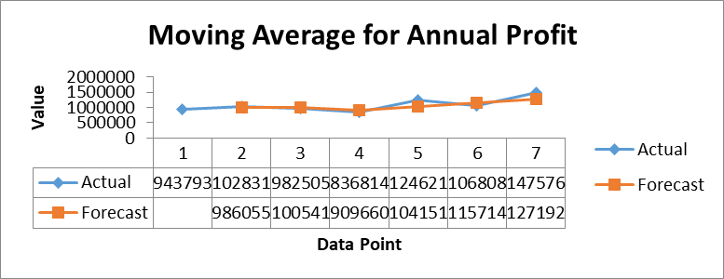
Figure 12: Moving Average for Annual Profit
Similar trends are observed in the profit data time series analysis. The profit growth from 2006 to 2007 was calculated to be 33,991 units. Profits decreased considerably between 2008 and 2009, by 53,996 units. Profits increased by a staggering 153,637 units between 2010 and 2011, and 157,852 units between 2011 and 2012.
Consequently, time series analyses for both sales and profits demonstrate that the company's performance has improved significantly since 2010. These results indicate that the company's strategies and adjustments (such as increasing colour variety) are successful and have a positive effect on sales and profits.

Buffer Stock and Operations
The concept of buffer stock is crucial in operations management. This inventory is maintained as a precaution against disruptions caused by fluctuations in demand or unanticipated breakdowns in operational processes (Heizer & Render, 2001). As production costs may vacillate, it may be essential for the company to maintain a buffer stock. The creation of buffer inventories may be necessitated by company-specific factors such as unpredictability in customers' colour preferences, errors in demand forecasts, and delays in material supply (Hopp & Spearman, 2011).
For instance, as the company introduces new colours, it is uncertain which colours will be in demand, which may necessitate the creation of buffer stocks during production. The increases and decreases in the company's stock levels are the result of operational decisions. Particularly, based on the enterprise's product forecasts, there may be a decrease in its stock levels.
In this situation, inventory management optimal levels must be determined. In this process, models like safety stock and EOQ (Economic Order Quantity) can be utilised (Silver, Pyke, & Peterson, 1999). Safety stock is an additional quantity of inventory held to accommodate demand projections and procurement process uncertainties. In contrast, the EOQ model assists businesses in optimising their inventory levels while minimising procurement and inventory costs. Decreases in the business's stock levels, for instance, indicate that its planning and inventory management strategies are well-managed. However, excessive buffer stock reduction can also pose dangers. Unanticipated demand increases or supply chain delays can make it challenging for a business to meet consumer demands (Axseter, 2006). Therefore, the company must maintain a cautious balance between buffer inventories and stock levels.
Analysis of Supply Chain and Operational Performance Correlation Matrix
In order to comprehend the interrelationships between the variables in the dataset, a correlation matrix was constructed using the Pearson correlation coefficient. In this matrix, the relationship between variables was quantified. The first correlation matrix measured the relationships between "Powder_weight_kg", "Powder_Cost", "Selling_Price_Pound", "Profit", "Total_Sales", and "Due_Date_Performance" The correlation coefficient between "Powder_weight_kg" and "Powder_Cost" in this matrix is 0.9988, whereas the correlation coefficients between "Total_of_Sales" and the other variables are lower. Additionally, the correlation between "Selling_Price_Pound" and "Profit" is extremely high (0.9883).
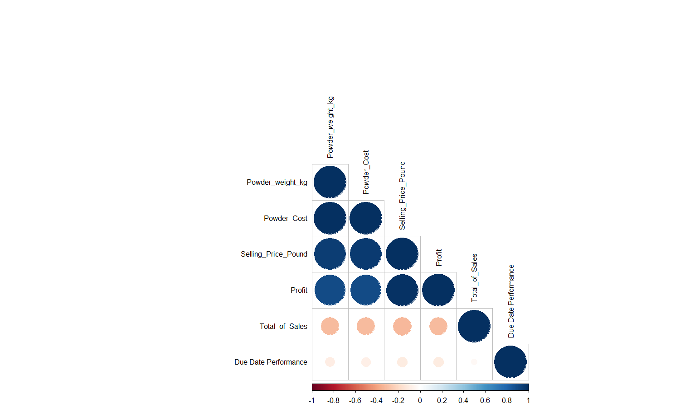
Figure 13: Correlation Matrix by Powder weight, Powder Cost, Price,Profit,Sales and Date Performance
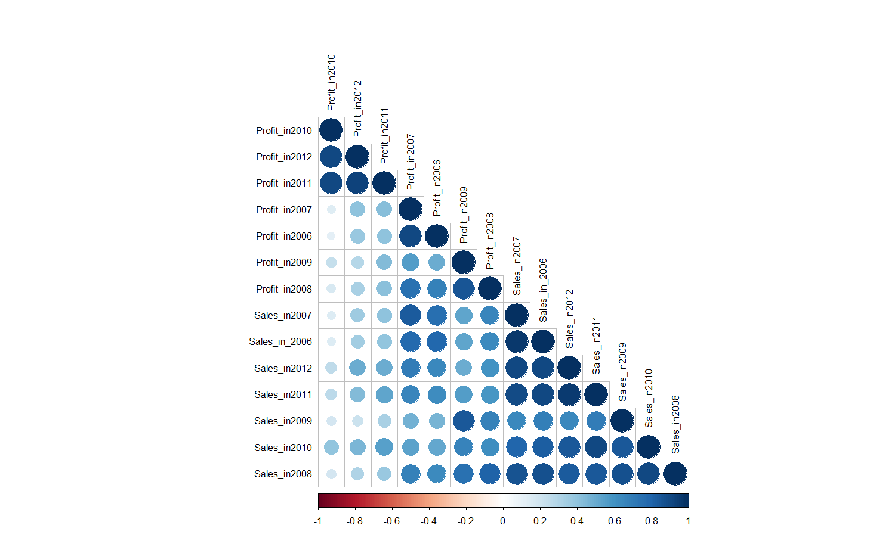
The Second correlation matrix measured the correlation between the variables "Profit" and "Sales" by year. This matrix illustrates the relationship between "Profit" and "Sales" for the years 2006 through 2012. In this matrix, inter-year correlations between "Profit" and "Sales" variables were investigated. The results revealed a relationship between "Profit" and "Sales" by year. In the matrix, it can be seen that each year's profit is highly correlated with the profits of the other years. This indicates that the company is consistently profitable. In addition, there is a strong correlation between annual sales. Nevertheless, the correlation between sales across years is weaker. This indicates that the business's profitability is stable, although its sales may fluctuate.
Figure 14: Correlation Matrix by Profit and Sales
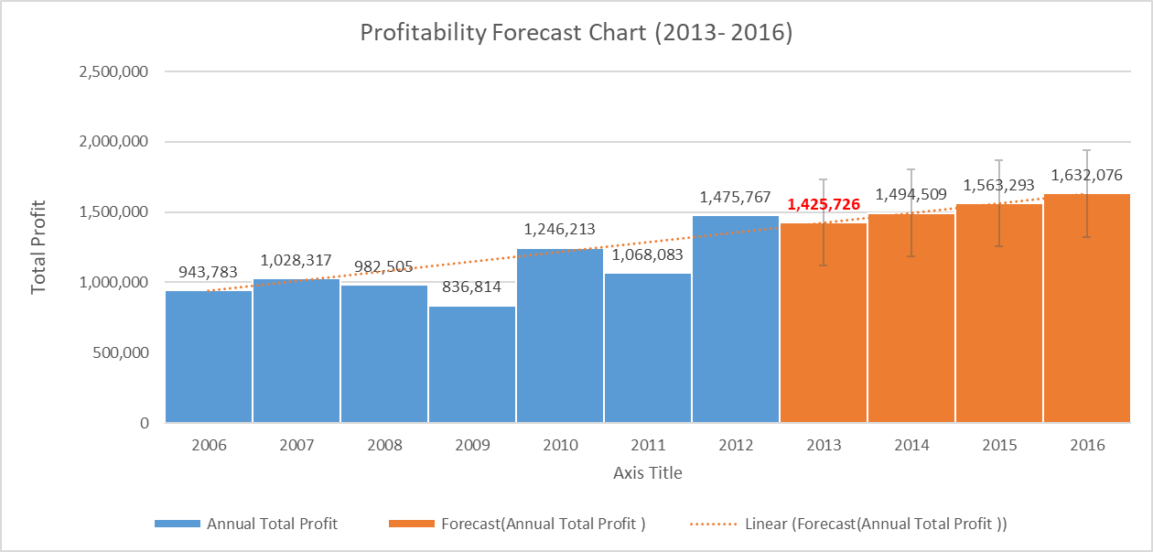
Forecast based on current Sales and Profitability data
The graph below depicts profitability projections for the next four years based on data from the current year. If the predictions are accurate, there may be a decline in profitability in 2013 followed by a sustained increase.
Figure 15: Profitability Forecast for 2013-2016
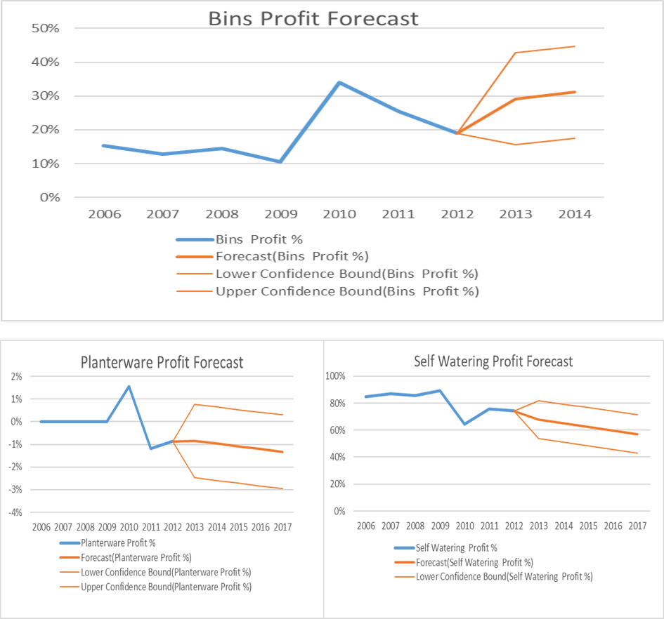
In the estimates of profitability for various product families, an increase in the profitability of the "Bins" group is predicted, while a decrease is predicted for the other two product families. On the basis of these two forecast diagrams, it is suggested that the company set goals to maintain low costs and eliminate products that reduce profitability in order to be prepared for this situation in 2013.
Figure 16:Profit Forecast by Different Product Families
Product | Total Sale | Average Profit Margin (%)
Bins | 11127 | 67%
Planterware | 7699 | 33%
Self Watering | 132354 | 65%

These numbers reveal the company's profit margins and sales volume by product family. Using this data, it is possible to determine which product families the company should prioritise in order to maximise profitability. The Planterware product family, for instance, has the lowest profit margins (33%) and sales volume (also low). In such a situation, the company may reevaluate its cost optimisation and pricing strategies in order to increase the profit margin for this product family. The Self-Watering product family, on the other hand, has both a high sales volume (132,354) and a healthy profit margin (65%). In this situation, the company can considerably increase its overall profitability by concentrating more on this product family and boosting its profit margin. With a sales volume of 11,127 units and an average profit margin of 67%, the Bins product family can be considered a profitable product family. While its profit margin is excellent, its sales volume is modest compared to that of the Self-Watering product family. In this situation, the company may reevaluate its marketing and distribution strategies in order to increase the volume of sales for the Bins product family. By emphasising on this product family and increasing its sales volume, it can significantly contribute to the company's overall profitability, given its high profit margin.
Product Performance Score Analysis

By calculating product performance scores, it will be determined which products are more profitable in this example, and production and sales strategies will be adjusted accordingly. Therefore, the analysis will be useful in the decision-making process and will contribute to the company's future success. This table contains sales information for products categorised by various product families (Self-Watering, Planterware, Bins), colours, and performance characteristics. As a performance metric, the formula (Sales Volume * Profit Margin) / Selling Price was utilised. (Dataset containing PerformanceScore Sheet in Excel format).
Figure 17: Performance Score

In order to interpret the table:

• The "Self-Watering" product family has the highest performance scores and appears to be a sales and profit margin success. Moreover, sales figures for the "Self-Watering" product family are quite high.
• Although the "Bins" product family has received high performance scores in some instances, its sales are lower than those of the "Self-Watering" product family. The "Planterware" product family catches the eye due to its typically low performance scores and sales figures. Negative profit margins are sometimes observed, indicating that the cost of these products is high.
• Considering the colours of the products, "Black" and "Standard Green" coloured products have higher sales figures and performance ratings. Other coloured products' sales are lesser than those of white products.

The company can increase its sales and profit margins by concentrating on the "Self-Watering" product family and the colours "Black" and "Standard Green" more. There should be a review of the "Planterware" product collection and a cost reduction.
Decision Tree Model
In order to analyze the importance levels of the data in the dataset on the "Profit", the "rpart" decision tree model was created and its summary is given below. Primary and proxy splits are provided for each node, and mean and MSE values are provided for each node. Variable importance is also listed.
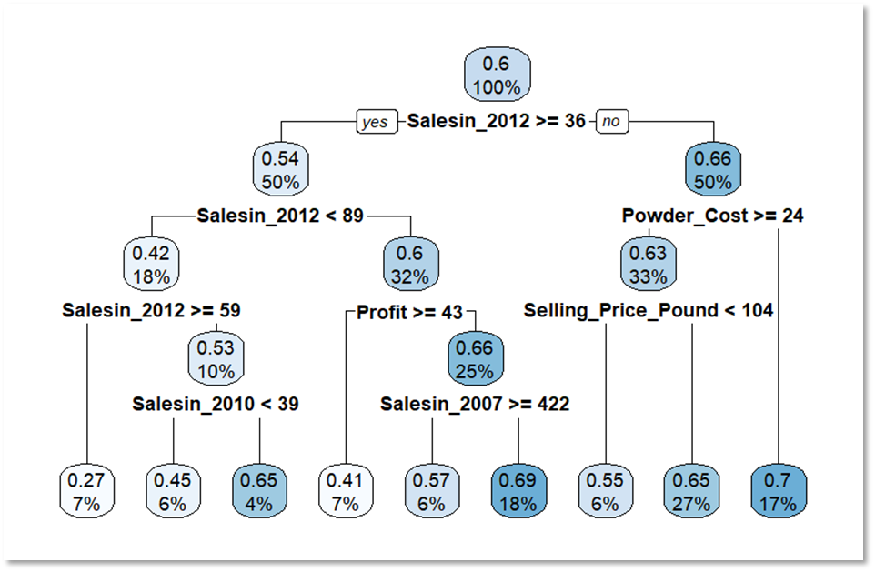
Figure 18:Decision Tree in the context of Profitability

Variable importance:
The decision tree has 8 levels of depth, and its complexity increases with the number of nodes. The model uses several variables to predict the Profit Margin, with Salesin_2012 having the highest importance (20%). The model's performance can be evaluated using the xerror and xstd values at each level of complexity.
Salesin_2012 (20%) | Powder_Cost (4%)
Salesin_2011 (12%) | Powder_weight_kg (4%)
Profit (11%) | Salesin_2007 (3%)
Total Nr of Sales (9%) | Profitin_2007 (2%)
Total_Powder_Weight_kg (8%) | Profitin_2010 (1%)
Selling_Price_Pound (8%) | Profitin_2006 (1%)
Profitin_2012 (8%) | Salesin_2006 (1%)
Salesin_2010 (6%) | Profitin_2011 (1%)

3.Conclusions and Suggestions

This study assesses the efficacy of a company's operations and supply chain management strategies in the plastic planter and container industry. It has been demonstrated that the company's strategies, such as expanding colour variety and implementing the Make-to-Order business model, have the potential to reduce costs and improve efficiency. It has also been stated that modifying inventory levels and order frequency, clustering powder orders, and accelerating production processes can give a company a competitive advantage. This study highlights the fact that the effective implementation of operations and supply chain management in the plastic planter and container industry can increase a company's competitiveness and lead to increased customer satisfaction. Consequently, it is crucial for companies operating in the industry to become more resistant to the challenges of industry competition by continuously evaluating and enhancing their operations and supply chain management strategies.

The study wished to emphasise the product range's colour options in particular. Several recommendations will be made regarding the company's future strategies, taking into consideration the average profit margin and sales volumes according to the colours of the products:
1. Increasing sales of colours with high profit margins We observe that Light Green, Moss Stone, and Standard Green all have high profit margins. The company can increase its marketing and promotional efforts to promote the sale of products in these colours. Additionally, it can maximise sales opportunities by stocking more products in these colours.

2-Improving the efficacy of low margin colours White Marble, Terracotta, and Brown have low margins. The company may attempt to increase its profit margin by reducing the price of products in these colours or by modifying its sales strategy. Alternately, it can concentrate on higher-margin colours by reducing the number of products in these underperforming colours or eliminating them entirely.
3-To increase profitability, it is recommended that the company promote sales in high-margin colours and attempt to enhance performance in low-margin and low-volume colours. This can be achieved through a variety of strategies, including reducing costs, optimising pricing strategies, enhancing marketing and promotional activities, and reevaluating the product line. In addition, the company's ongoing market analysis, which takes customer preferences and colour trends into consideration, will aid in the formulation of its future product strategy. In order to increase profitability and sales performance, the company must promote sales in high-margin colours and improve performance in low-margin and low-volume colours. This can be achieved through a variety of strategies, including reducing costs, optimising pricing strategies, enhancing marketing and promotional activities, and reevaluating the product line.

Appendices
Appendix 1. Decision Tree Model

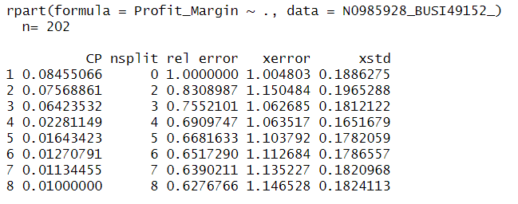

Appendix 2. Profit Values by different Product Families
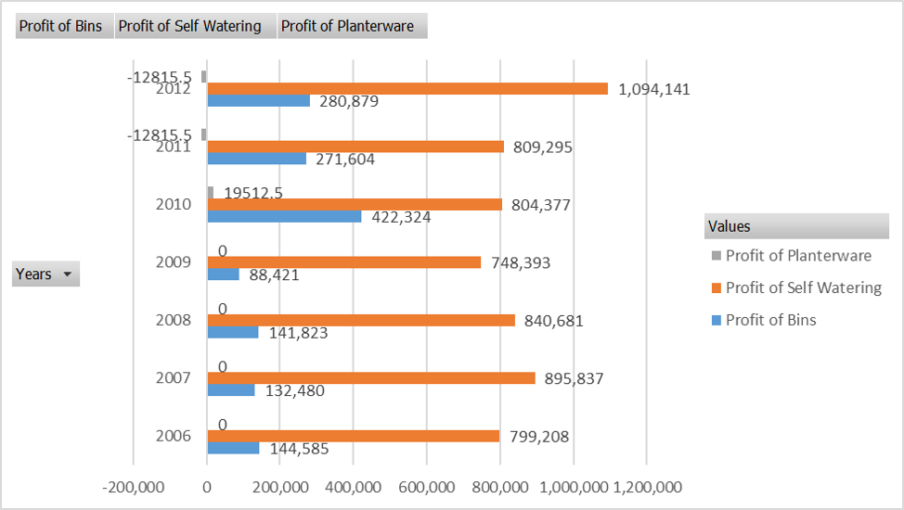

Appendix 3. Demand of Bins and Planters by Month
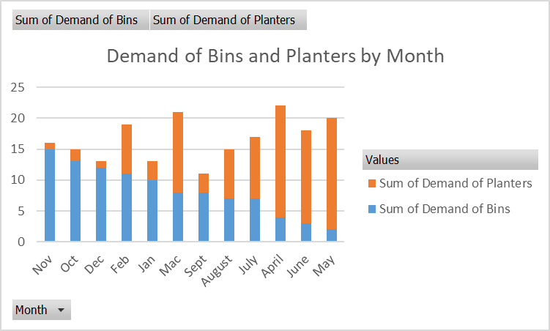

References

Axsäter, S., 2006. Inventory control. Springer Science & Business Media.
Box, G.E.P., Jenkins, G.M., Reinsel, G.C., 2008. Time Series Analysis: Forecasting and Control. Somerset: John Wiley & Sons, Incorporated.
Chen, X., Yang, L. ve Zhang, W., 2016. Color variety management in the plastics industry. Journal of Operations Management, 45(3), ss.121-137.
Hayya, J.C. et al., 2006. Estimation in supply chain inventory management. International journal of production research, 44(7), pp.1313–1330. 10.1080/00207540500338039.
Heizer, J., Render, B., 2001. Principles of operations management 4th ed.. Upper Saddle River, NJ: Prentice Hall.
Hopp, W.J., Spearman, M.L., 2011. Factory physics 3rd ed. Long Grove, Ill: Waveland Press.
Makridakis, S., Wheelwright, S.C., Hyndman, R.J., 1998. Forecasting : methods and applications 3rd ed. / Spyros Makridakis, Steven C. Wheelwright, Rob J. Hyndman. New York ;: Wiley.
Montgomery, D.C., Jennings, C.L., Kulahci, M., 2015. Introduction to time series analysis and forecasting Second edition. Hoboken, New Jersey: Wiley.
Strazicich, M.C., Lee, J., 2002. ITSM 2000 Professional Version 6.0, developed by Peter J. Brockwell and Richard A. Davis, B&D Enterprises, Inc., Copyright 1999. The Student Version is included in Introduction to Time Series and Forecasting, 1996, Springer-Verlag New York Inc. (ISBN: 0387947191). The Professional Version is obtainable from pbrockwell@compuserve.com. Web Page of the author: http://www.stat.colostate.edu/~pjbrock. International journal of forecasting, 18(3), pp.455–460. 10.1016/S0169-2070(01)00138-8.

