Damian Cisneros

CPE301 – SPRING 2018

Design Assignment 1

**DO NOT REMOVE THIS PAGE DURING SUBMISSION:**

The student understands that all required components should be submitted in complete for grading of this assignment.

|  |  |  |  |
| --- | --- | --- | --- |
| **NO** | **SUBMISSION ITEM** | **COMPLETED (Y/N)** | **MARKS**  **(/MAX)** |
| 1 | COMPONENTS LIST AND CONNECTION BLOCK DIAGRAM w/ PINS |  |  |
| 2. | INITIAL CODE OF TASK 1/A |  |  |
| 3. | INCREMENTAL / DIFFERENTIAL CODE OF TASK 2/B |  |  |
| 3. | INCREMENTAL / DIFFERENTIAL CODE OF TASK 3/C |  |  |
| 3. | INCREMENTAL / DIFFERENTIAL CODE OF TASK 4/D |  |  |
| 3. | INCREMENTAL / DIFFERENTIAL CODE OF TASK 5/E |  |  |
| 4. | SCHEMATICS |  |  |
| 5. | SCREENSHOTS OF EACH TASK OUTPUT |  |  |
| 5. | SCREENSHOT OF EACH DEMO |  |  |
| 6. | VIDEO LINKS OF EACH DEMO |  |  |
| 7. | GOOGLECODE LINK OF THE DA |  |  |
|  |  |  |  |
|  |  |  |  |

1. **DESCRIPTION/FLOW CHART**

This program uses all 3 pointers X, Y, and Z to complete all three task within 1 loop.

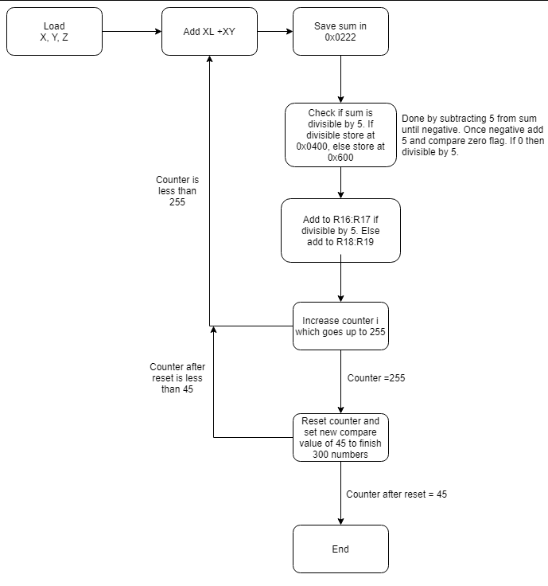

1. **SCREENSHOTS OF EACH TASK OUTPUT (ATMEL STUDIO OUTPUT)**

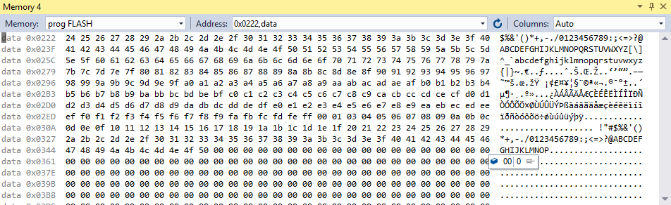

Task 1. Stored summations at memory 0x0222 after running. 300 numbers total.

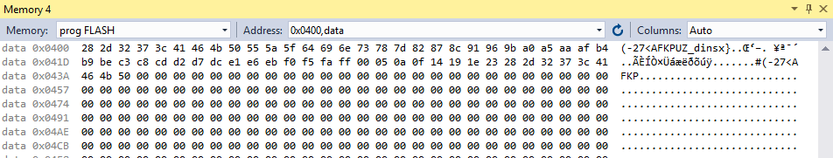

Task 2. Stored numbers that are divisible by 5 at location 0x0400.

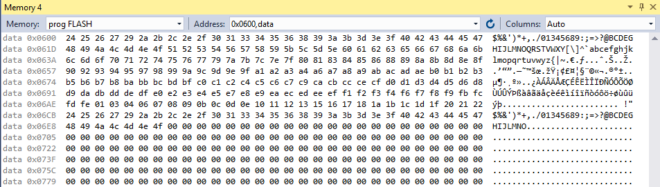

Task 2. Stored numbers that are not divisible by 5 at location 0x600.

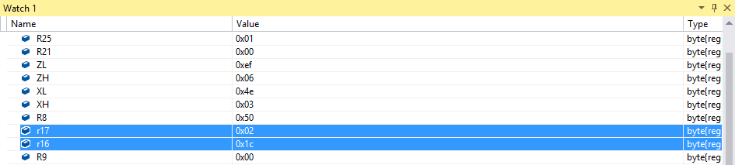

Task 3. Summation for all the numbers that were divisible by 5 is 0x1c02 as show above in registers

r16:r17.

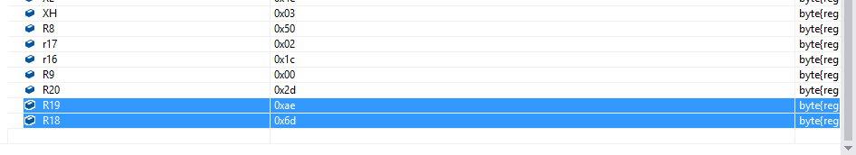

Task 3. Summation for all the numbers that were divisible by 5 is 0x6dae as show above in registers

r18:r19.

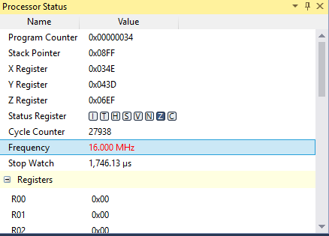

Task 4. The total execution time at a frequency of 16MHz is 1.746.13µs.

1. **GITHUB LINK OF THIS DA**

**Student Academic Misconduct Policy**

<http://studentconduct.unlv.edu/misconduct/policy.html>

“This assignment submission is my own, original work”.

NAME OF THE STUDENT