**Date Submitted: 11-15-2018**

**Task 00: Execute provided code (No submission required)**

**------------------------------------------------------------------------------------**

**Task 01: Task that toggles LED**

Youtube Link: <https://youtu.be/4LguQUOtmRc>

**Modified Code:**

//task01: task that toggles LED

/* TI-RTOS Header files */

#include <xdc/std.h>

#include <ti/sysbios/BIOS.h>

#include <ti/sysbios/knl/Task.h>

#include <ti/drivers/GPIO.h>

/* Example/Board Header files */

#include "Board.h"

void myDelay**(**int count**);**

/* Could be anything, like computing primes */

#define FakeBlockingSlowWork() myDelay(12000000)

#define FakeBlockingFastWork() myDelay(2000000)

Task_Struct workTask**;**

/* Make sure we have nice 8-byte alignment on the stack to avoid wasting memory */

#pragma DATA_ALIGN(workTaskStack, 8)

#define STACKSIZE 1024

static uint8_t workTaskStack**[**STACKSIZE**];**

void doUrgentWork**(**void**)**

**{**

GPIO_write**(**Board_GPIO_LED1**,** Board_GPIO_LED_OFF**);**

FakeBlockingFastWork**();** /* Pretend to do something useful but time-consuming */

GPIO_write**(**Board_GPIO_LED1**,** Board_GPIO_LED_ON**);**

**}**

void doWork**(**void**)**

**{**

GPIO_write**(**Board_GPIO_LED0**,** Board_GPIO_LED_OFF**);**

FakeBlockingSlowWork**();** /* Pretend to do something useful but time-consuming */

GPIO_write**(**Board_GPIO_LED0**,** Board_GPIO_LED_ON**);**

**}**

Void workTaskFunc**(**UArg arg0**,** UArg arg1**)**

**{**

**while** **(**1**)** **{**

/* Do work */

doWork**();**

/* Wait a while, because doWork should be a periodic thing, not continuous.*/

myDelay**(**24000000**);**

**}**

**}**

/*

* ======== main ========

*

*/

int main**(**void**)**

**{**

Board_initGeneral**();**

GPIO_init**();**

/* Set up the led task */

Task_Params workTaskParams**;**

Task_Params_init**(&**workTaskParams**);**

workTaskParams.stackSize = STACKSIZE;

workTaskParams.priority = 2;

workTaskParams.stack = &workTaskStack;

Task_construct(&workTask, workTaskFunc, &workTaskParams, NULL);

/* Start kernel. */

BIOS_start();

return (0);

}

/*

* ======== myDelay ========

* Assembly function to delay. Decrements the count until it is zero

* The exact duration depends on the processor speed.

*/

__asm(" .sect \".text:myDelay\"\n"

" .clink\n"

" .thumbfunc myDelay\n"

" .thumb\n"

" .global myDelay\n"

"myDelay:\n"

" subs r0, #1\n"

" bne.n myDelay\n"

" bx lr\n");

**------------------------------------------------------------------------------------**

**Task 02: Use Runtime Object View to show stack peak, heap space, and stack information that the program uses to run its tasks. Use execution graph to get a graphical representation of tasks running with respect to system time.**

Youtube Link: <https://youtu.be/4zCnpAgvwaM>

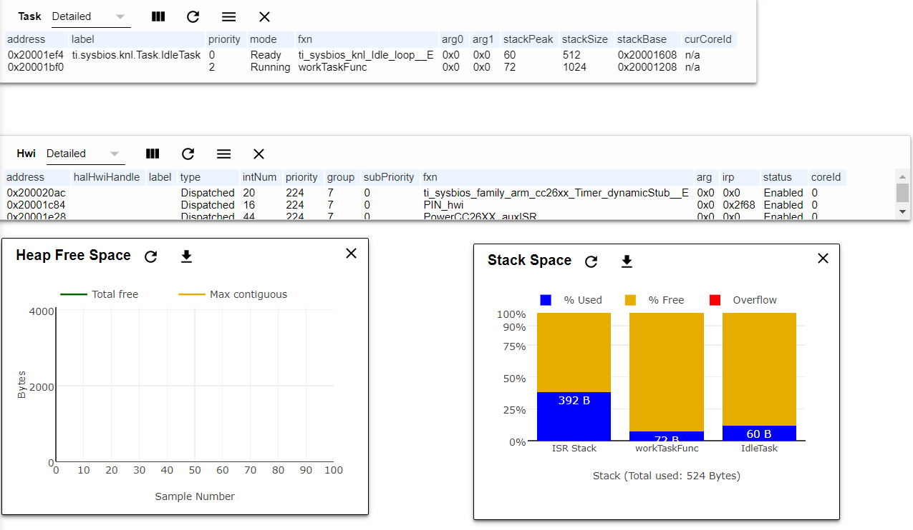

Runtime Object view stats.

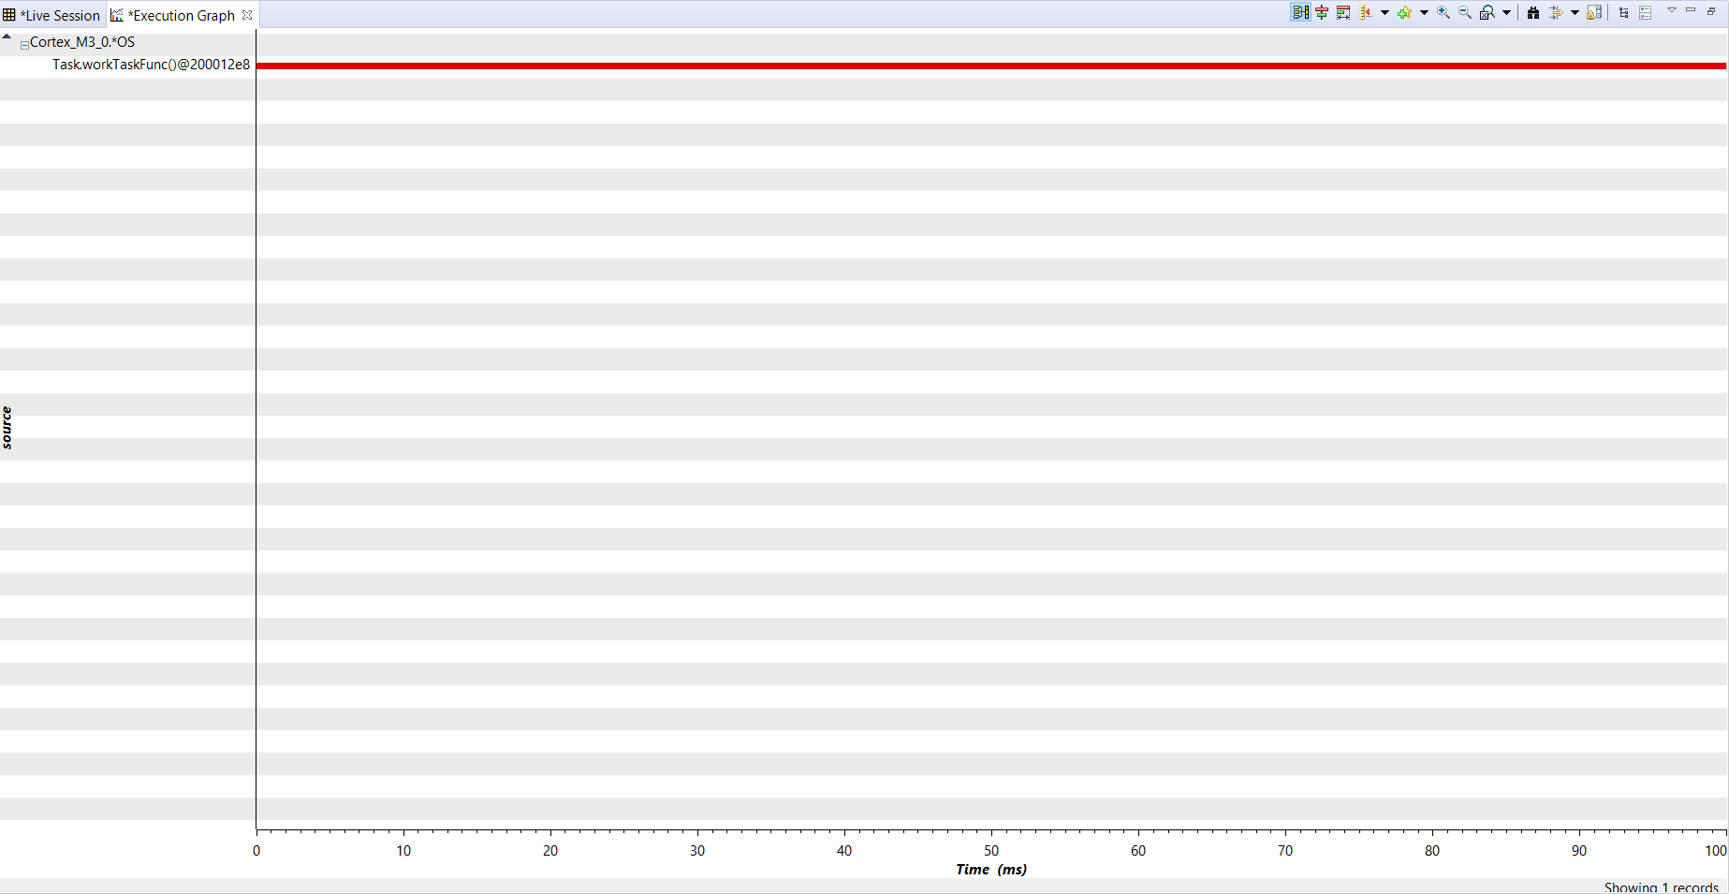

Execution Analysis graph.

**Modified Code:**

hello.cfg

.

.

.

*

* When using BIOS in ROM:

* This option must be set to false.

*/

BIOS.logsEnabled = true;

//BIOS.logsEnabled = false;

/* ================ ROM configuration ================ */

/*

* To use BIOS in flash, comment out the code block below.

*/

/*var ROM = xdc.useModule('ti.sysbios.rom.ROM');

if (Program.cpu.deviceName.match(/CC2640R2F/)) {

ROM.romName = ROM.CC2640R2F;

}

else if (Program.cpu.deviceName.match(/CC26.2/)) {

ROM.romName = ROM.CC26X2;

}

else if (Program.cpu.deviceName.match(/CC13.2/)) {

ROM.romName = ROM.CC13X2;

}

else if (Program.cpu.deviceName.match(/CC26/)) {

ROM.romName = ROM.CC2650;

}

else if (Program.cpu.deviceName.match(/CC13/)) {

ROM.romName = ROM.CC1350;

}

*/

.

.

.

**------------------------------------------------------------------------------------**

**Task 03: Replace the use of myDelay to sleep with Task_sleep and use it to sleep for 500ms. Show Execution Analysis Graph.**

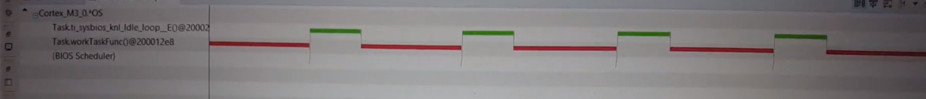

Youtube Link: <https://youtu.be/3VF_l1MzWz0>

**Modified Code:**

Task02.c

/* TI-RTOS Header files */

#include <xdc/std.h>

#include <ti/sysbios/BIOS.h>

#include <ti/sysbios/knl/Task.h>

#include <ti/drivers/GPIO.h>

#include <ti/sysbios/knl/Clock.h>

/* Example/Board Header files */

#include "Board.h"

void myDelay**(**int count**);**

/* Could be anything, like computing primes */

#define FakeBlockingSlowWork() myDelay(12000000)

#define FakeBlockingFastWork() myDelay(2000000)

Task_Struct workTask**;**

/* Make sure we have nice 8-byte alignment on the stack to avoid wasting memory */

#pragma DATA_ALIGN(workTaskStack, 8)

#define STACKSIZE 1024

static uint8_t workTaskStack**[**STACKSIZE**];**

void doUrgentWork**(**void**)**

**{**

GPIO_write**(**Board_GPIO_LED1**,** Board_GPIO_LED_OFF**);**

FakeBlockingFastWork**();** /* Pretend to do something useful but time-consuming */

GPIO_write**(**Board_GPIO_LED1**,** Board_GPIO_LED_ON**);**

**}**

void doWork**(**void**)**

**{**

GPIO_write**(**Board_GPIO_LED0**,** Board_GPIO_LED_OFF**);**

FakeBlockingSlowWork**();** /* Pretend to do something useful but time-consuming */

GPIO_write**(**Board_GPIO_LED0**,** Board_GPIO_LED_ON**);**

**}**

Void workTaskFunc**(**UArg arg0**,** UArg arg1**)**

**{**

**while** **(**1**)** **{**

/* Do work */

doWork**();**

/* Wait a while, because doWork should be a periodic thing, not continuous.*/

Task_sleep**(**500 **\*** **(**1000 **/** Clock_tickPeriod**));** //delay 500ms

**}**

**}**

/*

* ======== main ========

*

*/

int main**(**void**)**

**{**

Board_initGeneral**();**

GPIO_init**();**

/* Set up the led task */

Task_Params workTaskParams;

Task_Params_init(&workTaskParams);

workTaskParams.stackSize = STACKSIZE;

workTaskParams.priority = 2;

workTaskParams.stack = &workTaskStack;

Task_construct(&workTask, workTaskFunc, &workTaskParams, NULL);

/* Start kernel. */

BIOS_start();

return (0);

}

/*

* ======== myDelay ========

* Assembly function to delay. Decrements the count until it is zero

* The exact duration depends on the processor speed.

*/

__asm(" .sect \".text:myDelay\"\n"

" .clink\n"

" .thumbfunc myDelay\n"

" .thumb\n"

" .global myDelay\n"

"myDelay:\n"

" subs r0, #1\n"

" bne.n myDelay\n"

" bx lr\n");

**------------------------------------------------------------------------------------**

**Task 04: Set up a new task called urgent work which has higher priority than previous task called work task. Show the Execution Analysis Graph**

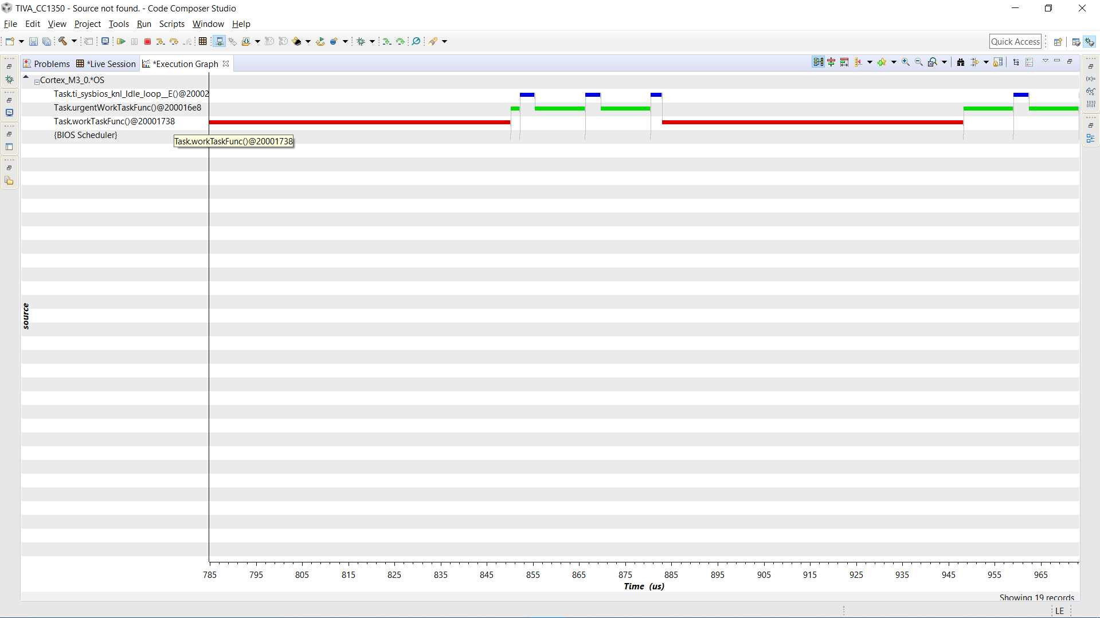

Execution Analysis Graph showing that UrgentTask interrupts lower priority workTask.

Youtube Link: <https://youtu.be/6dLklaQxVqo>

**Modified Code:**

Task04.c

/* TI-RTOS Header files */

#include <xdc/std.h>

#include <ti/sysbios/BIOS.h>

#include <ti/sysbios/knl/Task.h>

#include <ti/sysbios/knl/Clock.h>

#include <ti/drivers/GPIO.h>

/* Example/Board Header files */

#include "Board.h"

void myDelay**(**int count**);**

/* Could be anything, like computing primes */

#define FakeBlockingSlowWork() myDelay(12000000)

#define FakeBlockingFastWork() myDelay(2000000)

Task_Struct workTask**;**

Task_Struct urgentWorkTask**;**

/* Make sure we have nice 8-byte alignment on the stack to avoid wasting memory */

#pragma DATA_ALIGN(workTaskStack, 8)

#define STACKSIZE 1024

static uint8_t workTaskStack**[**STACKSIZE**];**

static uint8_t urgentWorkTaskStack**[**STACKSIZE**];**

void doUrgentWork**(**void**)**

**{**

GPIO_write**(**Board_GPIO_LED1**,** Board_GPIO_LED_OFF**);**

FakeBlockingFastWork**();** /* Pretend to do something useful but time-consuming */

GPIO_write**(**Board_GPIO_LED1**,** Board_GPIO_LED_ON**);**

**}**

void doWork**(**void**)**

**{**

GPIO_write**(**Board_GPIO_LED0**,** Board_GPIO_LED_OFF**);**

FakeBlockingSlowWork**();** /* Pretend to do something useful but time-consuming */

GPIO_write**(**Board_GPIO_LED0**,** Board_GPIO_LED_ON**);**

**}**

Void workTaskFunc**(**UArg arg0**,** UArg arg1**)**

**{**

**while** **(**1**)** **{**

/* Do work */

doWork**();**

/* Wait a while, because doWork should be a periodic thing, not continuous.*/

//myDelay(24000000);

Task_sleep(500 * (1000 / Clock_tickPeriod));

}

}

Void urgentWorkTaskFunc(UArg arg0, UArg arg1)

{

while (1) {

/* Do work */

doUrgentWork();

/* Wait a while, because doWork should be a periodic thing, not continuous.*/

//myDelay(24000000);

Task_sleep(50 * (1000 / Clock_tickPeriod));

}

}

/*

* ======== main ========

*

*/

int main(void)

{

Board_initGeneral();

GPIO_init();

/* Set up the led task */

Task_Params workTaskParams;

Task_Params_init(&workTaskParams);

workTaskParams.stackSize = STACKSIZE;

workTaskParams.priority = 2;

workTaskParams.stack = &workTaskStack;

Task_construct(&workTask, workTaskFunc, &workTaskParams, NULL);

workTaskParams.priority = 1;

workTaskParams.stack = &urgentWorkTaskStack;

Task_construct(&urgentWorkTask, urgentWorkTaskFunc, &workTaskParams, NULL);

/* Start kernel. */

BIOS_start();

return (0);

}

/*

* ======== myDelay ========

* Assembly function to delay. Decrements the count until it is zero

* The exact duration depends on the processor speed.

*/

__asm(" .sect \".text:myDelay\"\n"

" .clink\n"

" .thumbfunc myDelay\n"

" .thumb\n"

" .global myDelay\n"

"myDelay:\n"

" subs r0, #1\n"

" bne.n myDelay\n"

" bx lr\n");