**Date Submitted: 11-25-2018**

**Unable to complete first Task01-Task04 with the flashing and using BLE due to Android app not having functions from iOS app as shown in the PDF instructions. Android support does not seem active and we do not have an iPhone.**

**Task 01: Update CC1350 LaunchPad firmware**

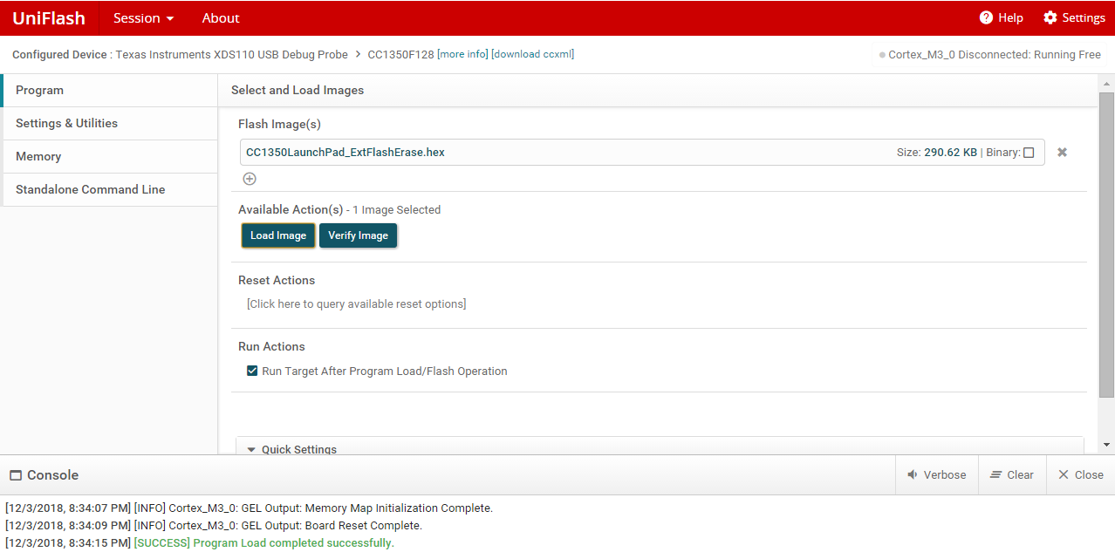

Successfully loading cc1350launchpad_extflasherase.hex

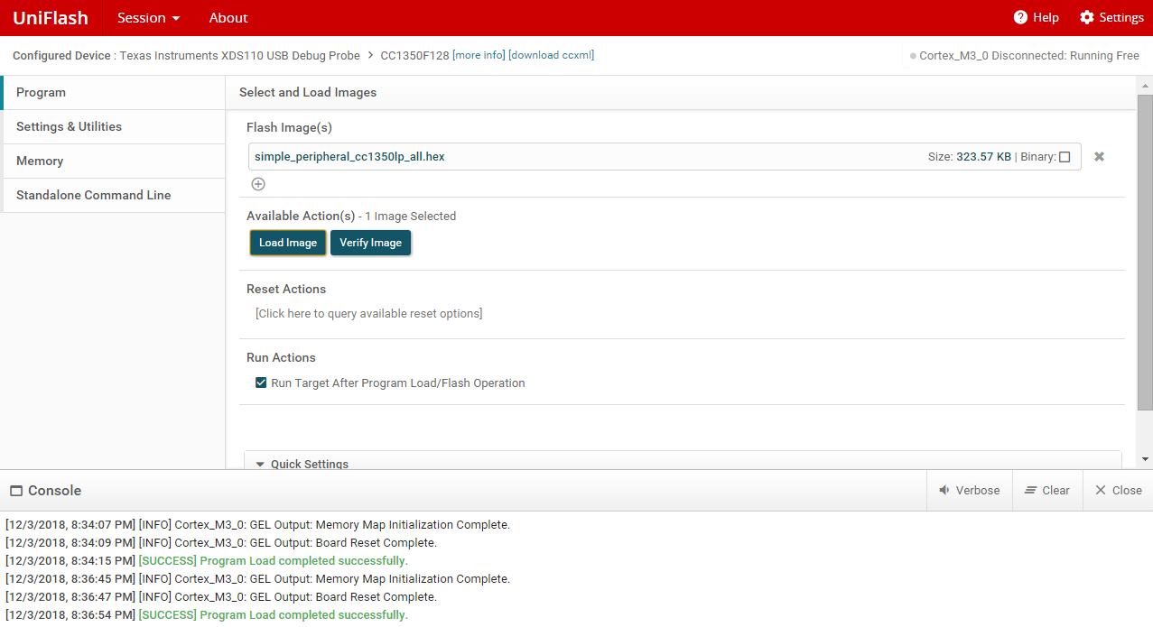

Successfully loading simple_peripheral_cc1350lp_all.hex

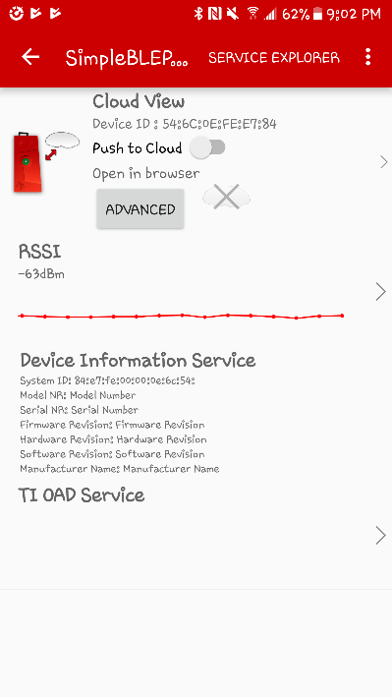

Able to connect to it but no capability of sending firmware like shown on iOS app.

Youtube Link: No video required.

**Modified Code:** No coding requried

**------------------------------------------------------------------------------------**

**------------------------------------------------------------------------------------**

**WSN Concentrator and WSN Node Part**

**Task 01: Importing the WSN Examples**

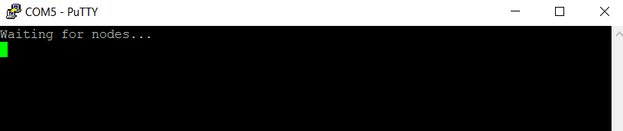

WSN Concentrator waiting for nodes. Node is not connected at this point.

Youtube Link: No video required for this par.

**Modified Code:** Same imported WSN Concentrator/Node project

**------------------------------------------------------------------------------------**

**Task 02: Putting it all to work**

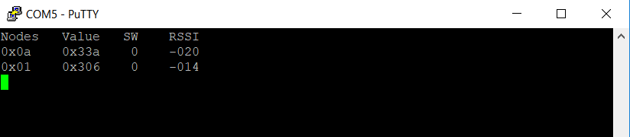

Concentrator receiving values.

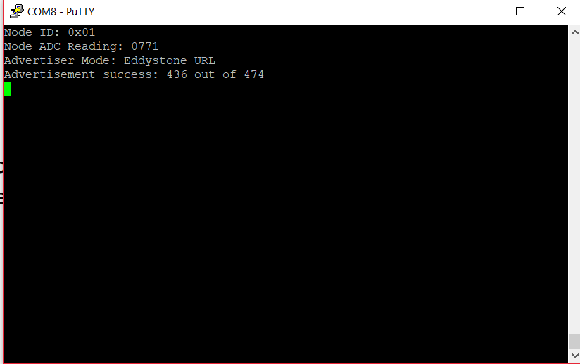

Node sending values.

Youtube Link: <https://youtu.be/IeDKvveIXQQ>

**Modified Code:** No code was modified from initial project import.

**Task 03: Change RF Channel**

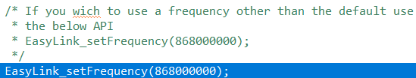

Modified frequency in ConcentratorRadioTask.c (highlighted). Operation is the same as Task02.

**Modified Code:** Highlighted portion above was modified in ConcentratorRadioTask.c

**Task 04: Switch from 2-GFSK 50 kbps to Long Range Mode (LRM)**



Switched to long range mode on Radioprotocol.h (highlighted in blue)

**Modified Code:** Highlighted portion above was modified in Radioprotocol.h

**Task 06: Modify Code Running on the Sensor Controller**

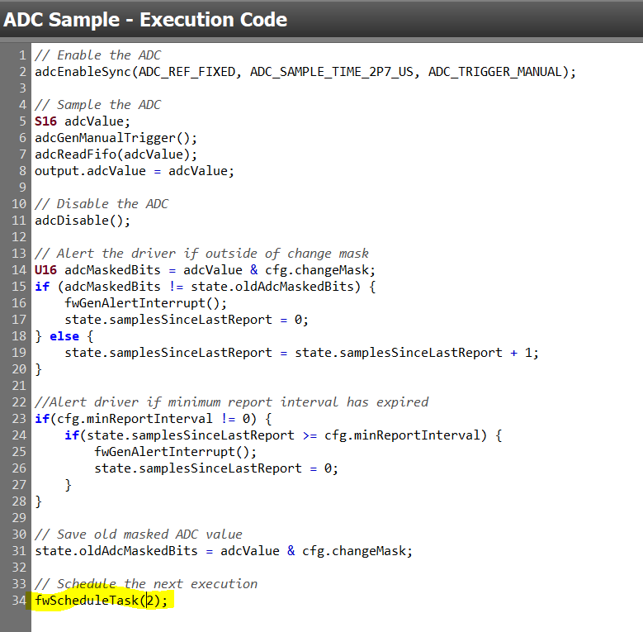

ADC Sample modified to read every 2s instead of 1s.