Supplementary Material S1

The three outliers of our dataset come from two different studies. The first one is a newborn study that used an unusual method, namely measuring the frequency of headturns, either to the left side or to the right side, in response to sound playback (Ecklund-Flores, 1996). They report the percentage of headturns to each side for each stimulus condition as the dependent variable. Because the authors only report the percentage of headturns to each side, it was not possible for us to obtain the total frequency of headturns, regardless of the side, and we coded the percentage of headturns to each side separately, as two different measurments. Because infants could preferably turn either to the left or to the right from one experimental session to the other, this can lead to very large differences when the two sides are analysed separately, even if the total percentage of headturns would not be so large (e.g. in cases where a majority of headturns goes to the left in one condition, and to the right in the other condition, leading to a small percentage of headturns to the right in the first condition, and a large percentage of headturns to the same side in the other condition, resulting in turn to an overly large difference between conditions). The second study has a more typical design, using a central fixation paradigm similar to other studies, in infants from 6 to 12 month-old (Segal & Kishon-Rabin, 2011). However, this study reports results from very small sample sizes for each age group (n=5), which is more likely to have inordinately large effect sizes.

Supplementary Material S2

Supplementary Figure S3

Supplementary Results S4

RVE: Correlated Effects Model with Small-Sample Corrections

**Model: g_calc ~ mean_age**

Number of studies = 38

Number of outcomes = 52 (min = 1 , mean = 1.37 , median = 1 , max = 3 )

Rho = 0.8

I.sq = 76.22232

Tau.sq = 0.1408137

Estimate StdErr t-value dfs P(|t|>) 95% CI.L 95% CI.U Sig

Intercept 0.270875 0.10664 2.54 17.2 0.021 0.046135 0.49562 **

mean_age_1 0.000849 0.00069 1.23 15.2 0.238 -0.000621 0.00232

------

Signif. codes: < .01 *** < .05 ** < .10 *

---

Note: If df < 4, do not trust the results

Supplementary Figure S5

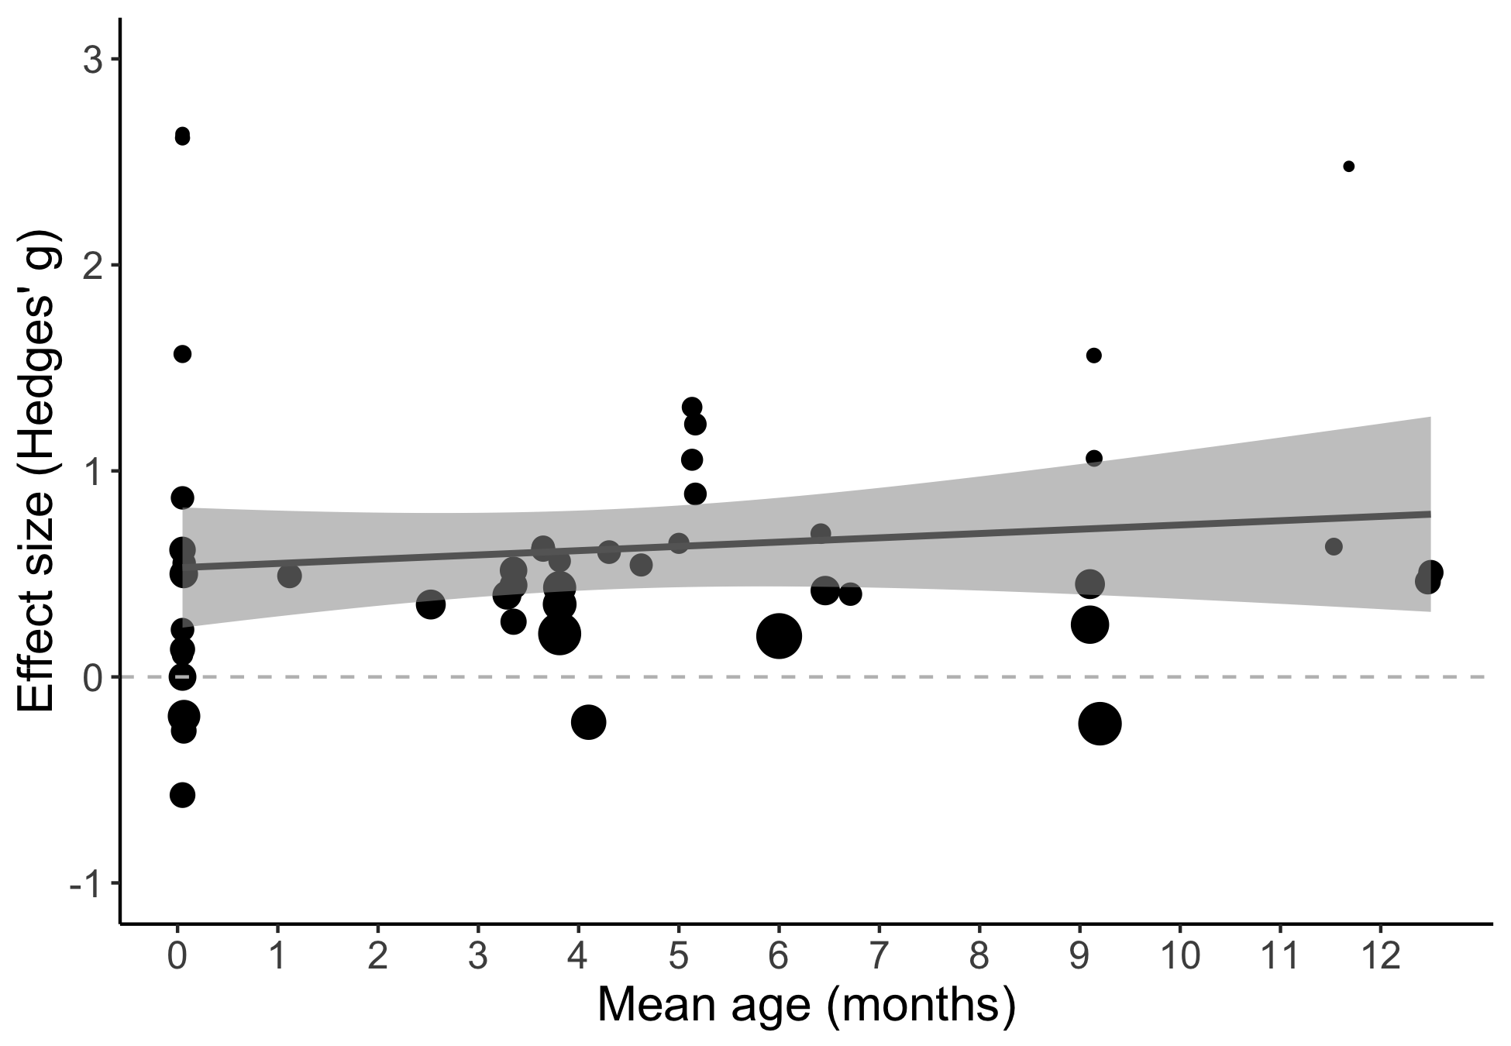

Supplementary Results S6

Number of studies = 38

Number of outcomes = 52 (min = 1 , mean = 1.37 , median = 1 , max = 3 )

Rho = 0.8

I.sq = 74.69059

Tau.sq = 0.1362283

Estimate StdErr t-value dfs P(|t|>) 95% CI.L 95% CI.U Sig

Intercept. 0.427956 0.12649 3.383 7.62 0.0103 0.13375 0.72216 **

Prosody IDS -0.246023 0.20194 -1.218 14.71 0.2423 -0.67719 0.18514

mean_age_1 0.000176 0.00046 0.384 4.65 0.7179 -0.00103 0.00138

prosody IDS*mean_age_1 0.001000 0.00137 0.729 10.95 0.4813 -0.00202 0.00402

---

Signif. codes: < .01 *** < .05 ** < .10 *

---

Note: If df < 4, do not trust the results

Supplementary Figure S7

