Flex Box Froggy – Level 24 Solution/Analysis:

## Solution:

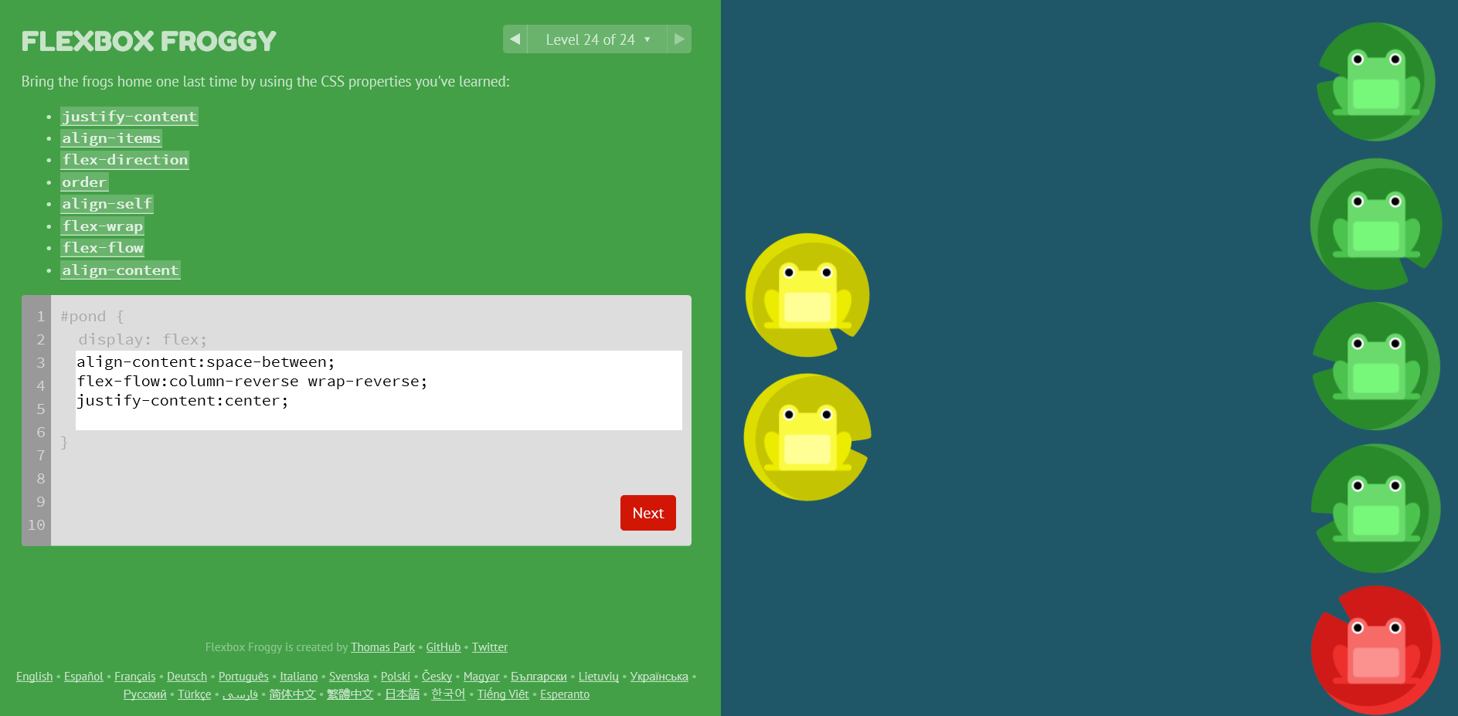

*#pond{*

*display:flex;*

*align-content:space-between;*

*flex-flow:column-reverse wrap-reverse;*

*justify-content:center;*

*}*

## Analysis:

At the beginning of level 24, all seven frogs are together on the same line in the top row. Given our final solution requires columns, it is safe to assume we need to modify the flex-flow property to include a column property. Moving from left to right, we want to have the yellow frogs first as they will be up against the left-hand side of our screen, so *column-reverse* is the correct property here. At this point we still have all the frogs in the same column, so a wrap property is needed. Using *wrap-reverse* we can ensure that the two yellow frogs stay on the left-hand side, while the other five frogs wrap to the center-right column. To correctly space each column of frogs on the left and right-hand sides of the screen we need to use the align-content property. Given there are only two columns here, *space-between* will allow us to bump each row to their respective sides of the screen. The last issue to resolve is that the yellow frogs on the left-hand side are towards the bottom. To center them all we need to do is specify the justify-content property to *center*. This will move the yellow frogs to the vertical center of the left-hand column and the right-hand column will stay the same, given the content is automatically centered because it has the maximum number of items there already. Very cool game!