**How to Install Course-equivalent Web Application**

**You probably need to be the root user to install all these. Make sure you log in as the root user.**

**For someone who has not installed LAMP:**

If you have not installed LAMP, please follow the following steps. My Linux is Ubuntu 14.04, which is the current newest version of Ubuntu. If you use Ubuntu, make sure you are up-to-date before you start.

LAMP is an abbreviation for Linux, Apache, MySQL, PHP, which is an essential bundle for website development environment.

Step1: install apache

Apache is currently the most popular web server in the world. You will need to use that to host your website.

Here are the commands:

sudo apt-get update // to update everything before we install

sudo apt-get upgrade // upgrade before we install

sudo apt-get install tasksel // install a helper

sudo tasksel //run the helper

Now we will find a window with a bunch of options. Press “up” and “down” on the keyboard to move to a different option. Press space bar to select or unselect an option. We need to choose:

[*] Basic Ubuntu server

[*] OpenSSH server

[*] LAMP server

[*] Print server

Here is a screen shot of how that would look like: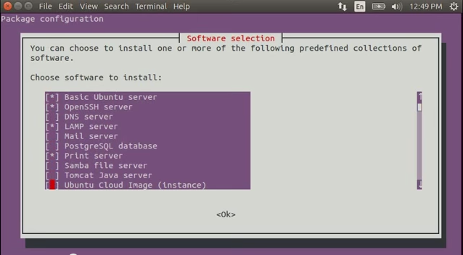

Now press ‘Tab” to go to <ok> button and press the space bar or enter to continue.

You will be asked to put a password for the MySQL “root” user: pass123

Repeat the password. This is a single sign on password.

Wait till it is done processing. Now we move back to the terminal.

Type:

sudo apt-get install phpmyadmin //this is good for managing mysql databases.

Now you will be asked to configure phpmyadmin, choose:

[*] apache2

Here is a screen shot of how it would look like:

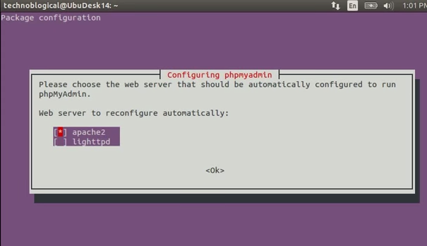

press ‘Tab” to go to <ok> button and press the space bar or enter to continue.

Now you will be directed to this page:

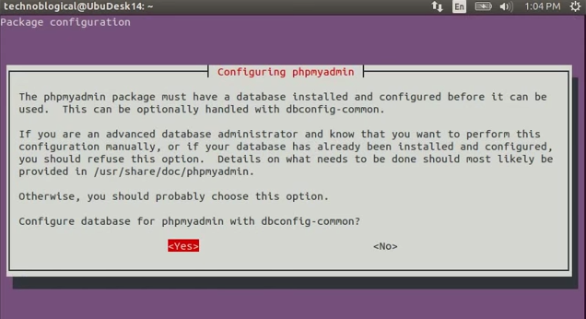

Click on yes and it will bring you to the next page:

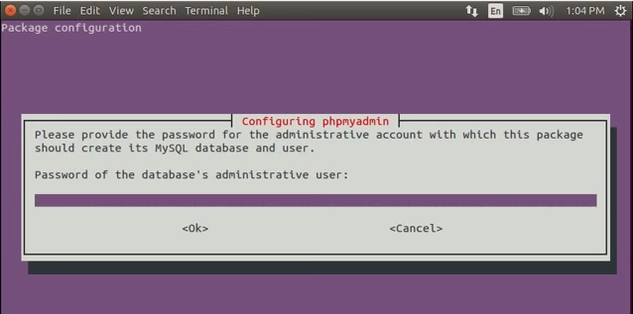

Put in: pass123

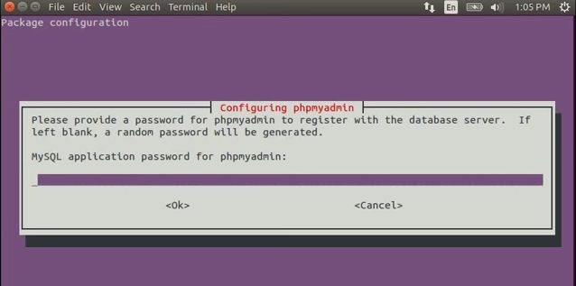

Put in: password and then repeat when it asks you to.

Wait for the terminal to finish processing. Now go to Chrome/firefox and type: localhost in the ip address bar: and if you see something like the following snap shot, you are good!

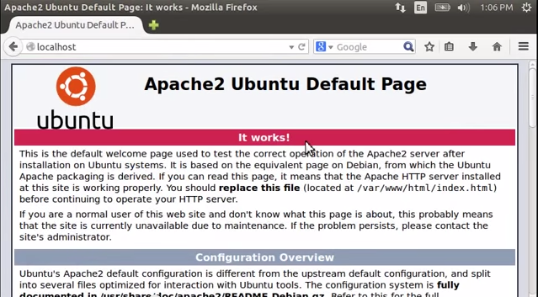

Now put: localhost/phpmyadmin/ in the search bar instead. You will be asked to log into the database file. To test if it works, input the following information:

Username: root

Password: pass123

If you successfully logged in, then you have set up your database password correctly.

Now in terminal, type:

cd //go back to the home directory

cd /var/www/html //this should be where the website files are installed

cd .. //go one directory up

sudo chown –R (your name in front of @):www-data /var/www/html //change the ownership. Here is a snap shot on how you would write this command:

C:\Users\mhcuser\Desktop\chmown.PNG

sudo chmod 777 /var/www/html //give the directory full permission(not a great idea but do that first to make sure everything is functioning well)

sudo chmod g+s /var/www/html //group everything in here with www-data tag

Now we are going to install PHP

sudo apt-get install php5 libapache2-mod-php5 php5-mcrypt //install php as well as some helper file

sudo nano /etc/apache2/mods-enabled/dir.conf //change the preference to php

It will look like this:

<IfModule mod_dir.c>

DirectoryIndex index.html index.cgi index.pl index.php index.xhtml index.htm

</IfModule>

We want to move the PHP index file highlighted above to the first position after the DirectoryIndex specification, like this:

<IfModule mod_dir.c>

DirectoryIndex index.php index.html index.cgi index.pl index.xhtml index.htm

</IfModule>

When you are finished, save and close the file by pressing "CTRL-X". You'll have to confirm the save by typing "Y" and then hit "ENTER" to confirm the file save location.

Now type:

sudo service apache2 restart // restart the Apache web server in order for our changes to be recognized.

You should be all set for LAMP installation!

**Install course-equivalent web application**

*Make sure LAMP is not installed on the computer. To check that, go to your terminal and type:*

sudo find / -type d -name "phpmyadmin" –print

*And it will ask you to type your password as a root user. If you get a message that says: etc/phpmyadmin or something similar, you have installed LAMP. Please refer to the next step.*

Download the web application from github:

https://github.com/cisxing/Course-equivalent-Web-App

Unzip the file. Put the folder on your desktop. Now type:

cd //go to the home directory

cd Desktop

cp –rf (thefoldername) /var/www/html //copy the file into the html directory recursively

cd //go to home directory

cd /var/www/html/ //go to the website holder

cd Course-equivalent-web-app(folder name) //go to the folder

mkdir pdf_files //make a new directory to save pdfs

chmod 777 pdf_files //give all permission to the directory

Now, go to Chrome and then open localhost/folderName. If you moved the directory correctly you will see a list of php files (the ones in the folder).

Click on initDatabase.php.

Now your database is set up!

Go to global_vars.php and make sure to change $folder_path to the correct path to save the pdfs (in our case “pdf_files/”)

You can start adding courses and search courses☺