**StockMaster User Manual**

**Setting up StockMaster**

1. Create a local Java project called StockMaster on Eclipse.

2. Clone from GitHub using the URL: <https://github.com/calchen01/StockMaster>

3. Move the contents of the folder StockMaster that you just cloned into the folder StockMaster (another one) for the local Java project. Replace all existing contents.

4. “Refresh” the Eclipse project.

5. Right click on the StockMaster project, under “Configure”, select “Convert to Maven Project”.

6. In the lib folder, there’re two .jar files. Right click on one of them, under “Build Path”, select “Add to Build Path”. Repeat for the other .jar file.

7. Right click on the project, under “Build Path”, select “Configure Build Path”. Click “Add Library”, select “JUnit” and then “JUnit 5”. Click “Apply and Close”.

8. “Refresh” the project and this should finish the setup.

**Using StockMaster**

Our app is very intuitive to use. Simply type in the ticker symbol of the company you want to look up and click “Search” and you will see a screen like this:

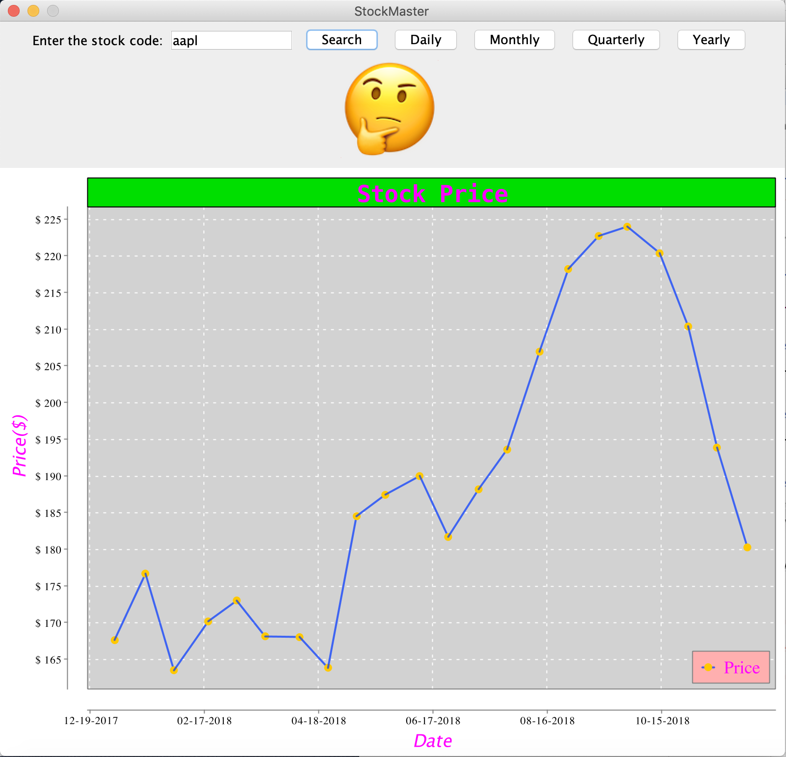

The emoji represents the sentiment of the 50 most recent news surrounding that company. It is on a 1-5 scale as defined below:

Scale 1Terrific news with a sentiment value > 0.67

Scale 2Good news with a sentiment value > 0.33 but <= 0.67

Scale 3Neutral news with a sentiment value > -0.33 and <= 0.33

Scale 4Bad news with a sentiment value <= -0.33 but > -0.67

Scale 5Terrible news with a sentiment value <= -0.67

*Note: overall range of sentiment value is between 1 and -1.

The user will also get a ytd chart of that company’s stock prices and has the option to select a different time range, specifically, the daily, monthly, or quarterly chart. For example, by clicking “Daily”, you will see the daily chart displayed for the same company.

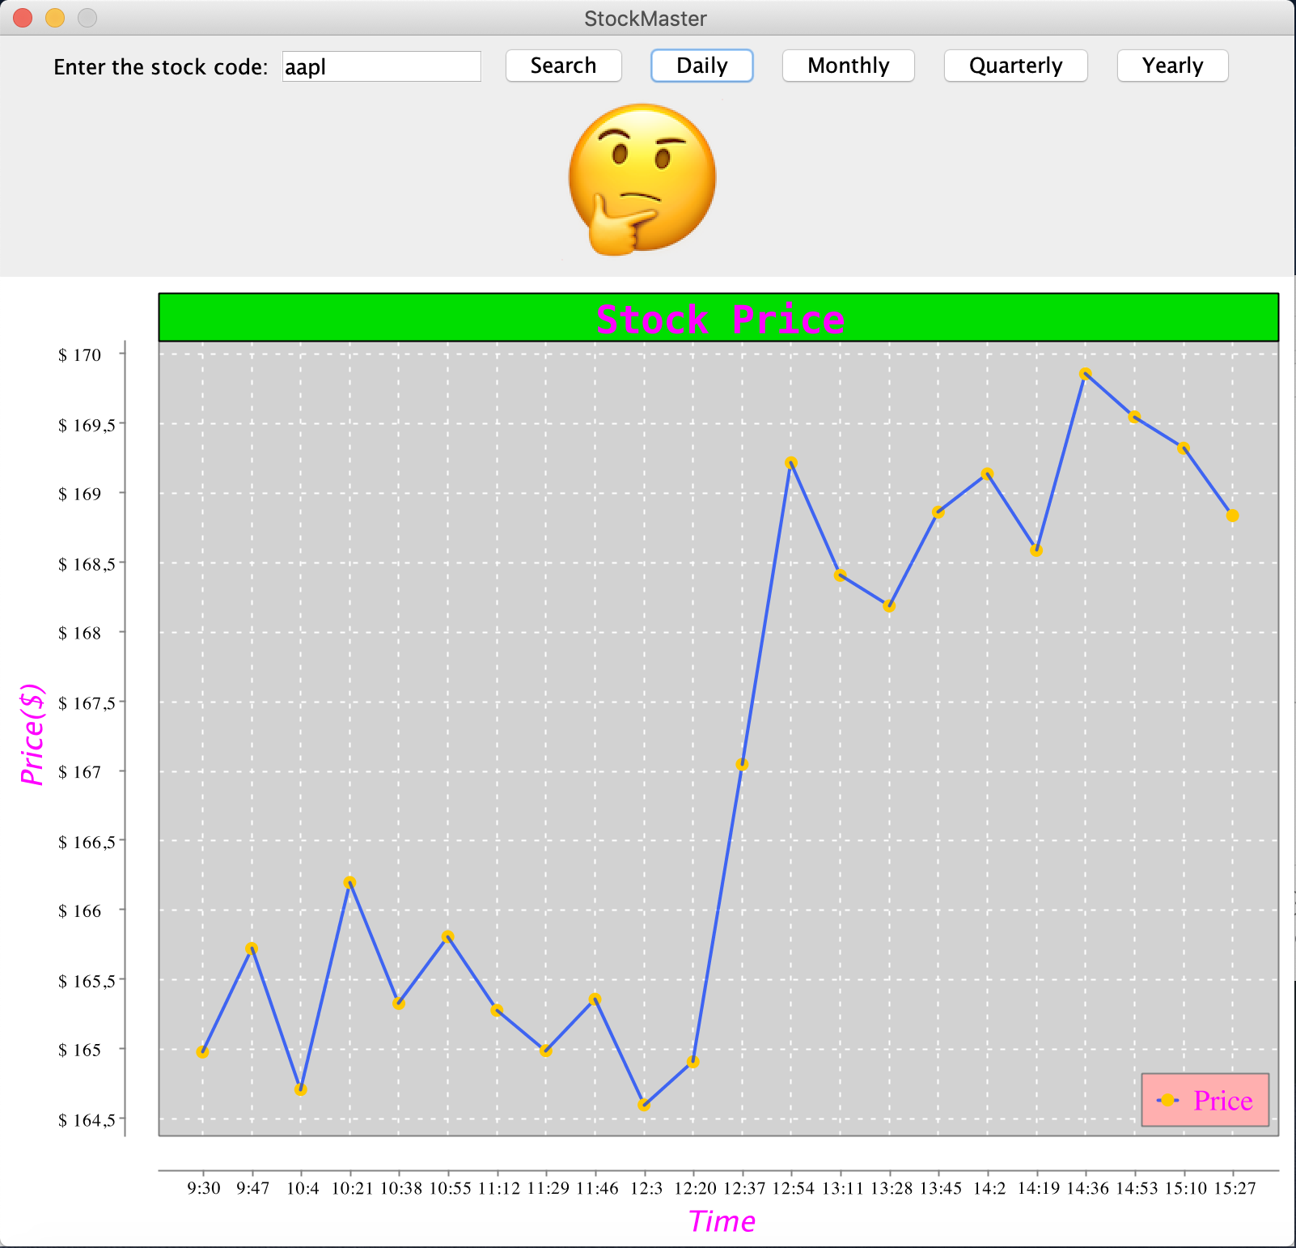

If the user types in an invalid ticker symbol, our app will display an error message notifying the user that the ticker symbol is invalid:

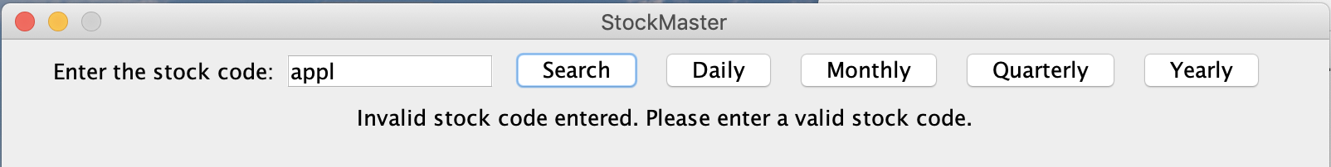

If the specific range of stock data that the user is requesting is not available on the server, our app will keep whatever we have (the emoji if news is available and the last available chart) and display an error message notifying the user that data is not available. For example, if the user selects “Daily” and the daily stock data is not available on the server, the user will see a screen like this:

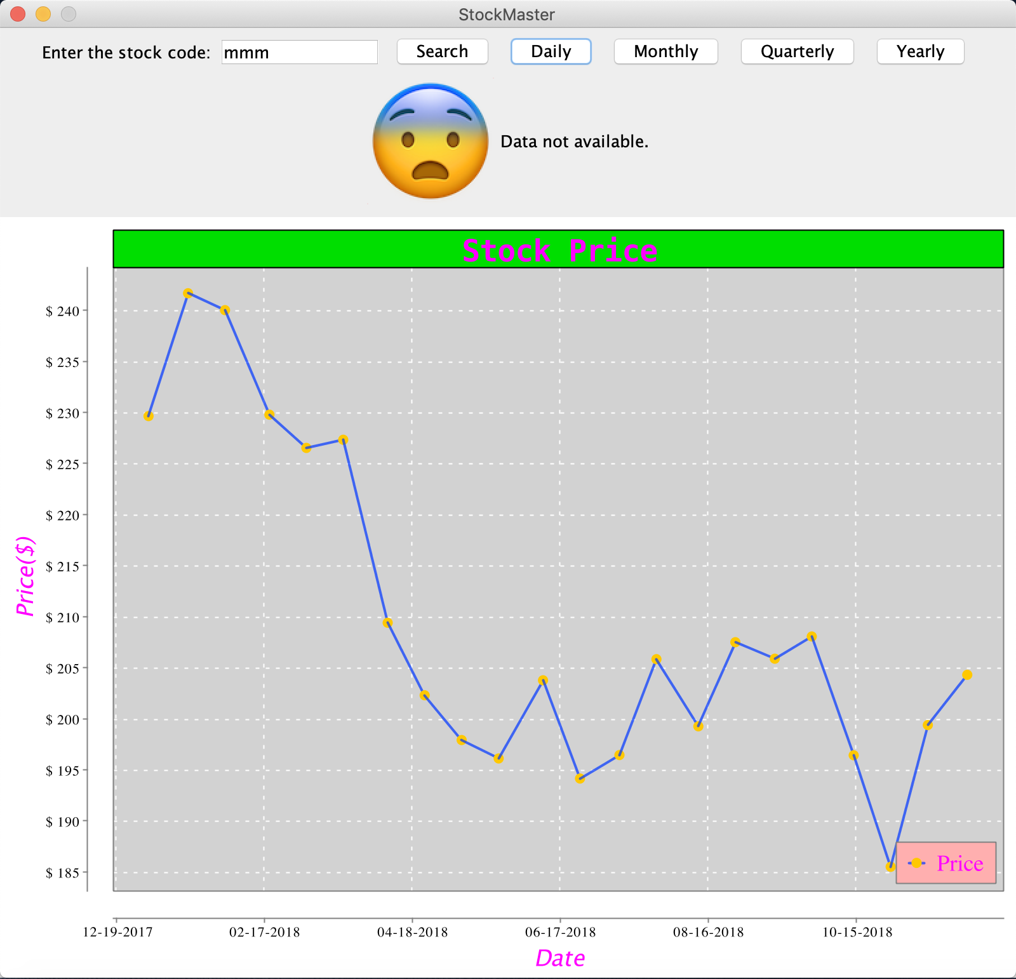

If no data is available at all, for example, the user clicks “Daily” without “Searching” a company’s ticker symbol first, a screen like this will be displayed:

