**PHL Airport App**

**User MANUAL**

**Introduction to Software Development**

Prepared by: Veronika Alex, Brian Sokas, Huong Vu

**USER'S MANUAL**

**TABLE OF CONTENTS**

Page #

1.0 GENERAL INFORMATION 1-1

1.1 Project Overview 1-1

2.0 SYSTEM SUMMARY 2-1

2.1 System Requirements 2-1

***3.0 USING the APPLICATION.....................................................................................*......** 4-1

3.1 Home Screen 4-1

3.2 TSA Checkpoint Times 4-1

3.3 Flight/Customs Delays 4-1

3.4 Parking Availability 4-1

# GENERAL INFORMATION

## 1.1 Project Overview

For our semester project we used data from Philadelphia International Airport to provide insight to a user about congestion levels at TSA security checkpoints, customs checkpoints, and flight delays at a specified time of year, day, and hour. Furthermore, we also assessed parking congestion at the PHL parking garages. The Federal Bureau of Transportation releases monthly statistics on travel in the nation’s airports and the Philadelphia International Airport provides access to APIs on TSA and parking garage data. These datasets provide details on passenger traffic density throughout the year.

Applying the file-parsing techniques we have learned thus far, we took the information from these datasets and combined it with JavaFX GUI, displaying PHL airport statistics with a visual representation of the congestion at a selected point during the day.

# SYSTEM SUMMARY

## 2.1 System Configuration

In order to run our application, Java must be installed. If you do not have Java already installed already you can download it [here](https://java.com/en/download/).

Once Java is installed, make sure you have downloaded our project (either from GitHub or Canvas).

# USING the APPLICATION

## 3.1 Home Screen

Below is what you will see upon starting the application. It is the main navigation page for the program and houses all of the functionality.

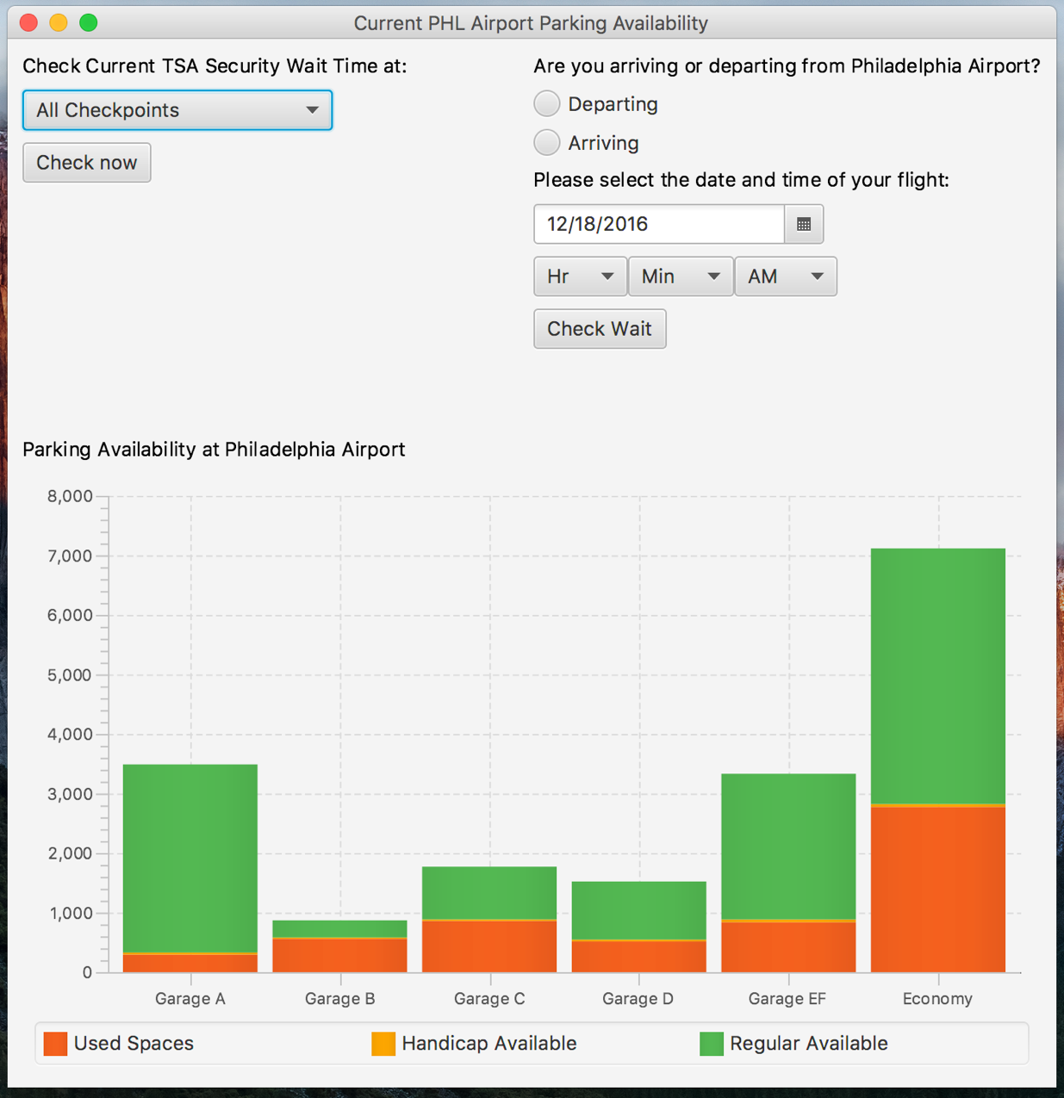

### 3.2 TSA Checkpoint Times

The TSA checkpoint times are pulled from a Philadelphia International Airport API in real-time. From the drop-down menu you can select the checkpoint for which you want to check the wait time, or you can select "All Checkpoints" to view a comparison of all the TSA security checkpoints.

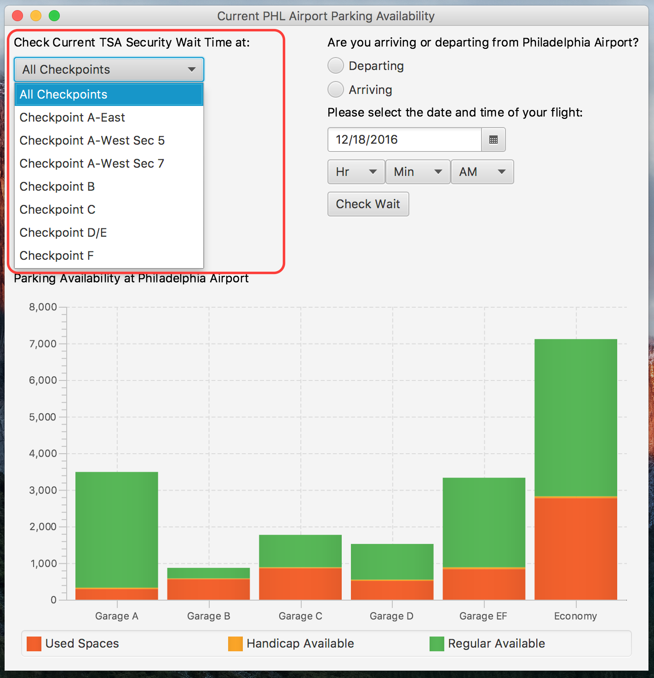

The TSA checkpoint output should look similar to below:

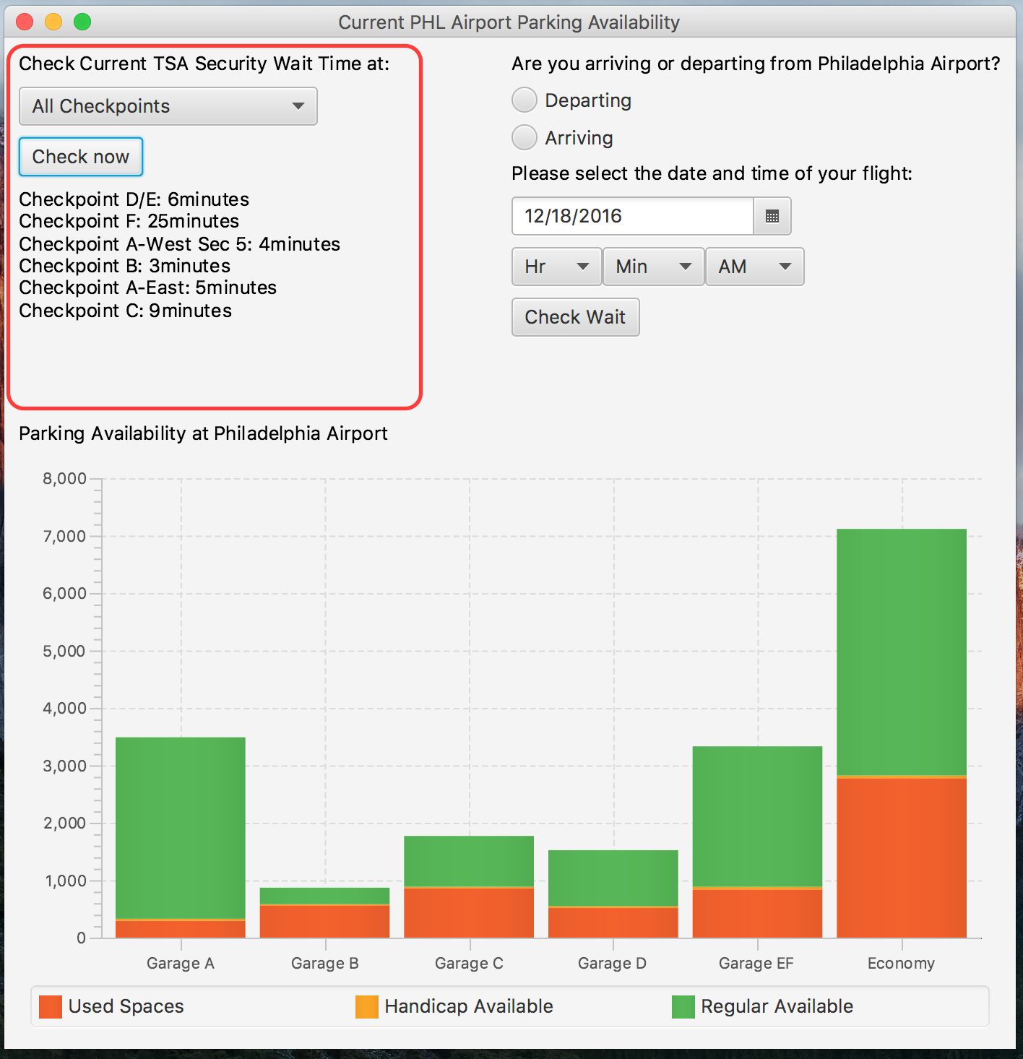

**3.3** **Flight/Customs Delays**

The contents to the right in the GUI show the user display flight and customs delay data. A user can select whether their flight is arriving or departing. If the user selects "arriving" then the data displayed is customs delay data. If the user selects "departing" the data displayed is flight delay data.

The user selects departing/arriving, the date from the calendar, and the time from the options on the screen.

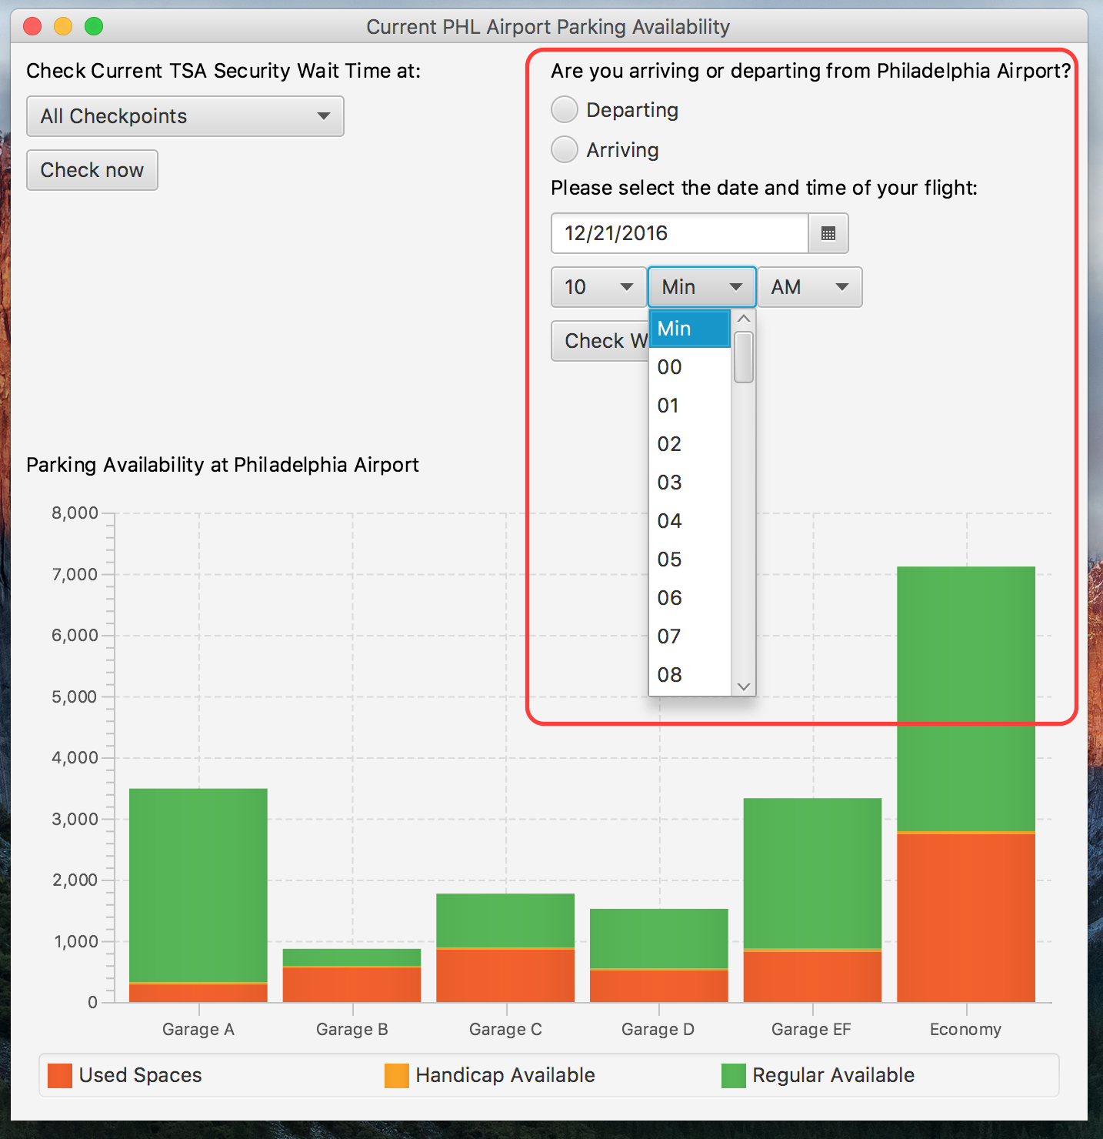

The TSA checkpoint output should look similar to below:

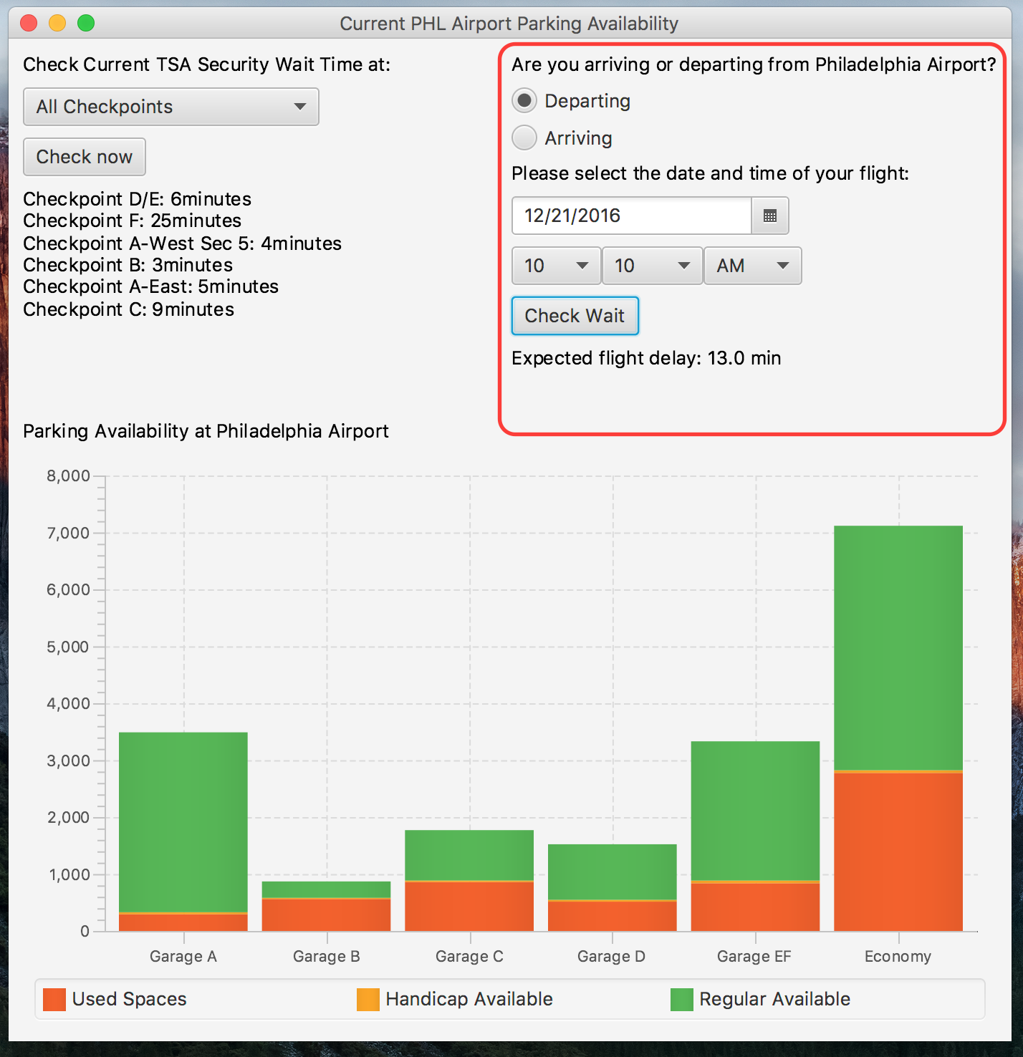

**3.4** **Parking Availability**

The parking data is from the Philadelphia International Airport parking API. The data is pulled in real-time. Each bar represents a different garage in the PHL airport. The green segment of each bar represents the number of available parking spaces in each garage, the orange segment represents the number of available handicap spaces in each garage, and the red segment represents the number of occupied parking spaces in each garage.

