David Milewicz, Carson Stack, Anthony Georgiades

Review Tone Analysis User Manual

**Build and Run**

The Review Tone Analysis is built to run locally on a tomcat server. It has been tested successfully on Tomcat 8.5.8 and 9.0.0 in Google Chrome and the Eclipse web browser (certain gifs do not load in the eclipse browser). It can be run in Eclipse Enterprise Edition by selecting Run>Run as>Run on server and specifying the directory of a Tomcat server. Alternatively, it can be run on an installed instance of Tomcat by placing the file ROOT.war in the Tomcat webapps directory (usr/local/Cellar/tomcat/X.X.X/libexec/webapps) and going to <http://localhost:8080> after the tomcat web server has been started.

**Usage**

The webapp will be deployed at <http://localhost:8080>. The page displayed has a HTML post form with two input fields: a book name field and a review count field. The book that the user wants to analyze should go into the the text box next to the text “Book Title (ex: Moby Dick):”. The number of reviews should be input into the number field. The default is five, the minimum zero and the maximum is twenty due to the restrictions on the Watson API usage. A screen shot of the page is shown below:

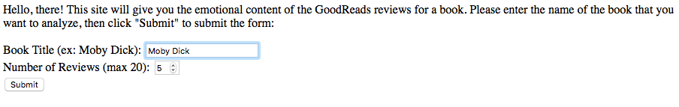

Once the information is entered the user should hit ‘submit’. The results take a long time to return from the GoodReads API and the Watson tone analyzer so please be patient. While the results are being fetched the page will display a loading message as shown below:



The results are then displayed. There are three possibilities: The book was not found, there was a connection problem, or the book was found the stats returned. If either of the former occur an appropriate error message will be displayed. If the results are found, the title and author of the book found will be displayed. This page also has a form to submit another book search in a manner identical to the original page.