# Introduction

The aim of our current apparatus is to setup a MIMO test jig which can perform over the air measurements. To enable us to do so we have a set up consisting of the following components as listed in *Tabelle 1*.

|  |  |  |  |  |
| --- | --- | --- | --- | --- |
| **S.Nr** | **Part Nr.** | **Manufacturer** | **Description** | **Quantity** |
| 1 | USRP2940 | NI | 50MHz - 2.2 GHz 40MHz BW SDR | 2 |
| 2 | CDA2990 | NI | Octoclock Clock distribution | 1 |
| 3 |  | NI | SMA Cables all of the same length | >5 |
| 4 |  | NI | 30dB attenuator | >5 |
| 5 | Celsius M770 | Fujitsu | Intel Xeon 4 Kerne, 16GB RAM, 256GB Festplatte | 1 |
| 6 | PCIe8371 | NI | MXI Cards for High speed comms to the PC | 2 |

Tabelle 1: Table of components in the current setup

Each USRP consists of 2 TXs and 2 RXs. A set of one TX and RX is referred to as an RF Channel. The current setup of the test Jig is in a loopback configuration as shown in *Abbildung 1.* Loopback eliminates the air interface and instead feeds the Tx port into the Rx port with a 50 Ohm transmission line and a 30db attenuator.

Octoclock

Abbildung 1: The figure show the configuration of the test setup

USRP 1

USRP 2

PC

RF0

RF1

RF0

RF1

Tx Rx

Tx Rx

Tx Rx

Tx Rx

PCIe Bus

PCIe Bus

-30dB

-30dB

-30dB

-30dB

10MHz

10MHz

# Issue

A pure sine wave is sent as **IQ** samples from both USRP 1 and USRP 2 i.e. The same signal is sent on all the Tx ports but received with a phase shift. The function sent at the transmitter side is

y(t) = cos(t) + j*sin(t)

The I Signal is cos(t) and the Q Signal is sin(t).

The Octoclock provides a common 10 MHz sampling clock which all the USRPs synchronize to. The Octoclock also has a PPS Trigger which is a pulse per second trigger as shown in *Abbildung 2.*

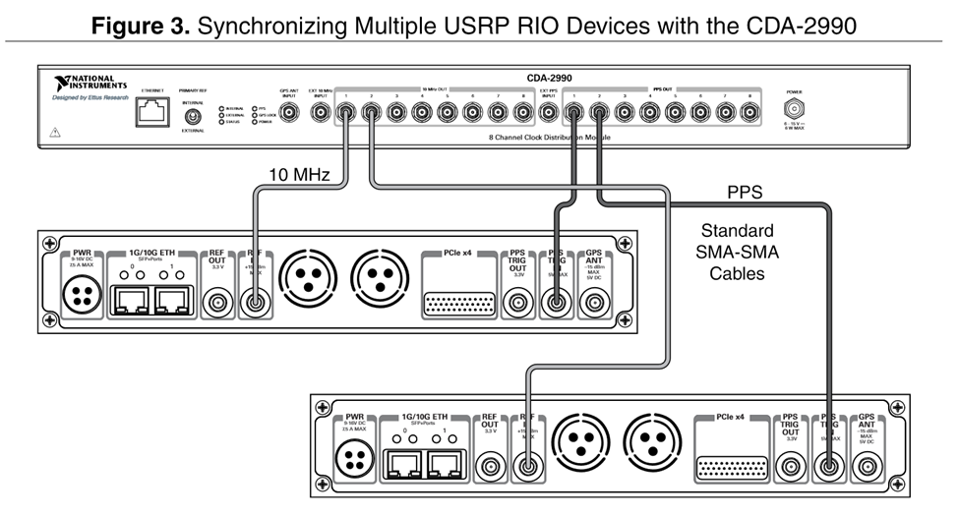

Abbildung 2: The connections from the Octoclock to the USRP

NI Claims that for the purposes of synchronizing the sampling times of the different RF Front ends the 10 MHz time base is the critical and that the PPS is an auxiliary signal.

However, both these lines were measured from the output of the Octoclock with a 50 Ohm termination resistor and confirmed empirically as shown below in the *Abbildung 3*. The figures shows the FFT peak at 10 MHz and that the 2 channels (yellow and green) which are the outputs of 2 different channels of the Octoclock.

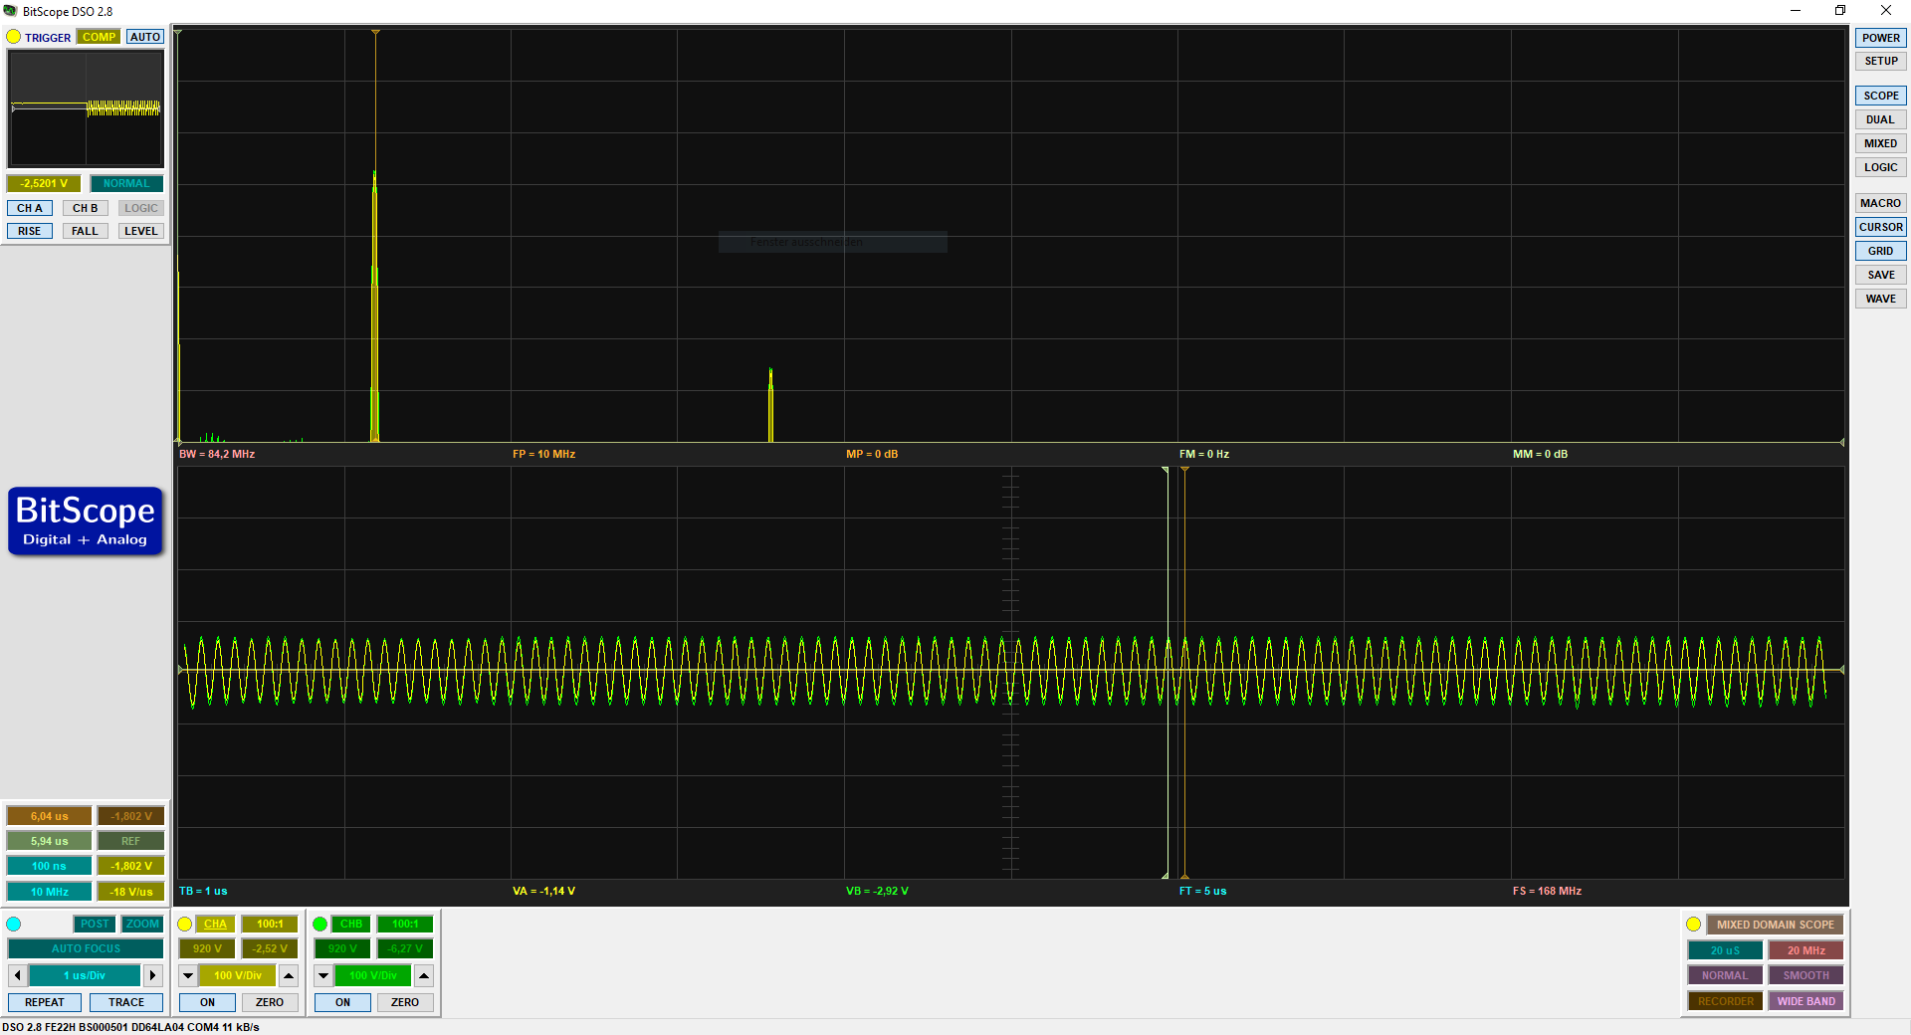

Abbildung 3: The 10 MHz clock as seen at the output of two respective channels of the Octoclock. The yellow is from ch1 and the green is from channel 2 which are connected to USRP1 and USRP2 respectively. The top half is the Fourier transform and the bottom half is the time domain signal

Further more the PPS trigger signals were measured at the output of the Octoclock and found to be synchronized as well as shown in *Abbildung 4* and *Abbildung 5.*

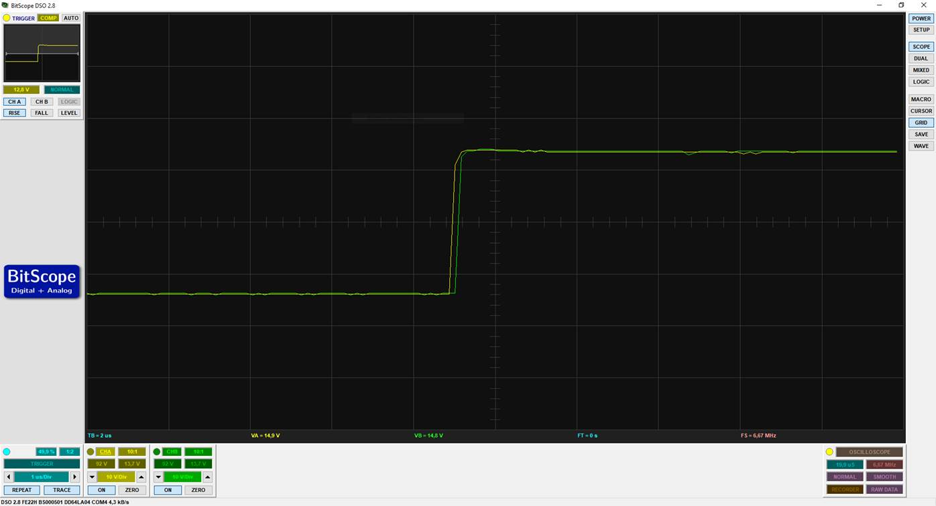

Abbildung 4: Figure shows the PPS trigger signal from the Octoclock. The slight shift is potentially an artifact from the measurement instrument as the bandwidth of the measurement tool was limited (20MHz).

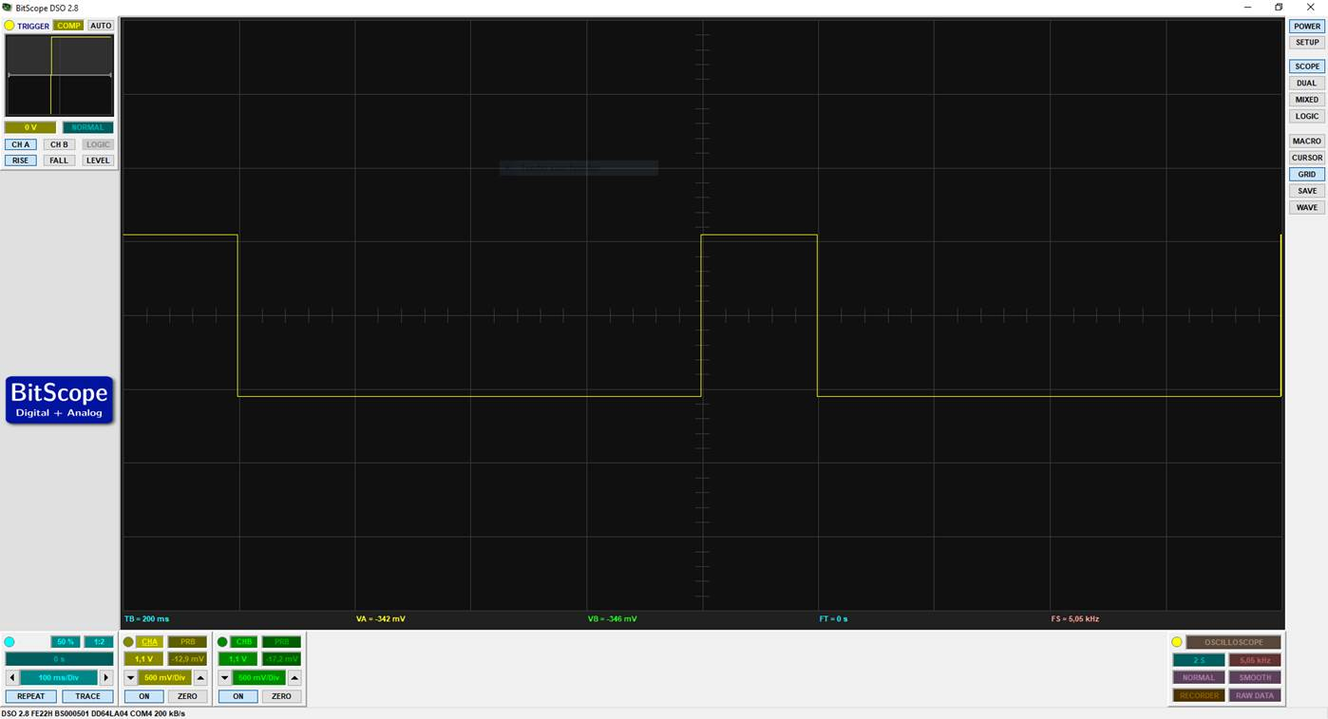

Abbildung 5: Figure shows a zoomed-out view of the PPS Trig Out which occurs every 1s and the high pulse is 200ms long.

# Results

Putting all our hypothesis together and if the system was processing data synchronously then we should observe the following in the receive signal plot (as shown in *Abbildung 6*). The **I** signals from **ALL** the channels should overlap and that the **Q** signals from **ALL** the channels should overlap. But they aren’t, which indicates a loss of synchronization somewhere along the way. Its not the Octoclock as measurements prove that the Clock supplys a common time base. According to the NI Senior Applications Engineering Specialist (Marco Brauner)

*die RF-Daughterboards in den USRPs sind nicht auf LO-Ebene* synchronisiert ! Deshalb bekommst du auch hier bei jedem neuen Start der Erfassung verschiedene relative Delays zwischen den Kanälen. Das ist also* ***Expected Behaviour****, und muss in Software herauskalibriert werden. Im MIMO-App-Framework ist eine Calibration der USRPs implementiert, in den USRP Streaming-Templates bleibt dieser Aspekt meines Wissens unberücksichtigt, weshalb du die Delays zwischen den Kanälen siehst.*

*LO - Local Oscillator

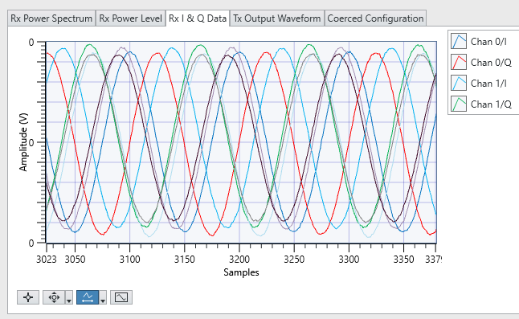

Abbildung 6: The received signals from all the each of the 2 RF channels from each of the 2 USRPs. The legend only labels channel 0 and channel 1 of USRP1 but the rest of the signals that are not labeled are for USRP2.

# Options for a realizable test Setup

1. MIMO Application Framework

 This option provides us with Realtime PHY Layer. Upto 128 Base Station Antennas and upto 12 UE Antennas. Provides implementations of different channel estimation algorithms.

 Modular

 Very expensive

 Requires additional HW for it to work.

1. LTE Application Framework

 This option provides us with Realtime PHY Layer of LTE Rel.10. Comes with Realtime stack with PHY and a mini MAC. Provides implementations of different channel estimation algorithms.

 Works with the current HW and doesn’t require additional HW.

 Expensive but not as much as the whole MIMO AF.

 Only has a **2x2** MIMO Setup. Not extendable!

1. Current Setup (assuming we have the time sync)

 Works with the current HW and doesn’t require additional HW.

 Time synchronization has to be achieved in order to make this work reliably.

A suggestion from NI was that the time sync is not necessary for channel estimation as this is one wa y to proceed. But this doesn’t guarantee reproducibility in our measurement setup. Although delays in the RF path can be roped into the Channel effects, this would mean it would be **different** every time we run the test.