自动控制原理实验报告
姓名：傅思雄 学号：2024030448 班级：自控2401

实验四 传递函数零极点对系统过渡过程的影响

一、实验目的
研究传递函数的闭环零点、闭环极点位置变化对系统单位阶跃响应和动态性能指标的影响，并理解高阶系统中闭环主导极点的作用。

二、实验内容与 MATLAB 实现
标准二阶系统： G0(s)=1/(s^2+s+1)
附加极点： T=0.2、2、5，对应 -5、-0.5、-0.2
附加零点： τ=0.2、2、5，对应 -5、-0.5、-0.2

三、实验结果
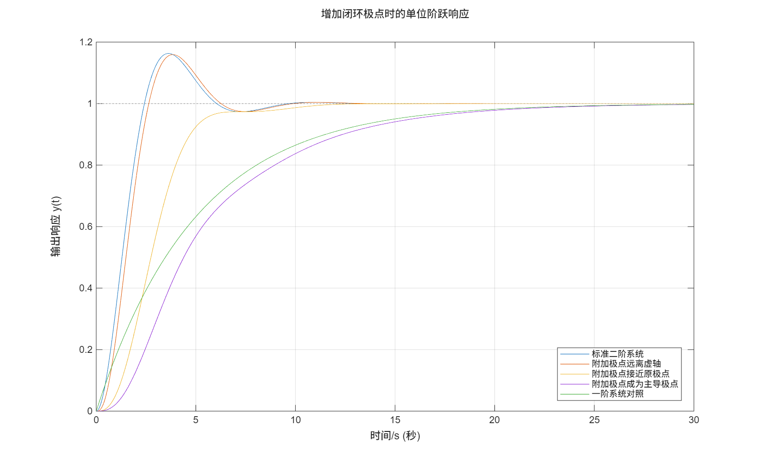
图 1 增加闭环极点时的单位阶跃响应
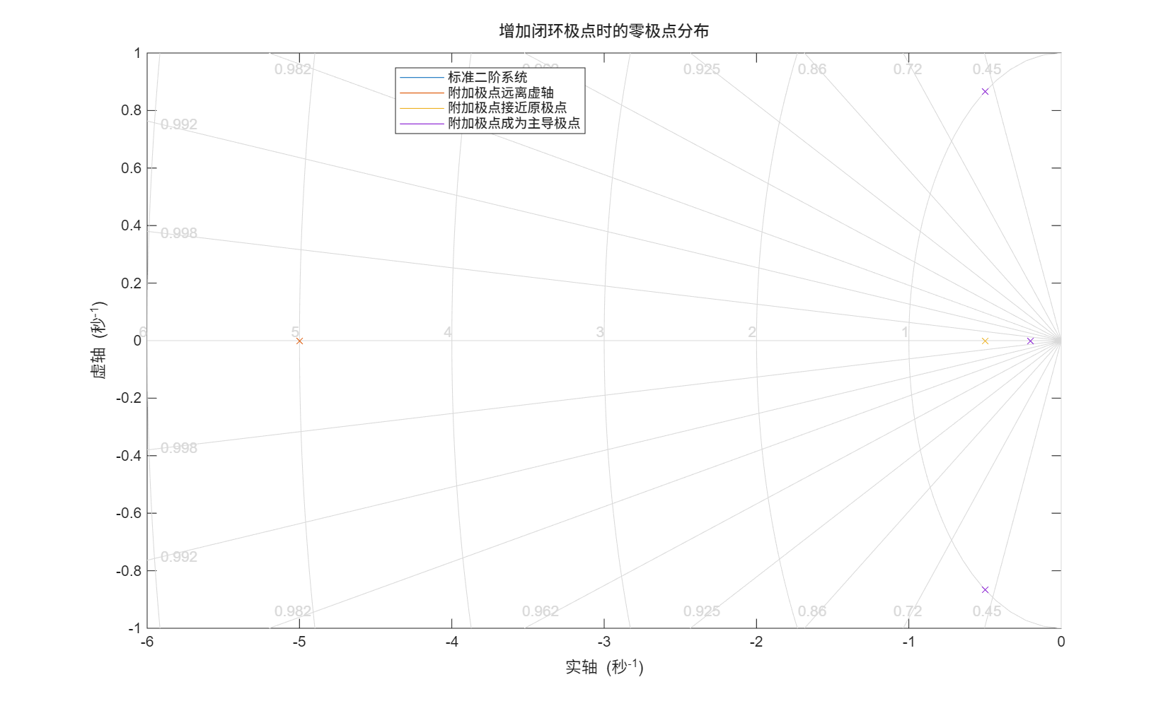
图 2 增加闭环极点时的零极点分布
表 1 增加闭环极点时的动态指标
工况 | 超调量/% | 峰值时间/s | 调节时间/s | 稳态值 | 稳态误差
标准二阶系统 | 16.3033 | 3.6300 | 8.0763 | 1.0000 | 0
附加极点远离虚轴 | 15.9391 | 3.8500 | 8.2612 | 1.0000 | 0
附加极点接近原极点 | 0 | 30.0000 | 9.1389 | 1.0000 | 0
附加极点成为主导极点 | 0 | 30.0000 | 20.4298 | 1.0000 | 0
一阶系统对照 | 0 | 30.0000 | 19.5601 | 1.0000 | 0
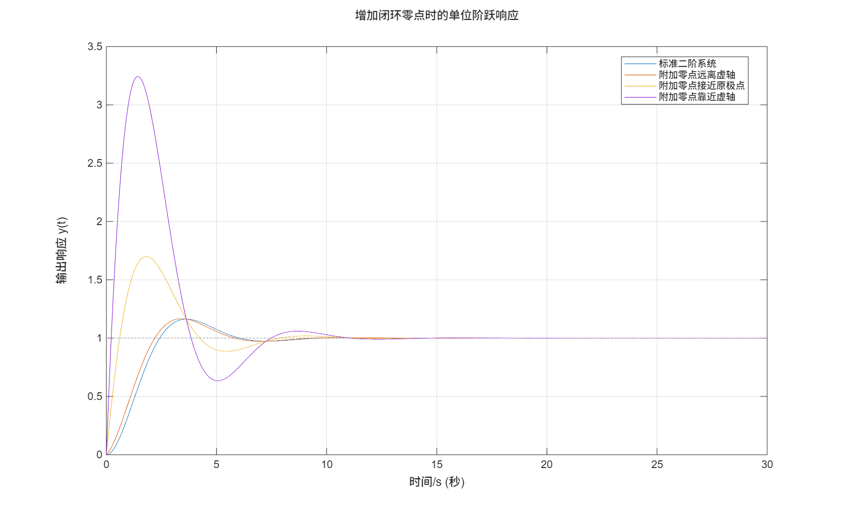
图 3 增加闭环零点时的单位阶跃响应
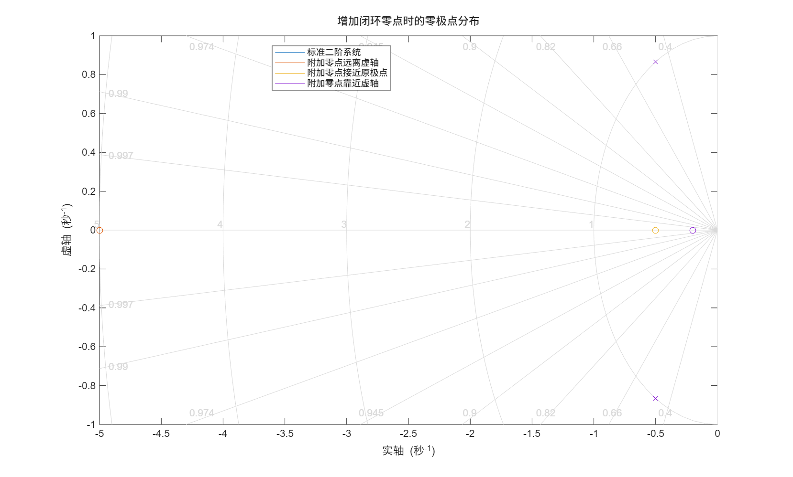
图 4 增加闭环零点时的零极点分布
表 2 增加闭环零点时的动态指标
工况 | 超调量/% | 峰值时间/s | 调节时间/s | 稳态值 | 稳态误差
标准二阶系统 | 16.3033 | 3.6300 | 8.0763 | 1.0000 | 0
附加零点远离虚轴 | 16.6758 | 3.4100 | 7.8902 | 1.0000 | 0
附加零点接近原极点 | 69.9352 | 1.8100 | 7.3832 | 1.0000 | 0
附加零点靠近虚轴 | 224.32 | 1.4300 | 10.2884 | 1.0000 | 0
标准二阶系统的闭环极点为 -0.5±0.8660j，超调量约为 16.30%，调节时间约为 8.08 s。
当附加极点为 -5 时，该极点远离虚轴，响应曲线与标准二阶系统接近，影响较小。
当附加极点靠近虚轴，特别是 -0.2 时，它成为主导极点，系统响应明显变慢，调节时间增大。
附加零点离虚轴较远时影响较小；附加零点靠近虚轴时会明显加快初始响应，但超调显著增大。

实验五 PID 调节规律对系统调节质量的影响

一、实验目的
通过改变 P、PI、PID 调节规律及参数，观察飞机自动驾驶仪航向角过渡过程，比较峰值时间、过渡时间、超调量、余差和衰减比等指标。

二、实验模型与参数
等效对象： G0(s)=10(s+5)/[(s+10)(s^2+3.5s+6)]
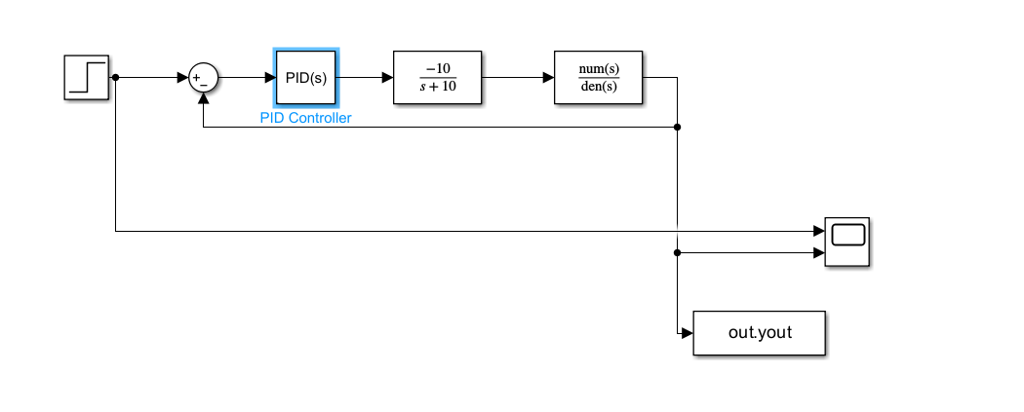
图 5 PID 控制仿真结构
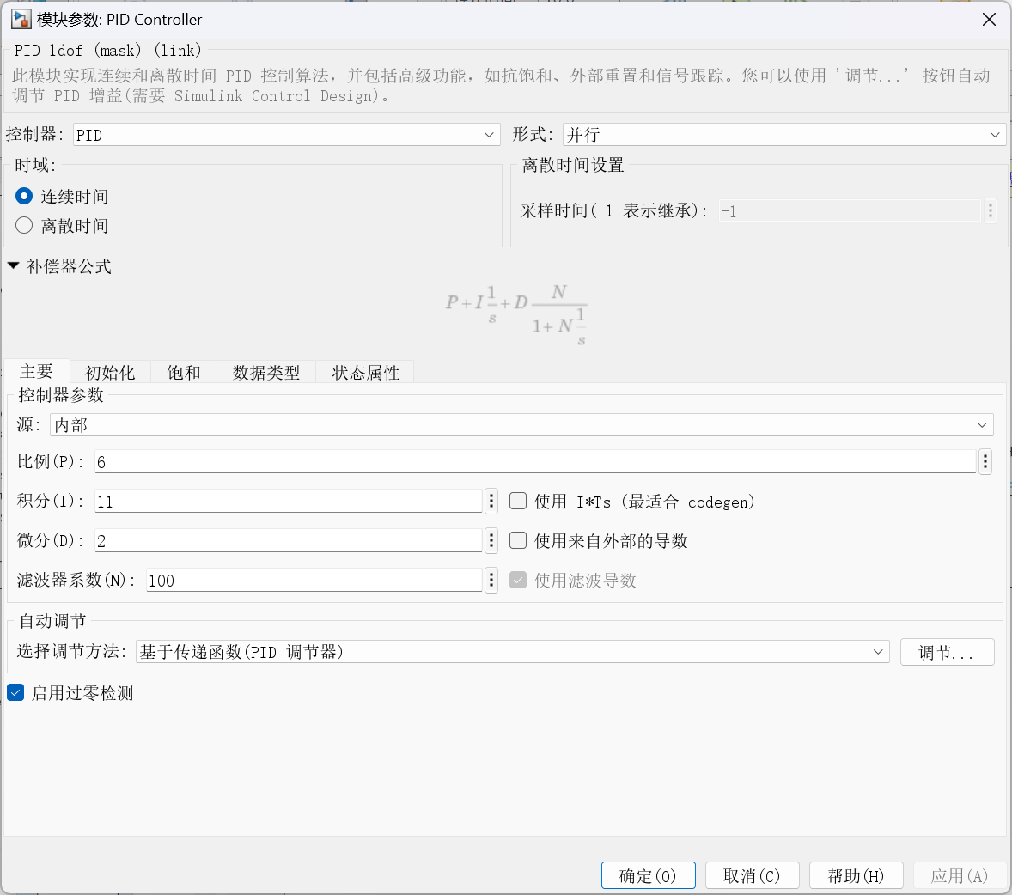
图 6 PID 控制器参数：P=6，I=11，D=2，N=100

三、阶跃响应结果
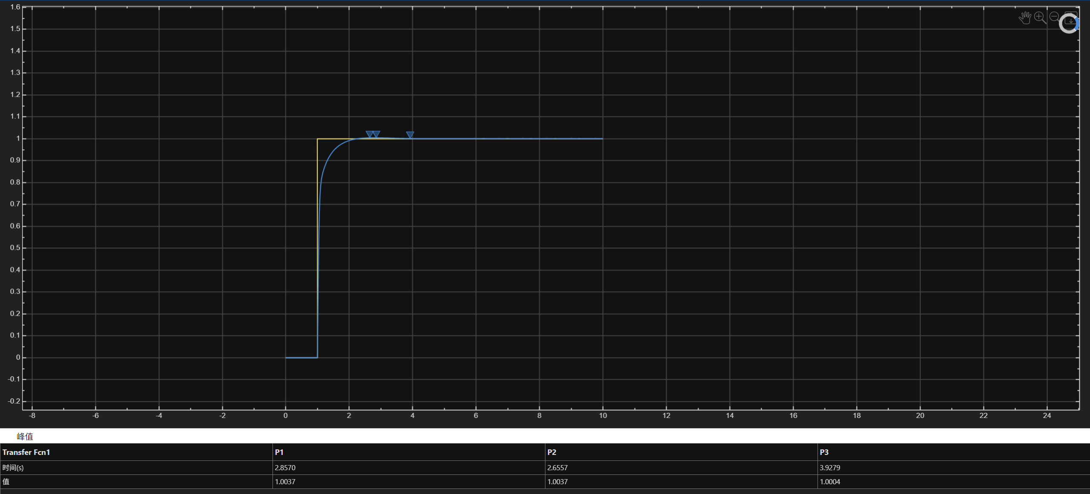
图 7 PID 控制单位阶跃响应曲线
表 3 不同调节规律的阶跃响应指标
工况 | 是否稳定 | 超调量/% | 峰值时间/s | 调节时间/s | DecayRatio | 稳态值 | 稳态误差 | 最大超调值
P: Kc=0.1 | 1.0000 | 5.5098 | 1.5500 | 2.2381 | nan | 0.0769 | 0.9231 | -0.9188
P: Kc=1 | 1.0000 | 11.4106 | 1.0100 | 1.6317 | nan | 0.4545 | 0.5455 | -0.4936
P: Kc=2 | 1.0000 | 15.9714 | 0.7600 | 1.2756 | nan | 0.6250 | 0.3750 | -0.2752
P: Kc=5 | 1.0000 | 24.8434 | 0.4800 | 1.2171 | 6.3722 | 0.8065 | 0.1935 | 0.0068
P: Kc=8 | 1.0000 | 30.7333 | 0.3800 | 0.9602 | 4.9394 | 0.8696 | 0.1304 | 0.1368
PI: Kc=5, Ti=1 | 1.0000 | 17.3308 | 0.5000 | 2.3823 | 1.4592 | 1.0000 | 0 | 0.1733
PI: Kc=5, Ti=2 | 1.0000 | 9.2276 | 0.5000 | 5.1226 | 0.6045 | 1.0000 | 0 | 0.0923
PI: Kc=5, Ti=4 | 1.0000 | 5.0038 | 0.4900 | 10.7490 | 0.2728 | 1.0000 | 0 | 0.0500
PI: Kc=5, Ti=6 | 1.0000 | 3.5736 | 0.4900 | 16.3780 | 0.1823 | 1.0000 | 0 | 0.0357
PID: Kc=5, Ti=1, Td=0.1 | 1.0000 | 0 | 30.0000 | 2.2936 | nan | 1.0000 | 0 | 0
PID: Kc=5, Ti=1, Td=0.5 | 1.0000 | 0.1701 | 4.3700 | 2.3857 | nan | 1.0000 | 0 | 0.0017
PID: Kc=5, Ti=1, Td=2 | 1.0000 | 2.2232 | 6.3600 | 7.0640 | 4.3315 | 1.0000 | 0 | 0.0222
PID: Kc=5, Ti=1, Td=4 | 1.0000 | 2.8908 | 8.8900 | 10.6771 | 2.7255 | 1.0000 | 0 | 0.0289
最终 PID 结果为：峰值时间 2.8570 s、过渡时间 1.8246 s、最大偏差 0.0037、超调量 0.37%、稳态余差约 0、衰减比 0.98。

四、斜坡输入结果
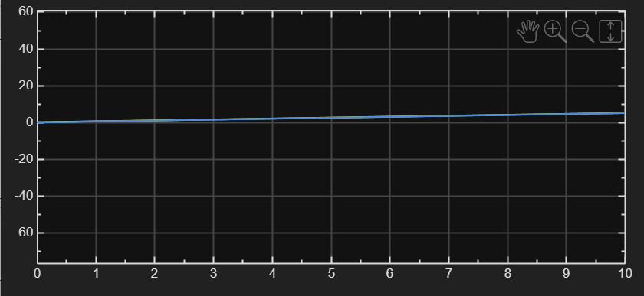
图 8 斜坡输入下航向角响应曲线
表 4 斜坡输入 10 s 后误差
工况 | 10s后误差/deg
P: Kc=2 | 1.9316
PI: Kc=5, Ti=2 | 0.2369
PID: Kc=5, Ti=2, Td=0.5 | 0.2388
输入为 θd(t)=0.5t，比例控制器 Kc=2 时，10 s 后航向角误差约为 1.9316

五、结果分析
比例作用能够提高响应速度、减小余差，但比例增益过大会增大超调和振荡。
积分作用能够消除阶跃输入下的稳态余差，但积分过强会降低稳定裕度。
微分作用根据误差变化趋势提前修正，可改善动态品质并减小超调。

实验六 根轨迹实验

内容 1：二阶水槽系统根轨迹
参数： A1=1000, A2=800, R1=0.005, R2=0.005, Kv=1250, KB=1, TB=0.5
环节： G1=1/(A1R1s+1), G2=R2/(A2R2s+1), GB=KB/(TBs+1)
等效开环： L0(s)=KvG1G2GB
图 9 二阶水槽系统资料与教材模型
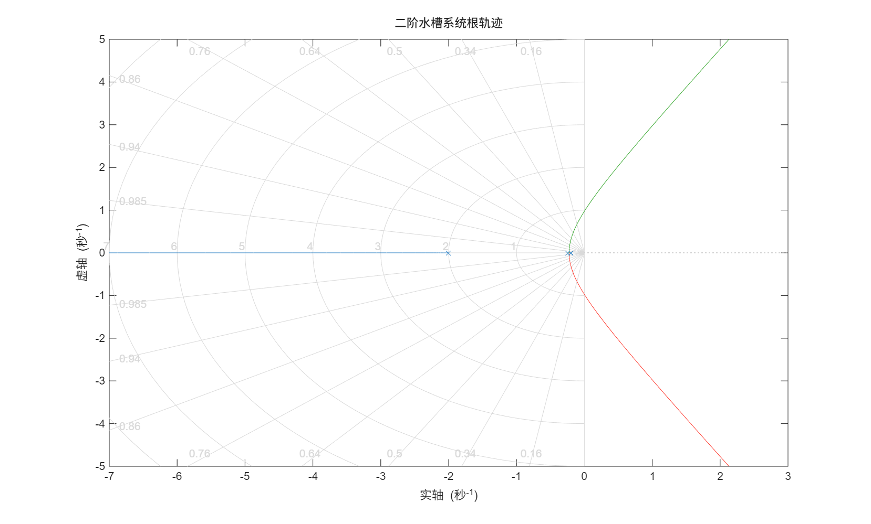
图 10 二阶水槽系统根轨迹
表 5 二阶水槽系统比例增益稳定范围
稳定区间 | Kc最小值 | Kc最大值
稳定区间1 | 0 | 3.5600
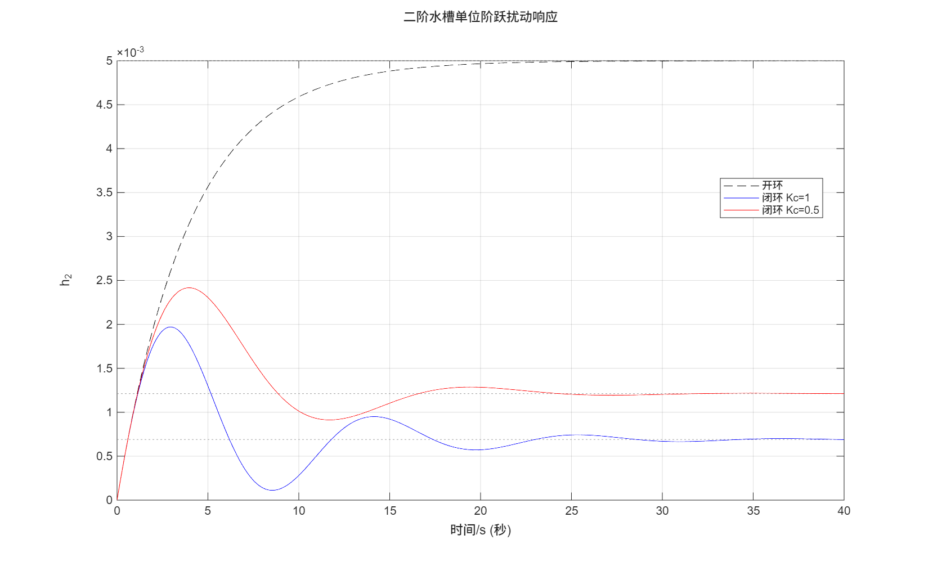
图 11 单位阶跃扰动下的液位响应
表 6 二阶水槽系统扰动稳态误差
开环稳态误差 | 闭环误差(Kc=1) | 闭环误差(Kc=0.5) | 误差比(Kc=1) | 误差比(Kc=0.5)
0.0050 | 0.0007 | 0.0012 | 0.1379 | 0.2424
由根轨迹扫描可得系统稳定的比例增益范围约为 0≤Kc≤3.56。
扰动响应中，开环稳态误差为 0.005；Kc=1 时闭环误差约为 0.00069；Kc=0.5 时闭环误差约为 0.00121。

内容 2：增加开环零点对稳定性的影响
开环对象： G(s)=K/[s^2(s+a)]，本实验取 a=2
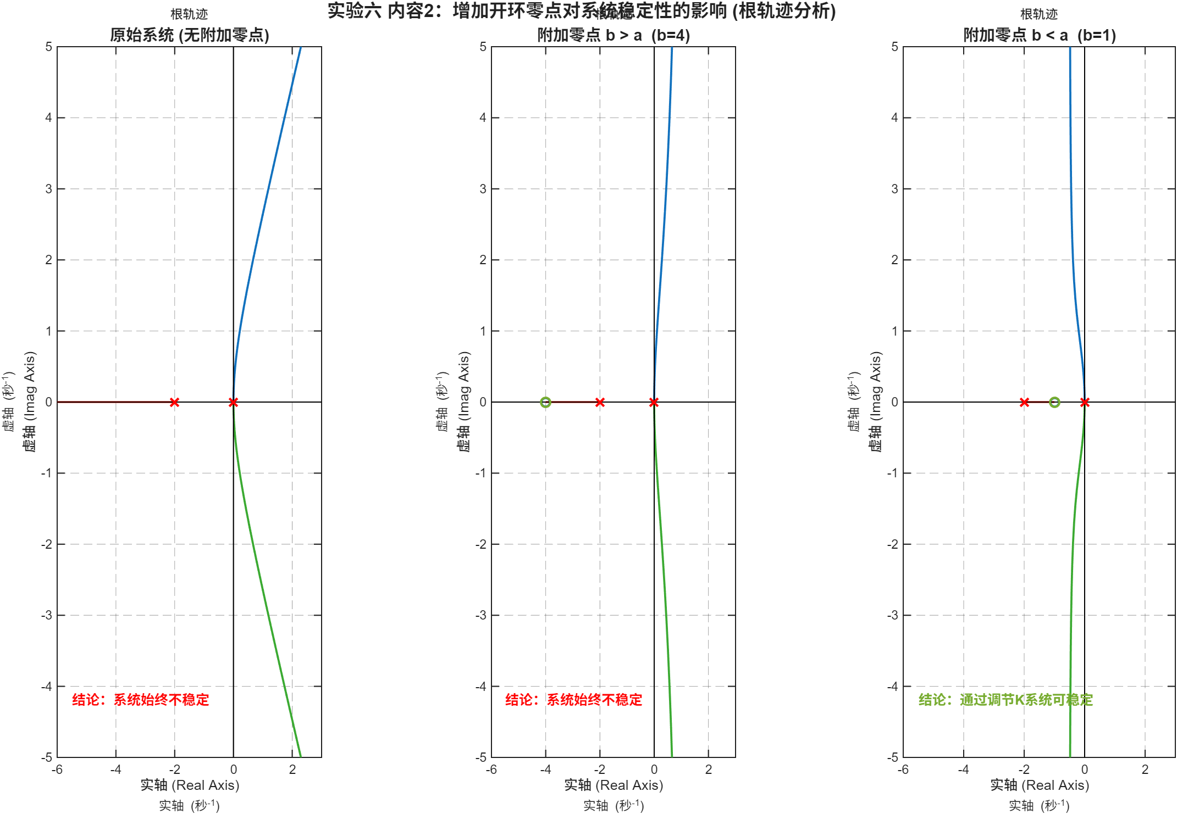
图 12 增加开环零点对根轨迹和稳定性的影响
表 7 内容 2 Routh 判据结论
工况 | 闭环特征方程 | 劳斯判据结论
未增加开环零点 | s^3 + a*s^2 + K = 0 | K>0时始终不稳定
附加零点 z=-4 | s^3 + a*s^2 + K*s + K*b = 0 | K>0时始终不稳定
附加零点 z=-1 | s^3 + a*s^2 + K*s + K*b = 0 | K>0时可稳定
未增加零点时，闭环特征方程为 s^3+a s^2+K=0；增加负开环零点 z=-b 后，闭环特征方程变为 s^3+a s^2+K s+Kb=0。
Routh 判据要求 b<a 才可能稳定，因此 b=4>a=2 时系统始终不稳定，b=1<a=2 时可通过调节 K 使系统稳定。

总 结
实验四表明，靠近虚轴的闭环极点会成为主导极点并显著减慢响应；靠近虚轴的闭环零点会明显改变过渡过程并可能增大超调。
实验五表明，P、I、D 三种调节作用分别影响响应速度、稳态误差和动态阻尼；合理整定 PID 参数后系统可满足给定动态指标。
实验六表明，根轨迹能够直观判断比例增益变化对闭环极点和稳定性的影响；对于二阶水槽系统可得到稳定增益范围，对于附加零点系统可由 Routh 判据判断 b<a 是稳定的重要条件。

附录：MATLAB 完整代码

附录 A：实验四 MATLAB 程序 lab4_zero_pole_effect.m
% Lab 4: effect of closed-loop zeros and poles on transient response.
% Source code is ASCII-only for MATLAB encoding compatibility.
clear; clc; close all;
outdir = fullfile(pwd, "results_lab4_5_6");
if ~exist(outdir, "dir")
mkdir(outdir);
end
s = tf("s");
zeta = 0.5;
wn = 1;
sigma = zeta * wn;
t = 0:0.01:30;
base = wn^2 / (s^2 + 2*zeta*wn*s + wn^2);
T_values = [0.2, 2, 5];
pole_systems = {base, base/(T_values(1)*s + 1), ...
base/(T_values(2)*s + 1), base/(T_values(3)*s + 1), ...
1/(T_values(3)*s + 1)};
pole_names = {u([26631 20934 20108 38454 31995 32479]), ...
u([38468 21152 26497 28857 36828 31163 34394 36724]), ...
u([38468 21152 26497 28857 25509 36817 21407 26497 28857]), ...
u([38468 21152 26497 28857 25104 20026 20027 23548 26497 28857]), ...
u([19968 38454 31995 32479 23545 29031])};
figure("Name", "Lab 4 - Added Pole Step Responses", "Color", "w");
hold on;
for k = 1:numel(pole_systems)
step(pole_systems{k}, t);
end
grid on;
xlabel(u([26102 38388 47 115]));
ylabel(u([36755 20986 21709 24212 32 121 40 116 41]));
title(u([22686 21152 38381 29615 26497 28857 26102 30340 21333 20301 38454 36291 21709 24212]));
legend(pole_names, "Location", "best");
saveas(gcf, fullfile(outdir, "lab4_added_poles_step.png"));
figure("Name", "Lab 4 - Added Pole Pole-Zero Map", "Color", "w");
hold on;
for k = 1:4
pzmap(pole_systems{k});
end
grid on;
xlabel(u([23454 36724]));
ylabel(u([34394 36724]));
title(u([22686 21152 38381 29615 26497 28857 26102 30340 38646 26497 28857 20998 24067]));
legend(pole_names(1:4), "Location", "best");
saveas(gcf, fullfile(outdir, "lab4_added_poles_pzmap.png"));
tau_values = [0.2, 2, 5];
zero_systems = {base, (tau_values(1)*s + 1)*base, ...
(tau_values(2)*s + 1)*base, (tau_values(3)*s + 1)*base};
zero_names = {u([26631 20934 20108 38454 31995 32479]), ...
u([38468 21152 38646 28857 36828 31163 34394 36724]), ...
u([38468 21152 38646 28857 25509 36817 21407 26497 28857]), ...
u([38468 21152 38646 28857 38752 36817 34394 36724])};
figure("Name", "Lab 4 - Added Zero Step Responses", "Color", "w");
hold on;
for k = 1:numel(zero_systems)
step(zero_systems{k}, t);
end
grid on;
xlabel(u([26102 38388 47 115]));
ylabel(u([36755 20986 21709 24212 32 121 40 116 41]));
title(u([22686 21152 38381 29615 38646 28857 26102 30340 21333 20301 38454 36291 21709 24212]));
legend(zero_names, "Location", "best");
saveas(gcf, fullfile(outdir, "lab4_added_zeros_step.png"));
figure("Name", "Lab 4 - Added Zero Pole-Zero Map", "Color", "w");
hold on;
for k = 1:numel(zero_systems)
pzmap(zero_systems{k});
end
grid on;
xlabel(u([23454 36724]));
ylabel(u([34394 36724]));
title(u([22686 21152 38381 29615 38646 28857 26102 30340 38646 26497 28857 20998 24067]));
legend(zero_names, "Location", "best");
saveas(gcf, fullfile(outdir, "lab4_added_zeros_pzmap.png"));
pole_metrics = make_metrics_table(pole_names, pole_systems, t);
zero_metrics = make_metrics_table(zero_names, zero_systems, t);
writetable(pole_metrics, fullfile(outdir, "lab4_added_poles_metrics.csv"));
writetable(zero_metrics, fullfile(outdir, "lab4_added_zeros_metrics.csv"));
fprintf("\nLab 4 finished. Results were saved in:\n%s\n", outdir);
fprintf("zeta*wn = %.3f. For T = %.1f, the added pole is %.3f, so it is dominant.\n", ...
sigma, T_values(3), -1/T_values(3));
fprintf("The second-order poles are:\n");
disp(pole(base));
function metrics = make_metrics_table(case_names, systems, t)
t = t(:);
n = numel(systems);
Case = strings(n, 1);
Overshoot_percent = nan(n, 1);
PeakTime_s = nan(n, 1);
SettlingTime_s = nan(n, 1);
FinalValue = nan(n, 1);
SteadyStateError = nan(n, 1);
for i = 1:n
Case(i) = string(case_names{i});
sys = systems{i};
y = squeeze(step(sys, t));
y = y(:);
final_value = dcgain(sys);
if ~isfinite(final_value)
final_value = y(end);
end
info = stepinfo(y, t, final_value, "SettlingTimeThreshold", 0.02);
Overshoot_percent(i) = info.Overshoot;
PeakTime_s(i) = info.PeakTime;
SettlingTime_s(i) = info.SettlingTime;
FinalValue(i) = final_value;
SteadyStateError(i) = abs(1 - final_value);
end
metrics = table(Case, Overshoot_percent, PeakTime_s, ...
SettlingTime_s, FinalValue, SteadyStateError);
end
function text = u(codes)
text = char(codes);
end

附录 B：实验六内容 1 MATLAB 程序 lab6_water_tank_root_locus.m
% Lab 6 Part 1: root locus of the second-order coupled water-tank system.
% Source code is ASCII-only for MATLAB encoding compatibility.
clear; clc; close all;
outdir = fullfile(pwd, "results_lab4_5_6");
if ~exist(outdir, "dir")
mkdir(outdir);
end
s = tf("s");
A1 = 1000;
A2 = 800;
R1 = 0.005;
R2 = 0.005;
Kv = 1250;
KB = 1;
TB = 0.5;
G1 = 1 / (A1*R1*s + 1);
G2 = R2 / (A2*R2*s + 1);
GB = KB / (TB*s + 1);
L0 = minreal(Kv * G1 * G2 * GB);
figure("Name", "Lab 6 Part 1 - Water Tank Root Locus", "Color", "w");
rlocus(L0);
grid on;
title(u([20108 38454 27700 27133 31995 32479 26681 36712 36857]));
xlabel(u([23454 36724]));
ylabel(u([34394 36724]));
saveas(gcf, fullfile(outdir, "lab6_water_tank_root_locus.png"));
kgrid = linspace(0, 100, 20001);
stable = false(size(kgrid));
for i = 1:numel(kgrid)
stable(i) = isstable(feedback(kgrid(i)*L0, 1));
end
starts = find(diff([false, stable]) == 1);
stops = find(diff([stable, false]) == -1);
if isempty(starts)
Range = "none";
Kc_min = NaN;
Kc_max = NaN;
else
Range = strings(numel(starts), 1);
Kc_min = nan(numel(starts), 1);
Kc_max = nan(numel(starts), 1);
for r = 1:numel(starts)
Range(r) = sprintf("stable range %d", r);
Kc_min(r) = kgrid(starts(r));
Kc_max(r) = kgrid(stops(r));
end
end
ranges = table(Range, Kc_min, Kc_max);
writetable(ranges, fullfile(outdir, "lab6_water_tank_stable_range.csv"));
t = 0:0.01:40;
Hopen = G2;
Hclose_K1 = feedback(G2, 1 * Kv * G1 * GB);
Hclose_K05 = feedback(G2, 0.5 * Kv * G1 * GB);
figure("Name", "Lab 6 Part 1 - Water Tank Disturbance Response", "Color", "w");
step(Hopen, "k--", Hclose_K1, "b-", Hclose_K05, "r-", t);
grid on;
title(u([20108 38454 27700 27133 21333 20301 38454 36291 25200 21160 21709 24212]));
xlabel(u([26102 38388 47 115]));
ylabel("h_2");
legend({u([24320 29615]), u([38381 29615 32 75 99 61 49]), ...
u([38381 29615 32 75 99 61 48 46 53])}, "Location", "best");
saveas(gcf, fullfile(outdir, "lab6_water_tank_disturbance_response.png"));
error_open = dcgain(Hopen);
error_close_K1 = dcgain(Hclose_K1);
error_close_K05 = dcgain(Hclose_K05);
ratio_K1 = error_close_K1 / error_open;
ratio_K05 = error_close_K05 / error_open;
metrics = table(error_open, error_close_K1, error_close_K05, ratio_K1, ratio_K05);
writetable(metrics, fullfile(outdir, "lab6_water_tank_disturbance_metrics.csv"));
fprintf("\nLab 6 water-tank part finished. Results saved in:\n%s\n", outdir);
fprintf("Stable proportional gain range from scanned root-locus data:\n");
disp(ranges);
fprintf("Disturbance steady-state errors: open=%.6g, Kc=1 %.6g, Kc=0.5 %.6g\n", ...
error_open, error_close_K1, error_close_K05);
function text = u(codes)
text = char(codes);
end

附录 C：实验六内容 2 MATLAB 程序 lab6_root_locus.m
% Lab 6: root-locus experiments.
% Source code is ASCII-only for MATLAB encoding compatibility.
clear; clc; close all;
outdir = fullfile(pwd, "results_lab4_5_6");
if ~exist(outdir, "dir")
mkdir(outdir);
end
s = tf("s");
%% Part 1 placeholder. Use lab6_water_tank_root_locus.m for the textbook
% water-tank system from problem 3-16.
%% Part 2: G(s) = K/(s^2*(s+a)), then add a negative open-loop zero z=-b.
a = 2;
b_values = [4, 1]; % b>a and b<a
kgrid = linspace(0, 100, 10001);
G0 = 1 / (s^2 * (s + a));
figure("Name", "Lab 6 - Root Locus Without Added Zero", "Color", "w");
rlocus(G0);
grid on;
xlabel(u([23454 36724]));
ylabel(u([34394 36724]));
title(u([21407 22987 31995 32479 26681 36712 36857]));
saveas(gcf, fullfile(outdir, "lab6_no_zero_rlocus.png"));
no_zero_ranges = stable_gain_ranges(G0, kgrid);
writetable(no_zero_ranges, fullfile(outdir, "lab6_no_zero_stable_k_range.csv"));
figure("Name", "Lab 6 - Root Locus With Added Zeros", "Color", "w");
for i = 1:numel(b_values)
b = b_values(i);
G = (s + b) / (s^2 * (s + a));
subplot(1, numel(b_values), i);
rlocus(G);
grid on;
xlabel(u([23454 36724]));
ylabel(u([34394 36724]));
if b > a
ttl = sprintf("%s z=-%.2g, b>a", u([38468 21152 38646 28857]), b);
else
ttl = sprintf("%s z=-%.2g, b<a", u([38468 21152 38646 28857]), b);
end
title(ttl);
end
saveas(gcf, fullfile(outdir, "lab6_added_zero_rlocus.png"));
Case = strings(numel(b_values) + 1, 1);
CharacteristicEquation = strings(numel(b_values) + 1, 1);
RouthConclusion = strings(numel(b_values) + 1, 1);
Case(1) = "no added zero";
CharacteristicEquation(1) = "s^3 + a*s^2 + K = 0";
RouthConclusion(1) = "unstable for K>0";
for i = 1:numel(b_values)
b = b_values(i);
Case(i+1) = sprintf("added zero z=-%.3g", b);
CharacteristicEquation(i+1) = "s^3 + a*s^2 + K*s + K*b = 0";
if b < a
RouthConclusion(i+1) = "can be stable for K>0";
else
RouthConclusion(i+1) = "unstable for K>0";
end
end
routh_table = table(Case, CharacteristicEquation, RouthConclusion);
writetable(routh_table, fullfile(outdir, "lab6_content2_routh_conclusions.csv"));
fprintf("\nLab 6 finished. Results were saved in:\n%s\n", outdir);
fprintf("For G(s)=K/(s^2(s+a)), K>0 gives no stable closed-loop range.\n");
fprintf("After adding z=-b, the characteristic equation is s^3+a*s^2+K*s+K*b=0.\n");
fprintf("Routh gives stability for K>0 only when b<a.\n");
function ranges = stable_gain_ranges(G, kgrid)
stable = false(size(kgrid));
for i = 1:numel(kgrid)
poles = pole(feedback(kgrid(i) * G, 1));
stable(i) = all(real(poles) < -1e-8);
end
starts = find(diff([false, stable]) == 1);
stops = find(diff([stable, false]) == -1);
if isempty(starts)
ranges = table("none", NaN, NaN, 'VariableNames', ...
{'Range', 'Kmin', 'Kmax'});
return;
end
Range = strings(numel(starts), 1);
Kmin = nan(numel(starts), 1);
Kmax = nan(numel(starts), 1);
for r = 1:numel(starts)
Range(r) = sprintf("stable range %d", r);
Kmin(r) = kgrid(starts(r));
Kmax(r) = kgrid(stops(r));
end
ranges = table(Range, Kmin, Kmax);
end
function text = u(codes)
text = char(codes);
end

