**HBW Location Quotient**

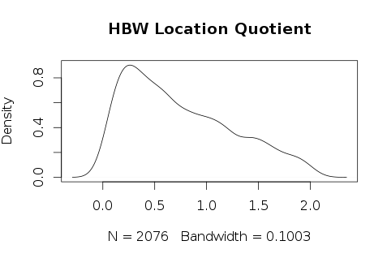

Table 1 HBW Location Quotient Statistical Descriptive

|  |  |  |  |  |  |
| --- | --- | --- | --- | --- | --- |
| Min | 1st Qu | Median | Mean | 3rd Qu | Max |
| 0.00758 | 0.30720 | 0.63040 | 0.74300 | 1.10400 | 2.04800 |

**HBS Location Quotient**

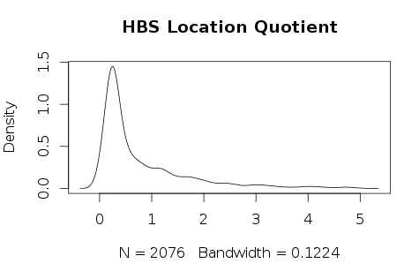

Table 2 HBS Location Quotient Statistical Descriptive

|  |  |  |  |  |  |
| --- | --- | --- | --- | --- | --- |
| Min | 1st Qu | Median | Mean | 3rd Qu | Max |
| 0.00093 | 0.24090 | 0.37760 | 0.79280 | 1.08100 | 4.98500 |

**HBR Location Quotient**

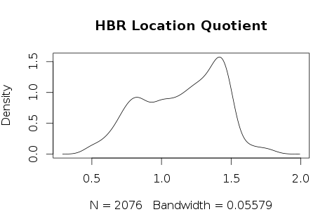

Table 3 HBR Location Quotient Statistical Descriptive

|  |  |  |  |  |  |
| --- | --- | --- | --- | --- | --- |
| Min | 1st Qu | Median | Mean | 3rd Qu | Max |
| 0.4575 | 0.9060 | 1.1850 | 1.1450 | 1.3860 | 1.8260 |

**HBO Location Quotient**

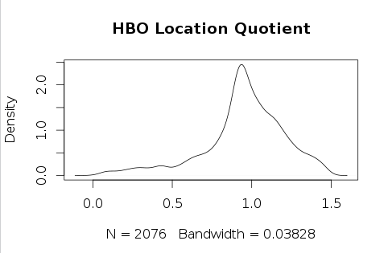

Table 4 HBO Location Quotient Statistical Descriptive

|  |  |  |  |  |  |
| --- | --- | --- | --- | --- | --- |
| Min | 1st Qu | Median | Mean | 3rd Qu | Max |
| 0.00275 | 0.85340 | 0.96030 | 321.500 | 1.11600 | 1.48600 |

**Centers by trip purpose**

Table 5 Total number of TAZs

|  |  |  |  |  |
| --- | --- | --- | --- | --- |
|  | hbwci | hbsci | hbrci | hboci |
| EMP and SizeTerm | 157 | 549 | 600 | 598 |
| Location Quotient | 570 | 493 | 1383 | 842 |