**HBW Location Quotient**

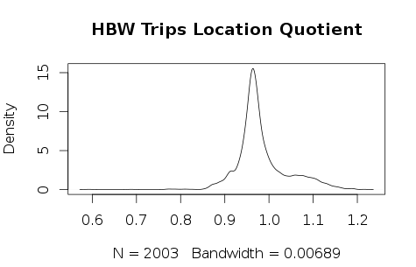

Table 1 HBW Location Quotient Statistical Descriptive

|  |  |  |  |  |  |
| --- | --- | --- | --- | --- | --- |
| Min | 1st Qu | Median | Mean | 3rd Qu | Max |
| 0.5924 | 0.9541 | 0.9692 | 0.9828 | 1.0010 | 1.2160 |

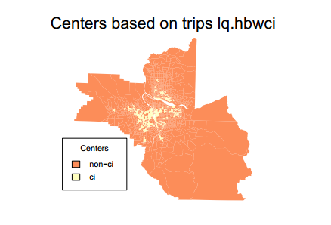

**HBS Location Quotient**

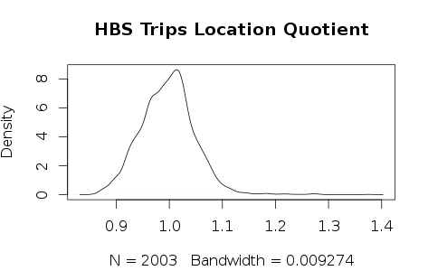

Table 2 HBS Location Quotient Statistical Descriptive

|  |  |  |  |  |  |
| --- | --- | --- | --- | --- | --- |
| Min | 1st Qu | Median | Mean | 3rd Qu | Max |
| 0.8590 | 0.9635 | 0.9981 | 0.9972 | 1.0270 | 1.3750 |

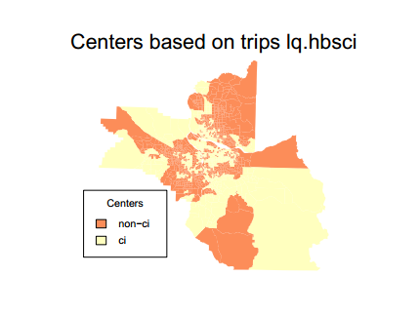

**HBR Location Quotient**

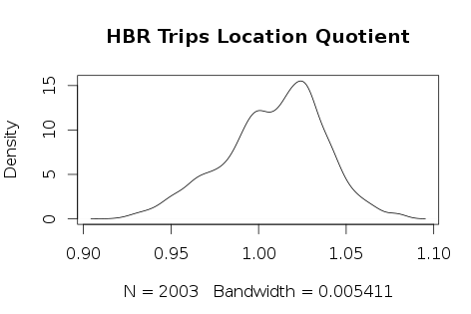

Table 3 HBR Location Quotient Statistical Descriptive

|  |  |  |  |  |  |
| --- | --- | --- | --- | --- | --- |
| Min | 1st Qu | Median | Mean | 3rd Qu | Max |
| 0.9205 | 0.9913 | 1.0120 | 1.0090 | 1.0280 | 1.0790 |

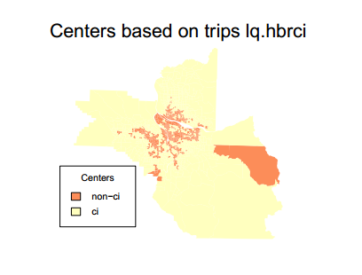

**HBO Location Quotient**

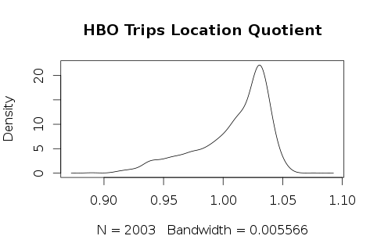

Table 4 HBO Location Quotient Statistical Descriptive

|  |  |  |  |  |  |
| --- | --- | --- | --- | --- | --- |
| Min | 1st Qu | Median | Mean | 3rd Qu | Max |
| 0.8892 | 0.9933 | 1.0180 | 1.0090 | 1.0310 | 1.0760 |

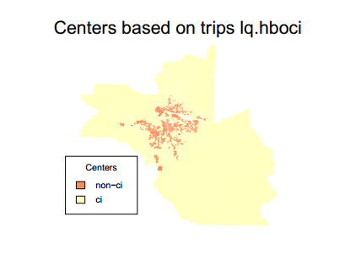

**Centers by trip purpose**

Table 5 Total number of TAZs

|  |  |  |  |  |
| --- | --- | --- | --- | --- |
|  | hbwci | hbsci | hbrci | hboci |
| EMP and SizeTerm | 157 | 549 | 600 | 598 |
| Location Quotient | 481 | 968 | 1277 | 1386 |