CASE STUDY1

* Here I’ve used the classic pipelines and the pipeline is executed successfully with the ‘azurerm -service-connections’.
* But in order to create yaml pipelines, a specific Docker service connection is required with a self hosted agent.
* But the Virtual machine created with low size isn’t supporting the Docker Desktop.
* I’ve tried to create a virtual machine with D series, but as it is a free tier account, the vm agent status is always not ready. Hence, couldn’t go forward with yaml pipelines for this deployment. The first pipeline didn’t get executed as it is yaml pipeline which needs docker setup in the vm agent.

* Here we can see that the Release pipeline got successfully executed in multiple environments.

* In free tier account, creating multiple load balancers in a single AKS cluster isn’t allowed as there is restriction from Azure portal.
* Hence, I’ve created two AKS clusters, for 3 environments.
* Cs1aks contains dev and prod environments, cs1aks2 contains test environment.
* This screenshot shows the namespaces present in cs1aks – dev, prod got successfully created

**Cs1aks :**

* This screenshot shows the workloads, related to dev and prod environment and both are in ready state

* This screenshot shows the external ID address of dev and prod environment

* This screenshot shows the namespaces in second AKS cluster- test environment

* This screenshot shows the workloads in cs1aks2 with test environment and it is in ready state.

* Here we can see the services and also the external IP address of the load balancer for test environment.

**OUTPUT:**

* Here we can see the output for Dev environment.

* Test environment:

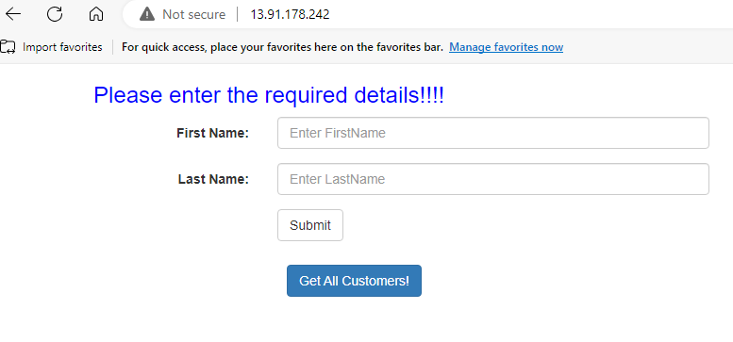

* Prod environment:

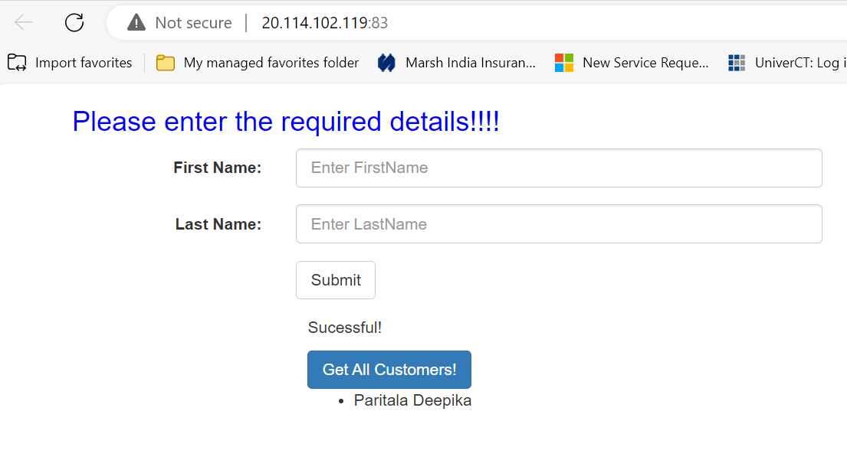

* This screenshot shows the metrics of first AKS cluster- cs1aks. Here I’ve used Number of pods in ready state, Inflight requests.

* This is the alerts created for cs1aks

* This screenshot shows the metrics of second AKS cluster- cs1aks2. Here I’ve used Number of pods in ready state, Inflight requests.

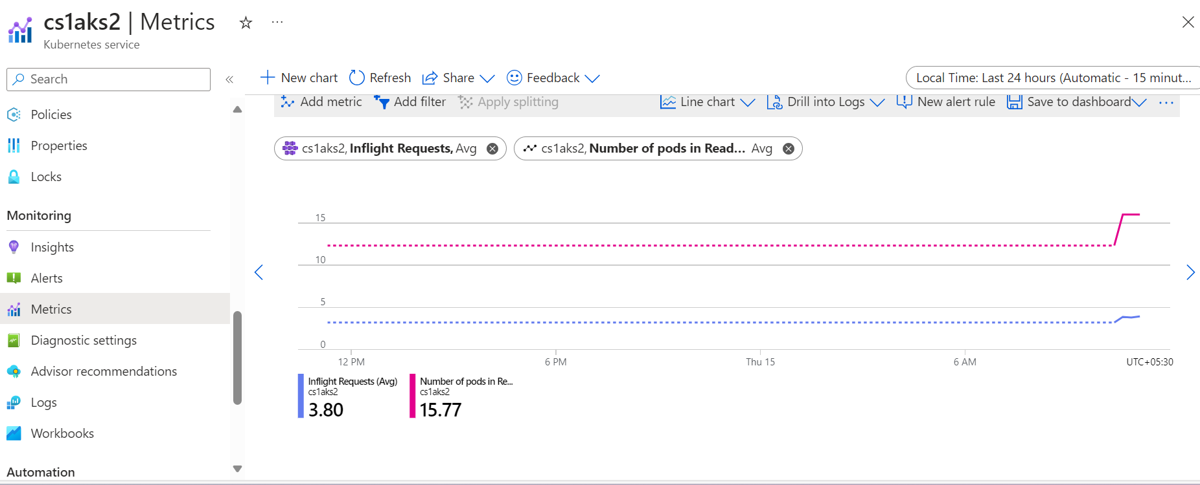

* This is alert rule for cs1aks2

**DEPLOYMENT DIAGRAM:**

