Top of Form

Bottom of Form

**Goals of Networks**

Computer Network means an interconnection of autonomous (standalone) computers for information exchange. The connecting media could be a copper wire, optical fiber, microwave, or satellite.

**Networking Elements –** The computer network includes the following networking elements:

1. At least two computers
2. Transmission medium either wired or wireless
3. Protocols or rules that govern the communication
4. Network software such as Network Operating System

**Network Criteria:**   
The criteria that have to be met by a computer network are:

**1. Performance –** It is measured in terms of transit time and response time.

* Transit time is the time for a message to travel from one device to another
* Response time is the elapsed time between an inquiry and a response.

Performance is dependent on the following factors:

* The number of users
* Type of transmission medium
* Capability of connected network
* Efficiency of software

**2. Reliability –** It is measured in terms of

* Frequency of failure
* Recovery from failures
* Robustness during catastrophe

**3. Security –** It means protecting data from unauthorized access.

**Goals of Computer Networks:** The following are some important goals of computer networks:

1. **Resource Sharing –**   
   Many organization has a substantial number of computers in operations, which are located apart. Ex. A group of office workers can share a common printer, fax, modem, scanner, etc.
2. **High Reliability –**   
   If there are alternate sources of supply, all files could be replicated on two or more machines. If one of them is not available, due to hardware failure, the other copies could be used.
3. **Inter-process Communication –**   
   Network users, located geographically apart, may converse in an interactive session through the network. In order to permit this, the network must provide almost error-free communications.
4. **Flexible access –**   
   Files can be accessed from any computer in the network. The project can be begun on one computer and finished on another.

Other goals include Distribution of processing functions, Centralized management, and allocation of network resources, Compatibility of dissimilar equipment and software, Good network performance, Scalability, Saving money, Access to remote information, Person to person communication, etc. 

## ****Applications of computer networks****

### **1. Resource Sharing**

  Resource sharing is an application of a computer network. Resource sharing means you can share one Hardware and Software among multiple users. Hardware includes printers, Disks, Fax Machines, etc. Computing devices. And Software includes Atom, Oracle VM Virtual Box, Postman, Android Studio, etc.

### **2. Information Sharing**

  Using a Computer network, we can share Information over the network, and it provides Search capabilities such as WWW. Over the network, a single information can be shared among the many users over the internet.

### **3. Communication**

  Communication includes email, calls, message broadcast, electronic funds transfer system etc.

### **4. Entertainment Industry**

 In Entertainment industry also uses computer networks widely. Some of the Entertainment industries are Video on demand, Multiperson real-time simulation games, movie/TV programs, etc.

### **5. Access to Remote Databases**

Computer networks allow us to access the Remote Database of the various applications by the end-users. Some applications are Reservation for Hotels, Airplane Booking, Home Banking, Automated Newspaper, Automated Library etc.

### **6. Home applications**

 There are many common uses of the computer network are as home applications. For example, you can consider user-to-user communication, access to remote instruction, electronic commerce, and entertainment. Another way is managing bank accounts, transferring money to some other banks, paying bills electronically. A computer network arranges a robust connection mechanism between users.

### **7. Business applications**

The result of business application here is resource sharing. And the purpose of resource sharing is that without moving to the physical location of the resource, all the data, plans, and tools can be shared to any network user. Most of the companies are doing business electronically with other companies and with other clients worldwide with the help of a computer network.

### **8. Mobile users**

 The rapidly growing sectors in computer applications are mobile devices like notebook computers and PDAs (personal digital assistants). Here mobile users/device means portable device. The computer network is widely used in new-age technology like smartwatches, wearable devices, tablets, online transactions, purchasing or selling products online, etc.

### **9. Social media**

Social media is also a great example of a computer network application. It helps people to share and receive any information related to political, ethical, and social issues.

# Computer Network Architecture or structure

A **Computer Architecture** is a design in which all computers in a computer network are organized. A architecture defines how the computers should get connected to get the maximum advantages of a computer network such as better response time, security, scalability etc. The two most popular computer architectures are **P2P (Peer to Peer)** and **Client-Server architecture**.

## Peer to Peer Architecture

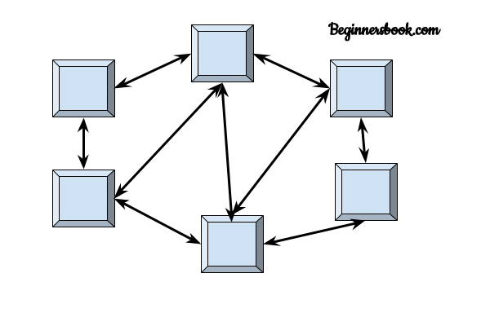  
In peer to peer architecture all the computers in a computer network are connected with every computer in the network. Every computer in the network use the same resources as other computers. There is no central computer that acts as a server rather all computers acts as a server for the data that is stored in them.

### Advantages of a Peer to Peer Architecture

1. Less costly as there is no central server that has to take the backup.  
2. In case of a computer failure all other computers in the network are not affected and they will continue to work as same as before the failure.  
3. Installation of peer to peer architecture is quite easy as each computer manages itself.

### Disadvantages of a Peer to Peer Architecture

1. Each computer has to take the backup rather than a central computer and the security measures are to be taken by all the computers separately.  
2. Scalability is a issue in a peer to Peer Architecture as connecting each computer to every computer is a headache on a very large network.

## Client Server Architecture

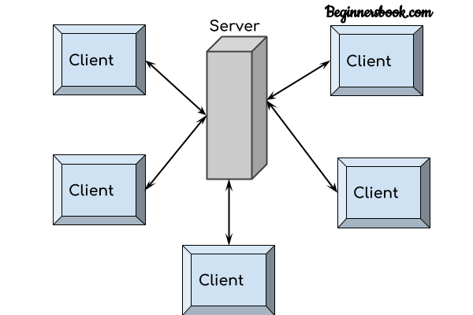  
In Client Server architecture a central computer acts as a hub and serves all the requests from client computers. All the shared data is stored in the server computer which is shared with the client computer when a request is made by the client computer.

All the communication takes place through the server computer, for example if a client computer wants to share the data with other client computer then it has to send the data to server first and then the server will send the data to other client.

### Advantages of Client Server Architecture

1. Data backup is easy and cost effective as there is no need to manage the backup on each computer.  
2. Performance is better as the response time is greatly improves because the server is more powerful computer than the other computers in the network.  
3. Security is better as unauthorised access are denied by server computer and all the data goes through the server.  
4. Scalability is not an issue in this Architecture as large number of computers can be connected with server.

### Disadvantages of Client Server Architecture

1. In case of server failure entire network is down.  
2. Server maintenance cost is high as the server is the main component in this Architecture  
3. Cost is high as the server needs more resources to handle that many client requests and to be able to hold large amount of data.

# Network Services

Computer systems and computerized systems help human beings to work efficiently and explore the unthinkable. When these devices are connected together to form a network, the capabilities are enhanced multiple-times. Some basic services computer network can offer are.

## Directory Services

These services are mapping between name and its value, which can be variable value or fixed. This software system helps to store the information, organize it, and provides various means of accessing it.

* **Accounting**

In an organization, a number of users have their user names and passwords mapped to them. Directory Services provide means of storing this information in cryptic form and make available when requested.

* **Authentication and Authorization**

User credentials are checked to authenticate a user at the time of login and/or periodically. User accounts can be set into hierarchical structure and their access to resources can be controlled using authorization schemes.

* **Domain Name Services**

DNS is widely used and one of the essential services on which internet works. This system maps IP addresses to domain names, which are easier to remember and recall than IP addresses. Because network operates with the help of IP addresses and humans tend to remember website names, the DNS provides website’s IP address which is mapped to its name from the back-end on the request of a website name from the user.

## File Services

File services include sharing and transferring files over the network.

* **File Sharing**

One of the reason which gave birth to networking was file sharing. File sharing enables its users to share their data with other users. User can upload the file to a specific server, which is accessible by all intended users. As an alternative, user can make its file shared on its own computer and provides access to intended users.

* **File Transfer**

This is an activity to copy or move file from one computer to another computer or to multiple computers, with help of underlying network. Network enables its user to locate other users in the network and transfers files.

## Communication Services

* **Email**

Electronic mail is a communication method and something a computer user cannot work without. This is the basis of today’s internet features. Email system has one or more email servers. All its users are provided with unique IDs. When a user sends email to other user, it is actually transferred between users with help of email server.

* **Social Networking**

Recent technologies have made technical life social. The computer savvy peoples, can find other known peoples or friends, can connect with them, and can share thoughts, pictures, and videos.

* **Internet Chat**

Internet chat provides instant text transfer services between two hosts. Two or more people can communicate with each other using text based Internet Relay Chat services. These days, voice chat and video chat are very common.

* **Discussion Boards**

Discussion boards provide a mechanism to connect multiple peoples with same interests.It enables the users to put queries, questions, suggestions etc. which can be seen by all other users. Other may respond as well.

* **Remote Access**

This service enables user to access the data residing on the remote computer. This feature is known as Remote desktop. This can be done via some remote device, e.g. mobile phone or home computer.

## Application Services

These are nothing but providing network based services to the users such as web services, database managing, and resource sharing.

* **Resource Sharing**

To use resources efficiently and economically, network provides a mean to share them. This may include Servers, Printers, and Storage Media etc.

* **Databases**

This application service is one of the most important services. It stores data and information, processes it, and enables the users to retrieve it efficiently by using queries. Databases help organizations to make decisions based on statistics.

* **Web Services**

World Wide Web has become the synonym for internet.It is used to connect to the internet, and access files and information services provided by the internet servers.

# Computer Network Types

A computer network is a group of computers linked to each other that enables the computer to communicate with another computer and share their resources, data, and applications.

A computer network can be categorized by their size. A **computer network** is mainly of **four types**:

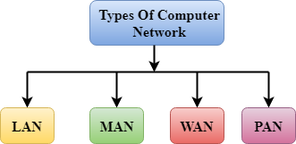

* LAN(Local Area Network)
* PAN(Personal Area Network)
* MAN(Metropolitan Area Network)
* WAN(Wide Area Network)

## LAN(Local Area Network)

* Local Area Network is a group of computers connected to each other in a small area such as building, office.
* LAN is used for connecting two or more personal computers through a communication medium such as twisted pair, coaxial cable, etc.
* It is less costly as it is built with inexpensive hardware such as hubs, network adapters, and ethernet cables.
* The data is transferred at an extremely faster rate in Local Area Network.
* Local Area Network provides higher security.

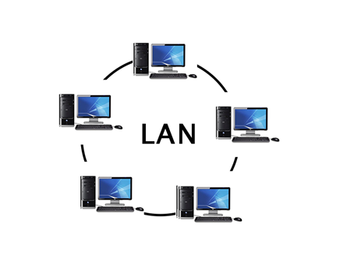

## PAN(Personal Area Network)

* Personal Area Network is a network arranged within an individual person, typically within a range of 10 meters.
* Personal Area Network is used for connecting the computer devices of personal use is known as Personal Area Network.
* **Thomas Zimmerman** was the first research scientist to bring the idea of the Personal Area Network.
* Personal Area Network covers an area of **30 feet**.
* Personal computer devices that are used to develop the personal area network are the laptop, mobile phones, media player and play stations.

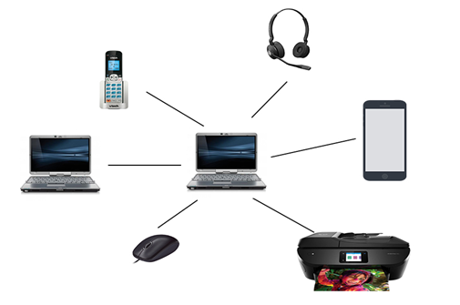

**There are two types of Personal Area Network:**

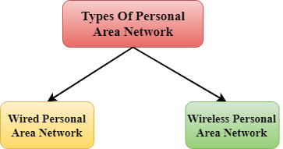

* Wired Personal Area Network
* Wireless Personal Area Network

**Wireless Personal Area Network:** Wireless Personal Area Network is developed by simply using wireless technologies such as WiFi, Bluetooth. It is a low range network.

Play Videox[](https://campaign.adpushup.com/get-started/?utm_source=banner&utm_campaign=growth_hack)

**Wired Personal Area Network:** Wired Personal Area Network is created by using the USB.

### **Examples Of Personal Area Network:**

* **Body Area Network:** Body Area Network is a network that moves with a person. **For example**, a mobile network moves with a person. Suppose a person establishes a network connection and then creates a connection with another device to share the information.
* **Offline Network:** An offline network can be created inside the home, so it is also known as a **home network**. A home network is designed to integrate the devices such as printers, computer, television but they are not connected to the internet.
* **Small Home Office:** It is used to connect a variety of devices to the internet and to a corporate network using a VPN

## MAN(Metropolitan Area Network)

* A metropolitan area network is a network that covers a larger geographic area by interconnecting a different LAN to form a larger network.
* Government agencies use MAN to connect to the citizens and private industries.
* In MAN, various LANs are connected to each other through a telephone exchange line.
* The most widely used protocols in MAN are RS-232, Frame Relay, ATM, ISDN, OC-3, ADSL, etc.
* It has a higher range than Local Area Network(LAN).

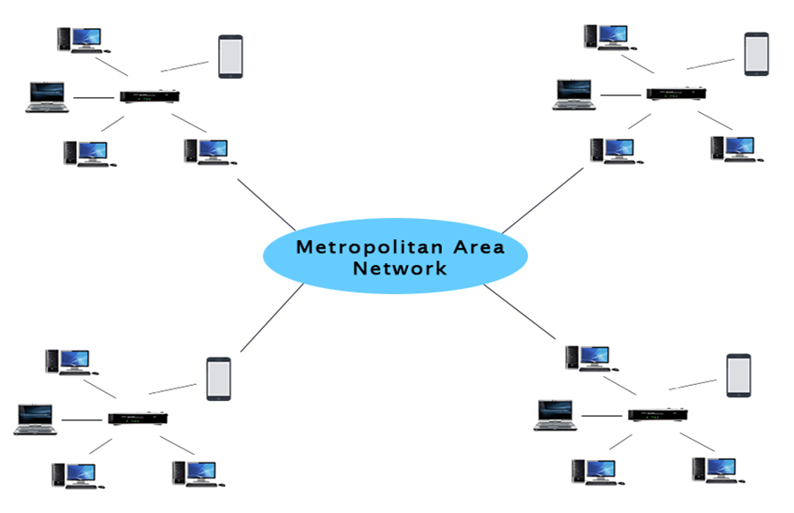

### **Uses Of Metropolitan Area Network:**

* MAN is used in communication between the banks in a city.
* It can be used in an Airline Reservation.
* It can be used in a college within a city.
* It can also be used for communication in the military.

## WAN(Wide Area Network)

* A Wide Area Network is a network that extends over a large geographical area such as states or countries.
* A Wide Area Network is quite bigger network than the LAN.
* A Wide Area Network is not limited to a single location, but it spans over a large geographical area through a telephone line, fibre optic cable or satellite links.
* The internet is one of the biggest WAN in the world.
* A Wide Area Network is widely used in the field of Business, government, and education.

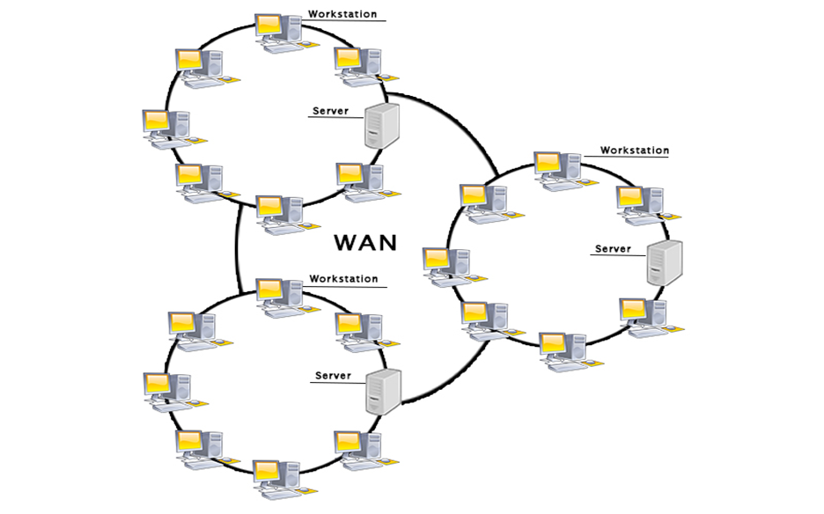

### **Examples Of Wide Area Network:**

* **Mobile Broadband:** A 4G network is widely used across a region or country.
* **Last mile:** A telecom company is used to provide the internet services to the customers in hundreds of cities by connecting their home with fiber.
* **Private network:** A bank provides a private network that connects the 44 offices. This network is made by using the telephone leased line provided by the telecom company.

### **Advantages Of Wide Area Network:**

Following are the advantages of the Wide Area Network:

* **Geographical area:** A Wide Area Network provides a large geographical area. Suppose if the branch of our office is in a different city then we can connect with them through WAN. The internet provides a leased line through which we can connect with another branch.
* **Centralized data:** In case of WAN network, data is centralized. Therefore, we do not need to buy the emails, files or back up servers.
* **Get updated files:** Software companies work on the live server. Therefore, the programmers get the updated files within seconds.
* **Exchange messages:** In a WAN network, messages are transmitted fast. The web application like Facebook, Whatsapp, Skype allows you to communicate with friends.
* **Sharing of software and resources:** In WAN network, we can share the software and other resources like a hard drive, RAM.
* **Global business:** We can do the business over the internet globally.
* **High bandwidth:** If we use the leased lines for our company then this gives the high bandwidth. The high bandwidth increases the data transfer rate which in turn increases the productivity of our company.

### **Disadvantages of Wide Area Network:**

The following are the disadvantages of the Wide Area Network:

* **Security issue:** A WAN network has more security issues as compared to LAN and MAN network as all the technologies are combined together that creates the security problem.
* **Needs Firewall & antivirus software:** The data is transferred on the internet which can be changed or hacked by the hackers, so the firewall needs to be used. Some people can inject the virus in our system so antivirus is needed to protect from such a virus.
* **High Setup cost:** An installation cost of the WAN network is high as it involves the purchasing of routers, switches.
* **Troubleshooting problems:** It covers a large area so fixing the problem is difficult.

## Internetwork

* An internetwork is defined as two or more computer network LANs or WAN or computer network segments are connected using devices, and they are configured by a local addressing scheme. This process is known as **internetworking**.
* An interconnection between public, private, commercial, industrial, or government computer networks can also be defined as **internetworking**.
* An internetworking uses the **internet protocol**.
* The reference model used for internetworking is **Open System Interconnection(OSI)**.

## Types Of Internetwork:

1. **Extranet:** An extranet is a communication network based on the internet protocol such as **Transmission Control protocol** and **internet protocol**. It is used for information sharing. The access to the extranet is restricted to only those users who have login credentials. An extranet is the lowest level of internetworking. It can be categorized as **MAN**, **WAN** or other computer networks. An extranet cannot have a single **LAN**, atleast it must have one connection to the external network.

2. **Intranet:** An intranet is a private network based on the internet protocol such as **Transmission Control protocol** and **internet protocol**. An intranet belongs to an organization which is only accessible by the **organization's employee** or members. The main aim of the intranet is to share the information and resources among the organization employees. An intranet provides the facility to work in groups and for teleconferences.

## Intranet advantages:

* **Communication:** It provides a cheap and easy communication. An employee of the organization can communicate with another employee through email, chat.
* **Time-saving:** Information on the intranet is shared in real time, so it is time-saving.
* **Collaboration:** Collaboration is one of the most important advantage of the intranet. The information is distributed among the employees of the organization and can only be accessed by the authorized user.
* **Platform independency:** It is a neutral architecture as the computer can be connected to another device with different architecture.
* **Cost effective:** People can see the data and documents by using the browser and distributes the duplicate copies over the intranet. This leads to a reduction in the cost.

# Network Standardization

[More Detail](https://www.tutorialspoint.com/computer_organization/index.asp" \t "_blank)

[](https://www.tutorialspoint.com/computer_networks/index.asp)

[More Detail](https://www.tutorialspoint.com/computer_networks/index.asp" \t "_blank)

[](https://www.tutorialspoint.com/computer_graphics/index.asp)

[More Detail](https://www.tutorialspoint.com/computer_graphics/index.asp" \t "_blank)

## Network Standards

Networking standards define the rules for data communications that are needed for interoperability of networking technologies and processes. Standards help in creating and maintaining open markets and allow different vendors to compete on the basis of the quality of their products while being compatible with existing market products.

During data communication, a number of standards may be used simultaneously at the different layers. The commonly used standards at each layer are −

* **Application layer −** HTTP, HTML, POP, H.323, IMAP
* **Transport layer −** TCP, SPX
* **Network layer −**IP, IPX
* **Data link layer −** Ethernet IEEE 802.3, X.25, Frame Relay
* **Physical layer −**RS-232C (cable), V.92 (modem)

## Types of Standards

**Standards are of two types**

* **De facto −** These are the standards that are followed without any formal plan or approval by any organization. They have come into existence due to traditions or facts. For example, the HTTP had started as a de facto standard.
* **De jure −** These standards are the ones which have been adopted through legislation by any officially recognized standards organization. Most of the communication standards that are used today are de jure standards.

## Standards Organizations

**Some of the noted standards organizations are**

* International Standards Organization (ISO)
* International Telecommunication Union (ITU)
* Institute of Electronics and Electrical Engineers (IEEE)
* American National Standards Institute (ANSI)
* Internet Research Task Force (IETF)
* Electronic Industries Association (EIA)

# What is Network Topology?

Topology defines the structure of the network of how all the components are interconnected to each other. There are two types of topology: physical and logical topology.

## Types of Network Topology

Physical topology is the geometric representation of all the nodes in a network. There are six types of network topology which are Bus Topology, Ring Topology, Tree Topology, Star Topology, Mesh Topology, and Hybrid Topology.

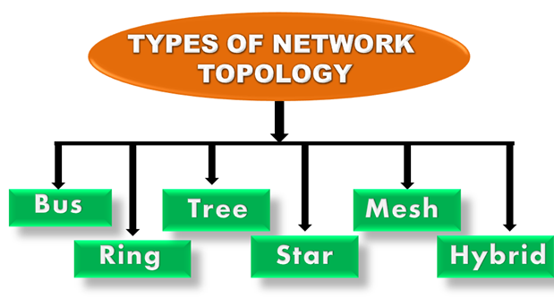

## 1) Bus Topology

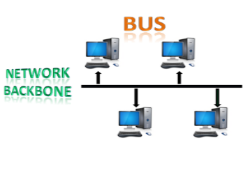

* The bus topology is designed in such a way that all the stations are connected through a single cable known as a backbone cable.
* Each node is either connected to the backbone cable by drop cable or directly connected to the backbone cable.
* When a node wants to send a message over the network, it puts a message over the network. All the stations available in the network will receive the message whether it has been addressed or not.
* The bus topology is mainly used in 802.3 (ethernet) and 802.4 standard networks.
* The configuration of a bus topology is quite simpler as compared to other topologies.
* The backbone cable is considered as a **"single lane"** through which the message is broadcast to all the stations.
* The most common access method of the bus topologies is **CSMA** (Carrier Sense Multiple Access).

**CSMA:** It is a media access control used to control the data flow so that data integrity is maintained, i.e., the packets do not get lost. There are two alternative ways of handling the problems that occur when two nodes send the messages simultaneously.

* **CSMA CD:** CSMA CD (**Collision detection**) is an access method used to detect the collision. Once the collision is detected, the sender will stop transmitting the data. Therefore, it works on "**recovery after the collision**".
* **CSMA CA:** **CSMA CA (Collision Avoidance)** is an access method used to avoid the collision by checking whether the transmission media is busy or not. If busy, then the sender waits until the media becomes idle. This technique effectively reduces the possibility of the collision. It does not work on "recovery after the collision".

### **Advantages of Bus topology:**

* **Low-cost cable:** In bus topology, nodes are directly connected to the cable without passing through a hub. Therefore, the initial cost of installation is low.
* **Moderate data speeds:** Coaxial or twisted pair cables are mainly used in bus-based networks that support upto 10 Mbps.
* **Familiar technology:** Bus topology is a familiar technology as the installation and troubleshooting techniques are well known, and hardware components are easily available.
* **Limited failure:** A failure in one node will not have any effect on other nodes.

### **Disadvantages of Bus topology:**

* **Extensive cabling:** A bus topology is quite simpler, but still it requires a lot of cabling.
* **Difficult troubleshooting:** It requires specialized test equipment to determine the cable faults. If any fault occurs in the cable, then it would disrupt the communication for all the nodes.
* **Signal interference:** If two nodes send the messages simultaneously, then the signals of both the nodes collide with each other.
* **Reconfiguration difficult:** Adding new devices to the network would slow down the network.
* **Attenuation:** Attenuation is a loss of signal leads to communication issues. Repeaters are used to regenerate the signal.

## 2) Ring Topology

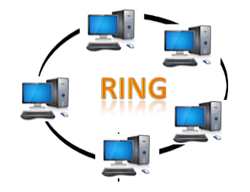

* Ring topology is like a bus topology, but with connected ends.
* The node that receives the message from the previous computer will retransmit to the next node.
* The data flows in one direction, i.e., it is unidirectional.
* The data flows in a single loop continuously known as an endless loop.
* It has no terminated ends, i.e., each node is connected to other node and having no termination point.
* The data in a ring topology flow in a clockwise direction.
* The most common access method of the ring topology is **token passing**.
  + **Token passing:** It is a network access method in which token is passed from one node to another node.
  + **Token:** It is a frame that circulates around the network.

### **Working of Token passing**

* A token moves around the network, and it is passed from computer to computer until it reaches the destination.
* The sender modifies the token by putting the address along with the data.
* The data is passed from one device to another device until the destination address matches. Once the token received by the destination device, then it sends the acknowledgment to the sender.
* In a ring topology, a token is used as a carrier.

### **Advantages of Ring topology:**

* **Network Management:** Faulty devices can be removed from the network without bringing the network down.
* **Product availability:** Many hardware and software tools for network operation and monitoring are available.
* **Cost:** Twisted pair cabling is inexpensive and easily available. Therefore, the installation cost is very low.
* **Reliable:** It is a more reliable network because the communication system is not dependent on the single host computer.

### **Disadvantages of Ring topology:**

* **Difficult troubleshooting:** It requires specialized test equipment to determine the cable faults. If any fault occurs in the cable, then it would disrupt the communication for all the nodes.
* **Failure:** The breakdown in one station leads to the failure of the overall network.
* **Reconfiguration difficult:** Adding new devices to the network would slow down the network.
* **Delay:** Communication delay is directly proportional to the number of nodes. Adding new devices increases the communication delay.

## 3) Star Topology

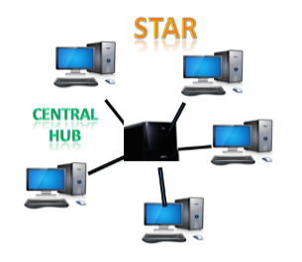

* Star topology is an arrangement of the network in which every node is connected to the central hub, switch or a central computer.
* The central computer is known as a **server**, and the peripheral devices attached to the server are known as **clients**.
* Coaxial cable or RJ-45 cables are used to connect the computers.
* Hubs or Switches are mainly used as connection devices in a **physical star topology**.
* Star topology is the most popular topology in network implementation.

### **Advantages of Star topology**

* **Efficient troubleshooting:** Troubleshooting is quite efficient in a star topology as compared to bus topology. In a bus topology, the manager has to inspect the kilometers of cable. In a star topology, all the stations are connected to the centralized network. Therefore, the network administrator has to go to the single station to troubleshoot the problem.
* **Network control:** Complex network control features can be easily implemented in the star topology. Any changes made in the star topology are automatically accommodated.
* **Limited failure:** As each station is connected to the central hub with its own cable, therefore failure in one cable will not affect the entire network.
* **Familiar technology:** Star topology is a familiar technology as its tools are cost-effective.
* **Easily expandable:** It is easily expandable as new stations can be added to the open ports on the hub.
* **Cost effective:** Star topology networks are cost-effective as it uses inexpensive coaxial cable.
* **High data speeds:** It supports a bandwidth of approx 100Mbps. Ethernet 100BaseT is one of the most popular Star topology networks.

### **Disadvantages of Star topology**

* **A Central point of failure:** If the central hub or switch goes down, then all the connected nodes will not be able to communicate with each other.
* **Cable:** Sometimes cable routing becomes difficult when a significant amount of routing is required.

## 4) Tree topology

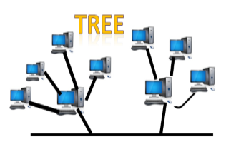

* Tree topology combines the characteristics of bus topology and star topology.
* A tree topology is a type of structure in which all the computers are connected with each other in hierarchical fashion.
* The top-most node in tree topology is known as a root node, and all other nodes are the descendants of the root node.
* There is only one path exists between two nodes for the data transmission. Thus, it forms a parent-child hierarchy.

### **Advantages of Tree topology**

* **Support for broadband transmission:** Tree topology is mainly used to provide broadband transmission, i.e., signals are sent over long distances without being attenuated.
* **Easily expandable:** We can add the new device to the existing network. Therefore, we can say that tree topology is easily expandable.
* **Easily manageable:** In tree topology, the whole network is divided into segments known as star networks which can be easily managed and maintained.
* **Error detection:** Error detection and error correction are very easy in a tree topology.
* **Limited failure:** The breakdown in one station does not affect the entire network.
* **Point-to-point wiring:** It has point-to-point wiring for individual segments.

### **Disadvantages of Tree topology**

* **Difficult troubleshooting:** If any fault occurs in the node, then it becomes difficult to troubleshoot the problem.
* **High cost:** Devices required for broadband transmission are very costly.
* **Failure:** A tree topology mainly relies on main bus cable and failure in main bus cable will damage the overall network.
* **Reconfiguration difficult:** If new devices are added, then it becomes difficult to reconfigure.

## 5) Mesh topology

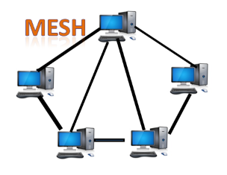

* Mesh technology is an arrangement of the network in which computers are interconnected with each other through various redundant connections.
* There are multiple paths from one computer to another computer.
* It does not contain the switch, hub or any central computer which acts as a central point of communication.
* The Internet is an example of the mesh topology.
* Mesh topology is mainly used for WAN implementations where communication failures are a critical concern.
* Mesh topology is mainly used for wireless networks.
* Mesh topology can be formed by using the formula:  
  **Number of cables = (n\*(n-1))/2;**

Where n is the number of nodes that represents the network.

Play Videox[](https://campaign.adpushup.com/get-started/?utm_source=banner&utm_campaign=growth_hack)

**Mesh topology is divided into two categories:**

* Fully connected mesh topology
* Partially connected mesh topology

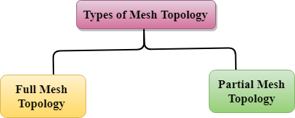

* **Full Mesh Topology:** In a full mesh topology, each computer is connected to all the computers available in the network.
* **Partial Mesh Topology:** In a partial mesh topology, not all but certain computers are connected to those computers with which they communicate frequently.

### **Advantages of Mesh topology:**

**Reliable:** The mesh topology networks are very reliable as if any link breakdown will not affect the communication between connected computers.

**Fast Communication:** Communication is very fast between the nodes.

**Easier Reconfiguration:** Adding new devices would not disrupt the communication between other devices.

### **Disadvantages of Mesh topology**

* **Cost:** A mesh topology contains a large number of connected devices such as a router and more transmission media than other topologies.
* **Management:** Mesh topology networks are very large and very difficult to maintain and manage. If the network is not monitored carefully, then the communication link failure goes undetected.
* **Efficiency:** In this topology, redundant connections are high that reduces the efficiency of the network.

## 6) Hybrid Topology

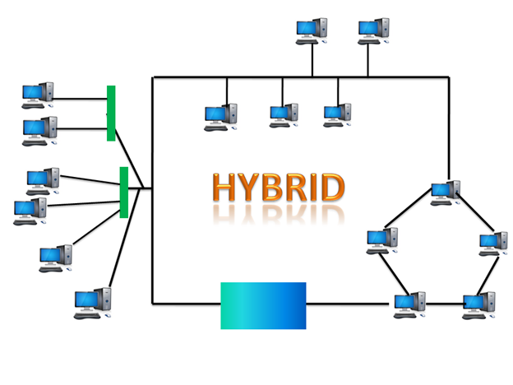

* The combination of various different topologies is known as **Hybrid topology**.
* A Hybrid topology is a connection between different links and nodes to transfer the data.
* When two or more different topologies are combined together is termed as Hybrid topology and if similar topologies are connected with each other will not result in Hybrid topology. For example, if there exist a ring topology in one branch of ICICI bank and bus topology in another branch of ICICI bank, connecting these two topologies will result in Hybrid topology.

### **Advantages of Hybrid Topology**

* **Reliable:** If a fault occurs in any part of the network will not affect the functioning of the rest of the network.
* **Scalable:** Size of the network can be easily expanded by adding new devices without affecting the functionality of the existing network.
* **Flexible:** This topology is very flexible as it can be designed according to the requirements of the organization.
* **Effective:** Hybrid topology is very effective as it can be designed in such a way that the strength of the network is maximized and weakness of the network is minimized.

### **Disadvantages of Hybrid topology**

* **Complex design:** The major drawback of the Hybrid topology is the design of the Hybrid network. It is very difficult to design the architecture of the Hybrid network.
* **Costly Hub:** The Hubs used in the Hybrid topology are very expensive as these hubs are different from usual Hubs used in other topologies.
* **Costly infrastructure:** The infrastructure cost is very high as a hybrid network requires a lot of cabling, network devices, etc.

# What is Transmission media?

* Transmission media is a communication channel that carries the information from the sender to the receiver. Data is transmitted through the electromagnetic signals.
* The main functionality of the transmission media is to carry the information in the form of bits through **LAN**(Local Area Network).
* It is a physical path between transmitter and receiver in data communication.
* In a copper-based network, the bits in the form of electrical signals.
* In a fibre based network, the bits in the form of light pulses.
* In **OSI**(Open System Interconnection) phase, transmission media supports the Layer 1. Therefore, it is considered to be as a Layer 1 component.
* The electrical signals can be sent through the copper wire, fibre optics, atmosphere, water, and vacuum.
* The characteristics and quality of data transmission are determined by the characteristics of medium and signal.
* Transmission media is of two types are wired media and wireless media. In wired media, medium characteristics are more important whereas, in wireless media, signal characteristics are more important.
* Different transmission media have different properties such as bandwidth, delay, cost and ease of installation and maintenance.
* The transmission media is available in the lowest layer of the OSI reference model, i.e., **Physical layer**.

### **Some factors need to be considered for designing the transmission media:**

* **Bandwidth:** All the factors are remaining constant, the greater the bandwidth of a medium, the higher the data transmission rate of a signal.
* **Transmission impairment:** When the received signal is not identical to the transmitted one due to the transmission impairment. The quality of the signals will get destroyed due to transmission impairment.
* **Interference:** An interference is defined as the process of disrupting a signal when it travels over a communication medium on the addition of some unwanted signal.

## Causes Of Transmission Impairment:

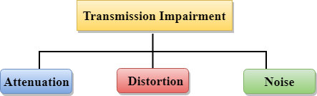

* **Attenuation:** Attenuation means the loss of energy, i.e., the strength of the signal decreases with increasing the distance which causes the loss of energy.
* **Distortion:** Distortion occurs when there is a change in the shape of the signal. This type of distortion is examined from different signals having different frequencies. Each frequency component has its own propagation speed, so they reach at a different time which leads to the delay distortion.
* **Noise:** When data is travelled over a transmission medium, some unwanted signal is added to it which creates the noise.

## Classification Of Transmission Media:

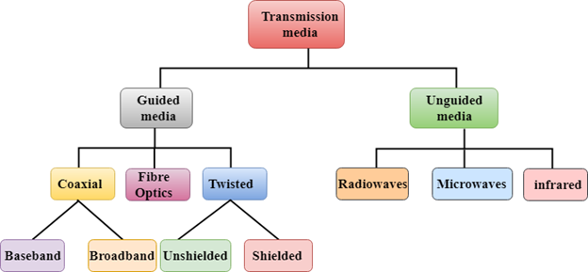

* [Guided Transmission Media](https://www.javatpoint.com/guided-transmission-media)
* [UnGuided Transmission Media](https://www.javatpoint.com/unguided-transmission-media)

# Guided Media

It is defined as the physical medium through which the signals are transmitted. It is also known as Bounded media.

Types Of Guided media:

## Twisted pair:

Twisted pair is a physical media made up of a pair of cables twisted with each other. A twisted pair cable is cheap as compared to other transmission media. Installation of the twisted pair cable is easy, and it is a lightweight cable. The frequency range for twisted pair cable is from 0 to 3.5KHz.

A twisted pair consists of two insulated copper wires arranged in a regular spiral pattern.

4M

Discontinued 3G Networks Are Affecting Millions of Vehicle Owners

**Next**

**Stay**

The degree of reduction in noise interference is determined by the number of turns per foot. Increasing the number of turns per foot decreases noise interference.

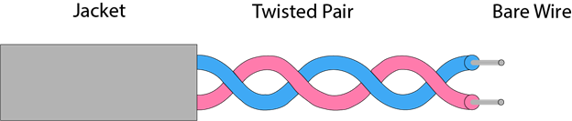

**Types of Twisted pair:**

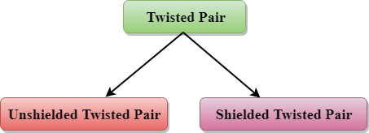

### **Unshielded Twisted Pair:**

An unshielded twisted pair is widely used in telecommunication. Following are the categories of the unshielded twisted pair cable:

* **Category 1:** Category 1 is used for telephone lines that have low-speed data.
* **Category 2:** It can support upto 4Mbps.
* **Category 3:** It can support upto 16Mbps.
* **Category 4:** It can support upto 20Mbps. Therefore, it can be used for long-distance communication.
* **Category 5:** It can support upto 200Mbps.

**Advantages Of Unshielded Twisted Pair:**

* It is cheap.
* Installation of the unshielded twisted pair is easy.
* It can be used for high-speed LAN.

**Disadvantage:**

* This cable can only be used for shorter distances because of attenuation.

### **Shielded Twisted Pair**

A shielded twisted pair is a cable that contains the mesh surrounding the wire that allows the higher transmission rate.

**Characteristics Of Shielded Twisted Pair:**

* The cost of the shielded twisted pair cable is not very high and not very low.
* An installation of STP is easy.
* It has higher capacity as compared to unshielded twisted pair cable.
* It has a higher attenuation.
* It is shielded that provides the higher data transmission rate.

**Disadvantages**

* It is more expensive as compared to UTP and coaxial cable.
* It has a higher attenuation rate.

## Coaxial Cable

* Coaxial cable is very commonly used transmission media, for example, TV wire is usually a coaxial cable.
* The name of the cable is coaxial as it contains two conductors parallel to each other.
* It has a higher frequency as compared to Twisted pair cable.
* The inner conductor of the coaxial cable is made up of copper, and the outer conductor is made up of copper mesh. The middle core is made up of non-conductive cover that separates the inner conductor from the outer conductor.
* The middle core is responsible for the data transferring whereas the copper mesh prevents from the **EMI**(Electromagnetic interference).

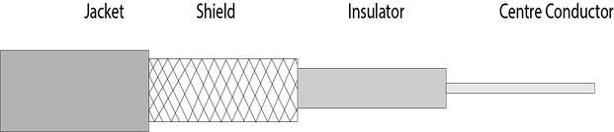

**Coaxial cable is of two types:**

1. **Baseband transmission:** It is defined as the process of transmitting a single signal at high speed.
2. **Broadband transmission:** It is defined as the process of transmitting multiple signals simultaneously.

**Advantages Of Coaxial cable:**

* The data can be transmitted at high speed.
* It has better shielding as compared to twisted pair cable.
* It provides higher bandwidth.

**Disadvantages Of Coaxial cable:**

* It is more expensive as compared to twisted pair cable.
* If any fault occurs in the cable causes the failure in the entire network.

## Fibre Optic

* Fibre optic cable is a cable that uses electrical signals for communication.
* Fibre optic is a cable that holds the optical fibres coated in plastic that are used to send the data by pulses of light.
* The plastic coating protects the optical fibres from heat, cold, electromagnetic interference from other types of wiring.
* Fibre optics provide faster data transmission than copper wires.

**Diagrammatic representation of fibre optic cable:**

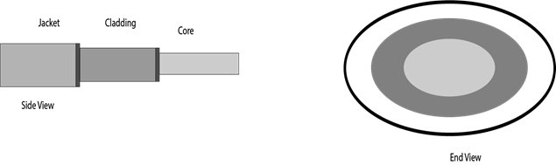

**Basic elements of Fibre optic cable:**

* **Core:** The optical fibre consists of a narrow strand of glass or plastic known as a core. A core is a light transmission area of the fibre. The more the area of the core, the more light will be transmitted into the fibre.
* **Cladding:** The concentric layer of glass is known as cladding. The main functionality of the cladding is to provide the lower refractive index at the core interface as to cause the reflection within the core so that the light waves are transmitted through the fibre.
* **Jacket:** The protective coating consisting of plastic is known as a jacket. The main purpose of a jacket is to preserve the fibre strength, absorb shock and extra fibre protection.

**Following are the advantages of fibre optic cable over copper:**

* **Greater Bandwidth:** The fibre optic cable provides more bandwidth as compared copper. Therefore, the fibre optic carries more data as compared to copper cable.
* **Faster speed:** Fibre optic cable carries the data in the form of light. This allows the fibre optic cable to carry the signals at a higher speed.
* **Longer distances:** The fibre optic cable carries the data at a longer distance as compared to copper cable.
* **Better reliability:** The fibre optic cable is more reliable than the copper cable as it is immune to any temperature changes while it can cause obstruct in the connectivity of copper cable.
* **Thinner and Sturdier:** Fibre optic cable is thinner and lighter in weight so it can withstand more pull pressure than copper cable.

Next Topic[UnGuided Media](https://www.javatpoint.com/unguided-transmission-media)