Nama : Citra Febriawirti

Tugas : Day -2

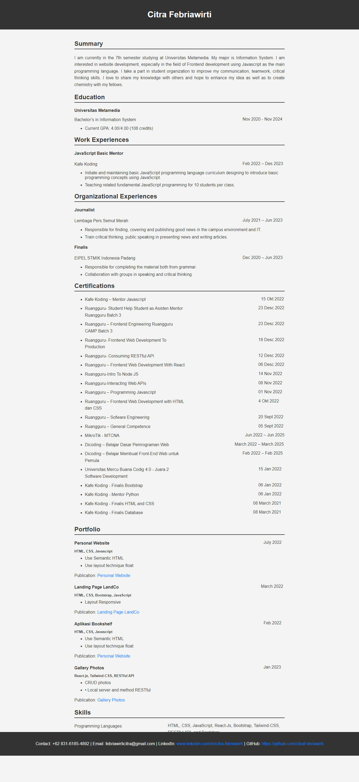

Code : <https://github.com/citraFebriawirti/PBI-NDPNusantech/tree/day-2>