# ECSE-48750 Term Project

## Team:

Tom Citriniti, Yu Chen

## Project Name:

Personal Robbie

## Pitch:

Everyone deserves his or her own robot, now you can own your own personal dancing robot.

## Description:

The Robbie project is an app that allows users to gain access to their own personal dancing robot. Robbie is a 3D generated robot with user customizable controls that allows you to define and control how Robbie moves.

The app allows users to define key time frames that define a robot position in time and then sequence multiple key time frames into an animation sequence. The goal is to generate a sequence of movements that allows the user to create custom movements and the app will interpolate between these key frames to generate a smooth experience.

## The App:

The app is designed to allow maximum control over how Robbie moves and responds to users controls.

The geometries are created in a graph-based approach to maximize performance and also allow for a realistic movement in response to user commands. The model definition is based on work previously done in a research project that experimented with the various methods of controlling a robot movements based on human characteristics.

The system is written in JavaScript and utilizes the WebGL capabilities of various browsers and platforms and builds on the Babylon library capabilities to handle scene organization, lights, cameras, and viewpoint interactors.

The goal is to experiment with the proper controllers to define how best to make the robot move in a realistic fashion. Currently the UI is based on Figure 1.

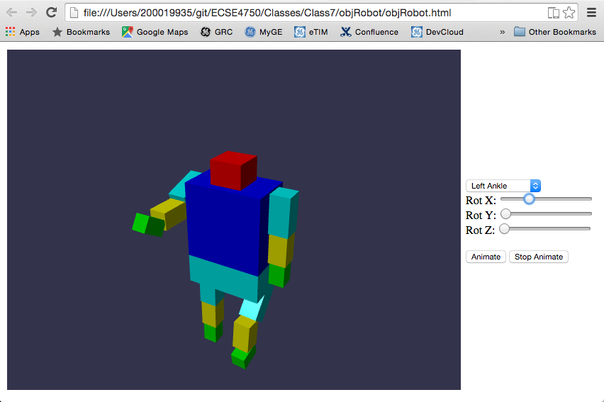

Figure

The user is allowed to modify the robot at various stages in the time sequence and the app will allow a smooth transition of how the robot moves based on these key time frames.

Current application controls allow for limited robot movements and in future releases the emphasis will be on user experience and the best methods to position and define key frames. Additional work will be done to create a customized animation sequencer with stock animation sequences that users can use as templates and augment for specific movement types.