Club Membership Application
Description:
The club membership application is for the Swedish Club of Western Australia. Until now the Club has had only a very basic public website, with virtually no back-end support. Their membership was previously maintained on an Excel spread-sheet and was not very efficient. The new aim is to build a web application to handle the day-to-day maintenance of the Club’s members.
Setting up the repository:
Requirements:
- Git (https://help.github.com/articles/set-up-git)
- A webserver (i.e Apache)
- PHP installation (version 5.0+)
- A text editor (such as notepad++)
- MySQL database
Setting up:
This walkthrough will focus specifically on getting the repository working locally with an installation of XAMPP (web package, includes PHP, Apache and more http://www.apachefriends.org/en/xampp.html ). The prologue will cover installing XAMPP and setting up, so if you already have a web-server and PHP set up, you can skip to the main content. If you’ve already worked with repositories and web applications before, you can skip to the content overview.
Prologue; Setting up your web-server with XAMPP:
XAMPP makes things very easy. Go to the XAMPP download page (link above) and download a copy of XAMPP for your operating system. Run the installer and follow the prompts to install XAMPP on your computer. The default installation path is C:\xampp for windows, but if you lack administrator rights you should install it elsewhere. From now on I’ll simply refer to XAMPP’s installation as %XAMPP%.
Once XAMPP is installed, open up %XAMPP%/xampp-control.exe. Start both Apache and MySQL. Once Apache has been started successfully, http://localhost/ now connects to your %XAMPP%/htdocs/ folder. Verify that Apache is running by visiting this link: http://localhost/index.html
If you prefer to map your server to a different directory other than %XAMPP%/htdocs/ you can edit this in %XAMPP%/apache/conf/httpd.conf by changing the value of the “DocumentRoot” value. Once XAMPP is set up and Apache is running, you are ready to continue.

Step 1a (optional); configure Git:
Essentially reiterating what’s on https://help.github.com/articles/set-up-git . Set your global username and email address. You can also optionally set up the password cache, but this is non-essential and up to you to figure out if you wish to use it or not.
If you are using windows, it’s a good idea to update your PATH environment variable to point to Git’s bin directory. See google on how to view and change your Environment Variables. Once you have the environment variables in front of you, edit the PATH variable. The folders are delimited with a semi-colon, so ensure that there is one between the last path and the one you’re about to add. Append the path to your Git\bin directory to the end and save the changes. An example of what the PATH variable could look like is shown below:
B:\xampp\php\;B:\Programs\Git\bin\;
Step 1b: Get the repository:
The Club Membership Application repository is publicly available on GitHub @ https://github.com/cits3200-project/Club-Membership-Application
You will need to clone the repository from GitHub (using the above link). You can do this in a variety of ways, with the easiest being to clone the repository from the github link above (via the Clone button on the web-page). However, it may do you some good to start getting used to using Git from the command line as it will be used extensively throughout the tutorial. Open up a command prompt and mimic the following (note: Git will automatically create a directory for the repository so you don’t need to make one beforehand)
>cd path/to/server/root
>git clone https://github.com/cits3200-project/Club-Membership-Application.git
>cd Club-Membership-Application
>git remote add origin https://github.com/cits3200-project/Club-Membership-Application.git
>git status

It’s as easy as that. Git will now proceed to get all the latest files from the repository and clone them onto your local computer so that you can work on them. Then you can change into the repository directory, set the remote git server and gets the status of the repository. If everything worked correctly, your console should output something like the following:
# On branch master
nothing to commit (working directory clean)

Now you are all set to begin working on the repository.

Step 2; Get comfortable with Git.
Disambiguation: Just to clarify, a “commit” doesn’t put the files onto the server, rather just commits a local version for your own use. To put your latest commit onto the server repository, you need to “push” your local repo into the remote environment (detailed below).
Resource: http://git-scm.com/book/en/Git-Basics
If this is your first time using Git, now is the time to learn the basics of the command line controls for Git. For the most part, you only need to be familiar with a handful of commands:
>git add <options>
Or
>git add –u
http://www.kernel.org/pub/software/scm/git/docs/git-add.html
You’ll need to use this before committing your changes (when creating new files or deleting existing ones). The second example is just an easy way to track all your changes and stage them for the next commit.
>git commit –m “Your commit message here”
http://www.kernel.org/pub/software/scm/git/docs/git-commit.html
Commit your local changes to the local repository. The –m switch indicates what the commit message you’d like to associate with the current commit.

>git push origin master
http://www.kernel.org/pub/software/scm/git/docs/git-push.html
Push your latest commit to the central repo. “origin” refers to the remote server defined in Step 1b, “master” refers to the branch you are committing to. At the time of writing this the repository isn’t likely to be used very much, so there is only one branch: the master branch.

Step 3; Setting up the application.
The application has a back-end component, and requires some configuration to run in your local environment. You will first need to create a new MySQL database on your webserver. If, like me, you are using XAMPP, this is fairly straightforward. Navigate your browser to http://localhost/phpmyadmin/index.php to begin. Once you have created a new database, you can either import, or manually paste the SQL contained in the repository’s /protected/data/schema.sql file into phpMyAdmin. Once run, the necessary schema will be created locally.
The application is built upon the PHP-based Yii MVC framework. There are some minor configuration changes that you will need to make (and some others you might want to make anyway) to get the application running.
Open the /protected/config/main.php file with any text editor to set up the configuration settings for Yii. Specifically, you will need to change the following section:
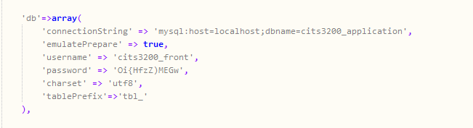
Figure 1. database configuration

To mimic your own database settings. Optionally, you can also run the testdata.sql script in the data folder to insert some dummy data and initialize an admin account.
Finally, there is one more thing you will need to change, the root-directory’s .htaccess file. This is the .htaccess file sitting in the top level of the repository. Open up the file and you will see a line similar to the following:
RewriteBase /cits3200/club-membership-application/
You will need to change /cits3200/club-membership-application/ to the path of your repository, relative to you apache server root. If you installed the repository directly in your server root, you should change this line to:
RewriteBase /club-membership-application/
The application, at this stage, should be ready to run via
http://localhost/<repository-directory>/index.php .
The <repository-directory> should match the path you just specified for the .htaccess RewriteBase.
Application Workflow:
To understand the application, it’s best to get an idea of how the Yii framework works. However, a brief summary of the application’s current workflow is below. Also, the application is based on the MVC design pattern, so a general idea of how that fits together is advisable.
The foundation of the Yii framework is that all interactions with the application enter through a single point, index.php (in the root directory of the repo). From this point, Yii begins to run the application according to the URL. The exact way that Yii treats the URL is detailed in the config file (protected/config/main.php), but at the time of writing the pattern in as follows:
<bootstrap(index.php)>/<controller>/<action>
The application controllers can be found in protected/controllers/. Within each controller file, you will find a list of functions prefixed with the word “action”. These functions each correspond to a “page” within the controller. To give a better idea of the structure, consider the following url:
http://localhost/index.php/site/index
As stated earlier, all requests go through the root index.php file. Following the format about, that would make the controller for this request “site”. Yii’s naming convention stipulates that the controller file be then called “SiteController.php”. Moving to the next section of the url, “index”. This is the action requested of the controller.
Aside from the explicit action<Name>functions for specifying actions, there is also a generalized “actions” function within each controller which can be used to return an action class which will handle the view rendering for you.
Figure 2. explicit actions within the controller
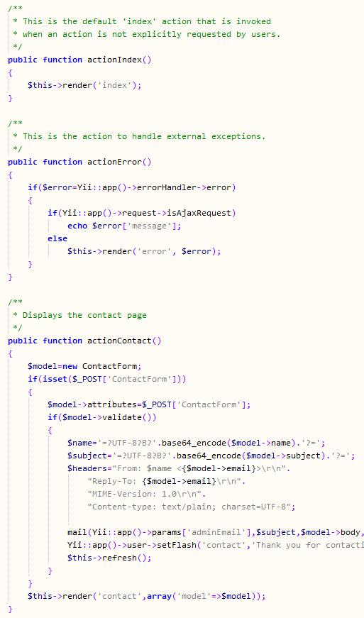
Within the action, often the model is called upon to process the user input. The models are found within the /protected/models/ folder, under a subdirectory named after their controller. Within this application the models are mapped to tables within the database and have core methods to enable easy CRUD operations as well as other, user-defined functionality. Most of the logic for processing should always reside in the model, not in the controller. The controller simply manipulates the user’s flow throughout the application, but hands off any serious processing to the model, before returning the results to the view for display to the user.
Views can be found within the /protected/views/ folder within the same directory hierarchy as the models. The views are what a user sees; the HTML/CSS/JS document that every internet user is familiar with. The view should do virtually no processing (aside from display-related logic and looping for example) as all of the business logic should have been addressed within the controller and the model.

