SOCIAL MEDIA & BRANDING • WORKFLOW DOCUMENTATION
Market Research
The first step after onboarding: understanding the brand, its audience, its market, and its competitors.
Document 1 of 6 Prepared for: Tech Team Stage in the flow: Step 1
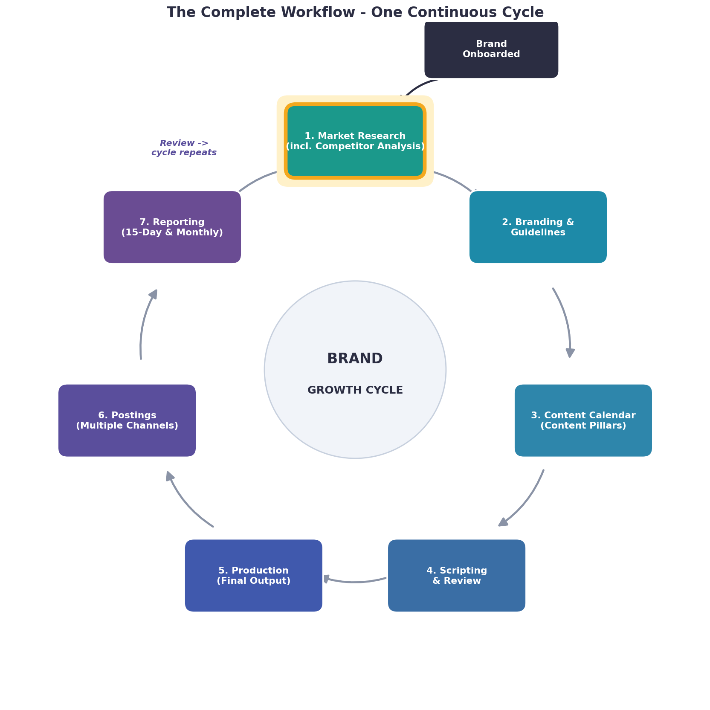
The full workflow cycle. This document explains the highlighted stage: Market Research.
WHERE THIS STAGE SITS IN THE FLOW
Market Research is the FIRST stage after a brand is onboarded. Its output feeds into the Branding & Guidelines stage and the Content Calendar. It is also repeated again after every Reporting review - that is what restarts the whole cycle.

What this stage is
Market research is the very first step after a new brand joins us. In this stage we study the brand, its customers, its market, and its competitors. The goal is to understand everything about the brand and the space it works in, so that every decision after this - the branding, the content, and the posts - is based on real facts and not guesswork.
This research is also refreshed later in the cycle, after each round of reporting. That keeps the brand's strategy up to date at all times.
What a complete market research document includes
A full market research document should cover all of the parts below:
Section | What it covers
Brand Overview | What the brand does, its products or services, its history, mission, vision, and current situation.
Business Goals | What the brand wants to achieve (more followers, more sales, more awareness) and its main objectives from social media.
Target Audience | Who the customers are: age, gender, location, income, interests, lifestyle, and online behaviour. Includes 2 to 3 audience personas (sample customer profiles).
Customer Needs & Pain Points | The problems customers face and what they are looking for.
Market Overview | The size of the market, how fast it is growing, current trends, opportunities, and challenges in the industry.
Competitor Analysis | A study of the main competitors: who they are, what they offer, how they position themselves, their strengths and weaknesses, the content they post, how often they post, and how their audience responds. It also highlights gaps the brand can use.
SWOT Analysis | The brand's Strengths, Weaknesses, Opportunities, and Threats in one clear view.
Positioning & USP | What makes the brand different (its Unique Selling Point) and why customers should choose it.
Platform Analysis | Which social media platforms the audience uses most, and which ones are right for the brand.
Trends & Content Opportunities | Popular topics, formats, hashtags, and seasonal moments the brand can use.
Key Takeaways & Recommendations | A simple summary of the findings and what they mean for the brand's strategy.

Note: Competitor analysis is included inside this market research document - it is not a separate stage.

Step-by-step process
1. Collect the basic details about the brand from the onboarding information.
2. Study the brand's products, services, and goals.
3. Research the target audience and build audience personas.
4. Study the market, its size, and current trends.
5. Identify the main competitors and analyse them in detail (competitor analysis).
6. Do a SWOT analysis of the brand.
7. Decide the brand's positioning and unique selling point.
8. Identify the best platforms and content opportunities.
9. Put everything together into one clear market research document.
10. Share the final document so it can be used for branding and content planning.
What this stage produces (and where it goes next)
Output: One complete market research document (including competitor analysis) for the brand. This is handed to the Branding & Guidelines stage and is used to plan the Content Calendar.

