|  |  |
| --- | --- |
| Gray Quarter, Inc. |  |

Release Notes

|  |  |
| --- | --- |
| City of Rancho Cucamonga  Master Script Upgrade Release Notes | Image result for rancho cucamonga city seal |

# Document Control

|  |  |  |  |
| --- | --- | --- | --- |
| Date | Author | Version | Changes |
| 5/31/2019 | John Schomp | 1.0 | Initial |
|  |  |  |  |
|  |  |  |  |

# Rancho Cucamonga Master Script Upgrade

## Summary

Gray Quarter, Inc. has upgraded the agency scripts extracted from the CITYOFRC Production environment to the newest scripting version 3.0 format. The original scripts that were stored in standard choices have been migrated into JavaScript files, using the Accela best practice directory structure. These standard choices have been converted to a structure that mirrors the record type structure for the agency. This document describes the details of the conversion, as well as implementation steps.

## Analysis

A review of the scripting shows that customary standards for scripting based on version 2.X have been used. Variable branching was previously used, so the script migration generally follows branching pattern established by the standard choices. In addition, several opportunities for code review and/or refactoring were identified. Please see the Recommendations section for details.

## Master Script Usage

The following events are in use for the CITYOFRC Production agency, shown with associated master scripts. The “Deploy Action” column describes the changes that will be required when implementing the upgraded scripts.

NOTE: Even though a single 3.0 master script is currently in use, it is running in backward-compatibility mode in order to execute the 2.x style standard choices that were in use.

|  |  |  |  |  |
| --- | --- | --- | --- | --- |
| Event | Script | Productized | Version | Deploy Action |
| AAAddressUpdateAfter |  | N/A |  | Delete Event |
| ApplicationDetailNewBefore |  | N/A |  | Delete Event |
| ApplicationDetailUpdateAfter | UNIVERSALMASTERSCRIPTV2.0 | No | 2.0 | Use latest version of 3.0 |
| ApplicationSpecificInfoUpdateAfter | APPLICATIONSPECIFICINFOUPDATEA | No | 2.0 | Use latest version of 3.0 |
| ApplicationSpecificInfoUpdateBefore | APPLICATIONSPECIFICINFOUPDATEB | No | 2.0 | Use latest version of 3.0 |
| ApplicationStatusUpdateAfter | APPLICATIONSTATUSUPDATEAFTERV2 | No | 2.0 | Use latest version of 3.0 |
| ApplicationSubmitAfter | APPLICATIONSUBMITAFTERV2.0 | No | 2.0 | Use latest version of 3.0 |
| ApplicationSubmitBefore | APPLICATIONSUBMITBEFORE | No | 2.0 | Use latest version of 3.0 |
| ContactAddAfter | ContactAddAfter | Yes | 2.0 | Disable Event |
| ContactAddBefore | ContactAddBefore | Yes | 2.0 | Use latest version of 3.0 |
| ConvertToRealCAPAfter | CONVERTTOREALCAPAFTER2.0 | No | 2.0 | Use latest version of 3.0 |
| DocumentUploadAfter | DOCUMENTUPLOADAFTERV2.0 | No | 2.0 | Use latest version of 3.0 |
| FeeAssessAfter | FEEASSESSAFTERV2.0 | No | 2.0 | Use latest version of 3.0 |
| FeeEstimateAfter4ACA | FEEESTIMATEAFTER4ACA | No | 2.0 | Use latest version of 3.0 |
| InspectionCancelBefore |  | N/A |  | Delete Event |
| InspectionMultipleScheduleAfter | INSPECTIONMULTIPLESCHEDULEAFTERV2.0 | No | 2.0 | Use latest version of 3.0 |
| InspectionMultipleScheduleBefore | INSPECTIONMULTIPLESCHEDULEBEFO | No | 2.0 | Use latest version of 3.0 |
| InspectionResultSubmitAfter | INSPECTIONRESULTSUBMITAFTERV2. | No | 2.0 | Use latest version of 3.0 |
| InspectionResultSubmitBefore |  | N/A |  | Delete Event |
| InspectionScheduleAfter | INSPECTIONSCHEDULEAFTERV2.0 | No | 2.0 | Use latest version of 3.0 |
| InspectionScheduleBefore | INSPECTIONSCHEDULEBEFOREV2.0 | No | 2.0 | Use latest version of 3.0 |
| InvoiceFeeAfter | InvoiceFeeAfter | Yes | 2.0 | Use latest version of 3.0 |
| LicProfAddAfter | UniversalMasterScript | Yes | 2.0 | Use latest version of 3.0 |
| LicProfUpdateAfter | LicProfUpdateAfter | Yes | 2.0 | Use latest version of 3.0 |
| PaymentProcessingAfter | PAYMENTPROCESSINGAFTER | No | 3.0 | Use latest version of 3.0 |
| PaymentReceiveAfter | PAYMENTRECEIVEAFTERV2.0 | No | 2.0 | Use latest version of 3.0 |
| RefLicProfUpdateAfter | UniversalMasterScript | Yes | 2.0 | Use latest version of 3.0 |
| V360InspectionResultSubmitAfter | V360INSPECTIONRESULTSUBMITAV20 | No | 2.0 | Use latest version of 3.0 |
| V360InspectionResultSubmitBefore | V360INSPECTIONRESULTSUBMITBEFO | No | 2.0 | Use latest version of 3.0 |
| WorkflowAdhocTaskAddBefore |  | N/A |  | Delete Event |
| WorkflowAdhocTaskUpdateAfter | WORKFLOWTASKUPDATEAFTERV2.0 | No | 2.0 | Use latest version of 3.0 |
| WorkflowAdhocTaskUpdateBefore | WORKFLOWTASKUPDATEBEFOREV2.0 | No | 2.0 | Use latest version of 3.0 |
| WorkflowTaskUpdateAfter | WORKFLOWTASKUPDATEAFTERV2.0 | No | 2.0 | Use latest version of 3.0 |

## Edits to Standard Master Scripts

* N/A

## Custom functions that conflict with Master Script distribution

|  |  |
| --- | --- |
| Function | Action |
| addAdhocTask | Identical, removed |
| addParameter | Identical, removed |
| createRefContactsFromCapContactsAndLink | Identical, removed |
| createRefLicProf | Newer standard version, removed |
| describeObject | Identical, removed |
| generateReport | Custom, retained |
| getACARecordParam4Notification | Identical, removed |
| getACARecordParamUrl | Identical, removed |
| getContactParams4Notification | Custom, retained |
| getInspectionResultParams4Notification | Identical, removed |
| getRecordParams4Notification | Custom, retained |
| refLicProfGetDate | Custom, retained |
| sendNotification | Custom, retained |
| setTask | Custom, retained |
| updateFee | Identical, removed |
| updateFeeItemInvoiceFlag | Identical, removed |

## Functions with multiple versions

* None

## Standard Choice Conversion Details

* Approximately 2159 Active Standard Choices containing scripts have been converted to 417 script files. This number could be dramatically reduced if the *updateGisObjects() calls are refactored, see the related TODO item below.
* All converted scripts have been tested for proper JavaScript syntax.
* To assist with testing, the original “*Branch*” standard choice names have been added as comments to the converted scripts. Once testing is complete these comments won’t be needed. For example:

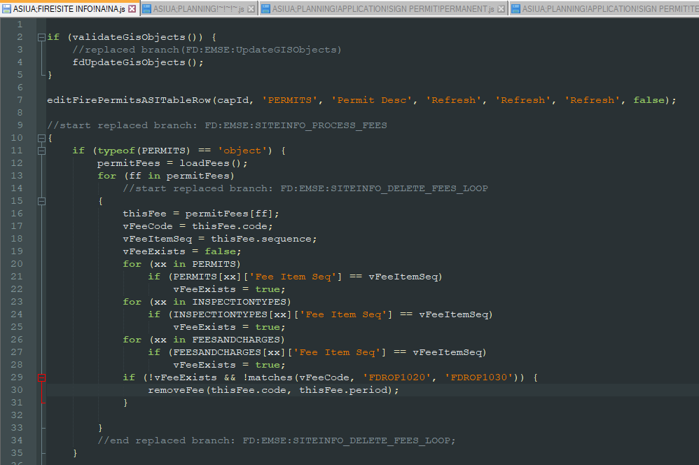

* The conversion algorithm may have created some instances where double sets of braces {{ … }} denote a code block. These can be removed if desired, but they have no impact on the script execution.
* In accordance with best practices, all references to *showDebug* within business scripts have been removed to simplify script debugging. Accela recommends setting this in one place, preferably using INCLUDES_CUSTOM_GLOBALS, which was designed for this purpose.
* In accordance with best practices, all references to setting *showMessage* to *false* within business scripts have been prevent messages from being suppressed unintentionally. Since this variable is false by default, it should only be set to true when a message is to be sent back to the user.
* Individual standard choices that were disabled are included in the conversion as code that is commented out.
* Standard choice branches that were not referenced by any script were converted into JavaScript and placed into the Scripts\Unused folder. This includes any code that was referenced by disabled standard choices. These should be reviewed.
* All script files have been formatted to JavaScript standards for indentation.
* The caret (^) is no longer valid for creating conditional logic. Standard JavaScript should be used instead (i.e., if, else, else if, switch)
* All references to Custom Fields, Task Specific Info, and Parcel Attributes that used braces (e.g., *{ASI Field})* have been changed to use the AInfo global Array (e.g., *AInfo[‘ASI Field’]*). Braces are now exclusively used to designate blocks of code.
* All references to the “*branch*” and “*endbranch*” functions have been removed. These are deprecated in Master Scripts 3.0.

## Code Analysis and Recommendations

* Scripts\Event\ASA;BUILDING!FCS!MISCELLANEOUS! FUEL DISPENSING SYSTEM.js

Line 2: // TODO: this code (and other's like it) are replicated at the individual record type level. The number of scripts can be drastically removed if this logic is refactored at the module level

* Scripts\Event\ASA;ENGINEERING!ONSITE SEWER AND WATER!NA!NA.js

Line 7: // TODO: these standard choices do not exist

* Scripts\Event\ASIUA;BUILDING!RESIDENTIAL!NEW CONSTRUCTION!~.js

Line 5: // TODO: branch does not exist

* Scripts\Event\IRSA;BUILDING!~!~!~.js

Line 8: // TODO syntax error here please review

* Scripts\Event\IRSA;BUILDING!COMMERCIAL!MEP PERMIT!NA.js

Line 22: // TODO syntax error here, please review

* Scripts\Event\WTUA;BUILDING!FCS!MISCELLANEOUS!HIGH PILE STORAGE.js

Line 17: // TODO: consider using a lookup std choice table for this list

## Script Repository

A script repository was provisioned by the City

|  |  |
| --- | --- |
| Repository Site | GitHub.com |
| SUPP Repository URL | https://github.com/city-of-rancho-cucamonga/RC-EMSE-SCRIPTS.git |

To connect to the repository, the “EMSEToolConfig” standard choice should be configured as per the Accela documentation. The “EMSETool” portlet should be enabled for the appropriate users/groups. Since Accela requires basic authentication, the user account that Accela uses to connect to the Visual Studio repository must use an account with “Alternate Credentials” enabled (or some other method that supports basic authentication). It’s recommended that this account is read-only for any connected repository. See below for an example:

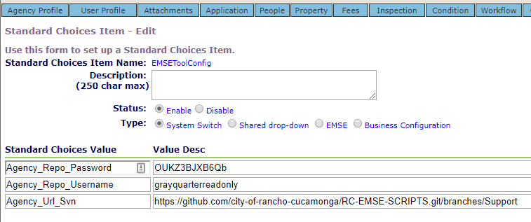

## Standard Choices

The following Standard Choices must be configured. These are documented in the Master Script distribution in the documentation folder. The “Master Script Distribution_Std_Choices.zip” data manager package can be used to load these values.

* EMSE_EXECUTE_OPTIONS determines if Scripts or Standard Choices, or both should be executed by the master script. This should be set to select Scripts only.
* EMSE_VARIABLE_BRANCH_PREFIX determines the naming convention used to determine if a script is associated to a particular event.
* MASTER_SCRIPT_DEFAULT_VERSION

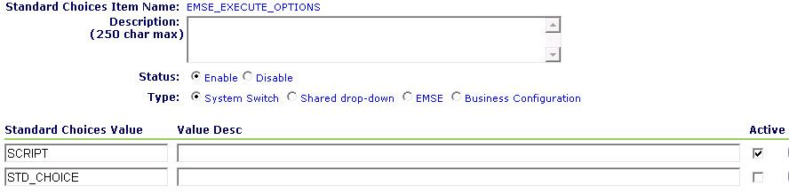

## Deployment to Higher Environments

After the initial migration, the deployment to a higher environment (e.g., DEV -> TEST, TEST-> PROD) can be achieved by the following steps:

|  |  |  |  |
| --- | --- | --- | --- |
|  | Step | Description | Est. Time |
| 1 | Create rollback package | In TARGET environment create a Data Manager export package that contains:   * all Event to Script associations (AA Configuration, Event Manager, Events, select all) * Master Includes (AA Configuration, Event Manager, Master Scripts, INCLUDES_CUSTOM) * Includes (AA Configuration, Event Manager, Master Scripts, INCLUDES*)   Save and run the job, saving the output in a dedicated folder. This package will only be used if a roll back is required. | 5 Minutes |
| 2 | Create master script package | In SOURCE environment create a Data Manager export package that contains:   * all Event to Script associations (AA Configuration, Event Manager, Events, select all) * Includes (AA Configuration, Event Manager, Master Scripts, INCLUDES*) * EMSE Standard Choices (AA Configuration, Standard Choices: EMSE_EXECUTE_OPTIONS, EMSE_VARIABLE_BRANCH_PREFIX, EMSEToolConfig)   Save and run the job, saving the output in a dedicated folder. | 5 Minutes |
| 3 | Deploy master script package | In TARGET environment create a Data Manager import job that will import the entire package in step 2. | 5 Minutes |
| 4 | Confirm EMSEToolConfig | In TARGET environment update the EMSEToolConfig standard choice with credentials and URL to access the environment repository. | 2 Minutes |
| 5 | Deploy Scripts | In TARGET environment deploy all scripts using the EMSE Tool. | 5 Minutes |
| 6 | Update INCLUDES_CUSTOM_GLOBALS | In TARGET environment update the INCLUDES_CUSTOM_GLOBALS script as needed for this environment (debugging options, environment variable, etc.) | 2 Minutes |
| 7 | Smoke Test | In TARGET environment perform smoke testing to ensure proper script execution. | 10 Minutes |