Tourism Montreal Knowledgebase – Sight Seeing

As March, 2025

10 must-sees for first time visitors

Labels: leisure activities, culture, arts and heritage, nature, fauna and flora

**1. Notre-Dame Basilica**

* **Historical Background:** Completed in 1829 as the first Gothic Revival church in Canada, Notre-Dame Basilica has an awe-inspiring interior of gilded wood carvings and vivid stained-glass windows​. It has seen historic moments, including a visit by Pope John Paul II and state funerals of notable Canadians​, making it a key part of Montréal’s heritage.
* **Activities:** Visitors can take a 20-minute guided tour included with admission to learn about the basilica’s history and architecture​. You may also attend a mass or experience the immersive *AURA* light-and-music show on select evenings.
* **Location:** 110 Notre-Dame Street West, Old Montréal (Place d’Armes metro). The twin towers are a centerpiece of the Old Montréal skyline.
* **Estimated Price:** **CA$16** for an adult sightseeing visit (includes the guided tour)​. Attending regular religious services is free.
* **Recommended Visit Duration:** Approximately **1 hour** to appreciate the interior and tour, or 1.5 hours if also viewing the evening light show.
* **Photo：**

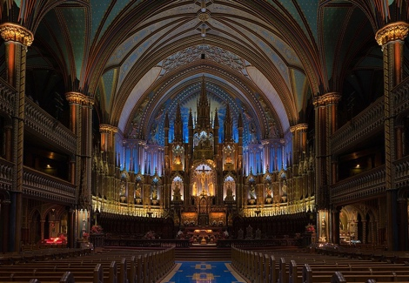

**2. Old Montréal (Vieux-Montréal) and Old Port**

* **Historical Background:** ​Founded in **1642**, Old Montréal is the city’s oldest district, with cobblestone streets and buildings dating back to New France​. Once a walled colonial town, it’s now a National Historic Site where centuries-old architecture and plazas like Place Jacques-Cartier bring European charm to Canada.
* **Activities:** Stroll the narrow streets (like Rue Saint-Paul) lined with boutiques and cafes, or take a horse-drawn carriage ride. Visit the Old Port waterfront for activities like the Montréal Science Centre, the Grande Roue de Montréal Ferris wheel, or riverfront ziplining. In winter, enjoy events like Igloofest, an outdoor music festival in the snow​.
* **Location:** Adjacent to downtown along the St. Lawrence River, covering roughly from Rue McGill to Rue Berri. Easily reached by metro (Champ-de-Mars or Place-d’Armes stations) and on foot from downtown.
* **Estimated Price:** **Free** to wander the neighborhood and historic sites. (Museum entries or paid activities in the area, like the Ferris wheel or museums, cost extra but are typically under $30 per adult.)
* **Recommended Visit Duration:** **2–3 hours** to explore the streets, visit a landmark or two (such as City Hall or Bonsecours Market), and enjoy a snack at a café.
* **Photo:**

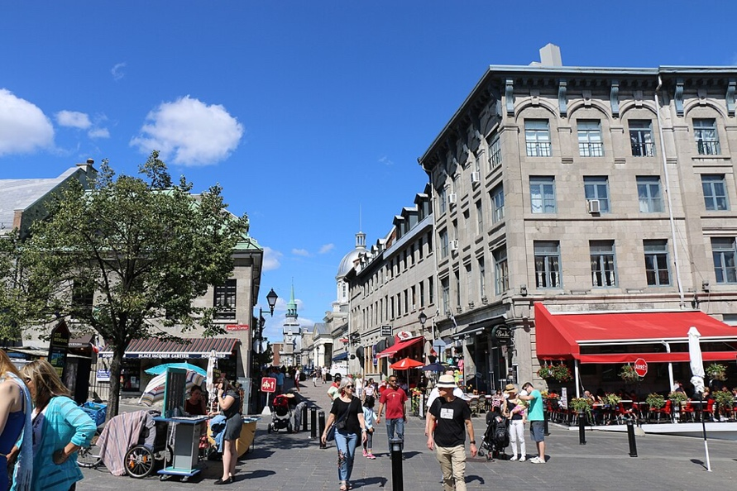

**3. Mount Royal Park (Parc du Mont-Royal)**

* **Historical Background:** Mount Royal is the volcanic hill that gives Montréal its name. In 1876, landscape architect Frederick Law Olmsted (designer of NYC’s Central Park) created this park as a natural refuge in the city​. The park’s summit features the historic **Mount Royal Cross**, first erected in 1643, symbolizing the city’s founding gratitude.
* **Activities:** Hike or bike up to the **Kondiaronk Belvedere** lookout for a panoramic view of Montréal’s skyline​. Visit the 103-foot illuminated cross at the peak, or join locals on summer Sundays for **Tam-Tams** – a free drum circle and festival-like gathering on the lower slope​. In winter, enjoy snowshoeing or skating on Beaver Lake.
* **Location:** Central Montréal – the park spans the mountain in the middle of the island. Multiple trail entrances; popular routes start near Avenue du Parc or Peel Street, and bus #11 reaches the summit chalet.
* **Estimated Price:** **Free.** There is no entrance fee to enjoy the park and viewpoints.
* **Recommended Visit Duration:** **2 hours** for a round-trip walk to the lookout and back, or up to 3–4 hours if you picnic, explore multiple trails, or attend the Tam-Tams.
* **Photo:**

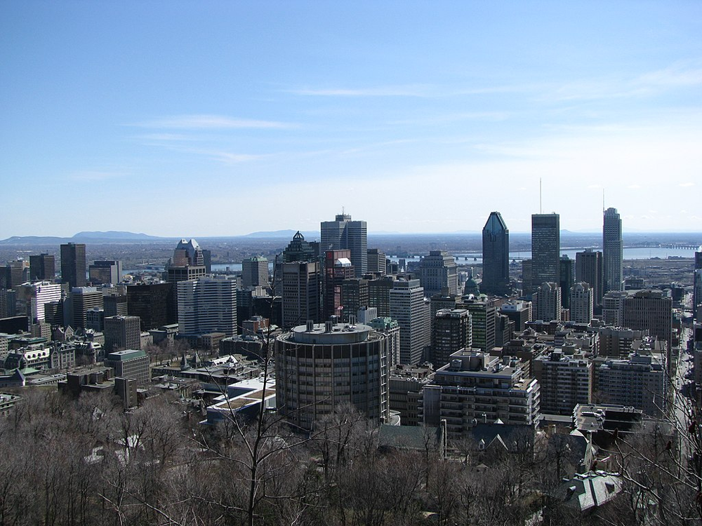

**4. Saint Joseph’s Oratory of Mount Royal**

* **Historical Background:** Opened in 1955 (after decades of construction led by Saint *Brother André*), Saint Joseph’s Oratory features the largest church dome in Canada at nearly 40 m in diameter​. This Roman Catholic basilica, built on Mount Royal’s western slope, has become a national shrine receiving millions of pilgrims and visitors, drawn by its history of Brother André’s healing ministry.
* **Activities:** Climb the grand outdoor steps (many pilgrims ascend on their knees in devotion), and view the hundreds of crutches in the Votive Chapel left by those who claimed to be healed. Explore the Oratory’s small museum of religious artifacts (notably a collection of international Nativity scenes)​, attend a mass or listen to an organ recital on the pipe organ, and enjoy the peaceful Gardens of the Way of the Cross on the grounds.
* **Location:** 3800 Queen Mary Road, Côte-des-Neiges (near Snowdon metro). Perched on Mount Royal’s slope, it offers a great vantage over the city from its terrace. **Parking** is available (fee ~$5)​
* **Estimated Price:** **Free** entry to the church and grounds (donations appreciated)​. The Oratory Museum charges a small fee (about **CA$3** for adults)​.
* **Recommended Visit Duration:** **1.5–2 hours** to tour the basilica, climb to the dome, and see the chapel and museum. Allocate a bit more time if attending a service or exploring the gardens.
* **Photo:**

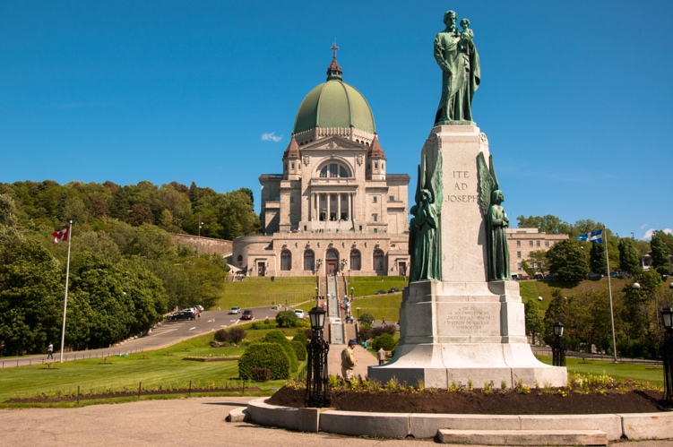

**5. Montréal Museum of Fine Arts (Musée des Beaux-Arts)**

* **Historical Background:** Established in **1860**, it is Canada’s oldest art museum and among the largest in North America​. The museum spans five pavilions, including a neoclassical 1912 building (with its columned facade shown above) and modern extensions, housing a diverse collection from classical antiquity to contemporary art (about **44,000 works** in total)​.
* **Activities:** Browse European masters, Indigenous Canadian art, decorative arts, and rotating blockbuster exhibitions. The permanent collections of Quebec and Canadian art are a highlight. Pick up an audio guide or join a public tour for insights. Don’t miss outdoor artworks along Sherbrooke Street and the museum’s sculpture garden.
* **Location:** 1380 Sherbrooke Street West, in the downtown **Golden Square Mile** district. The Guy-Concordia and Peel metro stations are each a 10-minute walk. The museum is split into buildings on either side of Sherbrooke, linked by underground passages.
* **Estimated Price:** **CA$30** for adult admission to major exhibits (discounts for seniors/students)​. Visitors **25 and under** enjoy free general admission, and the museum offers free access to main collections for all on the first Sunday of each month.
* **Recommended Visit Duration:** **2–3 hours** for a good overview of the collections and a special exhibit. Art enthusiasts could spend half a day; casual visitors can see highlights in about 2 hours.
* **Photo:**

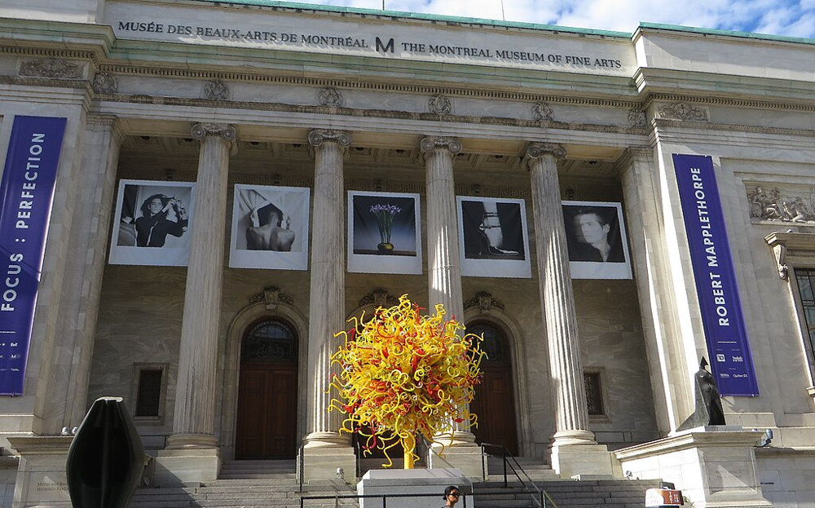

**6. Sainte-Catherine Street**

* **Historical Background:**

Spanning over **11 km** (about 7 miles) across the city, Sainte-Catherine Street has been Montréal’s primary commercial artery since the 19th century​. Once lined with grand department stores, it remains the heart of downtown shopping and entertainment, evolving with the city through eras of trams, movie palaces, and vibrant street life.

* **Activities:** Shop to your heart’s content at major malls (Eaton Centre, Complexe Desjardins) and flagship stores, or hunt for unique finds in local boutiques. Countless restaurants, pubs, and cafés line the street – in summer, many blocks turn into pedestrian-only zones with outdoor terraces​. Entertainment options abound: catch a concert or Broadway-style show at Place des Arts or simply enjoy street performers and festivals (the **Jazz Festival** and **Just for Laughs** spill onto Sainte-Catherine’s outdoor stages).
* **Location:** Cuts through downtown from Westmount to the Gay Village. The busiest stretch is between Atwater Avenue and Saint-Laurent Boulevard, passing major hubs like Philips Square and Place des Arts. Easily accessible via the Green Line of the metro (with stops along the length of the street).
* **Estimated Price:** **Free** to explore. Window-shopping and people-watching cost nothing. (Budget $10–$30 if you plan to grab lunch or a souvenir; costs vary with shopping or dining choices.)
* **Recommended Visit Duration:** **1–2 hours** for a walk through the central section to shop and see the atmosphere (add more time if you plan on serious shopping or attending an event).
* **Photo:**

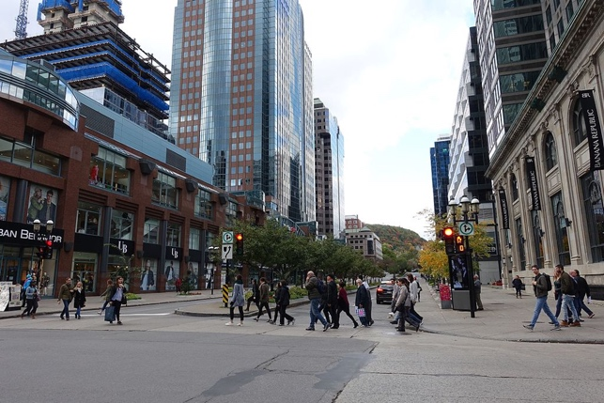

**7. The Underground City (RÉSO)**

* **Historical Background:**

Montréal’s “Underground City” is a network of climate-controlled pedestrian tunnels and plazas developed since the 1960s. Spanning **32 km** (20 miles)​, it grew from passageways under Place Ville-Marie and today links multiple downtown buildings, malls, hotels, and transit stations – the largest subterranean complex in the world. It has been pivotal in downtown development, especially given Montréal’s harsh winters.

* **Activities:** Escape bad weather by wandering this labyrinth of connected shopping centers (over **2,000 stores** and restaurants)​. You can access food courts, cinemas, and even museums entirely indoors. Look for art displays and architecture features in certain sections (like the colorful stained-glass at Place-des-Arts station). It’s also fun to follow the maps and **RÉSO** signs to navigate – make a game of finding your way between metro stations underground.
* **Location:** The network is mostly beneath downtown’s core (roughly between Atwater and Place-des-Arts, and from the Bell Centre up to McGill University). Entry points include many office towers and malls – e.g., Eaton Centre, Montréal Trust, Place Ville-Marie, or any connected metro (subway) station.
* **Estimated Price:** **Free** to use and enter. It’s essentially public space – you might end up spending money only if you shop or eat.
* **Recommended Visit Duration:** **1 hour** for a brief walkthrough of a couple of connected malls or segments. Allocate **2+ hours** if you plan to explore a larger section, shop, or use it as a convenient route to other sites.
* **Photo:**

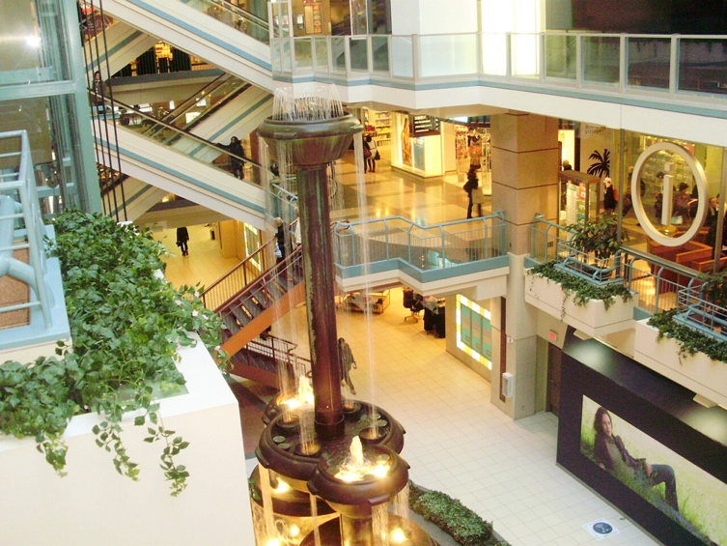

**8. Place des Festivals (Quartier des Spectacles)**

* **Historical Background:** Inaugurated in 2009 as part of Montréal’s Quartier des Spectacles project, Place des Festivals is a modern urban square designed to host the city’s famous festivals. Flanked by theaters and high-rises, it features the **largest interactive fountain in Canada** with 235 water jets dancing in sync​. The site has quickly become an iconic gathering spot, reflecting Montréal’s long festival tradition (the Jazz Festival, for instance, has roots back to 1980 and now centers on this plaza).
* **Activities:** Attend free outdoor shows and concerts year-round. In summer, you might catch nightly Jazz Festival performances or food trucks during festival season​. In winter, the area is animated by light installations and events like *Montréal en Lumière*. When no major events are on, enjoy the fountain (kids often play in the water jets on warm days) and public art. At night, the square’s signature glow comes from illuminated towers and building projections.
* **Location:** Corner of Jeanne-Mance Street and Sainte-Catherine Street, in downtown’s Quartier des Spectacles. It’s directly outside Place-des-Arts metro station and adjacent to venues like the Museum of Contemporary Art and Théâtre Maisonneuve.
* **Estimated Price:** **Free.** Outdoor festival events on the plaza are usually free to the public. (Nearby indoor performances or food vendors may have costs, but you can experience the main plaza without spending money.)
* **Recommended Visit Duration:** **1–2 hours**, depending on events. During a festival, you might stay for an evening of music; on a regular day, 30 minutes to an hour is enough to see the fountains and stroll the area, plus extra time if you relax at a café patio.
* **Photo:**

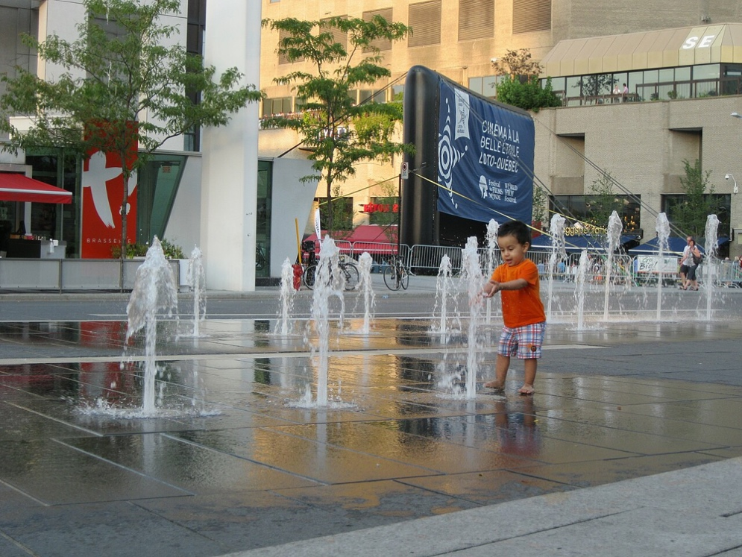

**9. Space for Life (Espace pour la Vie: Biodôme, Botanical Garden, Insectarium, Planetarium)**

* **Historical Background:** Branded as “Space for Life,” this is Canada’s largest natural science museum complex, born out of Montréal’s 1976 Olympic legacy. The **Biodôme** opened in 1992, repurposing the Olympic velodrome into an immersive zoo of ecosystems. The **Botanical Garden**, established 1931, is a 75-hectare garden park renowned for its collections. The **Insectarium** (opened 1990) and **Rio Tinto Alcan Planetarium** (opened 2013) complete the quartet, all aimed at reconnecting people with nature and the universe​.
* **Activities:** At the **Biodôme**, walk through five recreated ecosystems – from a tropical rainforest to the sub-arctic islands – and encounter wildlife like capybaras, sloths, penguins, and puffins (pictured) up close. In the **Botanical Garden**, explore themed gardens (the Japanese Garden and Chinese Garden are highlights) and greenhouses with over **22,000 plant species**​; seasonally enjoy events like the autumn Lantern Festival. The **Insectarium** offers a fascinating look at bugs (you might decide whether that twig is actually a stick insect!)​. At the **Planetarium**, sit back for immersive 360° astronomy shows, often featuring the constellations or phenomena like the aurora borealis​.
* **Location:** All four sites are located in Montréal’s Olympic Park area (Pie-IX metro station). The Biodôme and Planetarium sit adjacent to each other near the base of the Olympic Stadium tower, while the Insectarium and Botanical Garden are across the street on Sherbrooke East (within walking distance, or accessible via a free shuttle in summer).
* **Estimated Price:** **CA$20–$30 per adult** for single-site admission (varies by museum). Combo tickets and family passes are available – for example, around **CA$50–$60** to visit any three sites in one day. All individual attractions are under $100 per person, and children’s rates are lower (many around $10–$15).
* **Recommended Visit Duration:** **2–4 hours.** Visiting one attraction (e.g. Biodôme) takes about 1.5–2 hours. If you plan a multi-site day, allocate half a day for two sites or a full day for all four. (The Botanical Garden alone can fill 2+ hours, especially in summer.)
* **Photo:**



**10. Pointe-à-Callière, Montréal Archaeology and History Complex**

* **Historical Background:** Opened in 1992 for Montréal’s 350th anniversary, Pointe-à-Callière Museum is built atop the city’s birthplace – the actual site of the first colonial settlement​. The modern Éperon Building houses and protects in-situ ruins, including Indigenous artifacts, remains of the 17th-century Royal Insurance Building, and the city’s first Catholic cemetery. This unique museum “from the ground up” chronicles over **600 years** of history on the very spot where it happened​.
* **Activities:** Begin in the theatre with a multimedia show that brings Montreal’s history to life beneath your feet. Then descend underground to walk through archaeological excavations: you can literally stroll the old sewer tunnels and fortifications. Exhibits showcase artifacts from First Nations through French and British eras, and there are often temporary exhibits on themes of Montréal or Canadian history (e.g., pirates, or an exhibit like “Île de Pâques” as advertised on the banner in the photo). Interactive displays and family-friendly treasure hunts make the past engaging for all ages.
* **Location:** 350 Place Royale, in Old Montréal by the Old Port. It stands at the intersection of Place d’Youville and de la Commune Street. The area is easily reached on foot from other Old Montréal attractions (5-minute walk from Notre-Dame Basilica).
* **Estimated Price:** **CA$25**–$30 for adult admission​. Youth, student, and senior discounts available (e.g., students around $19​). Children under 5 are free.
* **Recommended Visit Duration:** **2 hours** to tour the permanent exhibits and underground remains. Add an extra 30–60 minutes if you plan to view temporary exhibitions or linger in the multimedia presentations.
* **Photo:**

