*Avaya one-X Communicator Softphone*

The one-X Communicator is softphone for the Avaya Communication Manager. No special licensing needed as the standard Avaya client licensing for station covers both physical and soft phones.

Initial Setup Instructions

Under the OneXCommunicator folder right click and run the Avaya one-X® Communicator.msi (need administrative rights and .NET Framework is a prerequisite)

Troubleshooting

1. No server address error. On first launch, the settings are download from web server location. Ensure that PC is on network and initiate Auto-configure located at bottom on Settings. Select All settings to update.

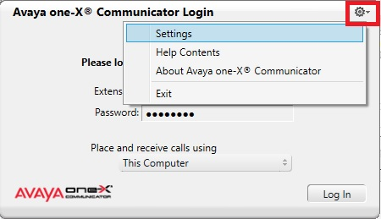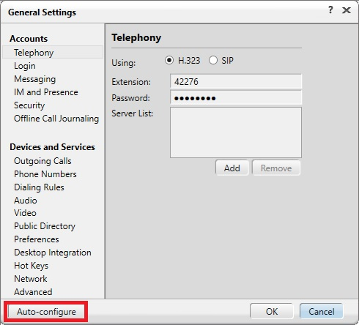

1. When launched user preferences and logs file are written to users profile\AppData\Roaming\Avaya\Avaya one-X Communicator. If application is failing to launch or login to station ID isn’t working, remove these files and relaunching application will rebuild to the base configuration.
2. It’s best to have headset connect before launching the client. If audio device mapping needs correcting then go into the General Settings and under Audio select the proper device for Microphone and Speaker.

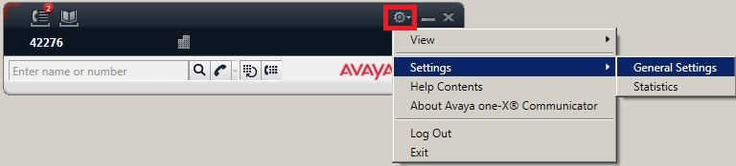

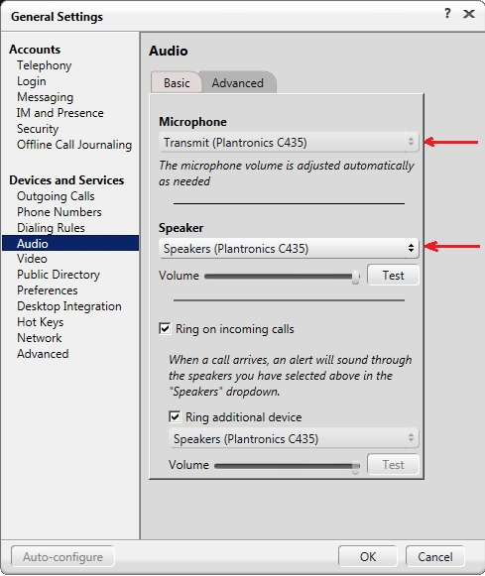

Basic User Guide

1. Launch One-X Communicator, enter 5 digit extension and the password. (Password is our standard and is same as those used to login physical phone station)
2. Select type of login, **Place and receive calls using**

‘This Computer’ full VoIP to PC, requires headset to PC

‘Desk Phone’ Allows control of physical phone from PC.

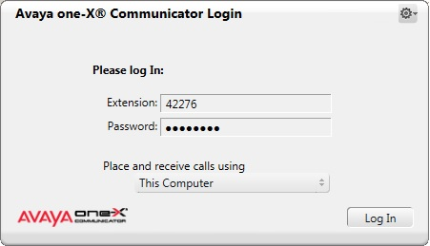

1. Once logged in the main control bar is displayed. Click phone icon to get dialtone and PC number pad to complete dialing.

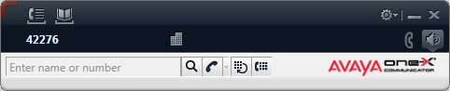

You may elect to display the dialpad which also display feature buttons assigned to station.

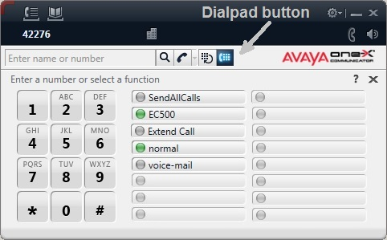

1. Call control, timer, and caller information displays once on call.

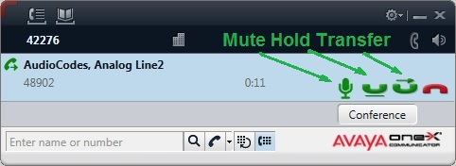

1. Incoming Call displays on Bottom toolbar and on main application. Green phone icon to answer, red icon to ignore and send to cover path (usually voice mail).

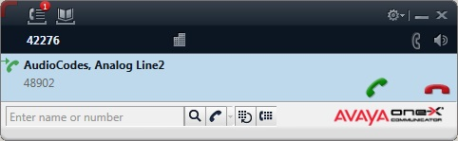

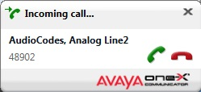

1. To logoff and close application click the Menu icon and choose exit.

