USRP N210 + UBX40 Filter Test

Characteristics of a 20MHz Analog Filter (after Mixer, before ADC)

*This experiment was designed and executed by Mr.Aragon.

Experiment Design

Fixed:
- Input Signal (sine wave)
- RF frequency (f_{c}) (but with different f_{c} for each iteration)
Independent Variable:
- DSP frequency (f_{DSP}), Local oscillator frequency (f_{LO}), such that:

f_{c} = f_{DSP} + f_{LO}

Dependent Variable:
- Power Level (dB)

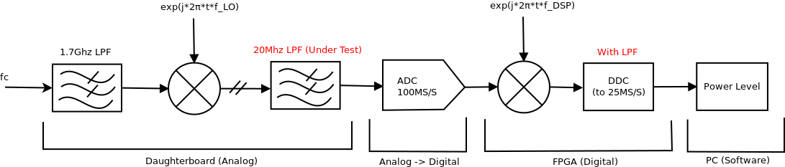
Figure 1. Block Diagram of the System (for 20MHz Analog LPF testing).

*Above diagram assumes 900MHz RF frequency with 25MS/s effective sampling rate. UBX board may use different paths for different settings. For an example, 1.7GHz low-pass filter in the above diagram is only applicable when the RF frequency is equal to or lower than 1.5GHz.

Full block diagram of the UBX board is available at : https://www.ettus.com/content/files/UBX_Data_Sheet.pdf .

Results

Figure 2. Frequency Response of the 20MHz Analog Filter

*Observed frequency response of the low pass filter for the 10~70MHz and 910-6000MHz RF frequency are significantly different. Cause of this is not identified yet.

Conclusion

- The frequency response of the low pass filter at 50MHz is -30~ -36dB.
- There are unexpected variations in the results (dependence to the reception frequency). This is under investigation.

Characteristics of the DDC Filter

Since the ADC readings are not aliased significantly (at least for the 900MHz range which was tested), frequency response of the DDC’s low pass filter can be approximated by measuring the frequency response of the USRP N210 + UBX daughterboard system itself.

Experiment Design

Fixed:
- Input Signal (sine wave) : approx. 1130MHz with amplitude approx. 45dB higher than the noise floor of the receiver. (Also done with 900MHz input signal (not shown); results agreed well).

Independent Variable:
- Local oscillator frequency (f_{LO})

*f_{DSP} = 0, so f_{c} = f_{LO} for this experiment.

Dependent Variable:
- Power Level (dB), in relative to the noise floor; observed from the averaged power spectral density data.

The location of the (real or aliased) inputted signal on the frequency domain is either f_{c}, f_{c}+25MHz, or f_{c}-25MHz. The relative power level of the signal is calculated by:

, where the power level of the signal or the noise floor are determined by:

, where F(k) is the FFT point (in complex) corresponding to the target frequency. The noise floor can be estimated by finding the minimum power level for all k (since the PSD data are averaged, and the signal is being injected using an 30dB attenuation cable, not over the air).

The results are represented in logarithmic scale (dB) for convenience. Since it is already in power level, it can be done by calculating 10*log10(relative power level).

Figure 3 shows the block diagram of the system. (Sampling rate = 25MS/s, f_{c} = 1130MHz)

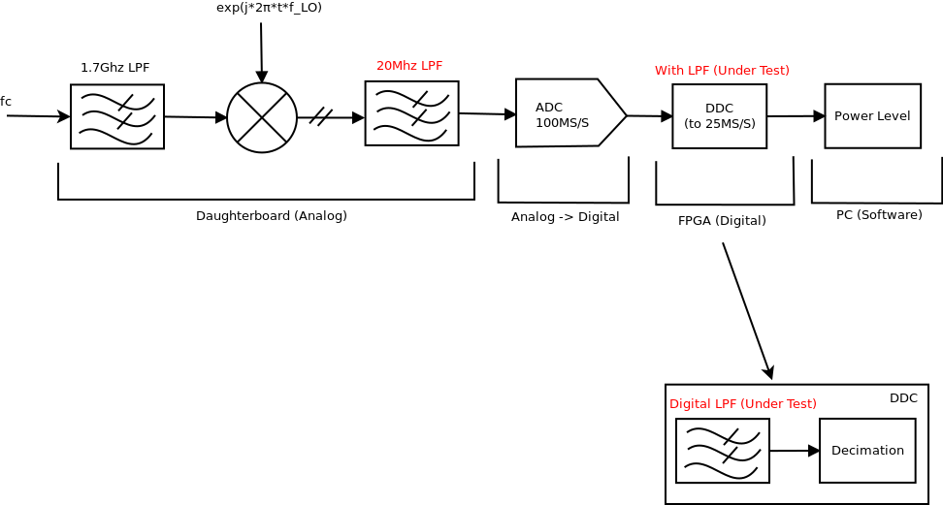
Figure 3. Block Diagram of the System (for the DDC’s LPF).

Results

Figure. 4: Filter Characteristics of USRP N210 + UBX daughterboard (@ 25.0MS/s).

Conclusion

- Aliasing is unavoidable: with 25MS/s of effective sampling rate, the filter may let pass up to 30MHz of bandwidth (assuming strong signals).

Solution #1 – Using Lower Effective Sampling Rate

One possible fix for the problem is using a relatively low effective sampling rate (=higher decimation rate on USRP). The DDC will automatically adjust the filter to match the decimation rate.

Experiment Design

Experiment on the above section (“Low-Pass Filtering by the DDC”) is repeated, but with the effective sampling rate of 12.5MS/s (instead of 25MS/s).

Results

Figure. 5: Filter Characteristics of USRP N210 + UBX daughterboard (@ 12.5MS/s).

Conclusion

- The absolute amount (bandwidth) of aliased signal decreases as we increase the decimation rate.
- So, if the signal of interest has a relatively low bandwidth, we can simply use a low effective sampling rate (Scanner Configuration :: Instantaneous Bandwidth per snapshot).

*Different effective sampling rates (down to 250kS/s) are also tested, but not shown. In most cases, the above result holds.

*Note that USRP N200/N210s cannot use the half band filter with some effective sampling rate settings, especially when (100MS/s) / (Effective Sampling Rate) is not an even number (like 20MS/s). The digital filter may perform worse in such cases. Try different effective sampling rates in such cases.

Solution for Aliasing #2 – Using Non-Zero DSP Frequnecy (IF Frequency)

As done in “Characteristics of a 20MHz Filter (after Mixer, before ADC)” section, it is possible to “move” the analog low-pass filter by introducing an non-zero DSP frequency (IF frequency). This can be used to suppress signals in known frequencies.

Unfortunately, CityScape stations do not support this function yet (as of Nov 26, 2016).

Sample Cases

PSD Chart

Figure 6 below shows aliasing in effect. PSD data from 600MHz to 625MHz shown in Fig.6 are calculated from snapshots taken at f_{LO} = 612.5MHz. Due to aliasing, spectrum from 625MHz to 627MHz(Approx) is aliased into 600-602MHz. Similarly, spectrum from 572-575MHz got aliased into 597-600MHz. As the result, we see a spurious signal @ 597MHz – 602MHz.

PSD charts in Figure 7-8, taken from a near site using GNURadio, proves that the signal is indeed spurious. Only DC spike is observed between 597MHz – 602MHz when snapshots are taken at f_{LO} = 600.00MHz. However, snapshots taken at f_{LO} = 612.50MHz shows a spurious peak at 600MHz region, like in Figure 6.

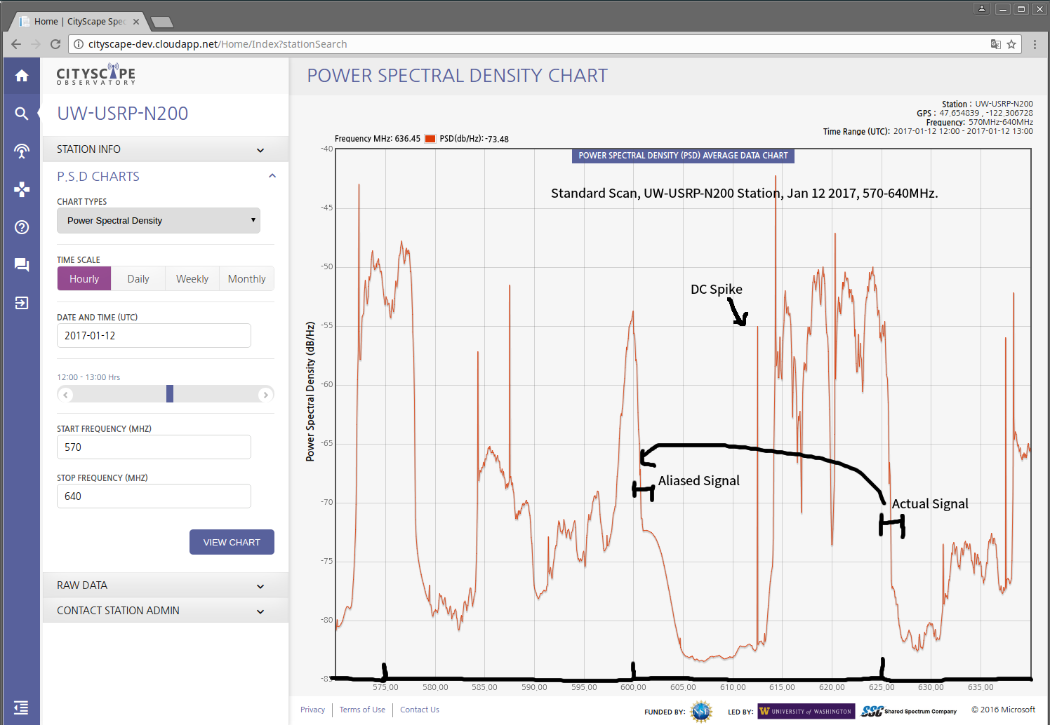
Figure. 6: PSD Chart, With Aliasing @ 600MHz.
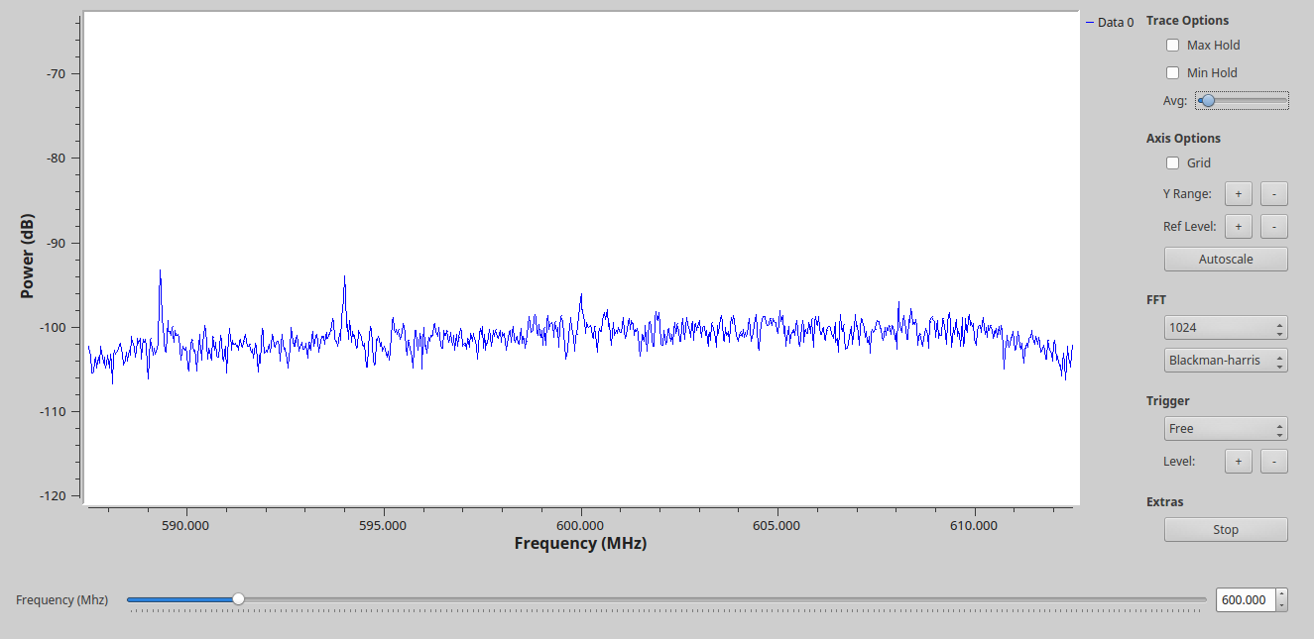
Figure. 7: PSD Chart, Taken From a Near Site, Without Aliasing @ 600MHz (F_LO 600MHz).

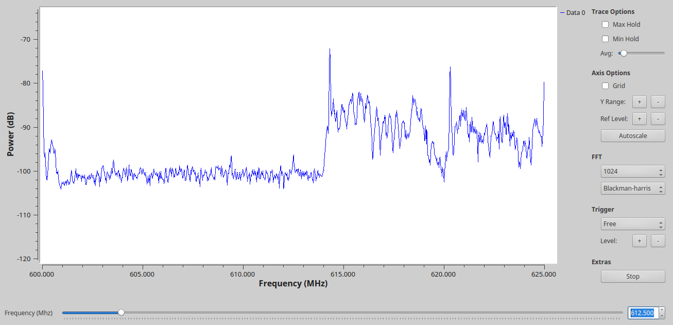
Figure. 8: PSD Chart, Taken From a Near Site, With Aliasing @ 600MHz (F_LO 612.5MHz).

*Unit of the Y-axis, for figure 6-8, is dBFS (decibel, in relative to the maximum ADC output; not calibrated to dBm). They are taken with same motherboard and daughterboard configurations.

IQ Data

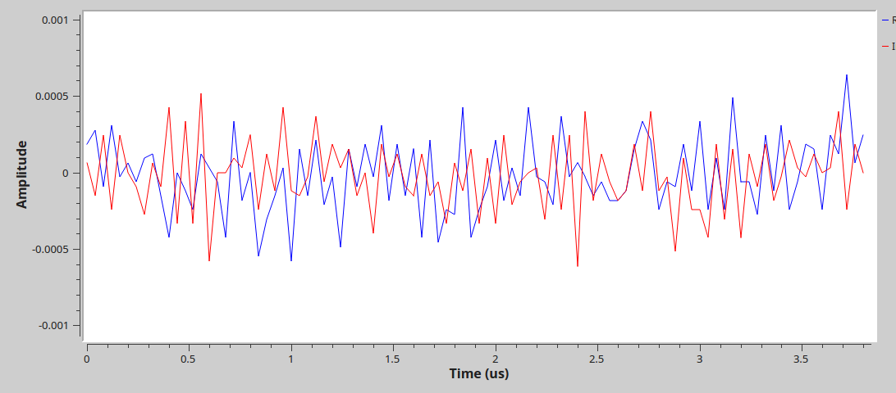
Figure. 9: I-Q Plot (Using USRP + GNURadio) of an Aliased Signal.

Due to the effect of the low-pass filters, aliased signals will tend to appear as high-frequency components. However, it can be difficult to identify aliased signals by observing I-Q data in time domain (and may yet impair the data demodulator if you are demodulating the received I-Q data). The easiest way to identify such issues is probably to look this problem in frequency domain, like in the above subsection.

Figure 9 shows a time-domain I-Q plot of an aliased CW signal (generated using GNURadio and USRP).

Other Data Quality Concerns

There are other factors which may affect the I-Q data quality. They are usually due to the nonlinearity of the components, variations in the components, or due to the signal leakages within the system.

Here is a list of possible quality issues (*not comprehensive):

- DC component (LO leakage)
- Spurious signals from other leakages or mismatches (ex : baseband anomalies of UBX boards)
- I-Q amplitude / phase offsets
- Harmonics
- IIP2, IIP3
- ADC overload

DC components and I-Q imbalances are automatically corrected by the UHD driver (assuming the station is correctly calibrated). ADC overload and intermodulation issues can be corrected or suppressed by adjusting the receiver amplifier gain.

Ettus Research provides RF performance measurement results for the UBX daugherboard at: https://files.ettus.com/performance_data/ubx/UBX-without-UHD-corrections.pdf

Appendix – UHD_USRP_PROBE

linux; GNU C++ version 5.3.1 20151219; Boost_105800; UHD_003.009.002-0-unknown

-- Opening a USRP2/N-Series device...
-- Current recv frame size: 1472 bytes
-- Current send frame size: 1472 bytes

UHD Warning:
Unable to set the thread priority. Performance may be negatively affected.
Please see the general application notes in the manual for instructions.
EnvironmentError: OSError: error in pthread_setschedparam
_____________________________________________________
/
| Device: USRP2 / N-Series Device
| _____________________________________________________
| /
| | Mboard: N210r4
| | hardware: 2577
| | mac-addr: a0:36:fa:38:38:2d
| | ip-addr: 192.168.10.2
| | subnet: 255.255.255.255
| | gateway: 255.255.255.255
| | gpsdo: none
| | serial: E2R28MEUP
| | FW Version: 12.4
| | FPGA Version: 11.1
| |
| | Time sources: none, external, _external_, mimo
| | Clock sources: internal, external, mimo
| | Sensors: mimo_locked, ref_locked
| | _____________________________________________________
| | /
| | | RX DSP: 0
| | | Freq range: -50.000 to 50.000 MHz
| | _____________________________________________________
| | /
| | | RX DSP: 1
| | | Freq range: -50.000 to 50.000 MHz
| | _____________________________________________________
| | /
| | | RX Dboard: A
| | | ID: UBX-40 v1 (0x0078)
| | | Serial: 30CEDF1
| | | _____________________________________________________
| | | /
| | | | RX Frontend: 0
| | | | Name: UBX RX
| | | | Antennas: TX/RX, RX2, CAL
| | | | Sensors: lo_locked
| | | | Freq range: 10.000 to 6000.000 MHz
| | | | Gain range PGA0: 0.0 to 31.5 step 0.5 dB
| | | | Bandwidth range: 40000000.0 to 40000000.0 step 0.0 Hz
| | | | Connection Type: IQ
| | | | Uses LO offset: No
| | | _____________________________________________________
| | | /
| | | | RX Codec: A
| | | | Name: ads62p44
| | | | Gain range digital: 0.0 to 6.0 step 0.5 dB
| | | | Gain range fine: 0.0 to 0.5 step 0.1 dB
| | _____________________________________________________
| | /
| | | TX DSP: 0
| | | Freq range: -50.000 to 50.000 MHz
| | _____________________________________________________
| | /
| | | TX Dboard: A
| | | ID: UBX-40 v1 (0x0077)
| | | Serial: 30CEDF1
| | | _____________________________________________________
| | | /
| | | | TX Frontend: 0
| | | | Name: UBX TX
| | | | Antennas: TX/RX, CAL
| | | | Sensors: lo_locked
| | | | Freq range: 10.000 to 6000.000 MHz
| | | | Gain range PGA0: 0.0 to 31.5 step 0.5 dB
| | | | Bandwidth range: 40000000.0 to 40000000.0 step 0.0 Hz
| | | | Connection Type: QI
| | | | Uses LO offset: No
| | | _____________________________________________________
| | | /
| | | | TX Codec: A
| | | | Name: ad9777
| | | | Gain Elements: None

