cscape_cal_ampl.py:

Bench measurement of SDRs to produce run-time calibration tables

Dave Aragon

July 7, 2017 (rev. 3)

This document, like the software tool it describes, is intended for system integrators who wish to measure an SDR receiver’s gain vs. frequency characteristic under laboratory conditions prior to deploying it in a system. By using the cscape_cal_ampl tool with the procedure given below, the user will obtain a data file that other software can use to normalize the SDR’s receive output level.

The tool and this document were created for the Cityscape Pilot project, and the written procedure frequently names specific equipment used in that project. The calibration tool itself is reasonably portable; it uses the GNU Radio framework and has been tested under Windows, Linux, and Mac OS.

This document is organized as follows: the first section shows the calibration tool’s role in the preparation (integration and test) of an SDR-based sensor node. The second and major part gives step-by-step instructions for using the tool and thereby generating a calibration file.

Introduction and Context

Fig. 1 illustrates the creation and deployment of Cityscape calibration tables. Architecturally, Cityscape amplitude calibration is similar to the Ettus (USRP) self-calibration tools: measurements are taken and written to a file, with a filename keyed to the board’s serial number; the file is stored in a known directory on the USRP’s host computer; and at runtime, the host computer’s software opens the file and loads the calibration data, which it applies to subsequent RF data captures. However, unlike the Ettus self-calibration tools, this amplitude calibration tool requires a signal generator calibrated in power. Also, the host computer at calibration time isn’t assumed to be (although it can be) the same as the host computer in the sensor node.

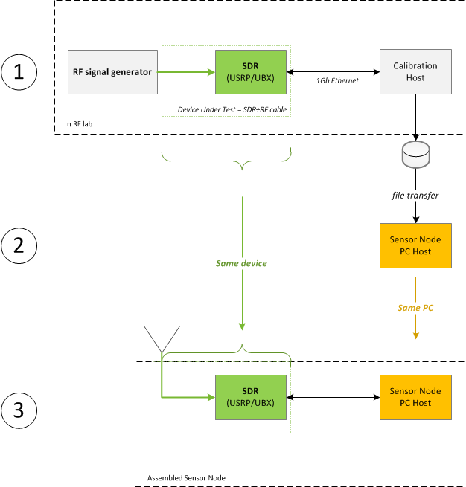

Fig. . Stages in preparation of a calibrated a Cityscape Sensor Node

Procedure for Amplitude Calibration

1. Collect the required hardware devices:

(1a) The *Device Under Test*, which is a USRP containing a UBX daughterboard together with an antenna cable. (The input point of the DUT is the antenna feedpoint end of the cable.)

(1b) A host computer (which may be a laptop), with a 1Gb Ethernet port, and able to run GNU Radio-based tools (including cscape_cal_ampl.py).

(1c) An RF signal generator, calibrated in power.

(1d) An adapter may be required for connecting the signal generator to the antenna cable. If so, the smallest suitable hardware should be used (e.g. an adapter only, not a pigtail or a combination of adapters.)

1. Make (or verify) the connections:

(2a) Connect the computer to the DUT by a Cat-6 or Cat-5E Ethernet patch cable.

(2b) *With the signal generator’s RF output disabled,* connect the antenna cable to the RF generator, and to the RX2 input of the SDR.

* + - Note: The SMA connectors on the USRP are marked “RF1” and “RF2” and they have no mandatory correspondence with the “TX/RX” and “RX2” outputs. If necessary, open the USRP case to determine how they are cabled. Once you have identified the correct external SMA connector, put a label on the USRP so you don’t have to keep opening the case.

1. Set up the computer side:

(3a) Bring up the Amplitude Calibration GUI:

* + - From a shell window, invoke the tool by:

cscape-cal-ampl.py

No command-line arguments are required. The tool will display a GUI window containing controls (sliders and text boxes) and text output regions.

* + - Verify that the GUI appears, resembling the screenshot below. Specifically, verify that serial numbers for the USRP and daughterboard are displayed.

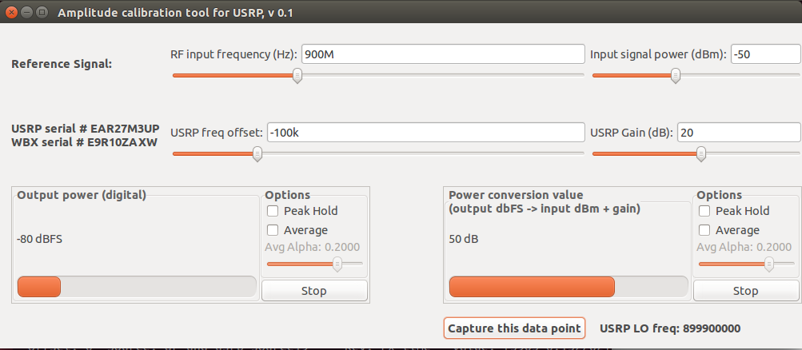

(3b) Set the inputs (sliders/text boxes) to the following values:

|  |  |
| --- | --- |
| USRP Freq offset: | −100k |
| USRP Gain: | 20 |
| input signal power: | −50 |
| RF input frequency: | (doesn’t matter at this step; will be set later) |

(In its first release, the tool will not provide an interface to configure a frequency sweep. In future versions, frequency sweep settings will be entered at this point. )

1. Set up the signal generator side:

(4a) On the RF signal generator, set the output power to −50 dBm.

(This level follows a NIST / NTIA recommendation that the input level be chosen so that the SDR output is approx. 10 dB below full scale.)

(4b) If an inline 30 dB attenuator is used, the signal generator’s output should be increased to −20 dBm (still presenting −50 dBm at the USRP’s antenna terminal.) In that case, take care that the attenuator really is connected! Otherwise, an input level of −20 dBm would be close to the damage threshold of the UBX.

1. Take the readings at each frequency:

For a manual sweep, the number of frequencies to include is limited by the required time and effort. A reasonable interval might be two steps per decade (i.e. a 1-3-10 sequence). As noted in *SSC Calibration Memo v.1,* more test frequencies should be allocated to the regions where sharp changes are expected. According to Ettus published curves, the UBX shows a smooth characteristic generally, but with a discontinuity at 500 MHz due to different signal paths above and below that frequency. By the same reasoning, a discontinuity at 1500 MHz is also possible. The recommended set of frequencies for a manual sweep of a UBX is therefore:

|  |  |
| --- | --- |
| Input Frequency (MHz) | Rationale |
| 10 | Lower limit of UBX range |
| 30 |  |
| 100 |  |
| 500.0  500.1 | Transition point between sub-bands in UBX front end  (lower frequencies are upconverted) |
| 1500  1500.1 | Transition point between sub-bands in UBX front end  (separate LNAs + input filters above & below this frequency) |
| 3000 |  |
| 6000 | Upper limit of UBX range  (If this is above the signal generator’s upper limit, test at the highest available frequency, e.g. 3000 MHz.) |

(5a) On the RF signal generator:

* + - Verify the amplitude setting (−50dBm).
    - Set the frequency.
    - Enable the RF output (if it is not already enabled.)

(5b) On the computer:

* + - Set “RF input frequency (Hz):” to the same frequency used by the signal generator.
    - Verify that “input signal power (dBm):” is set to −50.

(5c) Observe the GUI. The “Power conversion value” output text box should stabilize within one or two seconds.

(5d) Click upon the “ Capture this data point ” button.

(5e) For the first data point only, verify that the output file is being written. This can be done from a shell window, by searching for files *.csv in the working directory. There should be a new file with a name that includes the USB and UBX serial numbers. The last line of the file should be a pair of comma-separated numbers, representing the data point that you captured in step (5d).

Repeat steps (5a – 5d) for each desired frequency.

1. Turn off the RF output of the signal generator. Disconnect power from the USRP. Close the GUI window to exit the calibration tool.
2. Proofread and copy the output (.csv) file:

(7a) The output file is in the working directory (as verified in step 5e). Verify that its filename contains the USRP and UBX serial numbers, for example:

irving@lupine:~/rfdata$ ls -l *csv

-rw-rw-r-- 1 irving irving 255 Sep 9 13:13 rx_cal_ampl_EAR27M3UP_E9R10ZAXW.csv

irving@lupine:~/rfdata$

(7b) Open the file in a plain-text editor (e.g. vim, gedit, Notepad, etc.) and examine the header (metadata). An example is shown below.

* + - Verify that in the first line, the first field is “version” and the second is “0.1”.
    - Verify that the RF front end (daughterboard) type and serial number are present and correct.
    - Verify the human-readable part of the timestamp (merely to within a several minutes, i.e, sufficient to identify this calibration run.)

version, 0.1, Cityscape SDR calibration table name, Rx gain vs. frequency

SDR, N200, EAR27M3UP

**RF front end, UBX, E9R10ZAXW ←**check daughterboard model and serial #

timestamp, 1473477136, Fri 09 Sep 2016 08:12:16 PST ←check date & time

source, ./usrp_cal_amp.py

DATA STARTS HERE

frequency, gain_adj

… (your numeric data here) …

(7c) Examine the numeric data. The leftmost (key) values are the local oscillator frequencies. These will be the RF input frequency values that you used, offset by the USRP Freq offset value of −100 kHz. You can now use the text editor to clean up small mistakes such as capturing multiple lines for the same frequency. As well, you should sort the values in ascending order of frequency; for a manual calibration run there will be few enough values that sorting by hand is practical.

(7d) Save your changes and exit the editor.

(7e) Copy the .csv file to a safe location. The *ultimate* destination of the file is the sensor node PC with which the DUT will be deployed. However, other steps in the handling of the file are determined by the system integrator and may involve, for example, a “traveler” package tied to the DUT.

Regardless, the .csv file should be copied *somewhere* immediately, to guard against it being inadvertently overwritten bv a subsequent invocation of the calibration tool on the same hardware.

Results and Implications of UBX Gain Curves

## Hardware Units Tested

Measurements were performed on three UBX-40 boards, under the following conditions, and compared with the Ettus published gain curve:

|  |  |  |
| --- | --- | --- |
| **Device** | **Data obtained by** | **Where/When** |
| Typical characteristics for UBX | NI/Ettus publication |  |
| F36770 | Agilent, GRC | UW 08-24-16 |
| 30CEE12 | HP, GUI | SSC 09-23-16 |
| 3CEDF1 | Agilent, GUI | UW 09-24-16 |

### UBX #F36770

F36770 was tested by UW on Aug. 24. The signal source was an Agilent RF signal generator. A simple GRC flowgraph was used to display the USRP’s output power, which was recorded manually. (At the time, UW’s amplitude calibration software had not yet been written.) The only N-to-SMA adapter then available used components considered unsuitable for UHF frequencies, so all but two of the data readings were taken below 500 MHz. Immediately afterward, the USRP and UBX were sent to Microsoft (Kannam) to support software development/testing, so the Aug. 24 readings are the only RF calibration readings available for that unit.

### UBX #30CEE12

SSC used this board in testing UW’s GUI-based calibration tool. The wiring between the USRP front-panel connectors and the daughterboard antenna terminals was found to be reversed compared to UW’s hardware; that is, the RF2 antenna (used by the tool and by the Sensor Node software) was wired to RX2 on the front panel, which made the written instructions for the GUI tool incorrect. The readings below were taken with an HP (Agilent) signal generator correctly connected to the active antenna port (RX2), and were emailed to UW on Sep. 23.

### UBX #3CEDF1

3CEDF1 is kept in UW’s lab to support development and testing of the calibration software. The readings reported here were taken on Sep. 24 using the same GUI tool as SSC’s Sep. 23 readings. (The results shown here are consistent with other readings on 3CEDF1 taken throughout September and early October.)

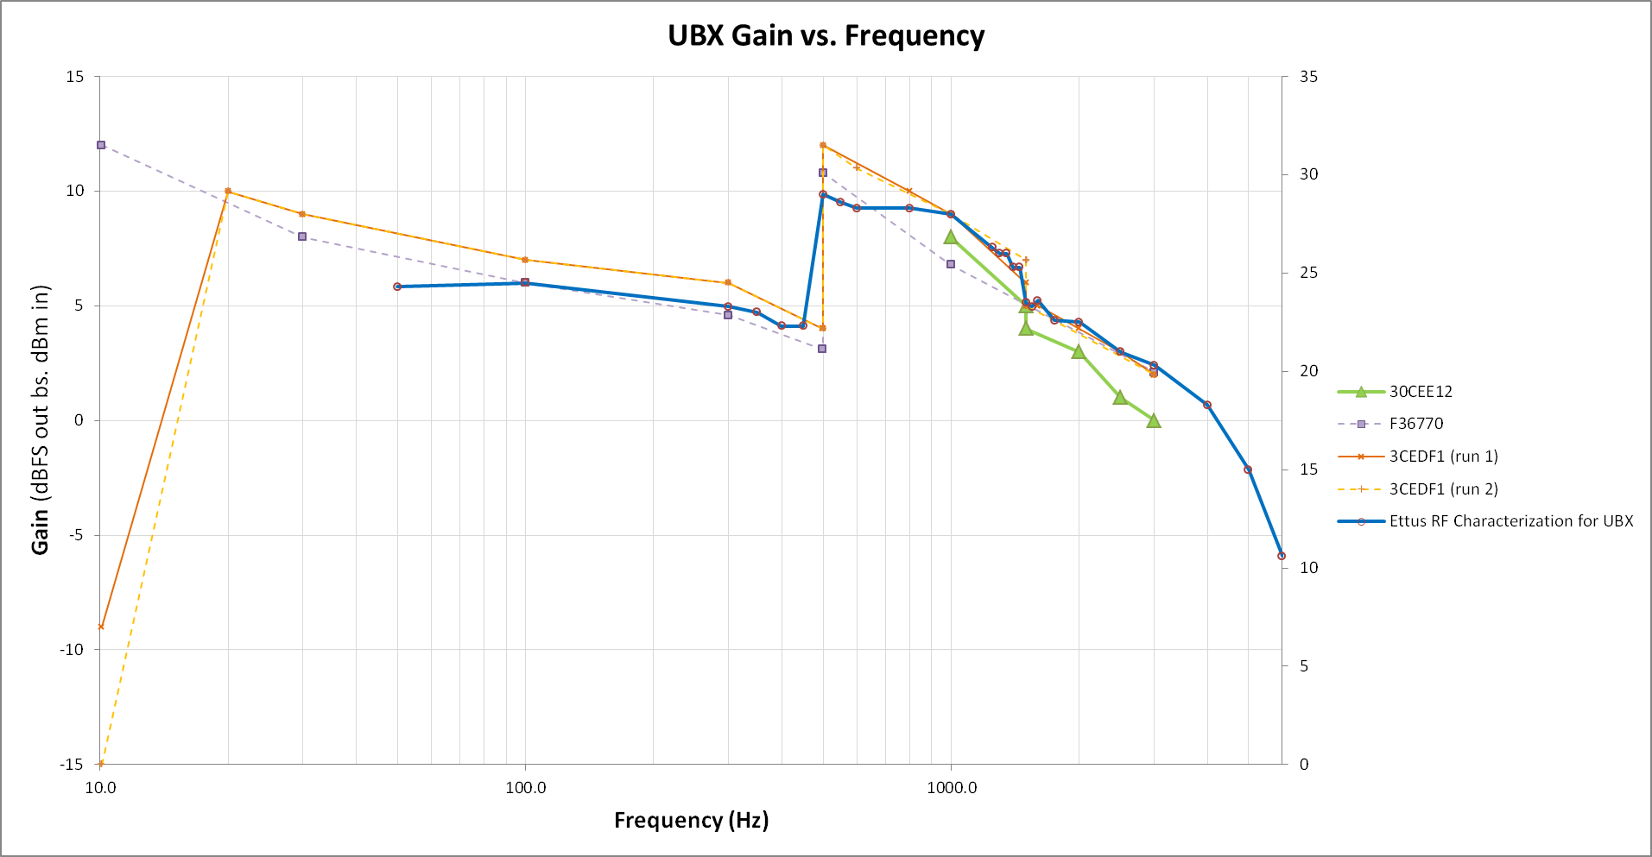

## Results

### All UBX boards have the same curves

Comparing the three boards with each other (or comparing any board’s data points with the straight-line interpolation between another board’s data points when they were not taken at exactly the same frequencies), the readings all agree within 2 dB. This suggests that individual calibration of UBX is not strictly necessary, because a calibration table representing a “typical” UBX will adequately represent any one of the three tested boards.

### Discontinuities are present where expected

Discontinuities in the frequency response at 500 MHz and 1500 MHz were found, as anticipated. The jump at 500 MHz is the larger one, about 8 dB. The 1500 MHz discontinuity is only 2 dB, not enough to cast doubt on the validity of either the upper or lower subset of data, but possibly large enough to cause curiosity among users of cityscape spectrum suite data.

### The response is smooth and monotonic except for the two discontinuities

Within each of the three regions bounded by those discontinuities, the amplitude versus frequency response is smooth, and very well modeled as logarithmic. (That is, if we plot power in dB versus log frequency, then straight-line asymptotes are easily drawn for each of the three regions.)

The Ettus measurements are plotted against a different vertical scale, because they exhibit a constant offset from all of the empirical readings. This offset is almost entirely accounted for by the 20 dB gain of the daughterboard’s analog amplifier. Our figures do not include that 20 dB because it is intentional and programmed, whereas the purpose of the calibration table is to compensate for gain effects that are not already accounted for elsewhere.