Power Shell 101
Module 3 Hands-on Activity – PowerShell in VSCode
4/23/2019 Developed by Jin Chang, Sion Yoon
4/27/2019 Tested by Sion Yoon, Jin Chang
Center for Information Assurance (CIAE) at City University of Seattle

Learning Outcomes
- Learn about using Get-Command and Get-Service cmdlets, the help system, and pipeline.

Resources
- Cmdlets and the help system
- https://docs.microsoft.com/en-us/powershell/scripting/overview?view=powershell-6
- Pipeline
https://www.youtube.com/watch?v=WpFc2m_uLfM&list=PL6D474E721138865A&index=15

Activities
- Get-Command & Get-Service
- Help-System
- Pipeline
- More
- Exporting to CSV and XML
- Code Example
- Q&A

Get-Command & Get-Service

- Open PowerShell in VSCode

- Before diving into the help system and pipeline, let’s quickly go over the “get-command” (alias: “gcm”) and “get-service” cmdlets, which are commands that you are going to use very often. The “get-command” cmdlet gets all commands that are installed on the computer and you can use this cmdlet to search for the command that you are looking for. Type:

%get-command *oper*

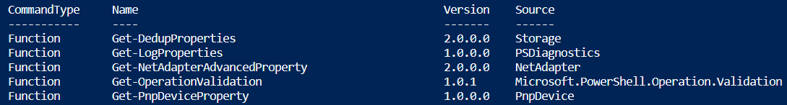

You will see a list of all commands that contain “oper”. If you are looking for a command that relates to operation, you can trim the search even more by typing:

%get-command *opera*

- The get-service cmdlet (alias: “gsv”) lists services that are running or currently stopped. To retrieve a list of services that has a display name of windows event, type,

%get-service –displayname “windows *event*”

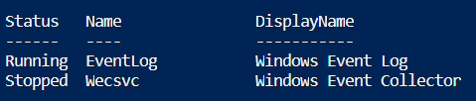

Help System

- The PowerShell help system is very useful in using to use PowerShell effectively. Type the following 3 help commands, see if you tell the difference and similarities. Use the ‘spacebar’ to move through the contents, ‘enter’ to proceed line-by-line, or ‘q’ to exit the page.

%get-help
%help
%man

Did you notice that the screen is scrolled all the way to the bottom for “get-help” while you can move through the contents for “help” and “man”?

- There are different ways in which to get help by using different parameters in the help system. A few of many parameters are:
  - Detailed - displays parameter descriptions and examples.
  - Full - displays parameter descriptions, examples, input and output object types, and additional notes.
  - Examples - displays only the name, synopsis, and all examples.
  - Online - displays the online version of the help topic in your default web browser.
  - ShowWindow - displays help in a pop-up window.

Test these help parameters using get-childitem.

%help get-childitem
%help get-childitem –full
%help get-childitem –detailed
%help get-childitem –example
%help get-childitem –online
%help get-childitem –showwindow

- Within the help system, you will see that there is information about syntax
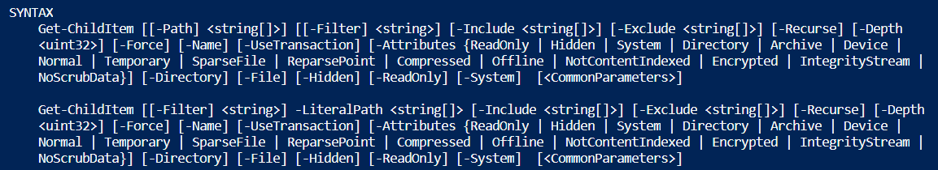

- Let’s look at the first parameter between the square brackets “[]” in the first parameter set. Anything between the square brackets are optional, so you can run the command “get-childitem” without typing the parameters and it defaults to the current path. But what if you want to type a path and get directory (childitem) from a specific path. You can type:

% get-childitem –path c:\

or

% get-childitem c:\

You can use either way since –path parameter name is also in the square brackets and also optional. So if you just provide a string in our example case at the first position, it will take that string and assume that it meant it the –path parameter.

- On the other hand, how about the –exclude parameter, which is not in square brackets.

The parameter itself is optional, but it means that you would need to type the parameter name “-exclude” before providing the value. You do not actually have to type all of the “-exclude” but just enough so that PowerShell can tell the difference between the parameter you are referring to and other existing parameter options. For example, you can just type “-e” since no other parameter starts with “–e”. Type:

% get-childitem –e *.txt

Note that the square brackets that are against one another mean that you can provide more than one value. Moreover, you can use “help get-childitem –full” that we went through above to learn about each parameter in the syntax.

Pipeline: More

- Piping is a powerful feature of PowerShell. This will greatly reduce the amount of scripting effort by simply relaying the output of the earlier command into the later command as an input. Type the following command,

% get-alias

- This displays a very long list of aliases where you would need to scroll up and down. Wouldn’t it be nice if we can display one page at a time? It will be possible by simply piping it to “more” command. In other words, you are getting the output of get-alias and piping it to the input of more. Type,

% get-alias | more
% help help | more

Pipeline: Exporting to CSV and XML

- You can also use the pipeline to pipe, for example, services into a CSV file. Type:

% get-service | export-csv c:\services.csv

If you get an error message on the access to the path, redirect the path to the directory that you are on. For example:

% get-service | export-csv c:\Users\sion\services.csv

You have exported services into a CSV file name “services”. To open the CSV file using notepad, type:

% notepad .\services.csv

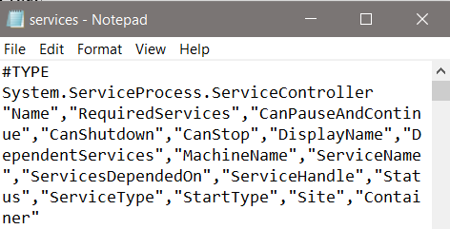

Also try opening the CSV file with Excel in your Windows file explorer.

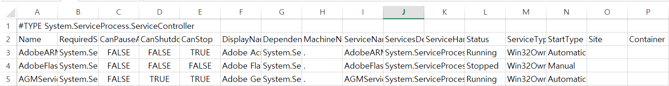

- We can do the same for XML files. Type (change the path to as you have done in #11):

% get-service | export-clixml c:\services.xml
% notepad .\services.xml

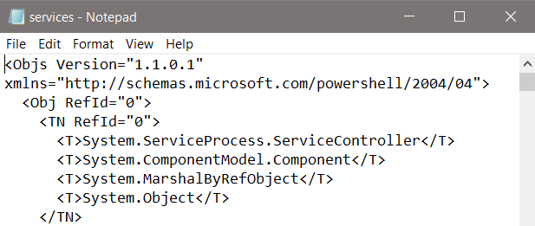

Double click the XML file on your Windows file explorer and you will see it displayed on an internet browser.
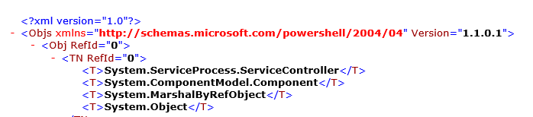

Pipeline: Code Example

- Now, let’s look little deeper in the pipe feature that can actually save your time as a system admin. Open a text file in Visual Studio Code, and name it filedisplay.ps1 like below.

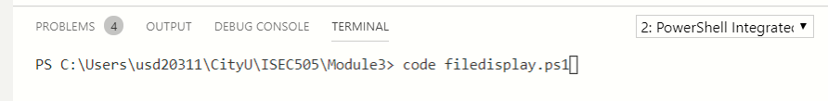

Go ahead and type the script that loops through a set of files and displays the files greater than 1000KB.

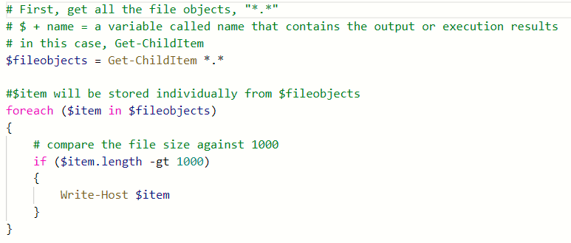

Save the file, and run it on the command line as follows;

We just spent our effort to write 8 lines of code just to display the files that have 1000KB or bigger. But here is a much quicker way to this in one shot thanks to pipe!

This is only possible because of piping mechanism where “ | ” carries over the output of the previous command to the next command. Note “$_” is an intermediate output variable.

Q&A
- What is the cmdlet that stops a service?
Stop-Service

- What is the cmdlet that gets service for Windows audio service? Hint: the answer is “get-service name”. Use the get-service –displayname parameter that we went over in #3 to find the name of the service.

get-service Audiosrv

- Using the pipeline, what is an operation that gets Windows audio service and then stop the service? This command should NOT run without the service name as it will stop all the services and you do not want to do that. Hint: answer from question #2 | answer from questions #1.

get-service Audiosrv | stop-service

- Test the command line from question 3. Before you do so, you need administrator privilege to perform this operation. Run the following command prior to modifying the service status.

% Start-Process PowerShell –Verb RunAs
If successful, you can see the speaker icon on the bottom taskbar showing 

Go to the Windows Start menu and type “services” and click on the “Services” manager. Scroll down to “Windows Audio” and you will see that there is nothing indicating for its status as shown as below:

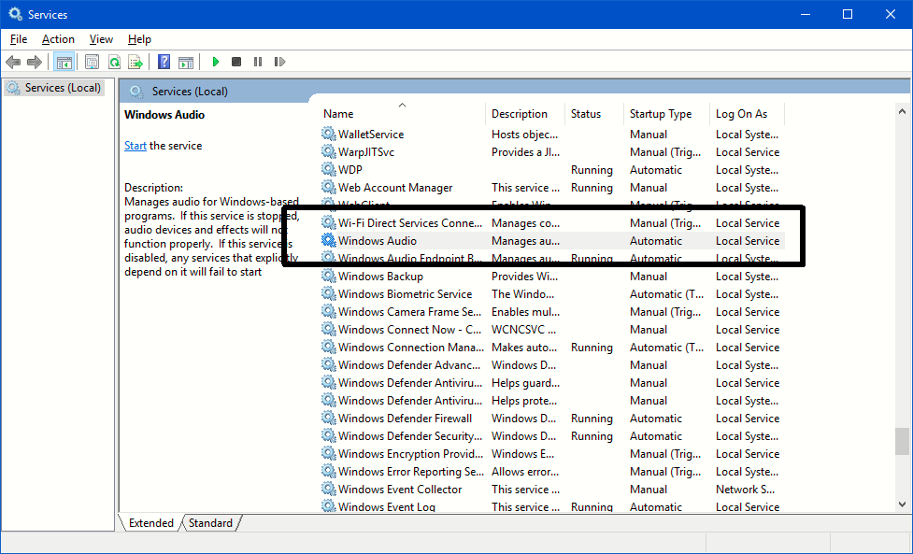

Take a screenshot of yours and paste it here:

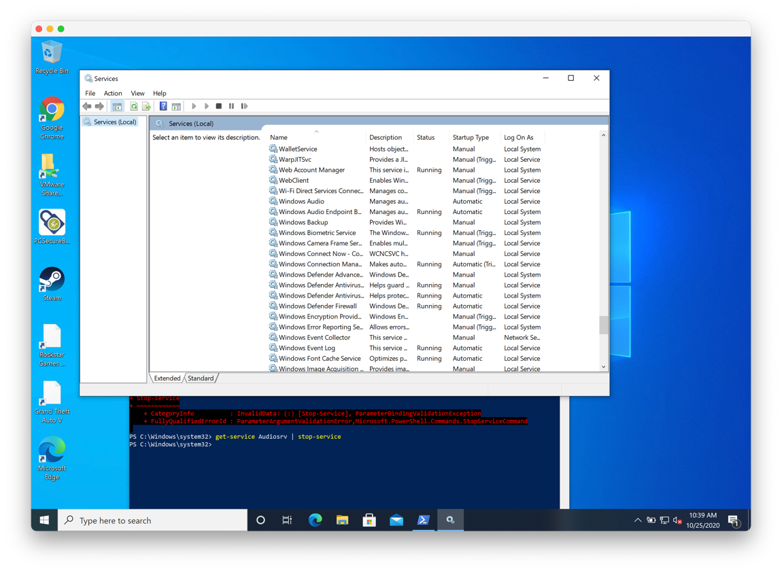

- Using the pipeline, what is an operation that gets Windows audio service and then start the service? Run the command as an administrator and take a screenshot of the Windows Audio service on the Services manager with the changed status.

get-service Audiosrv | start-service
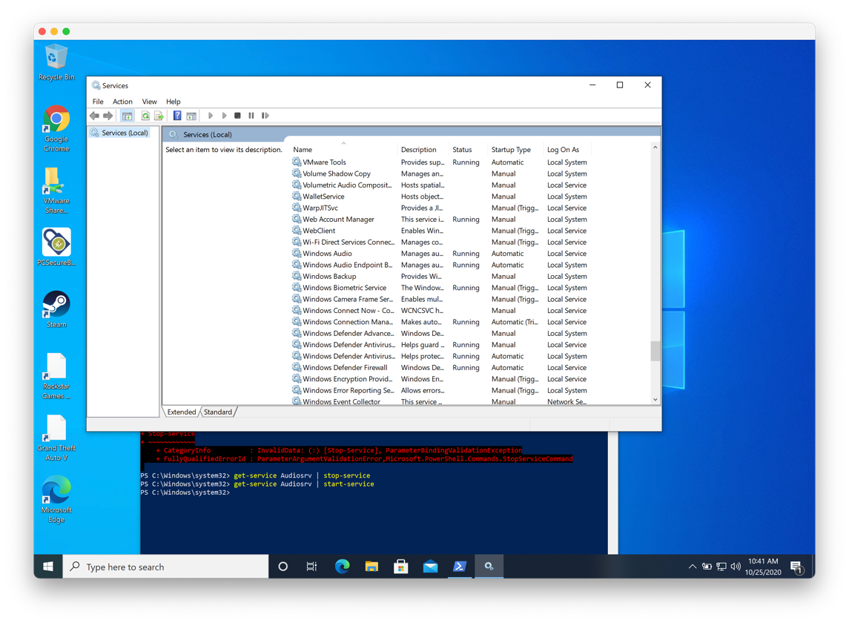
- Export the audio service into an XML file, open it up on a web browser, and provide the screenshot of the XML.

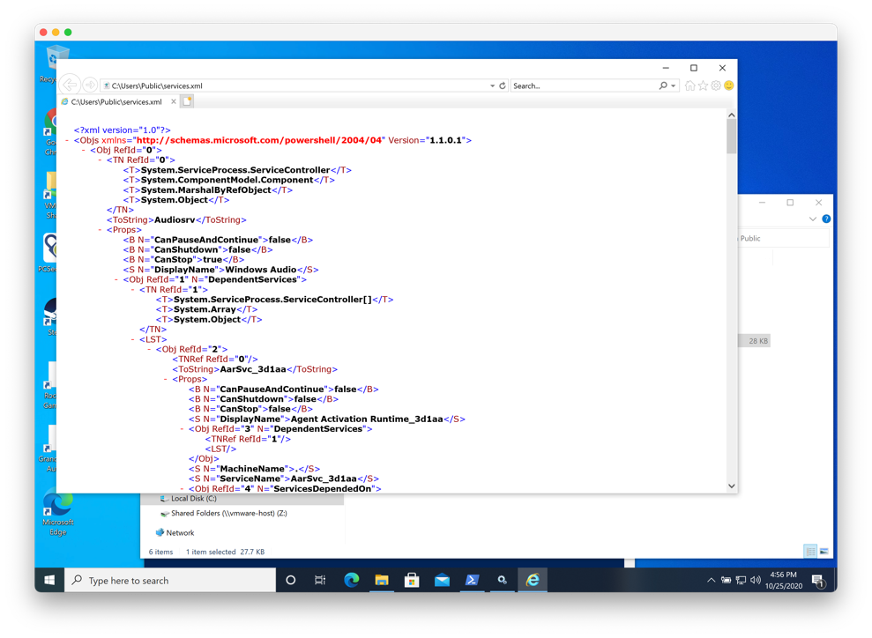

PUSH YOUR WORK TO GITHUB

Once you completed the Hands-on practice, export this file to PDF, then do the following to push your work to GitHub

Open the terminal from the VSCode by hitting the control + ~ key, make sure you are in the right path, for example: KimNguyen/Desktop/ISEC505/HOP03-KimNguyenMai/Module 3

Type the following command:

>>> git add . (to copy all changes you have made)
>>> git commit -m “Submission for Module 3 – YOUR NAME” (To add a message to your submission)
>>> git push origin master (to upload your work to Github)

