**HOS01A Install Python3 for VS Code:**

**HOS01B -Variables, Simple data types, UserInput and Loops :**

Section 2 - Variables, Data Types and User Input

Section 4 - String functions and Concatenation:

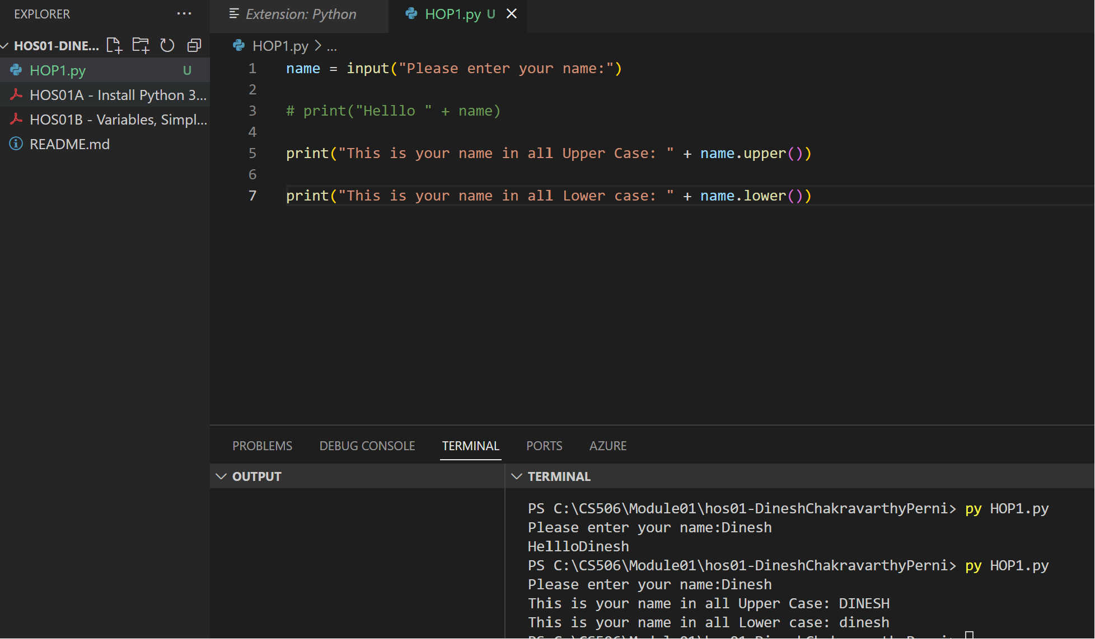

Section 5 - Numbers and operators

HOS01_ELIF.py

**Corrected Code :**

IfControl.py

Section 8 - While loop

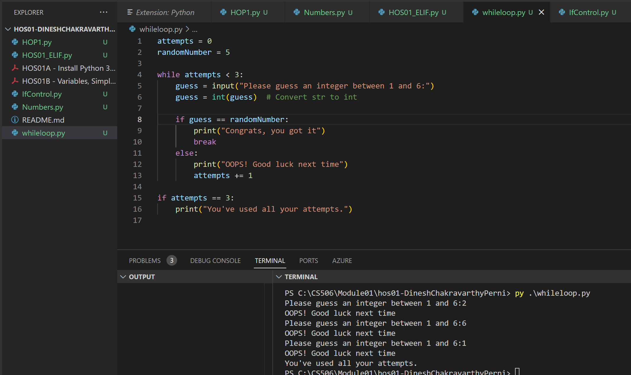

**Challenge code:**

ForControl.py

