#Creating accessing elementsA screenshot of a computer program

Description automatically generated

#**Challeneg1.py**

# adding elements

#Insert



List_remove.py

#pop

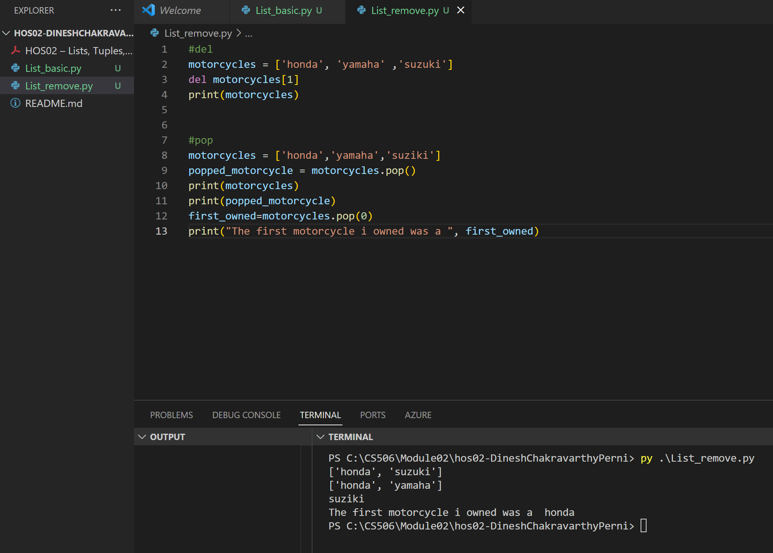

#remove

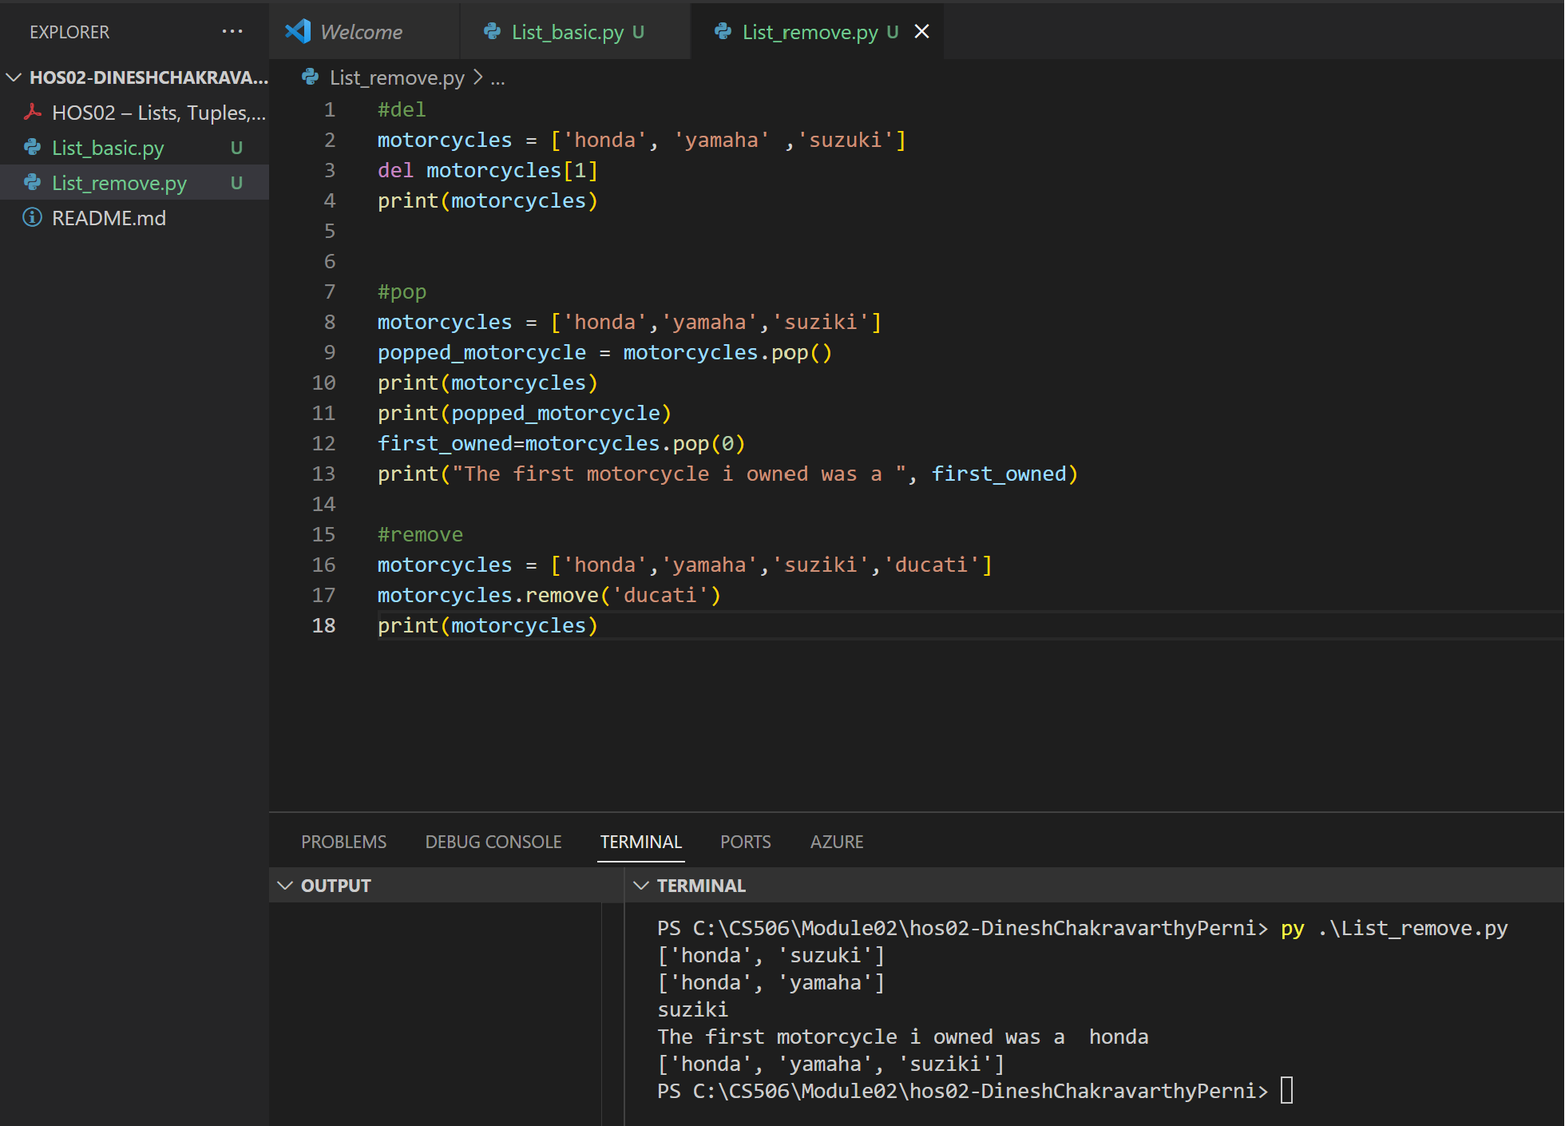

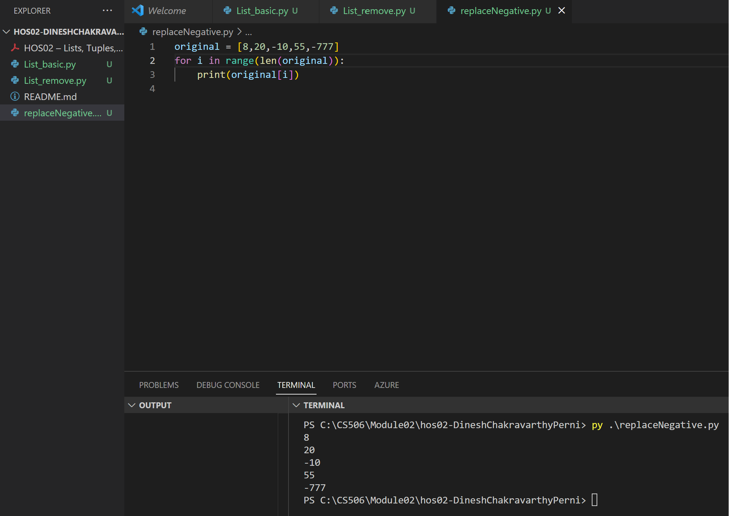

**Challenege2.py**

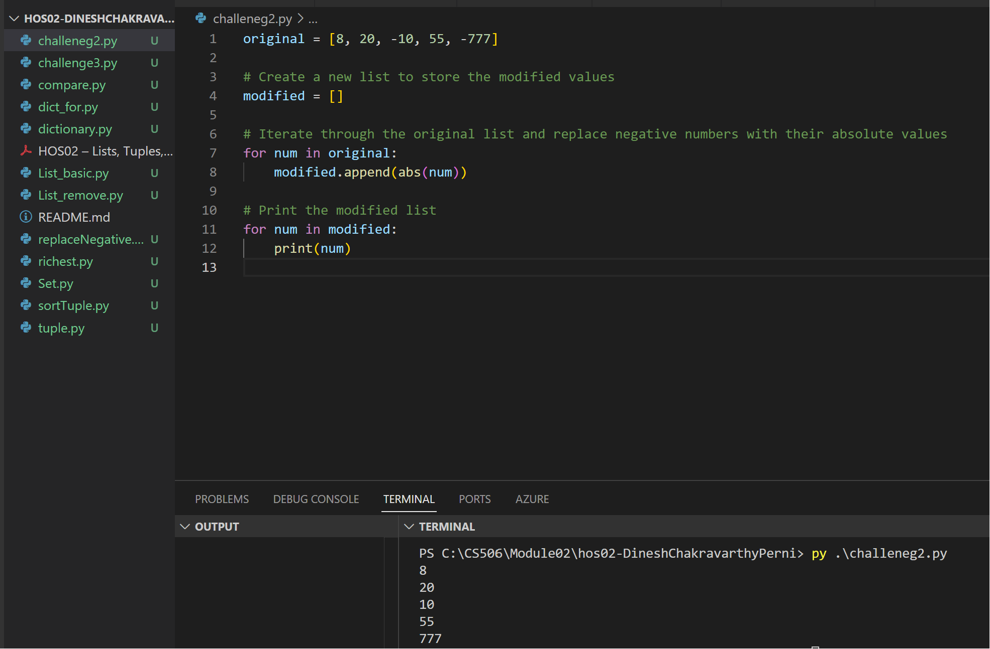

Tuple.py

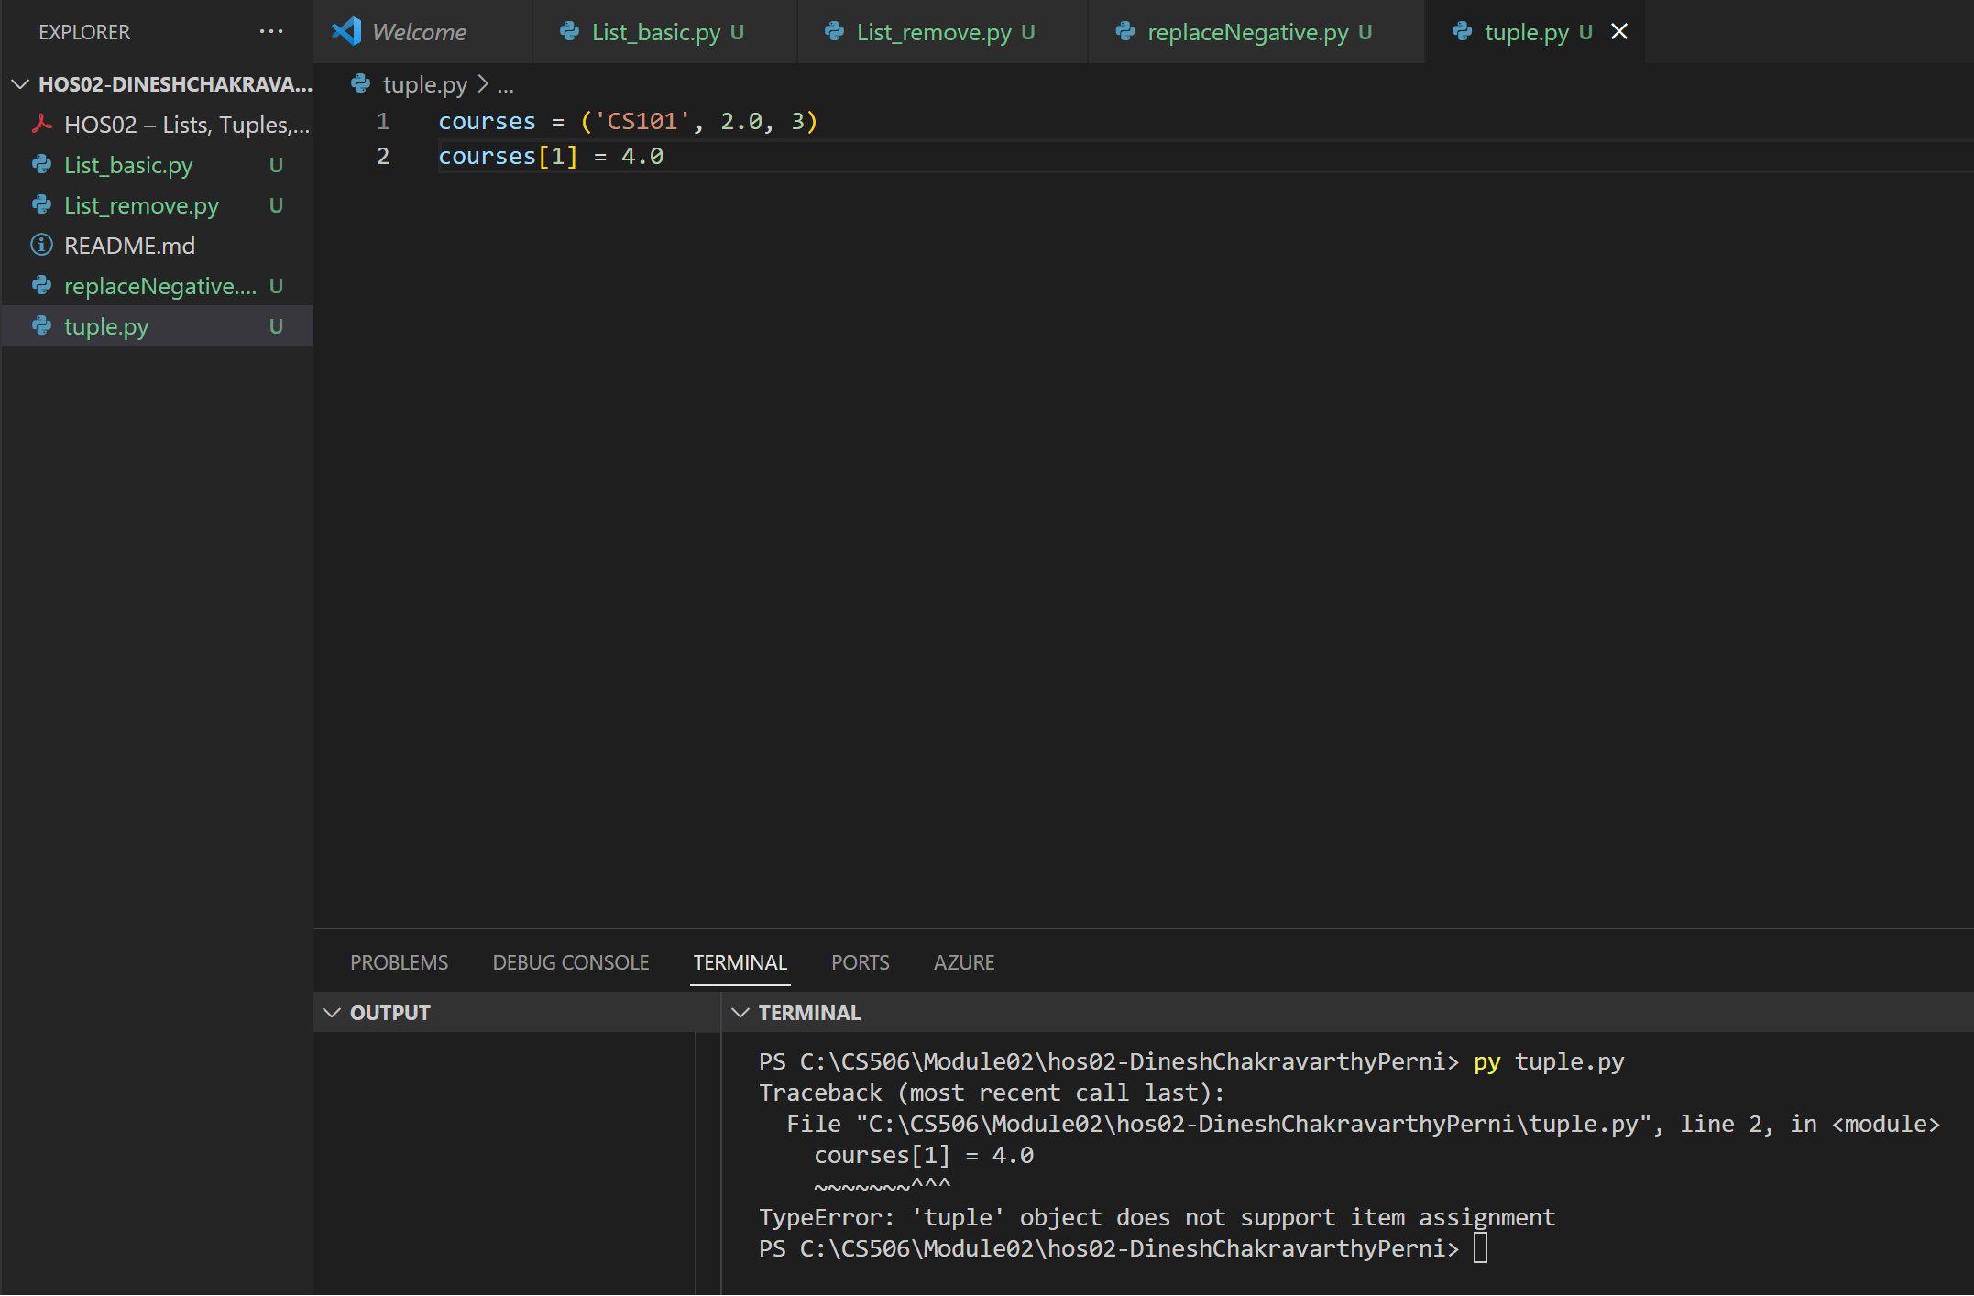

sortTuple.py

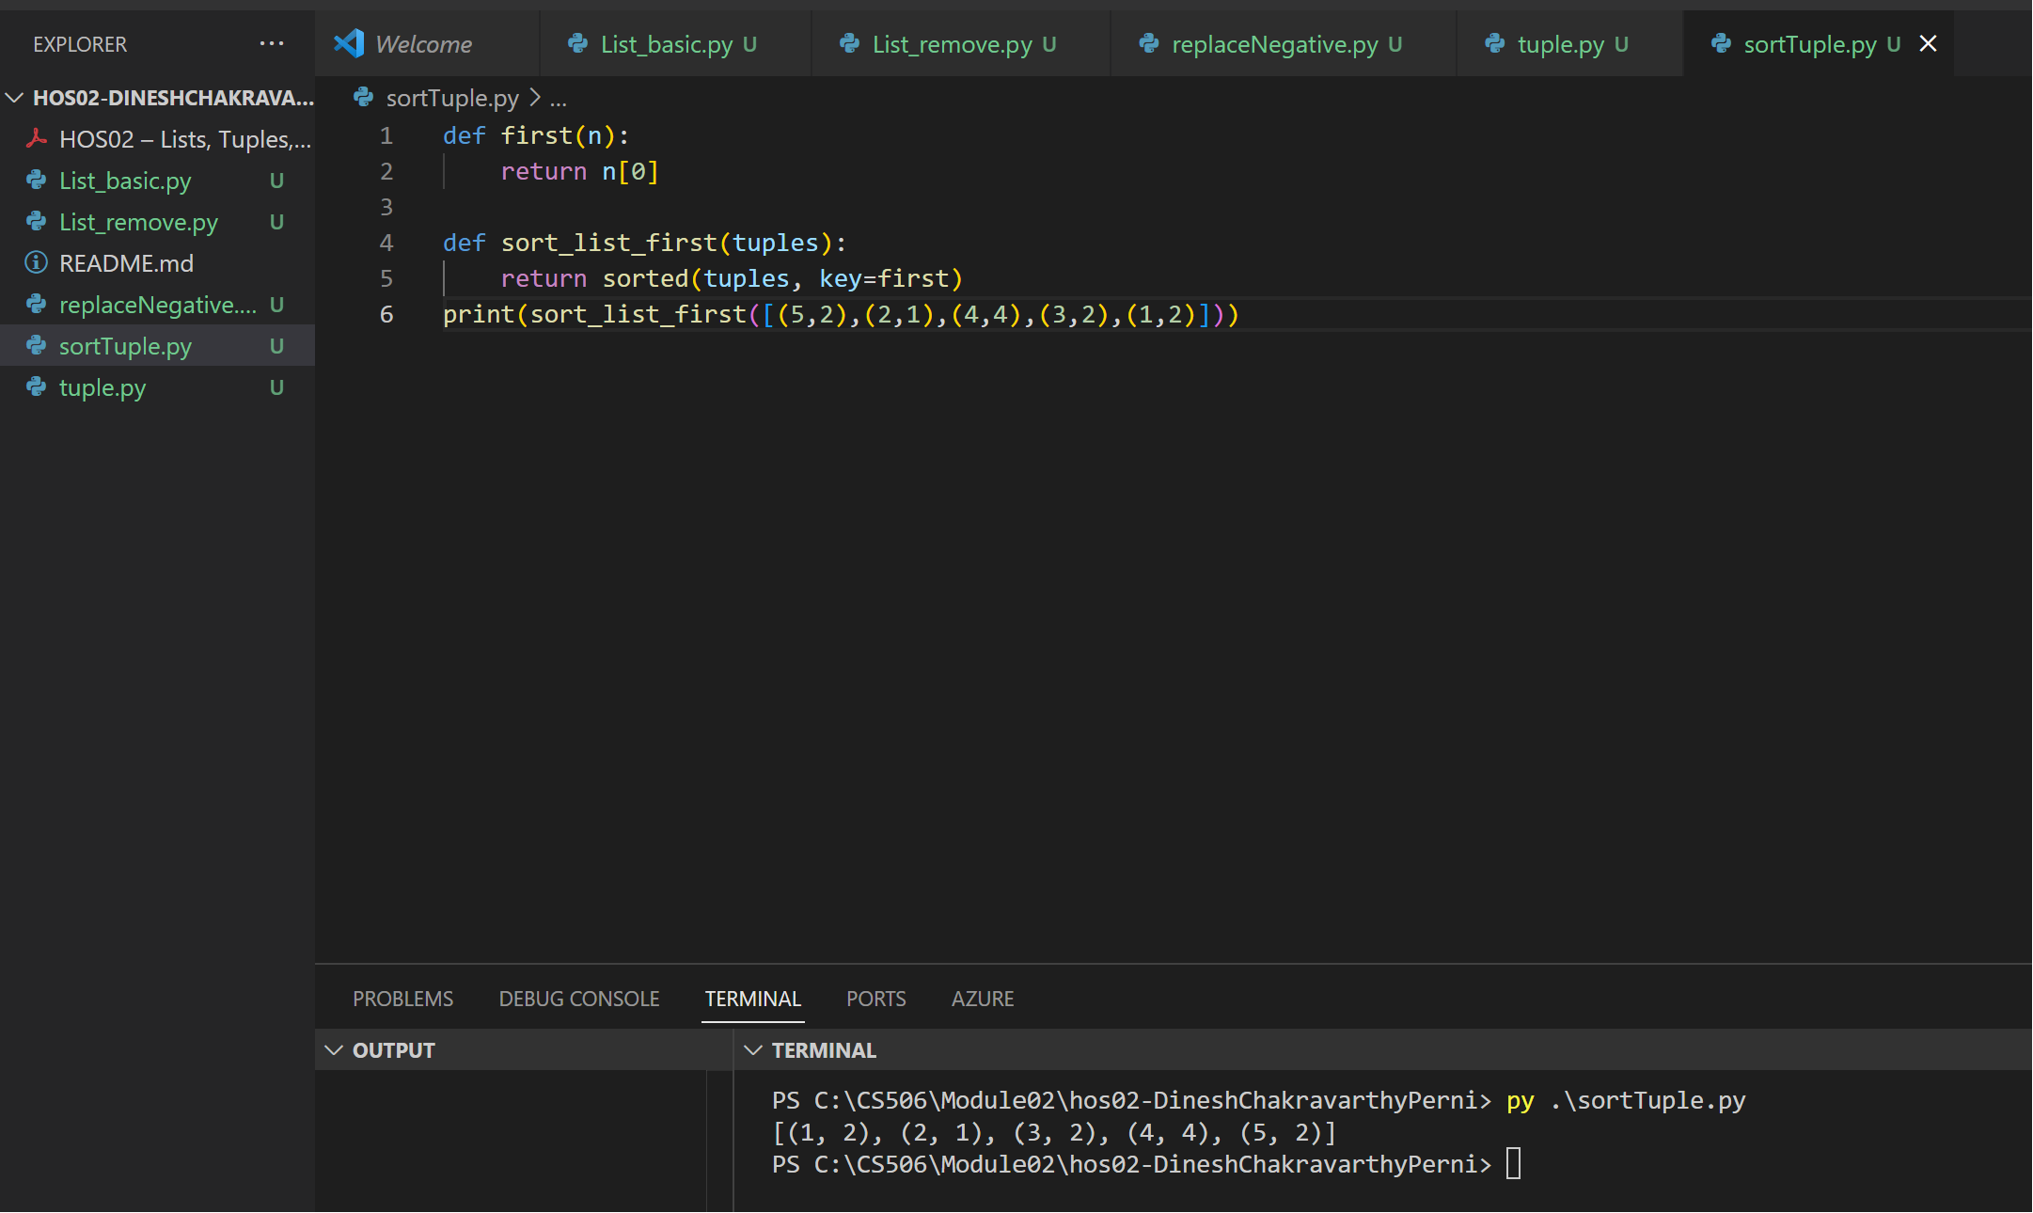

Dictionary.py

Compare.py

Dict_for.py

Richest.py

**Challeneg3:**

Set.py

