Challenge 1: It will not print the list of numbers.



Positional.py

Challenege 2:

Arbitrary_dict.py

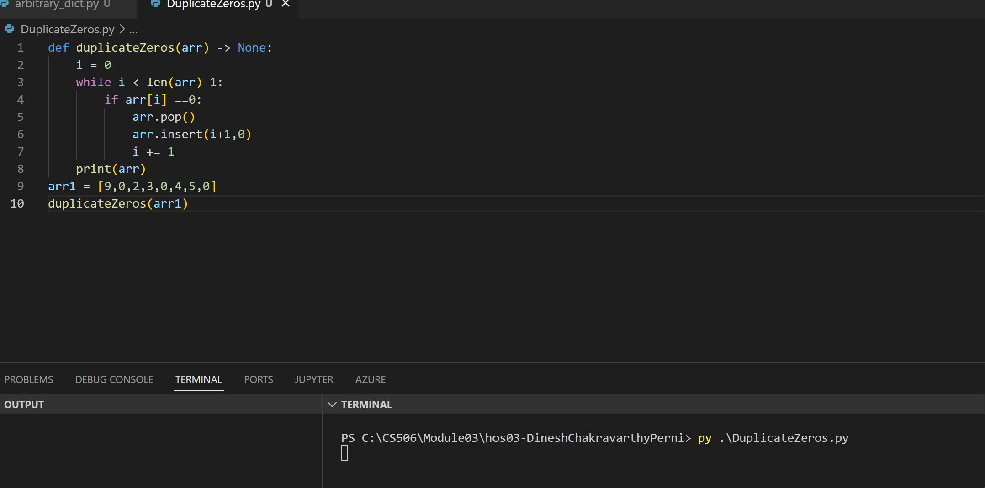

DuplicteZeros.py

Challenge:

The problem with using a for loop in the provided program is that it alters the list `arr` while in the process of iterating through it.