Social Need and Presidential Voting in Brazilian Municipalities, 2022 and 2026: Implications for Impersonal, Need-Based Resource Allocation
Abstract
Objective: to examine how municipal social need relates to the presidential vote in Brazil in 2022 and 2026, and what this relation implies for need-based, impersonal allocation of federal resources.
Methods: a design guided by CRISP-DM combined open data on 5,570 municipalities, a TOPSIS need index covering health, education, sanitation and income, k-means need profiles, a linear-programming allocation model, and regressions with cluster-robust and spatial specifications.
Results: need and Lula’s second-round vote share are strongly associated in both elections (r = 0.76). Income need dominates, education adds a smaller effect, and health and sanitation add little once region is held constant. The association holds within 25 of 26 states but is weaker in the Northeast. The 2022–2026 change is unrelated to overall need. A need-based allocation that ignores votes assigns 59% of resources to municipalities won by Lula, but the gap disappears once need is held constant.
Conclusions: in Brazil, need-based allocation will look partisan; managers should make allocation criteria explicit and auditable, so that impersonality can be demonstrated rather than presumed.
Keywords: public policy; resource allocation; voting behavior; regional disparity; social equity; CRISP-DM; impersonality principle
JEL Code: D72; H53; H77; R58; C38
1 INTRODUCTION
Every year the Brazilian federal government distributes resources for health, education, sanitation and social assistance among 5,570 municipalities that differ widely in their needs. The 1988 Constitution sets the reduction of poverty and of regional inequalities as a fundamental objective of the Republic (Art. 3), assigns to the federal budget the function of reducing interregional inequalities (Art. 165, § 7) and requires public administration to obey the principle of impersonality (Art. 37) (Brasil, 1988). Allocating resources according to need is therefore both a technical problem, which requires measuring need and choosing among competing criteria, and a problem of legitimacy, which requires showing that the criteria do not favor or punish anyone for political reasons.
These two problems meet in Brazilian electoral geography. Since 2006, the presidential vote for Luiz Inácio Lula da Silva and the Workers’ Party has been concentrated in poorer municipalities, particularly in the Northeast (Hunter & Power, 2007; Soares & Terron, 2008; Zucco, 2008). Part of this pattern has been linked to conditional cash transfers (Zucco, 2013), and the municipal distribution of the Bolsa Família program has itself been examined for political criteria (Fried, 2012). At the same time, there is evidence that discretionary federal transfers to Brazilian municipalities have followed partisan logic (Brollo & Nannicini, 2012). When need and vote overlap, a manager who allocates strictly by need will produce a distribution that looks partisan, and an observer cannot tell a need-driven allocation from a partisan one by looking at who received more.
Research on electoral geography has explained the vote, and research on distributive politics has tested allocation for political bias. Fewer studies bring need measurement, allocation decision support and electoral geography into a single design that a public manager can use. The 2026 election adds a further reason to revisit the question: Lula ran as a challenger in 2022 and as the incumbent in 2026, which makes it possible to check whether the association between need and vote survives a change of incumbency status.
This article examines how municipal social need relates to the second-round presidential vote in 2022 and 2026, and what this relation implies for impersonal, need-based allocation of federal resources. It answers five research questions, presented in Section 2.4, using official open data, a multicriteria need index, need profiles derived by clustering, a linear-programming allocation model and regression analyses with spatial robustness checks, organized according to the Cross-Industry Standard Process for Data Mining (CRISP-DM). The contribution is threefold. First, it updates the evidence on need and vote for 2022 and 2026 and decomposes need into four policy dimensions, showing which of them carry the association. Second, it proposes and applies an impersonality audit, a simple test of whether a need-based allocation favors one electorate beyond what need explains. Third, it offers a reproducible analytics pipeline built on open data that public organizations can adapt for strategic planning.
The article is organized as follows. Section 2 reviews strategic management, public value, social equity and the literature on need and vote in Brazil. Section 3 describes the data and methods. Section 4 presents the results for each research question. Section 5 discusses implications for public management, and Section 6 concludes.
2 THEORETICAL BACKGROUND
2.1 Strategic management, public value and evidence-informed allocation
Moore (1995) frames the work of public managers as the creation of public value, and argues that a public strategy must align three elements: the value it pursues, the legitimacy and support it needs from its authorizing environment, and the operational capacity to deliver. Territorial allocation of resources touches all three. It defines which needs come first, it must be accepted by elected officials, control bodies and citizens, and it depends on data and analytical capacity. Strategic planning in public organizations, as described by Bryson (2018), involves clarifying mandates and values, identifying strategic issues and choosing among options with explicit criteria. Bryson et al. (2014) add that public value governance places democratic values, and not only efficiency and effectiveness, at the center of public administration.
The use of evidence in such choices has limits. Head (2016) shows that evidence-informed policy making depends on the quality and relevance of data, on the analytical capacity of agencies and on how evidence is negotiated in a political context. Mergel et al. (2016) note that large administrative datasets open new possibilities for public affairs research, but call for theory-driven questions and attention to measurement validity. In Brazil, data mining has begun to appear in public administration research (Silva Filho et al., 2025). For allocation decisions, evidence matters only if it is organized into transparent criteria that a manager can justify and that others can reproduce.
2.2 Social equity, efficiency and the impersonality principle
Frederickson (1990) proposes social equity as a pillar of public administration alongside efficiency and economy, and argues that administrators must ask who benefits from public services and who bears their costs. The choice between efficiency and equity in allocation is a choice between values. An efficiency criterion directs resources to where each real produces the largest reduction in need, while an equity criterion, in the tradition of Rawls (1971), gives priority to improving the situation of the worst-off. Optimization models make this choice explicit, because each criterion becomes a different objective function with its own solution.
The impersonality principle in Article 37 of the Constitution requires the administration to act without favoring or harming individuals or groups for reasons unrelated to the public interest. In allocation, it means that the political alignment of a municipality should not influence what it receives. The distributive politics literature shows why this concern is concrete: Brollo and Nannicini (2012) find that federal infrastructure transfers in Brazil penalized municipalities whose mayors belonged to the opposition and had won by narrow margins. From the standpoint of the strategic triangle, impersonality is a condition of legitimacy. However, if need and vote are correlated, an allocation that is impersonal in its criteria will still be unequal across electorates, and the manager needs a way to demonstrate that the difference comes from need and not from politics.
2.3 Social need and the presidential vote in Brazil
Hunter and Power (2007) show that Lula’s 2006 reelection relied on a new electoral base of poorer voters, particularly in the Northeast, while he lost ground in the more developed South and Southeast. Zucco (2008) describes this new constituency as a pragmatic vote of less-developed areas for the incumbent, and Soares and Terron (2008) map the spatial reorganization of the vote between the 2002 and 2006 elections. Zucco (2013) estimates that conditional cash transfers increased support for incumbent presidential candidates between 2002 and 2010. Frey (2019) shows that the expansion of Bolsa Família reduced the scope for clientelism in municipal politics, which suggests that the relationship between transfers and voting is not only one of reward.
Two features of this literature are important for this article. First, most of the evidence comes from elections in which Lula or his party held the presidency, so the association between need and vote may partly reflect an incumbency reward. The 2022 election, in which Lula ran against the incumbent, and the 2026 election, in which he ran as the incumbent, allow a comparison across both roles. Second, municipal data describe places and not people. Robinson (1950) showed that correlations between aggregates can differ from correlations between individuals, so all results here refer to municipalities and not to the behavior of individual voters.
2.4 Research questions
Based on this background, the article addresses five research questions:
RQ1: How strongly is municipal social need associated with Lula’s second-round vote share in 2022 and 2026?
RQ2: Which need dimensions (health, education, sanitation or income) account for this association once region and municipal size are held constant?
RQ3: Does the association hold within regions, states and need profiles, or is it produced mainly by differences between regions?
RQ4: Is the change in vote share between 2022 and 2026 related to need?
RQ5: Does an allocation of resources based only on need, which ignores votes, favor municipalities won by one candidate beyond what need explains?
3 METHOD
3.1 Research design
The study follows CRISP-DM, a process model with six phases: business understanding, data understanding, data preparation, modeling, evaluation and deployment (Chapman et al., 2000). The model remains a common reference for analytics projects and has been extended to data science trajectories that include exploratory and goal-directed activities (Martínez-Plumed et al., 2021). Figure 1 shows how each phase was applied. In the public sector, the business-understanding phase corresponds to translating a policy question into analytical objectives, and the deployment phase corresponds to delivering a decision-support tool that can be updated when new data are released.
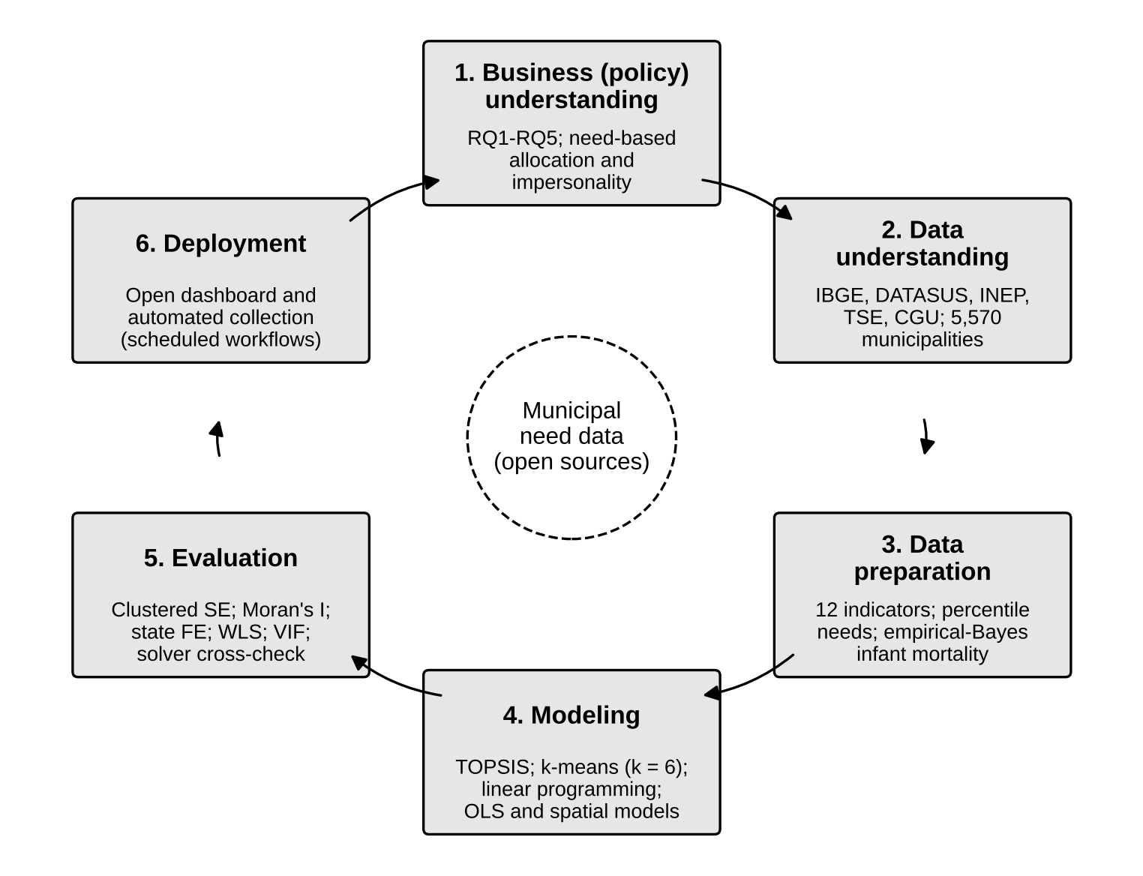
Figure 1. Application of the CRISP-DM phases in the study
Source: Elaborated by the author, based on Chapman et al. (2000).
The unit of analysis is the municipality. The study covers the 5,570 municipalities of the 2022 Demographic Census; one municipality created after the Census was excluded because it has no census indicators of its own. The design is cross-sectional, with two elections compared over the same set of municipalities.
3.2 Data and indicators
Need was measured with 12 indicators in four dimensions, all from official open sources (Table 1). Data were collected automatically from the application programming interfaces and download services of the Brazilian Institute of Geography and Statistics (IBGE), the Unified Health System information department (DATASUS), the National Institute for Educational Studies and Research (INEP), the Superior Electoral Court (TSE) and the Office of the Comptroller General (CGU), using scripts in R and Python run by scheduled workflows, so that the database can be rebuilt when sources are updated.
Table 1
Need indicators by dimension
Dimension | Indicator | Source and reference period
Health | Infant mortality per 1,000 live births (empirical Bayes) | DATASUS, SIM and SINASC, 2022–2024
 | Family Health Strategy coverage (%) | Ministry of Health, e-Gestor, March 2023
 | Basic health units per 10,000 inhabitants | DATASUS, CNES, 2026; IBGE population estimate, 2025
 | Distance to nearest municipality with a hospital (km) | DATASUS, CNES, 2026
Education | Literacy rate, 15 years and over (%) | IBGE, Demographic Census 2022
 | IDEB, early grades, public schools | INEP, 2025
Sanitation | Population served by water network (%) | Ministry of Cities, SINISA, 2023
 | Households with adequate sewerage (%) | IBGE, Demographic Census 2022
 | Households with garbage collection (%) | IBGE, Demographic Census 2022
Income | Household income per capita (R$) | IBGE, Demographic Census 2022
 | Formal private jobs per 1,000 inhabitants | Ministry of Labor, RAIS, 2024
 | Households in the Bolsa Família program (%) | CGU, Transparency Portal, August 2026
Note. Percentile ranks were computed with signs reversed where higher values indicate better conditions. IDEB = Basic Education Development Index; CNES = National Register of Health Establishments; SIM = Mortality Information System; SINASC = Live Birth Information System; SINISA = National Basic Sanitation Information System; RAIS = Annual Social Information Report.
Infant mortality was computed from deaths under one year of age and live births for 2022 to 2024 combined. Because 84 municipalities recorded fewer than 50 births in the period, crude rates were smoothed with the empirical Bayes estimator of Marshall (1991), using the state rate as the prior mean; the resulting national rate is 12.6 deaths per thousand live births. For the 251 municipalities without an IDEB score, the state median was used.
3.3 Need measurement and need profiles
Each indicator was converted to a percentile rank among the 5,570 municipalities, with signs reversed where higher values indicate better conditions, so that 0 corresponds to the best and 100 to the worst position in the country. The need of each dimension is the mean of its indicators. Percentile ranks place the indicators on a common scale and limit the influence of extreme values, but they measure relative and not absolute need.
An overall need index was computed with TOPSIS (Hwang & Yoon, 1981), which ranks alternatives by their relative distance to an ideal and to an anti-ideal point. Each dimension received a weight of one quarter, divided equally among its indicators. The index ranges from 0 to 100, and higher values indicate greater need.
Need profiles were obtained by k-means clustering (MacQueen, 1967) of the 12 standardized indicator needs. Solutions with three to nine clusters were compared by the silhouette coefficient. Silhouette values were low for every solution (0.21 for three clusters and 0.14 for six), indicating that need varies along a continuum rather than in well-separated groups. The six-cluster solution was retained because it separates situations that call for different policies, such as large urban centers with gaps in primary care and small interior municipalities without sewerage. Profiles were numbered from 1 (lowest mean need) to 6 (highest): (1) consolidated municipalities, 1,150; (2) large centers with gaps in primary care, 707 municipalities holding 54% of the population; (3) interior municipalities lacking sewerage and distant from hospitals, 1,089; (4) income and education vulnerability with intermediate infrastructure, 786; (5) multiple vulnerability with low sanitation, mostly in the Northeast, 1,053; and (6) acute social vulnerability with the highest infant mortality, 785.
3.4 Allocation model
The allocation model distributes a hypothetical budget of R$ 20 billion among 30 groups (five regions times six profiles) and four policies. The deficit of a group in a policy is measured in person-equivalents, as the sum over its municipalities of population times need divided by 100. Each deficit is split into three equal segments with effectiveness of 100%, 70% and 40%, which represents diminishing returns. Unit costs per person-equivalent are working assumptions (R$ 300 for health, R$ 250 for education, R$ 900 for sanitation and R$ 500 for income), intended to compare scenarios and not to estimate actual program costs. Constraints require each policy to receive at least 10% of the budget, each region to receive at least half of its share of the total deficit, and spending in a group not to exceed R$ 250 per inhabitant, which represents limited capacity to execute resources.
Two formulations were solved. The efficiency formulation maximizes the reduction of deficit weighted by the intensity of need. The equity formulation is a lexicographic maximin: it first maximizes the smallest fraction of deficit reduced across all group and policy pairs, and then maximizes efficiency while keeping that fraction at least 99.9% of its optimum. The models were solved with the HiGHS solver (Huangfu & Hall, 2018) and cross-checked with an independent two-phase simplex implementation, which reached the same optimal values. Group amounts were apportioned to municipalities in proportion to population times need. Electoral data do not enter the model at any stage.
3.5 Statistical analysis
The electoral variable is Lula’s share of valid votes in the second round, against Jair Bolsonaro in 2022 and against Flávio Bolsonaro in 2026, from TSE results by municipality. Votes cast abroad were excluded; the municipal totals reproduce Lula’s national shares of 50.90% in 2022 and 51.78% in 2026.
For RQ1, Pearson, Spearman and vote-weighted correlations between the TOPSIS index and vote share were computed, and the aggregate vote share was calculated for each quintile of need. For RQ2, ordinary least squares (OLS) regressions related vote share to the four standardized dimension needs and the logarithm of population, with region fixed effects and standard errors clustered by state. With 27 clusters, cluster-robust inference may be somewhat optimistic (Cameron & Miller, 2015), which is one reason for the spatial checks described below. For RQ3, correlations were computed within regions, states and profiles. For RQ4, the same regression was estimated for the change in vote share between 2022 and 2026. For RQ5, allocation per inhabitant was regressed on an indicator of a Lula victory in 2026, first alone, then with fixed effects for the 30 allocation groups and finally adding the TOPSIS index.
Robustness checks included Moran’s I (Moran, 1950) on the OLS residuals, using a row-standardized contiguity matrix built from shared boundary vertices; maximum-likelihood spatial error and spatial lag models (Anselin, 1988); state fixed effects; regressions weighted by valid votes; a decomposition of income need into its three indicators; and variance inflation factors. Analyses used Python with statsmodels (Seabold & Perktold, 2010) and the spatial regression library of PySAL, and R for data collection.
Generative artificial intelligence (Claude Opus 5.5, Anthropic) was used to write and debug data-collection and analysis code, to run exploratory analyses under the author’s direction and to assist with drafting and translating the manuscript. The author defined the research questions and methods, checked the code, results and references, and takes full responsibility for the content.
4 RESULTS
4.1 Association between need and vote (RQ1)
The correlation between the TOPSIS index and Lula’s second-round share was 0.765 in 2022 and 0.758 in 2026. Spearman correlations were similar (0.76 and 0.75), and correlations weighted by valid votes were 0.72 and 0.69. Figure 2 shows the aggregate vote share by quintile of need. In 2022, Lula received 39.5% of valid votes in the least needy fifth of municipalities and 74.4% in the neediest fifth; in 2026, the corresponding figures were 40.6% and 72.4%. The gap between the extreme quintiles narrowed from 34.9 to 31.8 percentage points, because Lula gained in the least needy quintile and lost in the neediest. The quintiles differ greatly in population: the least needy fifth holds 34% of the population and the neediest fifth 9%.
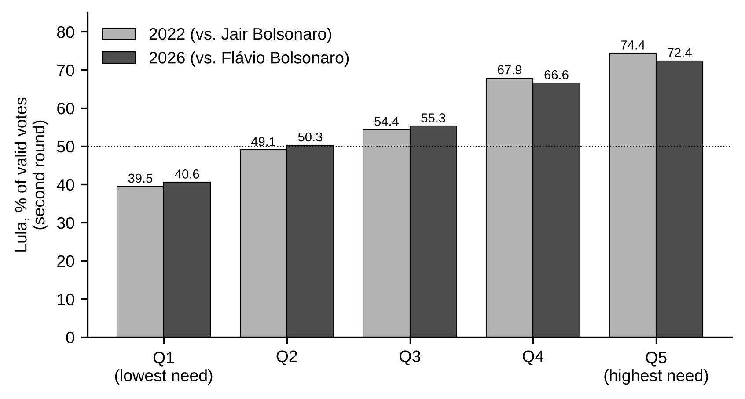
Figure 2. Lula’s share of valid votes in the second round, by quintile of need
Note. Quintiles of the TOPSIS need index; aggregate share of valid votes in each quintile. Votes cast abroad excluded.
Source: Elaborated by the author with data from TSE and the need index.
4.2 Need dimensions (RQ2)
Region alone explains 62% of the variance in vote share in 2022 and 66% in 2026. The four needs and population explain 71% and 73%, and the full model explains 77% and 80%. Table 2 shows that the association is carried mainly by income need. One standard deviation of income need corresponds to 10.5 percentage points more for Lula in 2022 and 10.8 points in 2026. Education need adds a smaller effect (1.8 and 1.9 points). Health and sanitation needs are not statistically different from zero once the other dimensions and region are held constant. Population is positively associated with the 2026 vote (1.4 points per standard deviation of its logarithm) but not with the 2022 vote. Among regions, the Northeast stands 15.2 (2022) and 15.8 (2026) points above the Center-West, even with need held constant.
Table 2
OLS estimates of Lula’s second-round vote share and its change
Variable | 2022 | 2026 | Change 2022–2026
Health need | −0.41 [−1.19, 0.38] | −0.43 [−1.09, 0.24] | −0.02 [−0.24, 0.20]
Education need | 1.83 [0.01, 3.66] | 1.92 [0.31, 3.54] | 0.09 [−0.34, 0.52]
Sanitation need | 0.93 [−0.47, 2.32] | 0.02 [−1.31, 1.36] | −0.91 [−1.19, −0.62]
Income need | 10.47 [8.28, 12.66] | 10.83 [8.79, 12.86] | 0.35 [−0.14, 0.85]
Log population | 0.30 [−0.96, 1.57] | 1.39 [0.17, 2.62] | 1.09 [0.85, 1.33]
Northeast | 15.24 [9.85, 20.64] | 15.79 [11.04, 20.54] | 0.55 [−0.71, 1.80]
North | −3.47 [−12.65, 5.72] | −2.89 [−10.58, 4.80] | 0.58 [−1.04, 2.20]
Southeast | 6.57 [0.42, 12.73] | 7.19 [1.75, 12.64] | 0.62 [−0.34, 1.58]
South | 3.62 [−1.67, 8.91] | 2.99 [−1.31, 7.30] | −0.63 [−2.04, 0.79]
Constant | 48.55 [44.26, 52.83] | 46.10 [42.53, 49.66] | −2.45 [−3.30, −1.60]
R² | 0.774 | 0.797 | 0.339
Note. N = 5,570 municipalities. Coefficients in percentage points per standard deviation of each predictor; 95% confidence intervals in brackets, with standard errors clustered by state (27 clusters). The reference region is the Center-West.
Income and education needs are correlated (r = 0.82), with variance inflation factors of 3.71 and 3.25, which is moderate collinearity; their separate coefficients should be read with that in mind. Decomposing income need into its indicators, in the 2026 model, shows that Bolsa Família coverage has the largest coefficient (5.00 points per standard deviation; 95% CI [2.86, 7.14]), followed by per capita income (−3.90 [−5.58, −2.23]) and formal employment (−1.14 [−2.03, −0.25]); R² is 0.785. The 2022 pattern is similar (Bolsa Família coverage 4.34). Because program coverage measures poverty as well as program reach, these ecological estimates do not identify an effect of the program on voting.
4.3 Association within regions, states and profiles (RQ3)
The association persists within regions but varies in strength. In 2022 and 2026, respectively, the correlation was 0.68 and 0.66 in the Southeast, 0.66 and 0.61 in the South, 0.44 and 0.43 in the North, 0.39 and 0.41 in the Center-West, and 0.41 and 0.37 in the Northeast. The weaker association in the Northeast reflects a ceiling: Lula won 98.9% of the region’s municipalities in both elections, which leaves little variation to be explained. Within states, the 2026 correlation was positive in 25 of the 26 states with more than one municipality, with a median of 0.50, and above 0.5 in 13 states. The only negative case was Rio de Janeiro (−0.13, 92 municipalities), an exception that calls for a study of its own. Within profiles, correlations ranged from 0.15 (profile 5) to 0.48 (profile 2), so the gradient also exists among municipalities with similar need structures.
4.4 Change between 2022 and 2026 (RQ4)
Lula’s national share rose by 0.9 points, but his share fell in 78% of municipalities, with a median change of −2.0 points. The aggregate gain came from the large centers of profile 2 (+2.0 points), while the largest loss occurred in the interior municipalities of profile 3 (−3.5 points). In total, 278 municipalities won by Lula in 2022 were won by Flávio Bolsonaro in 2026, 159 of them in profile 3, 31 changed in the opposite direction and one ended in a tie. The change was practically unrelated to overall need (r = −0.08; Spearman −0.10). In the regression (Table 2, last column; R² = 0.34), only two variables stand out: sanitation need (−0.91 points per standard deviation) and population (+1.09). The shift of 2026 was therefore a matter of municipal size and of the small interior municipalities lacking sewerage, not of need in general.
4.5 Robustness
The OLS residuals show strong spatial dependence: Moran’s I was 0.573 for 2022, 0.559 for 2026 and 0.437 for the change (p = 0.001 in all cases, by permutation). Table 3 and Figure 3 show how the main coefficients respond. In the spatial error model for 2026 (λ = 0.83), the income coefficient falls from 10.8 to 6.7 points but remains the largest and most precisely estimated; education remains at 1.8, and health becomes small and positive (0.25 [0.07, 0.44]). In the spatial lag model (ρ = 0.73), the direct income coefficient is 5.0. State fixed effects raise R² to 0.84 in 2026 and leave the income coefficient at 9.7, and weighting by valid votes gives 9.7. For the change between elections, the sanitation coefficient is negative in all specifications, ranging from −0.47 (spatial error) to −1.07 (weighted). The spatial models show that part of what OLS attributes to need is shared regional context, but no specification changes the conclusions for RQ1 to RQ4.
Table 3
Robustness of the main coefficients
Specification | Income need, 2022 | Income need, 2026 | Sanitation need, change
OLS, region fixed effects | 10.47 [8.28, 12.66] | 10.83 [8.79, 12.86] | −0.91 [−1.19, −0.62]
OLS, state fixed effects | 9.21 [7.28, 11.14] | 9.68 [7.59, 11.77] | −0.91 [−1.20, −0.62]
Weighted by valid votes | 8.96 [4.86, 13.06] | 9.66 [5.92, 13.40] | −1.07 [−1.40, −0.75]
Spatial error model | 6.50 [6.01, 6.98] | 6.71 [6.24, 7.17] | −0.47 [−0.56, −0.38]
Spatial lag model | 4.93 [4.53, 5.33] | 4.99 [4.60, 5.38] | −0.48 [−0.55, −0.41]
Moran’s I of OLS residuals | 0.573 | 0.559 | 0.437
Note. Coefficients in percentage points per standard deviation; 95% confidence intervals in brackets. OLS intervals use standard errors clustered by state; spatial models use maximum-likelihood standard errors and a row-standardized contiguity matrix. All specifications include the other three needs and log population. Spatial parameters: λ = 0.83 (2022, 2026) and 0.71 (change); ρ = 0.72, 0.73 and 0.63. Moran’s I p = 0.001 (999 permutations) in all cases.
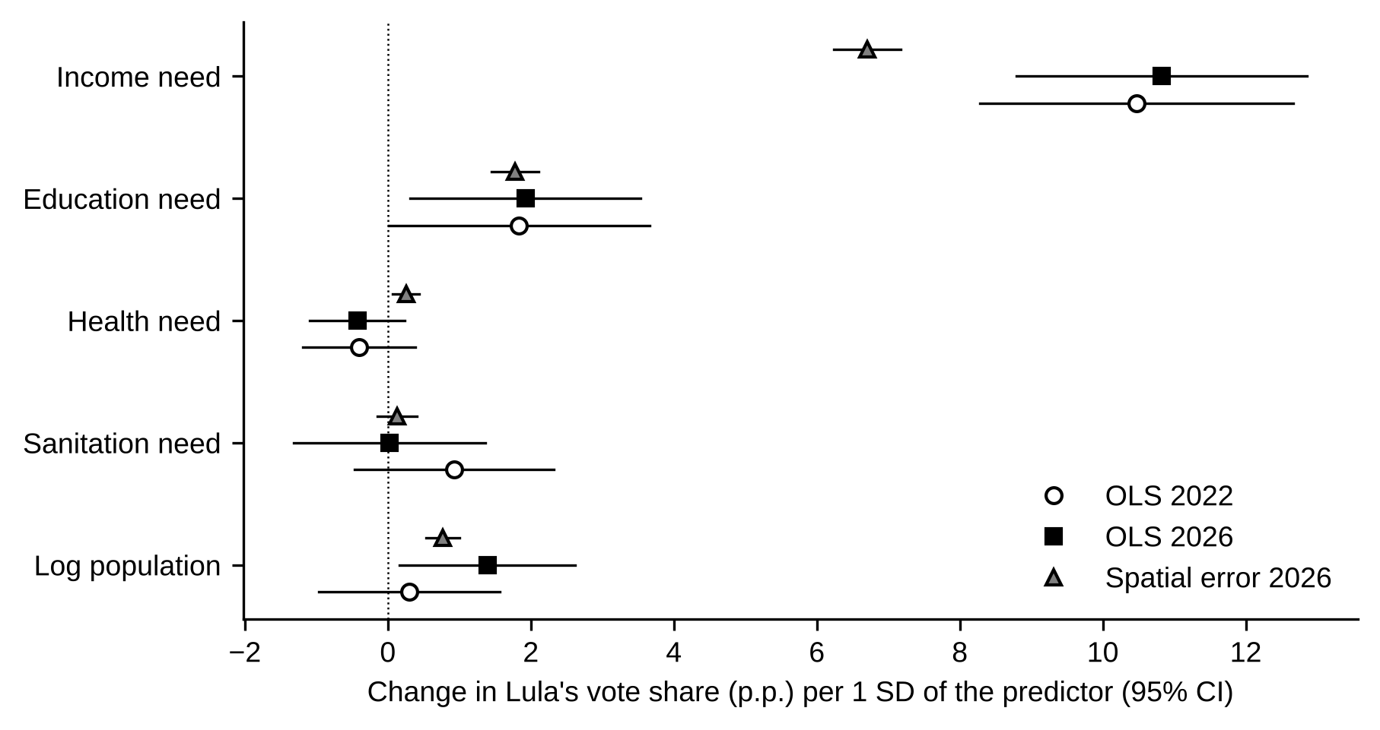
Figure 3. Coefficients of need dimensions and population on Lula’s second-round vote share
Note. All models include region fixed effects (OLS) or region dummies (spatial error model). OLS intervals use standard errors clustered by state.
Source: Elaborated by the author.
4.6 Need-based allocation and the impersonality audit (RQ5)
In the equity formulation, municipalities won by Lula in 2026, which hold 48.6% of the population, receive 59.4% of the R$ 20 billion, or R$ 114.6 per inhabitant against R$ 74.0 in municipalities won by Flávio Bolsonaro. In the efficiency formulation, they receive 67.2% of the budget (R$ 129.7 against R$ 59.7 per inhabitant). Read naively, these figures would suggest a partisan allocation, even though the model never uses electoral data.
Figure 4 shows the impersonality audit. Without controls, the average allocation per inhabitant in municipalities won by Lula exceeds that of municipalities won by his opponent by R$ 61.3 in the equity formulation and R$ 108.7 in the efficiency formulation (these are unweighted municipal averages, and therefore differ from the population-weighted figures above). Within allocation groups, the difference falls to R$ 10.1 (95% CI [7.1, 13.1]) and R$ 0.7 (not significant). When the TOPSIS index is added, the difference becomes −R$ 1.3 ([−3.5, 0.9]; p = 0.25) in the equity formulation and −R$ 8.2 ([−12.7, −3.7]) in the efficiency formulation. The apparent advantage of Lula’s municipalities is entirely explained by need; with need held constant, they receive the same or slightly less.
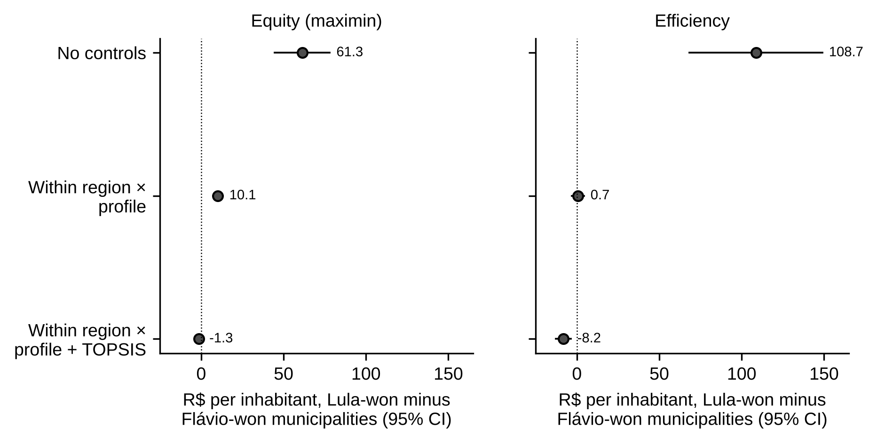
Figure 4. Impersonality audit: difference in allocation per inhabitant between municipalities won by each candidate in 2026
Note. Coefficient of an indicator of a Lula victory in OLS regressions of allocation per inhabitant; standard errors clustered by state. Allocation groups are the 30 combinations of region and need profile.
Source: Elaborated by the author.
5 DISCUSSION
5.1 A structural association between need and vote
The results confirm that the association between need and the vote for Lula, documented since 2006 (Hunter & Power, 2007; Zucco, 2008), remains strong and stable in 2022 and 2026. Because it appears with similar intensity when Lula was the challenger and when he was the incumbent, it cannot be attributed only to an incumbency reward. The association is carried by the income dimension. Gaps in health and sanitation, which are central to municipal service delivery, add little to the explanation of the vote once income, education and region are considered. For strategic management, this is a relevant finding: the electoral divide in Brazil is a divide of income, while deficits in sanitation and primary care cut across it. Policies addressing these deficits therefore have a broader potential base of support and can be placed on the strategic agenda as cross-partisan issues (Bryson, 2018).
The change between 2022 and 2026 shows the opposite risk. Losses concentrated in small interior municipalities without sewerage, in a period when overall need was unrelated to the change. Managers and analysts should not read electoral shifts as signals of changing need, nor should allocation respond to them.
5.2 Impersonality by design
RQ5 shows what can be called an observational equivalence between impersonal and partisan allocation. In a country where need and vote are correlated at 0.76, an allocation driven only by need will send more resources to municipalities that voted for one candidate, and the raw difference is large in both the efficiency and the equity formulations. Comparing totals by electorate cannot distinguish an allocation that follows need from one that rewards supporters. Only a comparison that holds need constant can.
This has practical consequences for public management. First, allocation criteria should be published before allocation, as formulas with their data sources, so that the basis for each transfer can be verified. Second, agencies can report impersonality audits like the one applied here, regressing allocation on electoral indicators with need held constant, and present them alongside the allocation. Third, rule-based transfers should be kept separate from discretionary transfers, which the literature shows to be vulnerable to political influence (Brollo & Nannicini, 2012). Fourth, the choice between efficiency and equity should be stated in strategic plans as a choice of values (Frederickson, 1990), because, as the results show, the formulations produce different distributions across policies and territories. Fifth, reproducible pipelines based on open data, as in this study, make these audits feasible for agencies, control bodies and researchers (Head, 2016; Mergel et al., 2016). In terms of the strategic triangle (Moore, 1995), these practices turn impersonality from a presumption into evidence, which strengthens the legitimacy of need-based policy.
5.3 Territorial heterogeneity
The association is weaker in the Northeast and reversed in Rio de Janeiro, and the need profiles reveal gradients that national averages hide. Need profiles can serve as a strategic segmentation of the territory, in which each segment requires a different combination of policies. The low silhouette values, however, indicate that profiles are bands of a continuum, and their boundaries should be treated as an analytical convenience that requires validation with sector specialists.
5.4 Limitations
The study has limitations. The analysis is ecological and cannot be used to infer individual behavior (Robinson, 1950). It is cross-sectional and does not identify causal effects of need or of programs on the vote. Need is measured in relative terms by percentile ranks. The allocation model uses hypothetical unit costs and should be calibrated with program costs before any practical use. Data refer to different reference dates, from the 2022 Census to Bolsa Família coverage in 2026. Inference relies on 27 clusters, and the spatial dependence of residuals shows that municipalities are not independent observations. The analysis uses shares of valid votes and does not consider abstention, which may itself be related to need.
6 CONCLUSIONS
This article examined the relation between municipal social need and the presidential vote in Brazil in 2022 and 2026, and its implications for need-based allocation. Need and Lula’s vote share are strongly associated in both elections (RQ1). The association is carried mainly by income need and, to a lesser extent, by education need (RQ2). It holds within regions, within 25 of 26 states and within need profiles, though it is weaker in the Northeast (RQ3). The change between the elections is unrelated to overall need and concentrates in small interior municipalities lacking sewerage (RQ4). An allocation that ignores votes sends more resources to municipalities won by Lula, but the difference disappears once need is held constant (RQ5).
The main implication for public administration is that, in Brazil, need-based allocation will look partisan, and that the impersonality principle must therefore be demonstrated with explicit criteria and audits rather than presumed. The study also shows that open data and a structured analytics process can support strategic decisions on territorial allocation. Future research could use individual survey data to address the limits of ecological inference, follow actual federal transfers over time to test the audit on real allocations, examine the case of Rio de Janeiro, and calibrate allocation costs with program data.
REFERENCES
Anselin, L. (1988). Spatial econometrics: Methods and models. Kluwer Academic.
Brasil. (1988). Constituição da República Federativa do Brasil de 1988. https://www.planalto.gov.br/ccivil_03/constituicao/constituicao.htm
Brollo, F., & Nannicini, T. (2012). Tying your enemy’s hands in close races: The politics of federal transfers in Brazil. American Political Science Review, 106(4), 742–761.
Bryson, J. M. (2018). Strategic planning for public and nonprofit organizations: A guide to strengthening and sustaining organizational achievement (5th ed.). Wiley.
Bryson, J. M., Crosby, B. C., & Bloomberg, L. (2014). Public value governance: Moving beyond traditional public administration and the new public management. Public Administration Review, 74(4), 445–456. https://doi.org/10.1111/puar.12238
Cameron, A. C., & Miller, D. L. (2015). A practitioner’s guide to cluster-robust inference. Journal of Human Resources, 50(2), 317–372. https://doi.org/10.3368/jhr.50.2.317
Chapman, P., Clinton, J., Kerber, R., Khabaza, T., Reinartz, T., Shearer, C., & Wirth, R. (2000). CRISP-DM 1.0: Step-by-step data mining guide. SPSS.
Frederickson, H. G. (1990). Public administration and social equity. Public Administration Review, 50(2), 228–237. https://doi.org/10.2307/976870
Frey, A. (2019). Cash transfers, clientelism, and political enfranchisement: Evidence from Brazil. Journal of Public Economics, 176, 1–17.
Fried, B. J. (2012). Distributive politics and conditional cash transfers: The case of Brazil’s Bolsa Família. World Development, 40(5), 1042–1053.
Head, B. W. (2016). Toward more “evidence-informed” policy making? Public Administration Review, 76(3), 472–484. https://doi.org/10.1111/puar.12475
Huangfu, Q., & Hall, J. A. J. (2018). Parallelizing the dual revised simplex method. Mathematical Programming Computation, 10(1), 119–142.
Hunter, W., & Power, T. J. (2007). Rewarding Lula: Executive power, social policy, and the Brazilian elections of 2006. Latin American Politics and Society, 49(1), 1–30. https://doi.org/10.1353/lap.2007.0005
Hwang, C.-L., & Yoon, K. (1981). Multiple attribute decision making: Methods and applications. Springer.
MacQueen, J. (1967). Some methods for classification and analysis of multivariate observations. In L. M. Le Cam & J. Neyman (Eds.), Proceedings of the Fifth Berkeley Symposium on Mathematical Statistics and Probability (Vol. 1, pp. 281–297). University of California Press.
Marshall, R. J. (1991). Mapping disease and mortality rates using empirical Bayes estimators. Journal of the Royal Statistical Society: Series C (Applied Statistics), 40(2), 283–294.
Martínez-Plumed, F., Contreras-Ochando, L., Ferri, C., Hernández-Orallo, J., Kull, M., Lachiche, N., Ramírez-Quintana, M. J., & Flach, P. (2021). CRISP-DM twenty years later: From data mining processes to data science trajectories. IEEE Transactions on Knowledge and Data Engineering, 33(8), 3048–3061. https://doi.org/10.1109/TKDE.2019.2962680
Mergel, I., Rethemeyer, R. K., & Isett, K. (2016). Big data in public affairs. Public Administration Review, 76(6), 928–937. https://doi.org/10.1111/puar.12625
Moore, M. H. (1995). Creating public value: Strategic management in government. Harvard University Press.
Moran, P. A. P. (1950). Notes on continuous stochastic phenomena. Biometrika, 37(1/2), 17–23.
Rawls, J. (1971). A theory of justice. Harvard University Press.
Robinson, W. S. (1950). Ecological correlations and the behavior of individuals. American Sociological Review, 15(3), 351–357.
Seabold, S., & Perktold, J. (2010). Statsmodels: Econometric and statistical modeling with Python. In S. van der Walt & J. Millman (Eds.), Proceedings of the 9th Python in Science Conference (pp. 92–96).
Silva Filho, A. I. da, Carneiro, D. K. O., & Coelho, F. S. (2025). Unveiling public innovation management: What data mining reveals by analyzing Brazilian experiences? BAR-Brazilian Administration Review, 22(2), e240077. https://doi.org/10.1590/1807-7692bar2025240077
Soares, G. A. D., & Terron, S. L. (2008). Dois Lulas: A geografia eleitoral da reeleição (explorando conceitos, métodos e técnicas de análise geoespacial). Opinião Pública, 14(2), 269–301. https://doi.org/10.1590/S0104-62762008000200001
Zucco, C. (2008). The president’s “new” constituency: Lula and the pragmatic vote in Brazil’s 2006 presidential elections. Journal of Latin American Studies, 40(1), 29–49.
Zucco, C. (2013). When payouts pay off: Conditional cash transfers and voting behavior in Brazil 2002–10. American Journal of Political Science, 57(4), 810–822. https://doi.org/10.1111/ajps.12026

