ECE568: Software Engineering of Web Application

Technical Analysis of AAPL

Chaoji Zuo

Cz296/190003416

February 14, 2019

ECE, Rutgers

# Trend lines and channels

Trend is the most basic concept in technical analysis, it indicates the current direction of share prices. When stock prices continue to rise higher, it is considered to be in an uptrend and vice versa for a downtrend. Uptrends indicate increasing demand for shares, as buyers are willing to pay higher prices as supply diminishes. Downtrends represent an oversupply of shares with waning buying interest resulting in falling prices. By connecting the various high and low points on a chart, we can manually generate trendlines that pinpoint support/resistance and direction of stock prices. When compared to historical templates of similar trendlines, we may be able to forecast the future direction, turning/inflection points and targets.

A trend line is a straight line that connects two or more price points and then extends into the future to act as a line of support or resistance. Therefore, it is easy to draw a trend line.

Figure 1 shows the trend lines I draw using the stock price of AAPL from 1/2018 to 1/2019.

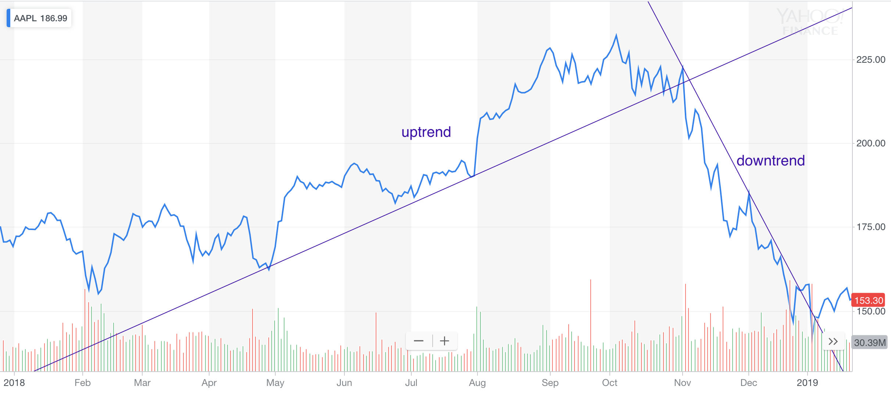

Figure 1. uptrend line and downtrend during 1/1/2018 to 1/22/2019

Another import thing about trend lines is channels. A price channel is used in technical analysis to chart the price action of a security between two parallel lines. can be upward or downward trending. It may also be trending sideways with no clear upward or downward trend.

Buying shares is safe when a stock is in upward channel. Therefore, the investor can likely expect a security to increase when reaching the lower bound, thus providing for a buy position at a discount price.

Figure 2 shows the channels I draw using the same data as Figure 1.

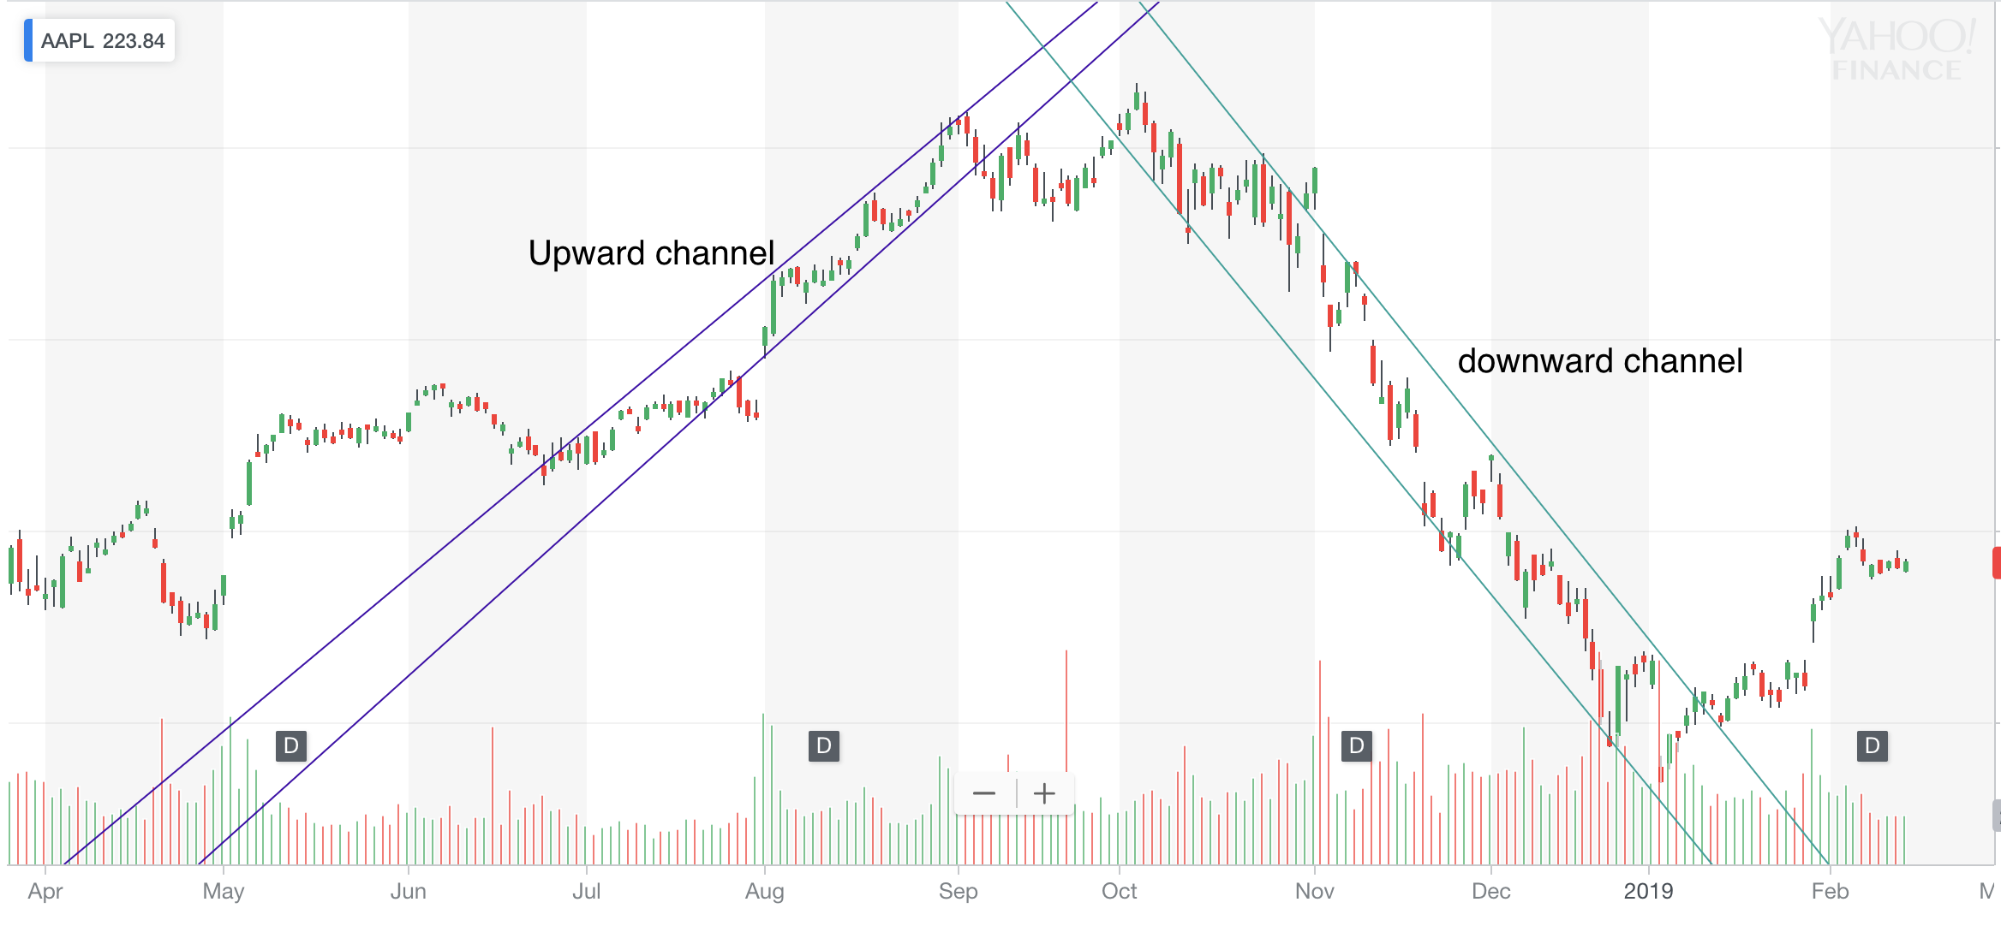

Figure 2. channels of AAPL during 3/26/2018 to 2/14/2019

The channels are the areas between the purple lines and green lines.

## Support and resistance

Support is the price level at which demand is thought to be strong enough to prevent the price from declining further. The logic dictates that as the price declines towards support and gets cheaper, buyers become more inclined to buy and sellers become less inclined to sell. By the time the price reaches the support level, it is believed that demand will overcome supply and prevent the price from falling below support.

Figure 3 shows a support I draw using the AAPL data.

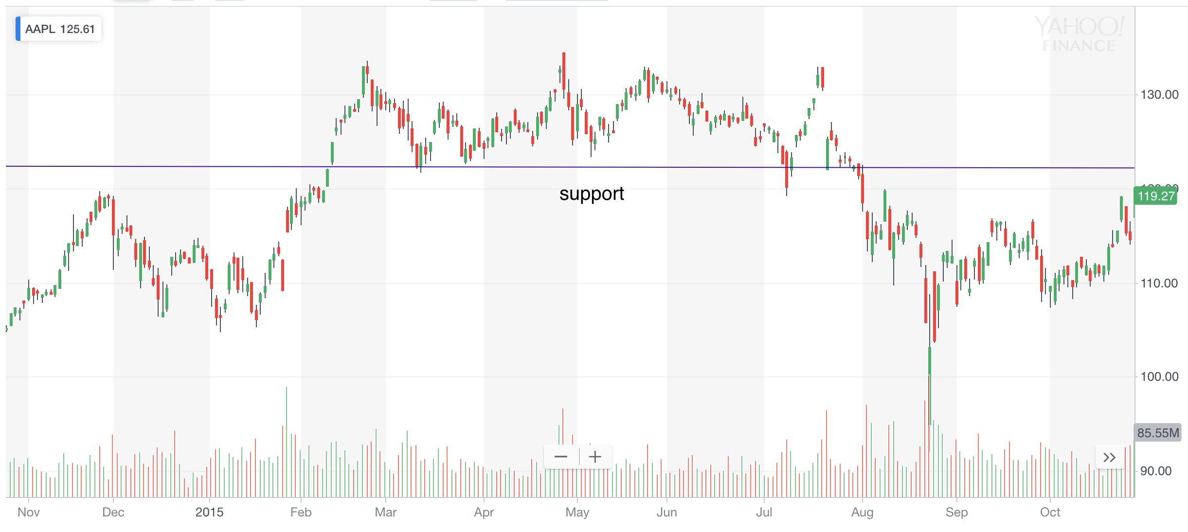

Figure 3. A support of AAPL stock during 10/29/2014 to 10/26/2015

Resistance is the price level at which selling is thought to be strong enough to prevent the price from rising further. The logic dictates that as the price advances towards resistance, sellers become more inclined to sell and buyers become less inclined to buy. By the time the price reaches the resistance level, it is believed that supply will overcome demand and prevent the price from rising above resistance.

Figure 4 shows a resistance I draw using the AAPL data.

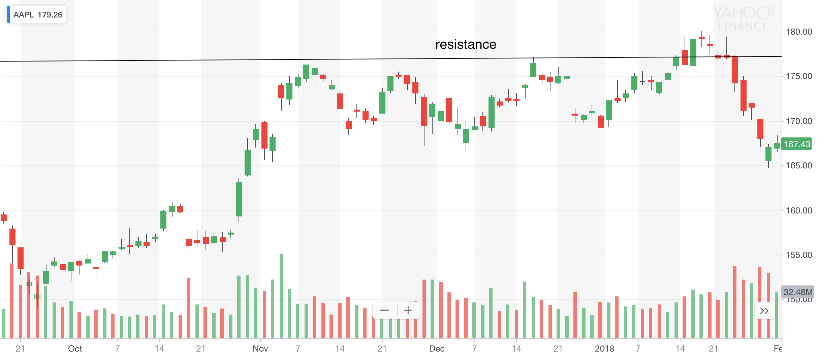

Figure 4. A resistance of AAPL stock during 9/18/2017 to 1/31/2018

## Indicators

Indicators are the cornerstones of technical analysis and play an important role in giving and confirming entry and exit signals in stock trading systems. They can help us to analysis the stocks. There are quite a number of different types of indicators but they all fall into two categories:

* Leading Indicators are indicators that lead price movement. In other words, they indicate the probability of a trend reversal in advance. Most leading indicators measure price momentum over a fixed look-back period. Some of the popular leading indicators include the Commodity Channel Index (CCI), the Relative Strength Index (RSI), the Stochastic Oscillator and the Williams' %R.
* Lagging Indicators, which follow the price movement, are usually trend-following indicators, such as the moving averages (MA) and Moving Average Convergence/Divergence (MACD). These indicators turn only after the price action has already turned and therefore lag price action.

#### The Moving Average (MA) indicators

Moving Averages (MAs) are trend indicators that can be used to determine the presence and direction of a trend.

There are several types of moving averages.

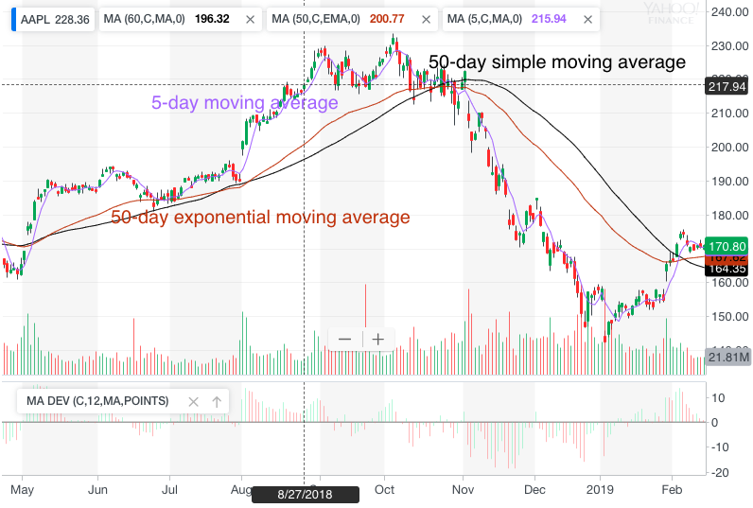

Figure 5. Moving averages of AAPL from 5/1/2018 to 2/12/2019

* The Simple MA is simply the average of the price data for the period under analysis with no extra weighting given to any of the data. Thus, a 5-day MA is calculated simply by calculating the sum of the price for the past 5 days and dividing the result by 5, with the formula being:

SMAn = ( price1 + price2 + ... + pricen ) / n. Where n is the period of the SMA as specified by the trader.

The black line in Figure 5 shows a 50-day SMA of AAPL and the purple shows a 5-day SMA.

* The Exponential MA is a refinement of the SMA that attempts to assign more weight to the most recent data, making it less sensitive to the price that is dropped from the calculation, and reduces lag. This is accomplished by applying a smoothing constant to a SMA and then calculating the EMA. Thus, the EMA is calculated in three stage: First, calculate the SMA for the period (n); Second, calculate the Smoothing Constant (Sm) using the formula:

Sm = ( 2 / ( n + 1 ) )

and finally, calculate the EMA using the formula:

EMA = ( price - previous EMA ) x Sm + previous EMA

The Brown line in Figure shows a 50-day EMA of AAPL.

#### Commodity Channel Index (CCI)

The Commodity Channel Index (CCI) is a leading oscillating momentum indicator that was developed by Donald Lambert to identify cyclical turns in commodities but can also be used on securities and bonds as well. The CCI is a comparison of the typical price (TP) and a simple moving average (SMA) of the typical price (SMATP) and is expressed as an oscillating percentage that can exceed -100% and 100%. It can be used to predict a price reversal, and to determine overbought or oversold conditions.

There are 4 steps to calculate the CCI: First, calculate the last period's Typical Price (TP) which is ( H + L + C ) / 3 where H = high, L = low, and C = close. Seconds, calculate the Simple Moving Average of the TP (SMATP) for the period of the CCI (i.e., 20 periods for a 20-period CCI). Third, calculate the Mean Deviation which is the sum of the difference between the last period's SMATP and the typical price for each period of the CCI periods divided by the number of periods. Finally, calculate the CCI using the formula: CCI = ( TP - SMATP ) / ( 0.015 x Mean Deviation )

Figure 6 shows the CCI of AAPL.

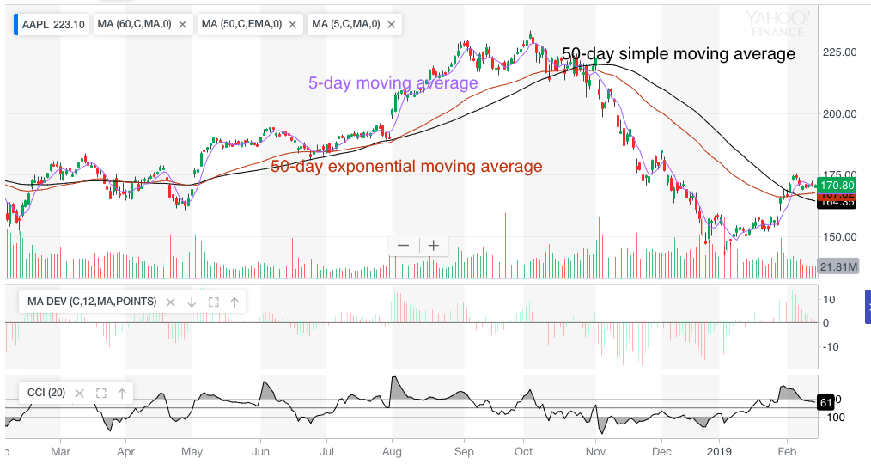

Figure 6. CCI of AAPL from 2/6/1018 to 2/12/2019

## Patterns

Technical analysts often study stock charts for recurring price patterns, or stock chart formations, that appear on price charts on fairly a regular basis. These recurring chart patterns are one of the key elements of technical analysis and can be used on their own or as confirmation for signals from technical indicators. They are based, by and large, on trend lines.

Chart patterns can be based on any price chart of any time-frame, and usually provide clear entry and exit signals, as well as price projections, stop levels and profit targets. Most patterns fall into two categories: continuation patterns and reversal patterns, but some are both continuation and reversal patterns, depending on the price breakout.

#### Head and shoulders pattern

The Head and Shoulders pattern is one of the most reliable trend reversal patterns and is usually seen in uptrends, where it is also referred to as Head and Shoulders Top, though they can appear in downtrends as well, where they are also referred to as Head and Shoulders Bottom or Inverse Head and Shoulders. As they are trend reversal patterns, the Head and Shoulders patterns requires the presence of an existing trend.

Figure 7 shows the head and shoulders pattern I found of AAPL

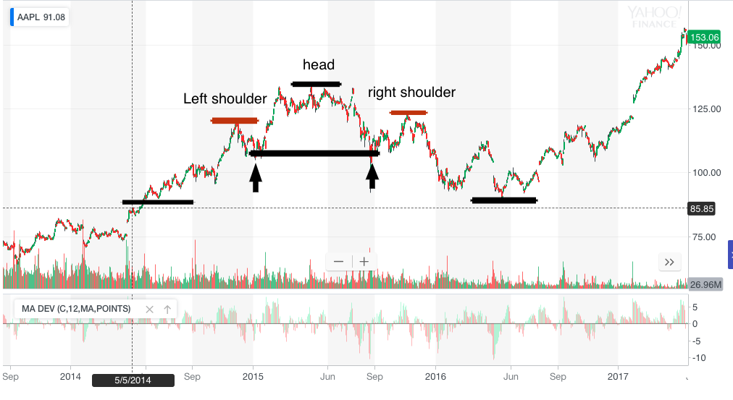

Figure 7. Head and shoulders pattern of AAPL from 8/26/2013 to 5/16/2017

#### Pennant patterns

The pennant graphical price model is a minor, short-term, trend continuation pattern that shows the previous direction will prevail in the future after its formation. As for the daily chart the pattern is generally formed within a week.

This pattern is represented by two converging trendlines, support is upward sloping and resistance is downward sloping, visually forming a triangle, which conclude price fluctuations within. The pattern is often characterized by a sharp price entering after intensive movement.

Figure 8 shows a pennant pattern I found of AAPL history. The black shape is the pennant. And purple arrow points the sell signal of this pattern.

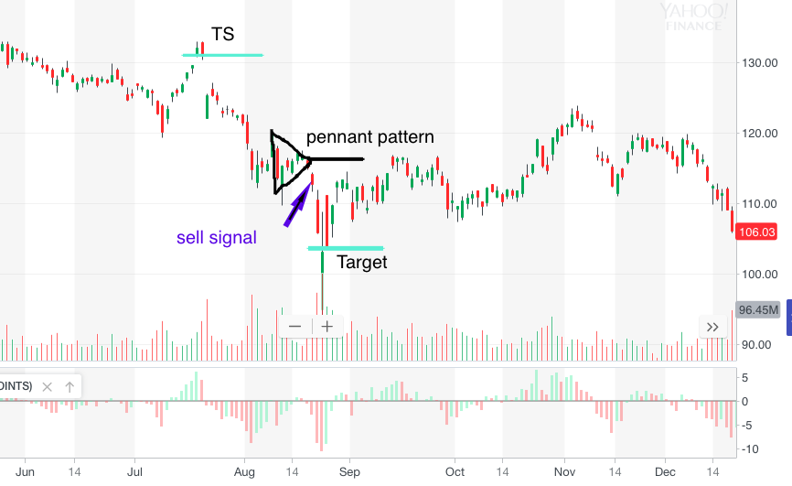

Figure 8. Pennant pattern of AAPL from 6/17/2015 to 12/16/2015

# Reference

[1] Apple Inc. stock

https://finance.yahoo.com/chart/AAPL

[2] trend lines

https://stockcharts.com/school/doku.php?id=chart_school:chart_analysis:trend_lines

[3] support and resistance

<https://stockcharts.com/school/doku.php?id=chart_school:chart_analysis:support_and_resistance>

[4] Technical Indicators

<http://www.chart-formations.com/indicators/default.aspx>

[5] char-information: chart patterns

<http://www.chart-formations.com/chart-patterns/default.aspx>

[6] Investopedia: technical analysis

https://www.investopedia.com/university/technical/techanalysis1.asp

[7] IFCmarkets: forex chart pattern

https://www.ifcmarkets.com/en/ntx-indicators/patterns