ECE568 Software Engineering HW5: neural network report

Chaoji Zuo

190003416/cz286

1. Target error = 0.1
   1. Learning rate=0.5, target error = 0.1

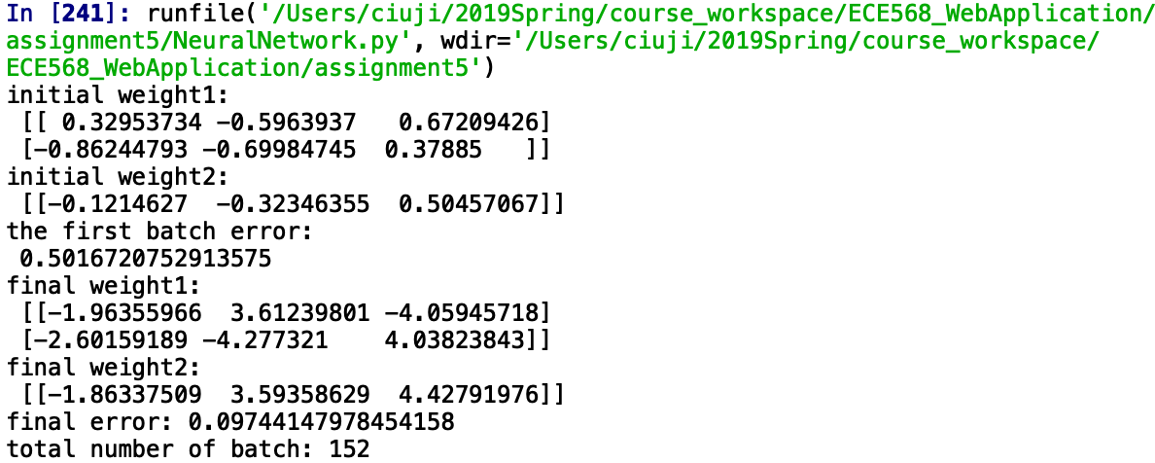

* 1. Learning rate=1.0, target error = 0.1

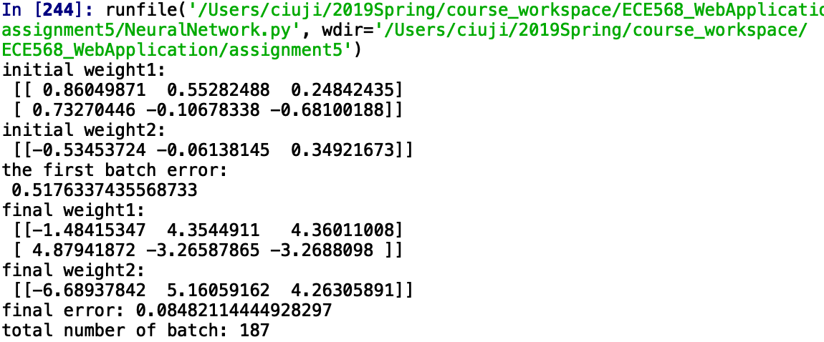

* 1. Best learning rate

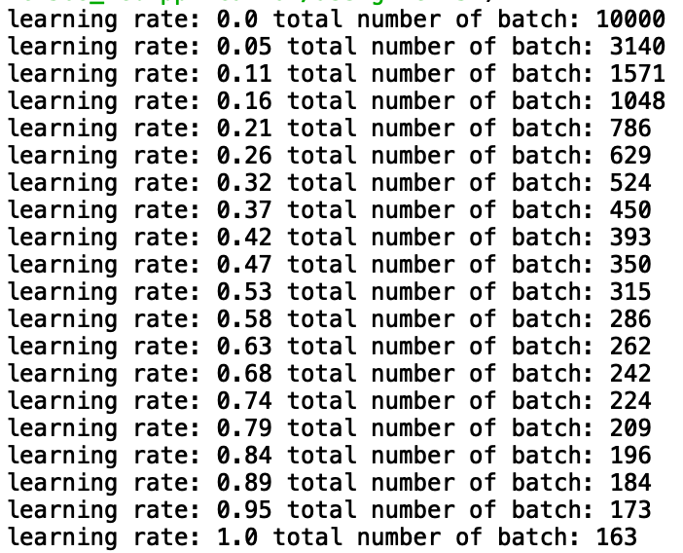

When the learning rate is 1.0, the program would converge fastest.

1. Target error = 0.02
   1. Learning rate = 0.5

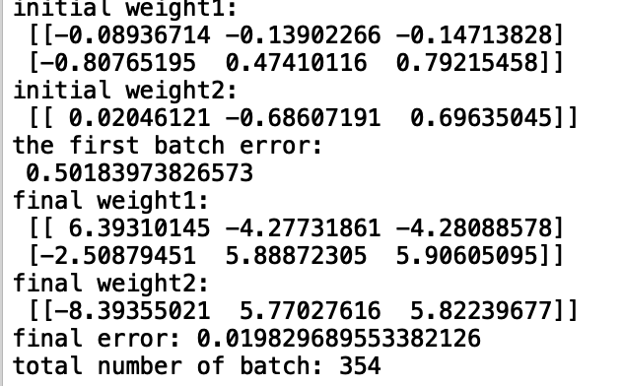

* 1. Learning rate = 1.0

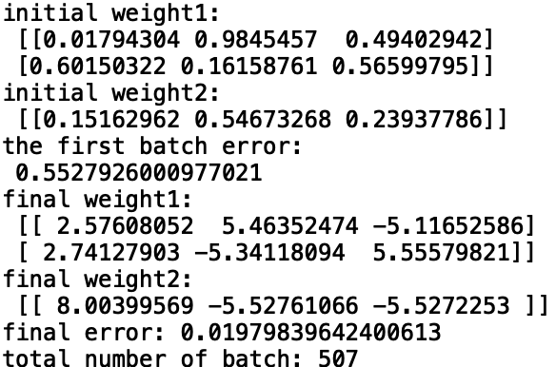

* 1. Best learning rate

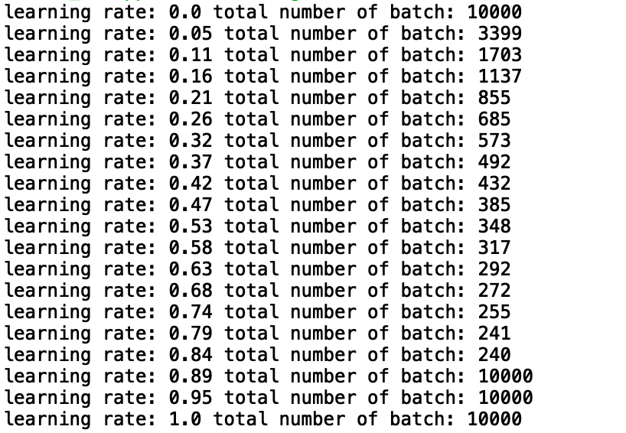

In this case, the best learning rate is 0.84.