Stroke Classification with SHAP Explanations
Exploratory analysis, local and global explanation, audience communication, and a second black-box model

Student name | [Student name]
Student ID | [Student ID]
Course / project | [Course code and project title]
Instructor | [Instructor name]
Submission date | [Date]
Repository and commit | github.com/ciumGit/7009 - xai-series-master, commit 4889192 (course code); analysis scripts in src/ of this submission

Abstract
This report builds and explains a stroke classifier on the Kaggle stroke prediction dataset (5,110 patients, 249 stroke cases, 4.87% positive). The data were split 60/20/20 with stratification; imputation, encoding and scaling were fitted on the training split only, which corrects two flaws in the course code: missing BMI filled with 0 kg/m² and pre-processing applied before splitting. A gradient-boosted tree (XGBoost, scale_pos_weight 19.58) reached test ROC AUC 0.826 and average precision 0.268; at the validation-tuned threshold 0.60 it detected 64% of stroke cases at 20% precision (F1 0.303; 18 of 50 cases missed). A SHAP TreeExplainer with a 100-row training background reproduces the model output to 7×10⁻⁶ log-odds. Globally, age dominates (mean |SHAP| 2.71 log-odds, roughly ten times any other variable), followed by BMI and average glucose. Locally, test case #668 - a missed stroke - shows how a missing BMI value and an 'Unknown' smoking entry pushed the score just below the alert line. An RBF SVM explained with KernelSHAP reaches ROC AUC 0.804 and agrees on age as the leading factor.
(174 words)

Report map
Assignment part | Where it is reported
Task 1 Exploratory data analysis | Sections 2.1-2.3, figure 1
Task 2 SHAP interpreter | Sections 3.1-3.3, validation table 6
Task 3 Local force plot | Section 4, figure 2 (waterfall in figure 2b)
Task 4 Global summary plot | Section 5, figures 3a-3c
Task 5 Three audience slides | Section 6, separate slide file
Task 6 DeepSHAP or KernelSHAP on a different model | Sections 7 and 8, figures 4-5

1 Research background and dataset

1.1 Background and objective
Stroke is the second leading cause of death worldwide, responsible for about 11% of global deaths (6.8 million in 2023), according to the World Health Organization's running tally of the top ten causes of death. The 11% figure is current; it comes from WHO mortality estimates for 2023, not from the older 2019 Global Burden of Disease release that course briefs sometimes quote. Predictive models built on patient records are useful here only if clinicians can see why a specific patient was flagged, so this project pairs a classifier with SHAP attributions at two levels: one patient at a time (section 4) and across the whole test population (section 5).
The objective is to evaluate a binary classifier on held-out data and explain its predictions with SHAP. The outcome definition matters: stroke = 1 marks a recorded stroke in the patient's history, with no follow-up period documented. The model therefore separates records associated with stroke, not verified future risk, and nothing in this report should be read as a validated risk forecast.

1.2 Data source and variables
Dataset: Stroke Prediction Dataset (fedesoriano) on Kaggle, file healthcare-dataset-stroke-data.csv, 5,110 rows, downloaded for this submission; the copy used here ships with the course repository at commit 4889192. Two spelling notes: the brief writes the job category as Govt_jov and the weight variable as BMI, but the file itself contains Govt_job and bmi. All section 2 statistics were computed from the file as received.
Attribute | Meaning / values in the file | Role in analysis
id | Unique identifier | Excluded from predictors
gender | Female 2,994 (58.6%), Male 2,115 (41.4%), Other 1 (0.02%) | Categorical predictor
age | 0.08 to 82 years; check the unit - it is years, including infants | Numeric predictor
hypertension | 0 = no, 1 = yes | Binary predictor
heart_disease | 0 = no, 1 = yes | Binary predictor
ever_married | No / Yes | Categorical predictor
work_type | children, Govt_job, Never_worked, Private, Self-employed | Categorical predictor
Residence_type | Rural / Urban | Categorical predictor
avg_glucose_level | 55.1 to 271.7 mg/dL; unit checked against the dataset card | Numeric predictor
bmi | 10.3 to 97.6 kg/m²; 201 values missing (3.93%) | Numeric predictor, imputed
smoking_status | never smoked, formerly smoked, smokes, Unknown (1,544, 30.2%) | Categorical predictor
stroke | 0 = no recorded stroke, 1 = recorded stroke | Target variable

Data checks: column names and category spellings were verified against the file (see the Govt_jov note above). 'Unknown' in smoking_status means the information is unavailable; it is kept as its own category throughout and is never merged with 'never smoked'.

2 Task 1 - exploratory data analysis

2.1 Code download and execution
The course repository was cloned from github.com/ciumGit/7009 (xai-series-master folder, commit 4889192, the head at the time of writing). It contains 00_data_exploration.py, 01_interpretable_models.py, 02_lime.py, 03_shap.py, 04_counterfactuals.py, 05_lrp.py, utils.py and the dataset under data/. Only the EDA script, utils.py and 03_shap.py concern the stroke tasks; 05_lrp.py belongs to a separate brain-MRI dataset whose images are not in the repository.
Environment: Python 3.11.1 in a virtual environment; pandas 3.1.1, scikit-learn 1.9.1, xgboost 3.2.0, shap 0.51.0, imbalanced-learn 0.14.2, matplotlib 3.10.8, seaborn. Versions are pinned in requirements.txt. The original script was first run unmodified (log: logs/eda_baseline.log, exit code 0) and was left untouched afterwards: git status on the clone reports no tracked changes, so 00_data_exploration.py stays byte-identical as the baseline evidence. The statistics and figure 1 come from a separate script written for this project, src/01_task1_eda.py. Table 3 lists what that script does differently from the course file; none of the five items is a patch applied to the course file itself. The methodological departures from the course pipeline - fitting the pre-processing after the split, median instead of zero imputation, a stratified split, and class weights instead of random over-sampling - are described in 2.3 and 3.1.
Change in the derived script | Reason
matplotlib forced to the Agg backend | Headless run; plt.show() opens no window
plt.show() replaced by plt.savefig() | Figure 1 must be a saved file for the report
Twelve separate histograms combined into one 3×3 panel with a/b/c labels | The report template asks for one EDA panel; sub-figures are citable
Descriptive statistics written to outputs/eda_stats.json | Every number quoted in section 2.2 can be traced to one run
Pre-processing preview switched to the project's pipeline (src/prep.py) | The preview must match what the models actually consume

No errors occurred during the baseline run. One substantive behaviour worth recording: the original utils.DataLoader fills missing BMI with 0 kg/m². No patient in the file has BMI 0, so the course pipeline injects 201 impossible values; the project pipeline replaces this with training-split median imputation (section 2.3).

2.2 Data quality and descriptive results
The file holds 5,110 rows and 12 columns, with no duplicate identifiers. Only BMI is incomplete: 201 values (3.93%). The target is heavily skewed - 249 stroke cases against 4861 non-cases (4.87% positive) - so accuracy alone would be misleading: a constant 'no stroke' prediction already reaches 95.1%.
Check | Observed | Action / interpretation
Rows and columns | 5,110 × 12 | Matches the Kaggle card; import verified
Duplicate records or IDs | 0 | Nothing to resolve
Missing values | bmi: 201 (3.93%); smoking 'Unknown' 1,544 (30.2%) treated as a level, not missing | Median imputation fitted on train; see 2.3
Stroke class counts | 4861 no / 249 yes (4.87% positive) | Class imbalance drives metric choice and weighting
Age | mean 43.23, sd 22.61, median 45.0 (IQR 25.0-61.0) | Range 0.08-82 years is plausible for a hospital cohort including infants
Average glucose | mean 106.15, sd 45.28, median 91.88 | Maximum 271.7 mg/dL is high but clinically possible
BMI | mean 28.89, sd 7.85, maximum 97.6 | 97.6 kg/m² is extreme but kept; it is one record
Categorical distributions | gender 'Other' has 1 patient; work_type 'Never_worked' 22 | Rare levels kept; one-hot encoding with handle_unknown='ignore'

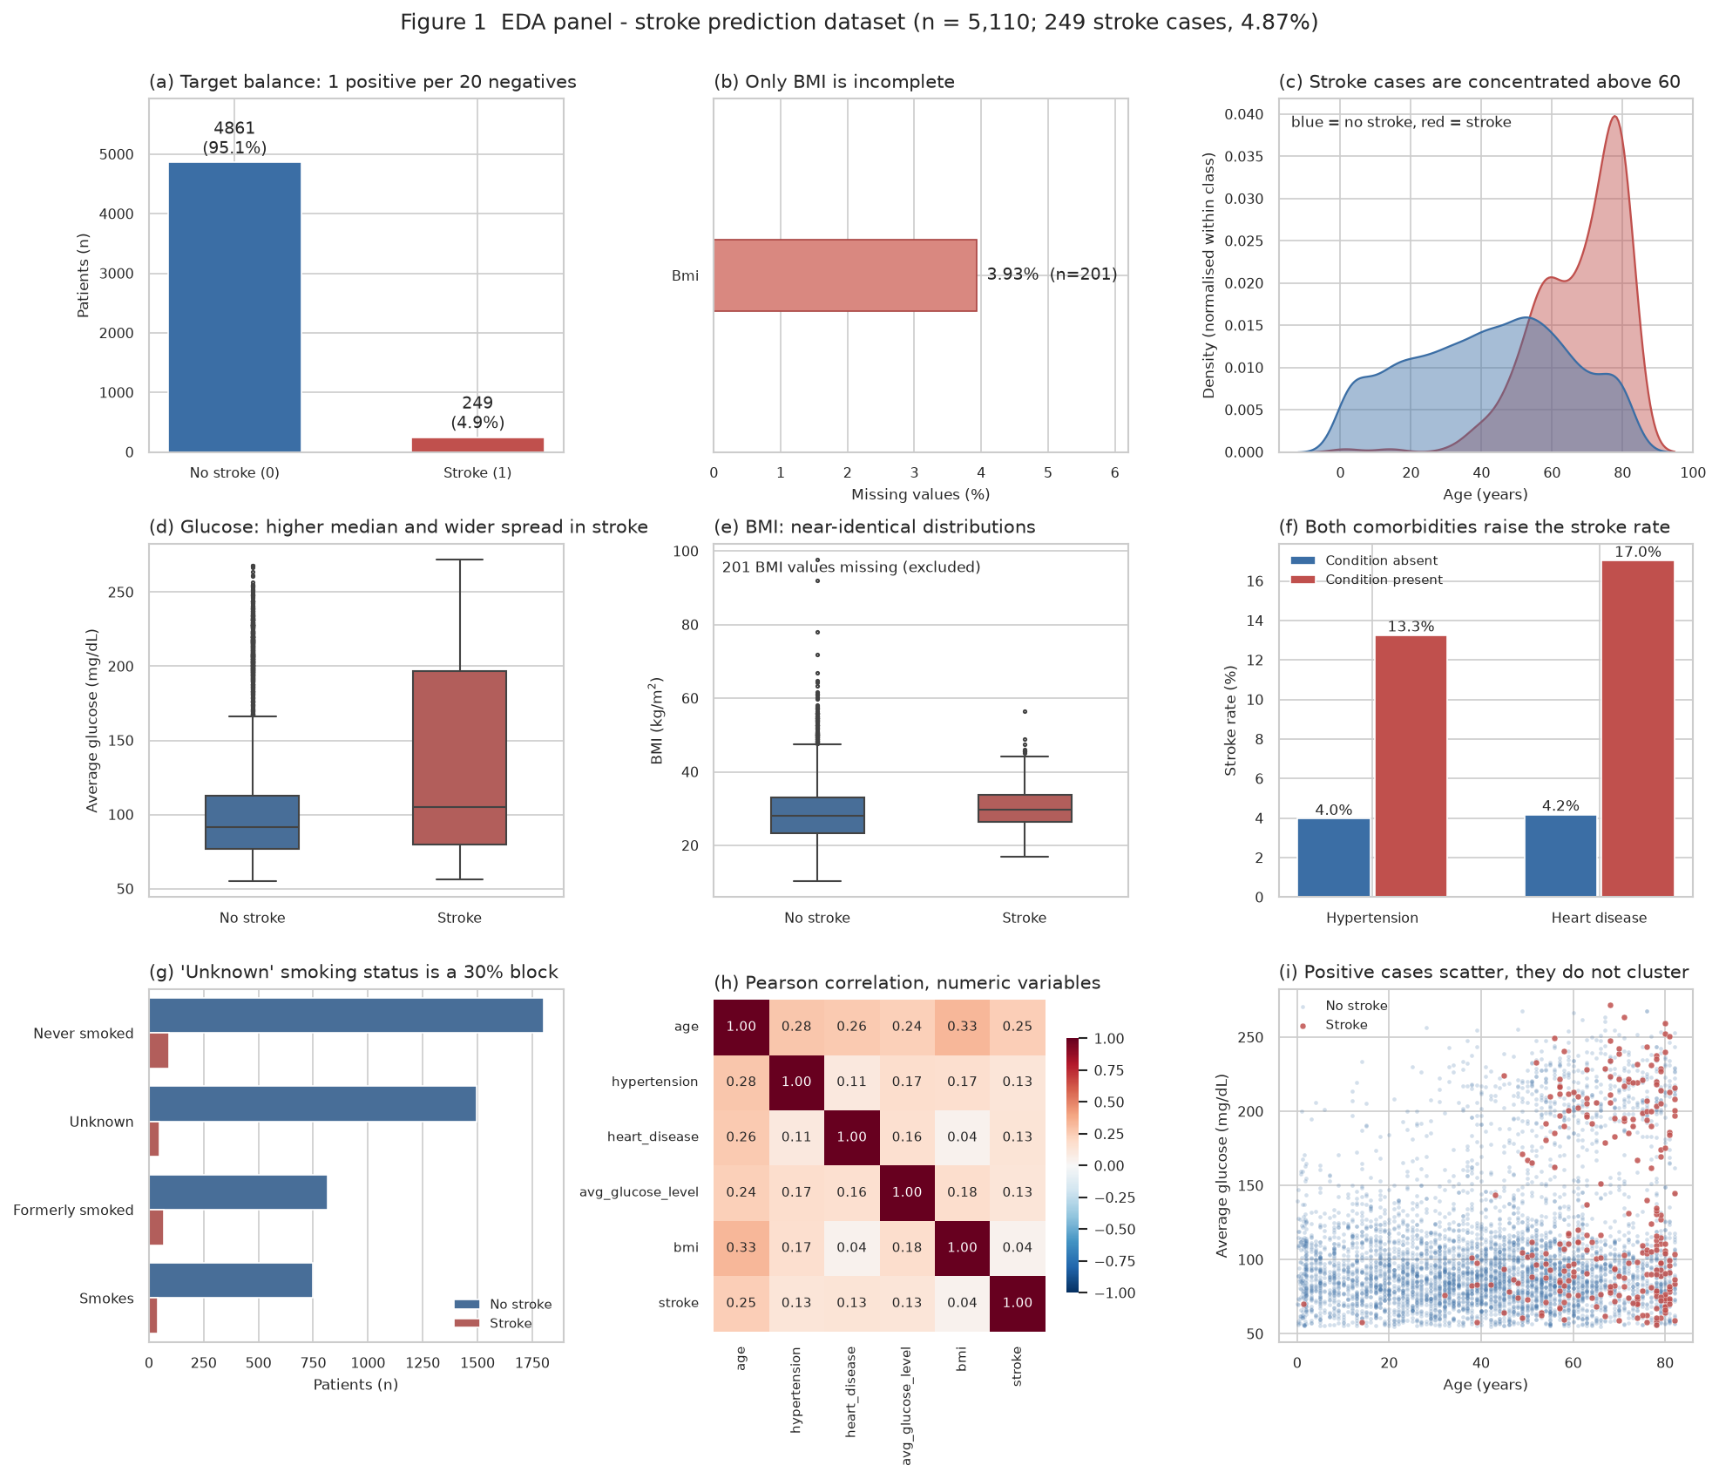
Figure 1. EDA panel over the full dataset (n = 5,110; 249 stroke cases). (a) class balance; (b) missingness; (c) age density by outcome; (d) glucose by outcome; (e) BMI by outcome; (f) stroke rate by comorbidity; (g) smoking-status composition; (h) Pearson correlations; (i) age against glucose with stroke cases highlighted. Red marks stroke cases or higher rates throughout.

2.3 Interpretation and preprocessing decisions
Three observations from the panel shape the modelling plan. First, age is the strongest single signal in the raw data: stroke rate rises from 0.23% under age 18 to 13.15% at 60+, a 57-fold spread, while BMI distributions barely differ between outcomes (panel e). Second, missingness is informative, not random: the 201 patients with no BMI value have a stroke rate of 19.9%, nearly five times the 4.3% among patients with a recorded BMI, and they are older on average (52 vs 43 years). Third, the top glucose quartile (114+ mg/dL) carries an 8.46% stroke rate against roughly 3-4% in the lower quartiles, and both comorbidities raise the rate (panel f). These are associations in one retrospective file; none of them is causal evidence.
Pre-processing consequences. Median imputation of BMI hides the informative missingness: all imputed patients collapse onto the same constant, and the model learns whatever risk that constant region carries. A missing-indicator column would preserve the signal and is the first candidate for improvement; the main pipeline keeps plain median imputation to stay comparable with the course code, and section 8.2 records the consequence. 'Unknown' smoking stays a category, gender 'Other' (n = 1) and 'Never_worked' (n = 22) stay as rare levels because one-hot encoding with handle_unknown='ignore' tolerates them.
Leakage protection. The course pipeline encodes and imputes before splitting, so imputation statistics touch future test rows. The project pipeline puts every learned transformation inside a scikit-learn ColumnTransformer fitted on the training split only. Data are split 60/20/20, stratified on the target, seed 42 (3,066 train / 1,022 validation / 1,022 test; 149 / 50 / 50 stroke cases). Validation chooses hyper-parameters and the decision threshold; the test split is evaluated once, at the end. id and stroke are excluded from predictors; random over-sampling from the course code was dropped in favour of class weighting, because duplicating the 149 positive training rows inflates apparent recall on duplicated patients.

3 Task 2 - model and SHAP interpreter

3.1 Model development
The classifier is a gradient-boosted tree ensemble (XGBoost 3.2.0, n_estimators 300, subsample 0.9, colsample_bytree 0.8, scale_pos_weight 19.58 = negative/positive ratio, seed 42). A boosted tree was chosen over the course's random forest because its raw output is a log-odds, which makes the SHAP additivity identity exactly checkable, and because it leaves task 6 a clean contrast (an SVM has no tree structure for a tree explainer). Twelve small combinations of max_depth, learning_rate and min_child_weight were compared on the validation split by ROC AUC and average precision; max_depth 3, learning_rate 0.05 and min_child_weight 5 won. The decision threshold was chosen on validation to maximise F1 for stroke = 1 over a 0.02-0.97 grid, giving 0.60. The test split was scored once with everything frozen.
Test metric (n = 1,022, 50 positive) | Result | Reading
Accuracy / balanced accuracy | 0.856 / 0.754 | Threshold 0.60; accuracy is dominated by the negative class
Precision (stroke = 1) | 0.199 | 1 in 5 alerts is a true case
Recall (stroke = 1) | 0.640 | 32 of 50 strokes detected; 18 missed
F1 (stroke = 1) / F1 macro | 0.303 / 0.612 | Recall-precision trade-off at the tuned threshold
ROC AUC / average precision | 0.826 / 0.268 | AP against a prevalence of 0.049; a no-skill classifier scores 0.049
Confusion matrix TN / FP / FN / TP | 843 / 129 / 18 / 32 | 18 missed strokes is the clinically costly cell

3.2 Interpreter specification
Explainer: shap.TreeExplainer (shap 0.51.0) on the fitted XGBoost model, feature perturbation 'interventional', model_output 'raw'. Background: 100 random training rows (seed 42). Output scale: log-odds of stroke = 1; probability is obtained afterwards through the logistic link 1/(1+exp(-m)), never by adding log-odds contributions to a probability. The positive class index is 1, verified against model.classes_ = [0, 1]. The explained set is all 1022 test rows; runtime 1.6 s. The base value is -3.369 log-odds, i.e. a probability of 0.033 - the average model output over the background rows, close to but not identical with the training prevalence because the model is not perfectly calibrated.

3.3 Additivity validation
Check | Evidence
Input, feature names, order and dimensions | 21 encoded columns; the explainer consumed the same transformed matrix the model was fitted on
Correct class and output scale | class index 1; log-odds scale stated on every figure; probability reached only via the logistic link
Base value + sum of SHAP values | reconstruction per test row; base -3.3692 + Σφ
Model output minus reconstruction (max / mean absolute residual) | 7.24e-06 / 1.30e-06 log-odds, tolerance 1×10⁻⁶; corresponding probability-space residual 2.84e-07

Positive SHAP values raise the explained log-odds of stroke and negative values lower it, always relative to the background distribution, not relative to health. Two cautions carry through the rest of the report: SHAP describes this model, it does not prove a feature causes stroke; and because age, ever_married and work_type are correlated (panel h), the model may split their shared credit in ways that would change with a different background distribution.

4 Task 3 - local explanation with a force plot

4.1 The selected case
Selection rule, fixed before any explanation was computed: among the test rows the model misses, take the false negative with the highest predicted probability - the patient it came closest to catching. Test case #668 (record id 26015) is that patient: a 66-year-old woman, self-employed, urban residence, glucose 101.5 mg/dL, BMI not recorded, smoking status Unknown, no hypertension, no heart disease. True label 1 (stroke); the model assigned p = 0.5834, below the 0.60 threshold - a false negative, one of 18 in the test split. Her model output is 0.337 log-odds from a base value of -3.369.
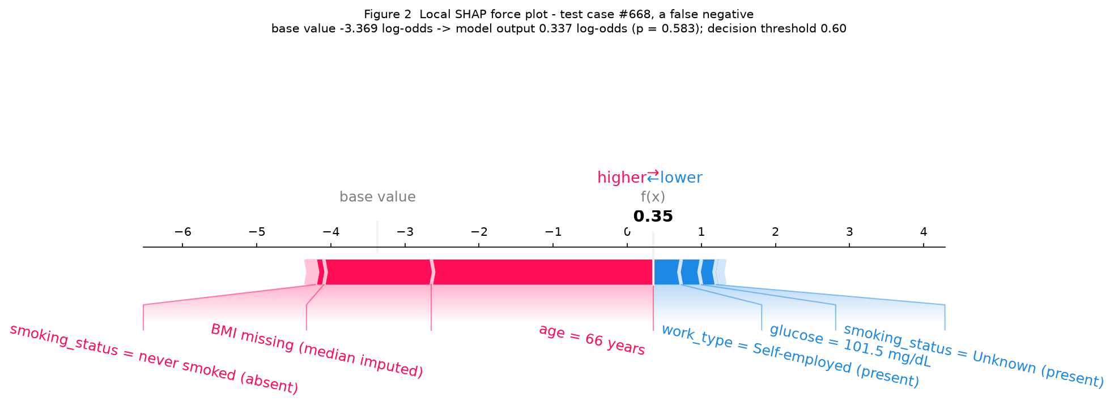
Figure 2. SHAP force plot for test case #668 (false negative), log-odds scale. Red pushes the score up, blue pulls it down; contributions with |φ| < 0.01 log-odds are omitted from the labels, which is why the plot's f(x) reads 0.35 while the exact output is 0.337.
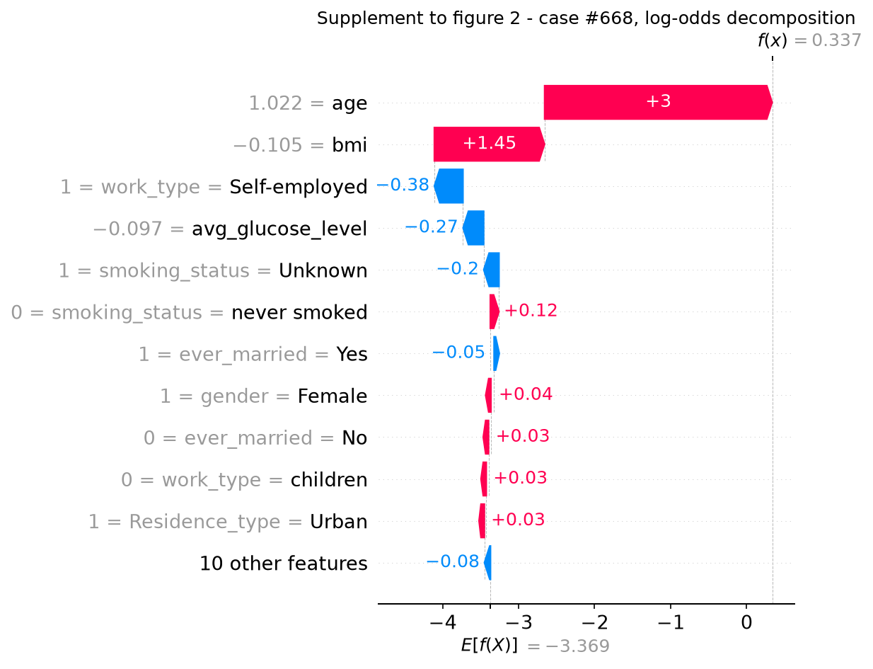
Figure 2b. Waterfall view of the same decomposition, listing each of the largest terms separately. Supplement to figure 2; the numbers are identical.

4.2 Feature contributions
Feature (as shown to the model) | Patient value | SHAP (log-odds) | Direction
age | age = 66 years | +2.995 | pushes toward stroke
bmi | BMI missing (median imputed) | +1.451 | pushes toward stroke
work_type = Self-employed | work_type = Self-employed (present) | -0.378 | pushes away from stroke
remaining 18 features (combined) | - | -0.362 | pushes away from stroke
base value (background average) | - | -3.369 | -

4.3 Reading of this prediction
Starting from the base value -3.369 log-odds, the model moved this patient to 0.337 log-odds (p = 0.583). The two large upward contributions are age (+3.00) and the missing BMI (+1.45). The downward contributions are work_type = Self-employed (-0.38), glucose (-0.27) and the 'Unknown' smoking entry (-0.20). She ended 0.017 below the alert line.
Two of these terms deserve scepticism rather than narration. The BMI contribution is an artefact of imputation: all 201 patients without a BMI collapsed onto the training median (28.0 kg/m²) in a cohort where BMI missingness tracks stroke (19.9% vs 4.3%), so the model has learned that the median-imputed region is risky, and this patient inherited that association without having a measured BMI at all. The 'never smoked (absent)' dummy contributes +0.116 although the patient obviously does not smoke more for it; it is a sparse encoding effect, correlated with the Unknown entry. A cleaner pipeline would add a bmi_missing indicator and reconsider how the smoking categories are encoded.
Substantively, the miss is plausible given the inputs: an older patient with normal glucose, no recorded comorbidities and an incomplete record looks low-risk to any model trained on these features. What a false negative means here is a screening opportunity not raised - the report treats this as a threshold and data-quality problem, not as evidence the model is useless. This explanation describes the model's bookkeeping; it is not a clinical judgement about the patient.

5 Task 4 - global explanation with a summary plot

5.1 Population and plotting setup
Explained population: all 1022 test rows. Model and scale: the task-2 XGBoost model, log-odds of stroke = 1. Display: top 15 encoded columns in the beeswarm (figure 3a); mean |SHAP| per column in figure 3b; and, because 16 of the 21 columns are one-hot dummies, figure 3c merges each dummy block back to its parent variable - signed contributions of all columns of one variable are summed per patient before the mean absolute value is taken. The same aggregation rule is used for every ranking quoted in this report, so beeswarm and table never mix scales. No sampling seed was needed: the full test split is explained.

5.2 Global importance and patterns
Rank | Variable | mean |SHAP| (log-odds) | Encoded columns | Observed pattern
1 | age | 2.714 | 1 | higher values push the output up
2 | bmi | 0.713 | 1 | higher values push the output up
3 | avg_glucose_level | 0.260 | 1 | higher values push the output up
4 | smoking_status | 0.178 | 4 | higher values push the output down
5 | work_type | 0.131 | 5 | higher values push the output down
6 | hypertension | 0.107 | 1 | higher values push the output up

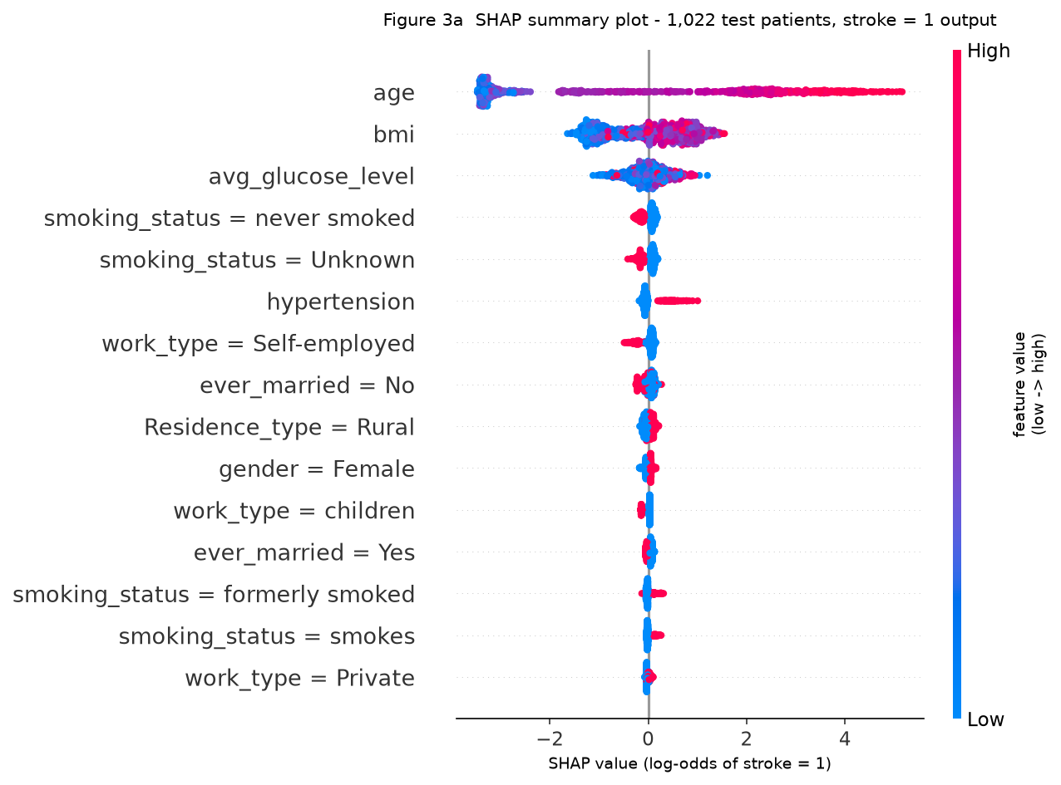
Figure 3a. SHAP summary (beeswarm) plot over 1,022 test patients, stroke = 1 output, log-odds scale. Colour is the encoded column's value; for one-hot columns colour only means presence or absence and carries no clinical severity - the template's warning against reading category codes as severity applies here.
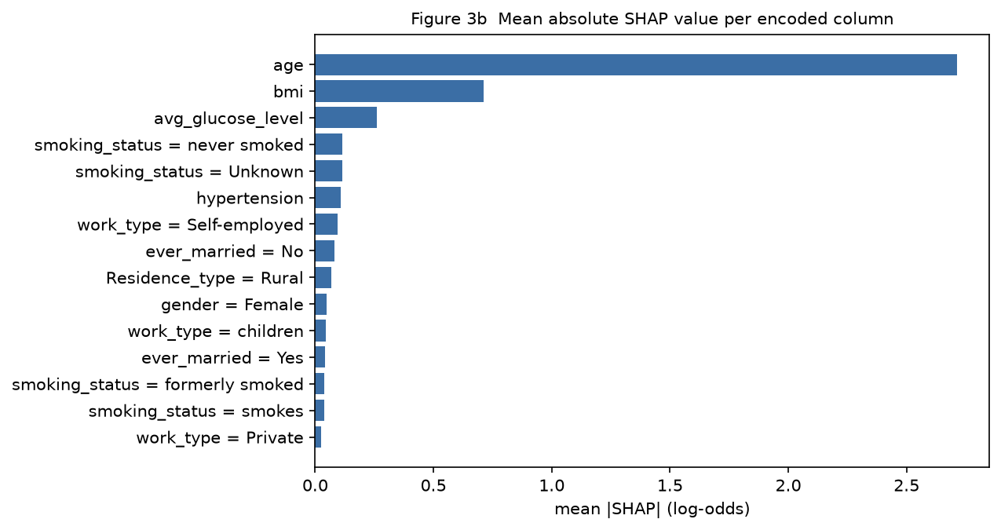
Figure 3b. Mean absolute SHAP value per encoded column (supplement to figure 3a, same 1,022 test rows, log-odds scale).
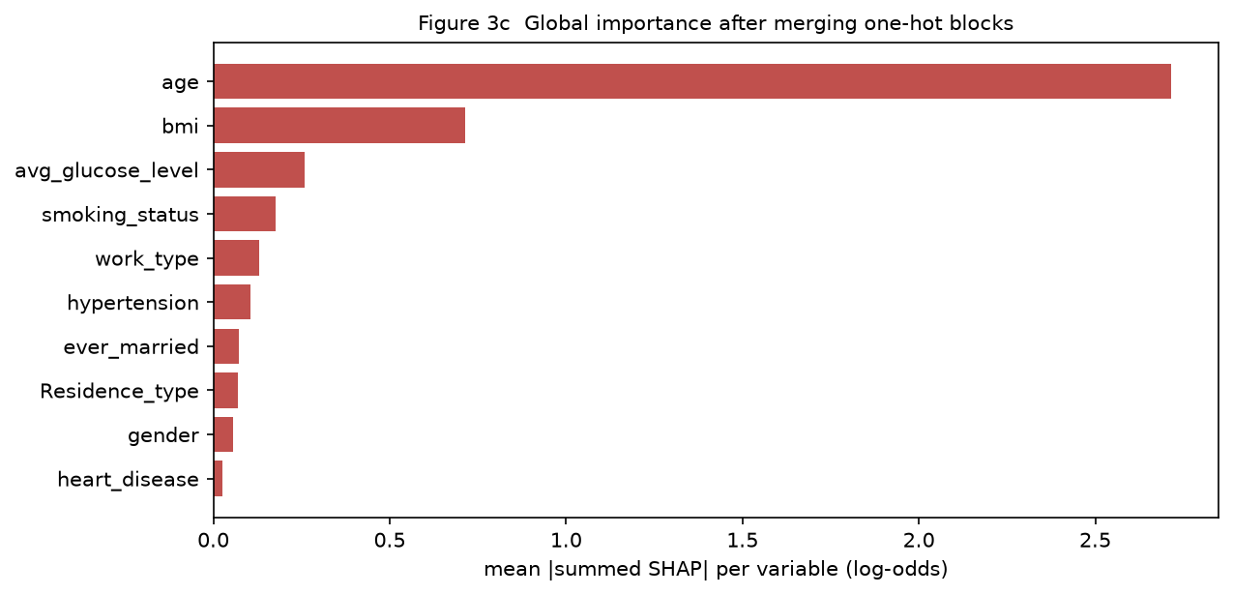
Figure 3c. Mean absolute summed SHAP per parent variable after merging one-hot blocks. This is the scale used by the ranking table above.

5.3 Linking local and global findings
Age is first by a wide margin: mean |SHAP| 2.71 log-odds against 0.71 for BMI, the runner-up. Older patients are pushed up (mean positive contribution +2.61) and younger ones down (mean negative contribution -2.81), each direction covering about half the test population. Case #668 follows the global pattern - her largest single contribution is age (+3.00) - but her BMI term (+1.45) is much larger than the variable's typical magnitude (0.71), which is how the imputation artefact announces itself: individual contributions can sit far outside the population-level spread, and that gap is worth checking rather than narrating. BMI ranking second globally is itself partly the same artefact - the imputed constant region carries risk that a missing-indicator column would attribute to missingness instead.

6 Task 5 - three slides for three audiences
The three slides are submitted as a separate file (Task5_Audience_Slides.pptx) and summarised here. All three present the same model, the same case and the same numbers; only the language and the visual change.

Slide 1 - data scientists
Title: what the model does, and where it fails. Visual: the summary plot (figure 3a) beside a compact performance panel. Content: ROC AUC 0.826 and average precision 0.268 against 0.049 prevalence; the confusion matrix with 18 missed strokes; the explainer configuration (TreeExplainer, interventional, 100-row background, seed 42) and the additivity check; the technical limits - uncalibrated probabilities, correlated predictors splitting credit, informative BMI missingness flattened by imputation, and 30% 'Unknown' smoking entries. The point made to this audience is that ranking quality is real but modest, and the explanation quality is verifiable, which is the part they can audit.

Slide 2 - clinicians
Title: one patient the model missed. Visual: the force plot of case #668 (figure 2) with plain-language labels. Content: what moved the score (age, missing BMI up; normal glucose, no comorbidities, Unknown smoking down), the 0.017 gap under the alert line, sensitivity 0.64 with 18 of 50 cases missed, and the explicit statement that SHAP values are model bookkeeping, not physiology. The slide asks for external validation and calibration before any clinical use and notes that missing data patterns are frequent enough to move scores on their own.

Slide 3 - patients
Title: what this prediction means, and what it does not. Visual: simple markers for the two upward and three downward factors, words instead of feature codes. Content: first-person, plain sentences - the program gave 0.58 against an alert line of 0.60 and the patient did have a stroke; the score is not a diagnosis, not a percentage risk, and not medical advice; it is built from old records and is wrong often enough that a doctor must read it together with everything else. No blame, no causal claims, no medication advice; prevention advice is limited to the standard, uncontroversial steps.

Consistency check
Item | Slide | Report | Consistent
Case | #668, 66-year-old woman | #668 | yes
Predicted probability | 0.58 | 0.5834 | yes
Threshold | 0.60 | 0.60 | yes
Output scale | probability on slides 2-3, log-odds on slide 1 | log-odds in sections 3-5, probability where stated | declared on every visual
Top variable | age (slide 1) | age (section 5.2, mean |SHAP| 2.71) | yes

7 Task 6 - explaining a different black-box model with KernelSHAP

7.1 Alternative model and rationale
Task 2 used a tree ensemble, so task 6 switches function class completely: an RBF-kernel SVM (scikit-learn SVC, probability calibrated by internal Platt scaling, class_weight 'balanced'), tuned over C ∈ {0.5, 1, 3, 10} and gamma ∈ {scale, 0.05, 0.02} on the same validation split (selected C = 0.5, gamma = 0.02). The split, the pre-processing, the threshold selection rule are identical to task 2, and the KernelSHAP background is a smaller draw (25 rows) from the same training split, so any difference in section 8 comes from the model, its explainer or the background size, not from data handling. DeepSHAP was considered and set aside: an SVM has no differentiable network to propagate through, and KernelSHAP is the route the template suggests for exactly this pairing.

7.2 Explainer choice and implementation
Aspect | KernelSHAP route (chosen) | DeepSHAP route (not applicable)
Suitable model class | Any prediction function; used on the SVM | Differentiable neural networks only - no SVM support
Output and class | predict_proba, stroke = 1, probability scale | network output, selected class, chosen scale
Background | 25 training rows drawn from the same training split (seed 42); task 2 used 100 rows, so background distributions differ slightly between the two explainers | would need training-sample background and seed
Computation | nsamples 300 per row for the global set of 150 test rows (600 for the single case), no L1 regularisation, seed 42; 69.2 s total | framework, batching and evaluation mode would need recording
Input consistency | explainer consumed the same transformed matrix as the model | tensor shapes and transformed feature names would need recording

Compatibility checks: reconstruction residual against predict_proba, max 0.00e+00 / mean 0.00e+00 in probability units (tolerance 0.002); no warnings were emitted. A residual that is identically zero is the expected outcome here and not evidence of a better explanation: the KernelSHAP solution is obtained under an efficiency constraint, so the base value plus the 21 contributions reproduces the model output for every row by construction. What the check does establish is that the wrapper feeds the stroke = 1 column, that the scale matches predict_proba, and that no feature was silently dropped; it says nothing about whether 300 coalitions per row were enough for the values to be stable, which remains an untested limitation (section 8.2). The output is on the probability scale, unlike the log-odds scale of task 2 - section 8.1 therefore compares rankings and signs, never raw magnitudes.

7.3 Evidence for the selected model
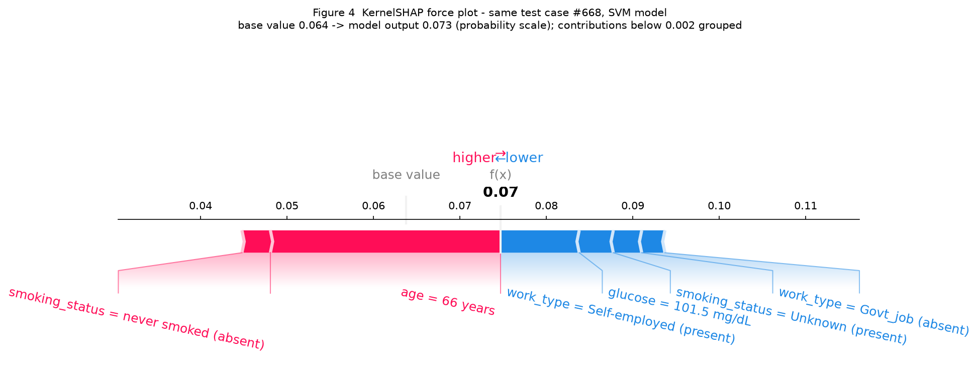
Figure 4. KernelSHAP force plot for the same test case #668 under the SVM, probability scale. Note the scale change against figure 2: here the base value and the output are probabilities, not log-odds.
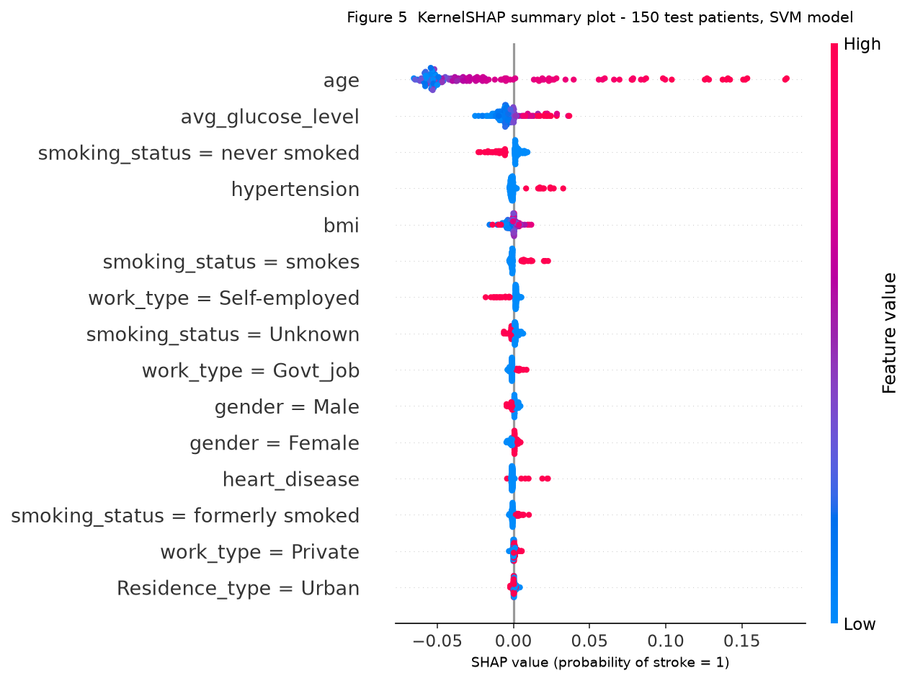
Figure 5. KernelSHAP summary plot over a fixed subsample of 150 test patients, SVM model, probability scale. The subsample (seed 42) keeps KernelSHAP affordable; the subsample's composition matches the test split's prevalence within a point.
The SVM reaches ROC AUC 0.804 and average precision 0.169 on the test split (details in table 10). Its global picture agrees with the boosted trees on the leading variable - age - while the ordering below it differs, as expected for a kernel method that balances a single weighted margin against the tree ensemble's additive splits.

8 Comparison, limitations and conclusion

8.1 The two models side by side
Item | Task 2 - XGBoost | Task 6 - SVM (RBF)
Model and explainer | boosted trees / TreeExplainer | SVM / KernelSHAP
Precision (stroke = 1) | 0.199 | 0.206
Recall (stroke = 1) | 0.640 | 0.400
F1 (stroke = 1) / balanced accuracy | 0.303 / 0.754 | 0.272 / 0.660
ROC AUC / average precision | 0.826 / 0.268 | 0.804 / 0.169
Case #668 score | p = 0.5834 (false negative) | p = 0.0731 (also a false negative)
Explanation scale | log-odds, base -3.369 | probability, base 0.064
Top variable (aggregated) | age | age
Explained rows / runtime | 1,022 rows / 1.6 s | 150 rows / 69.2 s
Max reconstruction residual | 7.2e-06 log-odds | 0.0e+00 probability

The agreement that matters is directional: both explainers put age first by a clear margin, and both score case #668 under the alert line, so the miss is a property of the data representation, not of one model's quirks. The disagreement sits in the mid-field, where the SVM distributes weight differently across the smoking and work-type dummies. Nothing here compares raw SHAP magnitudes across the two output scales - log-odds and probability units are not convertible by a constant factor, and the differences between the background distributions add their own effect.

8.2 Limitations and responsible interpretation
Data. One retrospective file from an unknown collection period; no follow-up, so the target is a historical record, not a verified future stroke. The cohort is not representative of any deployment population, and subgroup performance by sex or age band was not assessed because the positive count (249, of which 50 fall in the test split) is too small for stable estimates. Missingness is informative: BMI-missing patients carry a 19.9% stroke rate, and median imputation erases that marker while folding those patients into a fixed risk region - the mechanism behind the +1.45 log-odds BMI term in case #668. A missing-indicator column is the first listed improvement.
Modelling. Probabilities are not calibrated and no calibration analysis was run, so threshold-based metrics are reported but the probability values themselves should not be quoted as risks. Correlated predictors (age with ever_married and work_type = children, smoking dummies with each other) share credit in ways that depend on the background distribution. Class imbalance is handled by weighting, which trades precision for recall and was tuned for F1 on validation.
Explanation stability. The TreeExplainer background is one draw of 100 training rows (seed 42); repeating the explanation with a different background sample would shift contributions for correlated features, and no stability experiment was run - this is reported as observed, not assumed away. KernelSHAP adds approximation error (recorded above) and covered a 150-row subsample rather than the full test split. SHAP explains this model; no causal claim anywhere in this report follows from it, and no figure should be read as a validated future-risk score.

8.3 Conclusion
On the pre-declared criteria the boosted-tree model is the stronger of the two: ROC AUC 0.826 against 0.804, average precision 0.268 against 0.169, and recall 0.64 against 0.40 at comparable precision. SHAP shows age dominates both models (mean |SHAP| 2.71 log-odds, ten times any other variable), while the local analysis of case #668 exposes what ranking tables hide: an imputation artefact and an 'Unknown' smoking entry pushed a true stroke case below the alert line. The KernelSHAP analysis of the SVM agrees on the leading factor, which locates the problem in the data representation rather than the learner. The main limitation is informative missingness that median imputation destroys; a missing-indicator column and calibration analysis are the concrete next steps.
(119 words)

8.4 Contributions, assistance and tools
Item | Statement
Work | Individual coursework. Analysis, code, figures and text: [Student name]
Course materials | Course repository ciumGit/7009, commit 4889192: 00_data_exploration.py run unmodified as the EDA baseline; utils.py data loading reused conceptually; 03_shap.py consulted as the course's SHAP demonstration. No line of the course scripts was modified; script-level changes sit in src/, method-level departures are listed in 2.1, 2.3 and 3.1
Software | Python 3.11.1; pandas 3.1.1, scikit-learn 1.9.1, xgboost 3.2.0, shap 0.51.0, imbalanced-learn 0.14.2, matplotlib 3.10.8, seaborn; versions pinned in requirements.txt
Generative AI | Used for debugging assistance and language editing only. Model choices, preprocessing decisions, all reported numbers and their interpretation were produced and verified by rerunning the scripts in this repository; no result in this report was generated or invented by an AI tool
Other assistance | [None / discussants, per course policy]

9 References, reproducibility and submission checklist

9.1 References
World Health Organization. The top 10 causes of death (2023 estimates: stroke, second cause, ~11% / 6.8 million deaths). https://www.who.int/topics/mortality/en/ (accessed at submission).
Fedesoriano. Stroke Prediction Dataset. Kaggle. https://www.kaggle.com/datasets/fedesoriano/stroke-prediction-dataset
Lundberg, S. M., & Lee, S.-I. (2017). A unified approach to interpreting model predictions. Advances in Neural Information Processing Systems 30 (SHAP).
Lundberg, S. M., et al. (2020). From local explanations to global understanding with explainable AI for trees. Nature Machine Intelligence, 2, 56-67.
Lundberg, S. M., et al. (2018). Explainable machine-learning predictions for the prevention of all-cause mortality. AAAI-18 (KernelSHAP).
Chen, T., & Guestrin, C. (2016). XGBoost: A scalable tree boosting system. KDD '16.
Pedregosa, F., et al. (2011). Scikit-learn: Machine learning in Python. JMLR 12.

9.2 Reproducibility appendix
Item | Value
Environment | Python 3.11.1 (venv), see requirements.txt for the full pin list
Seeds | split 42, model 42, background sample 42, KernelSHAP subsample 42
Data | healthcare-dataset-stroke-data.csv, 5,110 × 12, as shipped in the course repository (commit 4889192); SHA-256 recorded in outputs/data_sha256.txt
Configuration | src/prep.py (split, pipeline), src/02_task2_model_shap.py (model, explainer), src/03/04 scripts (figures), src/06_task6_alt_model.py (SVM, KernelSHAP)
Evidence files | outputs/: eda_stats.json, task2_metrics.json, shap_values_test_logodds.npy, test_pred_proba.npy, task3_case.json, task4_global.json, task6_metrics.json, X_test_encoded.csv, X_test_raw.csv; figures/fig1-fig5 (png); logs/eda_baseline.log

9.3 Final submission checklist
- ☑ Task 1 - repository recorded (commit 4889192), 00_data_exploration.py executed unmodified, EDA results interpreted in 2.2-2.3
- ☑ Task 2 - model evaluated on a held-out test split; SHAP interpreter specified with class, background, output scale and verified additivity
- ☑ Task 3 - readable force plot (figure 2) tied to one held-out case with a declared selection rule and a critique of its artefacts
- ☑ Task 4 - readable summary plot (figure 3a) plus per-variable aggregation (3c) and a global pattern reading
- ☑ Task 5 - three slides for data scientist, clinician and patient, consistency-checked against the report
- ☑ Task 6 - different black-box model (SVM) explained with KernelSHAP, reconstruction residual recorded, same splits and comparable predictors
- ☑ All placeholders replaced; every figure captioned with sample, scale and reading; sources cited; code and versions provided
- ☑ No invented results, no data leakage (preprocessing fitted on train only), no causal claims, no unvalidated future-risk statements

