Question 1:How are inline and block element different from each other?

Answer: A block-level element always starts on a new line and takes up the full width available (stretches out to the left and right as far as it can).

Example: <div><address><article><aside><blockquote><canvas><dd><div><dl><dt><fieldset><figcaption><figure><footer><form><h1>-<h6><header><hr><li><main><nav><noscript><ol><p><pre><section><table><tfoot><ul><video>

An inline element does not start on a new line and only takes up as much width as necessary.
Example: <a><abbr><acronym><b><bdo><big><br><button><cite><code><dfn><em><i><img><input><kbd><label><map><object><output><q><samp><script><select><small><span><strong><sub><sup><textarea><time><tt><var>
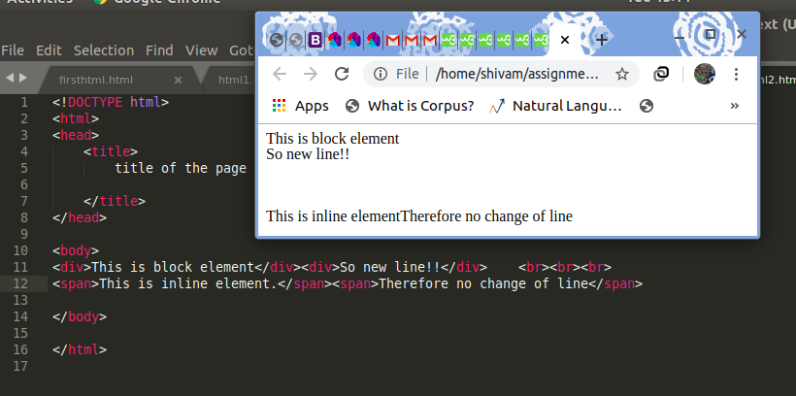

Question 2:Explain the difference between visibility:hidden and display:none

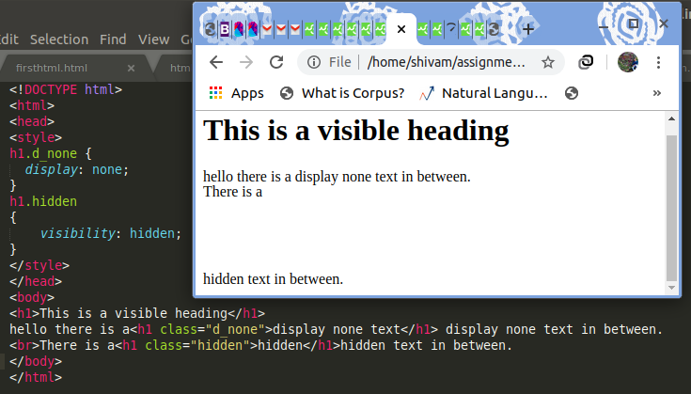

Question 3:. Explain the clear and float properties.
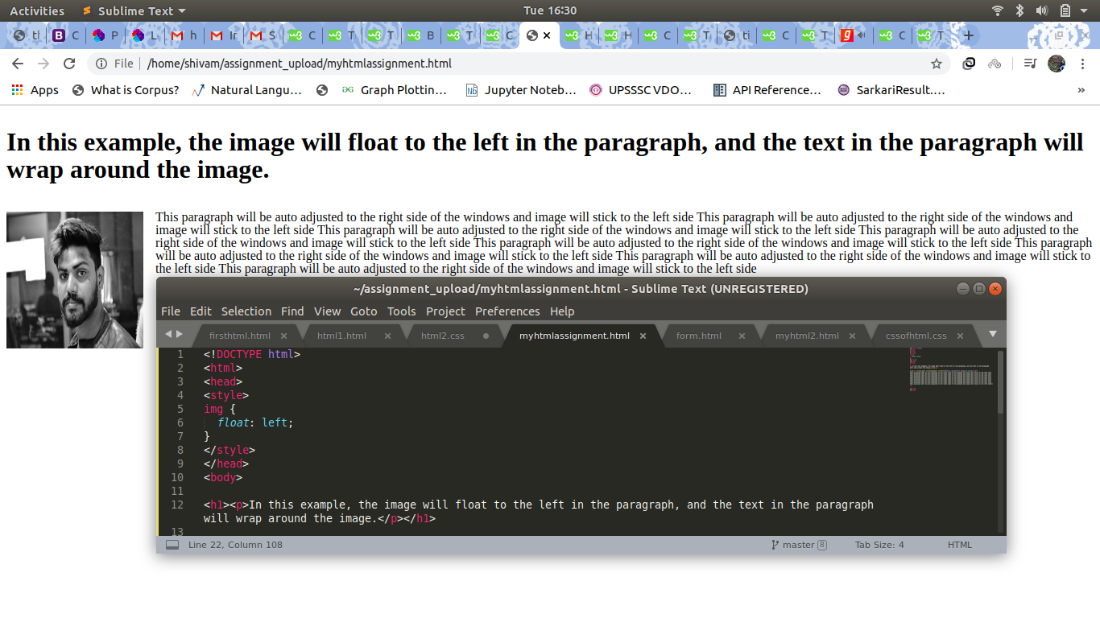

Question 4: Explain difference between absolute, relative,fixed and static.

HTML elements are positioned static by default.
Static positioned elements are not affected by the top, bottom, left, and right properties.
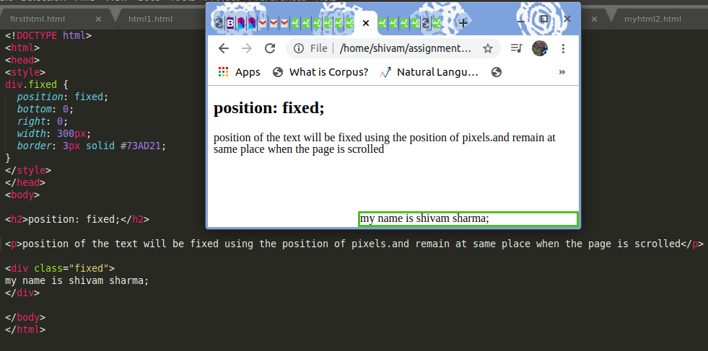

Static:-this is the default value, all elements are in order as they appear in the document.
- Relative- the element is positioned relative to its normal position.
- Absolute- the element is positioned absolutely to its first positioned parent.
- Fixed-the element is positioned related to the browser window.
- Sticky-- the element is positioned based on the user's scroll position.

Question 5:Write the HTML code to create a table in which there are 4 columns( ID , Employee Name, Designation, Department) and at least 6 rows. Also do some styling to it.

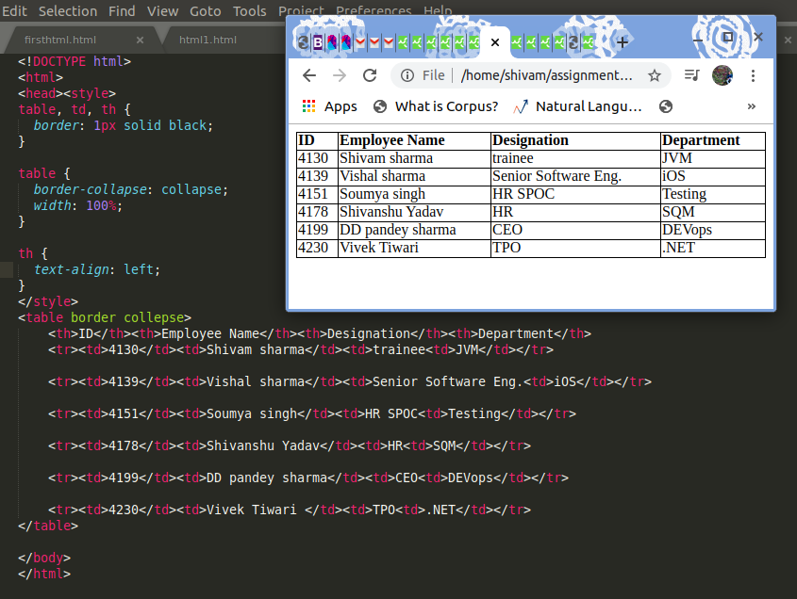
Question:6 Why do we use meta tags?
Meta tags are specific snippets of text and image content that provide a summary for a webpage. Often meta tag data shows up whenever someone shares a link on social media, in messaging, or in your business chat software.
Example of meta contents:
<head>
<meta charset="UTF-8">
<meta name="description" content="Free Web tutorials">
<meta name="keywords" content="HTML,CSS,XML,JavaScript">
<meta name="author" content="John Doe">
<meta name="viewport" content="width=device-width, initial-scale=1.0">
</head>

Question :7 Explain Box model.
All HTML elements can be considered as boxes. In CSS, the term "box model" is used when talking about design and layout.
The CSS box model is essentially a box that wraps around every HTML element. It consists of: margins, borders, padding, and the actual content.

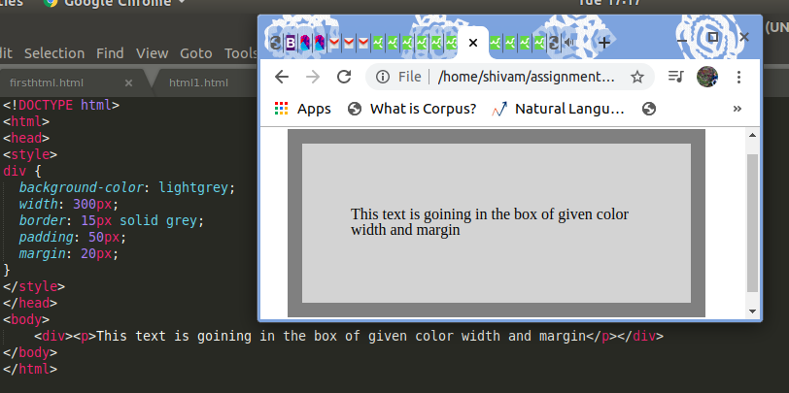

Question 8:What are the different types of CSS Selectors?

CSS selectors are used to "find" (or select) the HTML elements you want to style.

Simple selectors (select elements based on name, id, class)

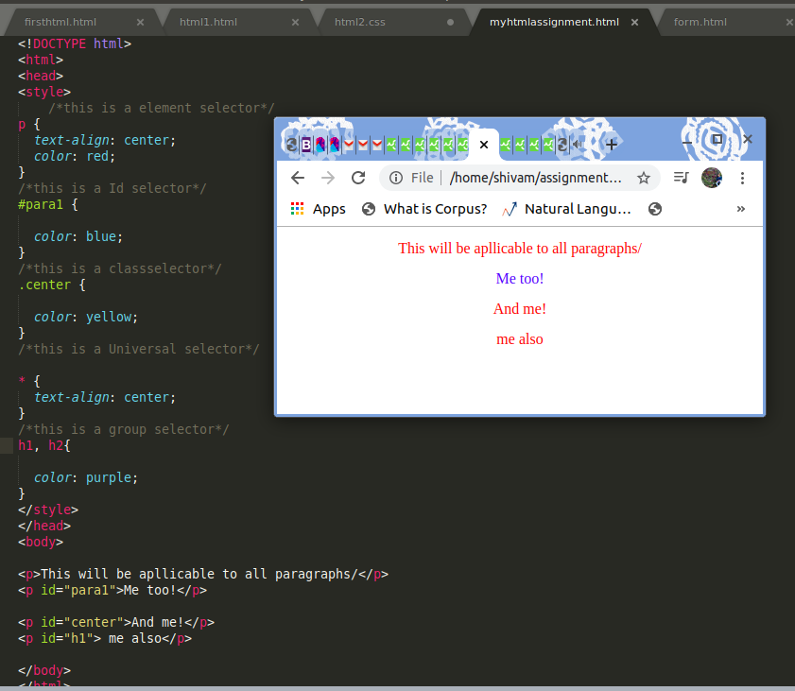

Question 9:
The <!DOCTYPE> declaration must be the very first thing in your HTML document, before the <html> tag.
The <!DOCTYPE> declaration is not an HTML tag; it is an instruction to the web browser about what version of HTML the page is written in.
In HTML 4.01, the <!DOCTYPE> declaration refers to a DTD, because HTML 4.01 was based on SGML. The DTD specifies the rules for the markup language, so that the browsers render the content correctly.
HTML5 is not based on SGML, and therefore does not require a reference to a DTD.
Tip: Always add the <!DOCTYPE> declaration to your HTML documents, so that the browser knows what type of document to expect.

Question 10: Explain 5 HTML5 semantic tags.

Semantics is the study of the meanings of words and phrases in a language.
Semantic elements = elements with a meaning.
A semantic element clearly describes its meaning to both the browser and the developer.
1.<header> :This element specifies a header for a document or section
2.<nav> :The<nav>element defines a set of navigation links.
3.<section>:
4.<aside>: The <aside>element defines some content aside from the content it is placed in (like a sidebar).
The<aside>content should be related to the surrounding content.
5.<footer> :This element specifies a footer for a document or section.A footer typically contains the author of the document, copyright information, links to terms of use, contact information, etc.

Question:11 Code file is given as question11.html along with ques11.css
Question:12 Code file is given as question12.html along with ques12.css

