Q1. Write a program to replace a substring inside a string with other string ?

class q1

{

public static void main(String[] args) {

System.out.println("Program to show the use of replace method");

String str="HELLO! java is a oop language and java support multi-threading";

System.out.println("Before replacement: "+str);

String replacewith="c++";

String newstring=str.replaceAll("java",replacewith);

System.out.println(newstring);

}

}



Q2. Write a program to find the number of occurrences of the duplicate words in a string and print

them ?

import java.util.Scanner;

class q2

{

public static void main(String[] args) {

Scanner sc=new Scanner(System.in);

String str=sc.nextLine();

str=str.toLowerCase();

int count=0;

System.out.println(str);

String Words[]=str.split(" ");

System.out.println("Duplicate words in inputed string: ");

for(int i=0;i<Words.length;i++)

{

count=1;

for(int j=i+1;j<Words.length;j++)

{

if(Words[i].equals(Words[j]))

{

count++;

Words[j]="0";

}

}

if(count>1 && Words[i]!="0")

{

System.out.println(Words[i]+ " "+ count);

}

}

}

}

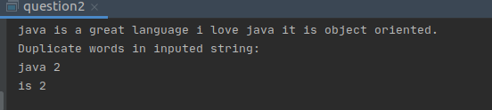

Q3. Write a program to find the number of occurrences of a character in a string without using loop?

import java.util.Scanner;

class q3

{

public static void main(String[] args)

{ Scanner sc=new Scanner(System.in);

System.out.println("Program to find no. of occurance of specific character ")

System.out.println("Please Enter a string.... ");

String str1 = sc.nextLine();

System.out.println("Enter the character which occurance to find");

String str2=sc.nextLine();

int count = str1.length() - str1.replace(str2,"").length();

System.out.println("Number of occurances of in "+str1+" = "+count);

}

}

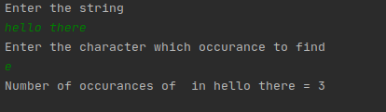

Q4. Calculate the number & Percentage Of Lowercase Letters,Uppercase Letters, Digits And Other

Special Characters In A String

import java.util.Scanner;

public class q4 {

public static void main(String args[]) {

Scanner sc=new Scanner(System.in);

System.out.println("Program to find quantity and Percentage of numbers,strings and special symbols:\t");

System.out.println("enter a string which contains some Uppercase,LowerCase,Numbers and special characters");

String data =sc.nextLine();

char [] charArray = data.toCharArray();

int upper = 0;

int lower = 0;

int digit = 0;

int others = 0;

int totalChars = data.length();

for(int i=0; i<data.length(); i++) {

if (Character.isUpperCase(charArray[i])) {

upper++;

} else if(Character.isLowerCase(charArray[i])) {

lower++;

} else if(Character.isDigit(charArray[i])){

digit++;

} else {

others++;

}

}

System.out.println("Total length of the string :"+totalChars);

System.out.println("Upper case :"+upper);

System.out.println("Percentage of upper case letters: "+(upper\*100)/totalChars+" %");

System.out.println("Lower case :"+lower);

System.out.println("Percentage of lower case letters:"+(lower\*100)/totalChars+" %");

System.out.println("Digit :"+digit);

System.out.println("Percentage of digits :"+(digit\*100)/totalChars+" %");

System.out.println("Others :"+others);

System.out.println("Percentage of other characters :"+(others\*100)/totalChars+" %");

}

}

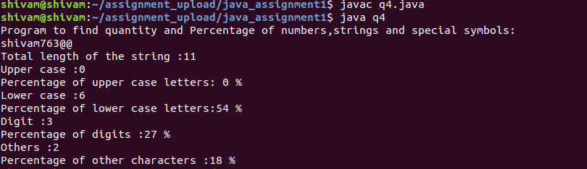

Q5. Find common elements between two arrays.

Q6. There is an array with every element repeated twice except one. Find that element

import java.util.Scanner;

class q6 {

static int firstNonRepeating(int arr[], int n)

{

for (int i = 0; i < n; i++) {

int j;

for (j = 0; j < n; j++)

if (i != j && arr[i] == arr[j])

break;

if (j == n)

return arr[i];

}

return -1;

}

public static void main(String[] args)

{

int[] array1;

array1=new int[5];

Scanner sc=new Scanner(System.in);

System.out.println("Enter 5 numbers with repeatation expect one number");

for (int i=0;i<5;i++)

{

array1[i]=sc.nextInt();

}

int n = array1.length;

System.out.print("The number which is occuring only once is: "+firstNonRepeating(array1, n)+"..\t");

}

}

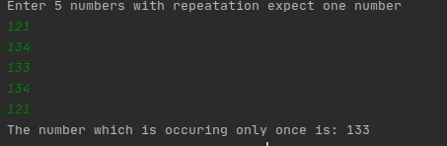

Q7. Write a program to print your Firstname,LastName & age using static block,static method & static variable respectively

import java.util.Scanner;

class q7

{

// static block

static {

System.out.println("First name: Shivam");

}

//static varibale

static int age=m1();

//static method

static int m1() {

System.out.println("Last name: Sharma");

//Enter age

System.out.println("Enter age");

Scanner sc=new Scanner(System.in);

int a=sc.nextInt();

return a;

}

public static void main(String[] args) {

System.out.println("Age is "+age);

}

}

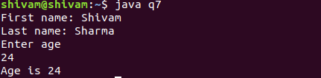

Q8. Write a program to reverse a string and remove character from index 4 to index 9 from the reversed string using String Buffer

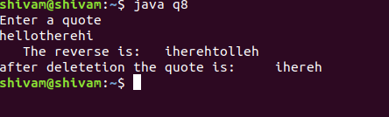

import java.lang.\*;

import java.util.Scanner;

class q8{

public static void main(String args[]){

Scanner scanner=new Scanner(System.in);

StringBuffer quote=new StringBuffer();

System.out.println("Enter a quote");

quote.append(scanner.nextLine());

//reverse the string

quote=quote.reverse();

System.out.println(" The reverse is: "+quote);

quote=quote.delete(4,10); //incuding 9th position

System.out.println("after deletetion the quote is: "+quote);

}

}

Q9.Write a program to display values of enums using a constructor & getPrice() method (Example display house & their prices)

public class q9{

public enum houseName{

A(10000),B(20000),C(30500),D(15000),E(20500);

private int p;

houseName(int price)

{

p=price;

}

int getPrice()

{

return p;

}

}

public static void main(String[] args)

{

System.out.println("House Name :Price");

System.out.println(houseName.A+":\t"+houseName.A.getPrice()+"Rupees");

System.out.println(houseName.B+":\t"+houseName.B.getPrice()+"Rupees");

System.out.println(houseName.C+":\t"+houseName.C.getPrice()+"Rupees");

System.out.println(houseName.D+":\t"+houseName.D.getPrice()+"Rupees");

System.out.println(houseName.E+":\t"+houseName.E.getPrice()+"Rupees");

}

}

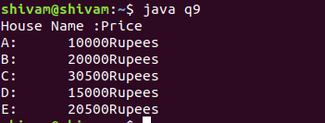

Q10.Write a single program for following operation using overloading

A) Adding 2 integer number

B) Adding 2 double

C) multiplying 2 float

D) multiplying 2 int

E) concate 2 string

F) Concate 3 String

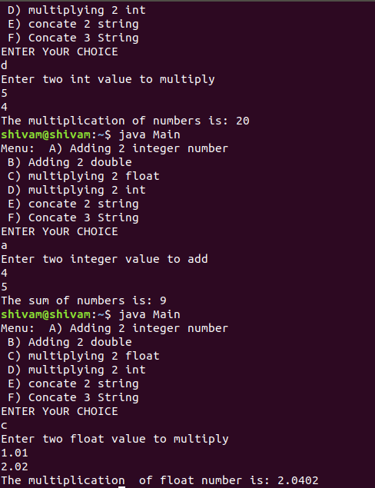

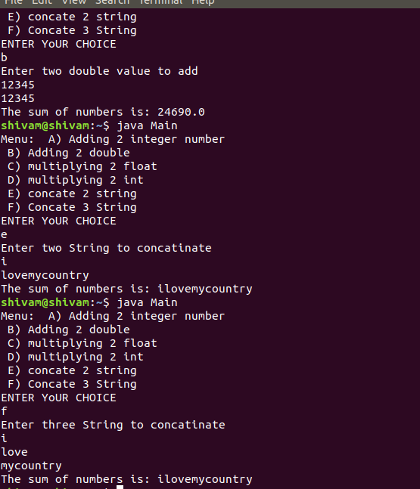

iimport java.util.Scanner;

class q10{

void addition(int num1,int num2)

{

System.out.println("The sum of numbers is: "+(num1+num2));

}

// to add two double num

void addition(double num1,double num2)

{

System.out.println("The sum of numbers is: "+(num1+num2));

}

//to multiply two float numbers

void multiplication(float num1,float num2)

{

System.out.println("The multiplication of float number is: "+(num1\*num2));

}

//to multiply two int

void multiplication(int number1,int number2)

{

System.out.println("The multiplication of numbers is: "+(number1\*number2));

}

//to concatinate two Strings

void concatination(String str1,String str2)

{

str1=str1.concat(str2);

System.out.println("After concatination: "+str1);

}

///to concatinate three strings

void concatination(String str1,String str2,String str3)

{

str1=str1.concat(str2.concat(str3));

System.out.println("After concatination: "+str1);

}

public static void main(String[] args) {

System.out.println("Menu: A) Adding 2 integer number \n B) Adding 2 double \n C) multiplying 2 float \n D) multiplying 2 int \n E) concate 2 string \n F) Concate 3 String");

//enum choice{A,B,C,D,E,F}

System.out.println("ENTER YoUR CHOICE");

Scanner scan=new Scanner(System.in);

char ch=scan.next().charAt(0);

ch=Character.toLowerCase(ch);

q10 m=new q10();

switch (ch)

{

case 'a':

System.out.println("Enter two integer value to add");

int n1=scan.nextInt();

int n2=scan.nextInt();

q10.addition(n1,n2);

break;

case 'b':

System.out.println("Enter two double value to add");

double d1=scan.nextInt();

double d2=scan.nextInt();

q10.addition(d1,d2);

break;

case 'c':

System.out.println("Enter two float value to multiply");

float f1=scan.nextFloat();

float f2=scan.nextFloat();

q10.multiplication(f1,f2);

break;

case 'd':

System.out.println("Enter two int value to multiply");

int nm1=scan.nextInt();

int nm2=scan.nextInt();

q10.multiplication(nm1,nm2);

break;

case 'e':

System.out.println("Enter two String to concatinate");

String str1=scan.next();

String str2=scan.next();

m.concatination(str1,str2);

break;

case 'f':

System.out.println("Enter three String to concatinate");

String string1=scan.next();

String string2=scan.next();

String string3=scan.next();

m.concatination(string1,string2,string3);

break;

default:

System.out.println("Wrong input");

}

}

}

Q11.Create 3 sub class of bank SBI,BOI,ICICI all 4 should have method called getDetails which provide there specific details like rateofinterest etc,print details of every banks

abstract class Bank{

float rateofinterest;

String branchname;

public abstract void getdetails();

}

class SBI extends Bank{

public void getdetails()

{

rateofinterest=20.0f;

branchname="palam";

System.out.println("Rate of interest of SBI bank is : "+rateofinterest);

System.out.println("Branch name of SBI bank is : "+branchname);

}

}

class BOI extends Bank{

public void getdetails()

{

rateofinterest=30.22f;

branchname="wazirabad";

System.out.println("Rate of interest of SBI bank is : "+rateofinterest);

System.out.println("Branch name of SBI bank is : "+branchname);

}

}

class ICICI extends Bank{

public void getdetails()

{

rateofinterest=50.21f;

branchname="sarojninagar";

System.out.println("Rate of interest of SBI bank is : "+rateofinterest);

System.out.println("Branch name of SBI bank is : "+branchname);

}

}

public class q11{

public static void main(String[] args) {

Bank b=new SBI();

b.getdetails();

System.out.println("");

b=new BOI();

b.getdetails();

System.out.println("");

b=new ICICI();

b.getdetails();

}

}