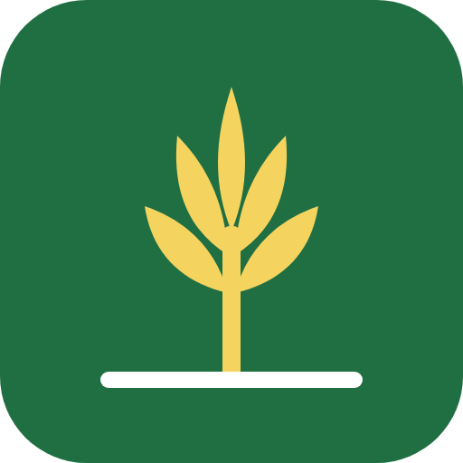
AgroHands
User Guide
Verified hands. Fair work.
How to use the AgroHands website, Android app and USSD service, step by step, with a picture of every screen.
For farm workers, farm owners, field agents and administrators.
Version 1.4 · October 2026
Applies to AgroHands app version 1.4.0 and later

How to use this guide
This guide explains every part of AgroHands. You do not need to read it from start to finish. Go straight to the chapter for your role:
If you are… | Read these chapters
A farm worker looking for paid farm work | 2 Getting started · 3 Your worker page · 4 Training · 5 Job offers and contracts · 7 USSD (no smartphone) · 8 Your account
A farm owner who needs workers | 2 Getting started · 6 Hiring workers · 8 Your account
An AgroHands field agent | All of the above (you will help both groups), then 9 The agent desk
An AgroHands administrator | 9 The agent desk · 10 The admin console · Appendices

How the guide is written. Steps you carry out are numbered. Words in bold are the exact words you will see on a button or screen. Each picture shows the real app; the people, farms and phone numbers in the pictures are demonstration data, not real people.
About the pictures. The pictures were taken on a phone screen, because most people use AgroHands on a phone. On a computer the same pages are wider, but the buttons and words are the same. Long pages are shown in parts side by side: read Part 1, then Part 2, and so on, as if you were scrolling down.
Your language
AgroHands works in English, Nigerian Pidgin, Yorùbá, Hausa, Igbo and French. This guide shows the English screens. If you use another language, the buttons are in the same places with the same icons.

How to use this guide
1. About AgroHands
1.1 What AgroHands does for you
1.2 Who uses AgroHands
1.3 Three ways to use AgroHands
1.4 Your phone number and PIN
2. Getting started
2.1 Opening AgroHands
2.2 Choosing your language
2.3 Creating an account
2.4 Confirming your phone number
2.5 Logging in
2.6 Forgot your PIN
2.7 Finding your way around
2.8 Installing AgroHands on your phone
3. Your worker page
3.1 The five steps to get hired
3.2 Completing your profile
3.3 Verifying your NIN
3.4 Adding a guarantor
3.5 Your level (tier)
3.6 Available for work
4. The Training Academy
4.1 Reading a course
4.2 Taking the quiz
4.3 Your certificate
4.4 Paid courses
5. Job offers and contracts (workers)
5.1 Receiving a job offer
5.2 Reading and signing your contract
5.3 When the contract is active
5.4 Ending a contract and rating
5.5 Reporting a problem (dispute)
6. Hiring workers (farm owners)
6.1 Your farm page
6.2 Adding your farm details
6.3 Posting a job
6.4 Your ranked shortlist
6.5 Sending offers
6.6 Signing and managing contracts
7. Using AgroHands without a smartphone (USSD)
7.1 Registering by USSD
7.2 Seeing and accepting job offers by USSD
8. Your account, security and privacy
8.1 Changing your PIN
8.2 Logging out of other phones
8.3 Downloading your data
8.4 Deleting your account
8.5 Privacy
9. The agent desk (field agents)
9.1 Your work queues
9.2 Reviewing a worker
9.3 Registering a worker who has no smartphone
10. The admin console (administrators)
10.1 Getting administrator access
10.2 Overview
10.3 Users
10.4 Farms
10.5 Jobs
10.6 Disputes
10.7 SMS delivery
10.8 Payments
10.9 Audit log
10.10 Exports
10.11 Using the console on a phone
Appendix A. SMS messages you may receive
Appendix B. Troubleshooting and questions
Appendix C. Glossary
Appendix D. Demonstration accounts for training

1. About AgroHands
AgroHands connects farm owners in Nigeria with farm workers whose identity has been checked. Every hire comes with a written contract that both sides sign on their phone, so pay, hours and rest days are agreed in writing before work starts.

1.1 What AgroHands does for you
For farm workers | For farm owners
Find paid farm work near you, matched to your skills | Find workers near your farm, ranked by skill, distance, reliability and rating
Never pay to get a job. AgroHands is free for workers | Only see workers whose identity has been checked
A written contract in your language before you start | A written contract that covers what the Labour Act requires
Free training and certificates that raise your level and your pay | Workers trained in farm safety, chemicals and good practices
A way to report unpaid wages or unsafe work | A way to report no-shows, theft or bad conduct

1.2 Who uses AgroHands
Role | What they do
Worker | Creates a profile, gets verified, takes training, receives job offers, signs contracts, rates farms.
Farm owner | Adds the farm, posts jobs, sends offers to the best-matched workers, signs contracts, rates workers.
Field agent | AgroHands staff in the field. Registers workers who have no smartphone, checks NIN slips, calls guarantors, confirms addresses and farms, tests skills.
Administrator | AgroHands head office. Manages users, verifies farms, moderates jobs, resolves disputes, watches SMS and payments, exports reports.

1.3 Three ways to use AgroHands
Way | What you need | Best for
Website | Any phone or computer with internet and a browser (Chrome, Opera Mini, Safari…) | Everyone
Android app | An Android phone (version 7 or newer) and the AgroHands app from Google Play | People who use AgroHands often
USSD | Any mobile phone, even a basic one with buttons. No internet, no data | Workers without a smartphone (chapter 7)

Your account is the same everywhere. A worker who registers by USSD can later log in on the website with the same phone number and PIN.

1.4 Your phone number and PIN
You log in with your phone number and a PIN of 4 to 6 digits that you choose. Your PIN is also your signature on contracts, so treat it like a bank PIN:
- Never tell anyone your PIN, not even AgroHands staff. Staff will never ask for it.
- If you type a wrong PIN 5 times, your account is locked for 15 minutes to stop guessing.
- If you forget your PIN, you can choose a new one with a code sent to your phone (section 2.6).

2. Getting started

2.1 Opening AgroHands
Open the AgroHands website in your phone's browser, or open the AgroHands app. The first page explains what AgroHands does and offers two buttons: I want farm work (for workers) and I need farm workers (for farm owners).
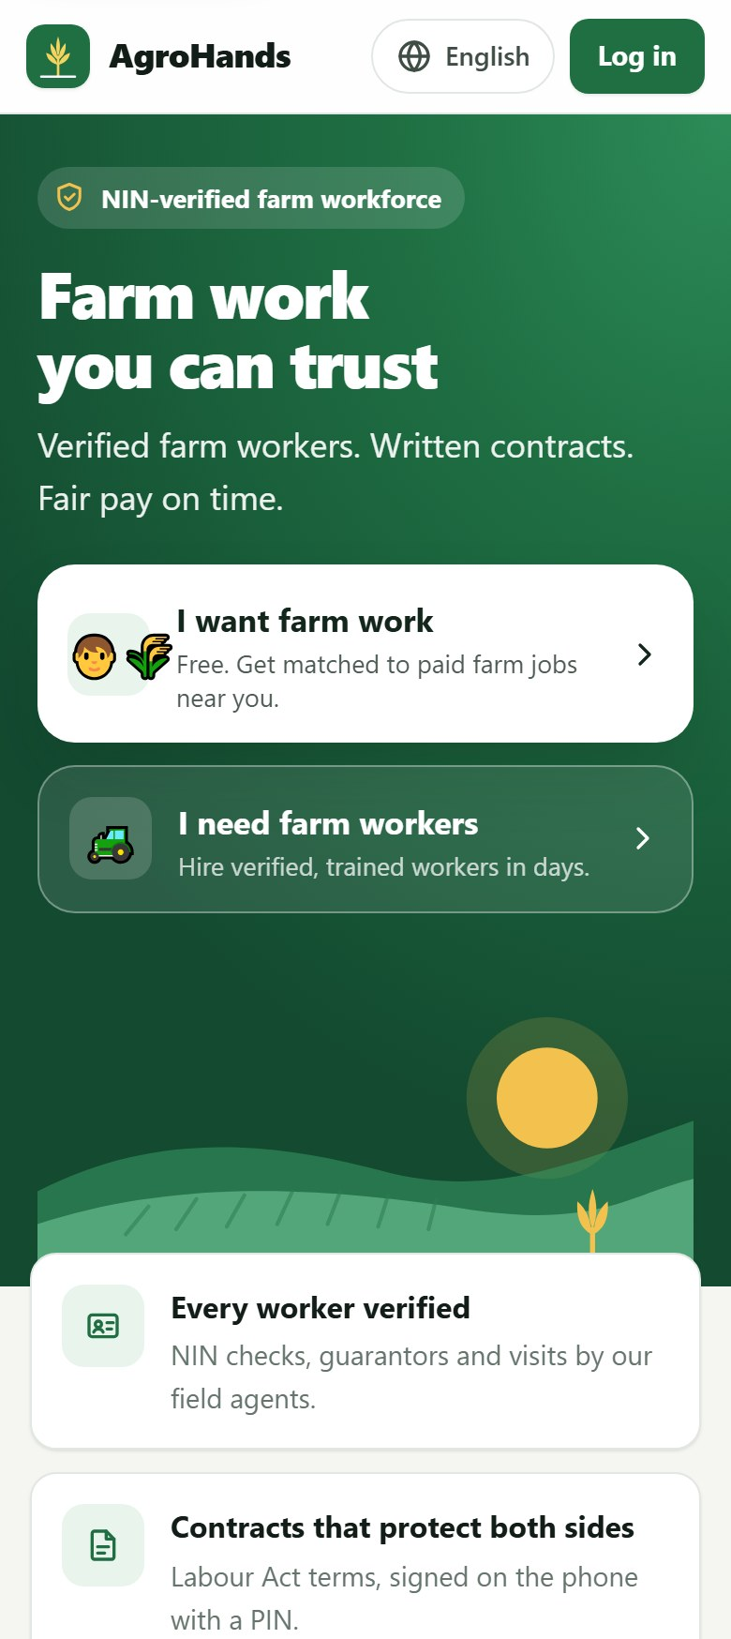  Part 1 of 2 | 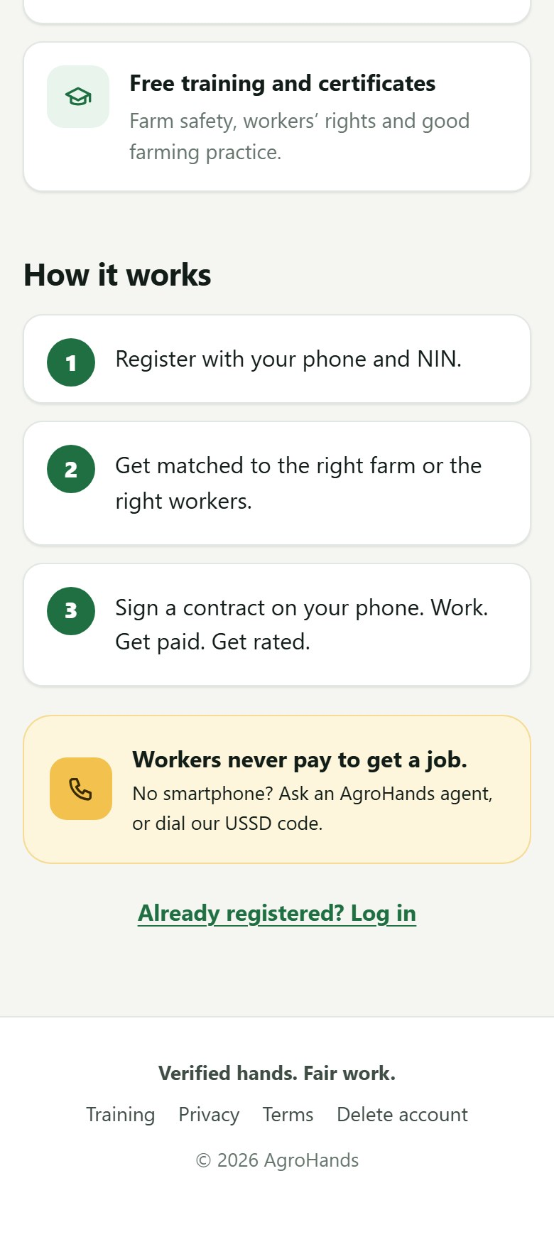  Part 2 of 2
Figure 1. The home page on a phone: choose "I want farm work" or "I need farm workers". If you already have an account, tap "Already registered? Log in" near the bottom.
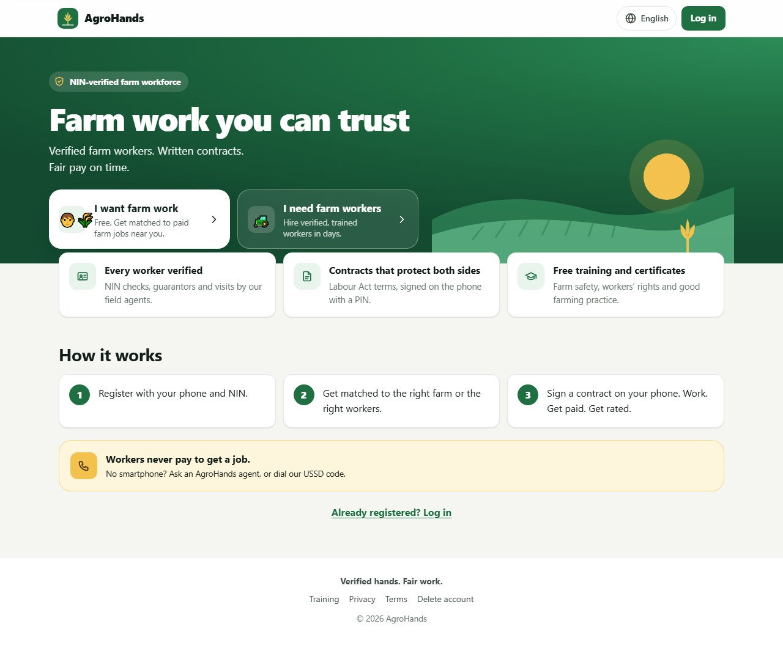
Figure 2. The same home page on a computer.

2.2 Choosing your language
- Tap the globe button at the top of the screen (it shows the current language, for example English).
- Tap your language: English, Pidgin, Yorùbá, Hausa, Igbo or Français.
- The page reloads in your language. AgroHands remembers your choice on this phone and in your account.
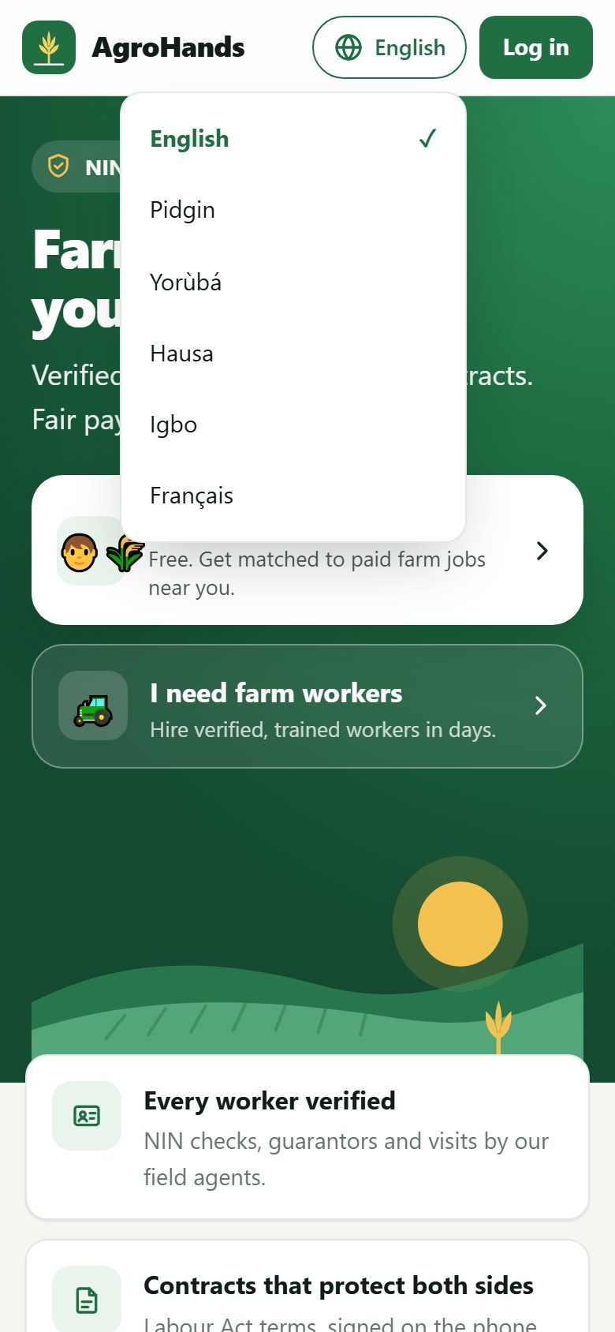
Figure 3. The language menu. A tick shows the language in use.

2.3 Creating an account
You need a phone number that receives SMS. One phone number can have only one AgroHands account.
- On the home page tap I want farm work (worker) or I need farm workers (farm owner). You can switch between Worker and Farm owner at the top of the form.
- Type your Full name exactly as it appears on your NIN slip or ID card.
- Type your Phone number, for example 0803 123 4567.
- Choose a PIN of 4 to 6 digits and type it again in Type the PIN again.
- Read the Terms and Privacy Notice (tap the links), then tick the box to agree.
- Tap Create account. AgroHands sends a 6-digit code to your phone by SMS.
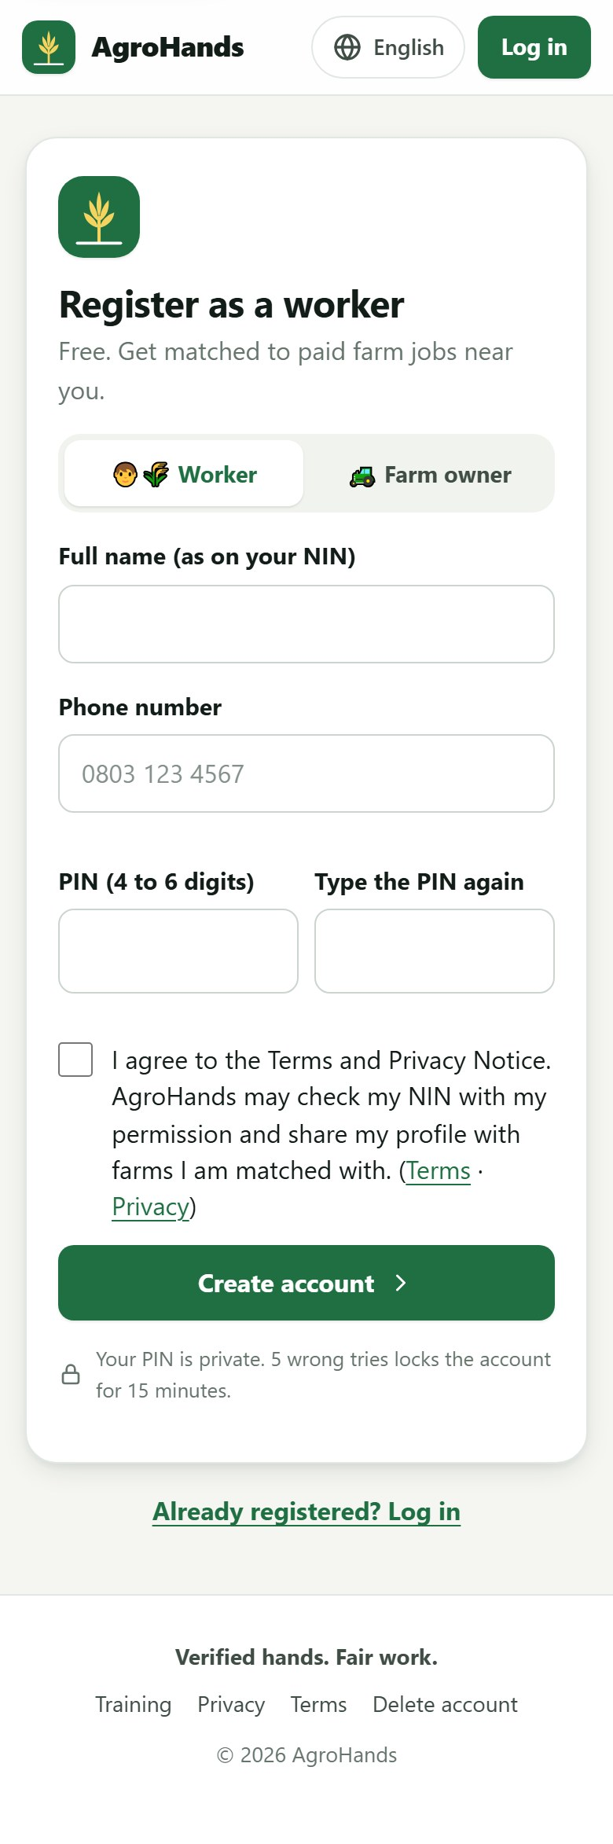
Figure 4. Registering as a worker.
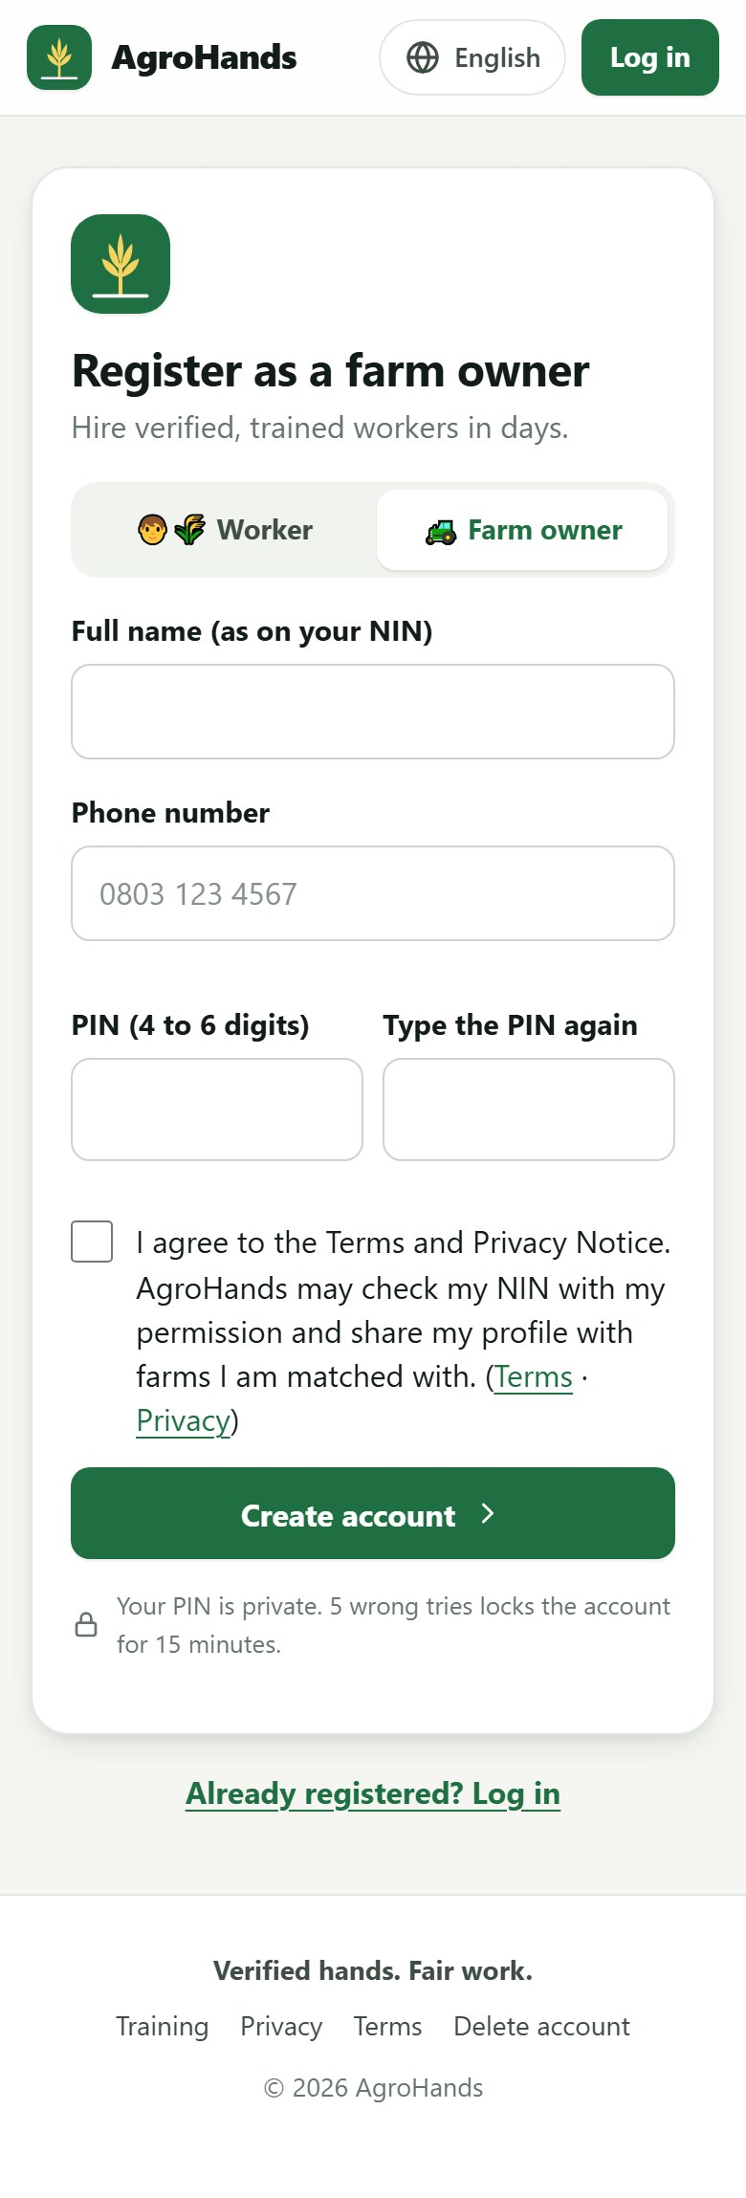
Figure 5. Registering as a farm owner. The form is the same; the switch at the top decides the account type.

2.4 Confirming your phone number
AgroHands creates your account only after you prove the phone is yours. This protects you: nobody can open an account or sign a contract with your number.
- Wait for the SMS from AgroHands. It contains a 6-digit code, for example AgroHands code: 482193.
- Type the code in Code from the SMS. On many phones the code fills in by itself.
- Tap Confirm. Your account is created and you are logged in.
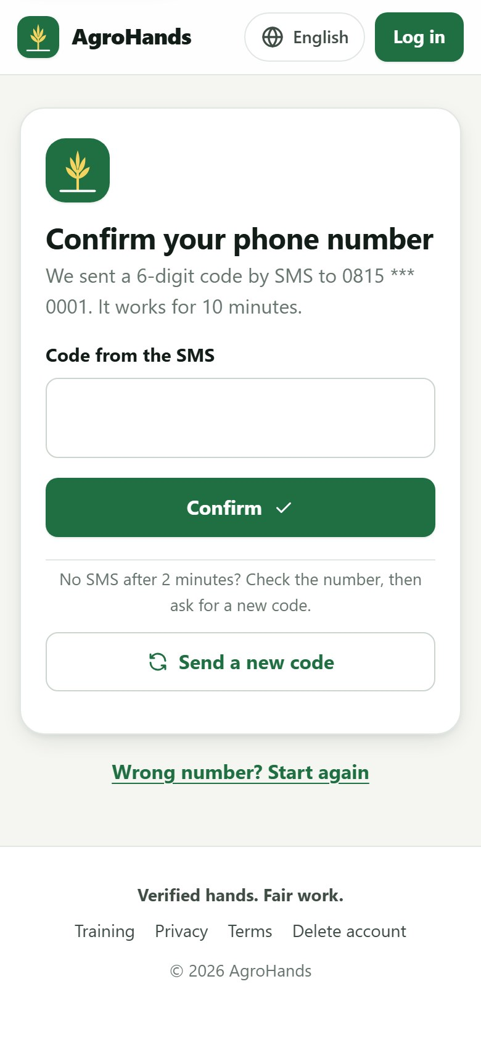
Figure 6. Enter the code from the SMS. The screen shows the last digits of the number the code was sent to.
If the SMS does not arrive
Wait two minutes. Check that the number shown on the screen is yours.
Tap Send a new code. You can ask for a new code once a minute, and up to 5 codes an hour.
Wrong number? Tap Wrong number? Start again.
A code works for 10 minutes and only once. After 5 wrong tries you must ask for a new code.

Never share your code
AgroHands staff will never ask you for the code in the SMS. Anyone who asks for it is trying to take over your account.

2.5 Logging in
- Tap Log in at the top of any page.
- Type your Phone number and your PIN.
- Tap Log in. You arrive on your own page: My page.
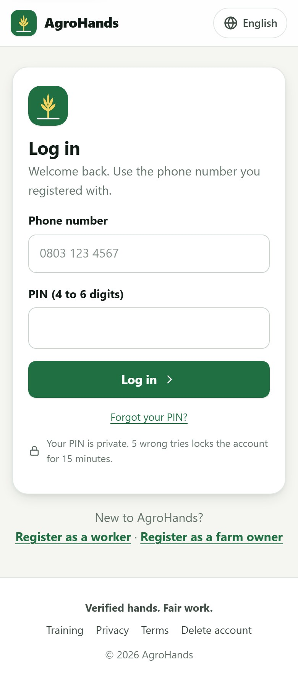
Figure 7. The login page. "Forgot your PIN?" is just below the Log in button.
You stay logged in on this phone for 30 days unless you log out. On a shared phone, always log out when you finish (section 2.7).

2.6 Forgot your PIN
- On the login page tap Forgot your PIN?
- Type your phone number and tap Send code.
- Type the 6-digit code from the SMS, then your New PIN twice.
- Tap Confirm. Your PIN is changed and you are logged in.
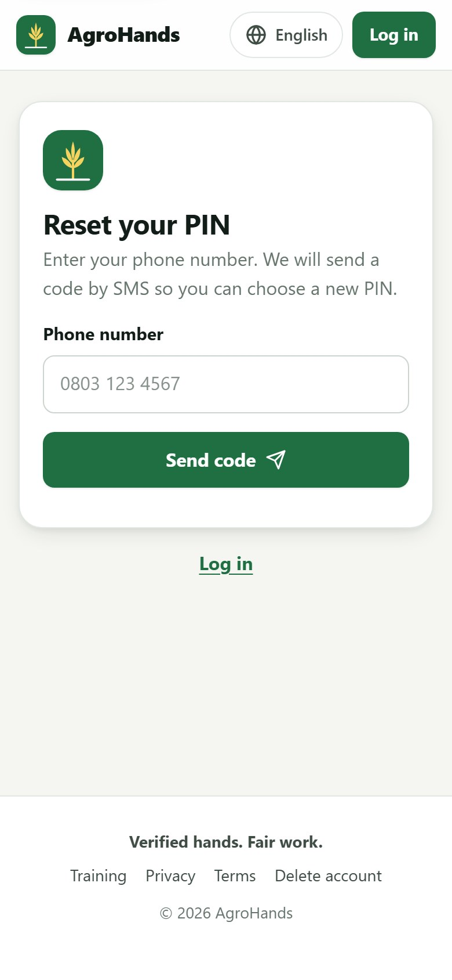
Figure 8. Step 1: enter your phone number to receive a reset code.
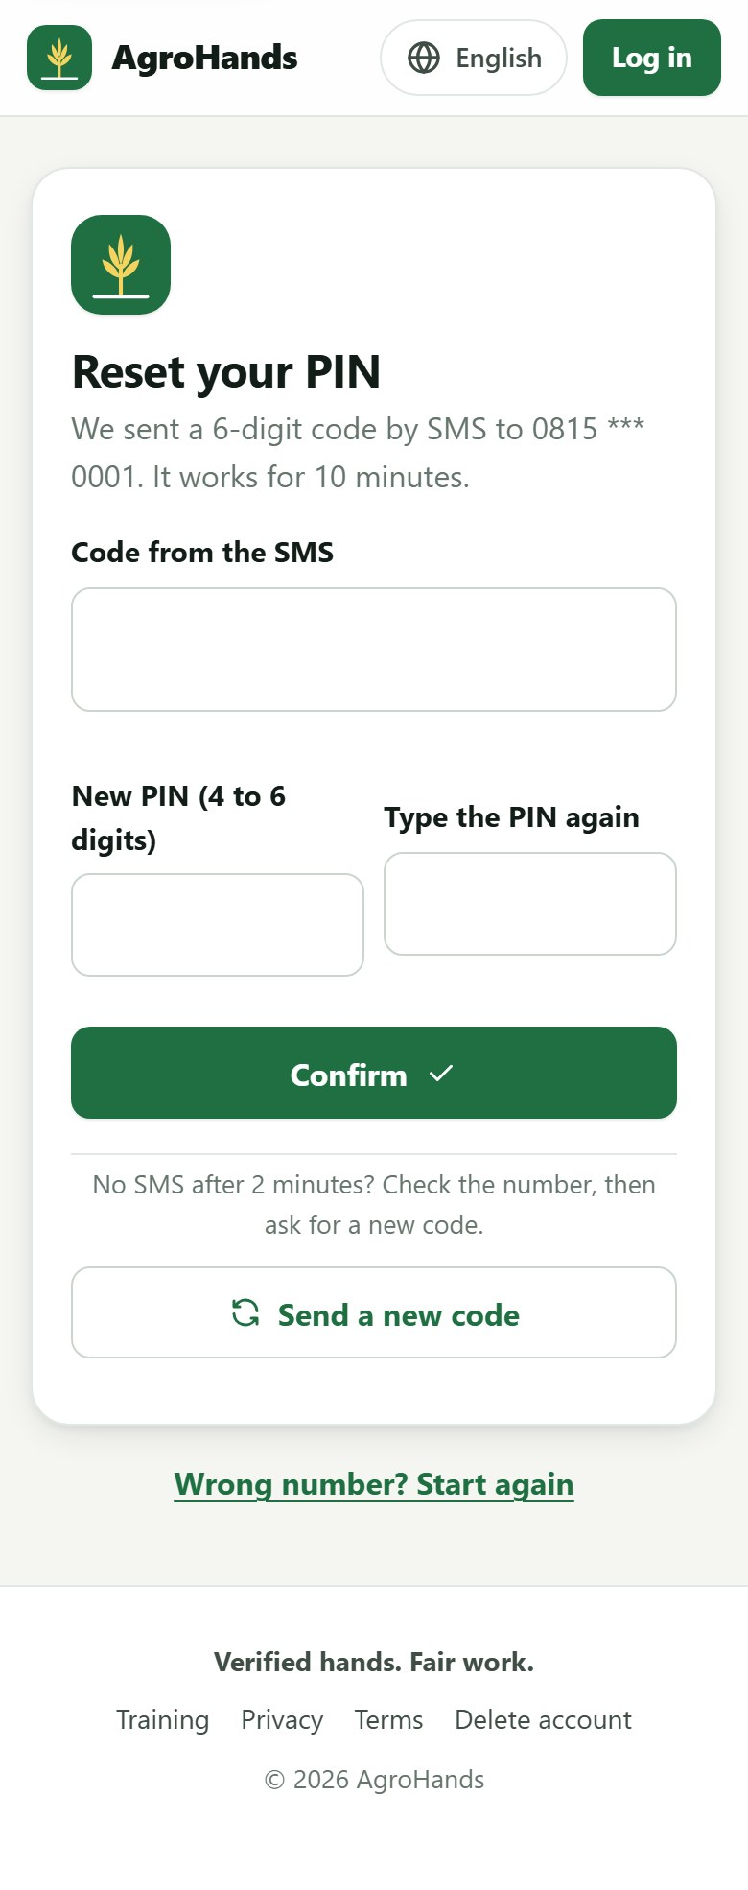
Figure 9. Step 2: enter the code and choose a new PIN.
Good to know
For your safety, a PIN reset logs your account out on every other phone or computer.
A reset also unlocks an account that was locked after 5 wrong PINs.
If the number has no account, the screen looks the same but no SMS is sent. This stops strangers from finding out who uses AgroHands.

2.7 Finding your way around
Once you are logged in, every page has the same frame:
- Bottom bar (on phones): the main sections for your role. For workers: My page, Training, Verify and Profile. For farm owners: My page, Post job, Training and My farm.
- Globe button (top): change language.
- Your initials (top right): your account menu, with My page, your profile, Change PIN, Download my data, Delete my account and Log out.
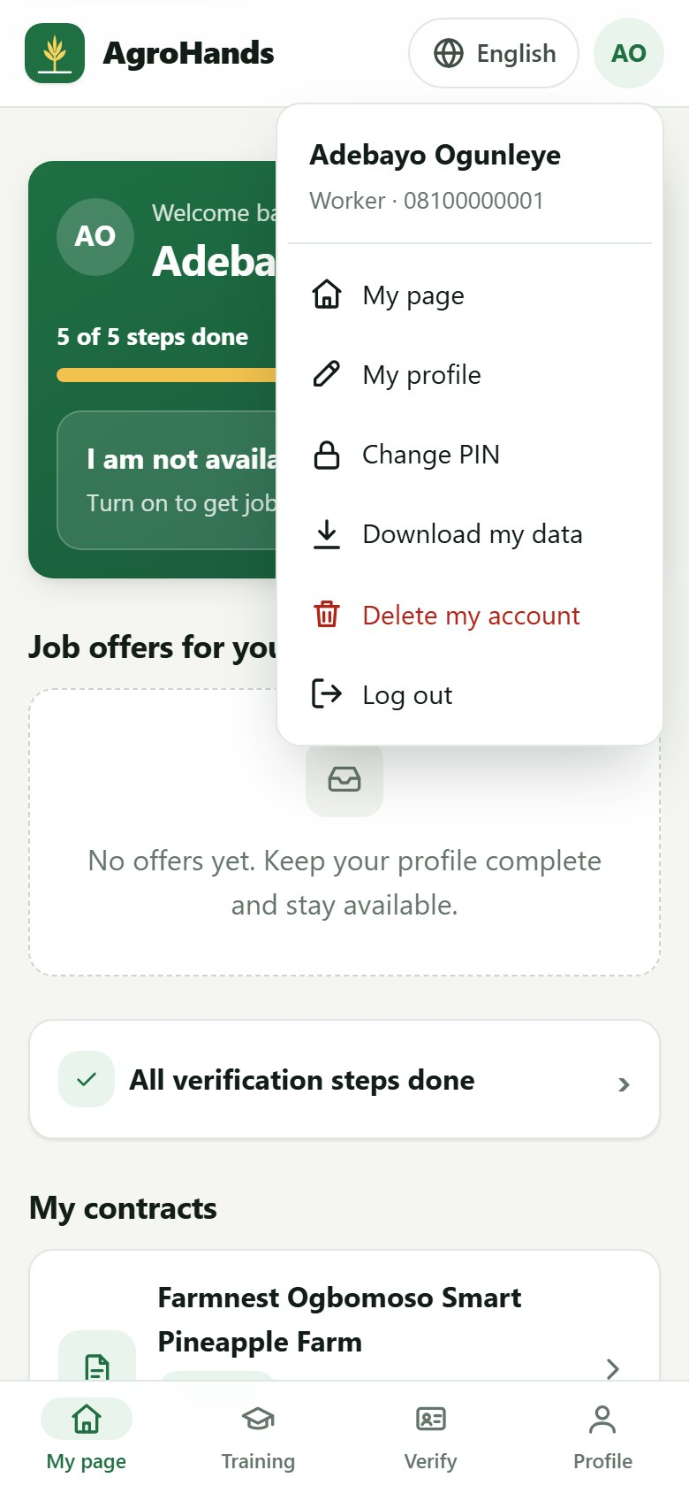
Figure 10. The account menu opens when you tap your initials at the top right.
AgroHands follows your phone's light or dark setting automatically. Dark mode saves battery on many phones.
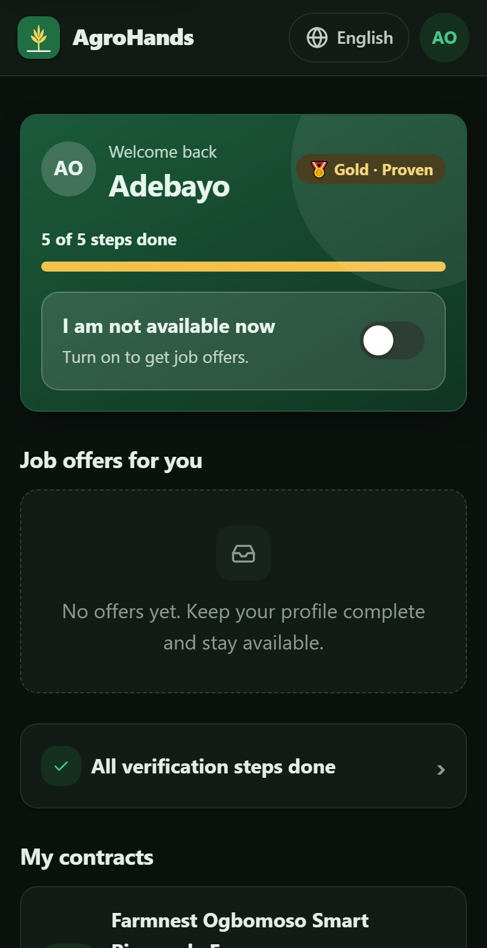  Part 1 of 2 | 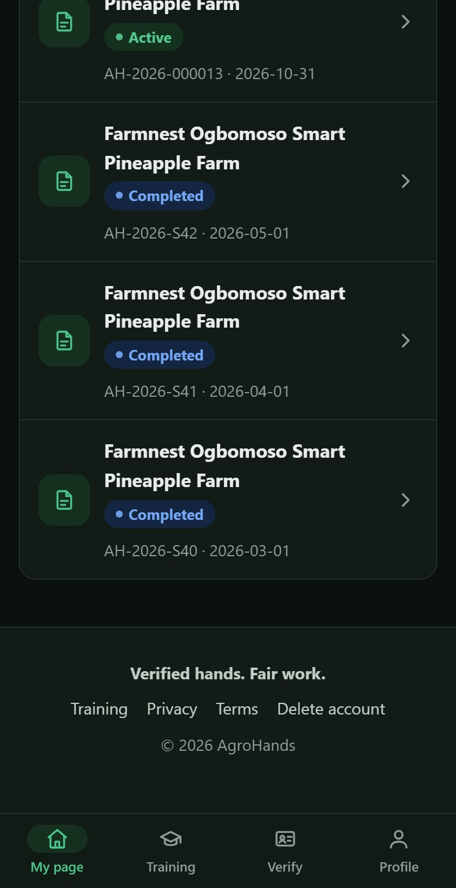  Part 2 of 2
Figure 11. A worker's page in dark mode.
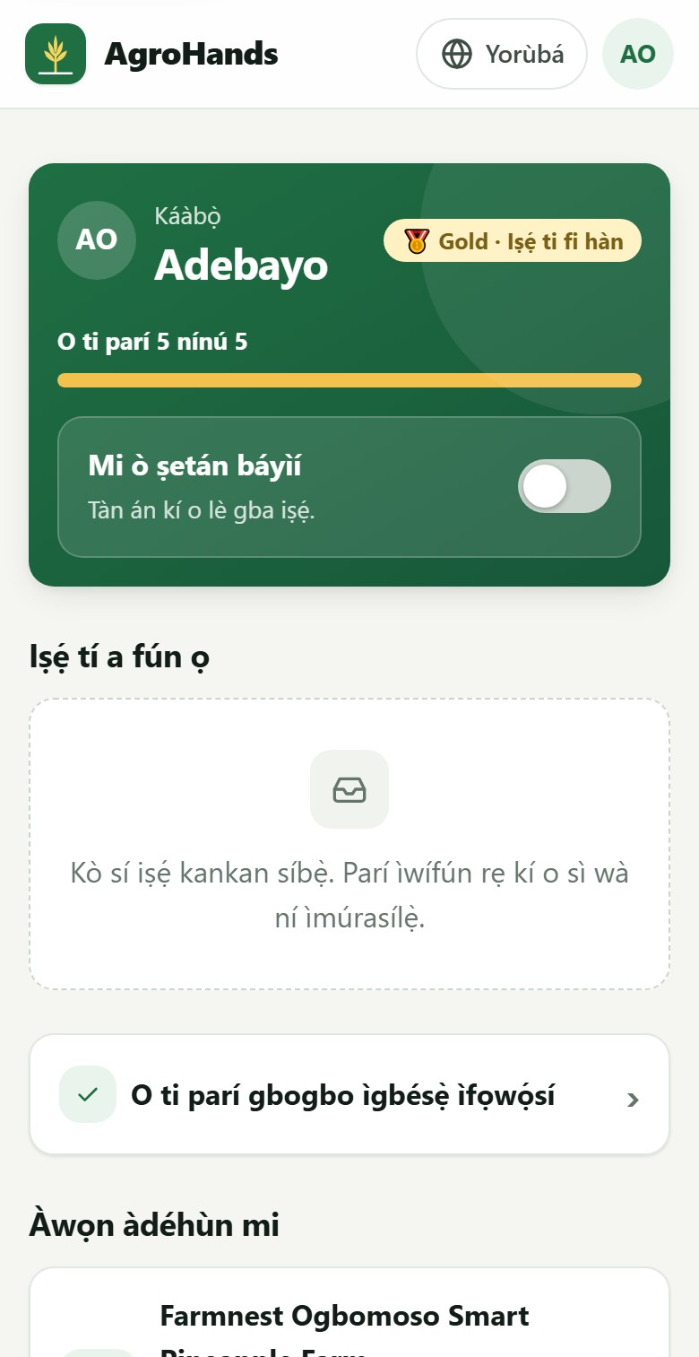  Part 1 of 2 | 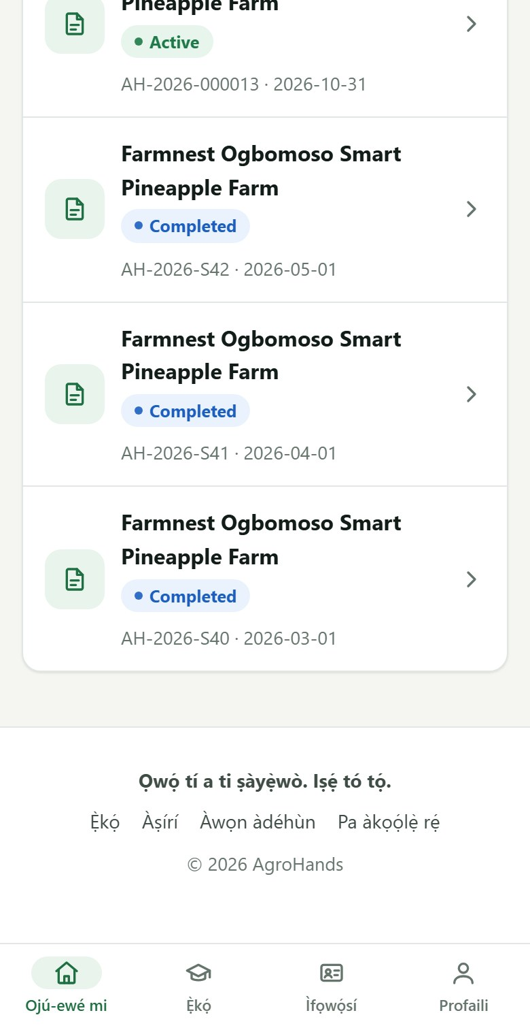  Part 2 of 2
Figure 12. The same page in Yorùbá. Every screen in this guide exists in all six languages.

2.8 Installing AgroHands on your phone

Android: from Google Play
- Open Google Play.
- Search for AgroHands and tap Install.
- Open the app and log in with your phone number and PIN.

Any smartphone: add to home screen
- Open the AgroHands website in Chrome (Android) or Safari (iPhone).
- Android: tap the menu (three dots) and choose Install app or Add to Home screen. iPhone: tap Share and then Add to Home Screen.
- An AgroHands icon appears on your home screen. Training pages you have opened before also work without internet.

3. Your worker page
After you register as a worker you arrive on My page. It shows how far you are with verification, any job offers, and your contracts.
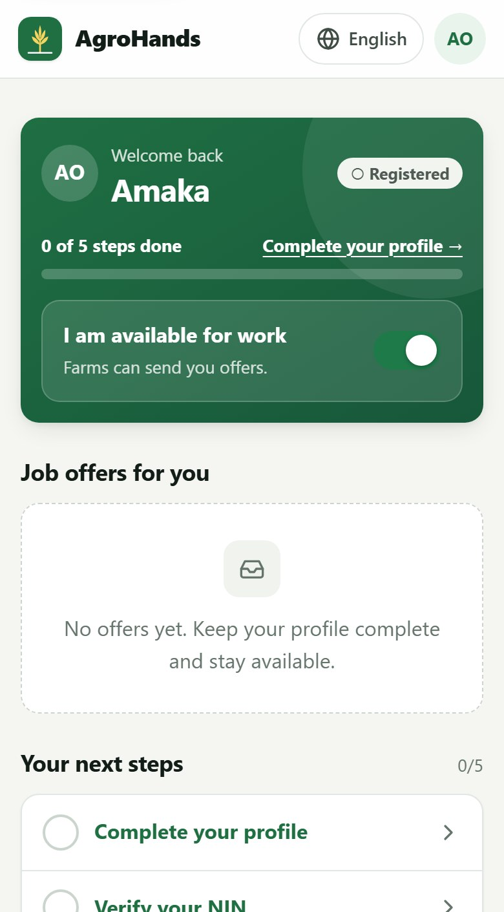  Part 1 of 2 | 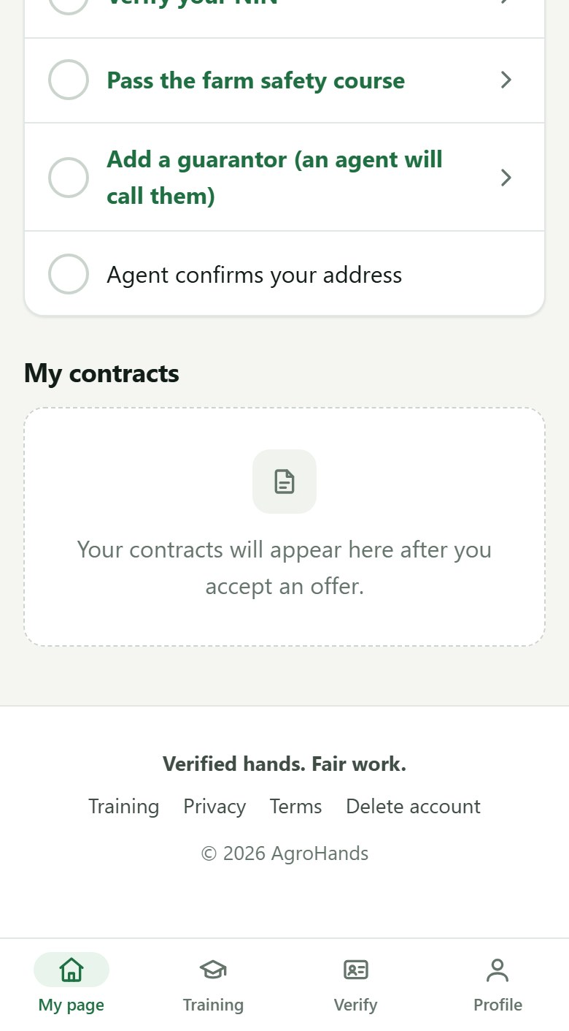  Part 2 of 2
Figure 13. A new worker's page. The green card shows progress ("0 of 5 steps done") and the availability switch; "Your next steps" lists what to do.

3.1 The five steps to get hired
Farms only hire workers they can trust. Each step you complete makes you visible to more farms and raises your level. Tap a step to do it.
Step | What you do | Where
1. Complete your profile | Tell farms about your skills, location and wage | Section 3.2
2. Verify your NIN | Prove your identity with your National Identification Number | Section 3.3
3. Pass the farm safety course | A short free course and quiz | Chapter 4
4. Add a guarantor | Someone who knows you and will vouch for you | Section 3.4
5. Agent confirms your address | A field agent checks where you live | Done by an agent

3.2 Completing your profile
- Tap Complete your profile (or Profile in the bottom bar).
- Fill in each field (see the table below).
- Tap Save at the bottom.
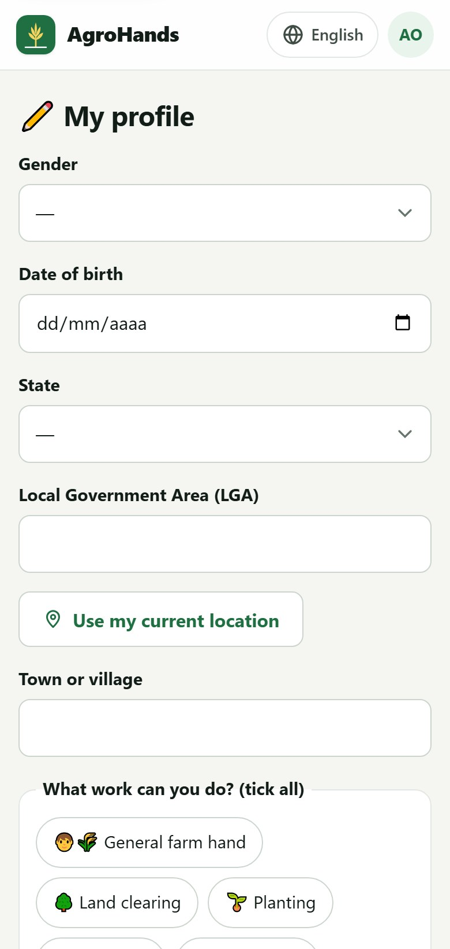  Part 1 of 3 | 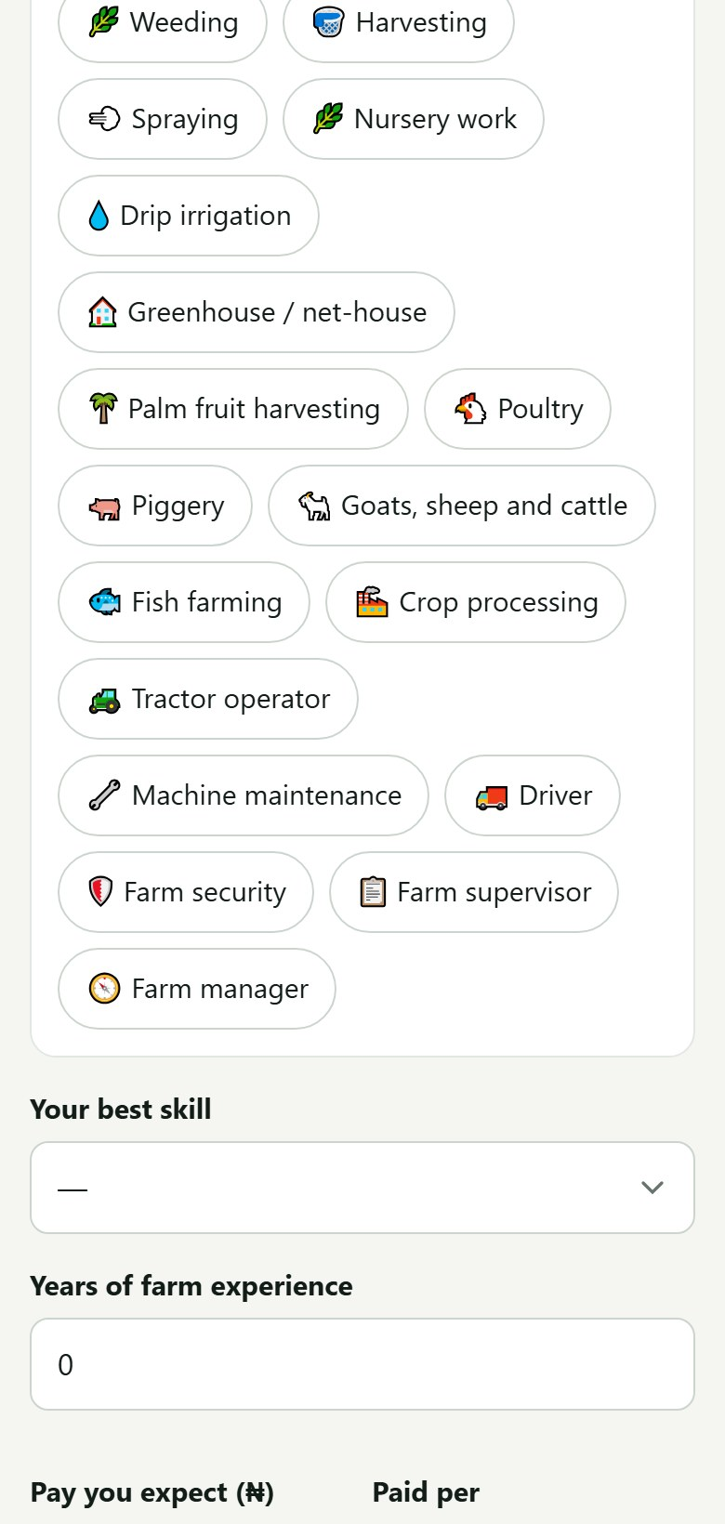  Part 2 of 3 | 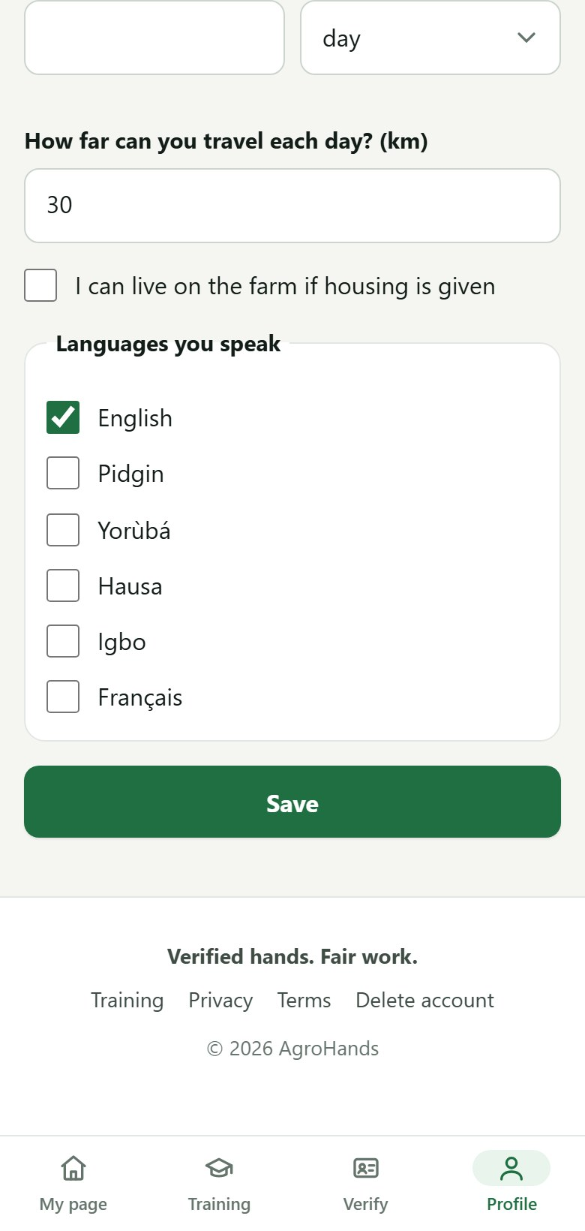  Part 3 of 3
Figure 14. The worker profile form (shown in three parts).
Field | What to enter
Gender, Date of birth | You must be 18 or older to be offered farm work.
State, Local Government Area (LGA), Town or village | Where you live. Farms see your distance from them, not your address.
Use my current location | Optional. Tap it while at home so distance is measured exactly. AgroHands reads your location once, only when you tap.
What work can you do? (tick all) | Every type of farm work you can do, for example Harvesting, Weeding, Spraying, Poultry.
Your best skill | The one you are best at. It counts most in matching.
Years of farm experience | Your total years doing farm work.
Pay you expect (₦) and Paid per | The wage you want, per day or per month. Ask fairly: offers well below your figure are not sent to you, and very high asks match fewer jobs.
How far can you travel each day? (km) | Jobs further away are not offered, unless the farm gives housing and you tick the next box.
I can live on the farm if housing is given | Tick to also receive offers from farms further away that provide housing.

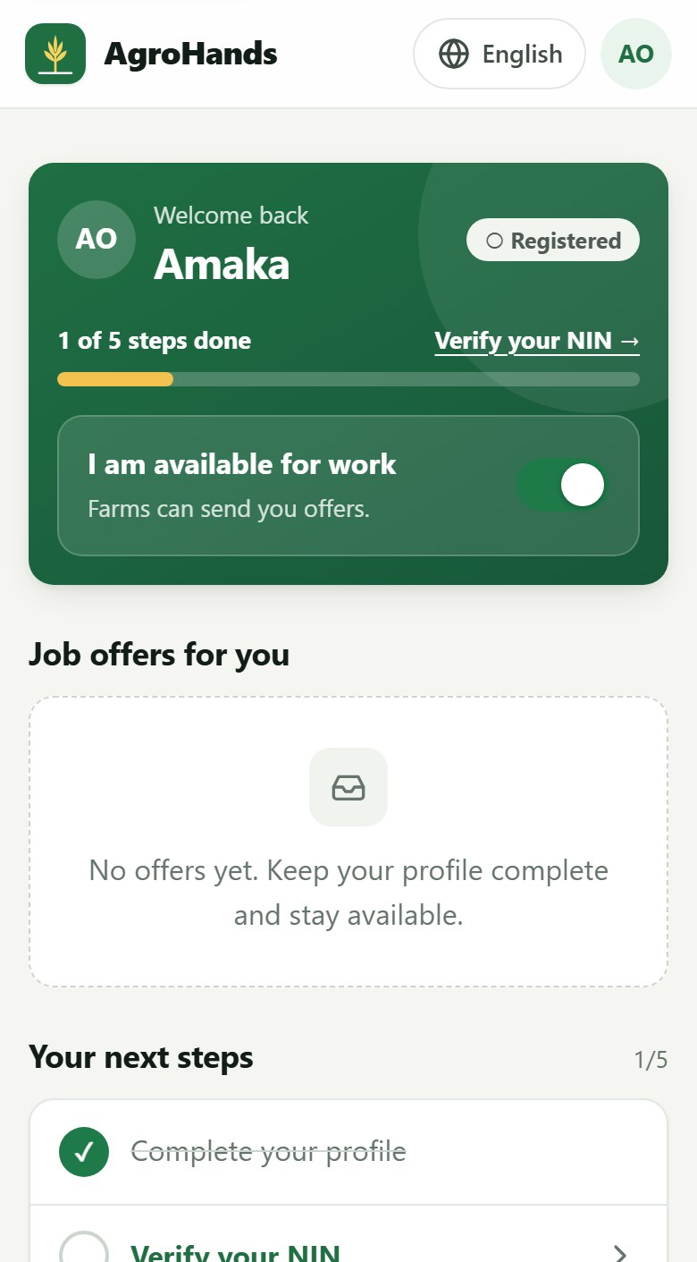  Part 1 of 2 | Part 2 of 2
Figure 15. After saving the profile: "1 of 5 steps done", and the next step is "Verify your NIN".

3.3 Verifying your NIN
Your National Identification Number (NIN) proves you are who you say you are. AgroHands checks it with your permission and does not keep your full NIN: it stores only a protected code and the last 4 digits.
- Tap Verify your NIN (or Verify in the bottom bar).
- Type your 11-digit NIN.
- Tick I give AgroHands permission to verify my NIN now.
- Tap Verify now.
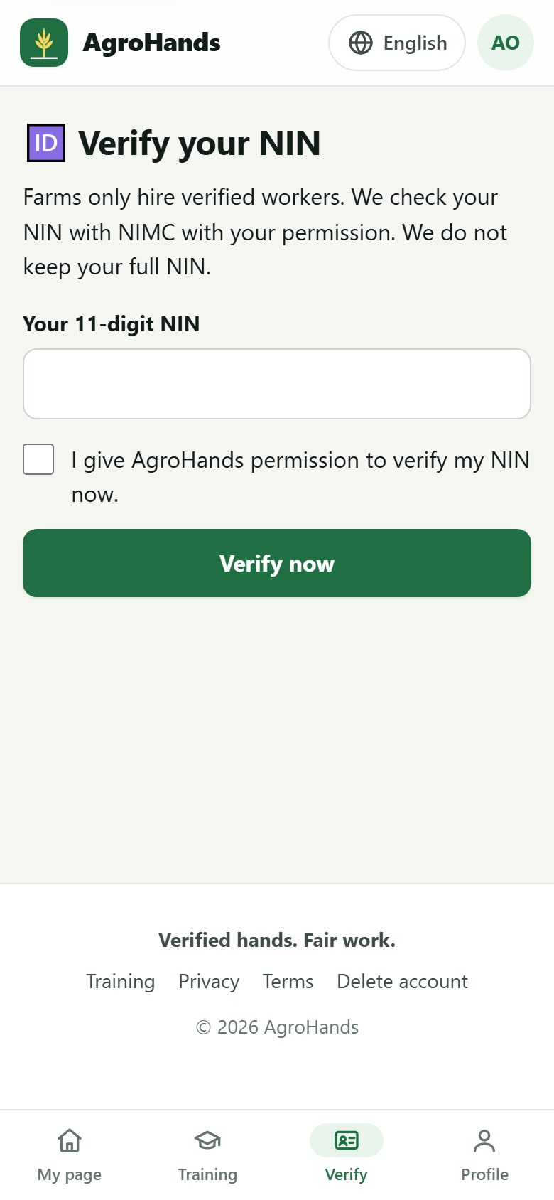
Figure 16. Entering your NIN.
Depending on how AgroHands is set up in your area, one of two things happens:
- Instant check: the NIN is checked straight away and the step turns green.
- Agent check: you see Received. An AgroHands agent will confirm your NIN slip with you. Show your NIN slip or ID card to an AgroHands field agent, who confirms it.
Common problems
A NIN has exactly 11 digits means a digit is missing or extra.
This NIN is already linked to another account means the NIN was used before. Each person can have only one account. See an agent.
The name on this NIN does not match your account name means your name was typed differently. See an agent to correct it.

3.4 Adding a guarantor
A guarantor is a respected person who knows you well, for example a pastor, imam, community leader, relative or former employer, and who will vouch for you. A field agent calls them to confirm.
- Tap Add a guarantor.
- Enter their full name, phone number and how they know you.
- Tap Save. Tell your guarantor to expect a call from AgroHands.
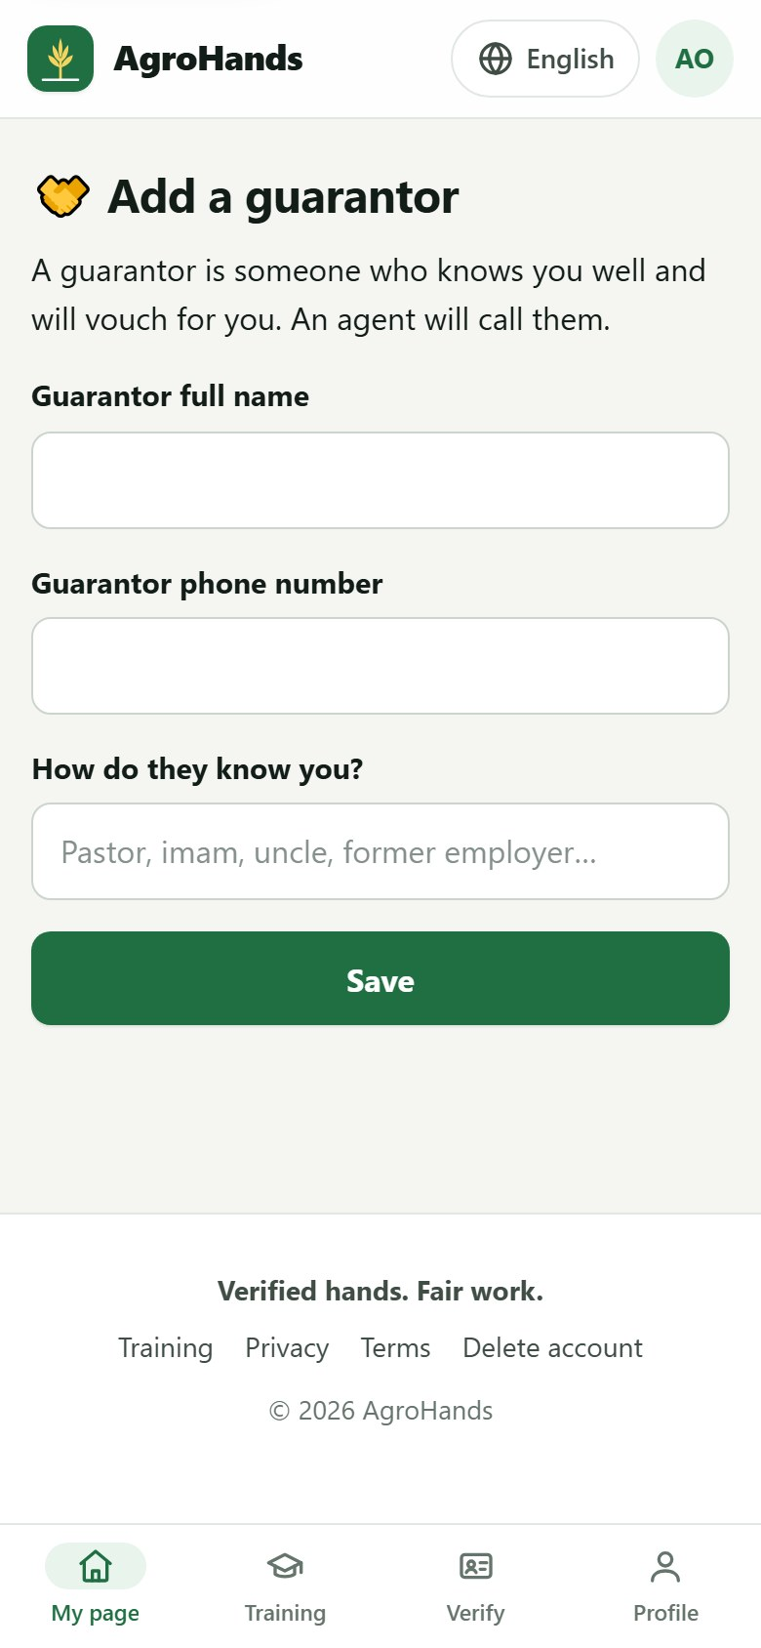
Figure 17. Adding a guarantor.

3.5 Your level (tier)
Your level is shown as a badge on your page and to farms. Higher levels are shown first and qualify for better-paid jobs. AgroHands updates your level automatically.
Level | Badge | What you need
Registered | Registered | An account and a profile.
Bronze | Bronze · ID verified | NIN verified and the farm safety course passed.
Silver | Silver · Vouched | Bronze, plus guarantor confirmed and address confirmed by an agent.
Gold | Gold · Proven | Silver, plus a practical skill test passed with an agent, and at least 3 completed jobs with an average farm rating of 4.5 stars or more.

3.6 Available for work
The switch I am available for work in the green card controls whether farms can send you offers. Turn it off when you are busy or travelling. When you start a job, AgroHands turns it off for you, and turns it back on when the contract ends.

4. The Training Academy
The AgroHands Training Academy has short courses in plain language. Each course has a few lessons and a quiz. Pass the quiz (75% or more) to earn a certificate that farms can check. Training is open to everyone: you can read lessons without an account, but you need to log in to take a quiz.
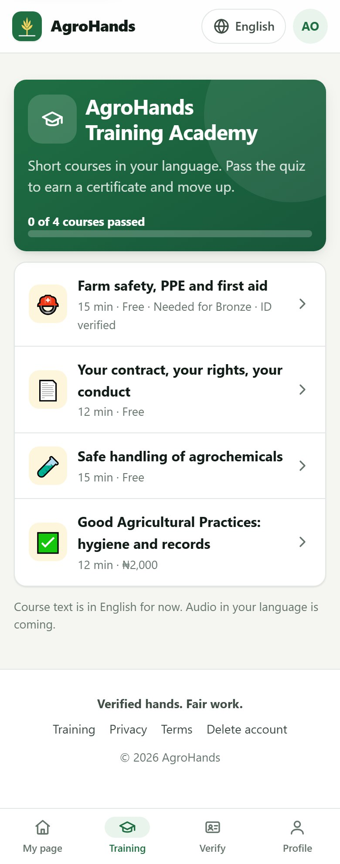
Figure 18. The Training Academy. Each course shows its length, price ("Free" for most) and whether it is needed for a level.
Course | For | Time | Price | Why take it
Farm safety, PPE and first aid | Workers | 15 min | Free | Required for Bronze. Dangers on a farm, protective equipment, heat, first aid.
Your contract, your rights, your conduct | Workers | 12 min | Free | Understand your contract and wages, and how to raise a problem.
Safe handling of agrochemicals | Workers | 15 min | Free | Reading labels, mixing and spraying safely, what to do after spraying.
Good Agricultural Practices: hygiene and records | Workers | 12 min | ₦2,000 | Hygiene at harvest and record keeping that buyers and exporters ask for.
Fair employment: contracts, wages and keeping good workers | Farm owners | 15 min | Free | The Labour Act basics, lawful wages and deductions, safety duties, keeping workers.

4.1 Reading a course
- Tap Training in the bottom bar, then tap a course.
- Read each lesson. Take your time; there is no limit.
- At the bottom tap Take the quiz.
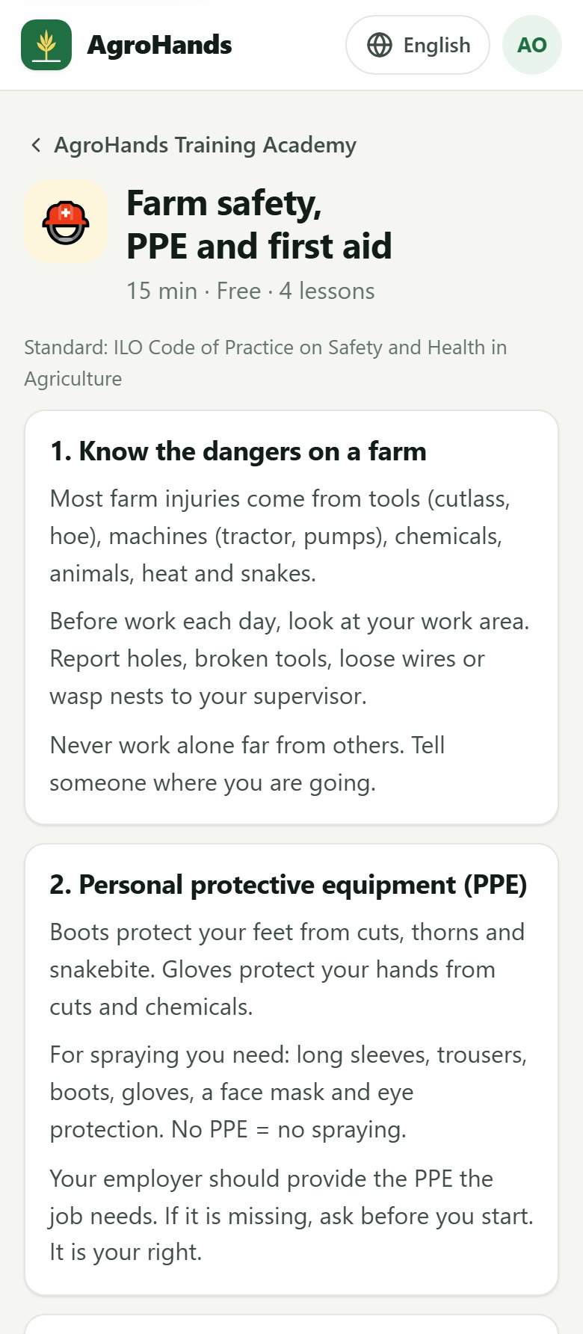  Part 1 of 2 | 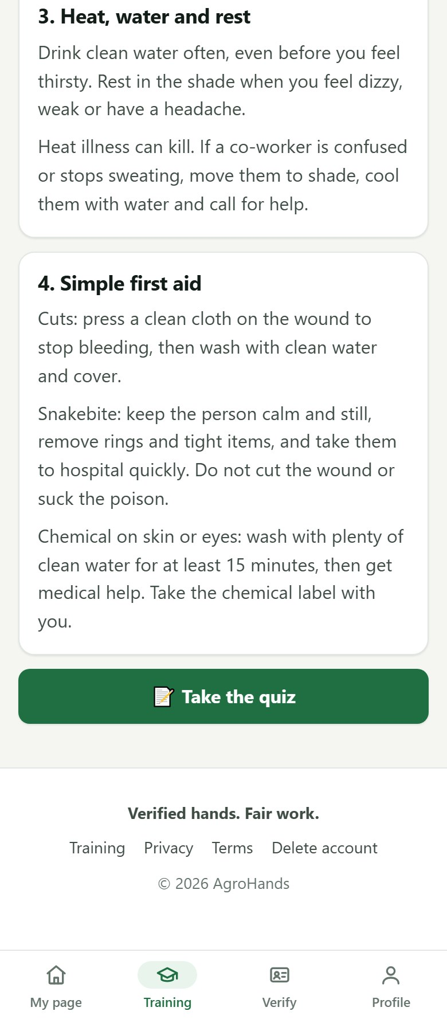  Part 2 of 2
Figure 19. A course page with its lessons (shown in two parts). The quiz button is at the bottom.

4.2 Taking the quiz
- Choose one answer for each question.
- Tap Submit answers.
- If you score 75% or more you pass and get a certificate. If not, read the lessons again and retry. You can retry as many times as you like, and your best score counts.
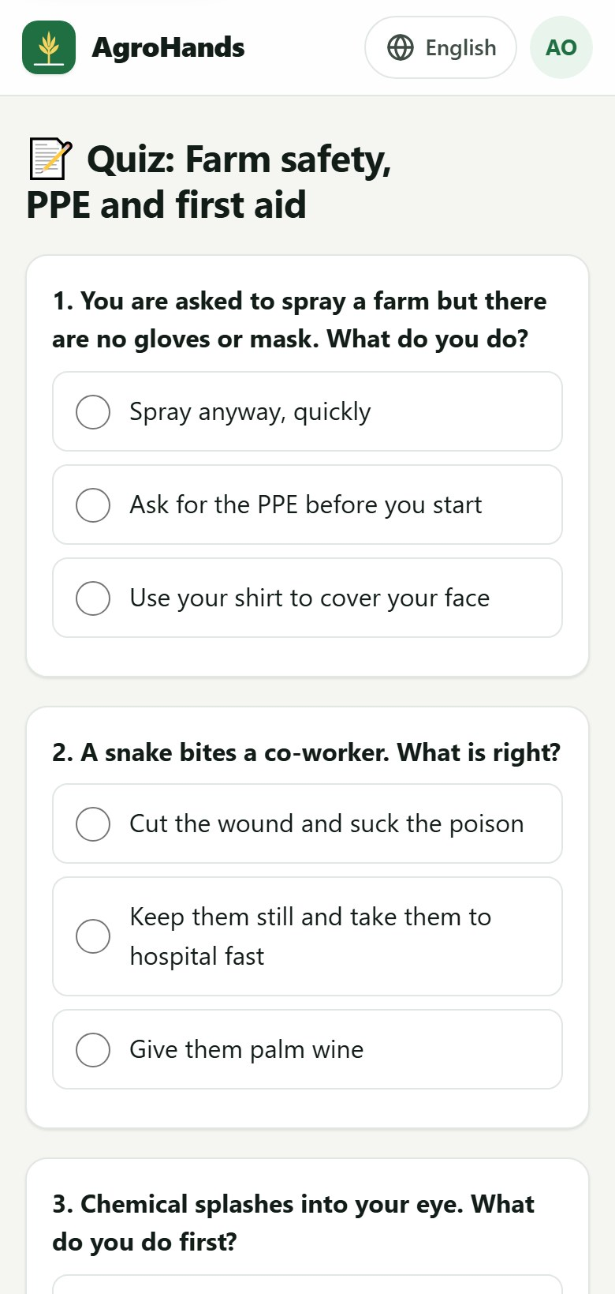  Part 1 of 2 | 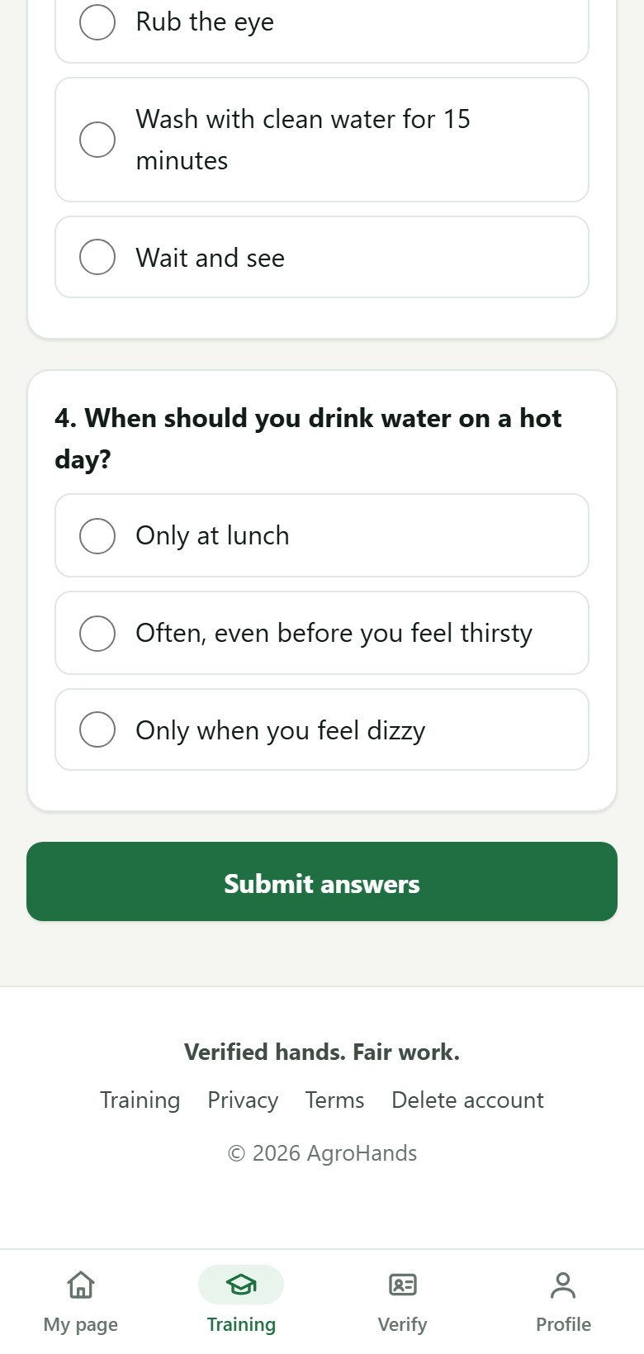  Part 2 of 2
Figure 20. A quiz (shown in two parts). Choose one answer per question.
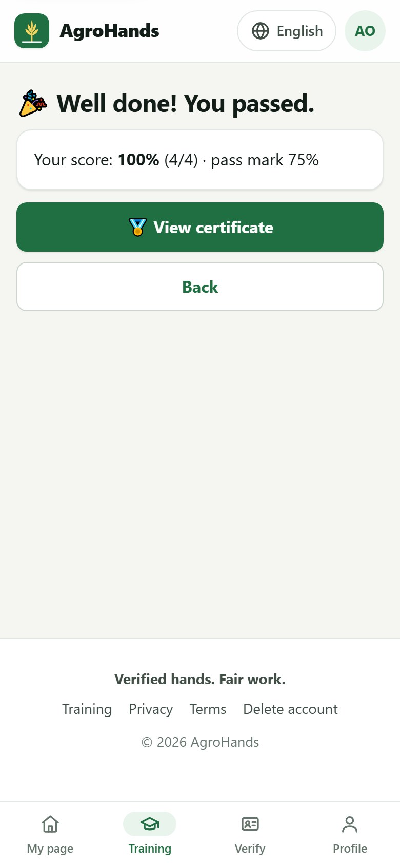
Figure 21. Passed: your score, and a button to view your certificate.

4.3 Your certificate
Every certificate has a code (for example AHC-1A2B3C4D). Anyone, for example a farm owner, can check that a certificate is real by opening its page; no login is needed. Tap Print to print it or save it as a PDF.
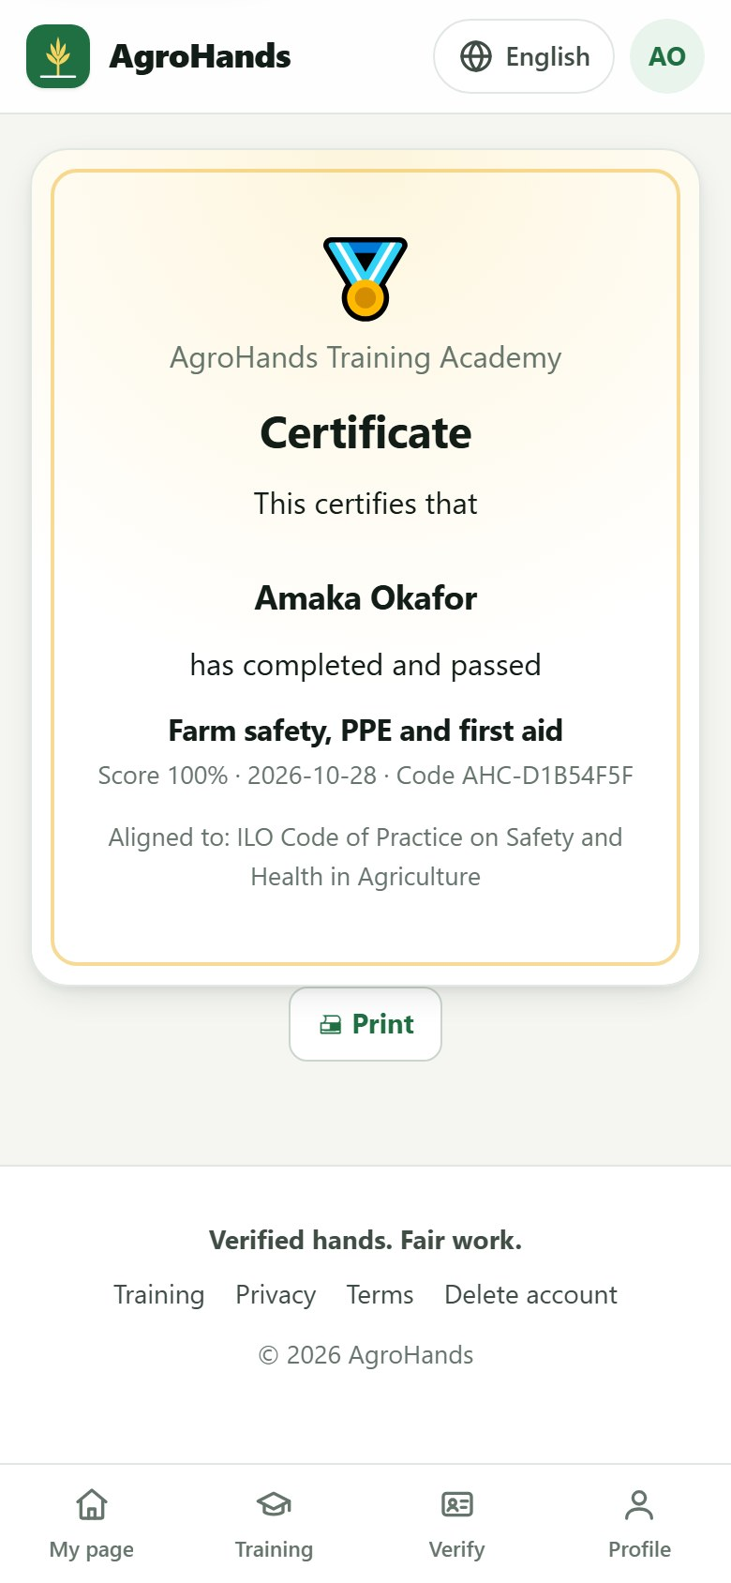
Figure 22. A certificate. The code at the bottom can be checked by anyone.

4.4 Paid courses
Some advanced courses cost a small fee, shown on the course and on the button, for example Pay ₦2,000 to take the quiz.
- Open the course on the AgroHands website and tap the pay button.
- You are taken to Paystack's secure payment page. Pay by card, bank transfer or USSD.
- After payment you return to AgroHands and the quiz opens. AgroHands never sees your card details.
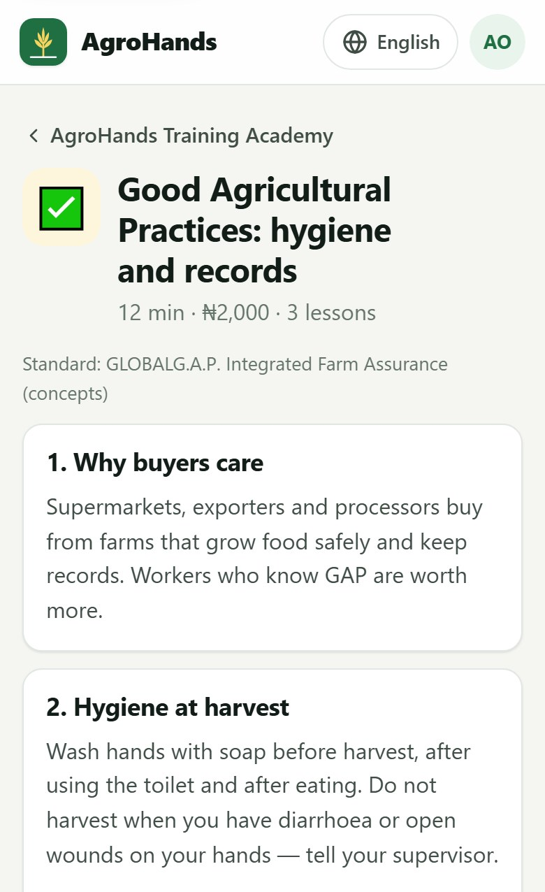  Part 1 of 2 | 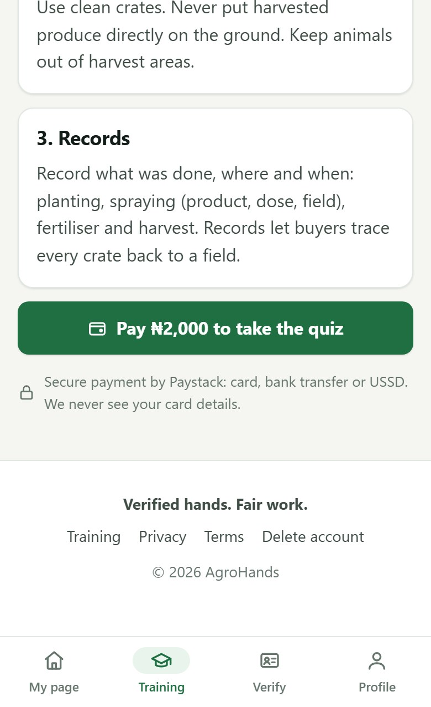  Part 2 of 2
Figure 23. A paid course on the website. The secure-payment note under the button explains how you pay.
Good to know
If a payment does not go through, you are not charged and you can try again.
Paid courses cannot be bought inside the Android app; use the website.
While paid courses have not been switched on in your area (pilot period), they are free and the course page says so.

5. Job offers and contracts (workers)

5.1 Receiving a job offer
When a farm owner chooses you, you receive an SMS and the offer appears under Job offers for you on your page. The offer shows the farm, the work, the pay, the dates, whether housing and meals are provided, and whether the farm has been verified by AgroHands.
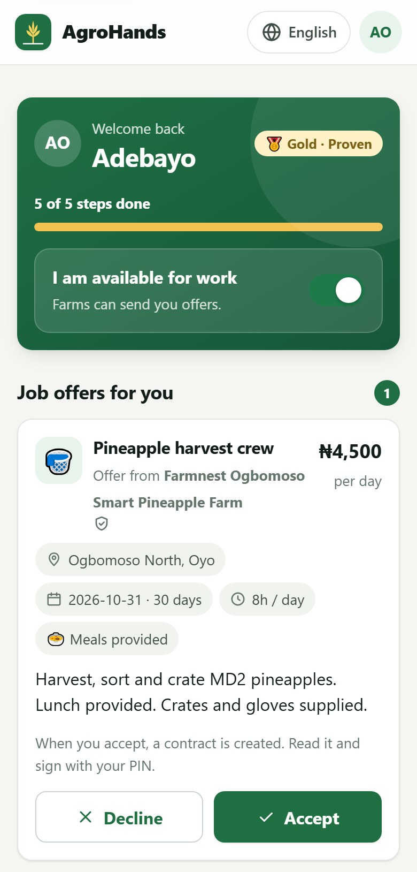  Part 1 of 2 | 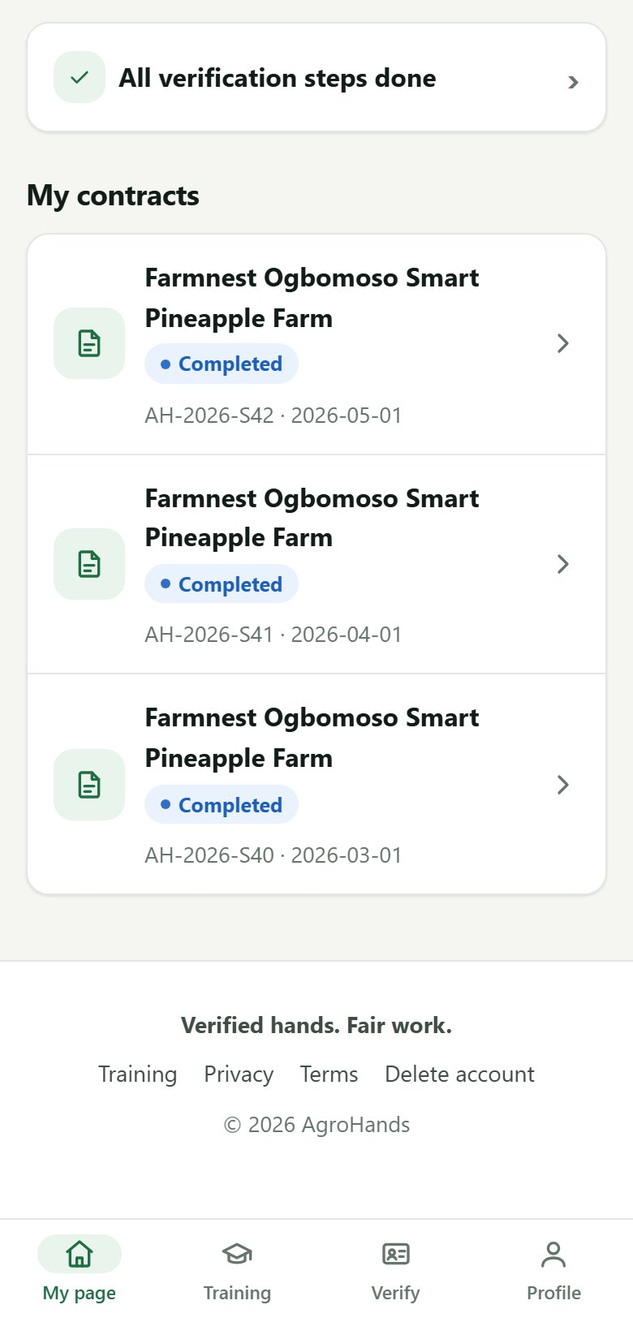  Part 2 of 2
Figure 24. A job offer on the worker's page (shown in two parts): pay per day, location, dates and hours, meals or housing, and Accept or Decline.
- Read the offer carefully: the pay, dates, hours, place and what is provided.
- Tap Accept to take the job, or Decline if it does not suit you. Declining does not count against you.
- When you accept, a written contract is created straight away.
Before you accept
You can only have one job at a time. Check that you can be there on the start date, and that the farm is not too far for you to travel every day.

5.2 Reading and signing your contract
Your contract lists every point the Nigerian Labour Act requires: the parties, the work, the wage and when it is paid, working hours, sick leave, holidays and notice. A short Summary in your language comes first; the full contract follows.
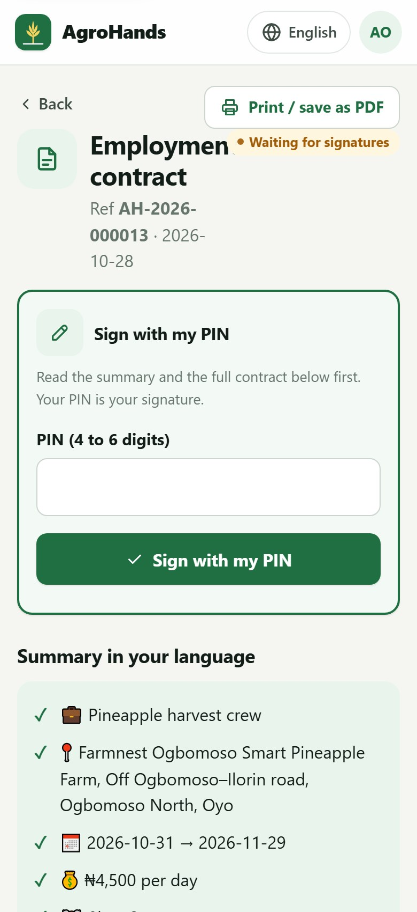  Part 1 of 4 | 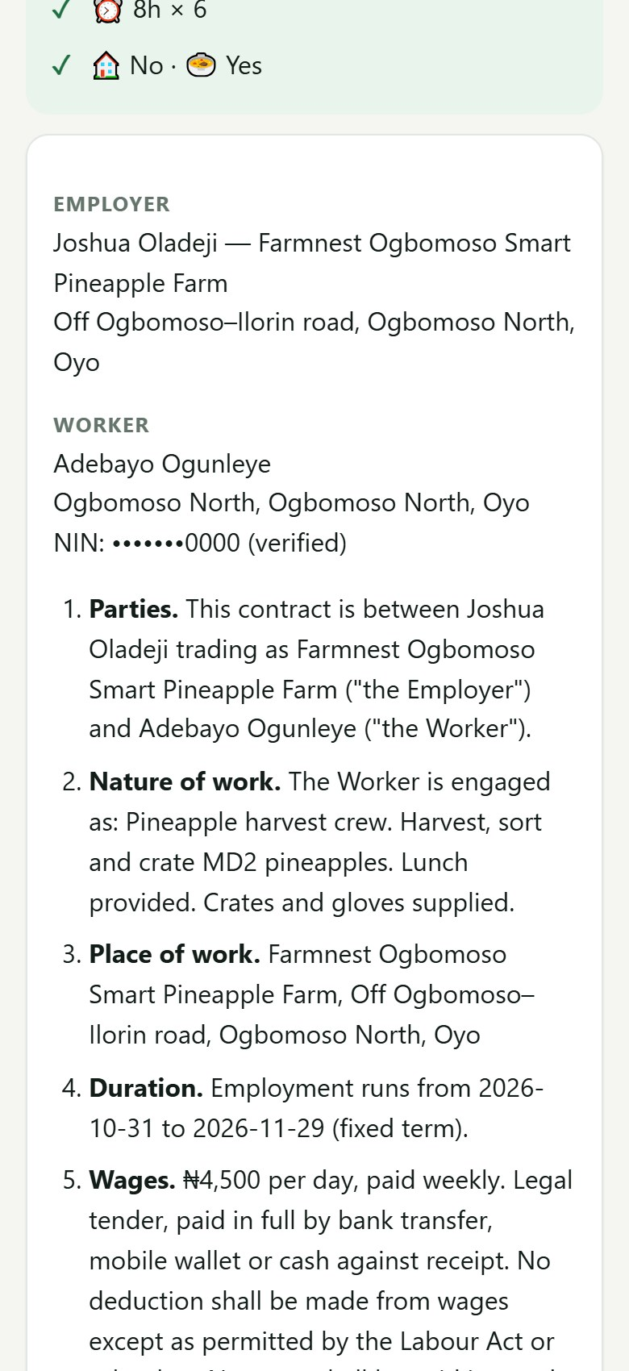  Part 2 of 4 | 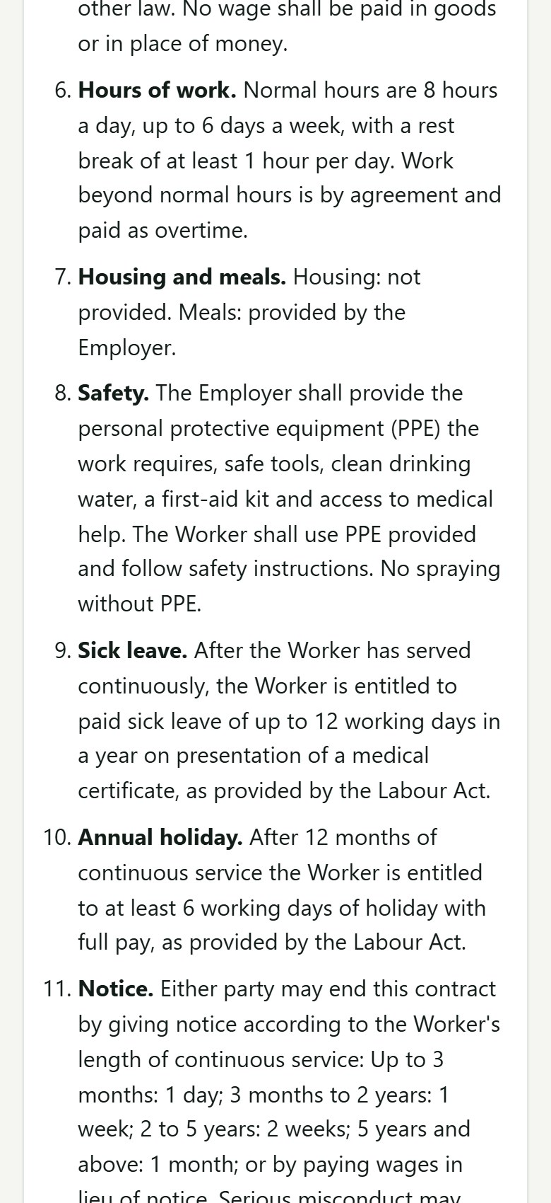  Part 3 of 4
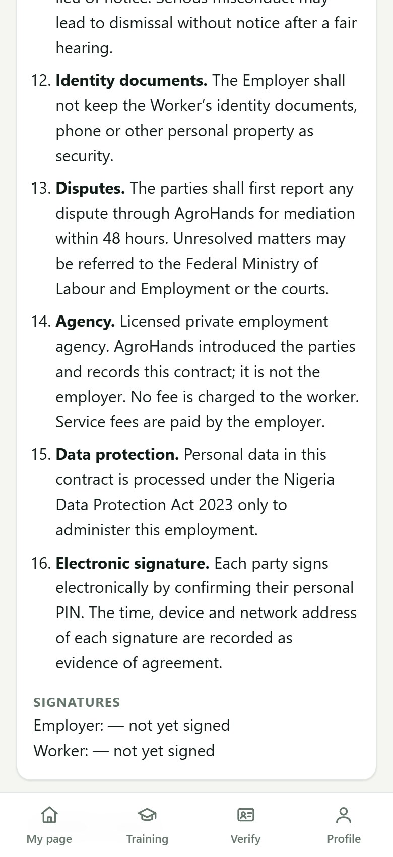
Part 4 of 4
Figure 25. A contract waiting for the worker's signature (shown in four parts). The signing box is at the top, the summary in your language next, then the full contract.
- Read the Summary in your language, then the full contract. If anything is unclear, ask an AgroHands agent before you sign.
- Type your PIN in the signing box and tap Sign with my PIN. Your PIN is your signature.
- AgroHands records the date, time and phone used, as proof of signature.
- The farm owner then signs. You get an SMS when the contract is Active.
Never sign what you do not understand
Nobody may make you pay to get a job, take your ID card, or keep your phone to stop you leaving. If this happens, report it (section 5.5).

5.3 When the contract is active
Once both sides have signed, the contract is Active. Only now can you and the farm owner see each other's phone number. Tap the button showing the other person's number to call them, or Chat on WhatsApp to message them. Use Print / save as PDF at the top to keep a copy.
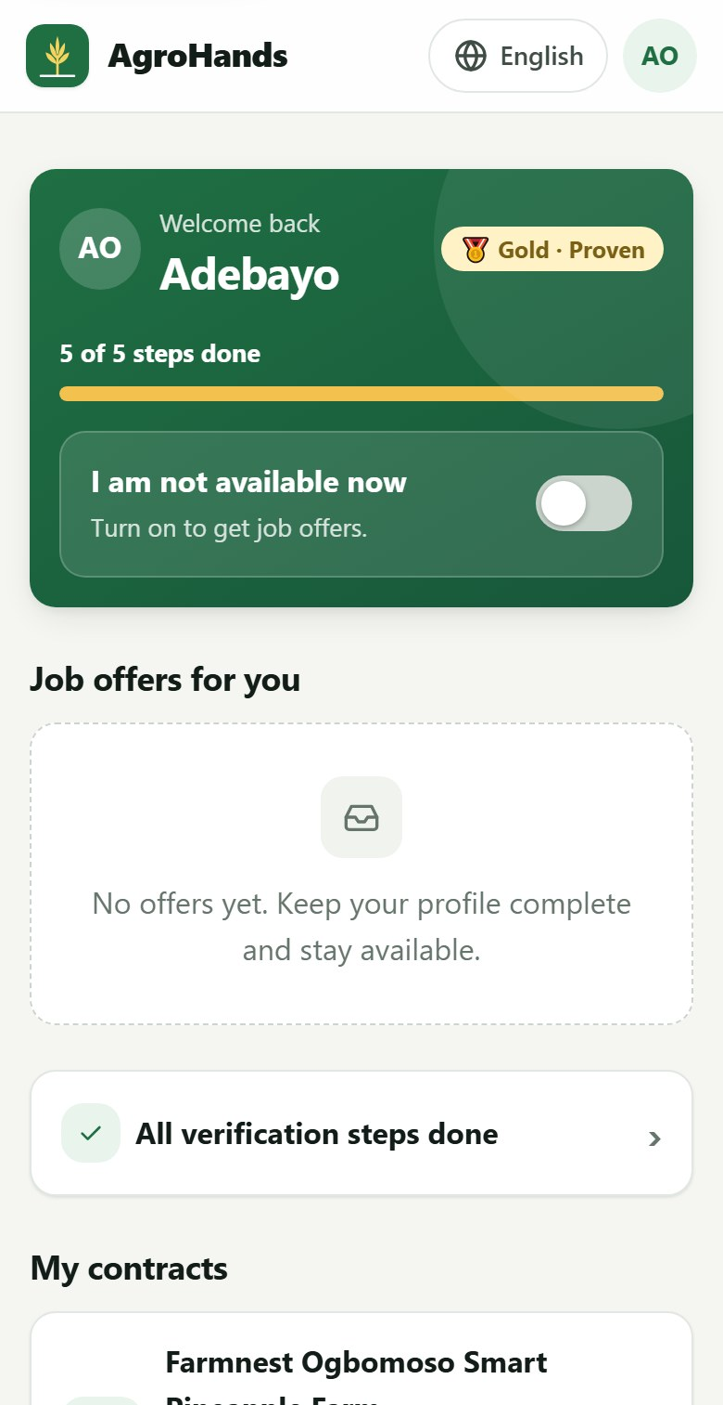  Part 1 of 2 | 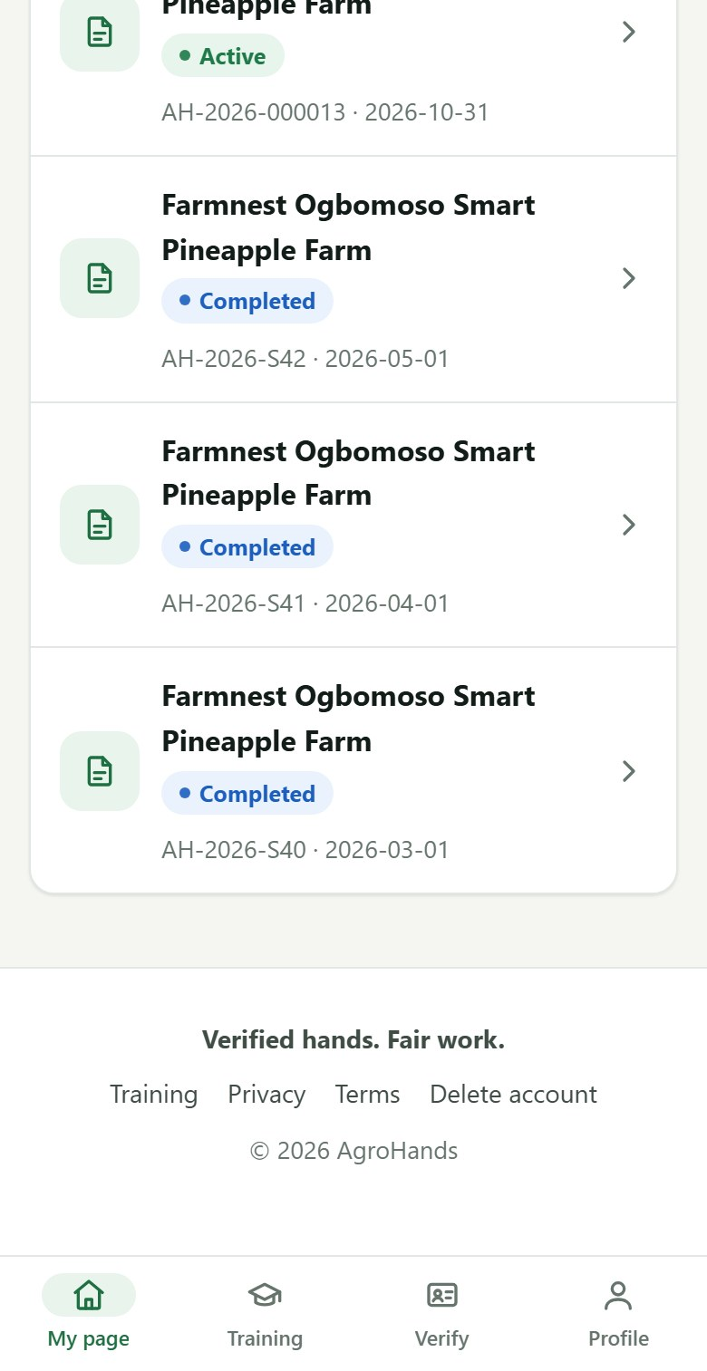  Part 2 of 2
Figure 26. A hired worker's page: the contract is listed under "My contracts" as Active, and availability has been switched off automatically.

5.4 Ending a contract and rating
At the end of the work, or if the job must stop early, open the contract and tap End this contract. As a worker you can choose Work completed, Both agreed to end or Farm closed / work stopped. Only the farm owner or AgroHands can record that a worker left or did not show up.
After a contract, rate the other person from 1 star (very bad) to 5 stars (excellent), with an optional comment. Ratings are honest feedback: good ratings help good farms find workers and good workers find farms.
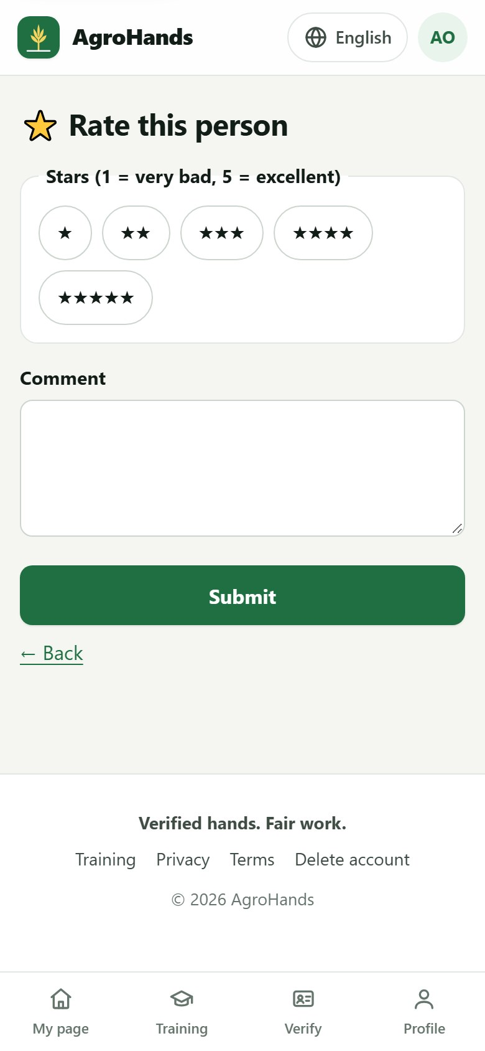
Figure 27. Rating the other person after a contract.

5.5 Reporting a problem (dispute)
If something goes wrong (unpaid wages, unsafe work, bad behaviour), open the contract and tap Report a problem.
- Choose what happened: Wages not paid / paid late, Bad behaviour or abuse, Unsafe work / no PPE, Worker absent / left, Theft or damage or Something else.
- Describe what happened in Tell us what happened: dates, amounts, who was involved.
- Tap Submit. AgroHands speaks to both sides and aims to respond within 48 hours. You get an SMS when your complaint has been answered.
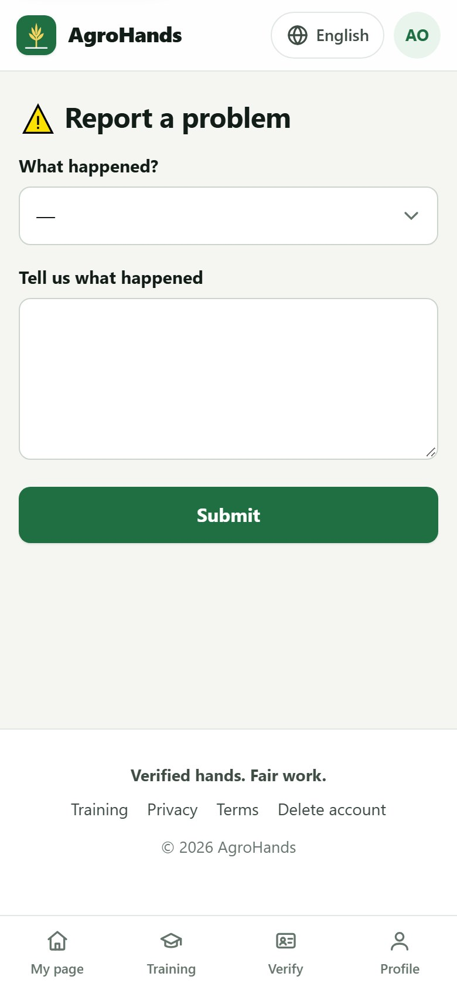
Figure 28. Reporting a problem on a contract.

6. Hiring workers (farm owners)

6.1 Your farm page
After registering as a farm owner you are asked for your farm details. Your page (My page) then shows your farm, your jobs, offers sent, workers hired and active contracts.
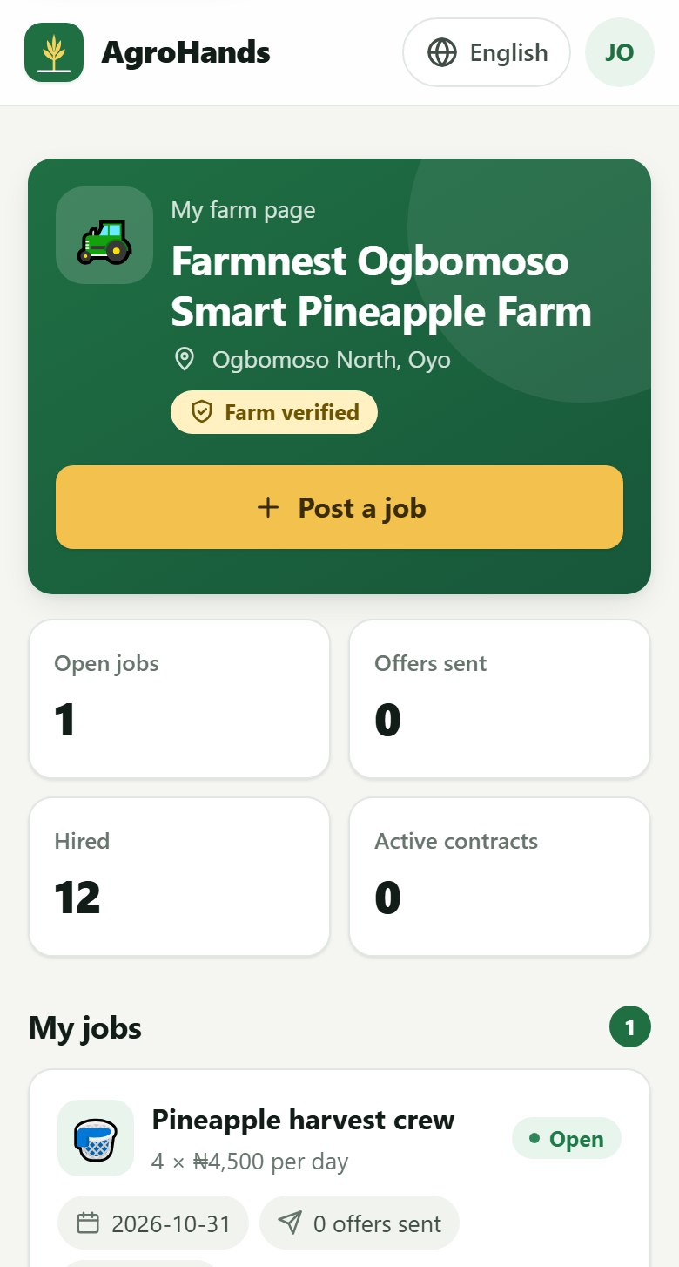  Part 1 of 3 | 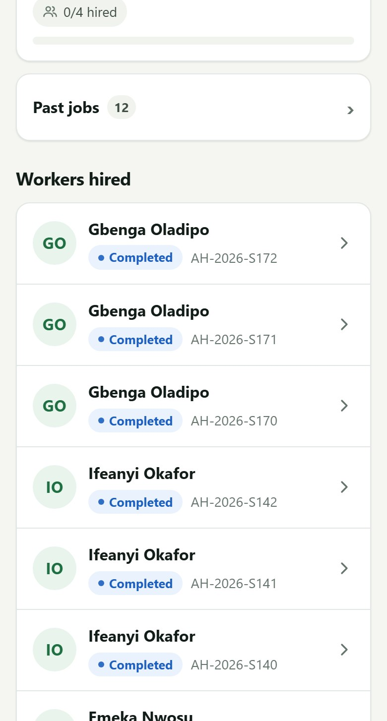  Part 2 of 3 | 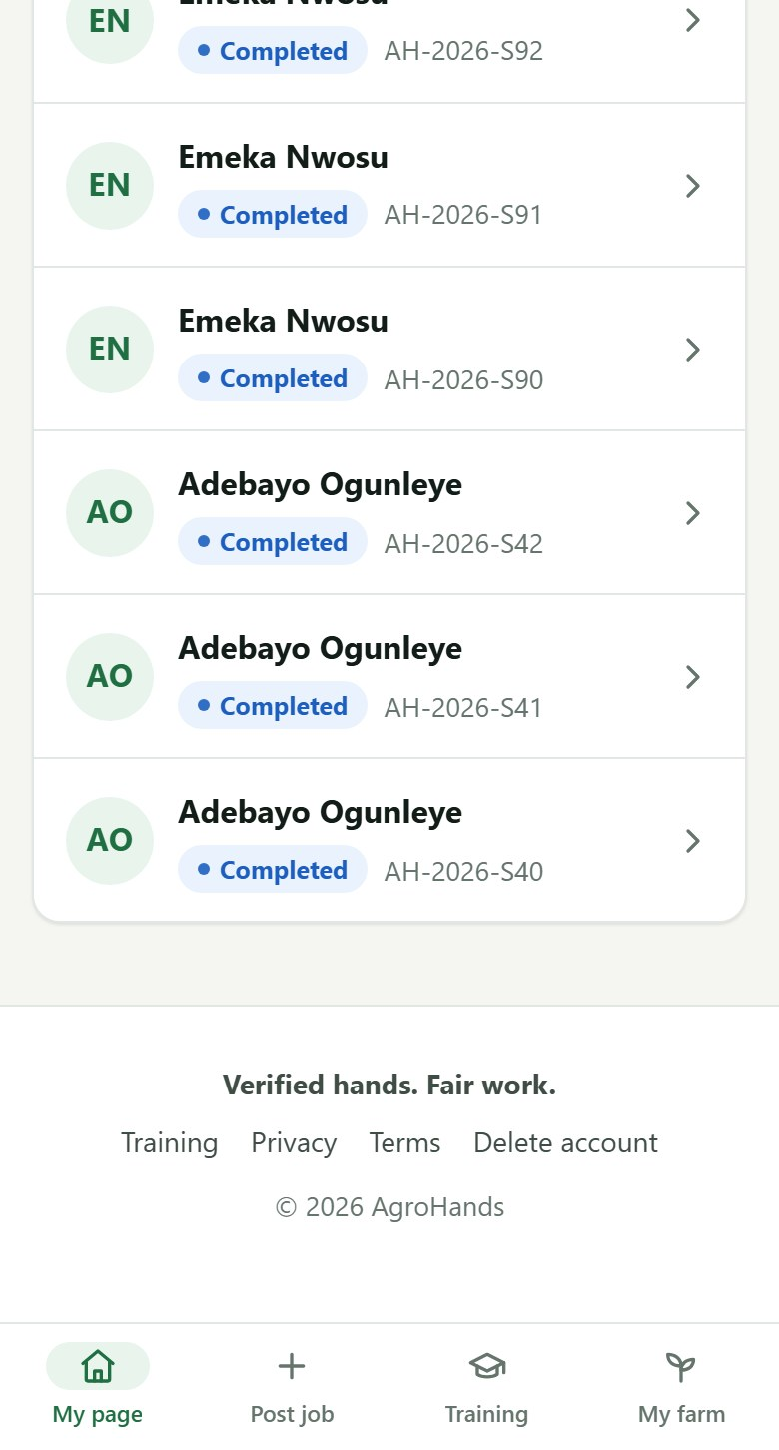  Part 3 of 3
Figure 29. The farm owner's page (shown in two parts): farm card with the Post a job button, totals, jobs, and workers hired.

6.2 Adding your farm details
- Tap My farm in the bottom bar.
- Fill in the farm name, State, LGA and the address or directions.
- Stand on the farm and tap Use my current location. Accurate location is what makes distance matching work.
- Add the size in hectares, the crops or animals, and your CAC number if the farm is a registered company.
- Tap Save.
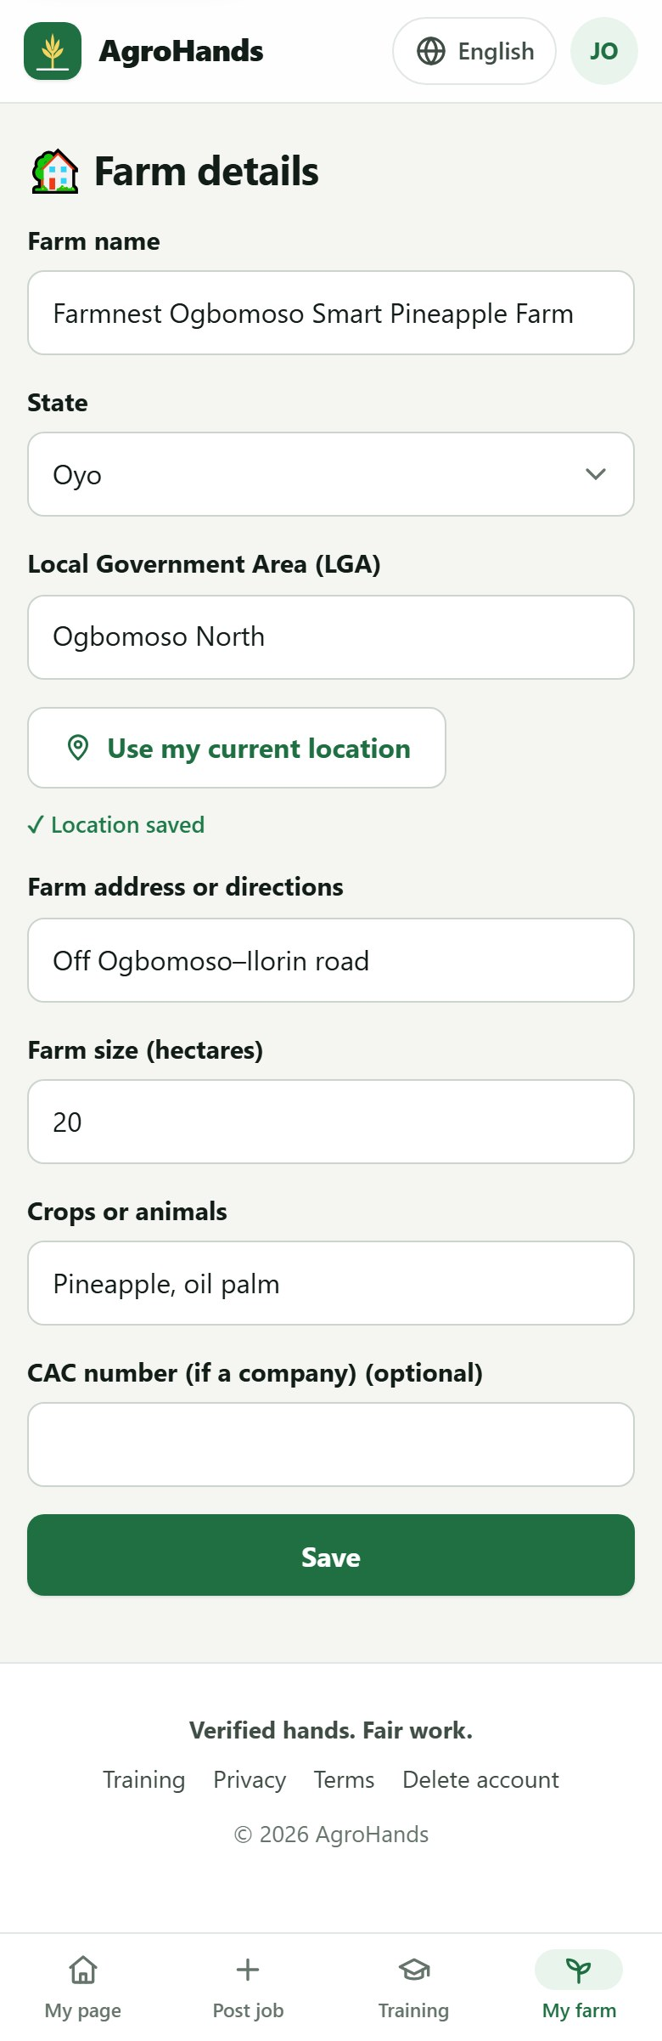
Figure 30. Farm details. "Location saved" confirms the GPS position.
A new farm shows Farm not yet verified. An AgroHands agent will confirm your farm. You can post jobs straight away, but workers see a Verified badge on verified farms, so offers from them are more likely to be accepted.

6.3 Posting a job
- Tap Post a job (on your page or in the bottom bar).
- Fill in the job details (see the table below).
- Tap Post job and find workers. AgroHands immediately ranks the best workers for the job.
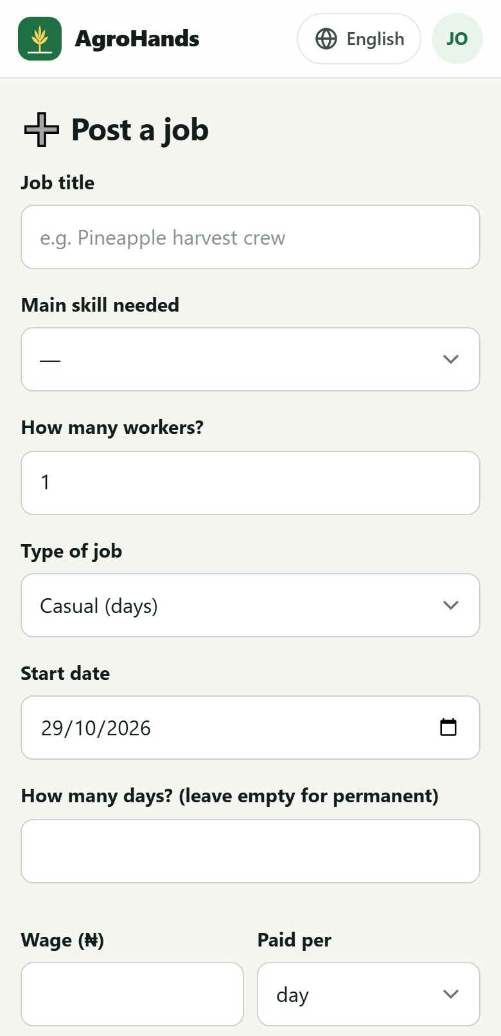  Part 1 of 2 | 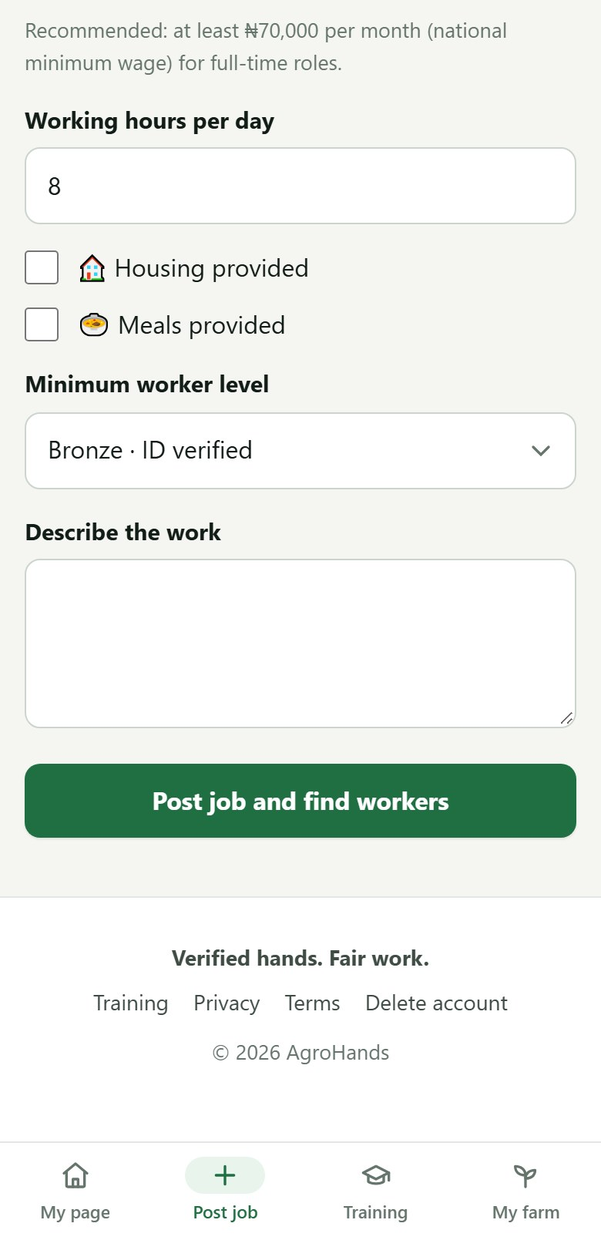  Part 2 of 2
Figure 31. The job form (shown in two parts).
Field | What to enter
Job title | A short name, for example Pineapple harvest crew.
Main skill needed | The skill that matters most; only workers with this skill are matched.
How many workers? | The job closes automatically when this many have signed.
Type of job | Casual (days), Seasonal (weeks or months) or Permanent.
Start date, How many days? | Leave days empty for permanent work.
Wage (₦), Paid per | Per day or per month. For full-time work AgroHands recommends at least ₦70,000 a month (the national minimum wage) and warns you if you offer less.
Working hours per day | Normally 8.
Housing provided, Meals provided | Tick what you offer. Housing lets workers from further away qualify.
Minimum worker level | Registered, Bronze, Silver or Gold. A higher level means more trusted workers, but fewer of them.
Describe the work | Tasks, tools, conditions. Clear descriptions get more acceptances.

6.4 Your ranked shortlist
For every job, AgroHands shows Best matches: workers who meet all of your requirements, ranked by a Match score out of 100. For privacy, you see a worker's first name and surname initial, level, distance, rating and experience, but not their phone number or address until both of you have signed a contract.
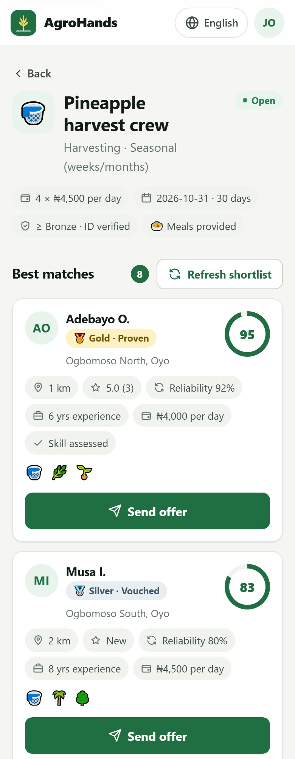  Part 1 of 3 | 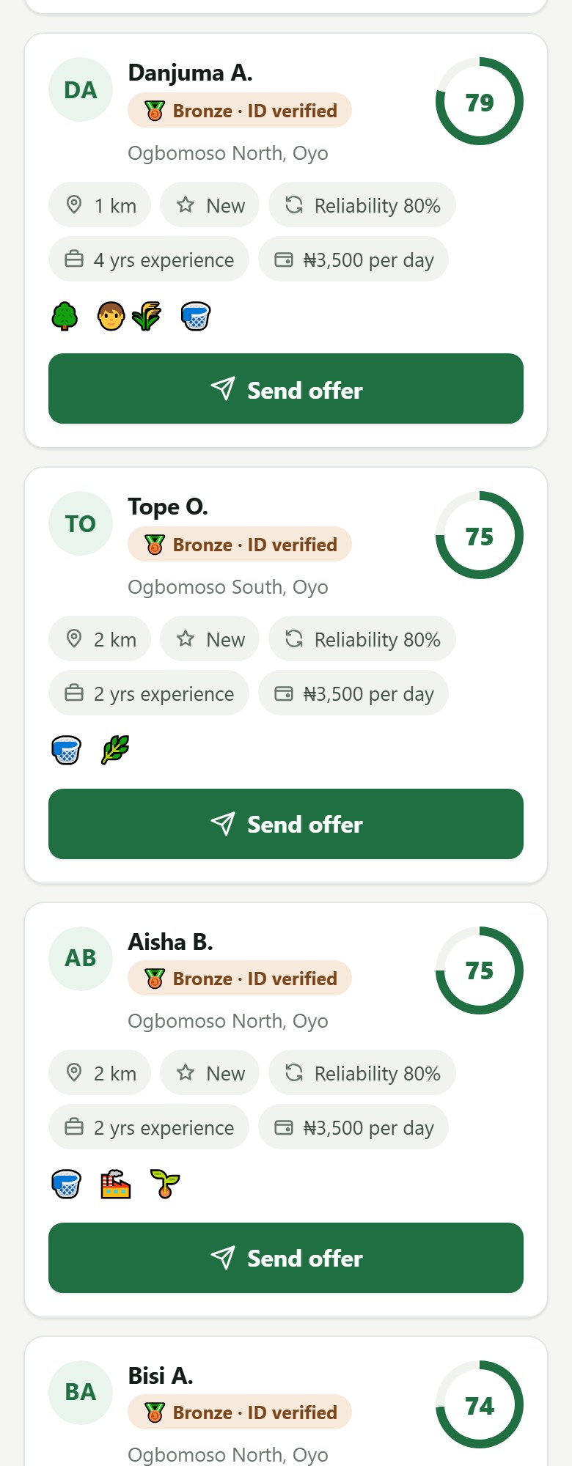  Part 2 of 3 | 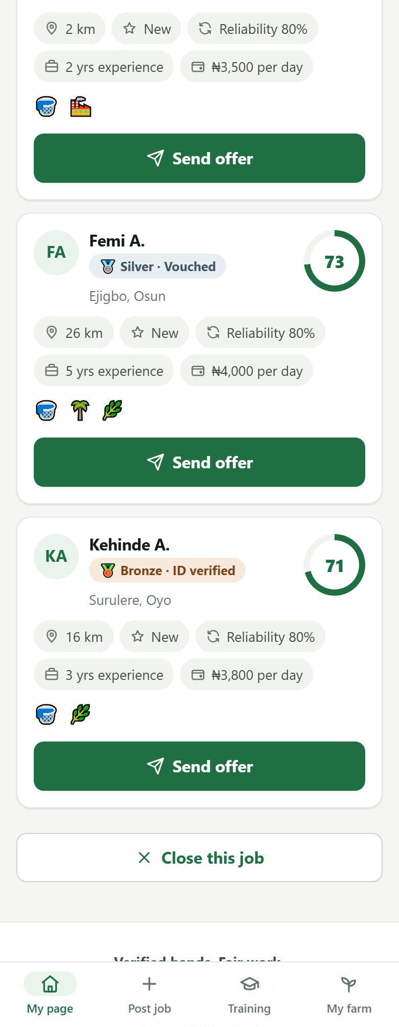  Part 3 of 3
Figure 32. A job with its ranked shortlist (shown in three parts). Each worker card shows the match score ring, level, distance, rating, reliability, experience, expected wage and skills.

How workers are chosen and ranked
A worker appears only if all of these are true: they have the main skill; they are available; they are at or above your minimum level; they are 18 or older; their expected wage is not far above yours; and they live within their travel distance, or you provide housing and they are willing to live on the farm.
Ranking factor | Weight | What it means
Skill | 30 | Main skill, and extra points if an agent has tested the skill (Skill assessed).
Reliability | 25 | How often the worker finished jobs instead of leaving early or not showing up.
Rating | 20 | Average stars from previous farms.
Distance | 15 | Closer is better.
Level | 10 | Bronze, Silver or Gold.

New workers with no history are marked New and given a fair middle score, so they can get their first job.
No matching workers?
Try a lower minimum level, a higher wage, or providing housing. Tap Refresh shortlist after changes, or later as new workers join. AgroHands agents also recruit in your area.

6.5 Sending offers
- On the shortlist, tap Send offer on the worker you want. The worker gets an SMS straight away.
- The card changes to Offer sent. You can send offers to more workers than you need; the job fills on a first-signed basis.
- When a worker accepts, you get an SMS with a link to sign the contract. If they decline, you are told so you can choose someone else.
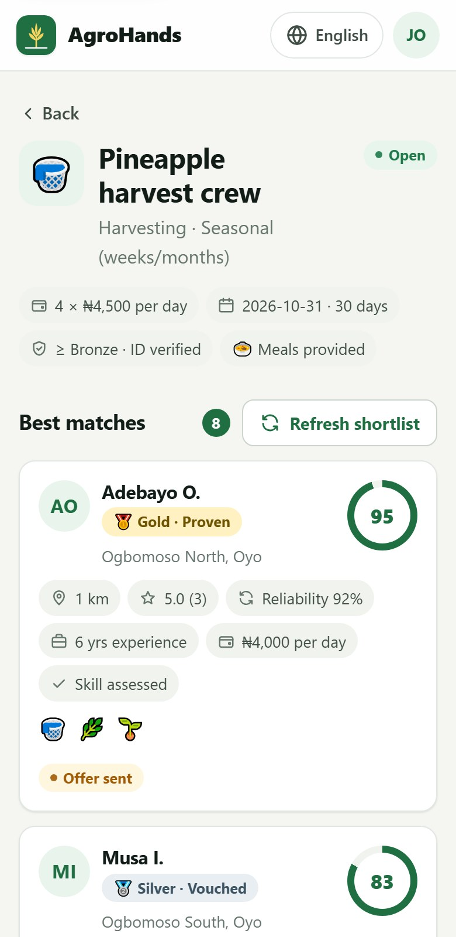  Part 1 of 2 | 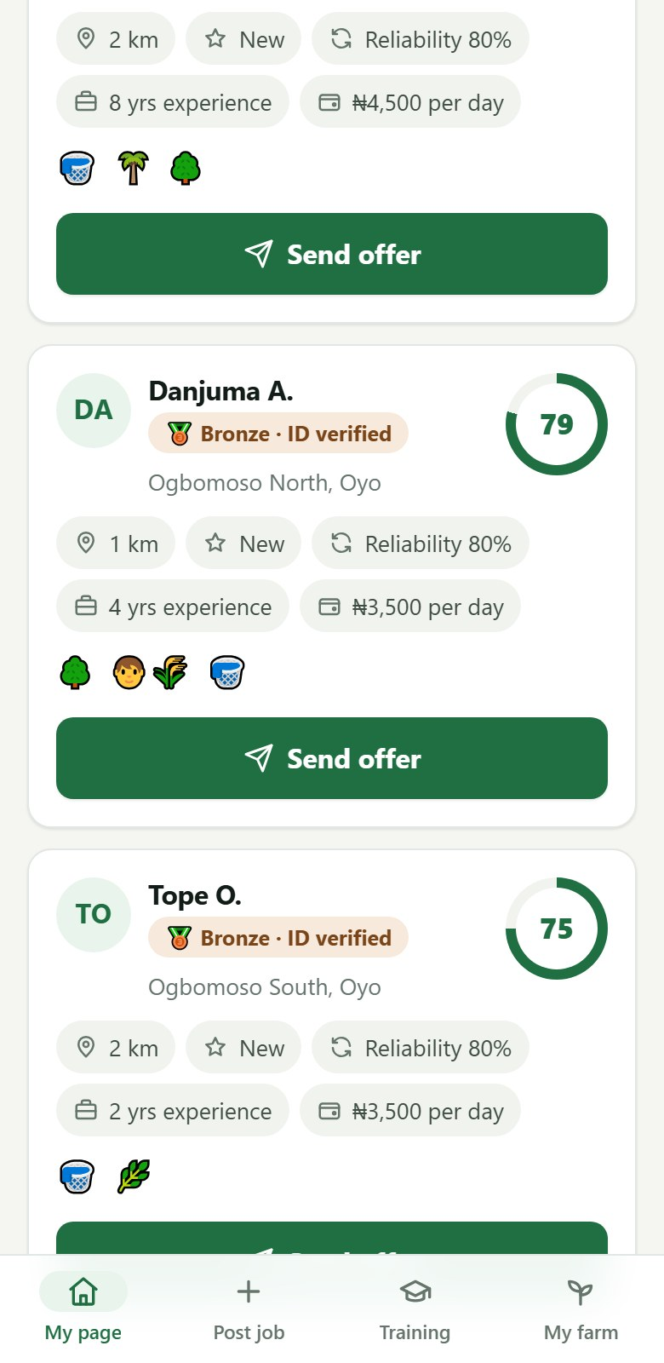  Part 2 of 2
Figure 33. After sending an offer, the worker's card shows "Offer sent" (shown in two parts).

6.6 Signing and managing contracts
The contract is created when the worker accepts. Open it from the SMS link or from Workers hired on your page, read it, then type your PIN and tap Sign with my PIN.
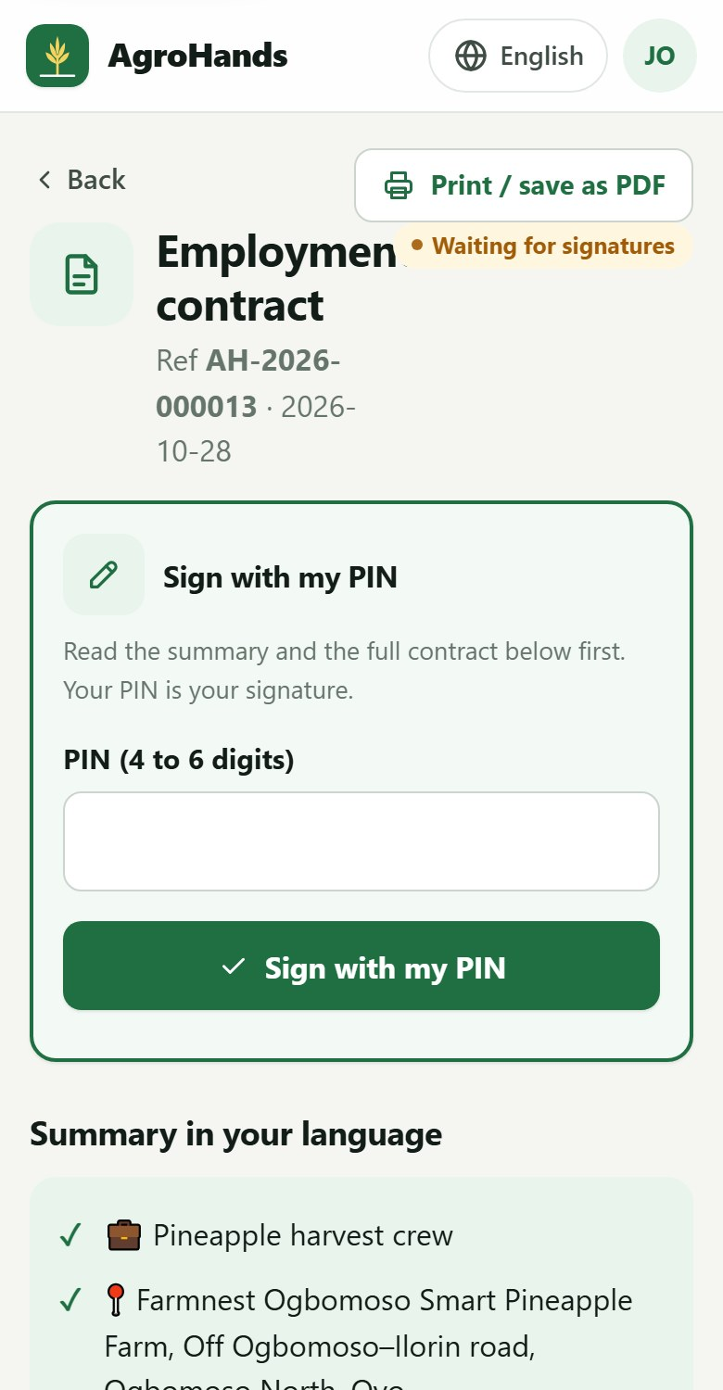  Part 1 of 2 | 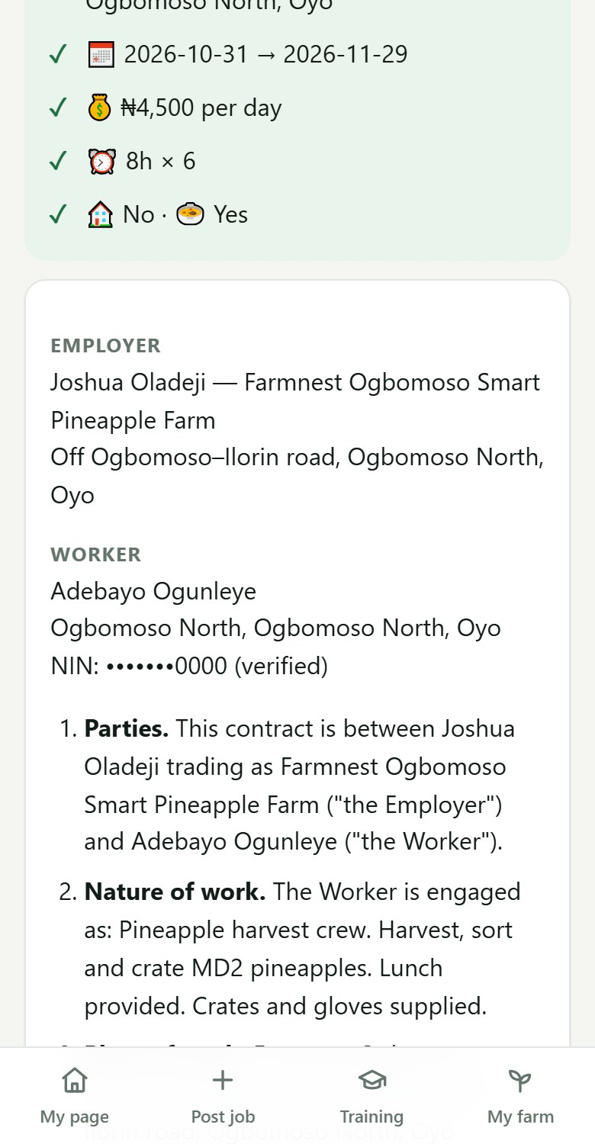  Part 2 of 2
Figure 34. The farm owner's view of a contract the worker has already signed (shown in two parts).
When both have signed, the contract is Active. The worker's phone number appears as a call button, next to Chat on WhatsApp.
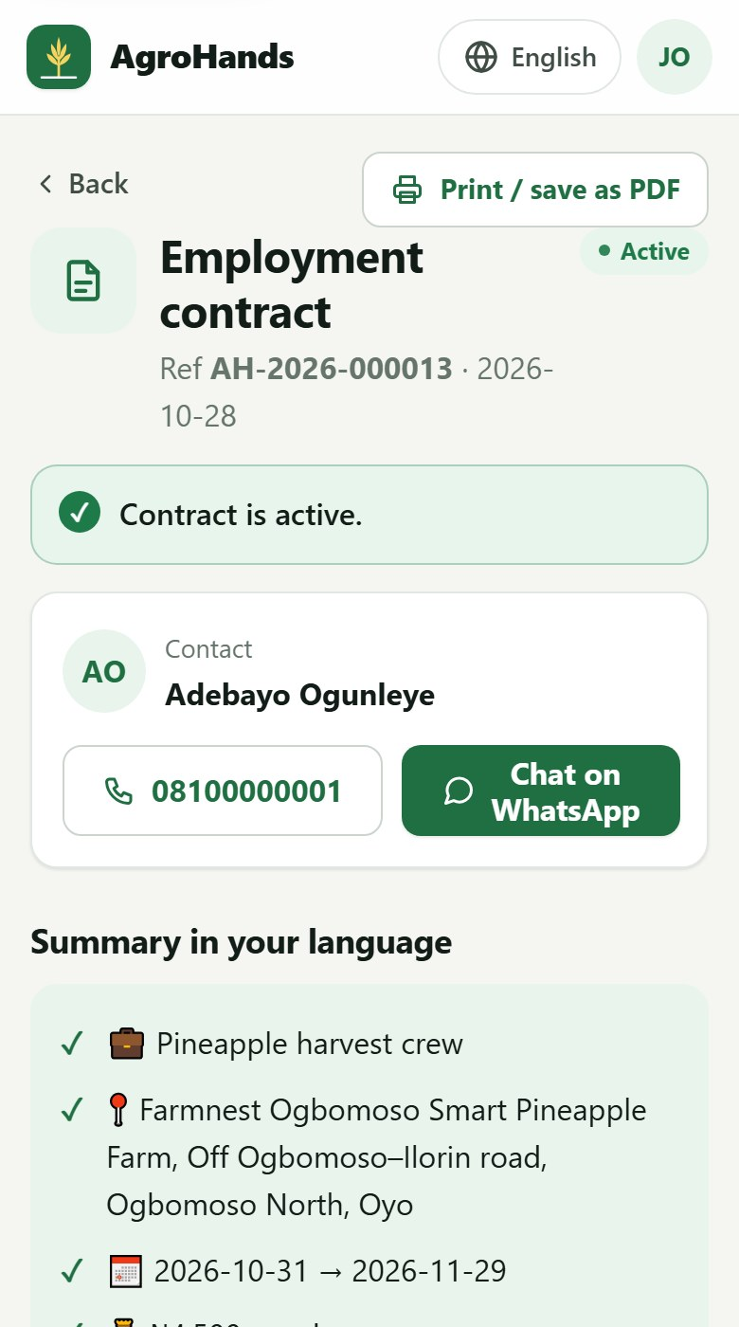  Part 1 of 2 | 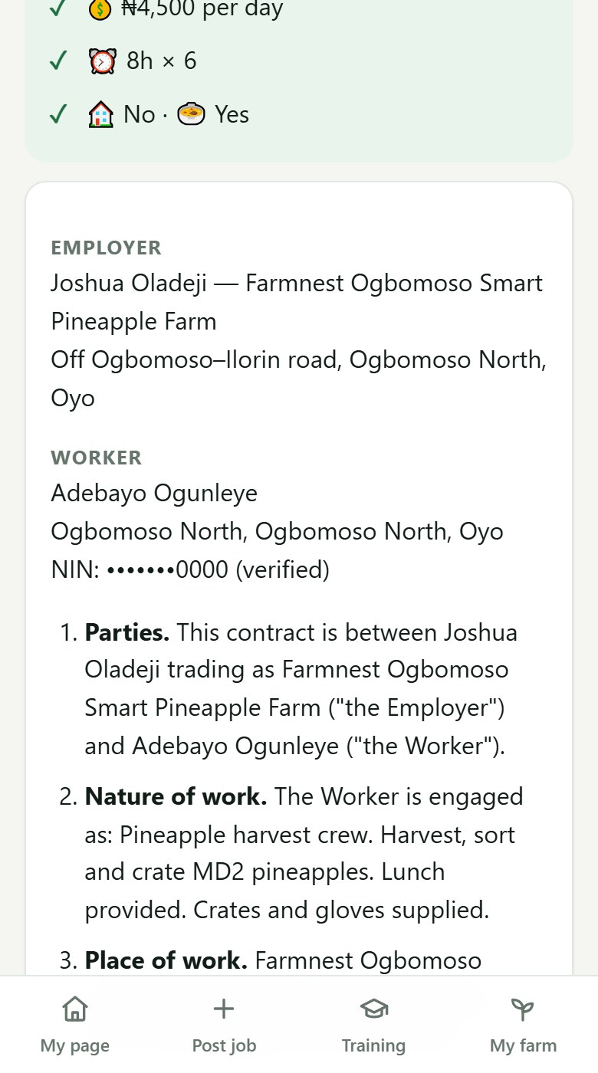  Part 2 of 2
Figure 35. An active contract (shown in two parts): the green banner, the worker's contact details, the summary, the full contract and, at the bottom, End this contract.

Ending a contract
Open the contract, tap End this contract, choose the reason and confirm. Be accurate: the reason affects the worker's reliability score.
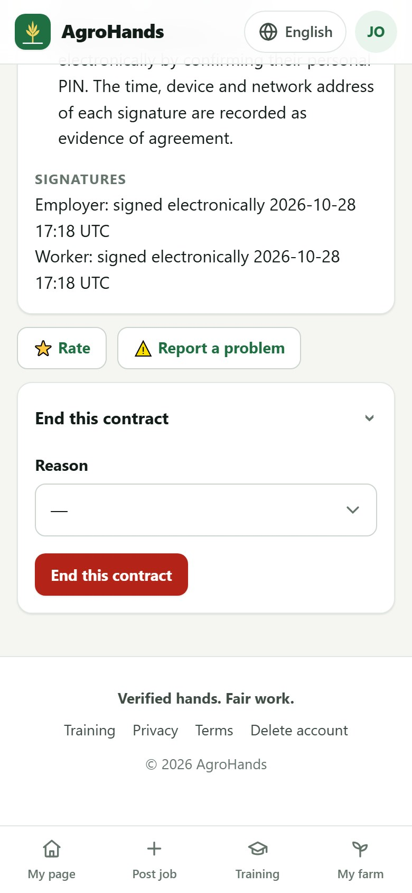
Figure 36. Ending a contract: choose the reason.
Reason | When to use it
Work completed | The work was done as agreed.
Both agreed to end | You and the worker agreed to stop early.
Farm closed / work stopped | The work ended for reasons that are not the worker's fault (weather, sale, illness…).
Worker dismissed | You ended the contract because of the worker's conduct or performance.
Worker left without notice | The worker stopped coming without the notice in the contract.
Worker did not show up | The worker never started.

Your duties as an employer
Pay the full wage in money, on the agreed day. Do not deduct for tools, food or "fines".
Provide the protective equipment the work needs, especially for spraying and machinery.
Never employ anyone under 18 for farm work. AgroHands blocks under-18s from shortlists.

Rating, disputes and contract printing work the same as for workers (sections 5.3 to 5.5).

7. Using AgroHands without a smartphone (USSD)
Workers with a basic phone can register, see and accept job offers, check their level and change language by dialling the AgroHands USSD code. It works on every network without internet or data. Your AgroHands team will announce the code at launch; it looks like *384*XXXX#.
- Dial the AgroHands USSD code and press Call.
- A menu appears. Type the number of your choice and press Reply (or Send).
- Keep replying until you see the final message.

7.1 Registering by USSD
1. Main menu  Reply 1 to register. | 2. Your name  Type your full name. | 3. Your State  Type your State, for example Kwara.
  AgroHands
  1. Register for farm work
  2. My job offers
  3. My status
  4. Language
  [ Reply ] [ Cancel ]
  Enter your full name
  (By continuing you accept AgroHands Terms & Privacy)
  [ Reply ] [ Cancel ]
  Enter your State (e.g. Oyo)
  [ Reply ] [ Cancel ]
4. Your main work  Reply with the number, for example 6. | 5. Choose a PIN  Choose 4 digits you will remember. | 6. Confirm the PIN  Type the same 4 digits again.
  Choose your main work:
  1. General farm hand
  2. Planting
  3. Weeding
  4. Harvesting
  5. Spraying
  6. Palm fruit harvesting
  7. Poultry
  8. Tractor operator
  9. Farm security
  [ Reply ] [ Cancel ]
  Choose a 4-digit PIN
  [ Reply ] [ Cancel ]
  Enter the PIN again
  [ Reply ] [ Cancel ]
7. Done  Take your NIN slip to an AgroHands agent to get verified. | Check your status (option 3)  Shows your level and your next step. | Change language (option 4)  Reply with the number of your language.
  Registered! Visit an AgroHands agent with your NIN slip to get verified.
  [ OK ]
  Level: Registered
  Next step: Verify your NIN
  [ OK ]
  Language
  1. English
  2. Pidgin
  3. Yorùbá
  4. Hausa
  5. Igbo
  6. Français
  [ Reply ] [ Cancel ]

When you register by USSD, your phone number is confirmed by your network, so no SMS code is needed. You can later log in on any smartphone with the same number and PIN.

7.2 Seeing and accepting job offers by USSD
Option 2: My job offers  Each offer shows the job, pay and place. Reply with its number. | The offer  Reply 1 to accept or 2 to decline. Accepting asks for your PIN. | Accepted  An agent reads the contract to you before you sign it.
  My job offers
  1. Pineapple harvest crew N4500/day Ogbomoso North
  [ Reply ] [ Cancel ]
  Pineapple harvest crew
  2026-10-31 N4500/day
  1. Accept
  2. Decline
  [ Reply ] [ Cancel ]
  Accepted! Contract created. An agent will read it to you before signing.
  [ OK ]

Contracts for USSD users
Contracts cannot be shown in full on a basic phone. After you accept, an AgroHands field agent reads the contract to you in your language before you sign.

8. Your account, security and privacy

8.1 Changing your PIN
- Tap your initials (top right) and choose Change PIN.
- Type your Current PIN, then the new PIN twice.
- Tap Save. You stay logged in on this phone; every other phone or computer is logged out.
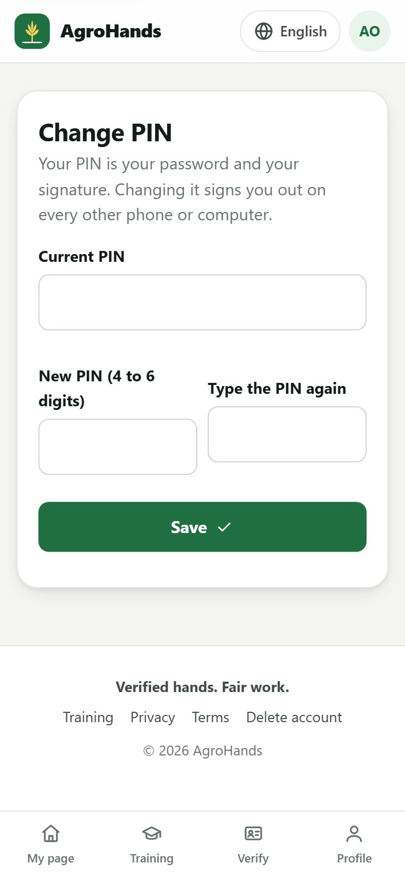
Figure 37. Changing your PIN.

8.2 Logging out of other phones
If you logged in on someone else's phone, or lost a phone, open Change PIN. If you are logged in elsewhere, a button Sign out on all other devices appears below the form. Tap it. If the phone was lost or stolen, also change your PIN.

8.3 Downloading your data
Under the Nigeria Data Protection Act you may see the information AgroHands holds about you. Tap your initials and choose Download my data. A file is downloaded with your profile, consents, contracts, ratings received and training results. Secrets such as your PIN are never included.

8.4 Deleting your account
- Tap your initials and choose Delete my account.
- Type the word DELETE in capital letters to confirm.
- Tap Delete my account. This happens immediately and cannot be undone.
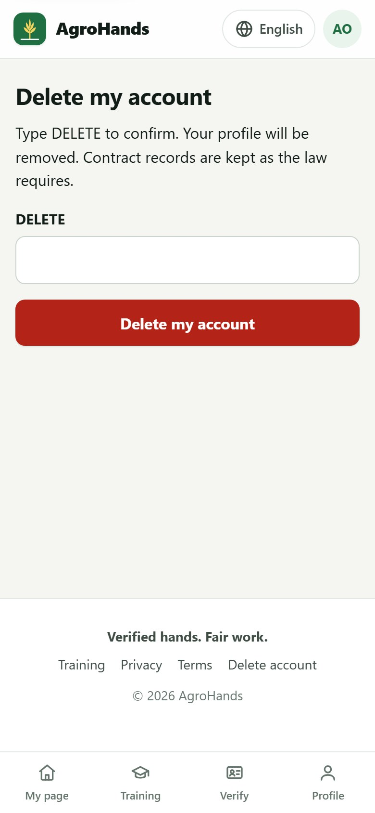
Figure 38. Deleting your account.
Your name, phone number, PIN, date of birth, location, guarantor and NIN code are removed. Signed contracts and signature records are kept for 6 years, as labour and tax law require, linked to "Deleted user". If you cannot log in (for example, you registered by USSD), the public page Delete account (link at the bottom of every page) explains how to ask AgroHands to delete it.
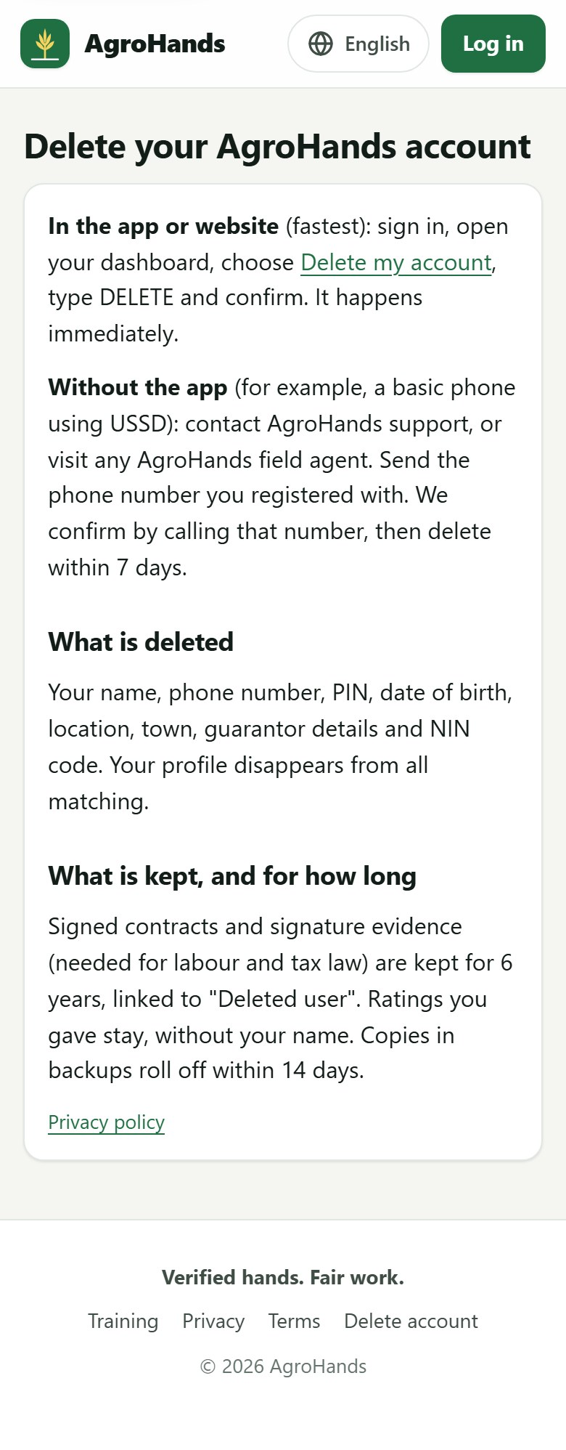
Figure 39. The public "Delete your AgroHands account" page, which needs no login.

8.5 Privacy
The Privacy page (link at the bottom of every page) explains what AgroHands collects, why, who can see it and how long it is kept. In short: farms see your first name, skills, level, rating and distance; your phone number is shared only after both sides sign a contract; your full NIN is never stored; there is no advertising or tracking.
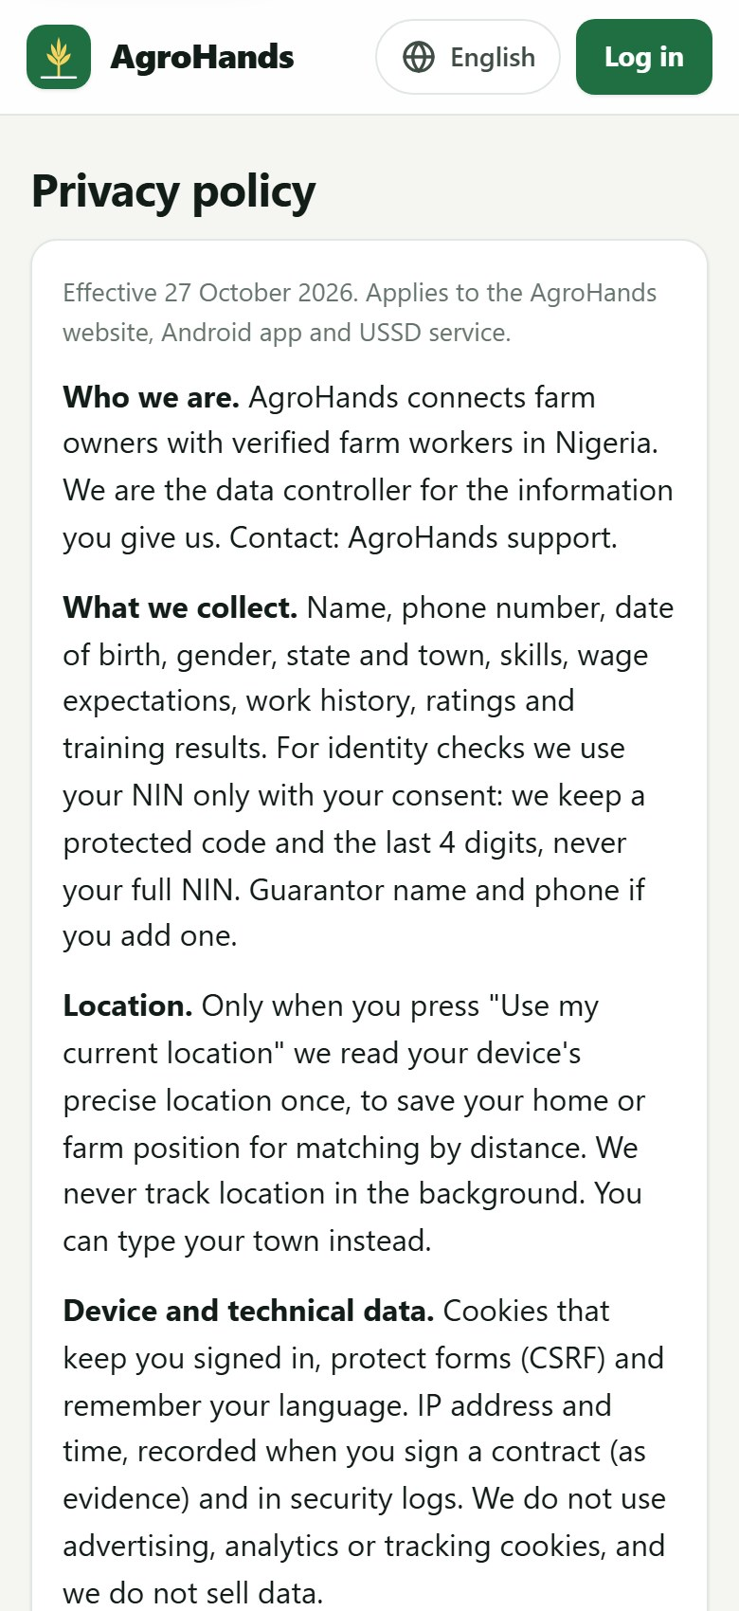  Part 1 of 2 | 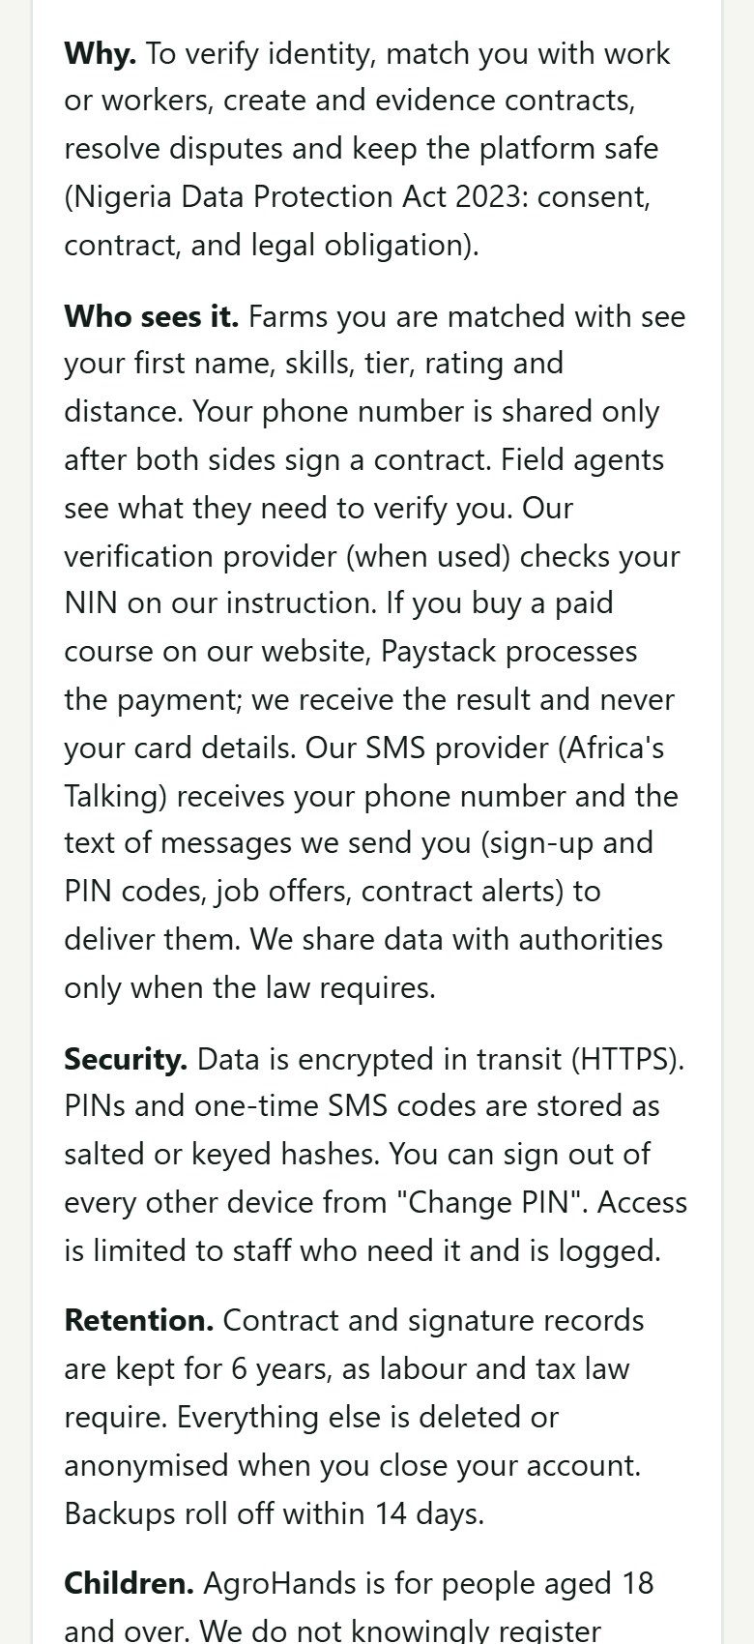  Part 2 of 2
Figure 40. The privacy policy (shown in two parts).

9. The agent desk (field agents)
Field agents are AgroHands staff who work in communities and on farms. Accounts are given the agent role by an administrator. When you log in as an agent, you arrive on the Agent desk.

9.1 Your work queues
The desk lists everything waiting for an agent, with the number of items in each queue:
Queue | What to do
NIN slips to confirm | Workers who entered a NIN that needs checking. Meet the worker, look at the NIN slip or ID card, and confirm or reject.
Guarantors to call | Call the guarantor, confirm they know the worker and will vouch for them, then confirm or reject.
Addresses to confirm | Visit or otherwise confirm where the worker lives.
Farms to verify | Visit the farm, confirm it exists at the location shown (tap map), then tap Farm visited and verified.
Disputes | Open contracts with a reported problem. Help both sides; administrators record the outcome.

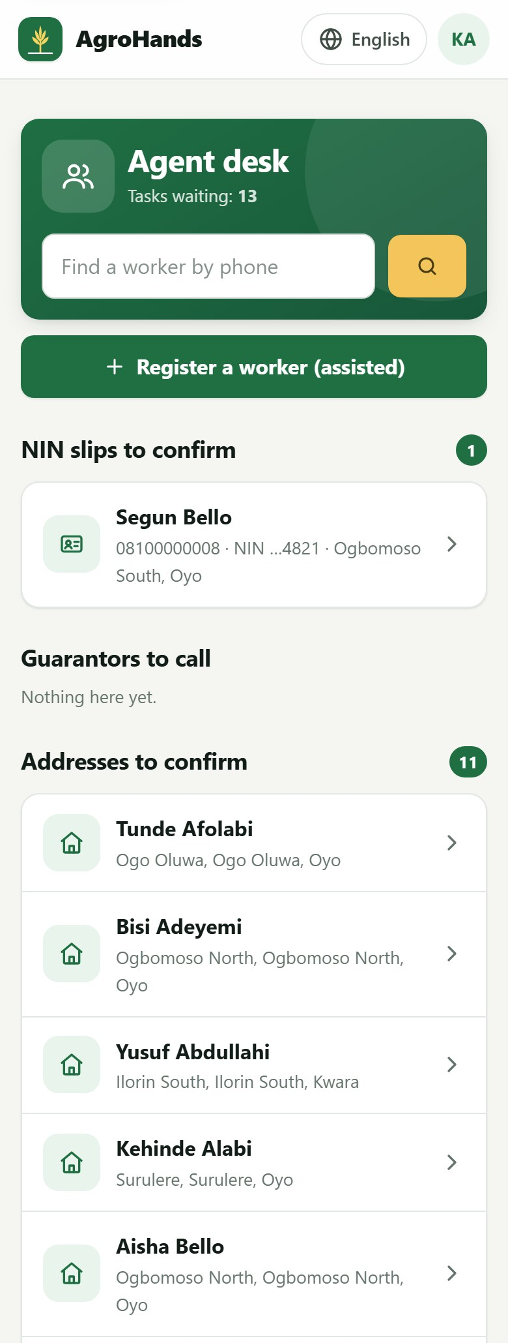  Part 1 of 2 | 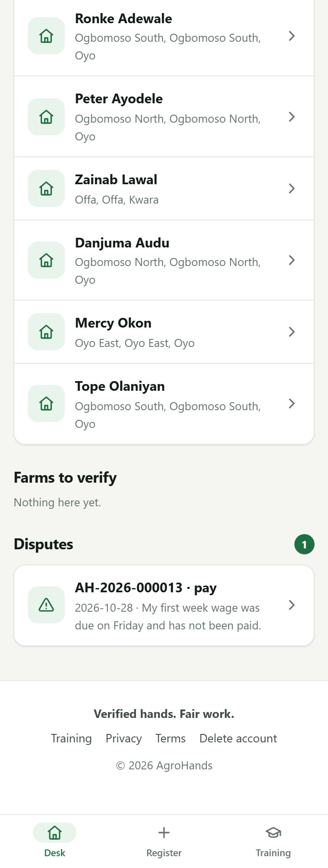  Part 2 of 2
Figure 41. The agent desk (shown in two parts): search by phone number, register a worker, and the queues.
Find a worker quickly
Type the worker's phone number in the search box at the top of the desk and tap the search button.

9.2 Reviewing a worker
Tap a worker in a queue (or search for them) to open their review page. It shows their details and a card for each check:
- NIN: when pending, tap I have seen the NIN slip and the face matches to confirm, or Reject NIN. If the worker has no NIN on file, you can enter it here with their consent.
- Guarantor: the guarantor's name and phone (tap to call). After the call tap Guarantor called and vouches or Guarantor did not vouch.
- Address: tap Address confirmed once checked.
- Practical skill assessment: watch the worker do the work, choose the skill they passed and tap the tick. Assessed skills are marked on the farm's shortlist and count towards Gold.
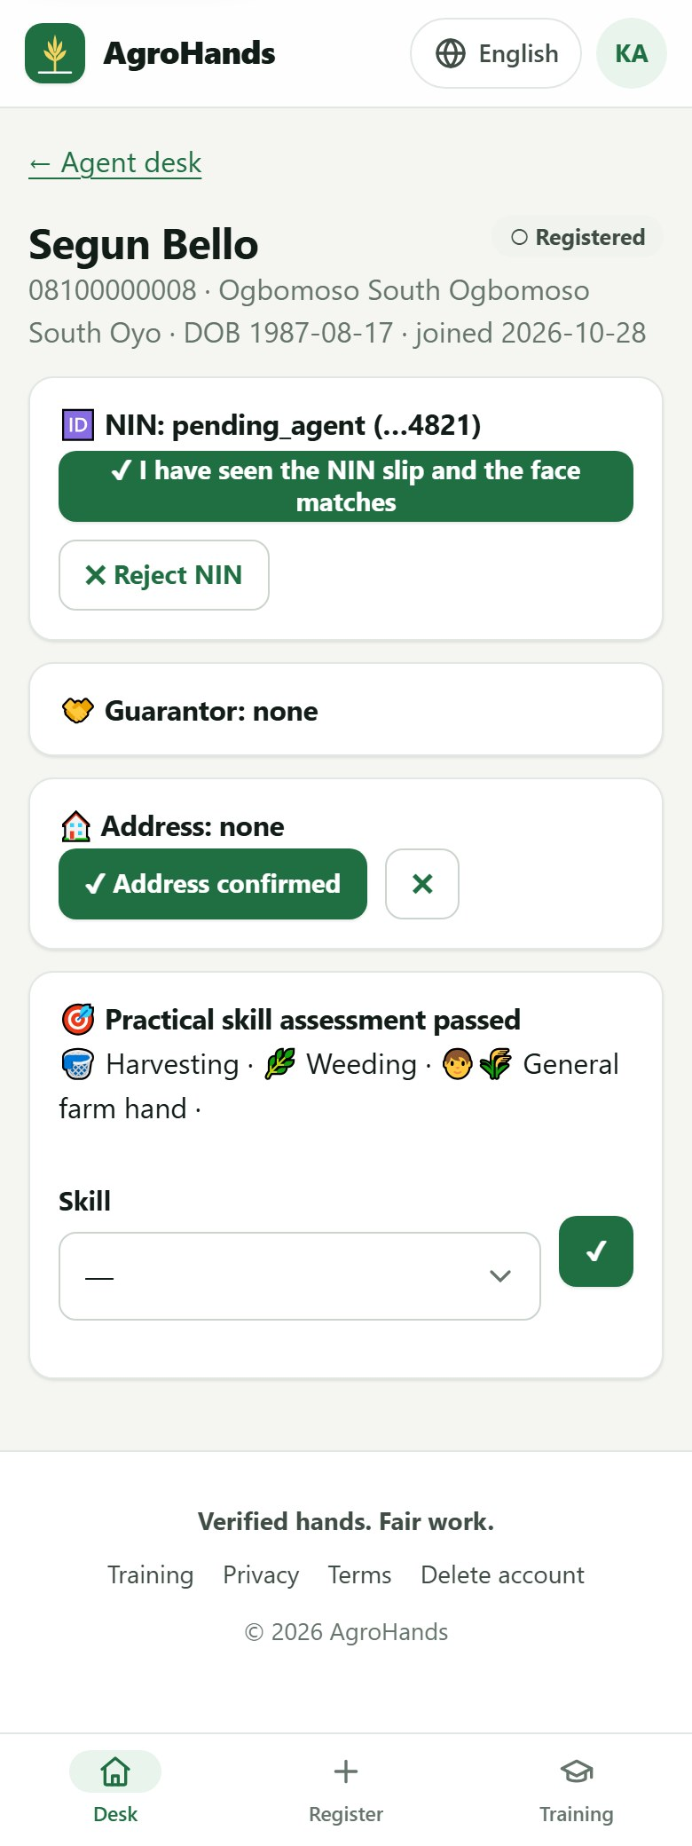
Figure 42. A worker's review page, with a NIN waiting for confirmation.
Only confirm what you have checked yourself
Every agent action is recorded with your name and the time. Never confirm a NIN without seeing the slip and the person, or a guarantor without speaking to them.

9.3 Registering a worker who has no smartphone
- On the desk tap Register a worker (assisted).
- Enter the worker's full name (as on their NIN), phone number, State, LGA, town and best skill.
- Read the Terms and Privacy Notice to the worker in their language. When they agree, tick the box.
- Tap Create account. A temporary PIN is shown once. Tell it to the worker privately.
- The worker also receives a welcome SMS. Advise them to choose their own PIN with Forgot your PIN? or by USSD.
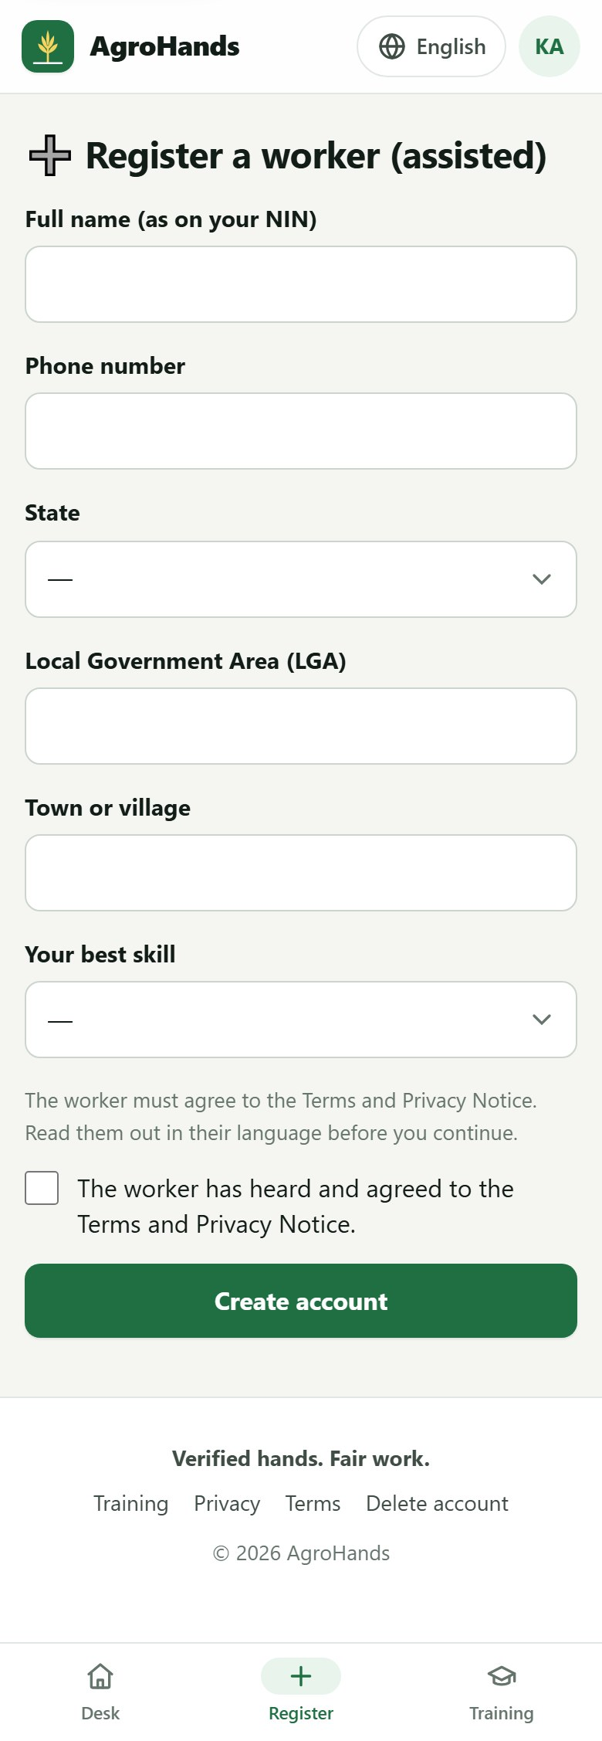
Figure 43. Assisted registration.
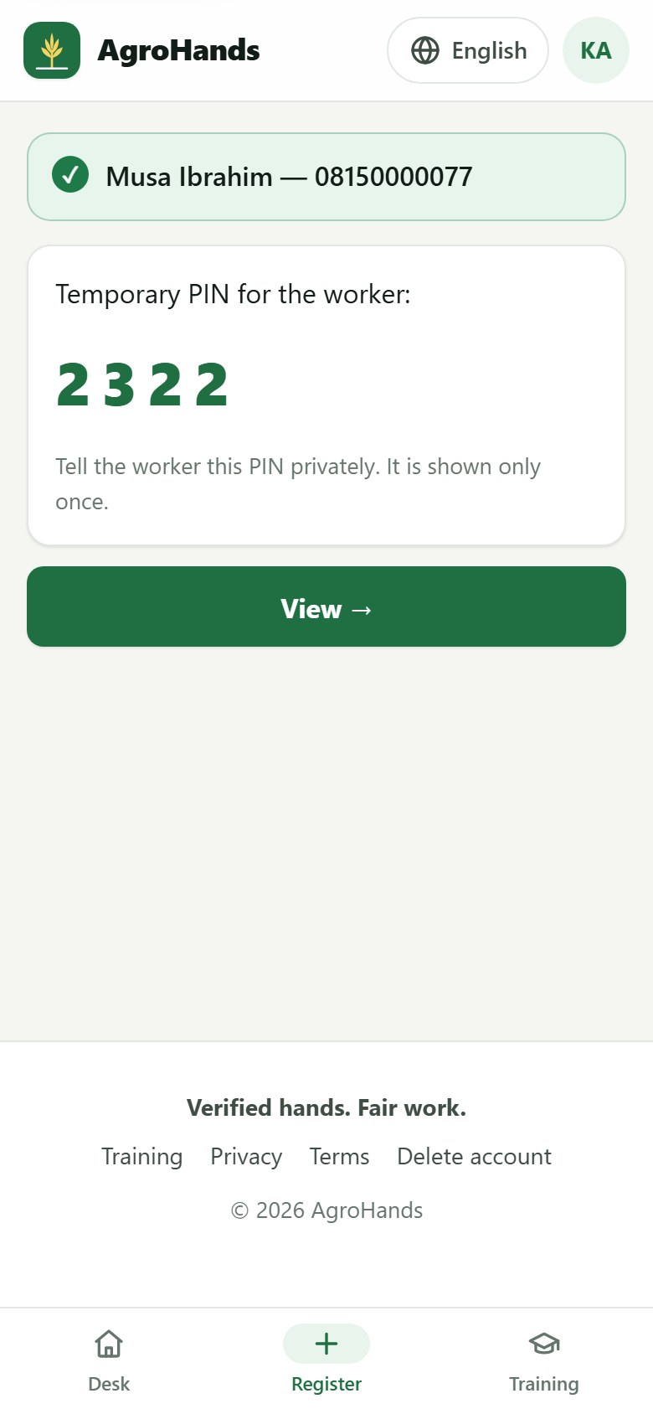
Figure 44. The account is created. The temporary PIN is shown only once.

10. The admin console (administrators)
Administrators run AgroHands day to day. The console works best on a computer; the pictures below are from a computer screen. Every action in the console is written to the audit log with the administrator's name.

10.1 Getting administrator access
The first administrator is created by the technical team on the server, which prints a one-time PIN to change after the first login. Phone numbers listed in the server setting ADMIN_PHONES also become administrators when they register. An administrator can then give other people the agent or admin role (section 10.3).

10.2 Overview
The Overview shows a Needs attention list: open disputes, farms waiting for verification, NIN slips waiting for an agent, failed SMS, payments stuck for more than an hour, and a warning when SMS use nears the daily limit. Tap an item to go straight to it. Below are marketplace figures and the CSV exports.
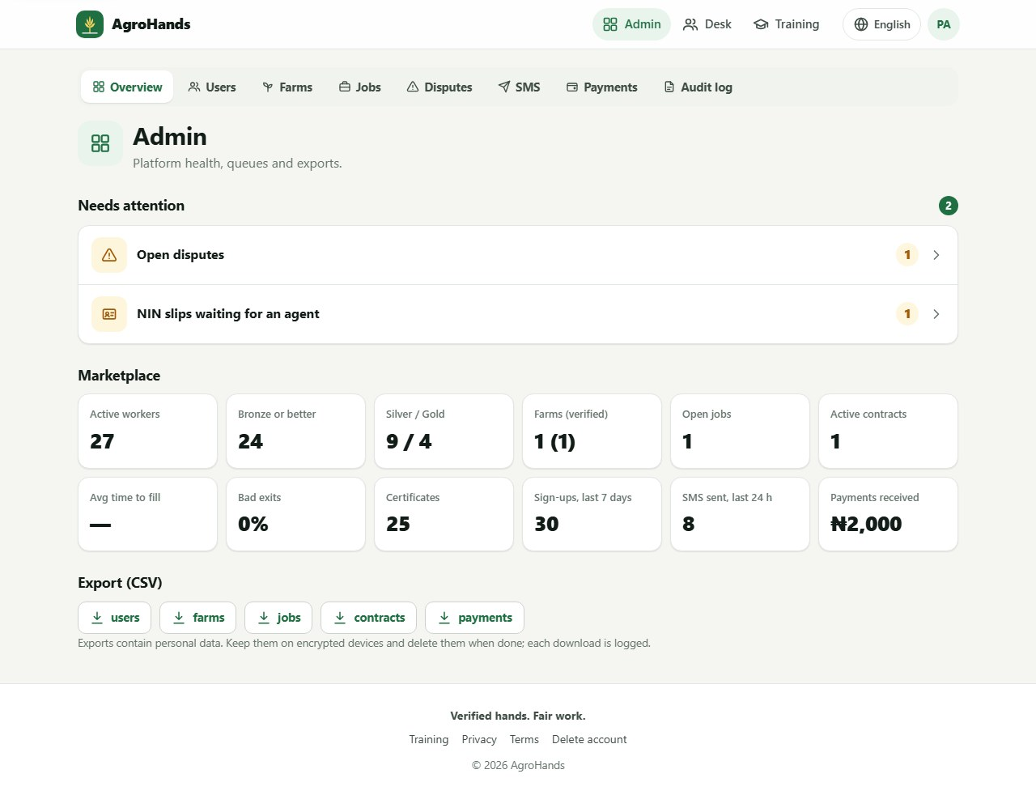
Figure 45. The admin overview: "Needs attention", marketplace figures and exports. The tabs at the top lead to each section.
Figure | Meaning
Active workers / Bronze or better / Silver / Gold | How many workers there are, and at what level.
Farms (verified) | All farms, and how many an agent has verified.
Open jobs / Active contracts | Work currently on offer, and people currently working.
Avg time to fill | Average hours from posting a job to filling it.
Bad exits | Share of finished contracts where the worker left without notice or did not show up.
Certificates | Courses passed.
Sign-ups, last 7 days / SMS sent, last 24 h / Payments received | Growth, messaging and income.

10.3 Users
Search by name or phone number (any format: 0803…, +234 803…), and filter by role and status. Tap a person to open their page: verification state, signed-in devices, farms, contracts and recent activity.
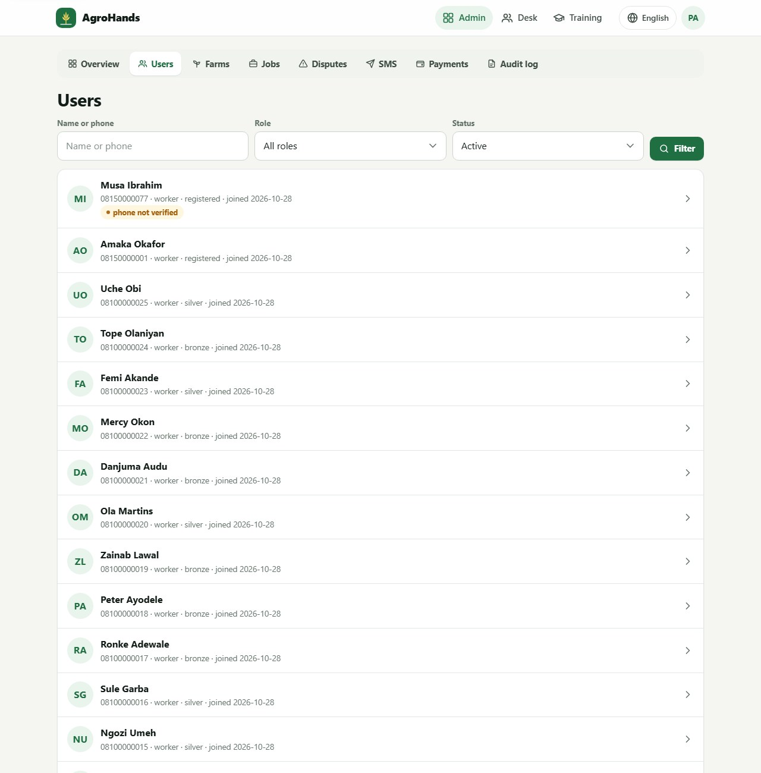
Figure 46. The user list with search and filters. "phone not verified" marks accounts whose number was never confirmed by SMS or USSD.
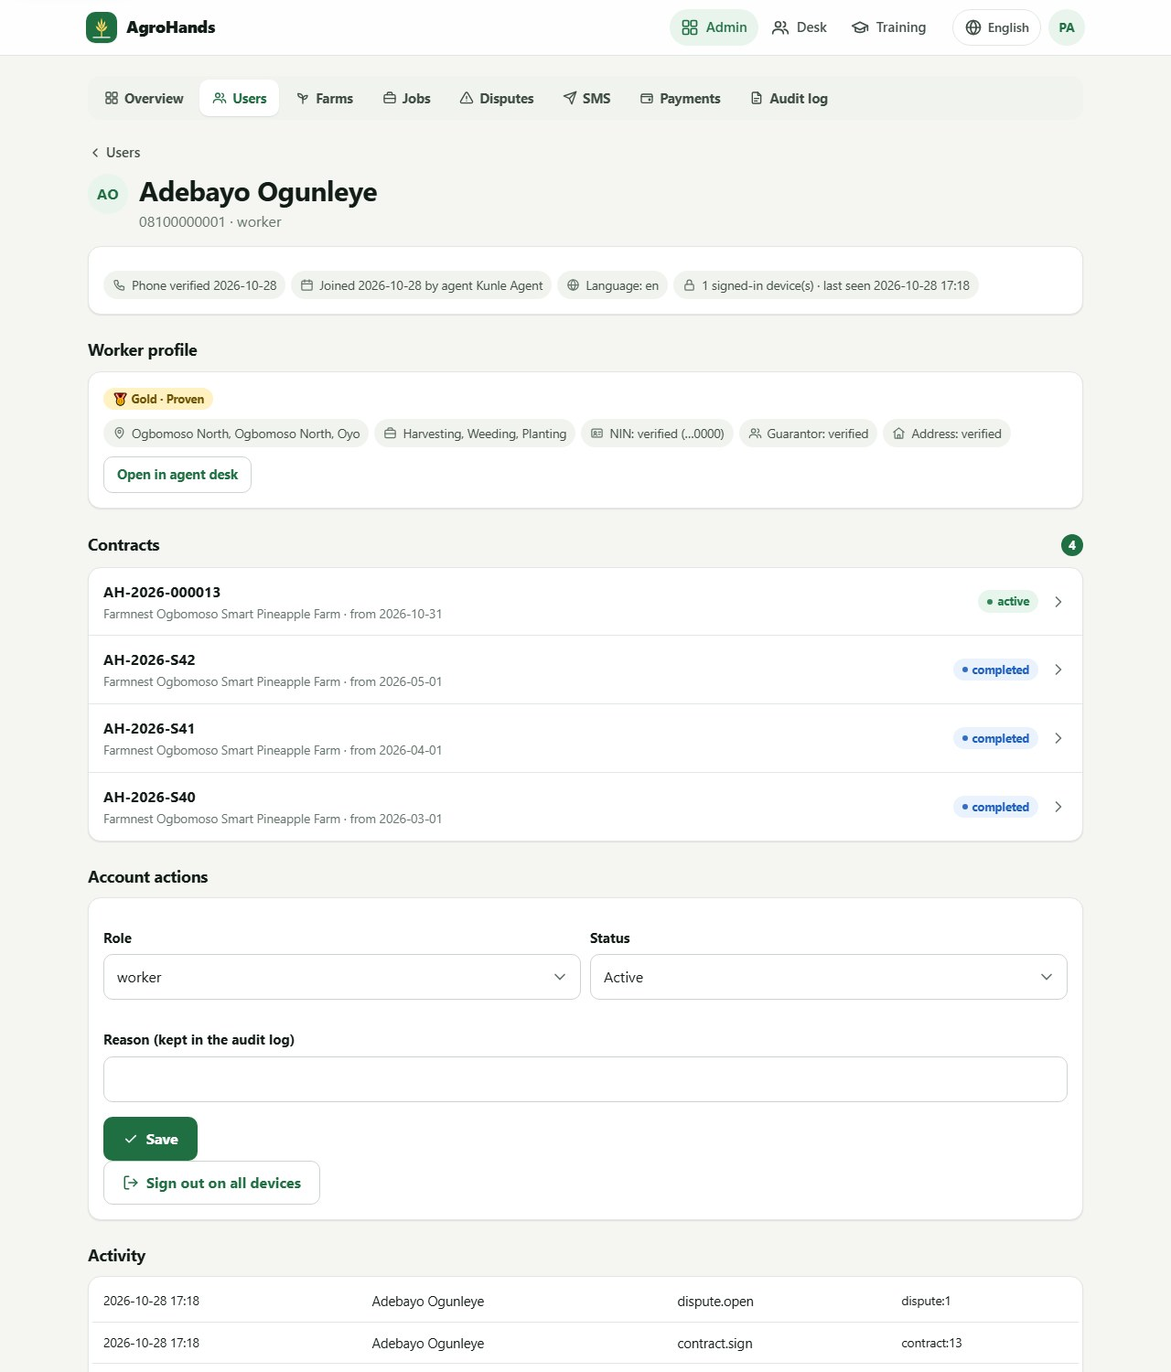
Figure 47. A user's page, with account actions near the bottom.

Changing a role or suspending someone
- Open the person's page.
- Under Account actions choose the Role (worker, farmer, agent, admin) and Status (Active or Suspended).
- Type a Reason. It is kept in the audit log.
- Tap Save. The change takes effect at once and the person is logged out on every device.
Sign out on all devices logs the person out without changing anything else, for example when they report a lost phone. You cannot change your own role or status.

10.4 Farms
Lists farms, unverified first, with owner, phone, location (with a map link), number of jobs and CAC number. Tap Verify after a field check, or Unverify if a farm turns out to be wrong.
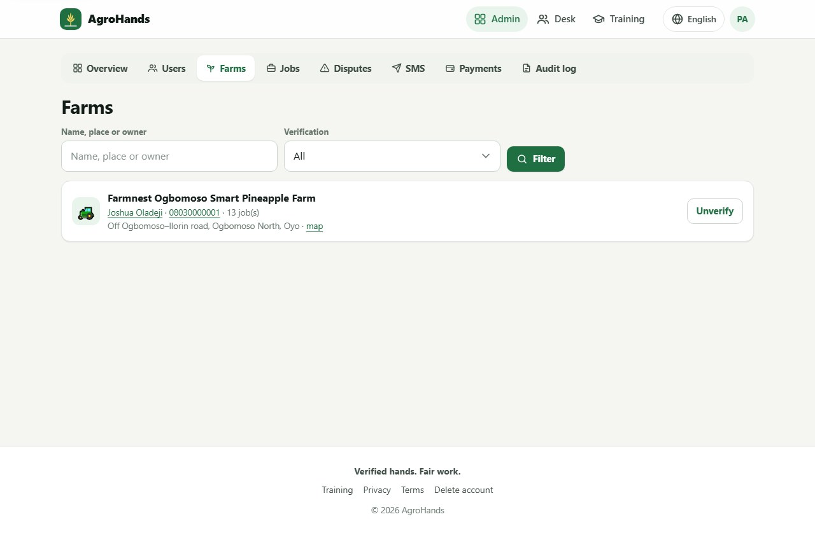
Figure 48. Farms.

10.5 Jobs
Lists jobs with farm, skill, number needed, wage, start date and offers outstanding. Filter by status. To remove a misleading or illegal job tap Close: the job stops and any outstanding offers expire.
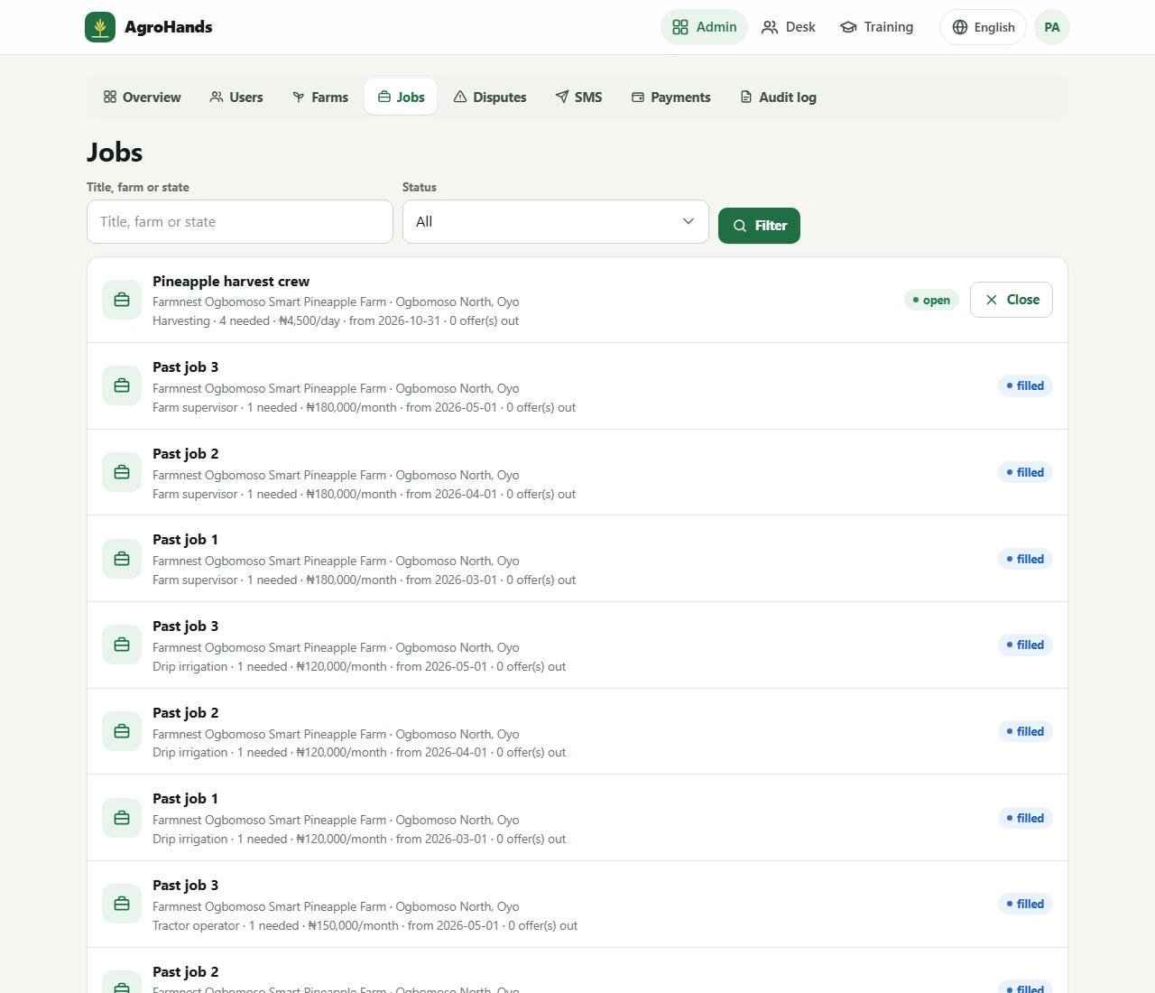
Figure 49. Jobs, showing all statuses.

10.6 Disputes
Open disputes show the contract reference, category, who raised it (with a call link) and their description. After speaking to both sides, type the Resolution, choose Resolved or Rejected, and tap Close dispute. The person who raised it receives an SMS. Recently closed disputes are listed below.
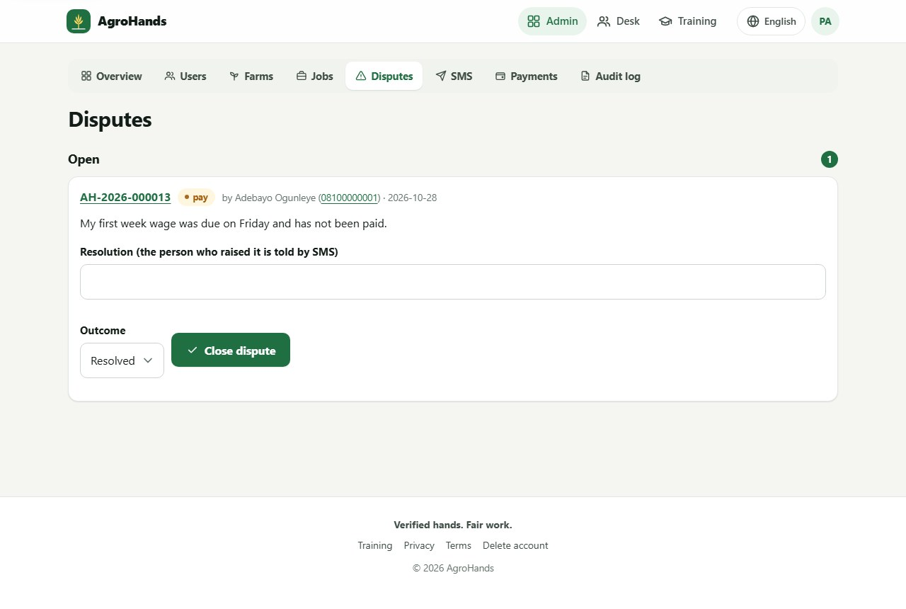
Figure 50. An open dispute about late wages.

10.7 SMS delivery
Every SMS AgroHands sends (sign-up codes, job offers, contract alerts) is listed with its status. Failed messages show the reason from the SMS network, for example DoNotDisturbRejection when the person has Do-Not-Disturb turned on. Tap Retry on a failed alert, or Retry … failed alert(s) for the last 24 hours. Sign-up and PIN codes are never retried from here; they expire in 10 minutes and the person can request a new one. The text of codes is removed once sent.
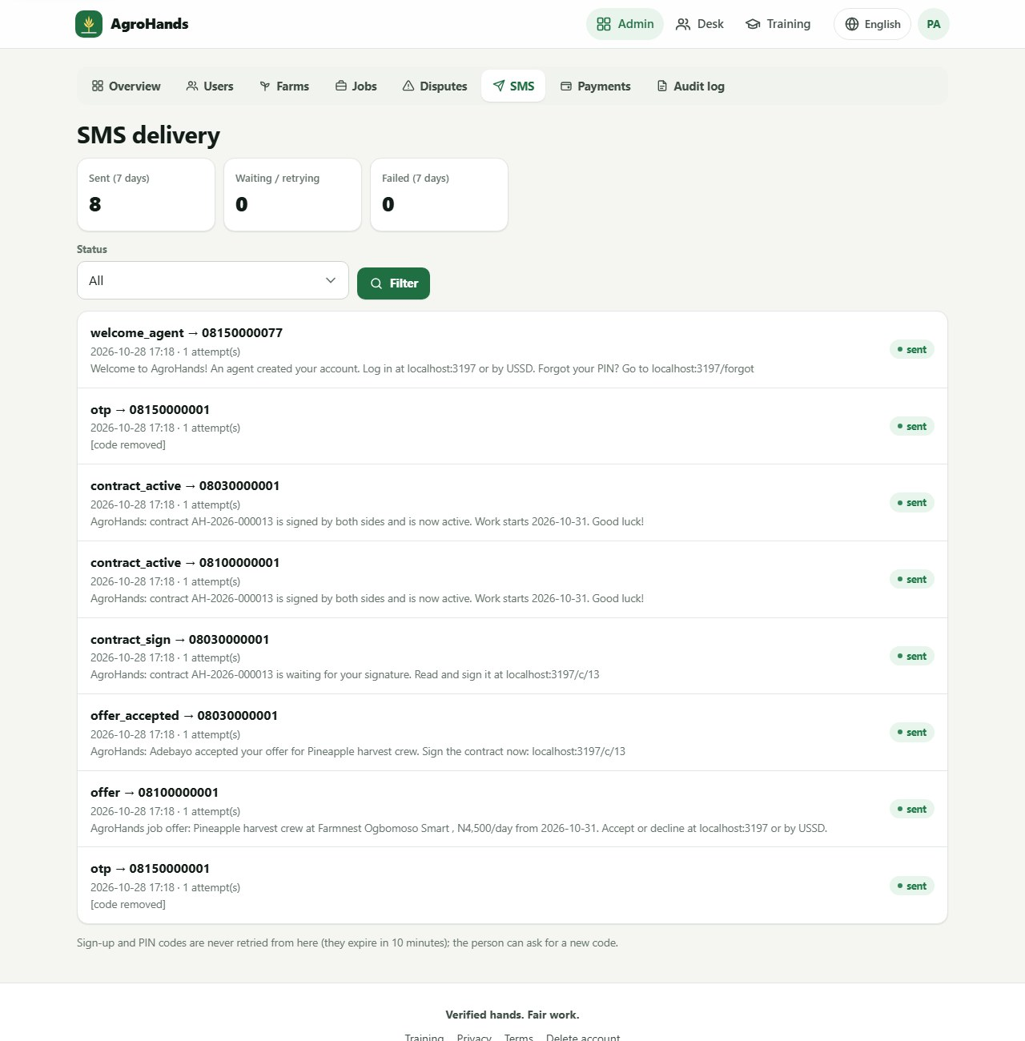
Figure 51. SMS delivery: totals for the last 7 days and every message with its status.
Daily SMS limit
To protect AgroHands from fraud that runs up the SMS bill, there is a daily limit on SMS (1,000 by default). Overview warns at 80%. If the limit is reached, no SMS are sent, sign-up shows a message, and the technical team is alerted. Ask them to raise the limit if the growth is genuine.

10.8 Payments
Every payment attempt with amount, purpose, the person, time, Paystack reference and method (card, bank transfer, USSD). Only payments that Paystack confirmed, for the right amount, show as success. Pending payments older than an hour appear under Needs attention.
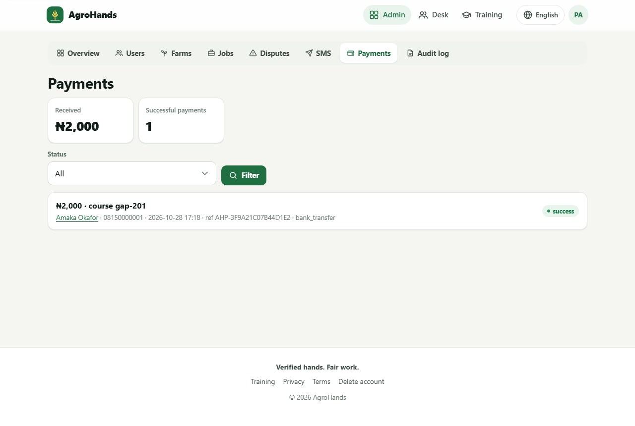
Figure 52. Payments.

10.9 Audit log
Every important action is recorded: logins, sign-ups, PIN changes, offers, signatures, agent checks, admin changes, exports and payments. Filter by Action (for example admin. for all admin actions, or agent. for agent checks) or by Subject (for example user:12). Click a person's name to open their page.
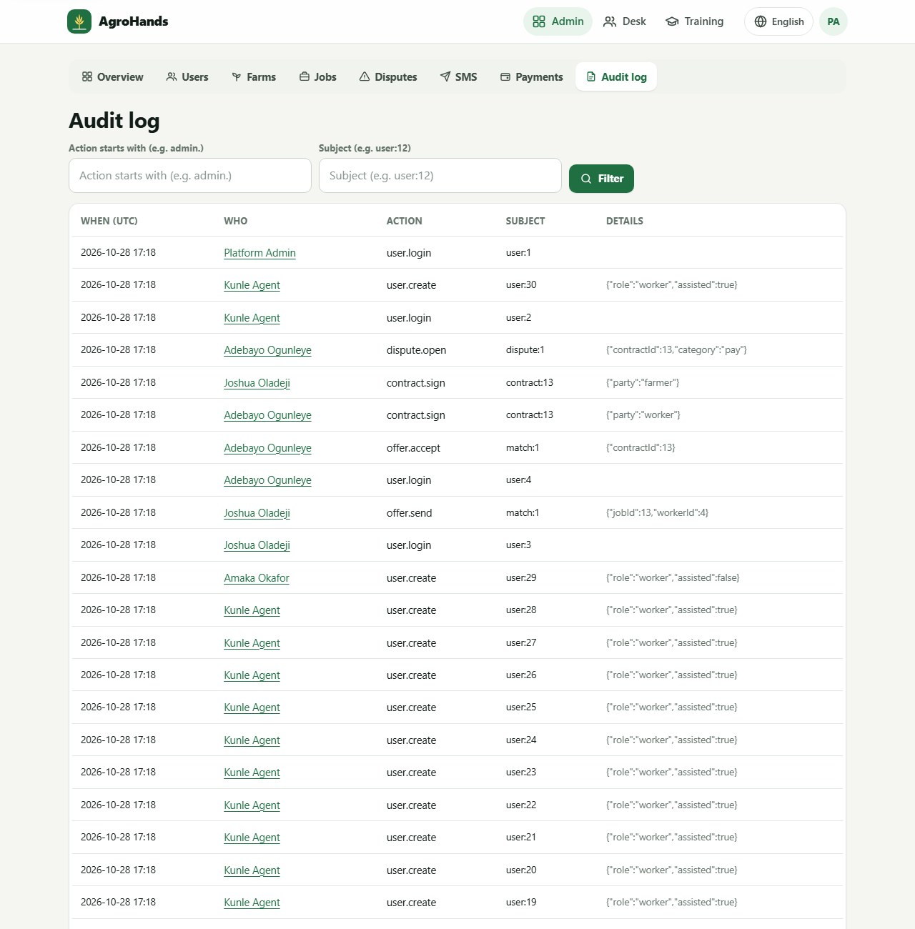
Figure 53. The audit log.

10.10 Exports
On the Overview, the Export (CSV) buttons download users, farms, jobs, contracts or payments as a spreadsheet file that opens in Excel or Google Sheets. Exports contain personal data: keep them on encrypted devices, share them only with people who need them, and delete them when done. Each download is recorded in the audit log.

10.11 Using the console on a phone
The console also works on a phone. The section tabs scroll sideways.
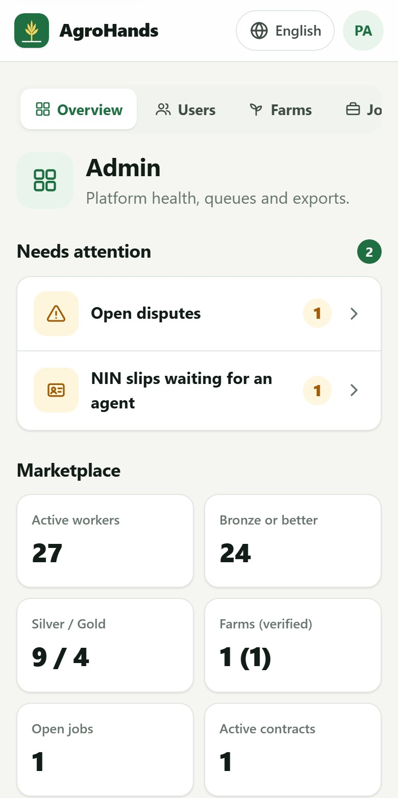  Part 1 of 2 | 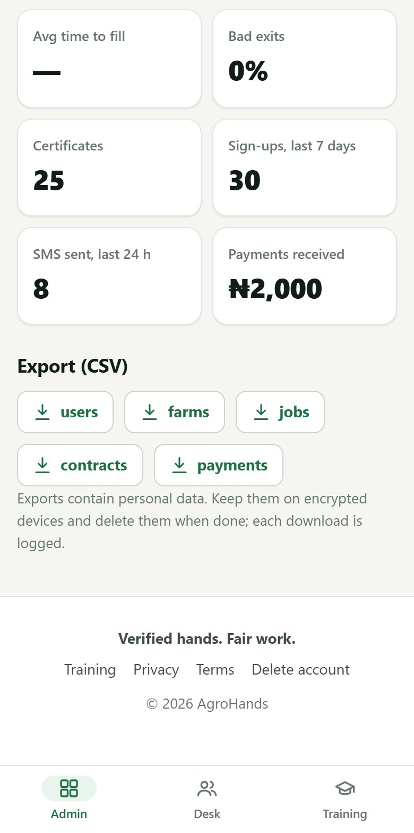  Part 2 of 2
Figure 54. The admin overview on a phone (shown in two parts).

Appendix A. SMS messages you may receive
AgroHands sends these messages in your own language. Each fits in one standard SMS. Messages always come from AgroHands and never ask for your PIN or code.
When | Who receives it | Message (English version)
You sign up | You | AgroHands code: 123456. Valid for 10 minutes. Never share this code. AgroHands staff will never ask for it.
You reset your PIN | You | AgroHands PIN reset code: 123456. Valid for 10 minutes. If you did not ask for this, ignore this SMS.
A farm sends you an offer | Worker | AgroHands job offer: [job] at [farm], N[wage]/day from [date]. Accept or decline at [website] or by USSD.
A worker accepts | Farm owner | AgroHands: [worker] accepted your offer for [job]. Sign the contract now: [link]
A worker declines | Farm owner | AgroHands: [worker] declined your offer for [job]. Open [website] to offer it to another worker.
The other side has signed | The one who has not signed | AgroHands: contract [ref] is waiting for your signature. Read and sign it at [link]
Both have signed | Both | AgroHands: contract [ref] is signed by both sides and is now active. Work starts [date]. Good luck!
Your complaint is answered | Who raised it | AgroHands: your complaint on contract [ref] has been answered. Log in at [website] to see the result.
An agent registers you | Worker | Welcome to AgroHands! An agent created your account. Log in at [website] or by USSD. Forgot your PIN? Go to [website]/forgot

Appendix B. Troubleshooting and questions
Problem or question | What to do
The SMS code does not arrive | Wait 2 minutes and check the number shown. Tap Send a new code. If you have Do-Not-Disturb (DND) active on your line, SMS may be blocked: dial your network's DND service to allow AgroHands, or ask an agent.
"Too many codes for this number" | At most 5 codes an hour are sent to one number. Wait an hour and try again.
"We can't send codes right now" | AgroHands has reached its daily SMS limit. Try later, or ask an AgroHands agent.
"Too many wrong PINs" | The account is locked for 15 minutes. Wait, or use Forgot your PIN? to choose a new PIN, which also unlocks it.
"This phone number is already registered" | You already have an account. Use Log in, or Forgot your PIN? if you do not remember the PIN.
I was logged out unexpectedly | This happens after a PIN change or reset, after 30 days, or if an administrator logged you out. Log in again.
I get no job offers (worker) | Complete all five steps, keep I am available for work switched on, check your expected wage and travel distance are realistic, and tick housing if you can live on a farm.
My shortlist is empty (farm owner) | Lower the minimum level, raise the wage, offer housing, then tap Refresh shortlist.
I cannot see the worker's phone number | Phone numbers appear only after both sides sign the contract.
I signed the wrong contract | Before both have signed, either side can end it with End this contract. Afterwards, contact AgroHands.
The page does not load | Check your internet. Training pages you opened before still work offline. Try again in a few minutes.
I want to stop using AgroHands | Delete your account (section 8.4).
Someone asked me to pay for a job | AgroHands never charges workers to find work. Do not pay. Report it to an agent or under the contract.

Appendix C. Glossary
Word | Meaning
Agent (field agent) | AgroHands staff who verify workers and farms in person and help people without smartphones.
Availability | The switch that lets farms send a worker offers.
Certificate | Proof that you passed a course. Anyone can check it using its code.
Contract | The written agreement between a farm owner and a worker, signed by both with their PINs.
Dispute | A problem reported on a contract, handled by AgroHands.
Guarantor | A respected person who vouches for a worker.
LGA | Local Government Area.
Match score | A number out of 100 showing how well a worker suits a job.
NIN | National Identification Number (11 digits), issued by NIMC.
PIN | Your 4 to 6 digit secret number: your password and your signature.
PPE | Personal protective equipment: boots, gloves, mask, goggles and similar.
Reliability | How often a worker completes jobs rather than leaving early or not showing up.
Shortlist | The ranked list of suitable workers for a job.
Level (tier) | Registered, Bronze, Silver or Gold. Shows how far a worker is verified and proven.
USSD | The menu service you dial on any phone, for example 384XXXX#. No internet needed.
Verified farm | A farm whose location and existence an AgroHands agent has confirmed.

Appendix D. Demonstration accounts for training
Trainers can practise with a demonstration copy of AgroHands that contains made-up people and farms (the same data shown in the pictures in this guide). These accounts exist only in the demonstration copy, never on the live service.
Role | Phone number | PIN
Administrator | 08000000001 | 1234
Field agent | 08000000002 | 1234
Farm owner (Farmnest Ogbomoso Smart Pineapple Farm) | 08030000001 | 1234
Workers (25 people) | 08100000001 to 08100000025 | 1234

Live service
On the live AgroHands service every person has their own account and PIN. Never share a PIN, even for training.

