# **Working of Food Recommendation project.**

In this documentation, I’m going to explain about how my food recommendation web application works and pre-installations required to run it successfully.

So, before running the project make sure to install the below applications or files:

**Installations:**

1. **Docker application:**

**Installing Docker on Windows**

**Requirements:**

Windows 10 64-bit: Pro, Enterprise, or Education (Build 15063 or later)

Hyper-V and Containers Windows features enabled

**Steps:**

* Go to the Docker Hub and download Docker Desktop for Windows.
* Run the installer and follow the prompts to install Docker Desktop.
* Start Docker Desktop.

Once installed, Docker Desktop should start automatically. You'll see the Docker icon in the system tray once it's running.

**Installing Docker on macOS**

**Requirements:**

macOS 10.13 or newer

**Steps:**

* Visit the Docker Hub and download Docker Desktop for Mac.
* Open the downloaded .dmg file and drag the Docker icon to your Applications folder.
* Start Docker Desktop.

1. **Python:**Install python from the python website according to the system OS and CPU bits and after installing run the exe file.

**Flow of Project**

**Frontend:**

First the user registers his details in "register.html" file and then he gets logged in using "login.html" and it validates the user and allow him into main "index.html" file where he enters the details regarding the nutritious values and gets the recommendations.

**Database:**

Here the tables are configured and integrated with the MySQL server, with the help of NodeJS. And the user details are stored and validated and in further it also stores the names of the dishes which the user want to save under his email in a table format and also fetches the details from the database by using MySQL queries..

**MySQL:**

In the docker-compose file we pulled an official image of MySQL from the dockerhub, and created a database by configuring it with the help of node js, which is present in database folder. And in this we are going to create a “user” table and “recipes” table and store the details.

**Backend:**

Here the recommendation is done, that is where whole logic works which includes training of the model and flask application to recommend dishes and returns the dishes according to the trained model to the frontend..

**Flowchart**

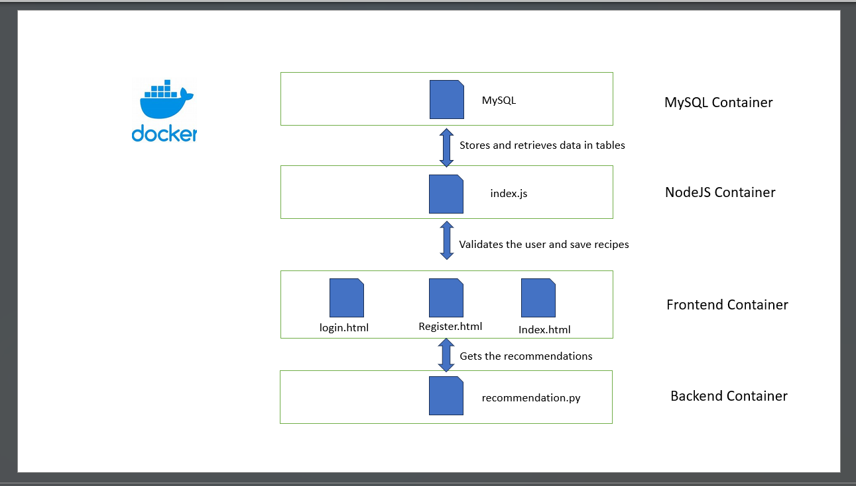

**Running the project in your local machine :**

**Clone the project**

* git clone <https://github.com/civilian-sai/food_recommendation.git>
* Open the food_recommendation folder.
* Steps to do before running by using docker

//enter into backend

cd backend

//save the recipes.csv file in this folder by using the above link or download from the google drive provided.

Google drive link: <https://drive.google.com/drive/folders/1y_9G-yE9NlRMDxRsfYg0d-0gQCxEBREC?usp=drive_link>  
  
Kaggle link:  
<https://www.kaggle.com/code/tanishqdublish/diet-recommendation-system-preprocessing/input>

//now run training.py to get the .pkl, .npy files which stores the training instances objects and trained data

* python training.py

**you can see the following highlighted files will get included into your backend directory**

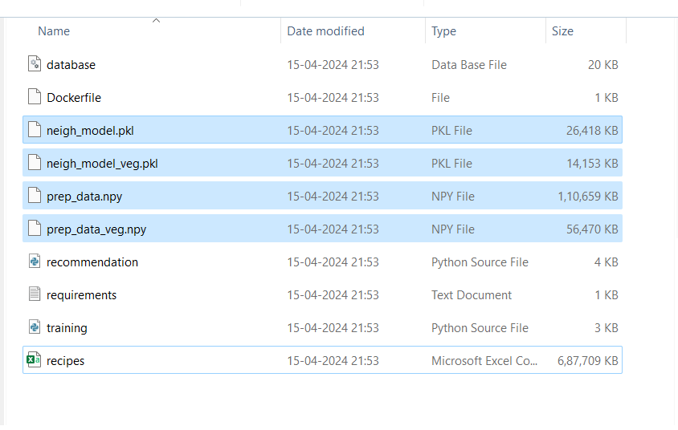

* Come to the directory where the docker-compose file is present.

**To run with docker**

* docker-compose up --build

// use the below URL in the browser to get started.

<http://localhost:5500/register.html>

More details.  
  
To check the tables in MySQL server use “ MySQL workbench” app, where after opening it with the help of our password which is “password” you can access the tables in the database section.