*Template for departmental intranet post for PrideON. Please use this template and encourage your department to publish it on their intranet to spread awareness of PrideON.*

**The Civil Service LGBT+ Network is keeping PrideON.**

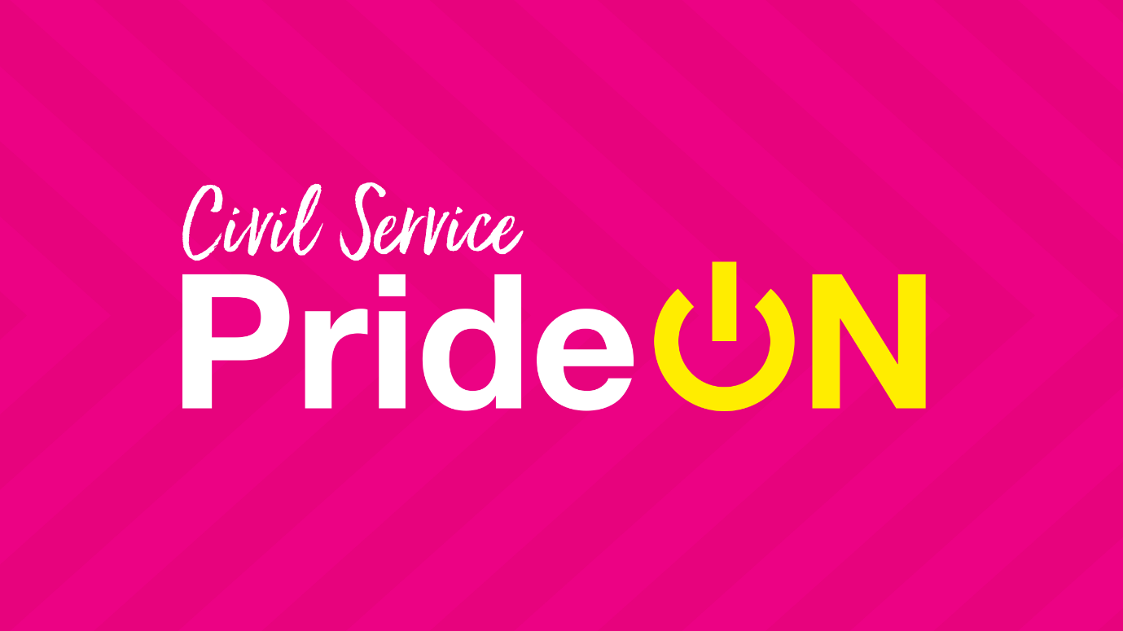

Pride is an important part of the LGBTI+ calendar. This year the events we would normally be celebrating together to recognise our LGBT+ colleagues and allies can’t go ahead in the same way, but here in [NAME OF DEPARTMENT] we are determined to make sure we celebrate our LGBT+ community.

The Civil Service LGBT+ Network has been working hard to keep PrideON in 2020 and with the help of their amazing members, have planned a programme of digital events and contents throughout June to celebrate Pride.

They have many exciting events planned such as a Big PrideON quiz, bingo, crafting activities, bake along, panel discussions and so much more. You can see the full calendar of events open to LGBT+ Civil Servants and Allies at [www.civilservice.lgbt/pride](http://www.civilservice.lgbt/pride). Be sure to check them out and sign up as some spaces are limited.

From w/c 15th June, they will be publishing digital content across all their channels. You will want to check out the PrideON playlist, the PrideON podcast and a set of blog posts on things that matter during the pride month. Also, keep an eye out for a famous face who has exclusively created some content for us all to enjoy. All content will be published on their [website](http://www.civilservice.lgbt/pride).

Make sure you are following their [Facebook](https://facebook.com/civilservicelgbt), [Twitter](https://twitter.com/cslgbt) and [Instagram](https://www.instagram.com/civilservicelgbt) to keep updated with everything they are doing throughout the month and help celebrate our LGBT+ community.

**Want to help spread visibility and show your support for LGBT+ Civil Servants?**

The Civil Service LGBT+ Network has created [a whole package of digital assets](https://www.civilservice.lgbt/publication/prideON-digital-assets-2020) for you to use and share around your teams to promote LGBT+ visibility. You can download these and share them across social media, using the hashtag #KeepingPrideON. Show your support by adding their banner to your [email signature](https://www.civilservice.lgbt/assets/documents/PrideON%20email%20signature%20upload.docx), change your video call background on MS teams/ Zoom, or simply just share the resources around your team.

**Are you hosting events to celebrate Pride during June?**

Drop the Civil Service LGBT+ network an [email](mailto:info@civilservice.lgbt) to find out how they can help you.

**Happy Pride month everyone, and together we will keep PrideON.**

*To find out more about the Civil Service LGBT+ Network, please visit their* [*website.*](https://www.civilservice.lgbt/about/)