Ameol2 Resource Kit

What Happens When Ameol2 Starts

Table of Contents
Introduction
Version Checking
Systems Time Sanity Check
Ameol Dialog Manager

Introduction
This chapter explains the Ameol2 startup sequence, what files are read and written, what registry entries are loaded and what it looks for. It is provided to help trouble-shoot common Ameol2 startup problems.

Version Checking
One of the first things that Ameol2 does is to extract the version number of the operating system on which it is running. It uses this to configure itself appropriately later.

Systems Time Sanity Check
The next step is to check the system date. If it is earlier than 1st September 1994, Ameol2 puts up an error and halts

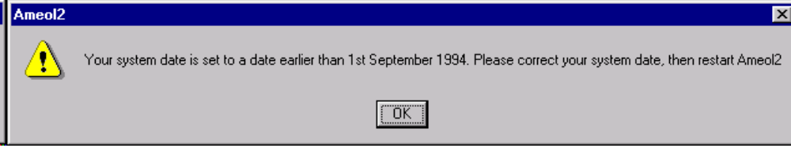

Ameol Dialog Manager
The Ameol dialog manager (ADM) is then initialised. The dialog manager takes over some parts of the Windows dialog manager functions in order to more efficiently handle dialogs. It also loads and initalises the CTL3D (3D Common Controls) library.

If the version of CTL3D.DLL on the system is earlier than version 2.29 then Ameol2 will refuse to run and display an error dialog.

System Class Registration
Next, Ameol2 registers all classes used by the controls.

Name | Use
amctl_frame | Frame window class
amctl_mdiclient | MDI workspace window class
amxctl_listviewcls | ListView control

If any of the classes cannot be registered, then Ameol2 will fail to start.

