# MarsHopper

## General information

MarsHopper is a plane for investigation poles and surroundings of poles on Mars. It uses CO2, that in solid form covers surface as a jet fuel. At landing, plane harvest CO2 for next flight and for deceleration. On the surface, plane accumulate isotopic energy in CO2, by changing it phase from solid to liquid(or gas). Liquid(or gas) CO2 at high pressure is used as a jet fuel for next jump, with possible short flight, hence the name of plane “hopper”.

By 2020, device for measurement is sent to north(or south) pole of Mars. Its main mission is to check the conditions for optimal functioning of the MarsHopper. First of all, it is density of the ice (we need to confirm hypothesis that plane could grab dry ice from the surface). Secondly, it is other parameters, like temperature, pressure etc.

By 2024, recalculations done based on measured data, MarsHopper sent to Mars. After entering the atmosphere, plane transform itself to its flight condition, like plane form ARES project. Before first landing, plane estimates its future landing points. At first landing plane harvest dry ice, accumulate energy in it and use it for next jump.

Generally, we need to estimate viability of the mission in terms of energy consumption and flight condition.

Firstly, we need to estimate plane size, mass, flight velocity. Secondly, to estimate how much we need jet fuel in form of liquid (or gas) CO2 to achieve flight conditions. Thirdly, to estimate whether we can obtain enough amount of energy to transform initial parameters of CO2 (P1,T1) to final(P2,T2).

Following calculations are only estimation to get order of magnitude of desired values to estimate viability of the project.

## Flight conditions

To estimate flight condition we used FoilSim, software developed at NASA Glenn Research Center.

In Mars atmosphere with following parameters:

wing size(chord = 1m, span = 10m),

airfoil angle = 12 deg,

flight speed 360 km/h,

we have lift force 1060N and drag 106N. It is enough to carry estimated mass of plane 200 kg with weight 742N (Mars gravity). Here we do not take in account the drag force of a fuselage.

## Jet thrust

Here we need to estimate amount of fuel needed to achieve flight speed 360 km/h. To make rough approximation we can use model of variable-mass system (Meschersky equation)



v and m are velocity and mas of CO2 respectively. To estimate v we can use equation of velocity for de Laval nozzle.

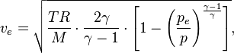



Let suppose that plane have acceleration 50 m/s2 and in 2 sec it achieveі velocity 100m/s that equals 360 km/h. Than, according to Meschersky equation we need consumption of CO2 17 kg/s. In 2 seconds we will consume 34 kg and achieve 360 km/h.

We will also use two screw motors (?) powered by CO2, and suppose we need 8 kg CO2 on each.

We can change acceleration and accordingly CO2 consumption, but totally, we need very roughly 50 kg of CO2.

## Energy consumption

Here we need to estimate how many energy we need to accumulate in 50 kg CO2 and to evaluate whether we can get this energy with existing technologies.

Dry ice harvested with surface condition T = -130 C, P = 600 Pa (green dot on plot below, very near to phase transition). Our goal is to accumulate energy (reach blue dot). While heating dry ice we sublimate it to gas phase. We have an advantage that dry ice is near phase transition. Pressure of gas rises and we achive triple point of CO2. After that, we begin to obtain liquid phase.

What energy we need to apply to transit from green dot to blue dot?

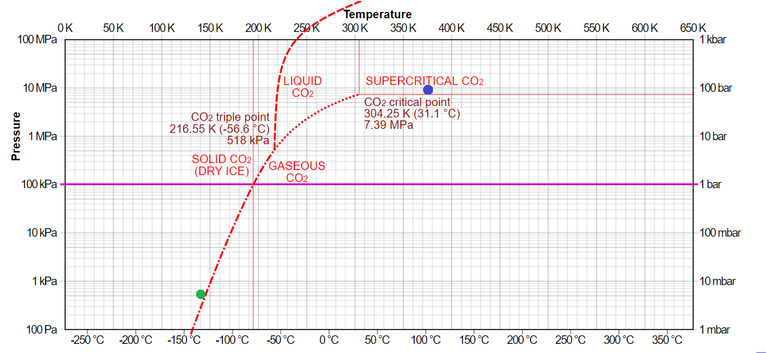

Suppose dry ice is crumbly, with density







Thus with reservoir with volume 50 l we have 50 kg of CO2/

Heat capacity of solid  (To heat 1 g of CO2 for an 1K we neet to apply 1J)

Enthalpy change of sublimation (To transit 1g solid CO2 to gas we need 590J)

Enthalpy change of fusion 

How much mass of CO2 we need to sublimate to reach triple point and how much energy we need for this?

We can use Van der Waals equation.

 , where a=0.36088 N•м4/mol2, b=42.840 sм3/mol

 

Thus, we need to sublimate approximately 240g of CO2 to reach triple point and 142 кJ.

How much energy we need to melt all ice?



To heat liquid to 100C we need:



Totally, to transit from green to blue dot we need approximately 20MJ.



We decided to heat to 100C because it accumulates sufficient amount of energy to prevent liquid transition to solid after it injection to de Laval nozzle.

**Energy source.**

We suggest using radioisotopes as a main energy source. Approximately 1 kg gives 0.5 kJ/s. Suppose we use 10 kg of radioisotopes, and we have ideal case when all energy goes to dry ice. Than we need

 to wait on surface for energy recharge.

If take in account roughness of estimations we may rely on 2-4 h of energy recharge.

Thus, we confirm energy viability of MarsHopper project.

## Open questions

Jet engine design at low temperatures.

Heat system design (energy transition from radioisotopes and CO2 )

Precise calculation of wings lift force

…