Svelte Project – Training
- Installation is common to angular
  - I installed node.js and was ready to work on this yeah bro obvious you require a code editor. I am using vs code
- Creating a new project, follow the step provided in the below link
  - https://shadcn-svelte.com/docs/installation/sveltekit
  - Also, while creating new project, I come to know that the first command does work so I used below command
    - npx sv create cj-svelte-seo
    - npx shadcn-svelte@latest init - Run the CLI
    - npx shadcn-svelte@latest add button - Adding the button to CLI
  - I come to know steps 2 to 4 is not required
  - Only perform the steps after 4, you will be fine.
- I add the button to the svelte project while doing that I come to know about two modes “Legacy” and “Runes” Mode
Legacy Mode | Runes Mode
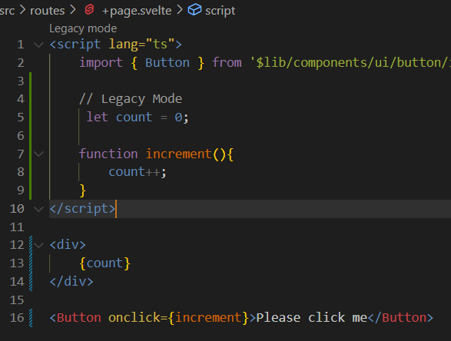 | 