**Reference Manual**

**Jersey Mike’s Subs: Managerial Database**

Taught by: Hong, Dr. Sungchul

Group Members: Colin Jose

  
Towson University

Table of Contents

1. Introduction to Jersey Mike’s Managerial System
   1. Who Should Use This Application…………………3
   2. Who Should Use This Guide……………………….4
2. Key Features……………………………………………..5
3. Tour of Features
   1. Login……………………………………………….6
   2. Manage Stores……………………………………...9
   3. Manage Employees………………………………...10
   4. Display Weekly Sales By Store……………………11

Who Should Use This Application

Having full control of your business is the only way to a sure path to success. Every business owner has multiple employees and can have a variety of store locations. Along with the task of keeping track of employees and store locations, an owner must gauge how each location is performing and must have a running sales total for each location. Owners should have access to a database application that has all of these functions in one place.

The Jersey Mike’s Managerial application provides an interface for managers or franchisee owners. Within this application, managers have the ability to add employees and stores. Managers also have the ability to view their current stores and see how many employees work in each of them. Managers can also load the current sales totals from each store, broken down into an easy to read weekly report. This information would help managers gauge if their locations are understaffed based on sales totals.

Who Should Use This Guide

This guide is intended for new users to the Jersey Mike’s Managerial Database Application:

Managers/Franchisee Owners: Can learn how to log into their respective accounts and manage employees or stores. They can additionally learn how each store is performing. They are able to view this inside a sales table.

Key Features

The following are key system functions available to users of the application:

* Add new employees
* Add new stores
* View current employees
* View current stores
* View current weekly sales of each store

Login

Upon launching the application, users will see a login window (Figure 1) with input fields for username and password. In order to log in and access the Jersey Mike’s Managerial Application, users must enter a username and password and then click the “Log In” button.

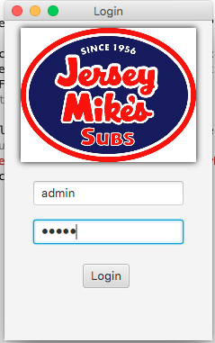

(Figure 1)

For simplicity in production deployment the default credentials are:

Username= “admin”

Password= “admin”

If the incorrect user name and password combination does not exist within the login table in the database. The user will be faces with an error message reading “Invalid Credentials” and not be granted access to the application. This can be seen in figure 2 below.

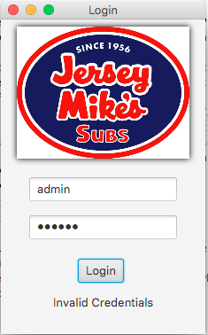

(Figure 2)

If the user enters in the correct credentials. The main interface is then displayed. (Figure 3)

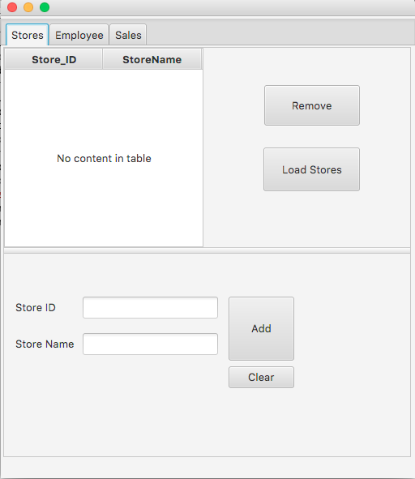The interface is divided by the tabs (Stores, Employee, Sales). Each tab contains the relevant functions to that topic.

(Figure 3)

Managing Stores

Since the application always opens up on the “Stores” tab you do not need to further navigate. In order to show the existing stores and store names that currently are in the database, you can click on the “Load Stores” button and the table will populate. The user can add a store into the table by filling out the “Store ID” and “Store Name” fields. Upon completion the user must select the first row within the table and click the “remove” button until the table is empty. Then, the user can click “Load Stores” again. This will display the new addition made to the stores table, which was just entered. The “clear” button will empty the text fields making it easier to input a new store. This can all be seen in figure 4 below.

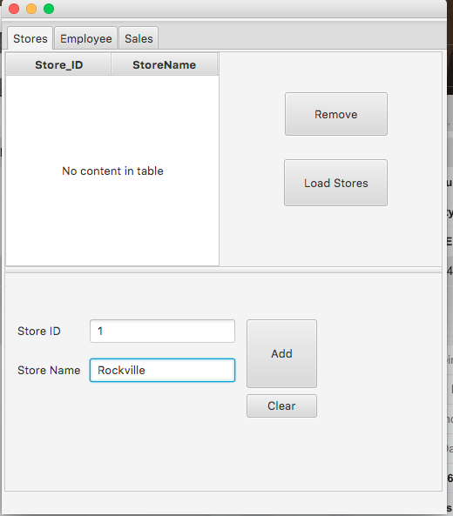

(Figure 4)

Managing Employees

In order to manage employees you must navigate to the “Employee” tab. Here a user can view current employees along with what store they belong too. Other useful information such as position and salary are displayed. The user can add an employee by filling out the 5 fields (fName, lName, Position, Salary, Store ID) and then click on the “add” button. The “clear” button is also available to clear the fields the user inputs, thus preparing them for the next entry. After a new employee has been added, you can then load the current employees in the database to the table by pressing the “Load Table” button. Upon each new update to the table in order to view the tables current state, user must click the top row of table and click “Remove” until the table is empty and then reload the table by pressing “Load Table”. All the above can be seen below in figure 5.

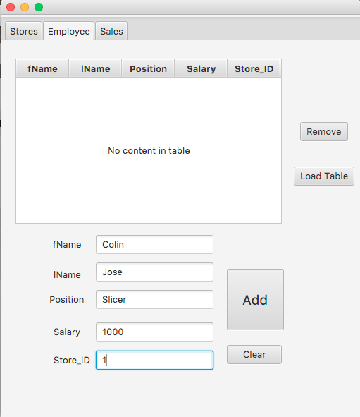

(Figure 5)

Displaying Weekly Sales by Store

In order to display the sales data kept on record, in the “sales” table, the user must navigate to the “Sales” tab. Here the user will be greeted with a table that has the following columns: Store_ID, Week 1, Week 2, Week 3, Week 4, Week 5. In order to populate the table, the user must click the “Load Sales” button. This can all be seen in the figure 6 below.

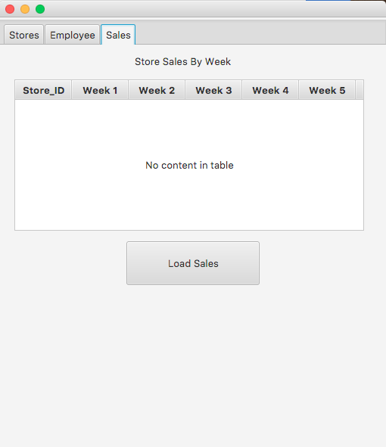

(Figure 6)