Question 2

i)

Initializing the repository

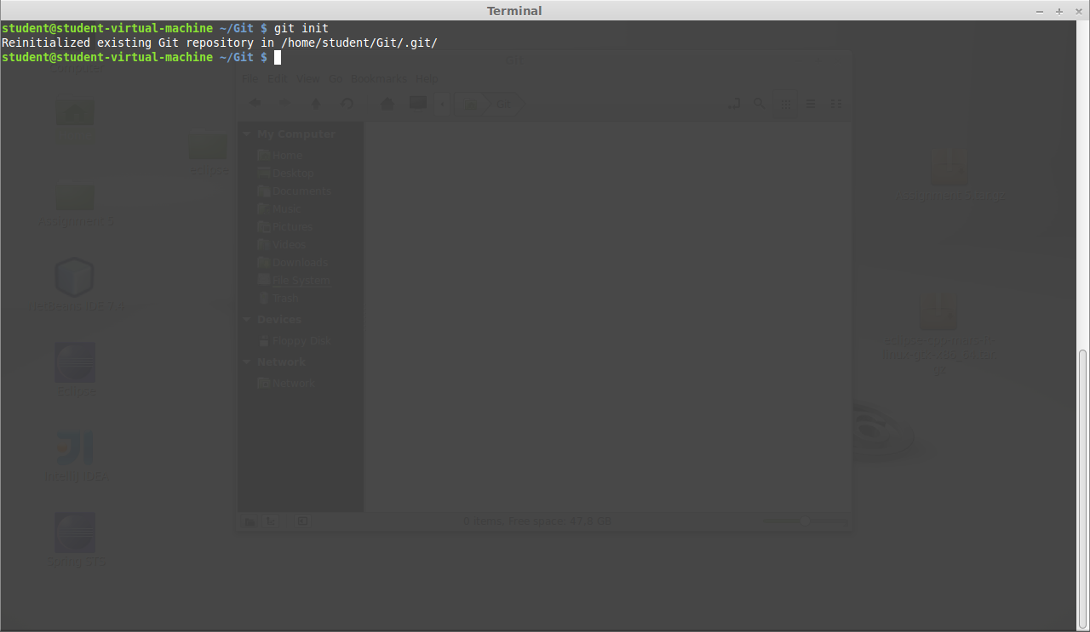

ii) File is created in the repository.

The status shows that the file is not tracked yet and no changes has been committed

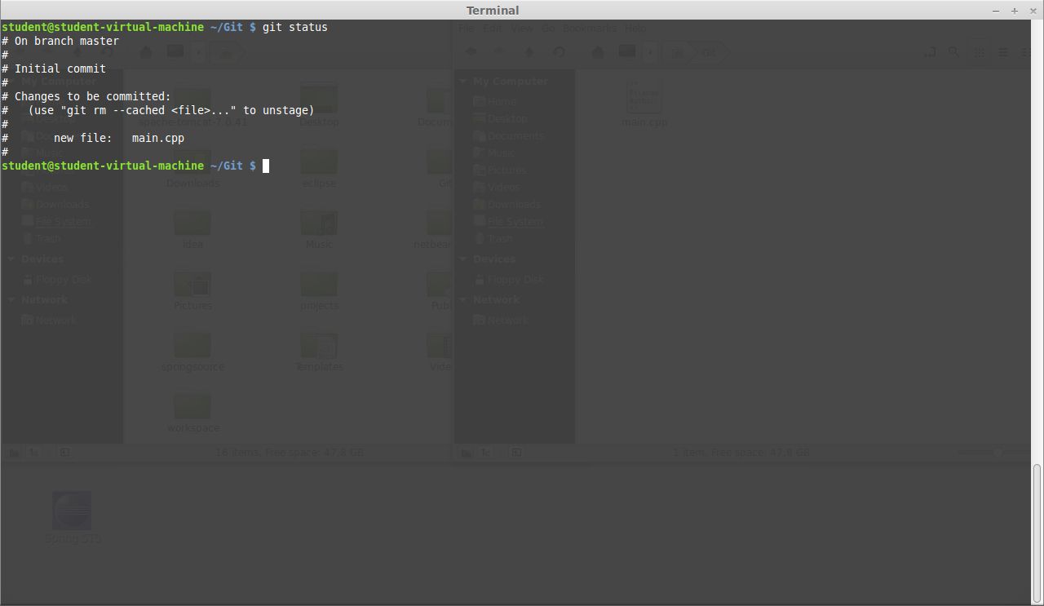

iii)

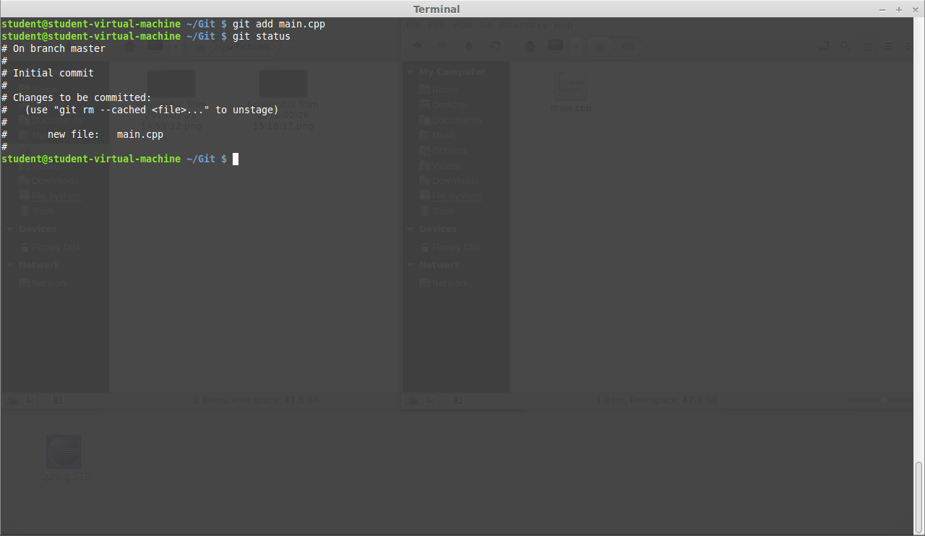

iv) By committing a snap shot of the project has been taken, in the status it shows that the project has been modified.

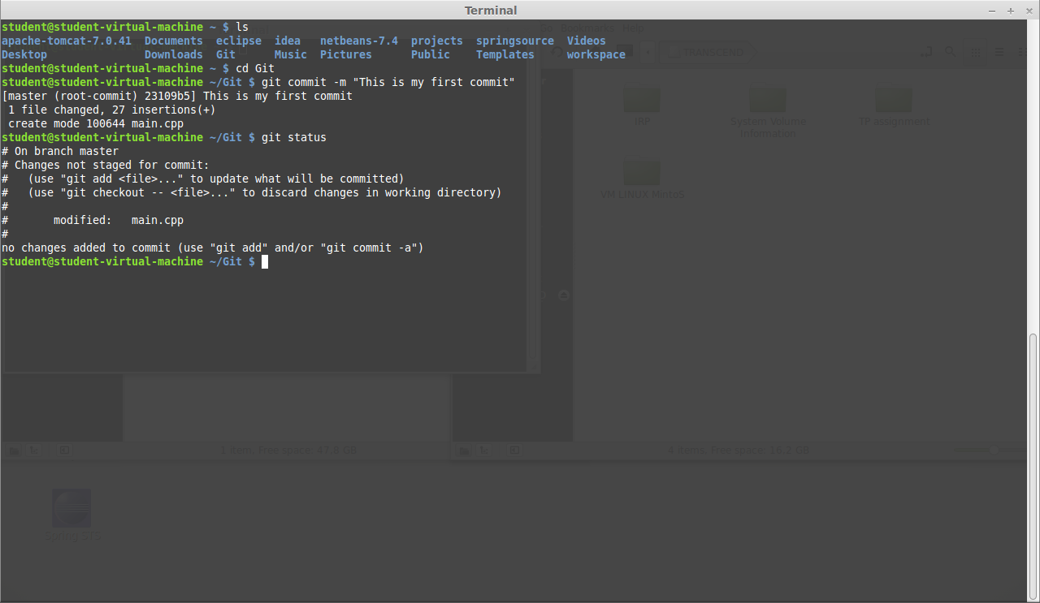

v) Three files has been created. They are untracked because they are in the working directory and not staged yet.

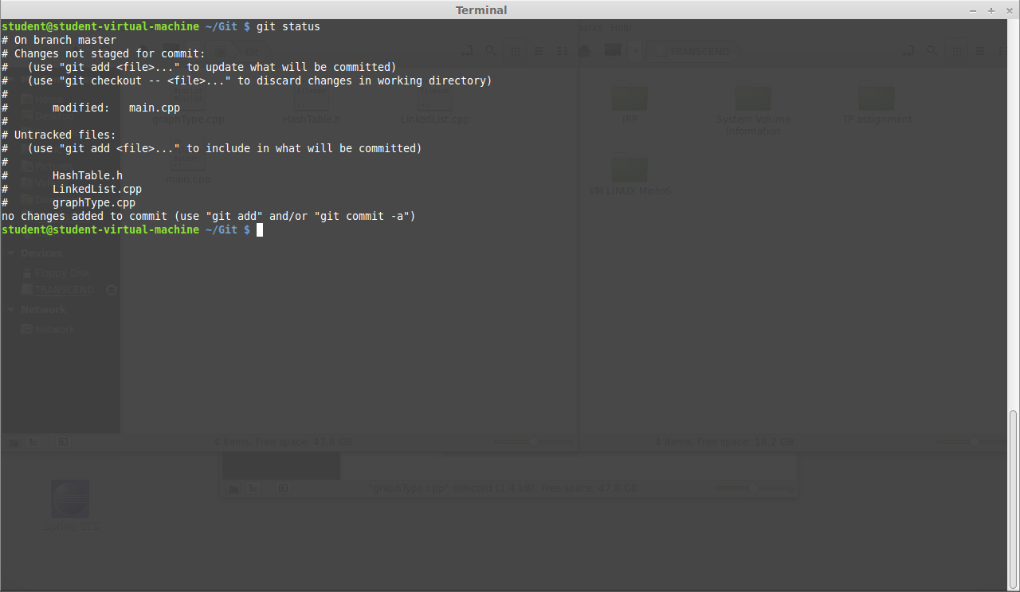

vi) status of changes made to the file commited

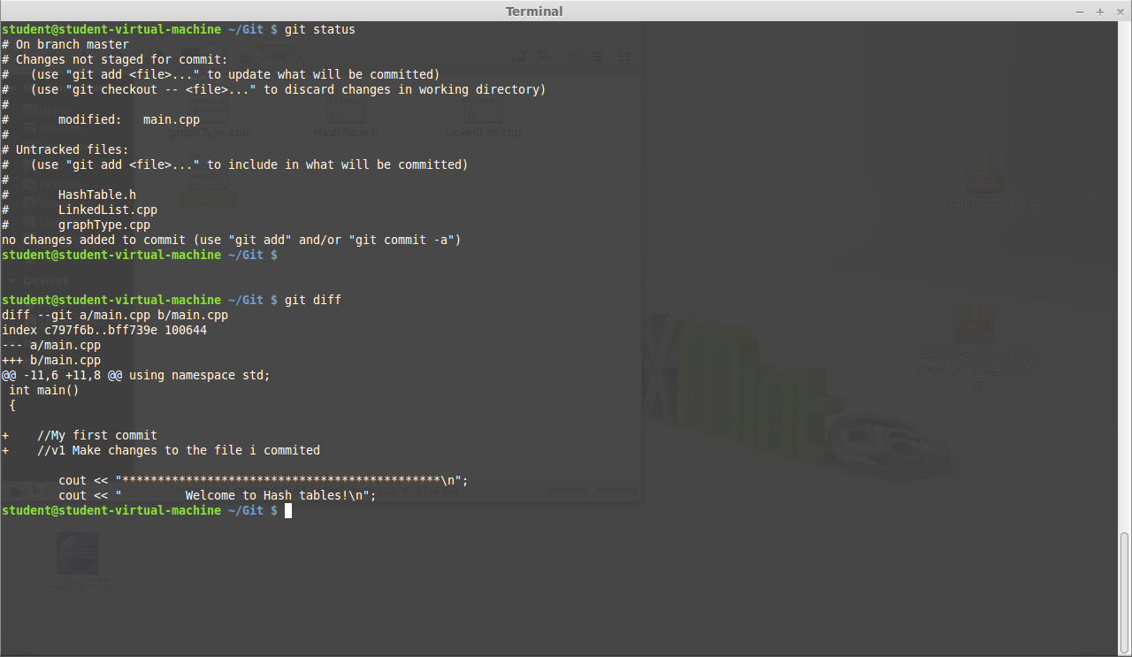

vii) Status of two files that are tracked

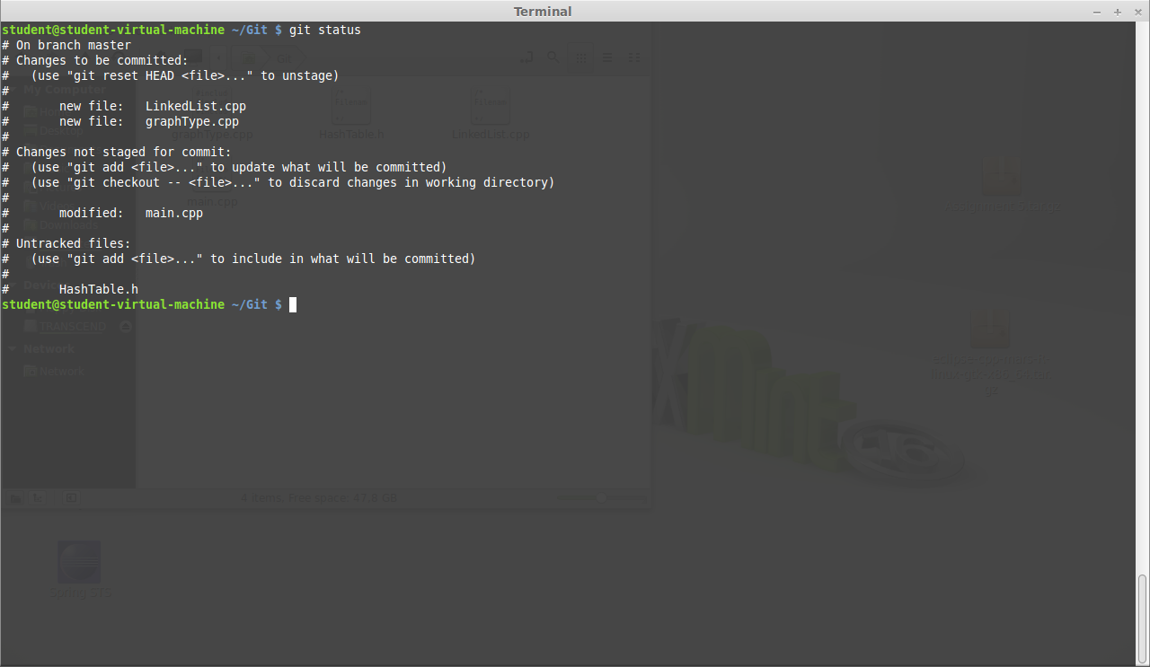

viii) Status of Modified file commited

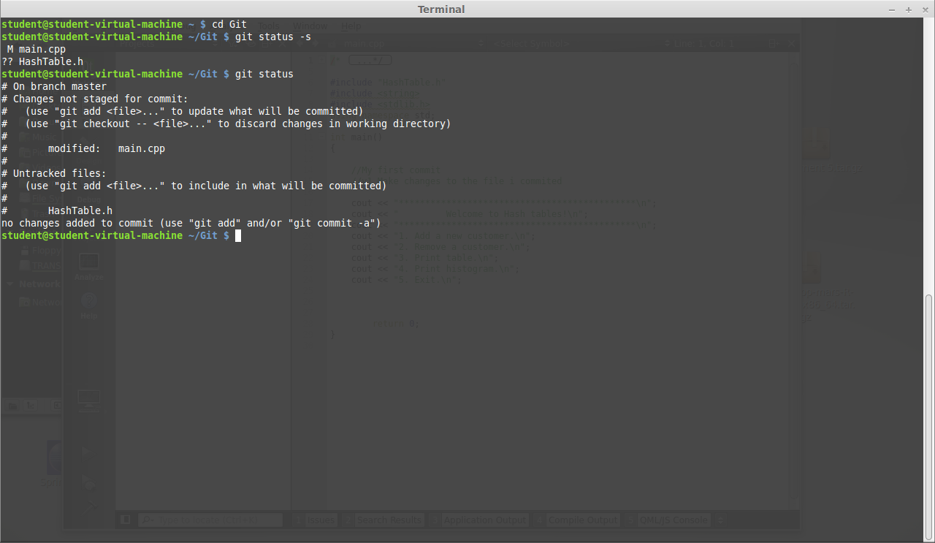

ix) Short status of the repo

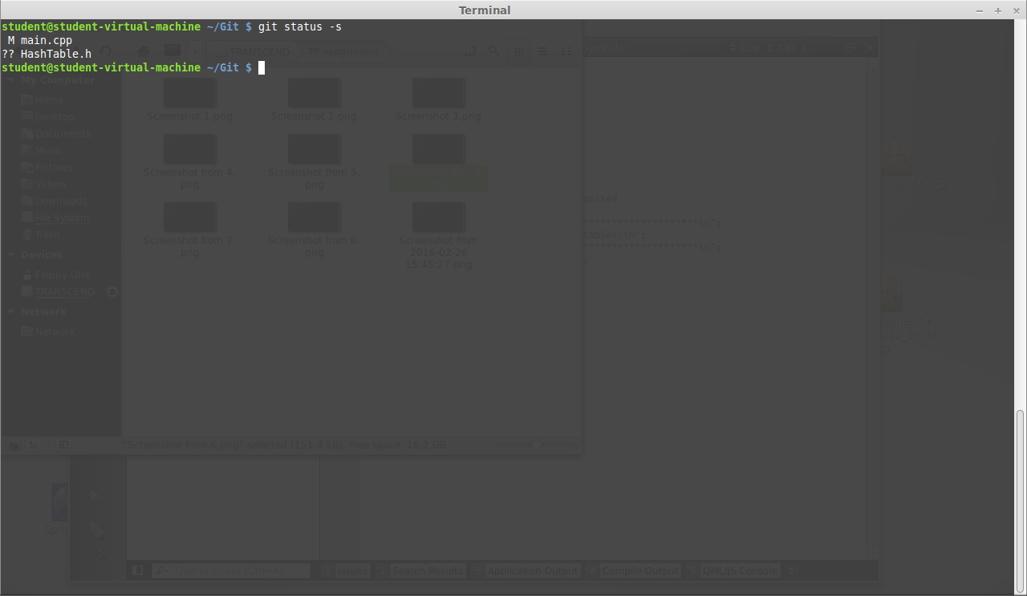

xi) status after one of three files recently created ignored

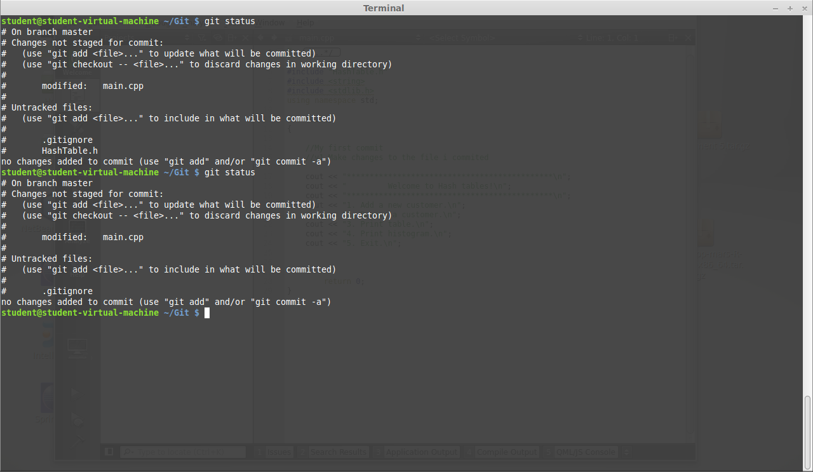

xii) Status after one file has been removed.

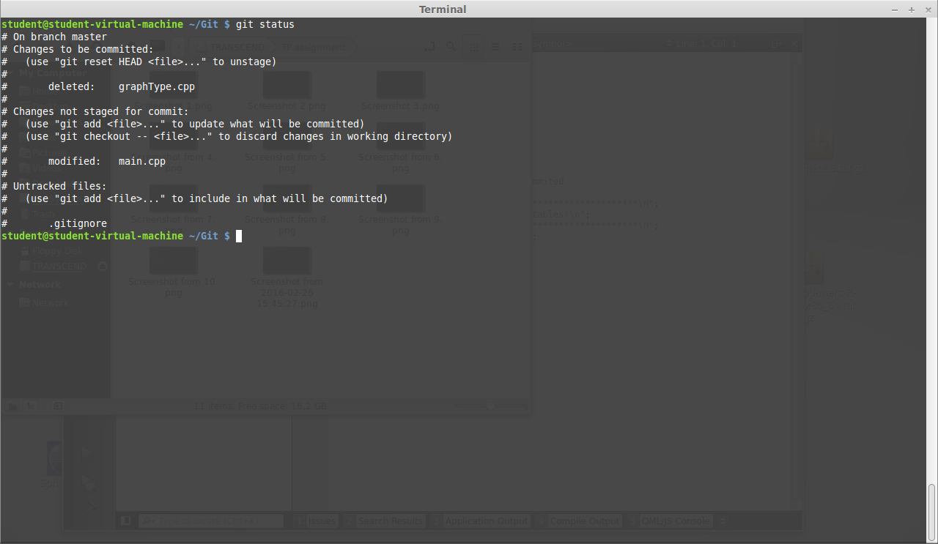

xiii) commit history out put

